Logan Williams
10/01/2025 – 10/9/2025
LaSalle Lab

CfDNA Extraction from LACOFD Plasma Samples
Purpose:
To isolate cfDNA from the provided LA Country Fire Department plasma samples to facilitate EM-seq WGBS, with the goal of investigating how differences in smoke exposure during training manifest in cfDNA methylation, with potential implications for cancer research.

Plasma DNA will be isolated in batches of 23 samples (plus one negative control) at a time, due to equipment limitations (limited space on the vacuum manifold).

The procedure for cfDNA isolation is adapted from the protocol for the QIAamp Circulating Nucleic Acids Kit. It is described below.

Procedure – DNA Isolation
- Prior to beginning the protocol in earnest, complete the following preparatory steps:
  - Equilibrate plasma samples to room temperature. This can be done by floating them in RT water.
    - The following 23 unique biospecimens (46 total aliquots) will be processed in Batch #1 (10/3/25).

Batch #1 Samples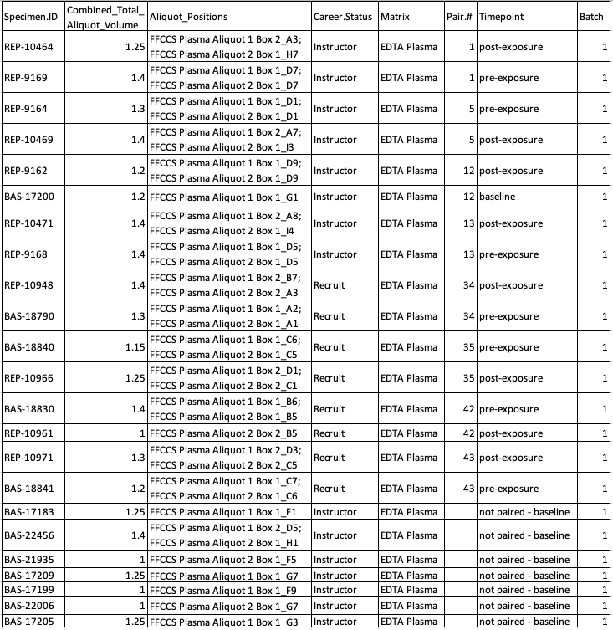

Batch #2 Samples (11/7/25)
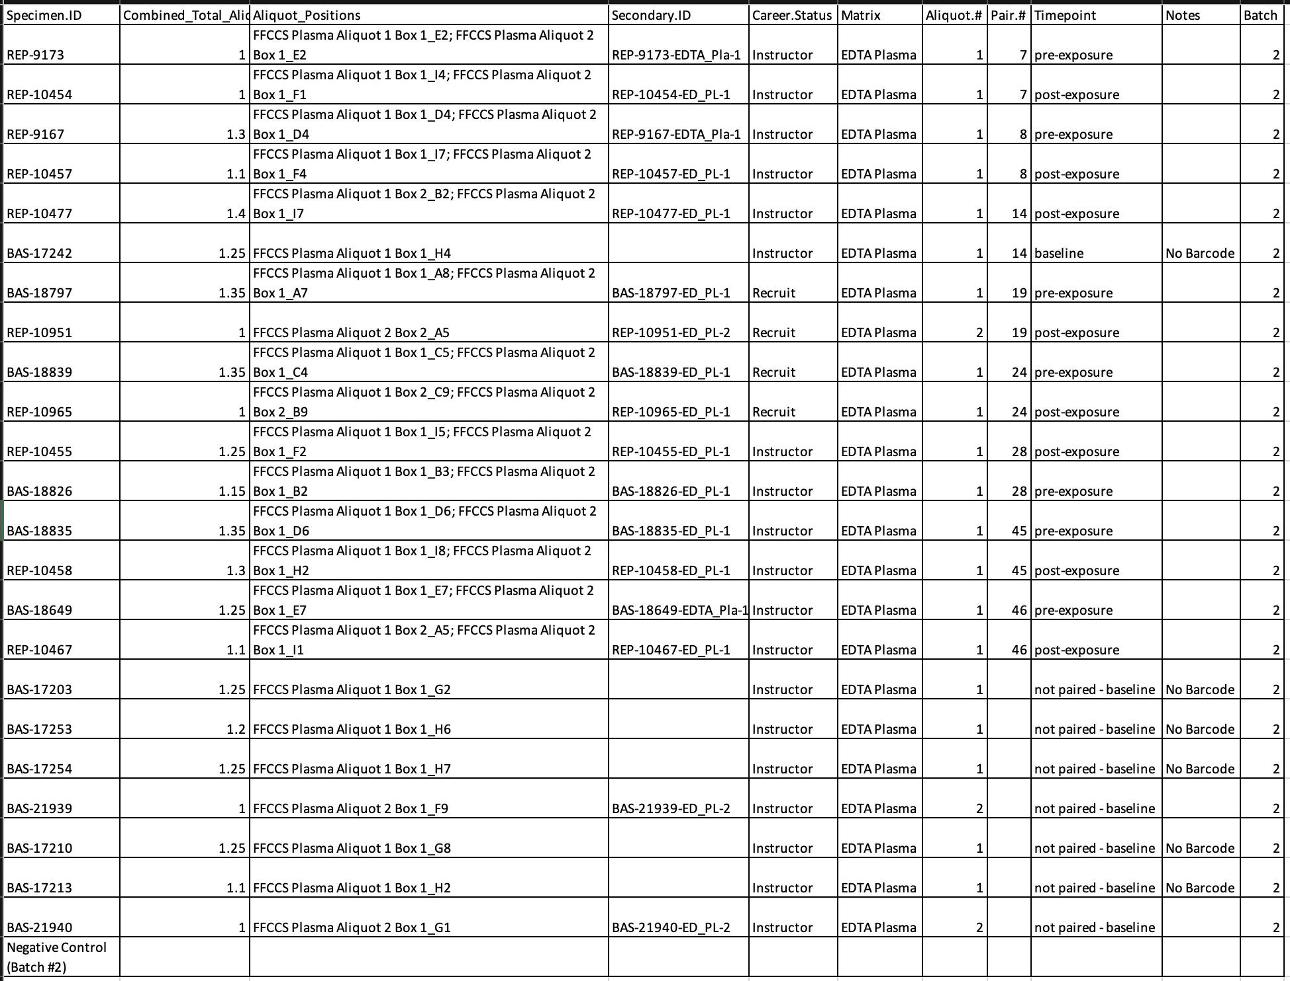

Batch #3 Samples
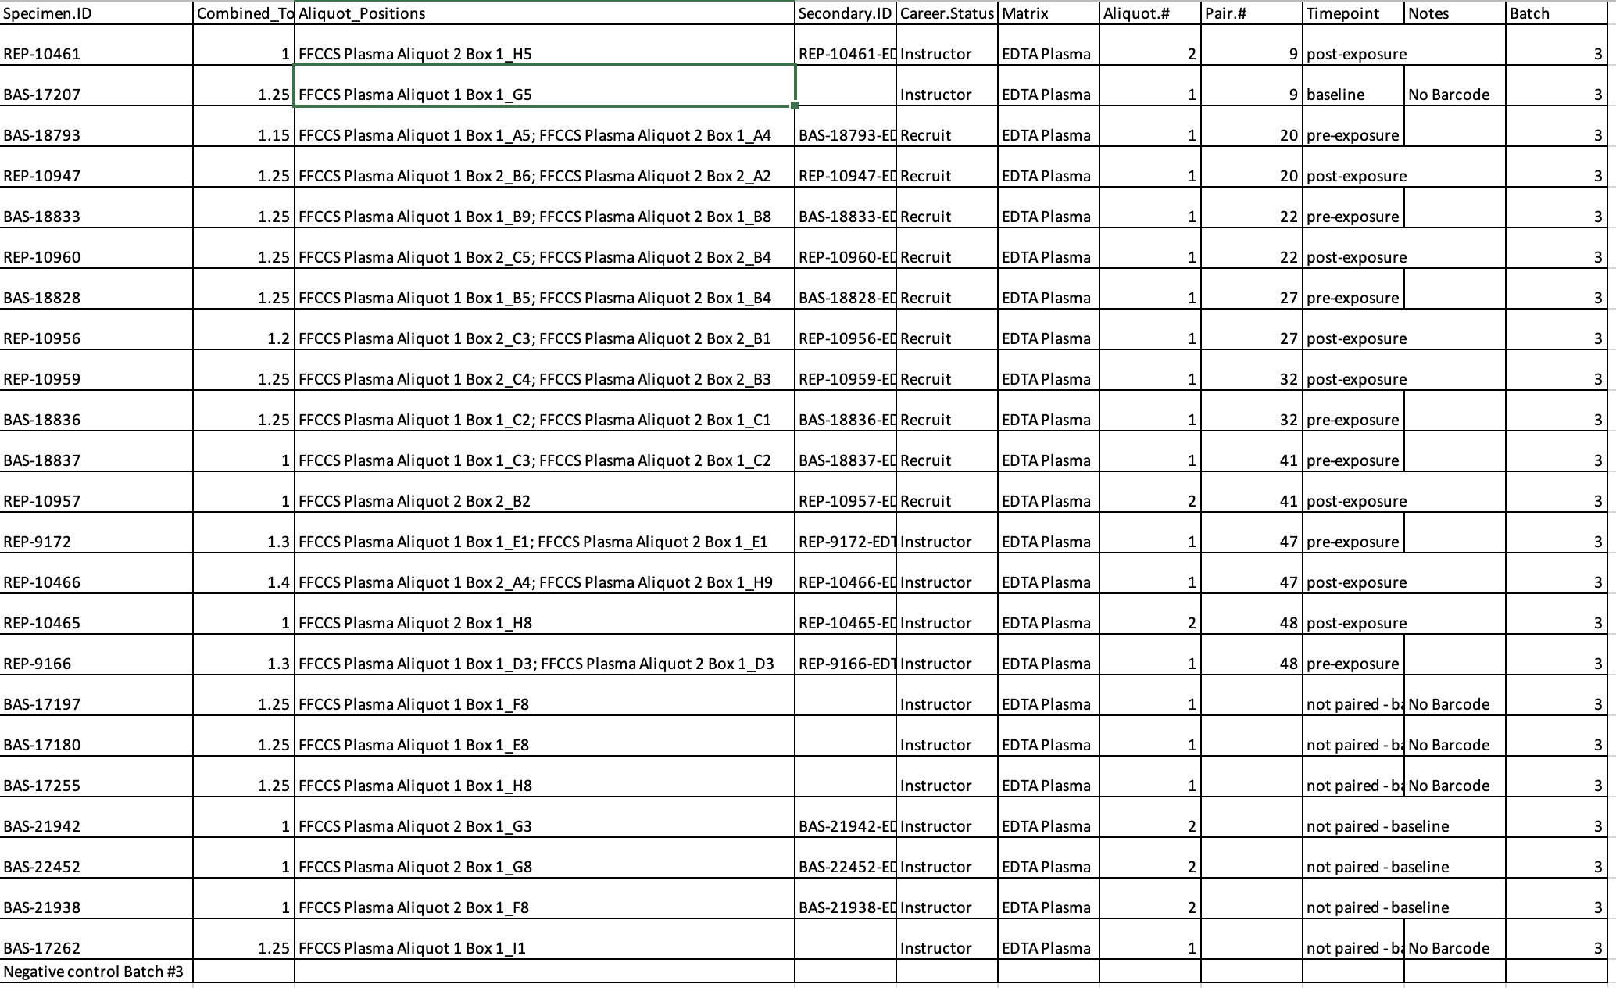

Batch #4 Samples
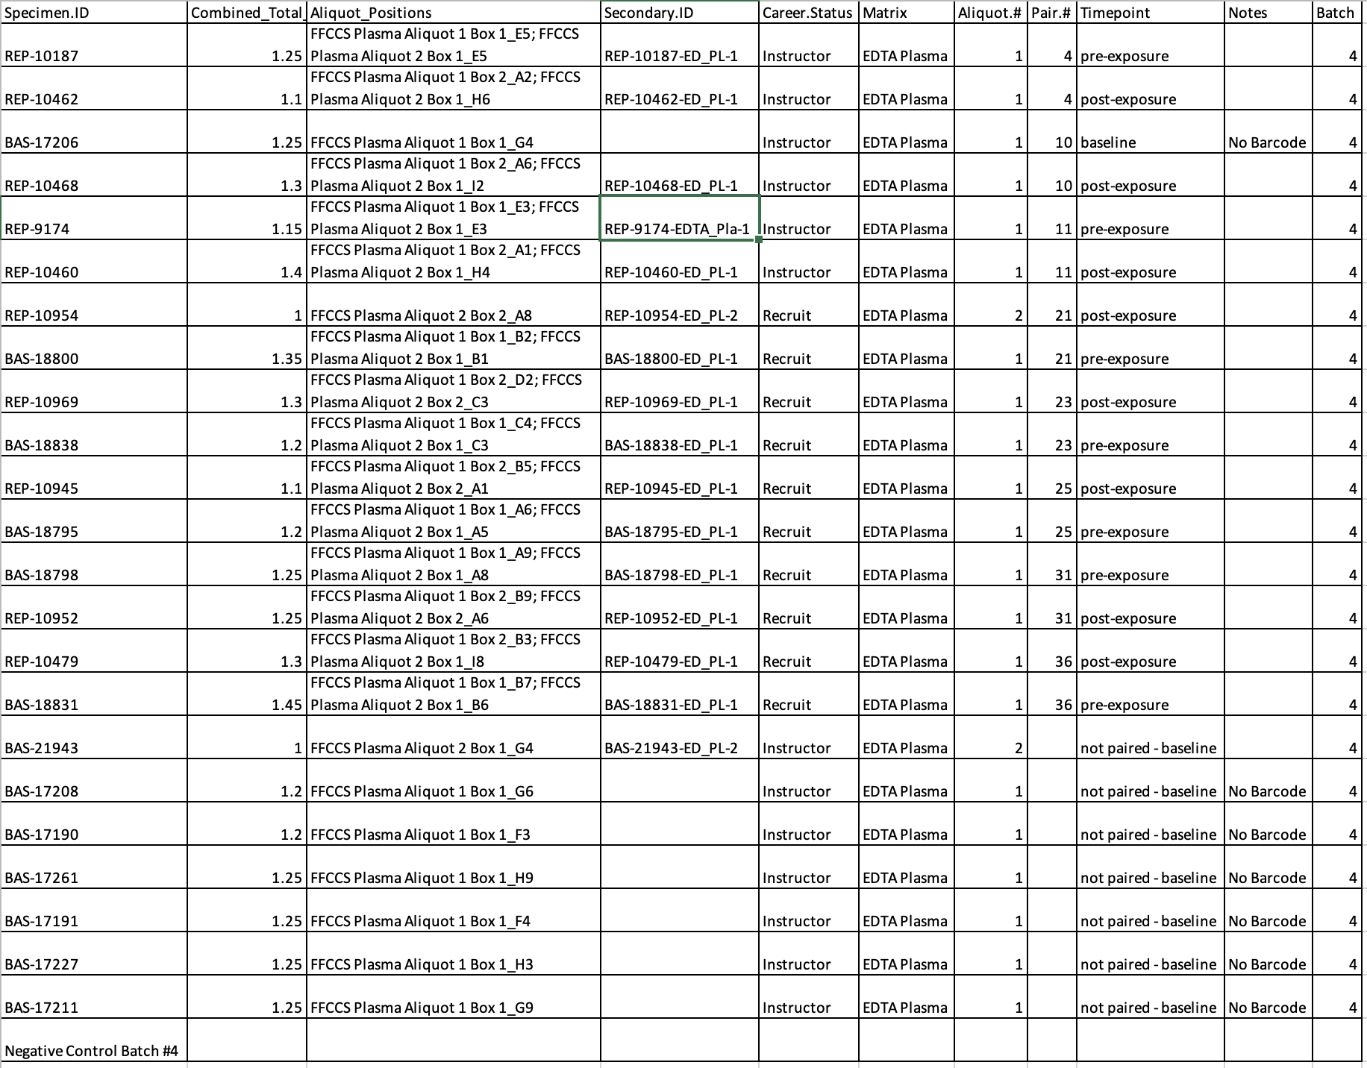

Batch #5 Samples
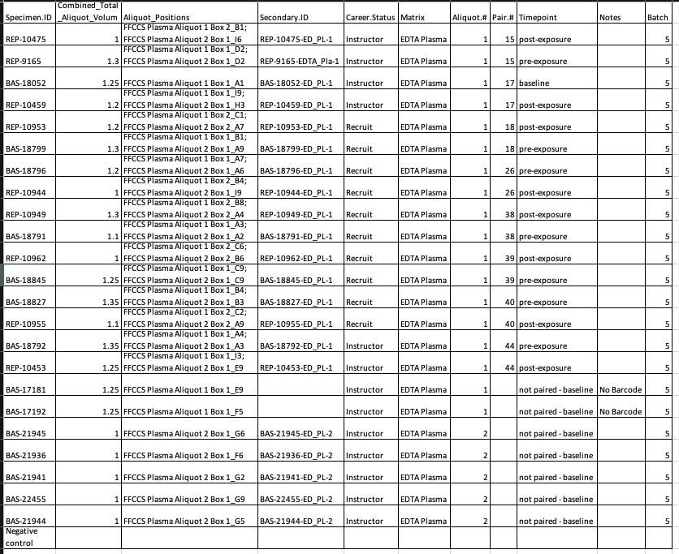

Batch #6
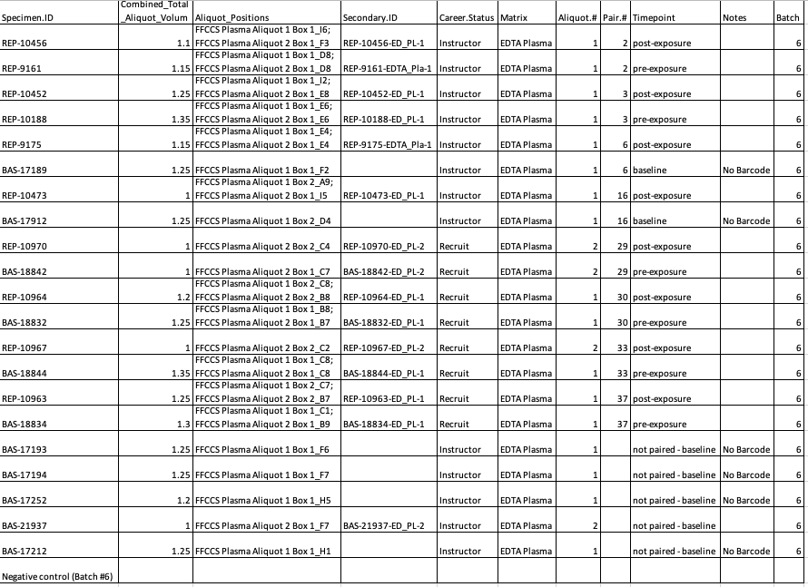

  - Once plasma samples have thawed, remove tubes from bath and dry them. For samples split across two aliquots, consolidate the two aliquots for each sample into a single tube.
    - If total plasma volume is less than 2mL, make up the difference in volume using 1X PBS.
      - PBS added to all Batch #4
    - If concerned about buddy coat contamination, spin tubes at 16,000g for 10min to pellet out/separate remaining particulate.
  - Set up your Vacuum apparatus.
  - Heat a water bath or heating block to 60C to be compatible with 50mL centrifuge tubes.
    - It takes ~30min to heat up the heat bath.
  - Heat a different heating block to 56C to be compatible with 2mL collection tubes.
  - Equilibrate Buffer AVE to room temperature for elution.
  - Ensure buffers ACB, ACW1, and ACW2 have been prepared according to the instructions.
  - Add carrier RNA reconstituted in Buffer AVE to Buffer ACL according to the following specifications:
    - To add carrier RNA to Buffer ACL, reference the table provided in the official QIAamp Circulating Nucleic Acids manual.
    - If no dissolved carrier DNA is available, make it fresh from lyophilized carrier RNA as described:
      - Add 1550uL Buffer AVE to a tube containing 310 ug lyophilized carrier RNA to obtain a solution of 0.2 ug/uL. Dissolve carrier RNA thoroughly and divide into conveniently sized aliquots, and store at -20C until use. Do not freeze-thaw carrier RNA more than 3 times.
    - For this experiment with 23 samples and 1 control, this step is completed by adding 135uL of Carrier RNA in Buffer AVE solution to 42.2mL of Buffer ACL.
- Once all preparatory steps are completed, begin by adding 200uL of QIAGEN Proteinase K into a 50mL centrifuge tube.
  - Added for batch #3
  - Added for batch #4
  - Added for batch #5 at 11am on 11/18
  - Added for batch #6 at 11am on 11/20
- Add 2mL of blood plasma sample to the 50mL tube. Note any colored tinge present in the sample (plasma should be straw colored, not red).
  - PBS added to all batch #4.
  - PBs added for all batch #6
  - R10944 from batch #4 lost due to liquid handling error.
- Add 1.6mL of Buffer ACL (containing 1.0ug of carrier RNA) to each 50mL tube. Cap tube and mix by pulse-vortexing for 30s.
  - Ensure that a visible vortex forms in the tube. Thorough mixture is essential to effective lysis.
  - Batch #2 started at 8am (for time estimation later). Finished at 1pm (5 hr total time, hard to push more than 1 per day).
- Following vortexing, immediately incubate the tube at 60C for 30min.
  - Get ice for step #7 during this incubation.
  - Note: For Batch #1’s samples, due to processing issues with the heat bath, only half of the samples could be incubate at 60C at a time. Thus, half of the samples had to wait 30min prior to their incubation.
- Place the tube back on the lab bench and unscrew the cap. Add 3.6mL of Buffer ACB to the lysate in the tube. Close the cap and mix thoroughly by pulse-vortexing for 15-30s.
- Incubate the lysate-Buffer ACB mixture in the tube for 5min on ice.
- Insert the QIAamp Mini column into provided VacConnector, then connect them to the vacuum manifold attached to your vacuum apparatus. Insert a 20mL tube extender into the open QIAamp Mini column.
  - Be sure tube container is firmly inserted into the mini column to avoid sample leakage.
  - Keep the collection tubes for the dry spin in step 13.
- Carefully apply the lysate-Buffer ACB mixture from step 7 into the tube extender of the QIAamp Mini column. Switch on the vacuum pump. When all lysates have been drawn through the columns completely, switch off the vacuum pump and release the pressure to 0mbar. Carefully remove and discard the tube extender.
  - Be sure to be extra careful when reducing pressure back to 0mbar. Complete release of vacuum in an instant may result in air pressure dislodging sample from the membrane.
  - Larger sample lysate volumes may take up to 10min to pass through the QIAamp membrane.
  - To avoid potential contamination, be sure not to move used tube extenders over neighboring QIAamp Mini columns.
- Apply 600uL of Buffer ACW1 to the QIAamp Mini Column. Leave the lid of the column open, and switch on the vacuum. After all of the Buffer ACW1 has been drawn through the QIAamp Mini Column, switch off the vacuum pump and release the pressure to 0mbar.
- Apply 750uL Buffer ACW2 to the QIAamp Mini column. Leave the lid of the column open and switch on the vacuum. After all the Buffer ACW2 has flown-through, switch off the vaccum and release pressure to 0mbar.
- Apply 750uL of 100% EtOH to the QIAamp Mini column. Leave the lid of the column open and switch on the vacuum. After all the EtOH has flown-through, switch off the vaccum and release pressure to 0mbar.
- Close the lid of the QIAamp Mini column and remove it from the vacuum manifold, discarding the VacConnector. Place the QIAamp Mini column in a clean 2mL collection tube and centrifuge at full speed (20,000g or 14,000RPM) for 3min.
- Place the QIAamp Mini column into a new 2mL collection tube. Open the lid, and incubate the assembly at 56C for 10min to dry the membrane completely.
- Place the QIAamp Mini column in a clean 1.5mL elution tube and discard the 2mL collection tube from the previous step. Carefully apply 20uL-150uL of Buffer AVE to the center of the QIAamp membrane. Close the lid and allow to incubate at room temperature for 3min.
  - Alter the volume of your elution buffer to alter final elution concentration.
    - 45uL elution buffer used with batch #1 and batch #2 and batch #3.
  - It is essential that Buffer AVE is equilibrate to room temperature before use. If elution is done at small volumes (<50uL), it is critical that Buffer AVE be dispensed directly onto the center of the membrane for maximal DNA retention.
  - The recovered eluate volume is typically ~5uL less than the volume applied to the membrane.
- After incubation, centrifuge tubes in a microfuge at full speed for 1min to elute nucleic acids.
  - cfDNA eluates stored at -20C overnight in a labelled Box.
  - Batch #6 box stored at -20C in the smaller freezer above thew fridge due to the main freezer beign dethawed at time of collection.

Procedure - Quantification
- After giving samples time overnight to rehydrate, quantify cfDNA yields via Qubit HS Assay Kit.
  - Batch #1 Quantification
    - Qubit Working Solution made by combining 5174uL of Qubit Buffer with 26uL of Qubit Reagent.
    - Sample tubes made by combining 3uL cfDNA Eluate with 197uL QWS. Standards made by combing 10uL of Standard with 190uL QWS.
    - Sample tubes made, vortexed, and allowed to incubate before quantification.
    - Results of quantification recorded in Excel sheet. (sample 106423 has 10uL sample in quantification instead, due to mess up)
  - Batch #2-#6 Quantifications completed in the same way as Batch #1.
    - Batch #2 quantified on its own, with its own Standards.
    - Batch #3 and #4 quantified with the same standards.
      - QWS made with 10,348uL QB with 52uL Qubit Reagent.
    - Batch #5 and #6 quantified with the same standards.
      - QWS made with 10,348uL QB with 52uL Qubit Reagent.
    - d
- Submit cfDNA eluate samples for Bioanalyzer HS Analysis.
  - Batch #1 Bioanalyzer Specimen Prep
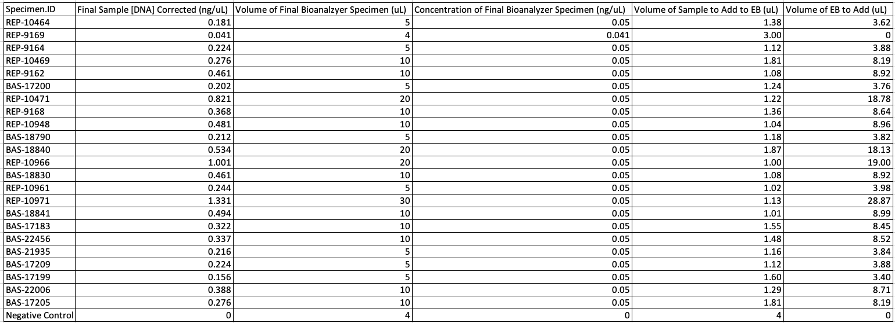
  - Batch #2-6 samples submitted for Bioanalyzer analysis undiluted on 12/1/25.
- Perform SPRIselect bead cleanup as necessary to remove high molecular weight DNA from samples.

Procedure – gDNA Removal via SPRIselect Beads
- Identify samples in need of cleanup.
  - Pilot Batch #1 – 10464 (L1, 38.4uL), 9169(L2, 33.3uL), 10471(H1, 38.4uL), 9162(H2, 38.2uL)
  - Main Batch: Processing all samples described in the “AllBatchesSizeSelection_1218” sheet of the “ConsolidatedPlasmaSampleManigfest_20251201” Excel document.
- Bring all samples that will be corrected up to 50uL final volume by adding additional TE/EB.
  - 27uL Buffer AVE added to all tubes to bring them to 50uL final volume.
    - Pilot Batch #1 - 10464 (+ 11.6uL NFW, 38.4uL), 9169((+ 16.66uL NFW, 33.3uL), 10471((+ 11.6uL NFW, 38.4uL), 9162((+ 11.8uL NFW, 38.2uL)
    - Primary Batch #1 – AVE added as necessary to get samples to 50uL final volume. See Excel sheet.
  - Reverse-pipet original samples as necessary to determine their current volume, which may differ tube to tube due to differences in initial Bioanalzyer submission.
- Thoroughly shake the SPRIselect bottle to resuspend the SPRI beads. Following the trend depicted in Figure 3, add the required volume of SPRIselect for the desired ratio to the sample.
  - Volume of samples times ratio = volume of SPRI Select. Ex. 50uL X 0.7X ratio = 35uL of SPRI select.
  - Will use 0.95X ratio, useful to have a final size profile of cfDNA <350bp. Thus, 50uL * 0.95X = 47.5uL SPRI select per sample.
    - 300uL SPRI select added to trough.
    - 2mL SPRI added to trough for Primary Batch #1 Subbatch #1

- Mix the total reaction volume by pipetting 10 times and incubate at RT for 1 minute OR vortex for 1min at appropriate speed until homogenous.
- Place the reaction vessel on an appropriate magnetic stand or plate and allow the SPRI beads to settle to the magnet. Settle times will vary; a higher initial sample volume, higher SPRIselect ratio, or weaker magnets will require a longer settle time.
- Transfer the clear supernatant, which contains the right size size selected(low molecular weight) sample to a new reaction vessel. The reaction vessel with the remaining beads (bound to high molecular weight DNA) can be discarded.
  - Care should be taken to not aspirate more than a trace amount of beads during this step as the undesired larger fragment sizes are associated with the beads. Significant bead transfer will cause tailing into the larger size range.
- Add the required amount of SPRIselect using the calculation below, to the supernatant from Step 4 above. This will bind the fragment in the supernatant to the new SPRI beads.
  - Sample Volume uL * (1.8X-the initial ratio) = volume of SPRI select.
  - For our purposes, sample volume in uL * (1.8X-0.95X) = volume in uL * 0.85X.
  - Supernatant volume ~91uL
  - For our purposes, 91uL * 0.85X = 77.35uL SPRIselect per sample.
    - Batch #1 Subbatch #1 : 91*0.85X = 77.35uL SPRI per sample (3mL to trough)
    - d
- Perform the following:
  - Mix the total reaction volume by pipetting 10 times and incubate at RT for 1minute OR vortex for 1min at an appropriate speed until homogenous (depending on labware and total volume).
  - Place the reaction vessel on an appropriate stand or plate and allow the SPRI beads to settle to the magnet. Settle times will vary; higher initial sample volume, higher SPRIselect ratio or weaker magnets will require longer settle time.
  - Remove and discard clear supernatant.
    - Don’t aspirate more than a trace amount of beads in this step.
- With the reaction vessel still on the magnet, add 180uL of 85% ethanol (non denatured) and incubate at RT for 30s. Remove and discard the ethanol supernatant.
  - 1800uL of 85% EtOH prepped by combining 765uL 100% EtOH with 135uL NFW. Additional 85% EtOH made by combining 170uL EtOH with 30uL NFW.
    - For Primary Batch #1 subsbatch #1, 7mL of 85% EtOH made by combining 5.95mL 100% EtOH with 1.05mL NFW.
    - For additional batches, 34mL 100% EtOH combined with 6mL NFW to create 85% etOH stock.
  - Do not aspirate more than a trace amount of beads in this step.

- To elute the sample:
  - Remove the reaction vessel form the magnet and add >20uL of molecular biology grade water or standard buffer solution such as Tris or TE.
    - Elution should be larger enough so that the liquid level is high enough for the beads to settle on the magnet.
    - We will use 22uL of EB for elution.
  - Mix the total elution volume by pipetting 10 times to resuspend the beads and incubate at RT for 1min OR vortex for 1min at an appropriate speed until homogenous.
  - Place the reaction vessel on an appropriate magnetic stand or plate and allow the SPRI beads to settle to the magnet. Settle times will vary, a higher elution volume or weaker magnets recquire longer settle time.
    - Batchj #1 Subbatch #1 completed. 2 hr protocol time. Tubes labeled as “3” are the final tubes containing product. Intermediate tubes #1 and #2 also stored.
      - 1 tube rack doesn’t have a functioning magnet, need to push more samples ton batch #4.
    - d
- Transfer the eluate (size-selected sample) to an appropriate storage vessel. Quantify by Qubit and submit for Bioanalzyer analysis as necessary.
  - Post Size selection cfDNA stored in 1.5mL tubes (labelled) at -20C until Qubit quantification and Bioanalzyer submission.
    - All samples from primary size-selection performed on 1/6/26 stored in PCR tube strips prior to Qubit quantification.
  - NC made with 3uL of Qiagen Kit elution buffer.
  - Samples quantified by combining 197uL Qubit Working Solution with 3uL of post-size selection sample.
    - Sample added to all tubes first, then QWS added after. 1 single set of standards created, then all tubes processed and read in serial.
  - Qubit Working Solution made by combining 7uL Qubit reagent with 1393uL Buffer.
    - For primary size selection, 31mL of Qubit Working Solution made by combining 155uL Qubit reagent with 30mL + 845uL Qubit Buffer to have enough for 128 samples + 2 controls.
    - d
- Samples submitted for Bioanalzyer analysis as 3uL eluate (no dilution). The exception to this is sample 108186, which was diluted to 0.5ng/uL by doing 1uL eluate to 2uL elution buffer.

Results
Batch #1 Samples Quantified
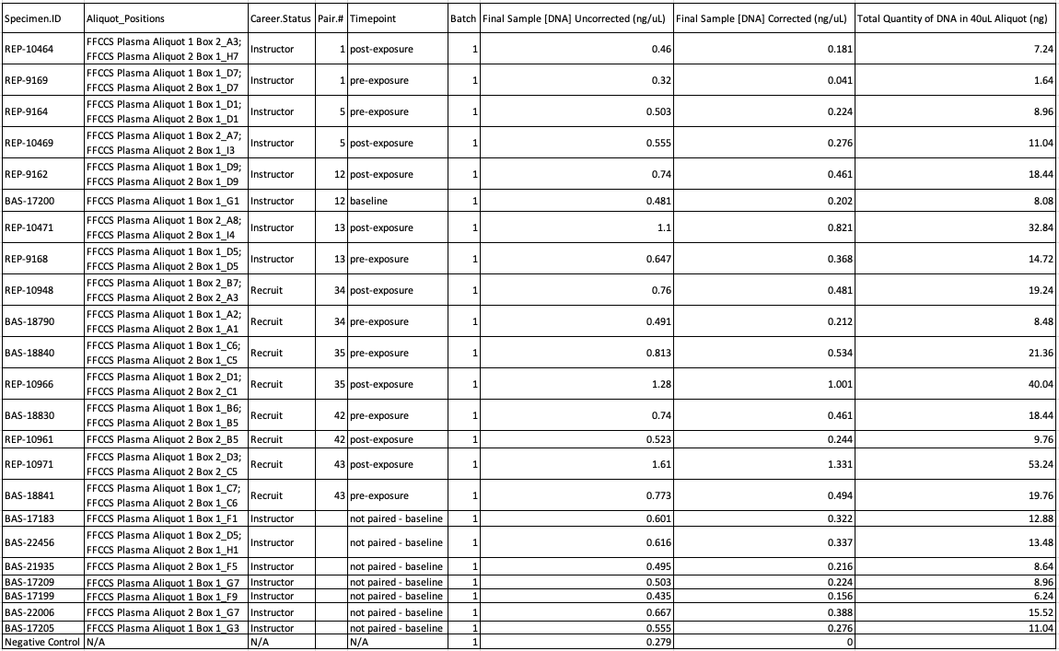
Range of DNA Quantity in Batch #1 (Negative Control-Adjusted): 1.64ng-53.24ng
Average Quantity of DNA in Batch #1: 16.09ng (Standard Deviation 11.81)
Range of [DNA] in Batch #1 (Negative Control-Adjusted): 0.041ng/uL-1.331ng/uL
Average [DNA] in Batch #1 (Negative Control-Adjusted): 0.402ng/uL (Standard Deviation 0.295)

Combined Batches Quantification Table
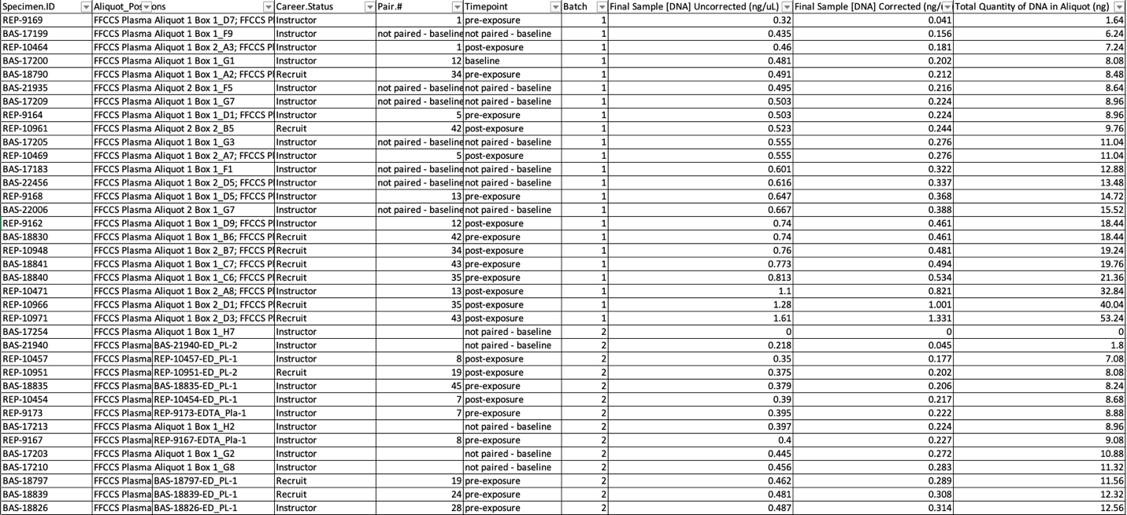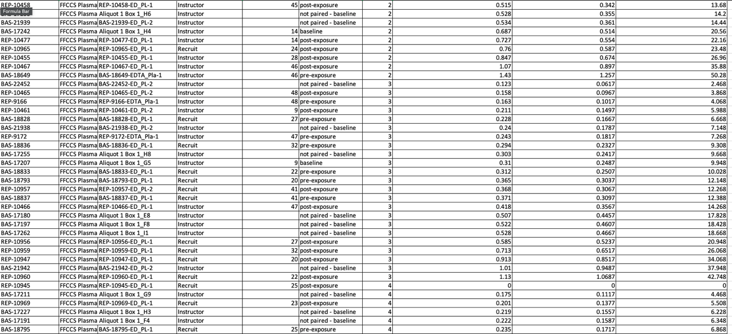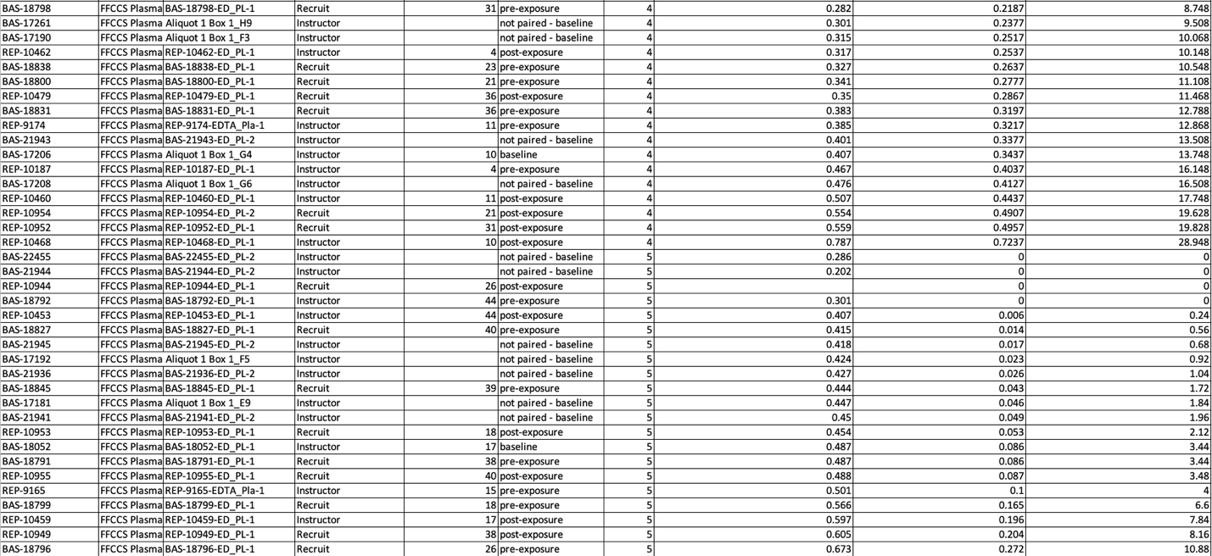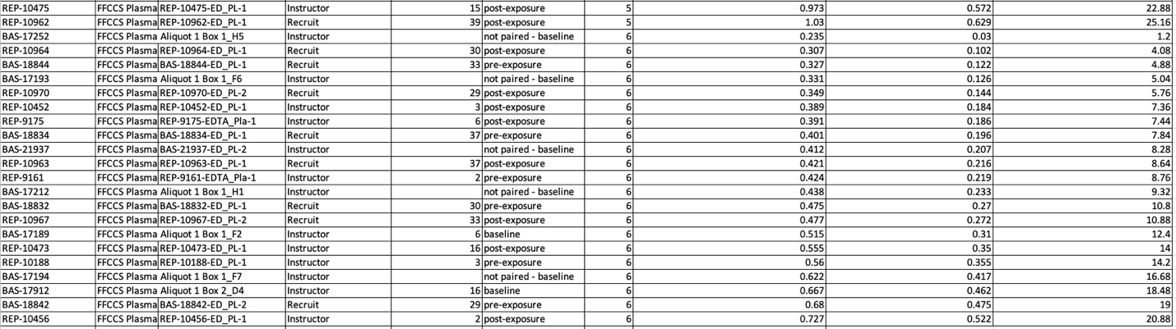

Discussion

Samples broadly displayed expected yield and size profiles for cfDNA, with some concerning presence of larger molecular weight contaminant in a few of the samples. This would have potential impacts on library prep. Attempt further size-selections as necessary. Also consider a preliminary plasma spin and supernatant extraction to limit the possibility of residual buffer coat contamination.

