**Identification of differences among the performance of the baseball players using Tableau**

Summary

The dataset used in this project contains information of 1,157 baseball players. The variables in the dataset describe as follows.

* Handedness: right handed (R), left (L) handed or both (B) handed
* Height: height in inches
* Weight: weight in pounds
* Avg: batting average,
* HR: home runs (HR)

Purpose of this exploratory data analysis (EDA) is to create a visualization that shows differences among the performance of the baseball players. To fulfil this purpose, the facilities and techniques available in Tableau suite is used.

Design

The Tableau visualization can be obtained from the following link and a snap shot of it is shown in the Figure 1 below.

Link to Tableau public workbook: [The visualization](https://public.tableau.com/profile/lasa6459#!/vizhome/Basebal_palyers_performance_Tableau/Summary_dashboard)

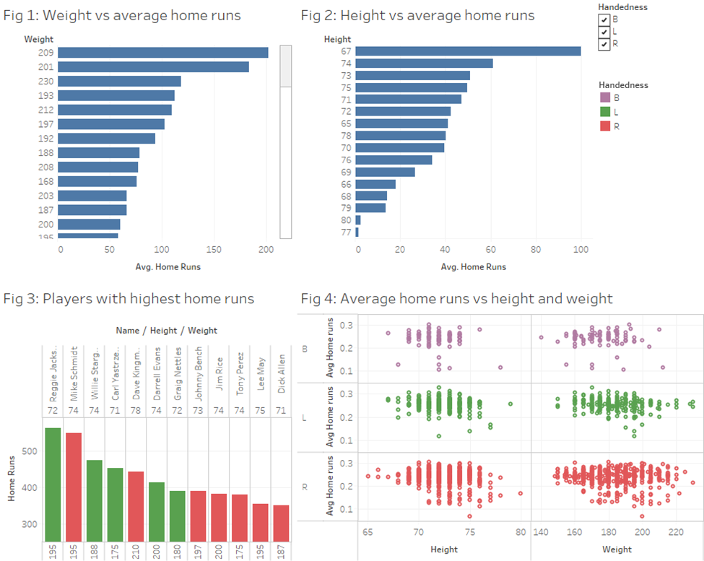

Figure 1: A snap shot of Tableau public workbook

In Tableau public workbook, the user can interactively visualize certain aspects by selecting different Handedness form the legend as shown in Figure 1. In addition, the user is capable of scroll down to invisible regions on some plots.

In the workbook, Fig 1: shows the changes of weight of player with average home runs per weight category.

Average of Home Runs for each Weight. The data is filtered on Handedness, which keeps B, L and R. The view is filtered on average of Home Runs, which includes values greater than or equal to 0.0.

Figure 2: Height vs average home runs per each weight category

Average of Home Runs for each Height. The data is filtered on Handedness, which keeps B, L and R.

Figure 3: Players who scored highest home runs with weight and height category

Sum of Home Runs for each Weight broken down by Name and Height. Color shows details about Handedness. The data is filtered on average of Home Runs, which includes values greater than or equal to 350. The view is filtered on Handedness, which keeps B, L and R.

Fig 4: Average home runs vs height and weight

Height and Weight vs. Average home runs broken down by Handedness. Color shows details about Handedness. The view is filtered on Average home runs and Handedness. The Average home runs filter includes values greater than or equal to 0.0001. The Handedness filter keeps B, L and R.

Feedback