Statistical Analysis of Stroop Effect

**Introduction**

This project is aiming to analyze the Stroop effect [Stroop, 1935] data gathered from an online test similar to the Stroop-test in the references [Stroop-test]. SAS/STAT package [SAS-9.4] was used to produce the plots, the tables and to implement the statistical tests. The analytical results, relevant findings and graphs are discussed in this report.

In an article form the web source, WiseGeek.org, the Stroop effect describes as follows;

“The Stroop effect is a demonstration of the phenomenon that the brain's reaction time slows down when it has to deal with conflicting information. This slowed reaction time happens because of interference, or a processing delay caused by competing or incompatible functions in the brain” [WiseGeek].

When carrying out a Stoop test, the participants are given a set of words of colors names to identify. In the congruent Stroop test, words of color names are the same with the colors themselves. On the other hand, in the incongruent Stroop test, words of colors names and colors are different. Then the time to recognize the colors of a word is collected for both test for each participants.

**Data exploration**

The following table (Table 1) shows a sample of the records in the dataset for the Congruent and Incongruent tests. The units of the records are time (in seconds) taken to complete the tests for the participants.

Table 1: A sample of the data in the Stroop test dataset (units: time in seconds)

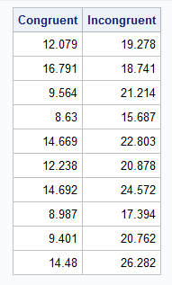

The Figure 1 and Figure 2 show the histograms and density plots of data distribution of congruent and incongruent test results, respectively. The distribution of data of both plots show fairly Gaussian like (see the density kernels) behaviors for both test variables. Based on the data in Figure 2, some individuals require relative large amount of time to complete the incongruent test.

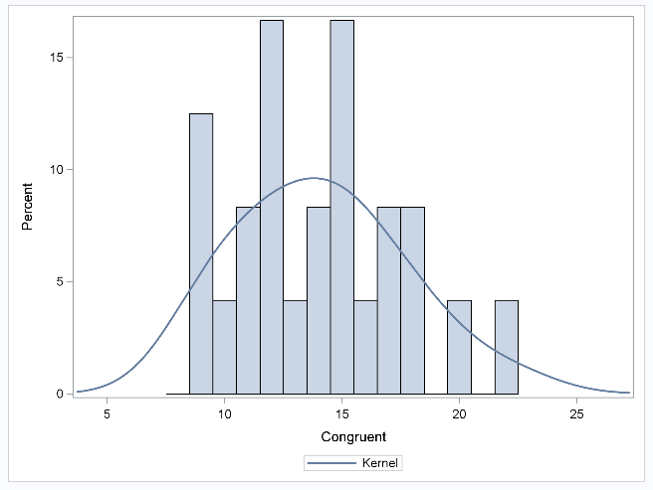

Figure 1: The data distribution of congruent test results.

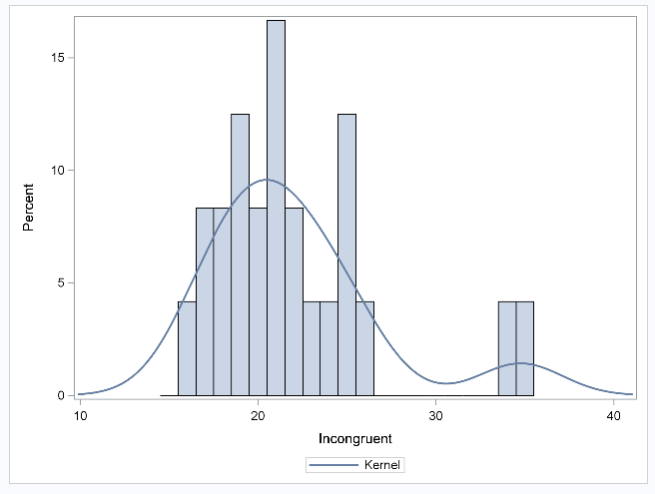

Figure 2: The data distribution of incongruent test results.

The Table 2 shows some summery statistics of the Stroop test dataset.

Table 2: The descriptive statistics of the Stroop test dataset

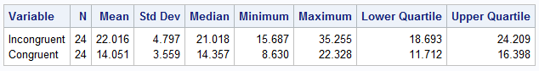

According to the data in Table 2, the Stroop test dataset contains 24 records for different individuals. All the measured and calculated values for incongruent Stroop test are greater than the corresponding values of congruent test (Table 2). The ranges (max - min) of data for incongruent and congruent tests values are 19.568 and 13.698 seconds, respectively.

Figure 3 shows the boxplots (basic statistics as a graphical fashion) of one directional data distribution for the variables congruent and incongruent. In Figure 3, the differences between statistical parameters (mean, median, lower quartile, upper quartile, min and max) can be clearly seen for the two variables. In addition, there are some potential outliers visible for the variable incongruent (Figure 3 – red color circles).

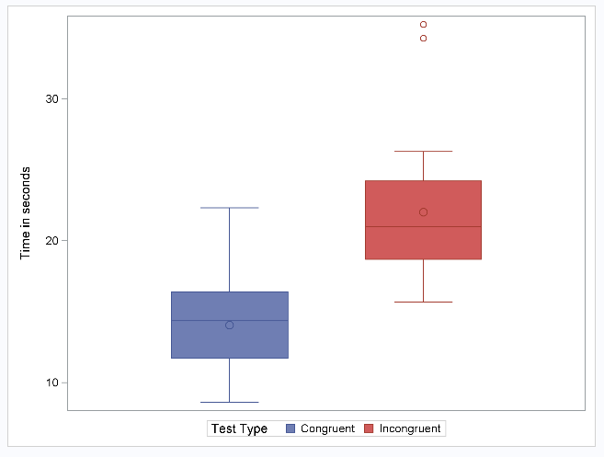

Figure 3: One-dimensional data distribution for the variables congruent and incongruent

**Statistical test setup**

The values of incongruent and congruent tests are independent each other, because, the test criteria are different for the each test type. The individual personal wise factors like relative brain speed can effect on both congruent and incongruent tests. Therefore, for this analysis, the **independent variable** is *congruent test value* and **dependent variable** is *incongruent test value* for the particular person tested.

Since the congruent test values (Table 1 and Table 2) are smaller than the corresponding incongruent test values, the congruent test values can be significantly smaller than the incongruent values. However, there are some overlapping of the data between the two variable as shown in the Figure 3. Therefore, to verify the data in the one variable is significantly smaller or not, **two-sample t-test** can be carried with the means of the variables.

For this purpose the null hypothesis (H0) is; there is no significant different between two means.

i.e., µ *(congruent)* = µ *(incongruent)*

Therefore, the alternative hypothesis (H1) is; the mean of congruent test is smaller than the mean of incongruent test.

µ *(congruent)* < µ *(incongruent)* or

µ *(congruent)* - µ *(incongruent)* < 1

Where, µ *(congruent)* and µ *(incongruent)* are means of congruent and incongruent test results, respectively.

To validate the results of two-sample t-test, following main assumptions are made.

* The variables are independent each other.
* The data in the variables are normally distributed.
* The variances of the two populations are equal.
* The data collections is randomly selected.

Since the selected data fulfilled the main assumptions made above, the two-sample t-test can be carried out for this analysis.

**Two sample t-test results**

The SAS t-test procedure was set to check the null hypothesis and compare the t-values at the lower level of 95% confidence interval. The calculated results are discussed below.

The upper 95% confidence intervals are 12.548 and 19.990, and the lower 95% confidence intervals are 2.766 and 3.728 (Table 3) for the variables congruent an incongruent, respectively.

The t-values for both Pooled and Satterthwaite methods are -6.53. The p-values for both methods are less than 0.0001 (Table 4).

Table 3: 95% confidence levels for means of the variables congruent and incongruent

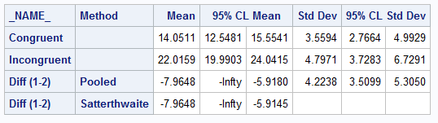

Table 4: T-test results

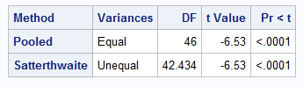

Since the p-value is less than 0.05 (95% confidence interval), null hypothesis is rejected. Therefore, alternative hypothesis (µ *(congruent)* < µ *(incongruent)*) can be accepted. In other words, the mean of the congruent test values is significantly smaller than the mean of incongruent test values.

**Final remarks**

Since null hypothesis is rejected, the difference between the test results was confirmed to be significantly smaller (µ *(congruent)* - µ *(incongruent)* < 1). i.e., the congruent Stroop tasks take significantly less time than the incongruent test tasks.

Among the several reasons and hypothesis, one of a reason that can influence the incongruent test to take longer time than congruent test is, the extra steps to process in a person’s brain when implementing the incongruent test. For example, in incongruent test, the brain has to overcome the confusion on the color identification section and the word identification section in the brain. Because, the word with color name and the color itself contradict to each other, therefore, the brain gets confused. Similar type of experiment can be done to measure the school subject learning speed for children in bilingual families vs children in monolingual families.

**References:**

* Stroop-test: https://faculty.washington.edu/chudler/java/timesc.html
* SAS-9.4: [www.sas.com/en_us/software/sas9.html](http://www.sas.com/en_us/software/sas9.html)
* WiseGeek: www.wisegeek.org/what-is-the-stroop-effect.htm
* The Stroop test original paper: Stroop, J. Ridley. "Studies of interference in serial verbal reactions." *Journal of experimental psychology* 18.6 (1935): 643.
* Data source: https://drive.google.com/file/d/0B9Yf01UaIbUgQXpYb2NhZ29yX1U/view