Statistical Analysis of Stroop Effect

**Introduction**

This project is aiming to analyze the Stroop effect [Stroop, 1935] data gathered from an online test similar to the Stroop-test in the references [Stroop-test]. SAS/STAT package [SAS-9.4] was used to produce the plots, the tables and to implement the statistical tests. The analytical results, relevant findings and graphs are discussed in this report.

In an article form the web source, WiseGeek.org, the Stroop effect describes as follows;

“The Stroop effect is a demonstration of the phenomenon that the brain's reaction time slows down when it has to deal with conflicting information. This slowed reaction time happens because of interference, or a processing delay caused by competing or incompatible functions in the brain” [WiseGeek].

When carrying out a Stoop test, the participants are given a set of words of colors names to identify. In the congruent Stroop test, words of color names are the same with the colors themselves. On the other hand, in the incongruent Stroop test, words of colors names and colors are different. Then the time to recognize the colors of a word is collected for both test for each participants.

**Data exploration**

The following table (Table 1) shows a sample of the records in the dataset for the Congruent and Incongruent tests. The units of the records are time (in seconds) taken to complete the tests for the participants.

Table 1: A sample of the data in the Stroop test dataset (units: time in seconds)

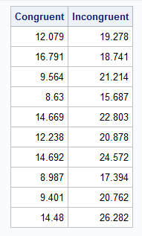

The Figure 1 and Figure 2 show the histograms and density plots of data distribution of congruent and incongruent test results, respectively. The distribution of data of both plots show fairly Gaussian like (see the density kernels) behaviors for both test variables. Based on the data in Figure 2, some individuals require relative large amount of time to complete the incongruent test.

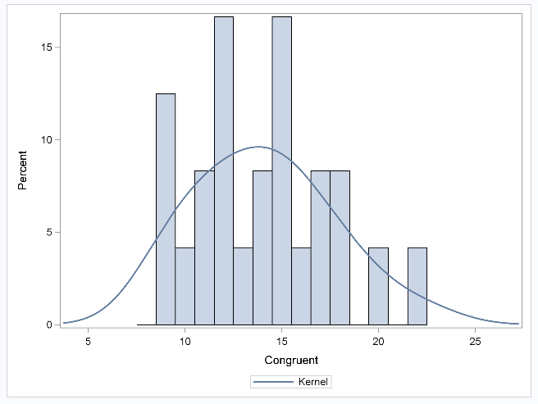

Figure 1: The data distribution of congruent test results.

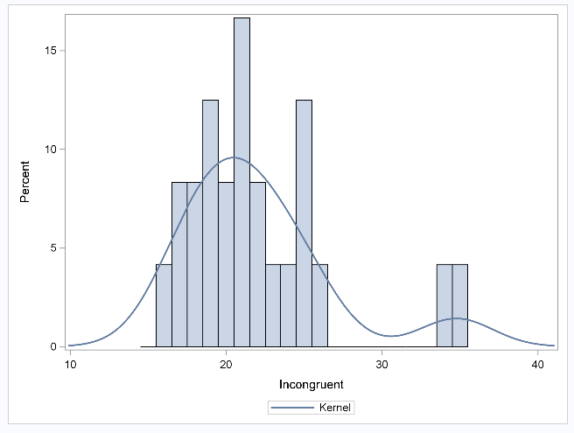

Figure 2: The data distribution of incongruent test results.

The Table 2 shows some summery statistics of the Stroop test dataset.

Table 2: The descriptive statistics of the Stroop test dataset

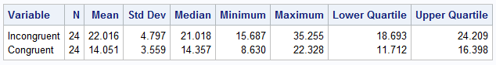

According to the data in Table 2, the Stroop test dataset contains 24 records for different individuals (sample size is 24). All the measured and calculated values for incongruent Stroop test are greater than the corresponding values of congruent test (Table 2). The ranges (max - min) of data for incongruent and congruent tests values are 19.568 and 13.698 seconds, respectively.

Figure 3 shows the boxplots (basic statistics as a graphical fashion) of one directional data distribution for the variables congruent and incongruent. In Figure 3, the differences between statistical parameters (mean, median, lower quartile, upper quartile, min and max) can be clearly seen for the two variables. In addition, there are some potential outliers visible for the variable incongruent (Figure 3 – red color circles).

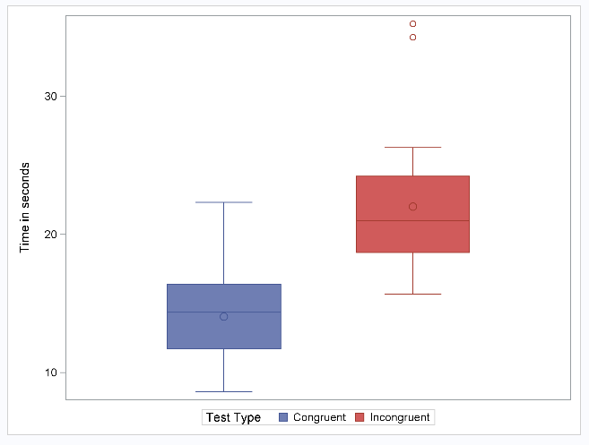

Figure 3: One-dimensional data distribution for the variables congruent and incongruent

**Statistical test setup**

In this experiment, each person in the experiment is undergoing incongruent and congruent Stroop tests in different occasions. Therefore, the **independent variable** isthe **changes of test conditions** (change the congruent conditions to the incongruent conditions). The **dependent variable** is the **time** (in seconds) has taken to complete each test for each person in the experiment.

Based on the sample test data, the congruent test values (Table 1 and Table 2) are smaller than the corresponding incongruent test values; the congruent test values can be significantly smaller than the incongruent values. However, there is some overlapping of the data between the two variables as shown in the Figure 3.

The experiment data only contain the sample information and the population values are unavailable. In addition, the experiment carried out in two different occasions with changed conditions for same sample of participants. Therefore, **paired sample t-test** is suitable to verify whether the population data in one variable is significantly smaller than the other variable in the population.

For this purpose the null hypothesis (H0) is; there is no significant different between two population means of response time under incongruent and congruent Stroop test conditions.

i.e., H0: µC = µI

Therefore, the alternative hypothesis (H1) is; the population mean of response times of congruent test is smaller than the population mean of response times of incongruent test.

H1: µC < µIor

µC - µI < 1

Where, µC and µI are the population means of congruent and incongruent test results, respectively.

To validate the results of two-sample t-test, following main assumptions are made.

* The variables are independent each other.
* The data in the variables are normally distributed.
* The variances of the two populations are equal.
* The data collection is randomly selected.
* The sample mean is equal to the population mean.

Since the selected data fulfilled the main assumptions made above, the two-sample t-test can be carried out for this analysis.

**Paired sample t-test results**

The SAS ttest procedure was set to check the null hypothesis and obtained the t-value for differences (congruent - incongruent) at the lower level of 95% confidence interval. The calculated results are discussed below.

The lower 95% confidence intervals for differences is 3.78 (Table 3) for the variables congruent an incongruent (one tailed t-test).

The t-value, p-value and degree of freedom are -8.02, less than 0.0001 and 23 (Table 4), respectively.

Table 3: 95% confidence levels for differences of congruent and incongruent

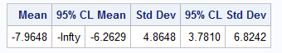

Table 4: T-test results

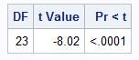

Since the p-value is less than 0.05 (95% confidence interval at lower level), there is enough evidence to reject null hypothesis. Therefore, the alternative hypothesis (µC < µI) can be accepted. In other words, the population mean of the congruent test values is significantly smaller than the population mean of incongruent test values.

**Final remarks**

Since null hypothesis was rejected, the difference between the test results was confirmed to be significantly smaller (µC - µI < 1). i.e., the congruent Stroop tasks take significantly less time than the incongruent test tasks.

Among the several reasons and hypothesis, one of a reason that can influence the incongruent test to take longer time than congruent test is, the extra steps to process in a person’s brain when implementing the incongruent test. For example, in incongruent test, the brain has to overcome the confusion on the color identification section and the word identification section in the brain. Because, the word with color name and the color itself contradict to each other, therefore, the brain gets confused. Similar type of experiment can be done to measure the school subject learning speed for children in bilingual families vs children in monolingual families.

**References:**

* Stroop-test: https://faculty.washington.edu/chudler/java/timesc.html
* SAS-9.4: [www.sas.com/en_us/software/sas9.html](http://www.sas.com/en_us/software/sas9.html)
* WiseGeek: www.wisegeek.org/what-is-the-stroop-effect.htm
* The Stroop test original paper: Stroop, J. Ridley. "Studies of interference in serial verbal reactions." *Journal of experimental psychology* 18.6 (1935): 643.
* Data source: https://drive.google.com/file/d/0B9Yf01UaIbUgQXpYb2NhZ29yX1U/view