SAS821S SECURITY ANALYTICS · CAPSTONE PROJECT · MILESTONE 2
Mining Remote Operations and Industrial-IoT Intrusion Analytics
Security analytics for detecting anomalous behaviour in mining remote operations, delivered through a working prototype
Topic T08 · Project Implementation Plan and Working Prototype


1. Group and project identification

Field | Group response
Topic ID and approved topic | T08 – Mining Remote Operations and Industrial-IoT Intrusion Analytics
Working project title | Security Analytics for Detecting Anomalous Behavior in Mining Remote Operations through a prototype
Member A | 222093471 · Sophia Kalume · Data and Modelling Lead
Member B | 215103815 · Lazarus Shithindi · Security Engineering and  Intelligence Lead
Repository/location | TBC
Date submitted | 20/09/2026

Contents
Contents
1.1 1. Group and project identification 1
Contents 1
2. Executive summary 1
3. Alignment with the approved Project Charter 2
3.1 Objectives and analytics questions 2
3.2 Data sources 3
3.3 Analytical methods 3
3.4 Scope 4
4. Architecture and data flow 4
5. Data inventory, dictionary, cleaning log and quality checks 6
5.1 Inventory and minimum-data compliance 6
5.2 Data dictionary 7
5.3 Cleaning and transformation log 7
5.4 Quality checks 8
6. Exploratory analysis, baselines and security hypotheses 9
6.1 Initial security hypotheses 10
7. Supervised model and anomaly/behavioural model 11
7.1 Supervised intrusion detection 11
7.2 Anomaly and behavioural methods 12
8. Incident timeline, access findings and response logic 15
8.1 Access and identity analytics 15
8.2 Selected case 15
8.3 Response logic 16
9. Security intelligence requirements, enrichment and first products 16
10. Simulation design and preliminary comparative results 18
11. Text-mining and NLP workflow and preliminary outputs 19
12. Predictive risk method and adversarial test cases 22
12.1 Daily risk score 22
12.2 Early warning 22
12.3 Adversarial and robustness tests 22
13. Working prototype, test cases, known defects and backlog 23
13.1 Prototype 23
13.2 Test cases 24
13.3 Known defects and limitations 24
13.4 Implementation backlog 25
14. Repository, environment and contribution evidence 26
15. Updated risk register and deviations from the charter 26
15.1 Declared deviations 27
16. Implementation plan to Milestones 3 and 4 27
16.1 Priorities for Milestone 3 28
17. Limitations, ethics and AI assistance 29
Appendix A. Requirement coverage C1–C10 29
Appendix B. Experiment log 30
Appendix C. Figure and file index 31

Executive summary
This milestone reports an implemented security analytics solution for the T08 mining remoteoperations scenario, not a plan for one. The pipeline runs end to end from raw data files to a compliance checklist in 1 seconds across 4 stages, and an analyst-facing console presents the results for decision-making. Every figure quoted in this document is read directly from the files the pipeline writes.
The analysis covers 635,833 records across 13 files and five source families. Roughly 612,519 of those records are real research data (ToN_IoT captures from UNSW Canberra and the MITRE ATT&CK for ICS corpus) and 23,314 are synthetic data generated by documented rules for the identity/access and maintenance-text components, which the charter and the capstone specification both permit.
The main results are:
Supervised detection. A random forest separates attack from normal network flows with F1 0.9987 (precision 0.9987, recall 0.9987) on a held-out 30 per cent, after 20,569 duplicate rows were removed to prevent leakage. Attack-family identification reaches macro-F1 0.9645. A Modbus telemetry classifier reaches F1 0.9887.
Anomaly detection. On remote-access behaviour, an Isolation Forest reaches ROC-AUC 0.997 against the behaviour patterns that were deliberately injected into the synthetic log, flagging 56 of 2,792 user-days at the chosen threshold. On the network flows the same method scores 0.28 when run fully unsupervised and 0.72 when fitted on known-good traffic; that contrast is reported as a finding rather than hidden.
Investigation. Case ranking selected account vend069 (vendor_technician), with 16 privileged actions of which 16 had no multi-factor authentication, touching 8 assets. The timeline holds 202 rows, each citing its evidence and its linkage basis.
Simulation. Five control scenarios at 5,000 Monte Carlo runs each. The chance of an intrusion reaching the OT zone falls from 54% under current controls to 19% with enforced MFA and 10% with the combined package. The ranking is stable across a sensitivity sweep of the assumed probabilities.
Text mining. 677 unstructured records processed, with classification, indicator extraction scored against an answer key (precision 0.972, recall 0.997) and ATT&CK enrichment.
Predictive risk and robustness. A six-component daily risk score separates the injected behaviour with ROC-AUC 0.988. Four families of adversarial and robustness tests were run; the largest degradation is a fall of 0.23 in F1 when half the collected fields are lost.
Status of the data. The ToN_IoT captures are real research data from a laboratory testbed, used here as a proxy for mining IIoT and OT behaviour. The remote-access log, the maintenance tickets, the asset inventory and the user directory are synthetic, produced by seeded generators whose rules are in the repository. Four abnormal access patterns were injected on purpose and recorded in a ground-truth column, so all detection results in this document mean that the method found behaviour we planted. No claim is made anywhere that a real intrusion was discovered.

Alignment with the approved Project Charter

The charter defined the problem as “identifying how security analytics can be used to detect and prioritise anomalous IIoT, network and remote-user behaviour in a simulated mining remoteoperations environment”. That statement is unchanged. This section maps each charter commitment to what now exists.

Objectives and analytics questions
Charter objective or question | Measure of completion  (charter) | Status at Milestone 2
Objective 1: prepare and integrate IIoT, network-flow and remote-user activity data | Cleaned datasets, documented preprocessing steps, identified analytical features | Met. 13 sources cleaned through a logged pipeline (37 recorded actions); engineered features for flows, telemetry and access behaviour.
Objective 2: develop a prototype that detects and prioritises anomalous IIoT, network and remote-user behaviour | Working anomaly/behaviour process, risk prioritisation, functioning dashboard | Met. Isolation Forest and seven behaviour rules feed a risk score and an eight-view Streamlit console.
Question 1: which IIoT and network behaviours deviate from normal patterns? | EDA and anomaly results identifying and ranking anomalous events | Answered with baselines per sensor, per service and per role, plus ranked anomaly scores; see sections 5 and 6.
Question 2: can remote-user activity identify unusual or suspicious access? | Behavioural indicators and identified anomalous user activities supported by evidence | Answered. 176 rule alerts, each citing event identifiers, plus a scored user-day ranking; see section 7.
Question 3: how can detected anomalies be prioritised for investigation? | Documented risk-scoring approach and ranked events in the prototype | Answered with a six-component score, four bands tied to actions, and a prioritised watchlist in the console; see section 11.
Table 1. Charter objectives and questions against the state of the implementation.

Data sources
The charter listed four source types with volumes “to be determined after dataset selection”. Selection is now complete.
Charter source | Charter key fields | What was actually used | Records | Provenance
IIoT telemetry | Timestamp, device ID, sensor readings, operating status | ToN_IoT telemetry, 7 sensor types | 401,119 | Public research data
Network-flow data | Timestamp, source, destination, protocol, port, packets, bytes, duration | ToN_IoT Zeek flow records | 211,043 | Public research data; no timestamp column in this release
Remote-user activity | User ID, timestamp, login/logout, source, device,  access/action | Generated remoteaccess log | 22,686 | Synthetic, seeded, documented generator
Maintenance/incident text | Timestamp, equipment ID, event description, category | Generated ticket corpus and MITRE ATT&CK for  ICS descriptions | 677 | Synthetic tickets;  ATT&CK corpus is real and public
(added) Asset and account context | Asset, site, zone, criticality, protocol, privilege | Asset inventory and user directory | 308 | Synthetic; required by C2 to interpret findings operationally
Table 2. Charter data sources mapped to the datasets actually used.

Analytical methods
Three charter entries were marked TBC or conditional. All three are now implemented, and two components were deliberately extended beyond the charter because the data supported more than was originally promised.
Component | Charter proposal | Change | What was implemented
Baseline / EDA | Python, pandas, NumPy, visualisation | As planned | Baselines per sensor, service, role and user; eight exploratory figures
Supervised ML | TBC in the charter | Specified and implemented | Logistic regression, decision tree and random forest compared by cross-validated F1
Unsupervised /  UBA | Isolation Forest and rulebased user behaviour analysis | As planned, extended | Isolation Forest, Local Outlier Factor, DBSCAN peer groups and seven behaviour rules
Incident investigation | Event filtering, correlation and timeline analysis | As planned | Evidence-ranked case selection and a 202-row correlated timeline
Security intelligence | Risk scoring and event prioritisation | As planned, extended | Five intelligence requirements, ATT&CK enrichment, operational watchlist and an executive brief
Simulation | Simple segmented-network scenario simulation | Extended | Five scenarios including segmentation, MFA and monitoring, with sensitivity analysis
Text mining / NLP | TBC, conditional on suitable data | Implemented | TF-IDF classification, indicator extraction with an answer key, NMF topics, ATT&CK similarity enrichment
Predictive / adversarial | Limited risk-pattern analysis | Extended | Interpretable risk score, next-day early warning and four adversarial test families
Prototype / dashboard | Python, Streamlit, Plotly | As planned | Eight-view analyst console plus a reproducible notebook
Table 3. Charter analytical methods against the implementation, with changes marked.

Scope
The scope boundaries in the charter hold. No live mining infrastructure, physical equipment, real credentials or confidential data were used, and no penetration testing of any kind was performed. All work was carried out on public research datasets and on synthetic data generated for the exercise.

Architecture and data flow
The charter's architecture ran from three data sources through ingestion and cleaning to anomaly detection and user-behaviour analytics, then risk scoring, a prototype and a segmentation simulation. The implemented architecture keeps that spine and adds the stages the specification requires: supervised modelling, investigation, text mining, intelligence products and adversarial testing. Every stage in the diagram corresponds to a script in src/ and to output files a marker can open; the diagram is generated from that list, so it cannot drift away from the code.
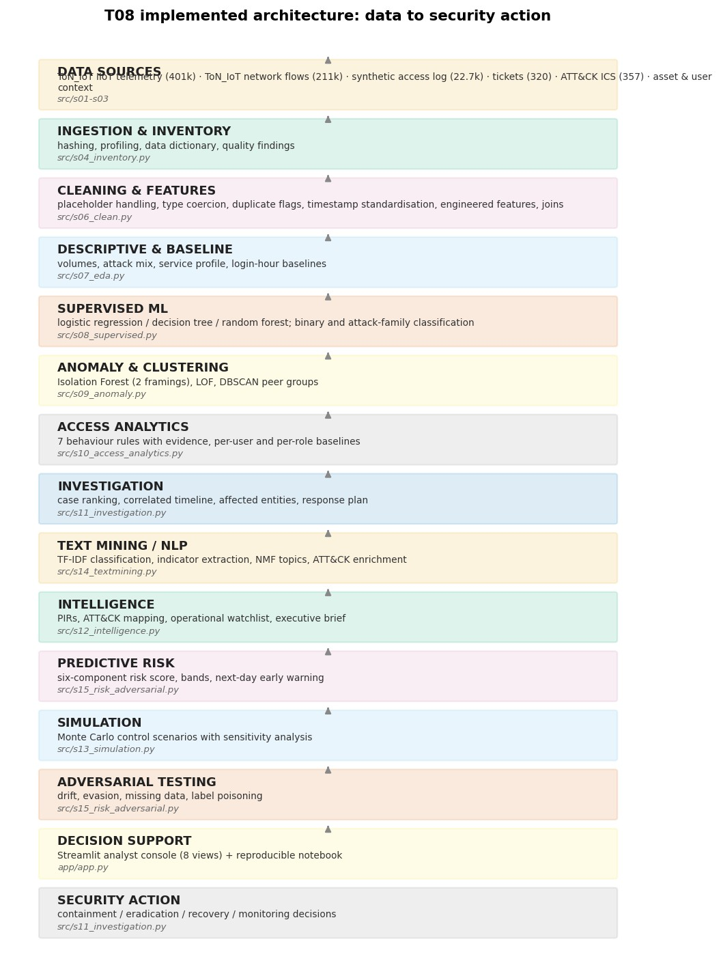

Figure 26. Implemented architecture. Each block names the script that implements it.
stage | implemented_in | evidence_present
DATA SOURCES | src/s01-s03 | 2/2
INGESTION & INVENTORY | src/s04_inventory.py | 2/2
CLEANING & FEATURES | src/s06_clean.py | 2/2
DESCRIPTIVE & BASELINE | src/s07_eda.py | 2/2
SUPERVISED ML | src/s08_supervised.py | 1/1
ANOMALY & CLUSTERING | src/s09_anomaly.py | 1/1
ACCESS ANALYTICS | src/s10_access_analytics.py | 1/1
INVESTIGATION | src/s11_investigation.py | 1/1
stage | implemented_in | evidence_present
TEXT MINING / NLP | src/s14_textmining.py | 1/1
INTELLIGENCE | src/s12_intelligence.py | 1/1
PREDICTIVE RISK | src/s15_risk_adversarial.py | 1/1
SIMULATION | src/s13_simulation.py | 1/1
ADVERSARIAL TESTING | src/s15_risk_adversarial.py | 1/1
DECISION SUPPORT | app/app.py | 1/1
SECURITY ACTION | src/s11_investigation.py | 1/1
Table 4. Architecture stages with the script that implements each one and the count of expected evidence files found on disk.
Data moves in one direction. Raw files are read but never written; cleaned tables are written to data/processed/ in Parquet; every analytical stage writes CSV or JSON into outputs/tables/; the console and the notebook read those outputs and never recompute them. This separation is what makes the prototype reproducible: the dashboard cannot show a number that is not in a file.

Data inventory, dictionary, cleaning log and quality checks

Inventory and minimum-data compliance
dataset | rows | columns | data_status | project_role | duplicate_rows | labelled
iot_fridge | 59944 | 7 | public research dataset | IIoT telemetry | 8901 | True
iot_garage_door | 59587 | 7 | public research dataset | IIoT telemetry | 38836 | True
iot_gps_tracker | 58960 | 7 | public research dataset | IIoT telemetry | 0 | True
iot_modbus | 51106 | 9 | public research dataset | IIoT telemetry (OT protocol) | 19744 | True
iot_motion_light | 59488 | 7 | public research dataset | IIoT telemetry | 28629 | True
iot_thermostat | 52774 | 7 | public research dataset | IIoT telemetry | 1154 | True
iot_weather | 59260 | 8 | public research dataset | IIoT telemetry | 0 | True
network_flow | 211043 | 44 | public research dataset | Network activity | 20569 | True
access_log | 22686 | 18 | SYNTHETIC | Identity/access activity | 0 | False
asset_inventory | 194 | 11 | SYNTHETIC | Asset/device context | 0 | False
user_directory | 114 | 7 | SYNTHETIC | User/account context | 0 | False
tickets | 320 | 10 | SYNTHETIC | Unstructured  maintenance/incident text | 0 | True
attack_ics_text | 357 | 11 | public, attribution required | Unstructured threatintelligence text | 0 | False

Table 5. Data inventory. Full provenance, SHA-256 hashes and time coverage are in outputs/tables/data_inventory.csv.
requirement | measured | threshold | status
At least three distinct security data sources | 5 source families: IIoT telemetry, network flows, remote-access log, ticket text, ATT&CK ICS text  (plus asset and user context) | >= 3 | MET
At least 5,000 combined event/transaction records | 635,833 records across 13 files | >= 5,000 | MET
At least one labelled dataset (recommended  >= 1,000 records) | IIoT telemetry 401,119 labelled rows; network flows 211,043 labelled rows | >= 1,000 | MET
At least one unlabelled/semi-labelled dataset for anomaly or behavioural work | Synthetic remote-access log 22,686 events with no operational label (injected patterns held back as ground truth only) | >= 1  dataset | MET
At least 200 unstructured text records | 677 records (320 tickets + 357 ATT&CK ICS descriptions) | >= 200 | MET
Documented asset/user/device/account/service context | 194 assets and 114 user accounts with site, zone, criticality, protocol and privilege attributes | documented | MET
Table 6. Minimum data expectations from specification 5.1, checked against the loaded data.

Data dictionary
Every column in every dataset was profiled and classified by the role it plays in the analysis: timestamp, user account, device or asset, IP address, network field, authentication or access field, security label, unstructured text, numeric or categorical. The full dictionary lists 153 columns and is supplied as outputs/tables/data_dictionary.csv and docs/member_a_data_dictionary.md. The classification is what demonstrates requirement C2 concretely: identity and access fields, network and OT fields and asset context all exist in the data rather than only in the proposal.

Cleaning and transformation log
37 cleaning actions were recorded, each with the dataset, the action, the detail, the reason and the row counts before and after. Four decisions are worth stating because a marker is likely to ask about them:
Zeek's ‘-’ placeholder is treated as missing, not as a category. Left as text it becomes one of the strongest predictors in the model, and an entirely artificial one.
Duplicates are flagged rather than deleted. The flag excludes them from model training and testing, but the rows remain in the stored data so no evidence is destroyed.
Missing telemetry values are not imputed. A gap in a sensor feed is a gap; an invented reading would teach the model a pattern that never happened.
Country codes use ISO-3. The original ISO-2 code for Namibia, ‘NA’, was silently read as a missing value and made every user-day look foreign. This was found, fixed and covered by a regression test.
dataset | action | detail | reason
iot_fridge | strip_whitespace_bom | all object columns | raw files contain a BOM and padded values such as ' off '
iot_fridge | drop_redundant_columns | date, time | both duplicate the information already held in ts
iot_fridge | standardise_category | temp_condition | case and spacing varied between records
iot_fridge | flag_exact_duplicates | 8901 rows flagged | identical ts and values; kept but flagged so models can exclude them without deleting evidence
iot_garage_door | strip_whitespace_bom | all object columns | raw files contain a BOM and padded values such as ' off '
iot_garage_door | drop_redundant_columns | date, time | both duplicate the information already held in ts
iot_garage_door | coerce_numeric | sphone_signal: 35000 values to NaN | non-numeric text found in a measurement column
iot_garage_door | standardise_category | door_state | case and spacing varied between records
iot_garage_door | flag_exact_duplicates | 38836 rows flagged | identical ts and values; kept but flagged so models can exclude them without deleting evidence
iot_garage_door | retain_missing | sphone_signal: 35000  NaN | gaps are treated as missing telemetry, not imputed, so that the model cannot learn from invented readings
iot_gps_tracker | strip_whitespace_bom | all object columns | raw files contain a BOM and padded values such as ' off '
iot_gps_tracker | drop_redundant_columns | date, time | both duplicate the information already held in ts
iot_gps_tracker | flag_exact_duplicates | 0 rows flagged | identical ts and values; kept but flagged so models can exclude them without deleting evidence
iot_modbus | strip_whitespace_bom | all object columns | raw files contain a BOM and padded values such as ' off '
iot_modbus | drop_redundant_columns | date, time | both duplicate the information already held in ts
iot_modbus | flag_exact_duplicates | 19744 rows flagged | identical ts and values; kept but flagged so models can exclude them without deleting evidence
Table 7. Extract from the cleaning log (first 16 of 37 actions). The full log is outputs/tables/cleaning_log.csv.

Quality checks
10 quality findings were recorded automatically before cleaning: 6 duplicate rows, 2 high missingness, 2 constant column. Sixteen columns in the flow data are more than 97 per cent empty; they are retained in the file for investigation but excluded from model features.

Exploratory analysis, baselines and security hypotheses
Before any model was fitted, the question asked was what normal looks like in each source. Baselines were computed per sensor and measure, per network service, per role and per user, and are stored as
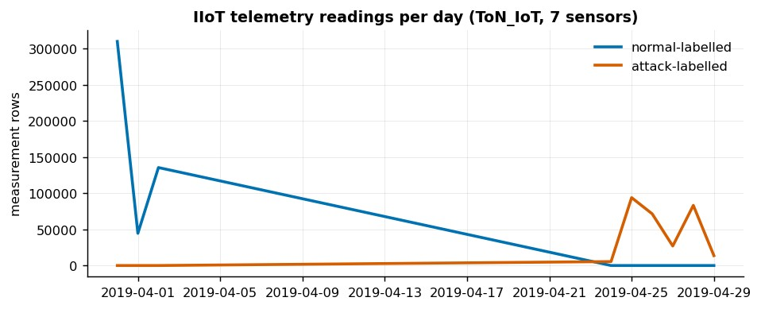

outputs/tables/baseline_*.csv
.

Figure 1. IIoT telemetry volume per day, separated by label. Attack-labelled activity in this capture is concentrated in the last week of April 2019.
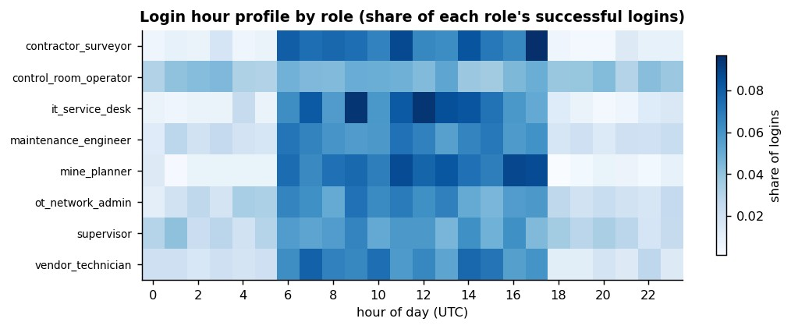
Figure 8. Login-hour baseline by role. Control-room operators and OT network administrators show genuine night activity, which is why an out-of-hours rule alone produces poor precision.

Four findings came out of this stage and were recorded in outputs/tables/eda_findings.csv:
area | finding | evidence
IIoT telemetry | Attack-labelled readings are not uniformly extreme | highest separation: weather/pressure with 26.4% of attack rows beyond 3  SD of the normal baseline; median across sensor-measures is 0.0%
Network flows | Connection state separates attack-labelled traffic strongly | state 'rej' carries 44,852 flows of which 100.0% are attack-labelled
Remote access | A small number of user-days break the behavioural baseline | 45 of 2792 user-days (1.6%) show either >= 3 failed logins, more than one source country, or any non-domestic source address; the 99th percentile of daily failures is 2.0
Remote access | Baseline authentication failure rate | 2.01% of all access events are failures (455 of 22,686)
Table 8. Exploratory findings with the evidence that supports each one.

Initial security hypotheses
# | Hypothesis | Evidence in the data | Status
H1 | Remote access, not the sensors themselves, is the most exposed path into the OT zone | Access events carry privileged actions without MFA from external addresses; telemetry anomalies alone rarely exceed the normal envelope | Supported so far; drives the investigation in section 7 and the simulation in section 9
H2 | Attack traffic is separable from normal traffic by connection behaviour rather than by volume | Connection state and protocol dominate feature importance; byte and duration features contribute little | Supported; also explains why the evasion test in section 11 has little effect
H3 | Sensor readings alone are a weak detector of manipulation | Median share of attack-labelled readings beyond three standard deviations of the normal baseline is 0 per cent across sensormeasure pairs | Supported; argues for learned models over threshold alarms
H4 | Unusual behaviour is  concentrated in a small number of account-days | 45 of 2,792 user-days (1.6 per cent) break the simple behavioural rules | Supported; sets the alerting budget used for the risk bands
Table 9. Working hypotheses carried into the modelling stages.

Supervised model and anomaly/behavioural model

Supervised intrusion detection
Three candidate models were compared on three-fold cross-validated F1 using the training split only; the test split was scored once, at the end. Exact duplicates were removed before splitting, which matters: 20,569 identical rows exist in the flow data and would otherwise appear on both sides of the split.
model | cv_f1_mean | cv_f1_sd
random_forest | 0.9983 | 0.0001
decision_tree | 0.9924 | 0.0006
logistic_regression | 0.969 | 0.0015

Table 10. Model selection by cross-validated F1 on the training data.
model | accuracy | precision | recall | f1 | roc_auc | pr_auc
logistic_regression | 0.9556 | 0.9934 | 0.9493 | 0.9708 | 0.9944 | 0.9983
decision_tree | 0.9923 | 0.9959 | 0.9942 | 0.9951 | 0.9959 | 0.9977
random_forest | 0.998 | 0.9987 | 0.9987 | 0.9987 | 1.0 | 1.0
Table 11. Held-out performance on 30 per cent of the flow data.
The random forest was selected. The justification is not the margin in the table but the shape of the data: flow records mix skewed numeric measures with categorical protocol fields that interact, which is what a tree ensemble handles without scaling assumptions. Logistic regression is kept as a transparent baseline and shows that much of the problem is linearly separable, although it still misses 5.1 per cent of attacks against 0.1 per cent for the forest.
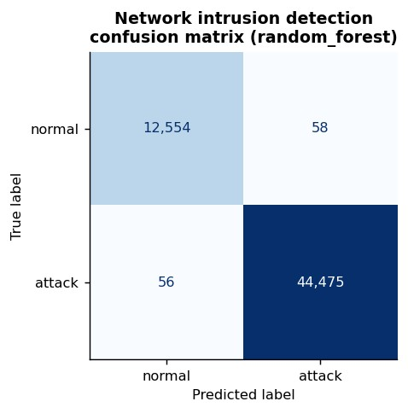

Figure 9. Confusion matrix for the selected network detector on the held-out split.
family | precision | recall | f1 | support
backdoor | 1.0 | 1.0 | 1.0 | 5613
ddos | 0.988 | 0.982 | 0.985 | 5998
dos | 0.994 | 0.982 | 0.988 | 5698
injection | 0.982 | 0.968 | 0.975 | 5989
family | precision | recall | f1 | support
mitm | 0.662 | 0.846 | 0.743 | 312
normal | 0.995 | 0.997 | 0.996 | 12612
password | 0.996 | 0.989 | 0.992 | 5959
ransomware | 0.999 | 1.0 | 0.999 | 4421
scanning | 0.991 | 0.992 | 0.992 | 6000
xss | 0.963 | 0.986 | 0.975 | 4541
Table 12. Attack-family identification (macro-F1 0.9645). The weakest class, mitm, has the fewest test examples.
model | accuracy | precision | recall | f1 | roc_auc | pr_auc
logistic_regression | 0.6244 | 0.5735 | 0.5917 | 0.5825 | 0.7852 | 0.723
random_forest | 0.9901 | 0.9998 | 0.9779 | 0.9887 | 0.9985 | 0.9985
Table 13. Modbus telemetry classifier. The gap between the linear and the ensemble model is the evidence that OT protocol abuse is not linearly separable.
feature | importance | sd
proto | 0.0608 | 0.0007
service | 0.0008 | 0.0001
is_internal_dst | 0.0007 | 0.0002
dst_port | 0.0006 | 0.0002
src_ip_bytes | 0.0005 | 0.0001
src_port | 0.0004 | 0.0001
Table 14. Permutation importance for the network detector: mean F1 decrease when each feature is shuffled.

Anomaly and behavioural methods
Two framings were run on the network flows, and the contrast is the most useful methodological result in the project.
Negative result, reported deliberately. Fitted on all flows with no labels, an Isolation Forest scores ROC-AUC 0.28 — below chance. The cause is that 78% of this capture is attack traffic, so what is statistically rare is ordinary office traffic. Fitting the same model on known-good traffic only, and scoring novelty against it, raises ROC-AUC to 0.72. The operational lesson for a mine is that anomaly detection needs a trusted baseline window rather than “whatever is rare today”.
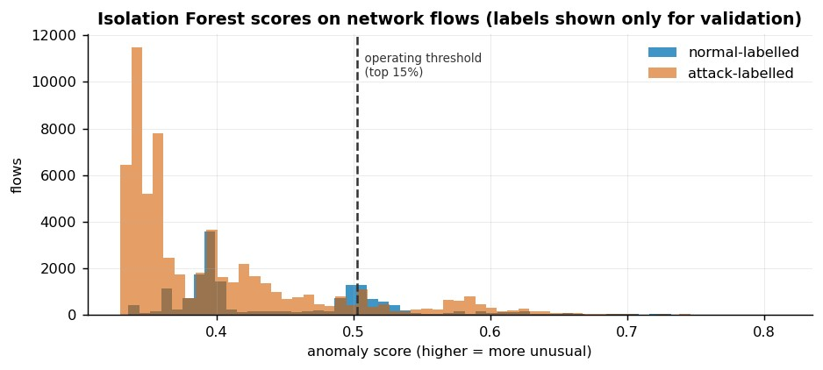
Figure 13. Isolation Forest score distribution on network flows. Labels are shown for validation only; they were not used for fitting.
On the remote-access data, where anomalies genuinely are rare, the same method performs well. The operating threshold is the 98th percentile of the score, which is an alerting budget decision rather than a statistical one: it produces about two cases per working day for an estate of 114 accounts.
method | flagged | precision_vs_injected | recall_vs_injected | f1 | roc_auc_vs_injected
iso | 56 | 0.643 | 0.818 | 0.72 | 0.997
lof | 56 | 0.107 | 0.136 | 0.12 | 0.501
Table 15. Anomaly methods on user-day behaviour, validated against the injected patterns. Local Outlier Factor does not beat chance on these features.

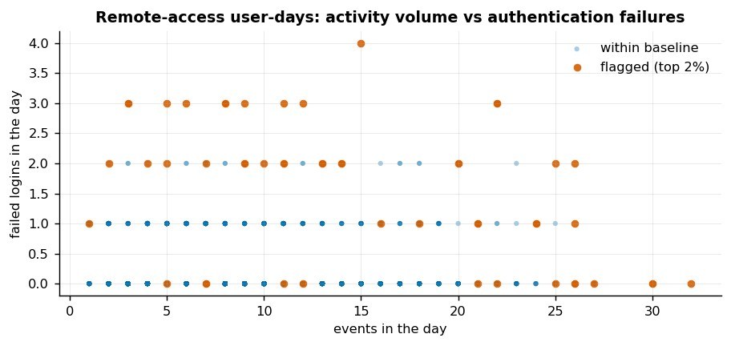

Figure 15. User-days by activity volume and failed logins, with the flagged 2 per cent highlighted.
username | role | day | failures | distinct_countries | out_of_hours | why_flagged
cont006 | control_room_operator | 2019-  04-24 | 2 | 2 | 13 | external +10.7 SD vs role mean; foreign +10.7 SD vs role mean;  distinct_countries +9.2  SD vs role mean
vend069 | vendor_technician | 2019-  04-25 | 1 | 2 | 8 | distinct_countries +6.5 SD vs role mean; foreign +6.4 SD vs role mean; external +6.4 SD vs role  mean
supe112 | supervisor | 2019-  04-24 | 4 | 2 | 5 | distinct_countries +11.6 SD vs role mean; foreign +11.3 SD vs role mean; external +11.3 SD vs role  mean
main042 | maintenance_engineer | 2019-  04-24 | 2 | 2 | 9 | external +11.6 SD vs role mean; foreign +11.6 SD vs role mean;  distinct_countries +7.5  SD vs role mean
cont015 | control_room_operator | 2019-  04-24 | 3 | 2 | 8 | external +10.7 SD vs role mean; foreign +10.7 SD vs role mean;  distinct_countries +9.2  SD vs role mean
username | role | day | failures | distinct_countries | out_of_hours | why_flagged
cont080 | contractor_surveyor | 2019-  04-24 | 3 | 2 | 7 | distinct_countries +6.4  SD vs role mean; failures +5.8 SD vs role mean; foreign +5.4 SD vs role  mean
cont021 | control_room_operator | 2019-  04-24 | 3 | 2 | 9 | external +10.7 SD vs role mean; foreign +10.7 SD vs role mean; distinct_countries +9.2  SD vs role mean
main049 | maintenance_engineer | 2019-  04-24 | 3 | 2 | 3 | external +11.6 SD vs role mean; foreign +11.6 SD vs role mean; distinct_countries +7.5  SD vs role mean
Table 16. Highest-scoring flagged user-days with the reason the model gives, expressed as deviations from the role baseline.

Incident timeline, access findings and response logic

Access and identity analytics
Seven behaviour rules were implemented on top of the measured baselines. Each alert records the rule, the account, the asset, the source address and the identifiers of the events that prove it, so an analyst never has to trust a score alone.
rule | severity | alerts | accounts | matched_injected | precision_vs_injected
R1 | medium | 11 | 11 | 11 | 1.0
R2 | high | 1 | 1 | 1 | 1.0
R3 | high | 3 | 3 | 3 | 1.0
R4 | medium | 101 | 30 | 6 | 0.06
R5 | low | 41 | 40 | 41 | 1.0
R6 | high | 1 | 1 | 1 | 1.0
R7 | high | 18 | 2 | 18 | 1.0
Table 17. Rule performance against the injected behaviour patterns. R4 is retained deliberately as the tuning counter-example.
Six of the seven rules match injected behaviour at full precision. Rule R4, which fires on privileged actions outside an account's usual hours, produced 101 alerts at 6% precision. That is not a failure to hide but the expected consequence of shift work in a mine: control-room operators and OT administrators legitimately work at night, as Figure 8 shows. The rule is kept, the weakness is logged as defect D07, and the planned fix is role-aware working windows.

Selected case
Cases were ranked by alert weight, rule diversity and peak anomaly score. The strongest case is account vend069, a vendor technician on a vendor contract, active on 4 consecutive nights. The account performed 16 privileged actions on OT targets, 16 of them without multi-factor authentication, from a foreign source address and outside any approved maintenance window.

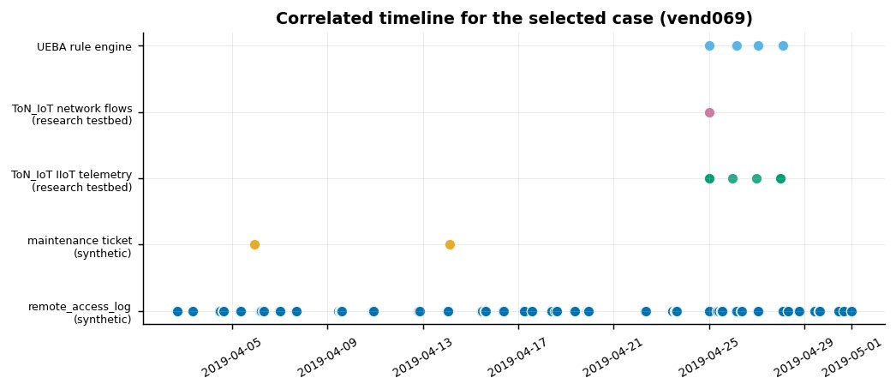
Figure 19. Correlated timeline for the selected case, by source.
How to read the timeline. Of 202 rows, 169 are direct evidence about the account and 11 are marked CONTEXT ONLY. Context rows come from the ToN_IoT captures, which are a different environment entirely; they share the calendar window by design and carry no shared identifiers. The linkage_basis column states this for every row. The case is an analytical scenario built on synthetic access data, not a real incident.

asset_id | asset_type | site | criticality | primary_protocol | patch_status
AST-0017 | sensor_thermostat | PIT-A | medium | mqtt | behind_1_cycle
AST-0090 | laptop | PLANT-01 | medium | nan | behind_2_cycles
AST-0124 | plc | WORKSHOP-01 | critical | modbus | current
AST-0133 | iiot_gateway | WORKSHOP-01 | high | mqtt | behind_1_cycle
AST-0135 | sensor_weather | WORKSHOP-01 | medium | mqtt | behind_1_cycle
AST-0137 | sensor_weather | WORKSHOP-01 | medium | mqtt | current
AST-0142 | sensor_motion | WORKSHOP-01 | low | mqtt | current
AST-0152 | laptop | WORKSHOP-01 | medium | nan | behind_2_cycles
Table 18. Affected entities identified from the timeline (extract).

Response logic
The response plan is tied to what the evidence shows rather than to a generic checklist; each action carries the observation that justifies it.
phase | action | evidence_basis
Containment | Suspend the remote-access entitlement for vend069 and terminate active sessions | 16 privileged actions in the window, 16 of them without MFA
Containment | Block the external source addresses at the VPN concentrator | non-domestic sources observed:  41.182.90.6 (ZAF)
Containment | Place the OT jump host and the engineering workstation used in the window under enhanced logging | out-of-hours privileged access to OT targets
Eradication | Reset credentials and re-enrol MFA for the account, and review any keys or tokens issued to it | authentication occurred without MFA
Eradication | Verify the configuration of the assets listed in  incident_affected_entities.csv against a known-good export | 8 assets touched in the window
Recovery | Restore vendor access only through a time-boxed, approved maintenance window with supervision | activity fell outside any approved window
Recovery | Confirm normal telemetry and control behaviour for the affected assets before closing the case | telemetry context rows in the same window
Monitoring | Keep rules R2, R3, R6 and R7 at high severity and review R4 tuning | R4 produced the majority of alerts at low precision against known behaviour
Monitoring | Alert on any first-seen country for privileged accounts (rule  R5) | R5 matched every injected pattern in the test window
Table 19. Containment, eradication, recovery and monitoring actions with their evidence basis.

Security intelligence requirements, enrichment and first products
Five priority intelligence requirements were defined each with the sources that answer it and a review cycle, so that analysis is driven by a question rather than by whatever the data happens to contain.
pir | question | sources | review_cycle
PIR1 | Which remote accounts show behaviour consistent with credential abuse, and which assets did they touch? | access log, UEBA rules, anomaly model | daily
PIR2 | Is there evidence of an attacker reaching the OT zone or an industrial protocol (Modbus, DNP3, MQTT)? | network flows, Modbus telemetry classifier | daily
PIR3 | Which IIoT devices or network sources deviate from their established behavioural baseline? | telemetry baselines,  Isolation Forest | daily
PIR4 | Which control package most reduces the chance of an intrusion reaching critical OT assets? | Monte Carlo simulation | quarterly
PIR5 | Are maintenance and incident reports describing security-relevant conditions that the technical telemetry has not surfaced? | ticket corpus, ATT&CK enrichment | weekly
Table 20. Priority intelligence requirements for the mining environment.
Enrichment links each detection rule to the closest descriptions in the MITRE ATT&CK for ICS corpus by TF-IDF similarity. The mapping is derived rather than asserted, and the similarity score and a confidence label are reported with it. Where the match is weak, the table says so instead of presenting a confident mapping.
rule | attack_id | attack_name | similarity | confidence
R1 | DC0002 | User Account Authentication | 0.246 | moderate
R2 | M0927 | Password Policies | 0.363 | moderate
R3 | M0936 | Account Use Policies | 0.141 | low - reported for context only
R4 | AN1935 | Analytic 1935 | 0.207 | moderate
R5 | M0936 | Account Use Policies | 0.244 | moderate
R6 | M0935 | Limit Access to Resource Over Network | 0.219 | moderate
R7 | DC0002 | User Account Authentication | 0.381 | moderate
Table 21. Nearest ATT&CK for ICS entry for each detection rule, with the similarity score that produced it.
Two products are produced. The operational product is a prioritised watchlist of 115 accounts combining alert weight, peak risk score and account attributes such as privilege and MFA enrolment; the top ten accounts are linked to the 52 assets they touched, ordered by criticality. The executive product is a one-page brief stating the key risks, the affected assets, the modelled effect of each control and what the group is not claiming. Both are generated from the analytical outputs, so they cannot contradict the technical results.
username | user_role | employment_type | alerts | rules | highest_sev | max_risk | band
vend069 | vendor_technician | vendor | 22 | R3,R4,R5,R7 | high | 98.1 | critical
cont081 | contractor_surveyor | contractor | 8 | R1,R4,R5,R6,R7 | high | 90.9 | critical
main029 | maintenance_engineer | employee | 9 | R4,R5 | medium | 75.6 | moderate
supe112 | supervisor | employee | 6 | R1,R4,R5 | medium | 96.0 | critical
ot054 | ot_network_admin | employee | 8 | R4,R5 | medium | 74.5 | moderate
ot051 | ot_network_admin | employee | 5 | R3,R4,R5 | high | 76.0 | high
cont001 | control_room_operator | employee | 7 | R4 | medium | 73.6 | moderate
ot052 | ot_network_admin | employee | 6 | R4 | medium | 76.9 | high
Table 22. Operational watchlist (extract). Full table: outputs/tables/intel_operational_watchlist.csv.

Simulation design and preliminary comparative results
The charter proposed a small segmentation simulation. This was extended to five control scenarios, because the access analysis showed that authentication, not only segmentation, is where this environment is exposed.
Model. The mine is represented as a directed graph built from the asset inventory: 195 nodes and 1963 edges spanning the internet, the IT zone, the IT-OT boundary and the OT zone. A run begins with one compromised remote-access session. At each step every compromised host attempts each outgoing link once, succeeding with a probability that depends on the boundary being crossed and on the controls in force. A run ends after 12 steps or when nothing new can be reached. 5,000 runs were executed per scenario, above the 1,000 the specification requires.
Inputs. One input is measured from our own data: the probability that a stolen remote credential yields a foothold is taken as the share of external privileged access events that had no MFA, which is 0.947 over 19 events. The per-boundary transmission probabilities and the effect size of each control are assumptions, stated in outputs/tables/simulation_summary.json and tested for sensitivity.
scenario | description | p_reach_ot | p_reach_critical | mean_assets_compromised | rel_reduction_ot
S0_baseline | current controls as described in the asset inventory | 0.541 | 0.539 | 29.598 | 0.0
S1_segmentation | IT-OT to OT traffic restricted to approved flows | 0.344 | 0.316 | 18.477 | 0.364
S2_strong_auth | MFA enforced for every remote and privileged session | 0.19 | 0.189 | 10.118 | 0.648
S3_monitoring | detection and isolation of a  compromised  host after 2 steps | 0.51 | 0.498 | 18.045 | 0.057
S4_combined | all three control packages together | 0.1 | 0.082 | 3.004 | 0.814
Table 23. Comparative results across five control scenarios, 5,000 runs each. Confidence intervals are in the source file.
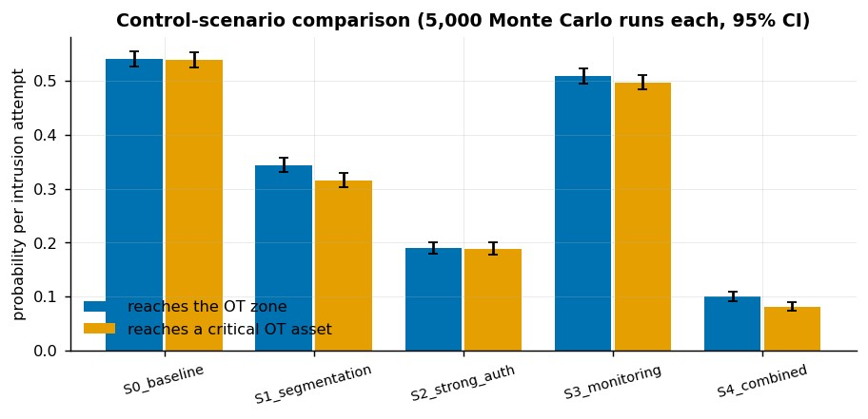
Figure 20. Probability of reaching the OT zone and a critical OT asset, with 95 per cent Wilson confidence intervals.

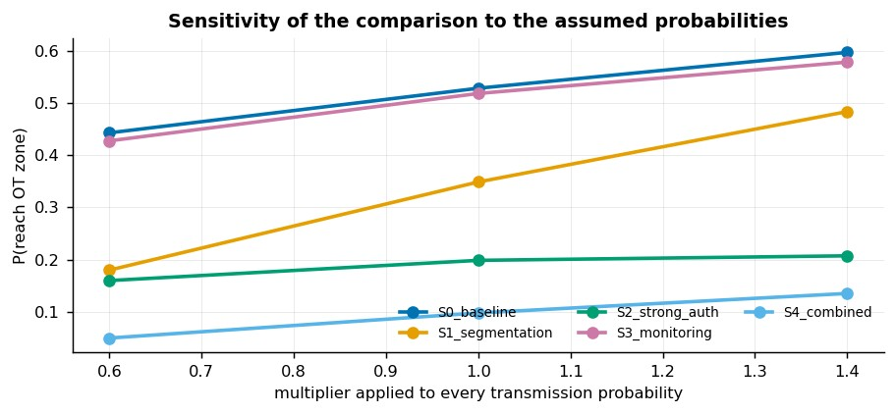
Figure 21. Sensitivity of the comparison when every transmission probability is scaled by 0.6, 1.0 and 1.4.
Under these assumptions, enforcing MFA on remote and privileged sessions is the single most effective control, reducing the chance of reaching the OT zone by 65%, followed by segmentation at 36%. Detection and isolation on its own has the smallest effect on reach (6%) but cuts the number of assets compromised from 30 to 18. The combined package reduces reach by 81%.
Two honest qualifications. First, MFA dominates partly because the measured foothold probability is high, and that figure comes from only 19 events in a synthetic log. Second, the absolute probabilities depend on assumed parameters; what is stable is the ranking, which holds across every point in the sensitivity sweep. The simulation therefore supports a comparison between control packages, not a forecast of how often a real intrusion would occur.

Text-mining and NLP workflow and preliminary outputs
The charter made this component conditional on suitable data being available. Two corpora were assembled, giving 677 unstructured records against the specification's minimum of 200: 320 synthetic maintenance and incident tickets with category labels, and 357 real MITRE ATT&CK for ICS descriptions.
Workflow. Text is lower-cased, punctuation that is not part of an indicator is stripped, and whitespace is collapsed. Features are TF-IDF over unigrams and bigrams with English stop words removed. Three tasks follow: classification of ticket category, indicator extraction, and topic structure with enrichment.
class | precision | recall | f1 | support
access_request | 1.0 | 1.0 | 1.0 | 17.0
instrumentation | 1.0 | 1.0 | 1.0 | 20.0
mechanical | 1.0 | 1.0 | 1.0 | 21.0
network_fault | 1.0 | 1.0 | 1.0 | 19.0
security_incident | 1.0 | 1.0 | 1.0 | 19.0
macro avg | 1.0 | 1.0 | 1.0 | 96.0
weighted avg | 1.0 | 1.0 | 1.0 | 96.0
Table 24. Ticket classification on a held-out 30 per cent.
Caveat that must be stated. The tickets are generated from a template bank, so each category has a highly consistent vocabulary and the task is far easier than real ticket text. The perfect score is evidence that the pipeline works end to end, not an estimate of accuracy on a real ticket system.
Indicator extraction uses regular expressions for IP addresses, asset identifiers, accounts, sites and protocols, plus a gazetteer of malware names taken from the ATT&CK corpus. Because the generator recorded which entities it placed in each ticket, the extractor can be scored rather than described: precision 0.972, recall 0.997, F1 0.984 (594 true positives, 17 false positives, 2 false negatives).

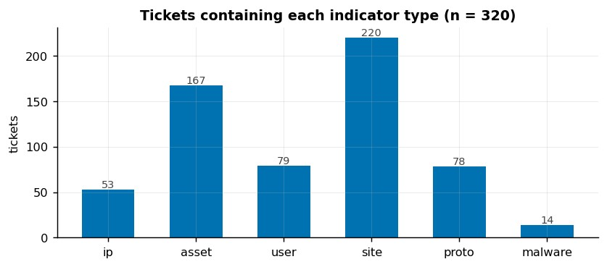
Figure 23. Tickets containing each indicator type.
Topic structure and enrichment. Six topics were extracted from the ATT&CK corpus with nonnegative matrix factorisation, and every ticket was matched to its nearest ATT&CK description by TF-IDF similarity. 225 of 320 tickets matched at a similarity of 0.15 or above, which is the enrichment that feeds the intelligence products in section 8.

topic | top_terms
T1 | attack, org, mitre org, attack mitre, https attack, https, mitre, org software, citation, software, org groups, groups
T2 | standard detection, exists technique, method currently, currently exists, detection method, currently, exists, method, standard, detection, technique, easily
T3 | adversaries, control, devices, adversary, systems, access, environment, citation, device, techniques, process, network
T4 | communications, help, blocked, technique used, loss, technique, alarms, identify loss, help identify, loss communications, monitor, indicate
T5 | program, management, alarms, monitor, monitor device, devices produce, produce, program download, download, logs, devices, device
T6 | monitor, network, files, file, traffic, executed, windows, changes, data, user, arguments, suspicious
Table 25. Topics extracted from the ATT&CK for ICS corpus, described by their leading terms.

Predictive risk method and adversarial test cases

Daily risk score
Each account-day receives a score from 0 to 100 built from six components that an analyst can read, each normalised as a percentile rank and weighted: failed logins (0.15), activity outside the account's normal hours (0.10), external or foreign source addresses (0.20), privileged actions without MFA (0.20), the anomaly score (0.20) and data egress volume (0.15). The score records its own largest contributor, so the console can state why a day scored as it did.
Band cut-points are set from the score distribution rather than from round numbers, because with percentile components an average account already scores about 50. The bands are an alerting budget: roughly the top 0.5 per cent critical, 1.5 per cent high and 8 per cent moderate.
risk_band | user_days | share | injected_rows | mean_score
critical | 15 | 0.005 | 12 | 89.5
high | 42 | 0.015 | 17 | 78.85
moderate | 223 | 0.08 | 15 | 69.99
low | 2512 | 0.9 | 0 | 47.527
Table 26. Risk bands, the volume of work each implies, and how many injected behaviour rows each band caught.

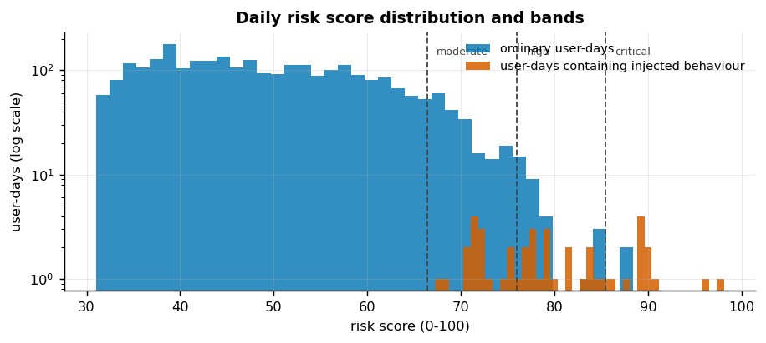
Figure 24. Risk score distribution with band cut-points. The vertical scale is logarithmic.
Validation: the score separates user-days containing injected behaviour with ROC-AUC 0.988, and 75% of the twenty highest-scoring user-days contain injected behaviour.

Early warning
A logistic regression was trained on the earlier 70 per cent of days to predict whether an account would raise an alert on the following day, and tested on the later days. The result is weak: ROCAUC 0.528 against a base rate of 0.082. This is reported as a negative result rather than tuned until it looked better. Alerts in this data are driven by single events rather than by a build-up in the previous day's behaviour, so there is little for a next-day model to learn. A longer observation window or event-level features would be the next thing to try.

Adversarial and robustness tests
Four families of test were run against the deployed network detector, each at three severities, on the held-out split only.
test | setting | f1 | recall_on_attacks | f1_change_vs_baseline
T0_baseline | unmodified held-out flows | 0.9987 | 0.9988 | 0.0
T1_drift_noise | multiplicative Gaussian noise, sigma=0.05 | 0.9983 | 0.9982 | -0.0004
T1_drift_noise | multiplicative Gaussian noise, sigma=0.15 | 0.9953 | 0.9963 | -0.0033
T1_drift_noise | multiplicative Gaussian noise, sigma=0.3 | 0.9877 | 0.9873 | -0.011
T2_evasion | attack flows padded x1.5 and slowed x2.0, conn_state=sf | 0.9986 | 0.9986 | -0.0001
T2_evasion | attack flows padded x3.0 and slowed x5.0, conn_state=sf | 0.9982 | 0.9978 | -0.0005
T2_evasion | attack flows padded x6.0 and slowed x10.0, conn_state=sf | 0.9977 | 0.9968 | -0.001
T3_missing_data | 10% of feature values lost | 0.9906 | 0.9854 | -0.0081
T3_missing_data | 25% of feature values lost | 0.9499 | 0.9169 | -0.0488
T3_missing_data | 50% of feature values lost | 0.7728 | 0.6449 | -0.2258
T4_label_poisoning | 5% of training labels flipped | 0.9979 | 0.9985 | -0.0008
T4_label_poisoning | 15% of training labels flipped | 0.9944 | 0.9932 | -0.0042
T4_label_poisoning | 30% of training labels flipped | 0.9582 | 0.9357 | -0.0405
Table 27. Detector performance under drift, evasion, missing data and label poisoning.

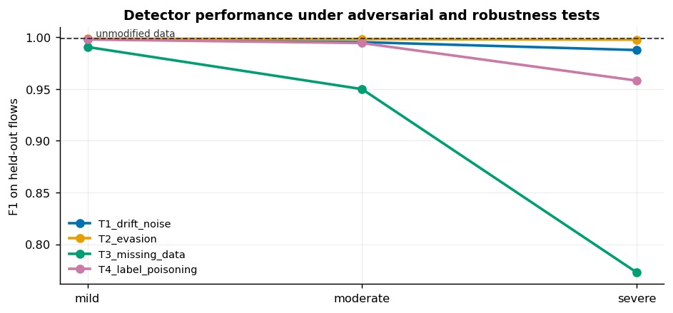
Figure 25. F1 under increasing severity for each test family, against the unmodified baseline.
Three conclusions follow. Collection reliability is the largest risk: losing half the collected fields costs 0.23 of F1, which makes telemetry completeness a security control in its own right. Label poisoning has to reach roughly a third of the training set before it does comparable damage, which argues for controlling who may label data. The evasion test is the weakest of the four, because it perturbs volume features while the detector relies on protocol fields; a stronger test that perturbs those fields is recorded as backlog item B02 rather than claimed as a result.

Working prototype, test cases, known defects and backlog

Prototype
The analyst console is a Streamlit application with eight views, launched with streamlit run app/app.py. It is organised the way an analyst works rather than by algorithm: Overview (volumes, alerts per day, risk bands), Accounts & risk (prioritised watchlist, per-account drill-down showing the risk components and the raw events), Anomalies, Investigation (timeline, affected entities, response plan), Intelligence (requirements, ATT&CK mapping, executive brief), Simulation, Models & robustness, and Data & method (inventory, cleaning log, dictionary, compliance checklist).
The decision the console supports is triage: which account or asset to work next, on what evidence, and what to do about it. Every view ends in something actionable rather than in a chart. A reproducible notebook, notebooks/capstone_walkthrough.ipynb, accompanies it and reproduces every number quoted in this document.

Test cases
Sixteen test cases run with python -m pytest tests -q and all pass. They were written to catch the mistakes that actually occurred during development, not as decoration: raw sources carry provenance hashes, and the minimum-data requirements are met; the identity/access and network sources both exist, as C2 requires;
duplicates are removed before the train/test split, and the count matches the data; Zeek placeholders do not survive into the processed data;
country codes are not parsed as missing values (a regression test for defect D02); timestamps are timezone-aware and inside the generation window; every alert cites evidence identifiers, and every timeline row states its linkage basis; the simulation has at least three scenarios and at least 1,000 runs each; risk scores stay within bounds and the bands are correctly ordered; no adversarial perturbation improves the score, and at least three families are covered; every evidence file named in the compliance checklist exists on disk.

Known defects and limitations
id | type | area | description | severity | status
D01 | defect | data | The ToN_IoT flow mirror used here has no timestamp column, so network flows cannot be joined to other sources on time | medium | OPEN
D02 | defect | data | Namibia's ISO-2 country code 'NA' was read by pandas as a missing value, making every user-day look foreign | high | FIXED
D03 | defect | modelling | Isolation Forest fitted on all flows scores below chance (ROC-AUC  0.28) because attacks are the majority class in ToN_IoT | medium | FIXED BY  DESIGN
D04 | defect | modelling | The first adversarial baseline was computed on rows the model had trained on, inflating the reference F1 | medium | FIXED
D05 | limitation | data | Access log, tickets, asset inventory and user directory are synthetic | high | ACCEPTED
D06 | limitation | modelling | Ticket classification reaches macro-F1 1.000 because the corpus is template-generated | medium | ACCEPTED
D07 | limitation | modelling | UEBA rule R4 (out-of-hours privileged action) fires 99 times at 4 per cent precision | low | OPEN
D08 | limitation | modelling | Next-day early warning is weak (ROC-AUC 0.53) because alerts are rare and largely driven by single events | low | OPEN
id | type | area | description | severity | status
D09 | limitation | simulation | Transmission probabilities are assumed; only p_foothold is measured from the data | medium | ACCEPTED
D10 | limitation | simulation | p_foothold of 0.947 comes from only 19 external privileged events in the synthetic log | medium | OPEN
D11 | limitation | prototype | The Streamlit console reads pre-computed outputs rather than live data | low | OPEN
D12 | limitation | scope | ToN_IoT is a research testbed, not mining equipment | high | ACCEPTED
Table 28. Known defects and limitations. Full workarounds are in docs/known_defects_and_backlog.csv.

Implementation backlog
id | area | description | workaround_or_plan
B01 | data | Replace the synthetic access log with an approved authentic identity source if one is released | re-run stages 06-15; no code changes needed
B02 | modelling | Evasion tests that perturb proto/service/conn_state, which the detector actually relies on | extend s15 test T2
B03 | modelling | Per-device telemetry baselines instead of per-sensor-type baselines | requires a device identifier that ToN_IoT does not publish
B04 | prototype | Analyst feedback capture in the console (true positive / false positive) to close the intelligence loop | small Streamlit form writing to a CSV
B05 | process | Automated re-labelling and drift monitoring on a schedule | needed for C1 feedback stage to be fully automated
Table 29. Backlog carried into Milestone 3.

Repository, environment and contribution evidence

Repository. The project is a git repository with the structure src/ (pipeline stages), app/ (console), notebooks/, data/raw and data/processed, outputs/ (tables, figures, models, logs), docs/ and tests/. The two ToN_IoT datasets are not redistributed; the README gives the exact clone commands and the original UNSW source, and the ATT&CK bundle records the upstream commit hash.
Environment. requirements.txt pins the ten libraries used, and every summary file records the Python version, library versions and the random seed (3815, derived from a member's student number). python src/run_all.py reproduces every output from the raw sources in 1 seconds; outputs/tables/experiment_log.json records the runtime of each stage and outputs/logs/run_log.txt keeps an append-only log of every run.
stage | description | seconds
s16 | architecture diagram | 0.9
s17 | Member A evidence pack (dictionary, evaluation, experiment log) | 0.1
nb | build the walkthrough notebook | 0.0
s20 | compliance checklist C1-C10 | 0.0
Table 30. Stage runtimes from the last full pipeline run.
Contribution evidence. Module ownership and the review pairing are recorded in docs/contribution_and_review.md, which follows the RACI allocation in the charter: Member A owns data acquisition, cleaning, features, supervised and unsupervised modelling, the risk model and reproducibility; Member B owns the log-source architecture, access analytics, investigation, simulation, text mining and the intelligence products; both own the prototype, documentation and testing.
Declared honestly. The implementation was completed in a compressed working period with AI assistance, disclosed in full in docs/ai_assistance_disclosure.md as the charter's section 12 requires .
(docs/member_a_model_evaluation.md, docs/member_a_data_dictionary.md, docs/experiment_log.csv) exists to support that.

Updated risk register and deviations from the charter

Risk (charter) | Likelihood | Impact | Mitigation (charter) | Status at Milestone 2
Data unavailable or unsuitable | High | High | Assess datasets early, prioritise public or synthetic alternatives | Closed. Public ToN_IoT captures obtained; identity and text sources generated under documented rules.
Privacy or sensitive data exposure | Low | High | Only authorised, public or synthetic data; anonymise identifiers; exclude credentials | Closed. No real personal data, credentials or live systems were used at any point.
Model bias or misleading results | Medium | High | Establish baselines, validate results, compare against known anomalies, document limitations | Managed. Leakage control, cross-validation, validation against known injected behaviour, and negative results reported rather than removed.
Scope or time overrun | High | High | Keep anomaly detection and user behaviour analytics as the core, make advanced methods  conditional | Realised in part. The schedule compressed severely; all components were nonetheless implemented, with the weaker ones flagged instead of overstated.
Technical integration failure | Medium | Medium | Develop components independently before integrating, maintain version-controlled backups | Closed. Stages are independent modules writing to files; the console reads outputs only, and the full pipeline reruns cleanly.
Unequal contribution | Medium | Medium | Assign clear responsibilities, maintain contribution records, review progress | Open. One member was unwell during the implementation period; see section 13 and the contribution record.
Table 31. Charter risk register updated with current status.

Declared deviations
Change | Charter position | Milestone 2 position | Reason
Datasets named | Volumes and sources were to be determined after selection | ToN_IoT telemetry and flows; generated access log, tickets, asset and user context; ATT&CK for ICS corpus | Charter section 6 permits public, synthetic or approved data with documented provenance
Supervised ML specified | TBC | Logistic regression, decision tree and random forest; binary and multiclass | Required by C4; the labelled  ToN_IoT data made it possible
Text mining implemented | Conditional on suitable data | 320 labelled tickets plus 357 ATT&CK descriptions | Required by C8; a real public corpus removed the dependency on unavailable ticket data
Simulation widened | Segmentation scenarios only | Five scenarios: baseline, segmentation, MFA, monitoring, combined | The access analysis showed authentication was the dominant exposure, so testing it was necessary
Repository location | TBC | Local git repository, to be pushed to the group remote | Required for contribution evidence
Schedule | Ten-week plan, tasks 1 to  8 | Implementation completed in a compressed period before the deadline | Stated plainly rather than presented as the original plan having run to schedule
Table 32. Differences between the approved charter and what was implemented, with the reason for each.

Implementation plan to Milestones 3 and 4
The table below is the live plan. Tasks T01 to T17 are complete and their evidence is in the repository; the remaining tasks carry to Milestone 3 (documentation, due 25 September 2026) and Milestone 4 (presentation and oral verification, 25–30 September 2026).
task_id | task | responsible | expected_output | status | estimated_completion
T01 | Acquire and verify data sources | Member A | data/raw/ populated, SHA-256 in data_inventory.csv | DONE | 19 Sep 2026
T02 | Generate documented  synthetic sources | Member B | 3 synthetic CSVs + provenance  JSONs | DONE | 19 Sep 2026
T03 | Data inventory and dictionary | Member A | data_inventory.csv, data_dictionary.csv, data_quality.csv | DONE | 19 Sep 2026
T04 | Requirements matrix | Member B | requirements_matrix.csv, minimum_data_check.csv | DONE | 19 Sep 2026
T05 | Cleaning and feature pipeline | Member A | processed parquet tables + cleaning_log.csv (37 actions) | DONE | 19 Sep 2026
T06 | Baselines and exploratory analytics | Member A | 8 figures + baseline_*.csv + eda_findings.csv | DONE | 19 Sep 2026
T07 | Supervised detection | Member A | supervised_*.csv, confusion matrices, saved models | DONE | 19 Sep 2026
T08 | Anomaly detection | Member A | anomaly_*.csv, threshold tables, flagged user-days | DONE | 19 Sep 2026
T09 | Access analytics | Member B | ueba_alerts.csv, ueba_rule_summary.csv | DONE | 19 Sep 2026
T10 | Investigation and response | Member B | incident_*.csv + fig19 | DONE | 19 Sep 2026
T11 | Control simulation | Member B | simulation_summary.csv, simulation_sensitivity.csv | DONE | 19 Sep 2026
T12 | Text mining and  NLP | Member B | nlp_*.csv + fig22 fig23 | DONE | 19 Sep 2026
T13 | Predictive risk and adversarial tests | Member A | risk_*.csv, adversarial_results.csv, fig24 fig25 | DONE | 19 Sep 2026
T14 | Intelligence products | Member B | intel_*.csv,  intelligence_executive_brief.md | DONE | 19 Sep 2026
T15 | Analyst prototype | Both | working dashboard verified in a headless browser | DONE | 19 Sep 2026
T16 | Reproducibility pack | Member A | green test run, reproducible pipeline | DONE | 19 Sep 2026
T17 | Compliance checklist | Member B | compliance_checklist.csv and .md | DONE | 19 Sep 2026
T18 | Repository and contribution evidence | Both | commit history showing both members | IN  PROGRESS | 20 Sep 2026
T19 | Milestone 2 document | Both | submission PDF | TO DO | 20 Sep 2026
T20 | Presentation preparation | Both | deck + speaker notes | TO DO | 25 Sep 2026
task_id | task | responsible | expected_output | status | estimated_completion
T21 | Replace synthetic access log with an approved real source | Member B | updated results and caveats | BACKLOG | after Milestone 2
T22 | Stronger evasion testing | Member A | extended adversarial_results.csv | BACKLOG | after Milestone 2
T23 | Live ingestion for the prototype | Both | dashboard that updates on a schedule | BACKLOG | after Milestone 2
Table 33. Implementation plan with ownership, status and dependencies. Full detail in docs/implementation_plan.csv.

Priorities for Milestone 3
- Split the repository commits so that both members' contributions are visible, and record the review notes as issues.
- Strengthen the evasion test to perturb the categorical protocol features the detector actually relies on (backlog B02).
- Make rule R4 role-aware so that shift patterns stop generating avoidable alerts (defect D07).
- Add analyst feedback capture to the console, which closes the intelligence cycle's feedback stage that is currently documented but not automated (backlog B04).
- Rehearse the presentation against the speaker notes, with both members able to answer on any component.

Limitations, ethics and AI assistance

Limitations. Four should be read alongside every result in this document.
- ToN_IoT is a controlled laboratory testbed, not mining equipment. Scores close to 1.0 reflect a clean capture; the same models would need recalibration against site data before any operational use.
- Attack traffic is the majority class in that capture, which is unlike any real network and directly explains the unsupervised anomaly result in section 6.
- The identity/access source and the ticket corpus are synthetic, so detection results demonstrate that the methods find behaviour whose ground truth we know, not that an attacker was found.
- The simulation's transmission probabilities are assumptions; only the foothold probability is measured, and from a small number of events.
Ethics. No real credentials, personal data, confidential information or live systems were involved. No testing was performed against any third-party infrastructure. The synthetic accounts are fictional and carry no connection to real people. Outputs that name accounts are marked need-to know in the intelligence products.
AI assistance. Declared in full in docs/ai_assistance_disclosure.md, as the charter commits the group to do. AI assistance was used to build the pipeline, the console and the generated documentation. It supplied no data and produced no results: every figure in this document comes from running the code, the pipeline reruns end to end in 1 seconds and the test suite and provenance hashes allow any claim here to be checked independently.

Appendix A. Requirement coverage C1–C10

Status is produced by a script that checks each evidence file exists when it runs, not by assertion.
code | requirement | evidence_produced | status | files_present | remaining_work
C1 | Security analytics lifecycle | all 5 sources | COMPLETE | 5/5 | Feedback loop is documented but not yet automated (no relabelling workflow).
C2 | Multi-source data (>=3, incl. identity/access and network/OT) | 5 source families, 635k+ records | COMPLETE | 4/4 | Access log and tickets are synthetic; this must be stated in the report and defence.
C3 | Data engineering and baseline | dictionary + 37 cleaning actions + baselines | COMPLETE | 5/5 | Network flow source has no timestamp column, so timebased joins to it are not possible.
C4 | Machine learning (supervised + unsupervised) | 3 supervised models,  IF/LOF/DBSCAN | COMPLETE | 4/4 | Scores on ToN_IoT are high because the capture is a controlled testbed.
C5 | Security investigation | 202-row timeline with evidence IDs | COMPLETE | 3/3 | The case is an analytical scenario built on synthetic access data, clearly labelled.
C6 | Security intelligence | 5 PIRs, ATT&CK mapping,  2 products | COMPLETE | 4/4 | ATT&CK mapping is TF-IDF similarity, not an analystvalidated mapping.
C7 | Simulation of >=3 control scenarios | 5 scenarios x 5,000 runs  + sensitivity | COMPLETE | 3/3 | Transmission probabilities are assumed; only p_foothold is measured from data.
C8 | Text mining / NLP | 677 text records, classify  + extract + topics | COMPLETE | 4/4 | Ticket text is templategenerated, so classification accuracy is optimistic.
C9 | Predictive risk + >=3 adversarial tests | risk score + 4 test families | COMPLETE | 4/4 | Next-day forecast is weak  (ROC-AUC ~0.53); reported as a negative result.
C10 | Decision-support prototype | Streamlit console (8 views) + notebook | COMPLETE | 3/3 | Prototype reads pre-computed outputs; it does not yet ingest live data.
Table 34. Compliance checklist against the standard technical specification.

Appendix B. Experiment log

id | area | experiment | result | decision
E01 | data | Search for an accessible  ToN_IoT mirror | Located public GitHub mirrors for the IoT telemetry and the Zeek flows | Cloned both; documented the clone commands in the README
E02 | data | Check whether the flow mirror carries timestamps | No `ts` column in this mirror | Recorded as defect D01; crosssource joins use address and asset instead of time
E03 | data | Choose an identity/access source for C2 | Wrote a documented synthetic generator with a fixed seed | Accepted, with the synthetic status stated in every product
E04 | data | Country codes in the access log | pandas read 'NA' as missing, so every user-day looked foreign  (100% flagged) | Switched to ISO-3 codes and added a regression test (defect D02)
id | area | experiment | result | decision
E05 | features | Handle Zeek '-' placeholders | Left as text the placeholder becomes an artificial predictor | Converted to missing; sparse columns excluded from features
E06 | supervised | Compare LR, decision tree and random forest | RF 0.9983, DT 0.9924, LR 0.9690 | Random Forest selected; the other two kept as interpretable comparators
E07 | supervised | Duplicate leakage check | Removing them before the split changes the evaluation honestly | Duplicates flagged in the data and excluded from train and test
E08 | supervised | Modbus telemetry classifier | RF F1 0.9887 against LR 0.5825 | Kept both to show that the OT signal is non-linear
E09 | anomaly | Isolation Forest on flows, fully unsupervised | ROC-AUC 0.279 - below chance because attacks are the majority class | Kept and reported as a finding rather than discarded
E10 | anomaly | Isolation Forest fitted on known-good traffic only | ROC-AUC 0.716 on held-out flows | Adopted as the realistic framing for an OT site
E11 | anomaly | LOF as a contrasting method on user-days | ROC-AUC 0.501 versus 0.997 for IF | IF retained for the prototype; LOF reported as a negative comparison
E12 | access | Threshold for the failedlogin burst rule | A threshold of 5 per hour produced no alerts at all | Lowered to 3 per hour, justified against the measured baseline
E13 | access | Out-of-hours privileged action rule (R4) | 99 alerts at 4% precision against injected behaviour | Kept deliberately as the tuning counter-example; flagged as defect  D07
E14 | simulation | First network graph was too densely connected | Every scenario compromised about 177 of 195 assets, so controls looked useless | Sparsened the OT and IT meshes, lowered base probabilities, shortened the horizon
E15 | simulation | MFA modelled on internal edges | No effect, because the foothold node is already compromised at step 0 | Moved the MFA effect onto the foothold probability, which is where it acts
E16 | simulation | Final scenario comparison | P(reach OT): baseline 0.541 to combined 0.100 | Ranking stable across all sensitivity scales
E17 | nlp | Ticket classification | macro-F1 1.000 - optimistic because the corpus is templategenerated | Kept, with the caveat recorded in the outputs and repeated in the report
E18 | nlp | Indicator extraction scored against an answer key | precision 0.972, recall 0.997 | Accepted; false positives come from extra entities not in the answer key
E19 | risk | Risk band cut-points | Fixed cut-points put 44% of userdays in the 'high' band | Cut-points moved to score quantiles (0.900, 0.980, 0.995) as an alert budget
E20 | risk | Next-day early warning | ROC-AUC 0.528 against a base rate of 0.082 | Reported as a negative result rather than tuned until it looked better
E21 | adversarial | First robustness baseline was computed on training rows | Reference F1 was inflated relative to the true held-out score | Stage-08 split reproduced exactly; only test rows are perturbed  (defect D04)
E22 | adversarial | Four perturbation families | Largest loss is missing data at 50% (F1 -0.23); evasion costs almost nothing | Evasion test recorded as insufficient; backlog item B02
E23 | pipeline | End-to-end reproducibility run | Completed in 135 seconds; 16 test cases pass | Accepted as the Milestone 2 baseline
Table 35. Experiment log: what was tried, what happened and what was decided, including the failures.

Appendix C. Figure and file index

figure | file
fig01_telemetry_volume_over_time.png | outputs/figures/fig01_telemetry_volume_over_time.png
fig02_attack_mix_by_sensor.png | outputs/figures/fig02_attack_mix_by_sensor.png
fig03_modbus_registers.png | outputs/figures/fig03_modbus_registers.png
fig04_network_type_counts.png | outputs/figures/fig04_network_type_counts.png
fig05_network_service.png | outputs/figures/fig05_network_service.png
fig06_top_talkers.png | outputs/figures/fig06_top_talkers.png
fig07_access_events_over_time.png | outputs/figures/fig07_access_events_over_time.png
fig08_login_hour_by_role.png | outputs/figures/fig08_login_hour_by_role.png
fig09_confusion_network.png | outputs/figures/fig09_confusion_network.png
fig10_feature_importance_network.png | outputs/figures/fig10_feature_importance_network.png
fig11_confusion_network_multiclass.png | outputs/figures/fig11_confusion_network_multiclass.png
fig12_confusion_modbus.png | outputs/figures/fig12_confusion_modbus.png
fig13_network_anomaly_scores.png | outputs/figures/fig13_network_anomaly_scores.png
fig14_anomaly_share_by_type.png | outputs/figures/fig14_anomaly_share_by_type.png
fig15_access_anomaly_scatter.png | outputs/figures/fig15_access_anomaly_scatter.png
fig16_top_anomalous_user_days.png | outputs/figures/fig16_top_anomalous_user_days.png
fig17_ueba_rule_alerts.png | outputs/figures/fig17_ueba_rule_alerts.png
fig18_alerts_per_day.png | outputs/figures/fig18_alerts_per_day.png
fig19_incident_timeline.png | outputs/figures/fig19_incident_timeline.png
fig20_simulation_scenarios.png | outputs/figures/fig20_simulation_scenarios.png
fig21_simulation_sensitivity.png | outputs/figures/fig21_simulation_sensitivity.png
fig22_ticket_classification_cm.png | outputs/figures/fig22_ticket_classification_cm.png
fig23_indicator_counts.png | outputs/figures/fig23_indicator_counts.png
fig24_risk_score_distribution.png | outputs/figures/fig24_risk_score_distribution.png
fig25_adversarial_tests.png | outputs/figures/fig25_adversarial_tests.png
fig26_architecture.png | outputs/figures/fig26_architecture.png
Table 36. Figures produced by the pipeline.
Key evidence files: outputs/tables/data_inventory.csv, data_dictionary.csv, cleaning_log.csv, eda_findings.csv, supervised_network_test.csv, anomaly_access_validation.csv, ueba_alerts.csv, incident_timeline.csv, incident_response_plan.csv, intel_operational_watchlist.csv, simulation_summary.csv, nlp_extracted_indicators.csv, risk_user_day_scores.csv, adversarial_results.csv, compliance_checklist.csv; plus outputs/intelligence_executive_brief.md and the documents in docs/.

