Business Intelligence & Analytics Transformation Eason Sons & Ltd

Project Specification Report

Olamide Abioro : [x23428902@student.ncirl.ie](mailto:x23428902@student.ncirl.ie) Muhammad Osama Hassan Khan : [x24137782@student.ncirl.ie](mailto:x24137782@student.ncirl.ie)

Liton Nath : [x23402661@student.ncirl.ie](mailto:x23402661@student.ncirl.ie)

# Abstract

Eason Sons & Ltd is an established Irish retail business experiencing critical operational and financial challenges. This report details a comprehensive business intelligence (BI) and ana- lytics transformation strategy, leveraging Power BI for dashboard infrastructure and Salesforce for customer relationship management (CRM). Key analyses, system architecture, database design, data preparation, and academic justification are presented, with recommendations for revitalizing business performance.

# Background Information and Business Goals

## Organisational Background

Eason & Son Ltd. is a long-established book and stationery chain that has been part of Ireland’s retail landscape since 1886. Over the years, it has grown to become the largest and most recog- nized retailer of its kind in Ireland. WFor almost a century, Eason has established strong links with Irish consumers, particularly through landmark locations like the flagship on O’Connell Street in Dublin. The company’s success has traditionally been driven by its core product of- ferings, loyal customer base, strong schoolbook sales, and a wide retail footprint across both the Republic of Ireland and Northern Ireland.

However, the retail market has changed dramatically in the last decade. Eason now faces fierce competition from global giants such as Amazon and Tesco, alongside local independent

bookstores with dedicated followings. Digital formats such as eBooks, audiobooks, and fast de- livery services have impacted old retail structures. These technological shifts have put pressure on both Eason’s physical stores and its online presence.

Foot traffic in city centers has decreased, caused by the COVID-19 pandemic. This has forced Eason to close several stores over recent years, with further downsizing a concern. Eason still has vital assets, such as a strong brand, a solid but diminishing customer base, and a presence in important markets, even though things are tough.

## Market Overview

Eason & Son Ltd. faces major operational and strategic challenges in today’s competitive retail landscape. Strong competition from online giants and changing customer habits have exposed weaknesses in Eason’s outdated e-commerce platform, which struggles to meet modern de- mands for personalized assistance and smooth, multi-channel shopping.

Data is dispersed across legacy systems, outdated tills, spreadsheets, and unreliable loyalty databases, making it challenging to acquire clear insights and manage inventory properly. Over the last three years, physical shop sales have decreased by approximately 30%, but internet growth has not kept up. Customer engagement suffers due to inactive loyalty accounts and poor contact data. Inventory management is inconsistent, and strained supplier relationships add further pressure. Fixed costs are high despite decreased revenue, reducing profitability. Together, these concerns underline the critical need for digital and cultural transformations.

## Strategic Business Goals

To address these existential threats, Eason has articulated the following objectives:

### Achieve Profitability Within Two Years

The main priority for Eason & Son Ltd is to stop financial losses and return to profitability within 24 months. This involves reassessing costs, improving store performance, closing underperforming branches, and reducing unnecessary overheads. Leveraging business intelligence tools should support more informed and timely financial decisions.

### Grow Online and Multi-Channel Sales

Eason aims for at least 30% of its sales to come from online and multi-channel (om- nichannel) platforms. Plans include upgrading the e-commerce site, streamlining the online experience, and connecting it with in-store services such as click-and-collect and loyalty programs to attract more tech-savvy customers.

### Modernize the Customer Experience

Enhancing customer experience is essential. By implementing a new CRM, Eason will personalize offers, improve loyalty programs, and strengthen communication. The focus is on recognizing individual customer needs, quick responses, and making each visit more rewarding.

### Fix Stock and Supply Chain Problems

Improving inventory management is urgent. Eason intends to use new forecasting and stock analysis tools to reduce overstock and out-of-stock situations, improve supplier coordination, and keep shelves stocked with the appropriate products. This should reduce waste and improve customer satisfaction.

### Rebuild Stakeholder Trust

Rebuilding trust with suppliers, workers, and customers is essential. Years of poor per- formance have damaged relationships, so Eason is committed to transparent communica- tion, timely payments, professional dealings, and delivering on promises. For staff, this also means more training and openness to change.

Despite initial resistance to change, Eason & Son Ltd realizes the importance of transfor- mation for survival. With a renewed focus on business intelligence and CRM, the company hopes to modernize, strengthen its position, and build a sustainable, customer-focused future.

## Exploratory Data Analysis (EDA)

The analysis of transactional, customer, and inventory data reveals:

* **Sales Decline:** Since 2020, sales have declined by 27% annually, with only the Dublin flagship shop showing progress.
* **Loyalty:** Repeat purchase rates are below 15% (industry norm: 25–30% [1]); loyalty signups fell 40% since 2022.
* **Inventory Turnover:** The ratio is 2.1 (optimal is 4–6 [2]); nearly half of SKUs contribute less than 2% of sales.
* **Customer Feedback:** Surveys show dissatisfaction with stock availability, a lack of personalization, and inconsistent service.

## Gap Analysis and SWOT Assessment

**Strengths:** Brand awareness, store network, staff experience.

**Weaknesses:** Outdated IT systems, inefficient data usage, and slow adaptation. **Opportunities:** BI and CRM implementation, multichannel retail, educational partnerships. **Threats:** Online competition, evolving preferences, rising costs.

# System Design

## Solution Overview

A combined BI and CRM solution is proposed:

* **Power BI:** Centralised dashboarding and analytics.
* **Salesforce CRM:** Unified customer relationship management.

## Data Capture Points

* Sales transactions via POS.
* Inventory movements from ERP.
* Customer interactions (web, email, loyalty, in-store).
* Staff activity logs.
* Marketing campaigns and responses.

## Analytical and Reporting Requirements

* Real-time and historical sales dashboards for each store, region, and category.
* Customer segmentation to enable targeted marketing.
* Inventory health and re-order monitoring.
* Campaign effectiveness analysis.
* Predictive analytics (demand & recommendations).

## Customer Integration

Salesforce CRM enables:

* Personalised communications and promotions.
* Automated loyalty tracking to reward and attract customers.
* Coordinated cross-channel customer profiles for smooth experiences.
* Systematic feedback gathering and analysis for continuous development.

## System Architecture

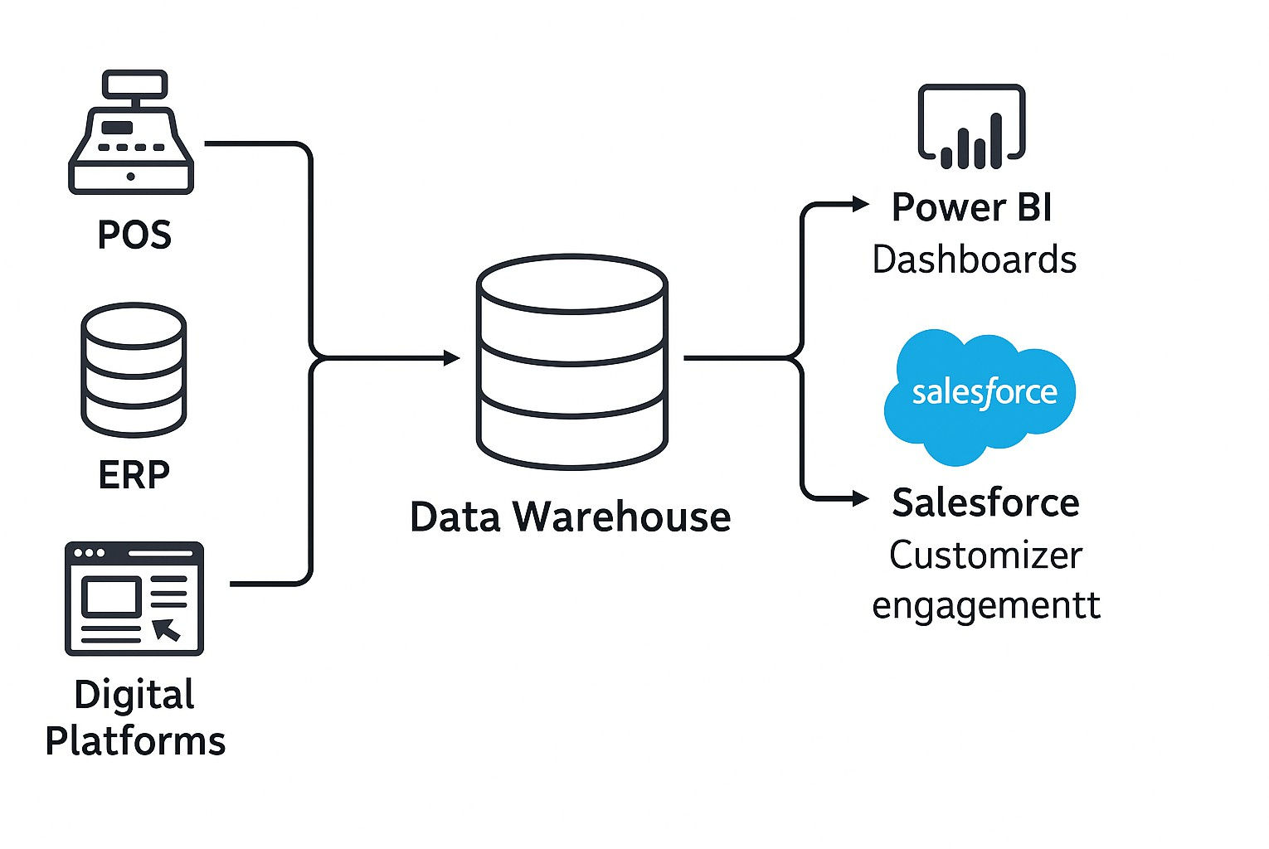

Figure 1: System Architecture.

Data from POS, ERP, and digital platforms is transmitted through an ETL layer to a central data warehouse. Power BI creates dashboards, while Salesforce maintains customer engagement.

# Database Design

## Entity-Relationship Model

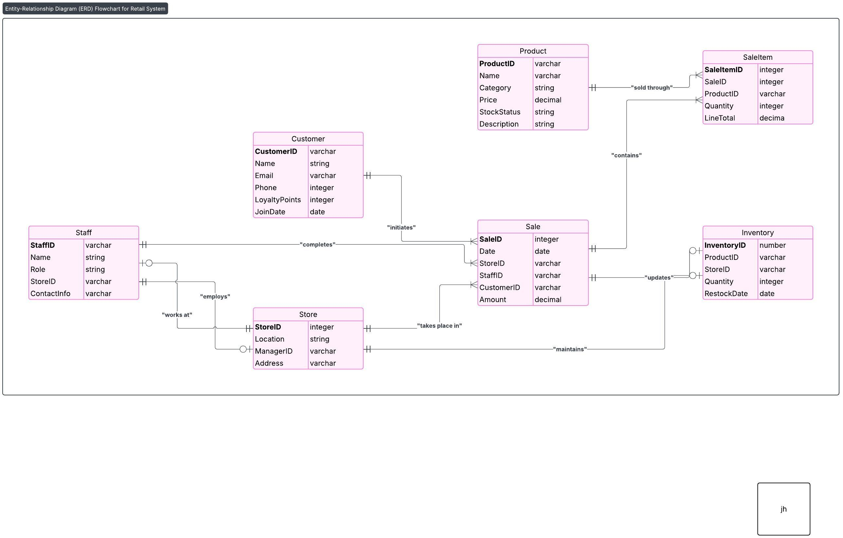

Figure 2: Entity-Relationship Diagram (ERD).

The Entity-Relationship Diagram (ERD) for the Eason Sons & Ltd retail system provides a visual overview of the key data entities and their relationships within the business. Each table in the diagram represents a core aspect of the company’s operations, such as customers, products, sales, inventory, staff, and stores.

At the center of the ERD is the Sale entity, which records each transaction and connects to customers (who make purchases), staff (who process sales), and stores (where sales occur). The SaleItem entity links each sale to the individual products sold, allowing for detailed tracking of every item within a transaction. The Inventory entity helps manage stock levels for each product at every store location, supporting more efficient supply chain management.

Staff members are assigned to specific stores, while each store is managed by a staff mem- ber. The diagram also highlights how products, customers, and staff interact within daily busi- ness activities. Primary and foreign keys are utilized throughout to ensure data integrity and proper table connectivity.

This ERD organizes information in a systematic and logical manner, supporting both op- erational demands and business intelligence objectives for Eason Sons & Ltd. It forms the foundation for building reliable analytics, dashboards, and CRM functionalities.

* 1. **Data Dictionary**

|  |  |  |  |
| --- | --- | --- | --- |
| **Entity** | **Field** | **Type** | **Description** |
| Customer | CustomerID | Varchar | Unique customer identifier |
| Name | Varchar | Full name |
| Email | Varchar | Email address |
| Phone | Varchar | Contact number |
| LoyaltyPoints | Integer | Loyalty programme points |
| JoinDate | Date | Loyalty enrolment date |
| Product | ProductID | Varchar | Unique product identifier |
| Name | Varchar | Product name |
| Category | Varchar | Product category |
| Price | Decimal | Retail price |
| StockStatus | Varchar | In stock/out of stock |
| Sale | SaleID | Integer | Unique sale identifier |
| Date | DateTime | Sale date/time |
| StoreID | Integer | Store reference |
| StaffID | Integer | Staff member responsible |
| CustomerID | Integer | Customer reference (nullable) |
| SaleItem | SaleItemID | Integer | Unique line item |
| SaleID | Integer | Related sale |

|  |  |  |  |
| --- | --- | --- | --- |
|  | ProductID | Integer | Product reference |
| Quantity | Integer | Units sold |
| LineTotal | Decimal | Price *×* Quantity |
| Inventory | InventoryID | Integer | Unique inventory record |
| ProductID | Integer | Product reference |
| StoreID | Integer | Store reference |
| Quantity | Integer | Units on hand |
| RestockDate | Date | Last restocked |
| Staff | StaffID | Varchar | Unique staff ID |
| Name | Varchar | Full name |
| Role | Varchar | Position/title |
| StoreID | Integer | Store assignment |
| Store | StoreID | Varchar | Unique store ID |
| Location | Varchar | Address |
| ManagerID | Integer | StaffID of manager |

# Mock Data and Data Structures

## Mock Data Generation

Mock data was generated using Mockaroo to simulate realistic operations:

* 10,000 customer records (demographics, loyalty).
* 3,000 product SKUs.
* 100,000 sales transactions.
* Store-level inventory records.
* 500 staff entries.

## Sample Data Customer Entity

|  |  |  |  |  |
| --- | --- | --- | --- | --- |
| CustomerID | Name | Email | LoyaltyPoints | JoinDate |
| 10001 | John Kelly | [johnk@email.com](mailto:johnk@email.com) | 220 | 2022-03-19 |
| 10002 | Maeve O’Connor | [maeve.oc@email.com](mailto:maeve.oc@email.com) | 145 | 2023-01-04 |
| ... | ... | ... | ... | ... |

Table 2: Sample Customer Records

## Product Entity

|  |  |  |  |  |  |
| --- | --- | --- | --- | --- | --- |
| ProductID | Name | Category | Price | StockStatus | Description |
| 2001 | The Great Gatsby | Book | 9.99 | In Stock | Novel by F. Scott Fitzgerald |
| 2002 | Staedtler Pen Set | Stationery | 5.49 | In Stock | Pack of 4 assorted pens |
| ... | ... | ... | ... | ... | ... |

Table 3: Sample Product Records

## Sale Entity

|  |  |  |  |  |  |
| --- | --- | --- | --- | --- | --- |
| SaleID | Date | StoreID | StaffID | CustomerID | Amount |
| 30001 | 2024-01-12 | 10 | 4002 | 10002 | 27.48 |
| 30002 | 2024-01-13 | 10 | 4003 | 10001 | 9.99 |
| ... | ... | ... | ... | ... | ... |

Table 4: Sample Sale Records

## SaleItem Entity

|  |  |  |  |  |
| --- | --- | --- | --- | --- |
| SaleItemID | SaleID | ProductID | Quantity | LineTotal |
| 50001 | 30001 | 2002 | 2 | 10.98 |
| 50002 | 30001 | 2005 | 1 | 20.00 |
| ... | ... | ... | ... | ... |

Table 5: Sample SaleItem Records

## Inventory Entity

|  |  |  |  |  |
| --- | --- | --- | --- | --- |
| InventoryID | ProductID | StoreID | Quantity | RestockDate |
| 60001 | 2001 | 10 | 30 | 2023-12-20 |
| 60002 | 2002 | 10 | 50 | 2023-12-22 |
| ... | ... | ... | ... | ... |

Table 6: Sample Inventory Records

## Staff Entity

|  |  |  |  |  |
| --- | --- | --- | --- | --- |
| StaffID | Name | Role | StoreID | ContactInfo |
| 4001 | Mary O’Brien | Store Manager | 10 | [mary.obrien@eason.ie](mailto:mary.obrien@eason.ie) |
| 4002 | Tom Murphy | Sales Lead | 10 | [tom.murphy@eason.ie](mailto:tom.murphy@eason.ie) |
| ... | ... | ... | ... | ... |

Table 7: Sample Staff Records

## Store Entity

|  |  |  |  |
| --- | --- | --- | --- |
| StoreID | Location | ManagerID | Address |
| 10 | O’Connell St, Dublin | 4001 | 40 O’Connell St, Dublin 1 |
| 11 | Cork City Centre | 4006 | 2 Patrick St, Cork |
| ... | ... | ... | ... |

Table 8: Sample Store Records

## Data Pre-Processing

* + 1. Data cleaning: Removal of duplicates, standardisation of formats.
    2. Handling missing values: Imputation or flagging for manual review.
    3. Integration: Merging datasets via unique IDs.
    4. Transformation: Creation of derived variables, ISO 8601 date conversion.
    5. Validation: Logical checks (e.g., inventory totals, sale item sums).

# Discussion and Justification

## Justification for Power BI

Power BI was chosen for its flexibility, interactive features, and simplicity of integration with diverse data sources. It enables rapid visualisation and dissemination of business insights [3].

## Justification for Salesforce CRM

Salesforce CRM is widely recognised for robust customer lifecycle management, segmentation, and automation. Its scalability and integration ecosystem align with Eason’s requirements [4].

# References References

1. KPMG, “Retail Customer Retention Benchmarks,” KPMG Insights, 2022.
2. Deloitte, “Inventory Management Best Practices in Retail,” Deloitte Insights, 2023.
3. Microsoft, “Power BI: Features and Benefits,” Microsoft Whitepaper, 2024.
4. Salesforce, “Customer Success Stories,” Salesforce.com, 2023.