Business Intelligence & Analytics Transformation Eason Sons & Ltd

Project Implementation Report

Olamide Abioro : [x23428902@student.ncirl.ie](mailto:x23428902@student.ncirl.ie) Muhammad Osama Hassan Khan : [x24137782@student.ncirl.ie](mailto:x24137782@student.ncirl.ie)

Liton Nath : [x23402661@student.ncirl.ie](mailto:x23402661@student.ncirl.ie) August 1, 2025

# Introduction

Eason Sons & Ltd, a retail company operating in Ireland, recently experienced serious opera- tional inefficiencies, data fragmentation, and declining sales. To address these issues, a business intelligence and customer relationship management solution was developed using Salesforce for CRM and Power BI for reporting.

This report focuses on the implementation phase of the Salesforce CRM system and Power BI. It outlines the development steps, system configuration, access controls, and data validation strategies used to improve business operations. It also assesses the degree to which the new system has addressed the business’s original pain points and provides early observations on performance improvements and potential areas for future enhancement.

# Development Process

## From Conceptualisation to Implementation

The implementation of the BI and CRM solutions followed a structured, phased approach. Ini- tially, the project began with the conceptual design phase, referencing specifications previously outlined. This stage involved defining essential business requirements, system architecture, database design, and selecting suitable platforms, Salesforce for CRM and Power BI for ana- lytics.

During the implementation phase, mock datasets were generated using Mockaroo and then uploaded into PostgreSQL. Following thorough data validation and cleaning, Salesforce CRM was configured, creating custom objects, fields, relationships, validation rules, and user profiles tailored specifically to the organization’s requirements. At the same time, dashboards and reports were built in Power BI, using PostgreSQL as the primary data source.

## Additional Validation Rules

Several unexpected elements emerged during implementation, requiring adjustments to the ini- tial plan:

### Salesforce Data Upload Limitations

Salesforce restricts bulk uploads to a maximum of 50,000 records per import operation [1]. This constraint was not initially anticipated, and as a result, larger datasets, particularly Sales and SaleItems, were reduced or divided into smaller segments. This necessitated additional data processing steps and careful checks to maintain data integrity and accuracy.

### Handling Relationships in Power BI

In Power BI, only one relationship between two tables can be active at any given time. When multiple relationships exist, the inactive ones can still be utilized for calculations by manually activating them within specific measures using the USERELATIONSHIP() function in DAX. This approach allows for flexible analysis based on alternative relationships without altering the overall data model structure.

### Adjustment of Data Types and Field Formats

During the data import and mapping phase, we noticed that some fields, like phone numbers and dates, needed to be reformatted to meet Salesforce’s strict field type requirements. Dates, for instance, had to be in the YYYY-MM-DD format, and we had to standardize phone numbers to ensure everything uploaded smoothly.

# System Implementation

## Salesforce CRM Configuration

### Objects, Fields, and Relationships

Salesforce was configured to meet Eason Sons & Ltd’s specific operational needs by setting up custom objects, fields, and relationships. Key custom objects created include Customers, Sales, Products, Staff, Stores, Inventory, and Sale Items.

The Customer object was created to manage detailed customer information, including fields like Name, Email, Phone, LoyaltyPoints, and Marketing Consent.

The Sales object tracks transactional data, including Date, Store, Customer, Staff, and SaleIt-

ems . Relationships between objects were defined via Lookup fields, clearly shown in the provided screenshot.

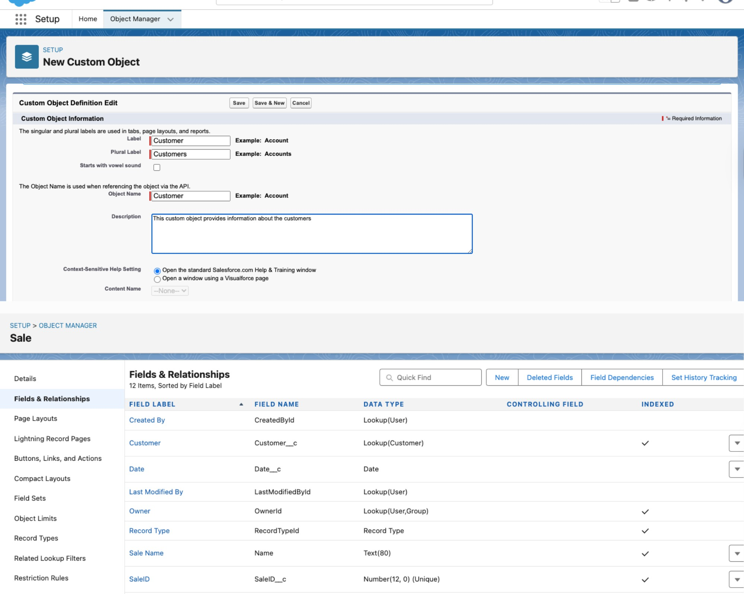

Figure 1: Salesforce Custom Object Setup / Fields & Relationship

### Validation Rules and Page Layouts

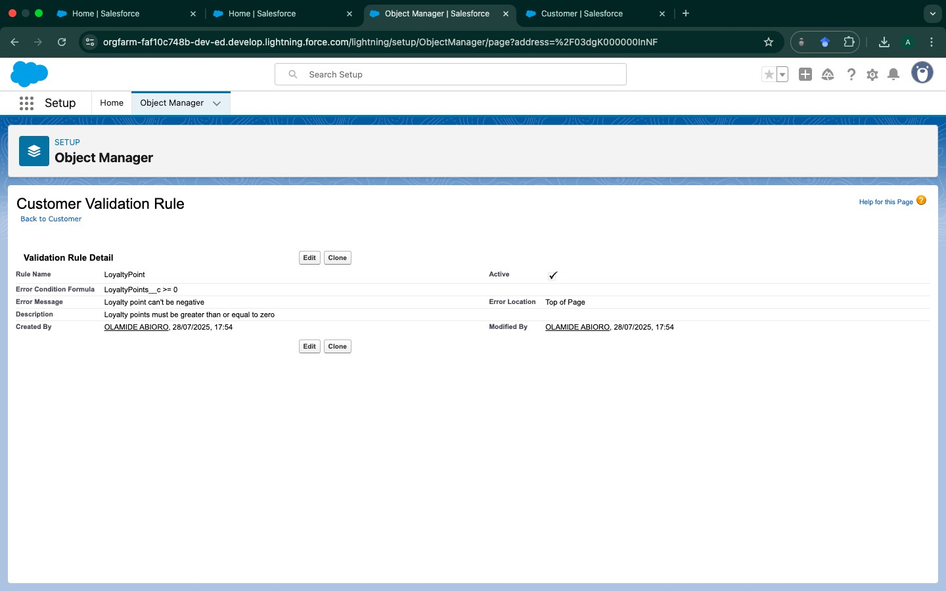

Figure 2: Customer Validation Rule

Validation rules were set to maintain data integrity. For instance, a validation rule for the Customer object was established to ensure that loyalty points cannot be negative.

Page layouts were configured to enhance user interaction and ensure essential fields were ac- cessible and logically grouped, demonstrated clearly through screenshots provided in the setup process.

## Access Controls and Sharing Rules

### Profiles and Permissions

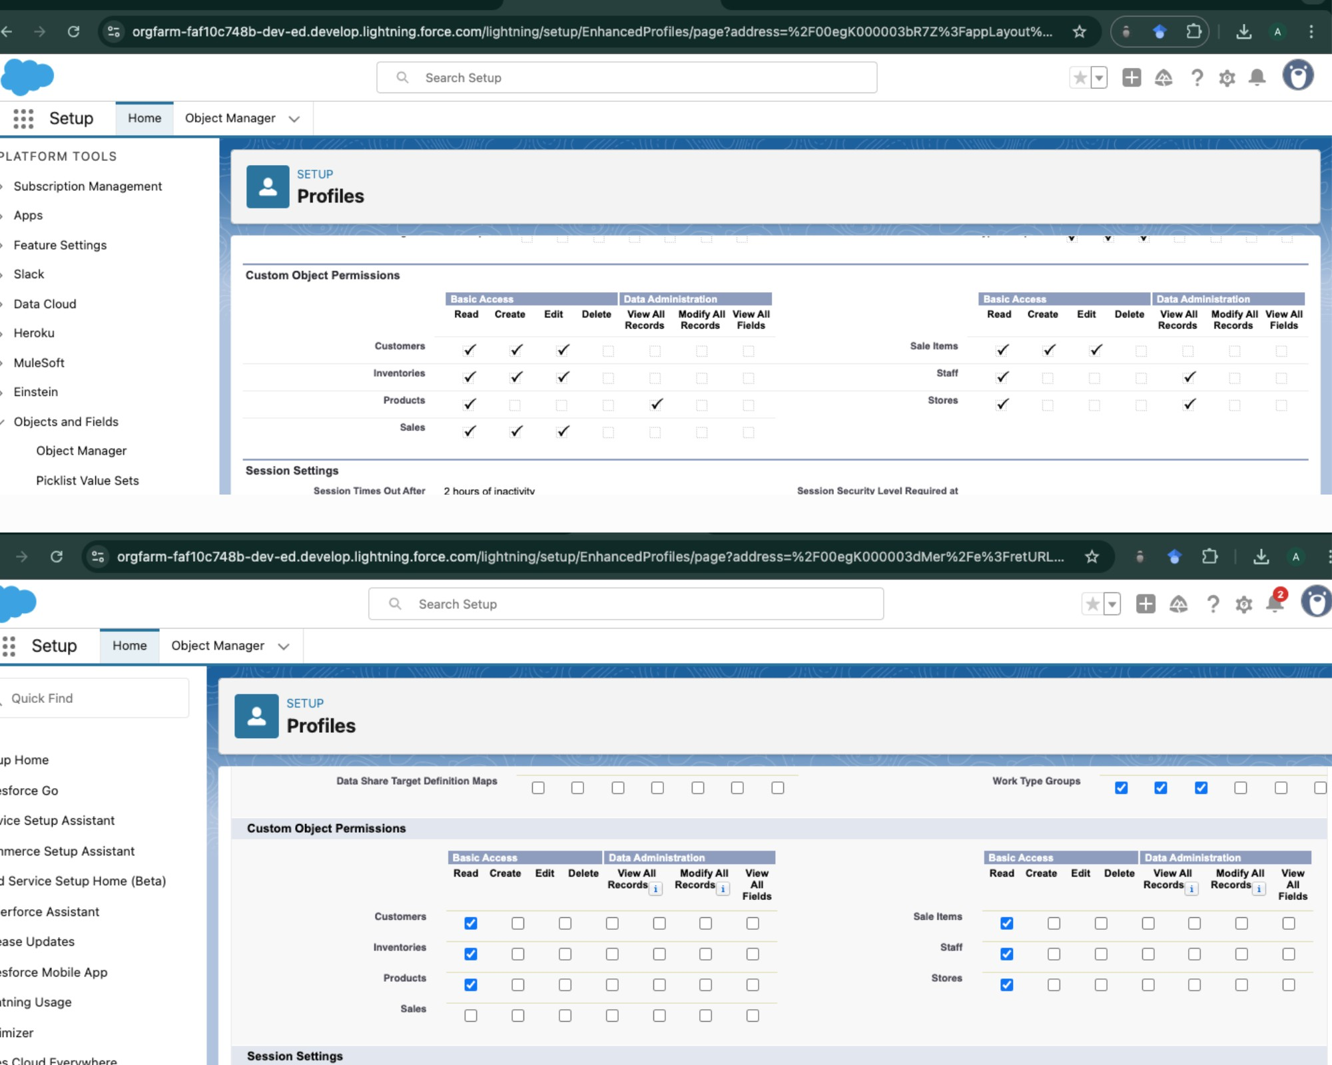

Figure 3: Store Manager vs Sales Staff Profile Permissions screenshot

Profiles were carefully configured to ensure users had appropriate access. Two critical profiles including, Store Manager and Sales Staff were set up, with distinct permissions.

* + - * Store Manager Profile: Provided full access to read, create, and edit most records within their store, including sensitive fields like Sales Amount (Figure 5 & 6: Store Manager

Profile Permissions screenshot).

* + - * Sales Staff Profile: Restricted permissions, primarily read-only access, and limited visi- bility to sensitive data, as demonstrated in subsequent testing.

### Field-Level Security and Sharing

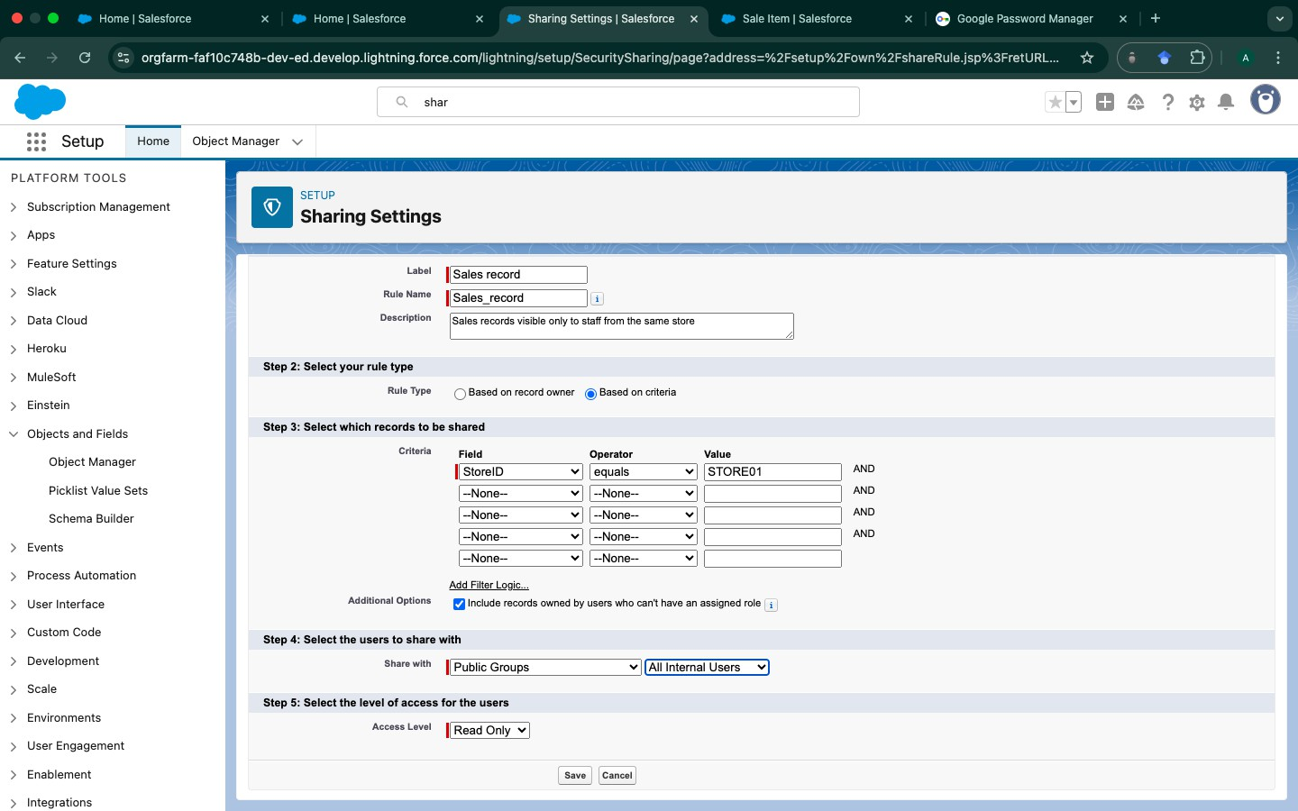

Figure 4: Sharing Settings for Sales Records screenshot

Field-level security was implemented to restrict sensitive fields. For example, the LineTotal (Sales Amount) was configured to be visible only to authorized profiles, ensuring data privacy.

Sharing rules were defined to ensure store-specific data visibility. A specific rule was set to allow staff within the same store to view relevant sales records, enhancing operational effi- ciency while maintaining data confidentiality (Figure 8: Sharing Settings for Sales Records screenshot).

### Testing Access Controls

To validate these configurations, comprehensive testing was performed using the Salesforce ”Login As” feature:

The Sales Staff profile was tested to ensure restricted access, demonstrated by the ”Insufficient Privileges” message encountered when attempting to access detailed staff information.

The Store Manager profile demonstrated full access and visibility to the same staff information, highlighting the correct implementation of permissions.

This thorough testing confirmed that access controls and permission settings functioned as intended, clearly distinguishing data visibility based on user roles and ensuring compliance with organizational data policies.

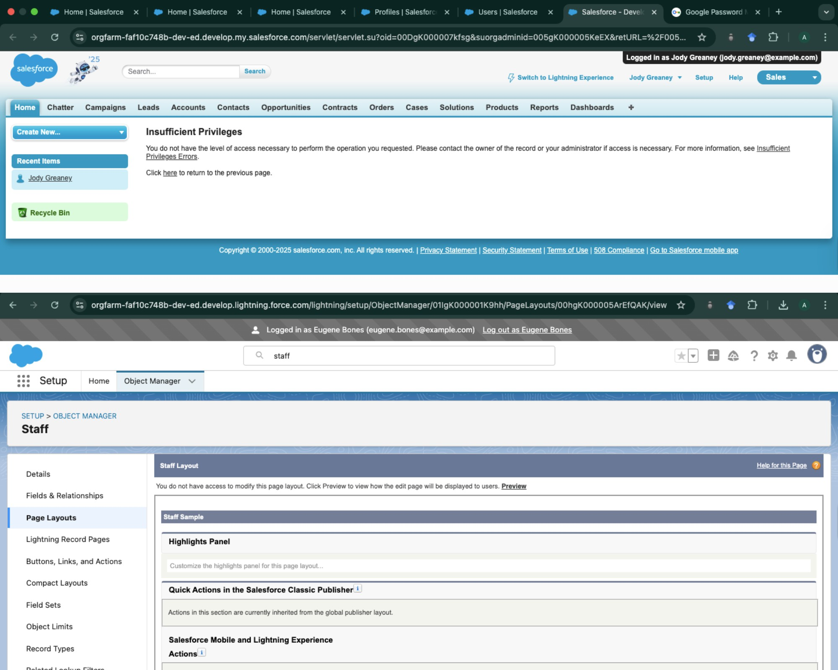

Figure 5: Salesforce Custom Object Setup

# Reports and Dashboards

## Power BI Integration

Following the deployment of Salesforce CRM, the next phase focused on data analytics and interactive reporting using Microsoft Power BI. Data from PostgreSQL, populated with the

cleansed and integrated business data, was connected directly to Power BI. The architecture and process for this implementation are described in detail below.

## Relationship Modeling & DAX

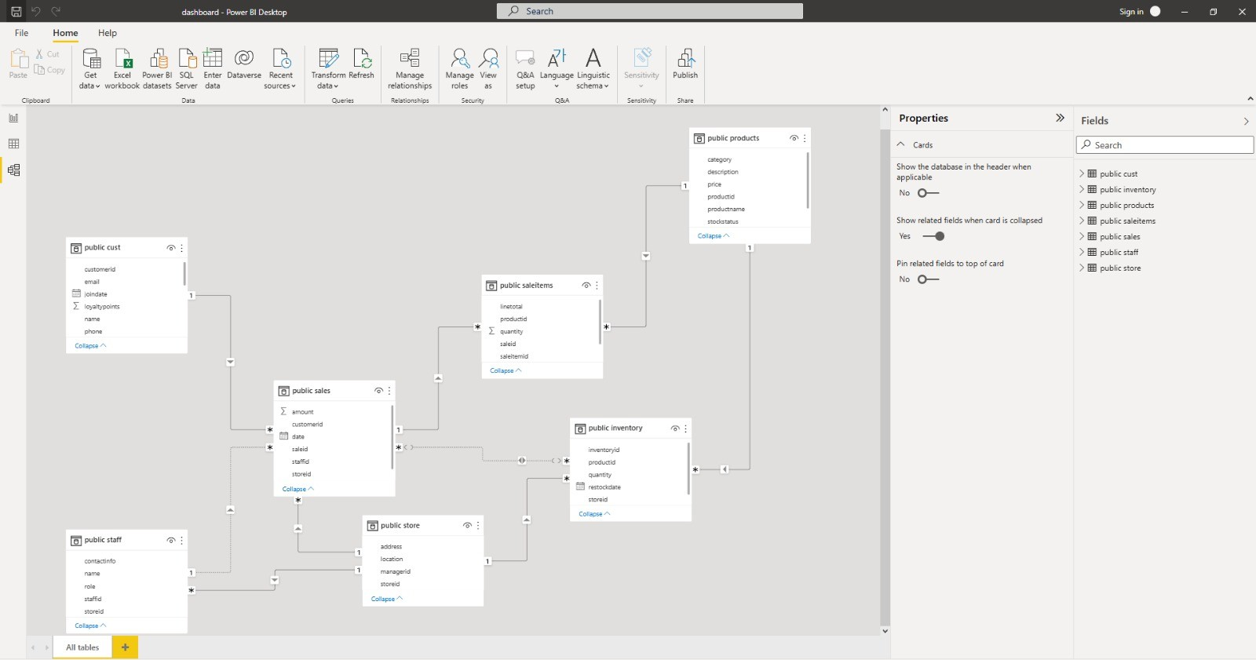Relationships were established to mirror the logical connections between the seven tables stored in PostgreSQL. These relationships are fundamental for accurate reporting, ensuring that mea- sures and dimensions are appropriately joined during aggregation and filtering.

Figure 6: Power BI Sales Dashboard

Relationships were created manually in the “Manage Relationships” view. Measures and calcu- lated columns were defined using DAX for custom KPIs such as total sales, Inventory Turnover rate, Instock% , out of stock%, low stock%, top 5 performing product, top 5 underperforming products, customer segment,purchase count, customer type, last 6 month active customer.

**KPI**:

customer_Segment = SWITCH(

TRUE(),

SELECTEDVALUE(’public cust’[loyaltypoints]) < 100, "Bronze", SELECTEDVALUE(’public cust’[loyaltypoints]) >= 100 && SELECTEDVALUE SELECTEDVALUE(’public cust’[loyaltypoints]) > 300, "Platinum"

)

Figure 7: DAX formula for customer segment classification in Power BI

## Dashboard Design and Implementation

### Sales Dashboard

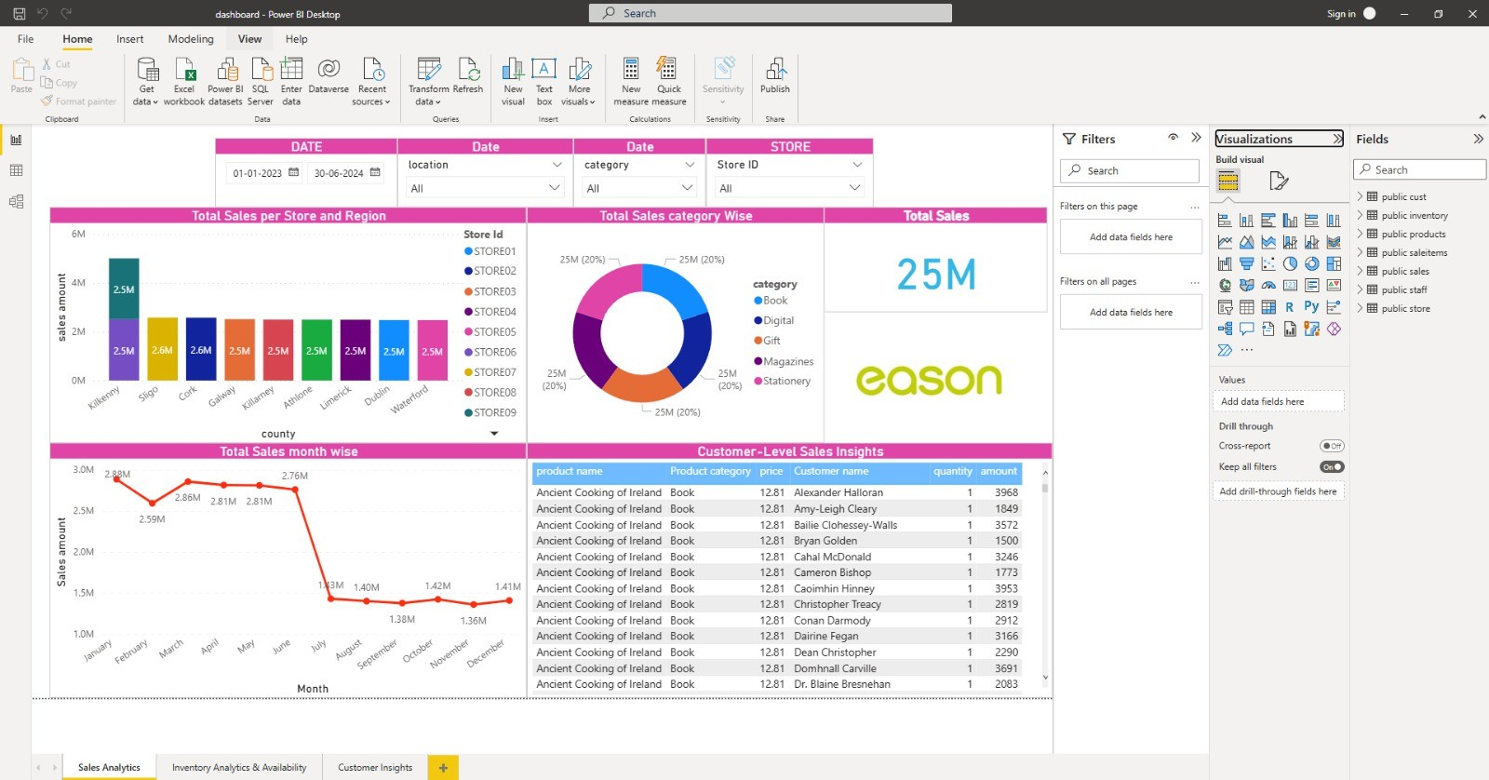

Figure 8: Power BI Sales Dashboard

The Power BI dashboard offers an interactive overview of sales from January 2023 to June 2024, enabling detailed analysis by time, product, location, and customer behavior. Sales peaked at approximately 2.8M per month from January to June, then declined and stabilized at

1.3M–1.4M monthly, indicating strong first-half seasonality.

### Inventory Dashboard

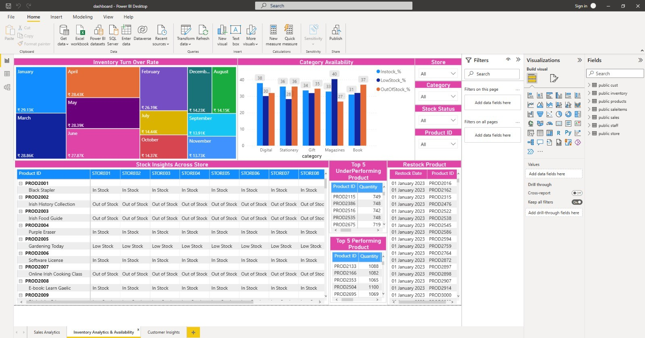

Figure 9: Power BI Inventory Dashboard

The inventory dashboard enables detailed analysis of product availability and turnover across stores. Most categories display low in-stock rates (34–40%), reflecting suboptimal inventory health. These shortages result in lost sales, reduced customer satisfaction, and inefficient in- ventory management.

### Customer Dashboard

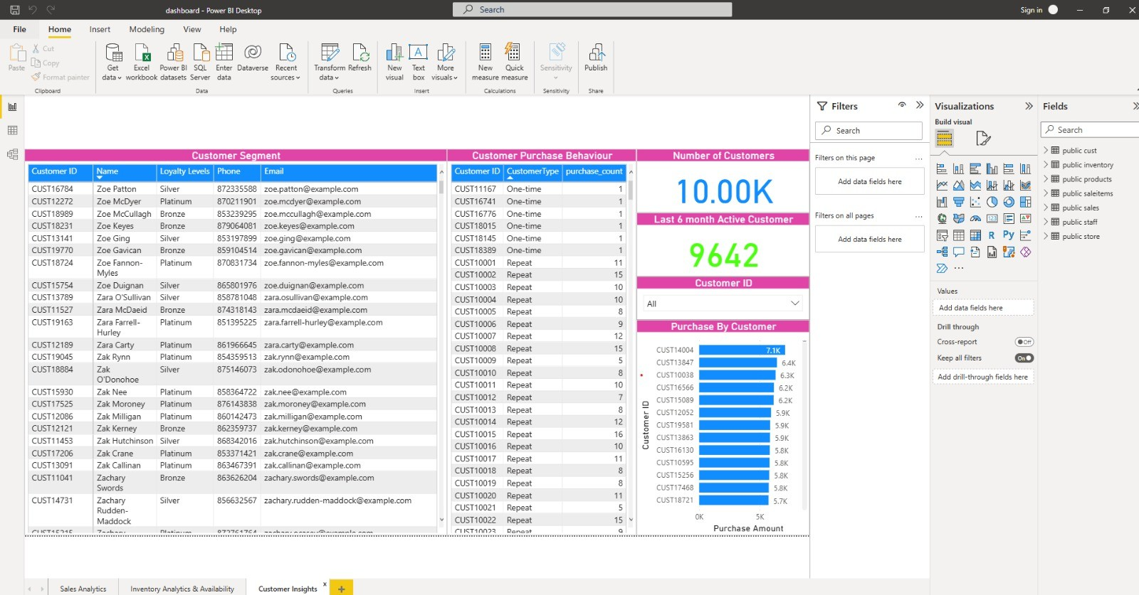

Figure 10: Power BI Customer Dashboard

The customer dashboard highlights a large share of one-time buyers and revenue concentra- tion among repeat customers. However, it lacks segmentation by purchase timing, category, and customer value, and does not offer trend or RFM analysis. Loyalty and contact data are underutilized, limiting targeted marketing and retention strategies.

# Initial Response to the Solution

Following the deployment of the Salesforce CRM solution, initial evaluations indicate promis- ing progress toward closing the previously identified business gaps. The structured data han- dling and streamlined processes have already begun improving operational efficiency and ac- curacy in managing customer data, sales records, and inventory.

Store managers have reported significantly improved visibility into sales transactions and inven- tory levels, which has notably reduced stock-outs and improved inventory forecasting accuracy. The customized dashboards and real-time reporting functionalities have enabled managers to quickly identify trends, track performance, and make informed decisions promptly.

The implementation of clearly defined access controls has strengthened data security and en- hanced regulatory compliance. Employees have clearly defined roles, and the reduction in manual data entry has minimized errors and increased productivity. Additionally, the valida- tion rules have significantly improved data quality, ensuring reliability and consistency across the company’s data assets.

Although it is early to quantify the precise long-term impacts, initial feedback suggests that the implemented Salesforce CRM solution has substantially closed critical operational gaps, improved business processes, and is positively trending toward achieving targeted performance outcomes for Eason Sons & Ltd.

# Conclusions and Lessons Learned

Throughout the implementation of the Salesforce CRM solution, several valuable insights and lessons were acquired. Setting up comprehensive access controls and profiles proved complex, demanding a detailed understanding and meticulous configuration to ensure proper data visi- bility and security. If approached again, investing more upfront time in the initial planning and testing phases could streamline the implementation process significantly.

For future improvement, the integration of Salesforce CRM with live e-commerce platforms and other third-party applications could enhance real-time inventory management and customer engagement. Additionally, exploring predictive analytics using historical sales data could sig- nificantly enhance inventory forecasting, customer segmentation, and targeted marketing strate- gies. Recent research indicates substantial improvements in forecasting accuracy and inventory

optimization through predictive analytics techniques [2,](#_bookmark1) [3,](#_bookmark2) [4,](#_bookmark3) [5] .

# References

**References**

1. Salesforce, “Import Limits - Salesforce Help,” Salesforce Documentation. [Online]. Available: [https://help.salesforce.com](https://help.salesforce.com/). [Accessed: Jul. 29, 2025].
2. P. Ganguly and I. Mukherjee, “Enhancing Retail Sales Forecasting with Optimized Ma- chine Learning Models,” *arXiv preprint arXiv:2410.13773*, Oct. 2024.
3. S. Darshan, A. Rao, and T. Mehta, “Integrating Data Mining and Predictive Modeling Techniques for Enhanced Retail Optimization,” *arXiv preprint arXiv:2409.19248*, Sep. 2024.
4. A. Hossam, Y. Khaled, and M. Said, “Revolutionizing Retail Analytics: Advancing In- ventory and Customer Insight with AI,” *arXiv preprint arXiv:2405.00023*, Feb. 2024.
5. Itransition, “Predictive analytics in retail: applications, examples & adoption guidelines,” *Itransition Blog*, Mar. 2025. [Online]. Available: [https://www.itransition.](https://www.itransition.com/predictive-analytics/retail) [com/predictive-analytics/retail](https://www.itransition.com/predictive-analytics/retail)