4. Submission Instructions
Submit a single PDF named Lab0_YourName.pdf containing:

- IDE: IntelliJ Project Structure showing SDK set to 25.
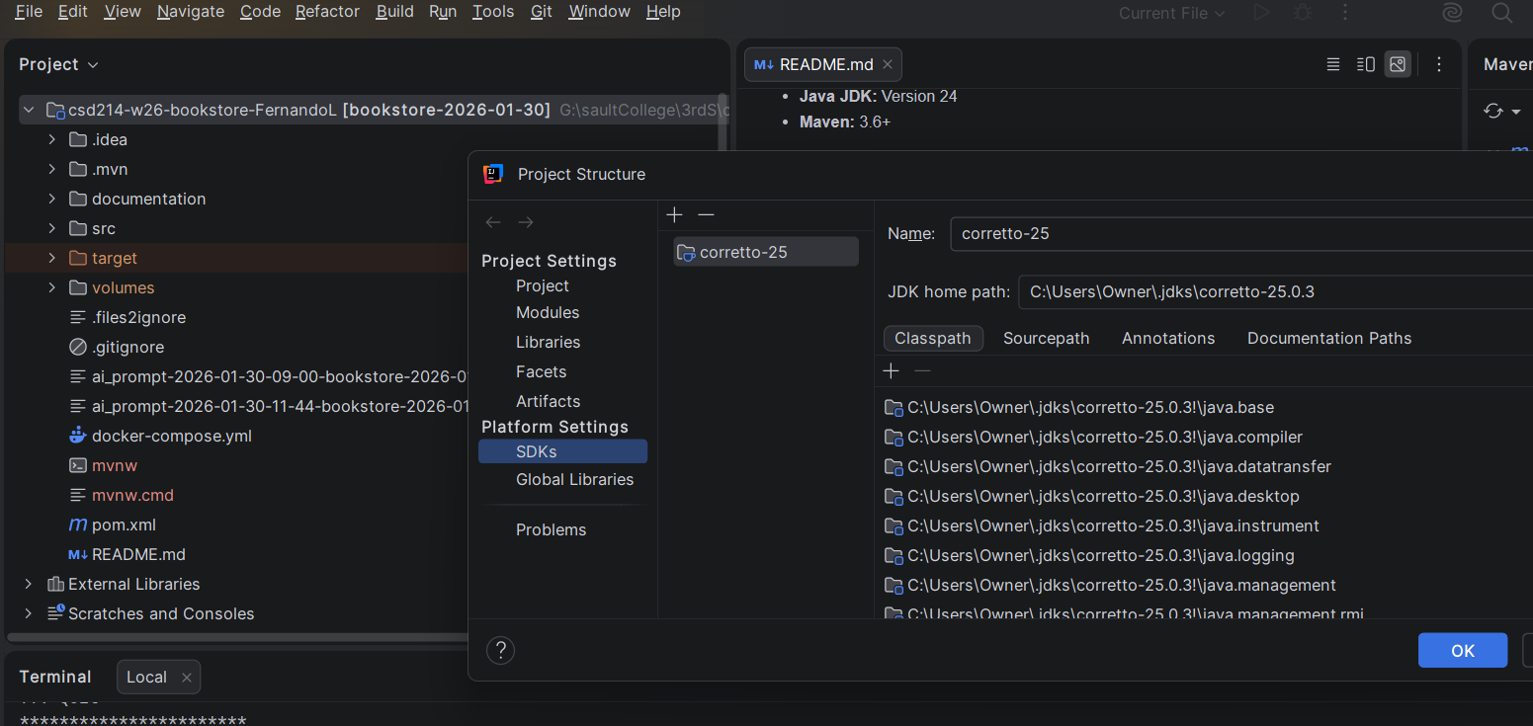

- Docker: Services tab showing your MySQL container running.
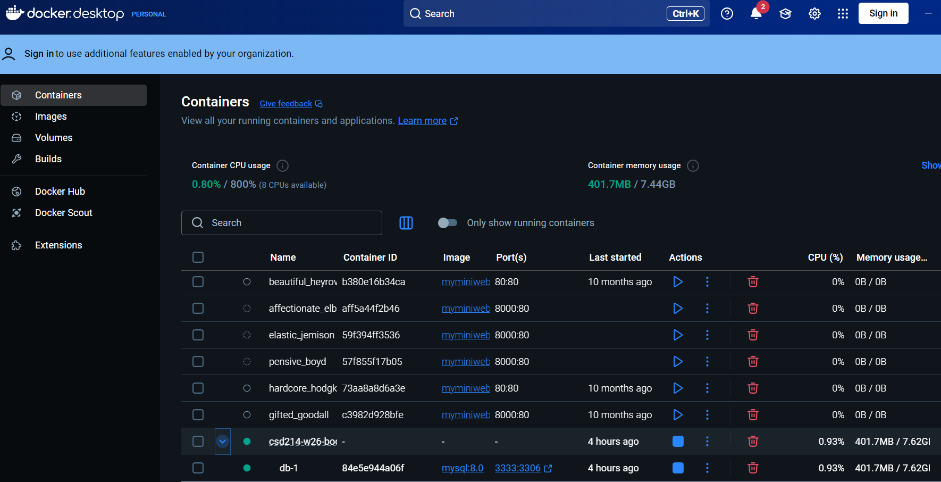

- Workbench Connection: The "Successfully made the MySQL connection" popup.
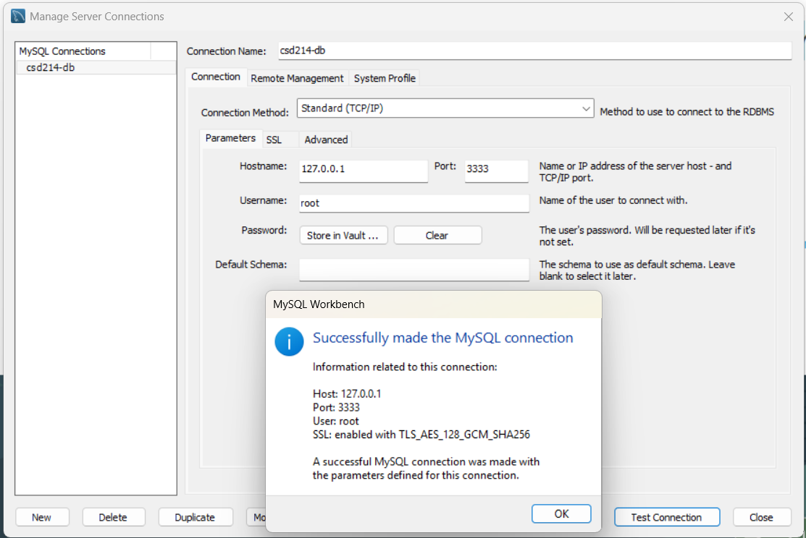

- Workbench Data: A screenshot of the Result Grid in MySQL Workbench showing the two users in lab0_users.
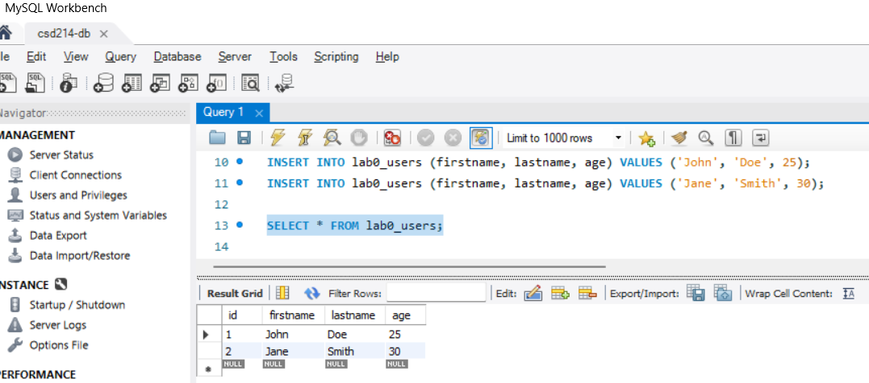

- Git: A screenshot of your new GitHub repository home page.

