FinReason: Explainable Graph and Rule-Based Detection of Anomalous Financial Transactions
Project Proposal - Coursework 1, 7COSC013W Foundations of AI
Hewage Lasen Hewage - 20251197 - w2223897 - University of Westminster
1. Problem Statement and Real-World Context
Financial institutions execute millions of financial transactions on a daily basis. Some of these transactions contain information that can be used to obscure the origin or destination of funds. The people who regulate this stuff want these transactions to be flagged. Most of the time these flags come from simple rules or from computer programs that say something is risky but they do not say reason. When someone is looking into one of these transactions they still have to figure out why it was flagged. They have to do this by hand which's a lot of work. This is the problem that FinReason is trying to solve. Money laundering usually leaves a trail in the way money moves. For example one account might send money to a lot of accounts or a lot of accounts might send money to one account. Sometimes money moves through a lot of accounts before it ends up back where it started. These patterns look like graphs, not unusual numbers. So FinReason looks at all the transactions as a graph searches for these patterns and uses rules to explain what it finds. This way the person looking into the transaction can understand what is going on and do something about it. FinReason is about helping with this process especially when it comes to money laundering and transactions that FinReason is designed to flag.

2. Proposed AI Technique(s)
The project brings together two of the module’s three categories: search and knowledge representation putting it in the hybrid category. Each transaction turns into a directed time stamped link between two account nodes in a multigraph because two accounts can have transactions. Breadth search, done both forward and backward from each account, finds out how transactions spread out and come in within a set time frame. Depth search tracks chains of transfers going forward in time and needs most of the amount to stay through each step to find layering and repeated movement. Both searches look at direction, time, type and amount never at an anomaly label so a result can be explained without being given the answer beforehand. What breadth search and depth first search find becomes a group of observed facts that go to a forward chaining rule engine (Match – Resolve – Act) that uses them with transaction details to make higher-level conclusions; every conclusion has a link back, to its proof and rule so an alert shows the whole reasoning path instead of just a number. An account focused Z-score and an IQR check are also used as a comparison to see if the graph is actually useful compared to simple row level numbers.

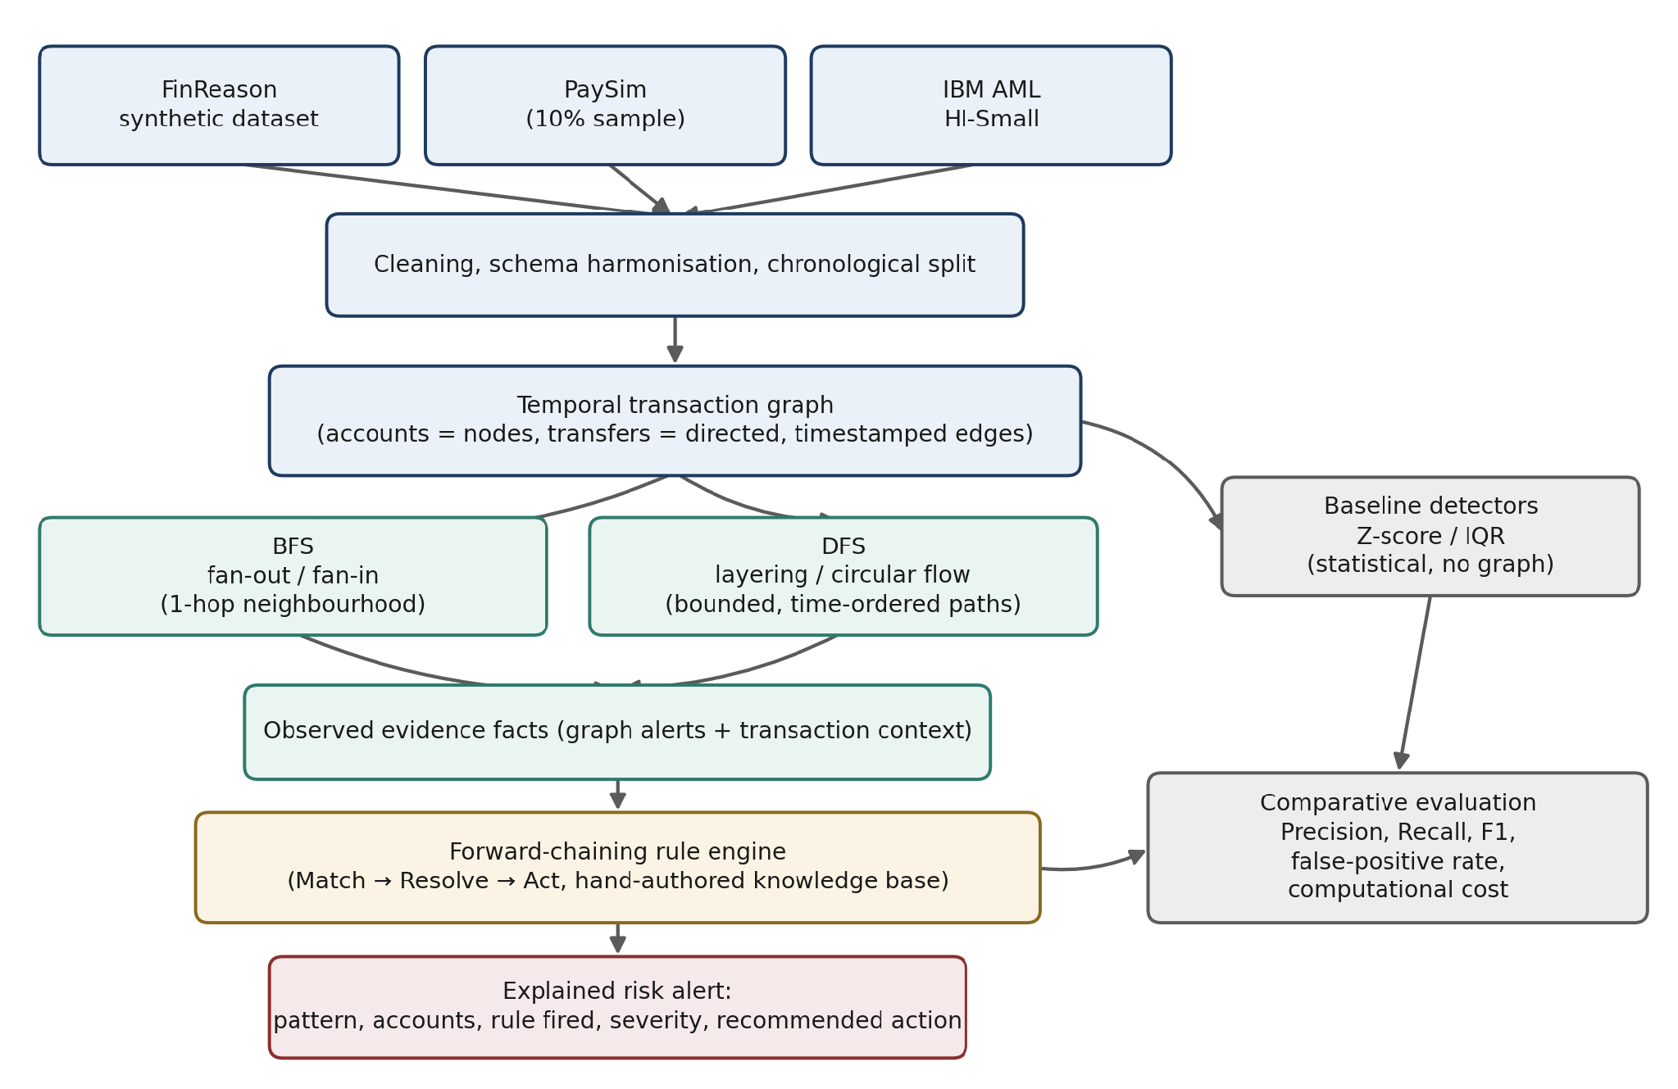
Figure 1: FinReason pipeline, from raw transactions to an explained risk alert.
3. Dataset and Problem Instance Description
The project uses three sources. FinReason (self-generated) is the dataset: public AML data often does not show which structural pattern caused a flag so a synthetic ledger with every planted scenario marked by type gives the truth to check BFS, DFS and the rule engine’s derived facts separately. IBM AML adds about five million real-scale transactions, used to test whether graph construction and bounded search stay efficient when much larger, with its pattern file providing examples of types, for checking. PaySim (10% sample) is a mobile-money simulation whose "fraud" label's not an AML label; it checks whether the same graph patterns work for a different institution and fraud type instead of adding more AML truth. The synthetic set confirms the method exactly; the two real-scale sets test it for size and ability to work in situations since neither can provide the graph-typology truth this project requires.
4. Success Criteria and Evaluation Metrics
The project will be success if:
- BFS and DFS recover the planted fan-out, fan-in, layering and circular-flow scenarios in the FinReason training split, checked against the known labels;
- The rule engine chains facts deterministically with no duplicate firings on replay, and every alert carries a complete explanation pattern, accounts, rule fired, severity, recommended action;
- on held-out data, graph-only, rule-hybrid, combined-union and statistical-baseline detectors are compared according to precision, recall, F1 and false-positive rate, with discussion of trade-offs off between the measures, rather than presentation of a single headline figure;
Precision and F1 are both important since false positives are a waste of investigator time, while false negatives allow potential structuring through lack of detection, and so both metrics are reported, along with the false-positive rate, rather than just one headline measure.

