Classifying Fruit
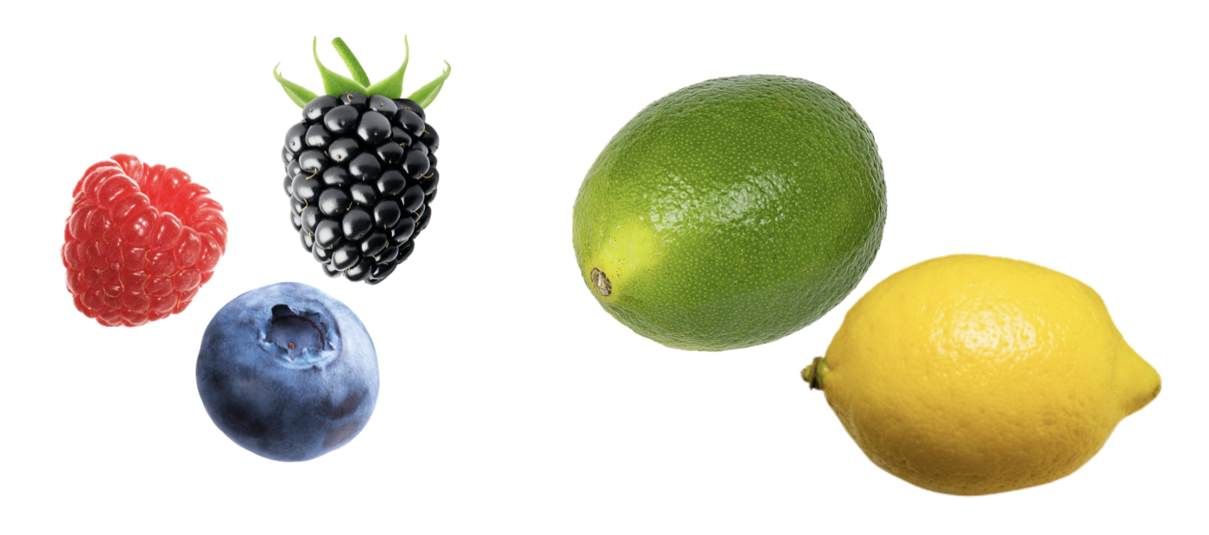

Introduction
There are a number of categories of fruits (fruit types) that are determined by things like number of flowers needed to produce the fruit, number of seeds in the grown fruit, and flesh and/or skin of the fruit, to name a few. When a new fruit is discovered, being able to classify the fruit’s type helps farmers and scientists learn more about the fruit’s properties and even how to market it to the general public. In this activity, you will be classifying a newly discovered fruit with the working name of Goldy Fruit.

Part I: Eyeballing Similarity
In order to classify the Goldy Fruit, we need to compare its properties to properties of other fruits that we know the classification for. On the next page is a table of fruits, their fruit type, and properties for those fruits.

Name | Type | Number of Seeds
Blackberry | Berry | 94
Blueberry | Berry | 50
Raspberry | Berry | 110
Grapefruit | Citrus | 40
Lemon | Citrus | 8
Orange | Citrus | 10
Apricot | Drupe | 1
Cherry | Drupe | 1
Peach | Drupe | 1
Apple | Pome | 6.5
Asian pear | Pome | 5
Pear | Pome | 10

- To begin, you will only focus on a single attribute: the number of seeds. Create a one-dimensional axis (number line) and plot the number of seeds for each of the 12 fruits given in the table. Label each fruit with its name and fruit type.

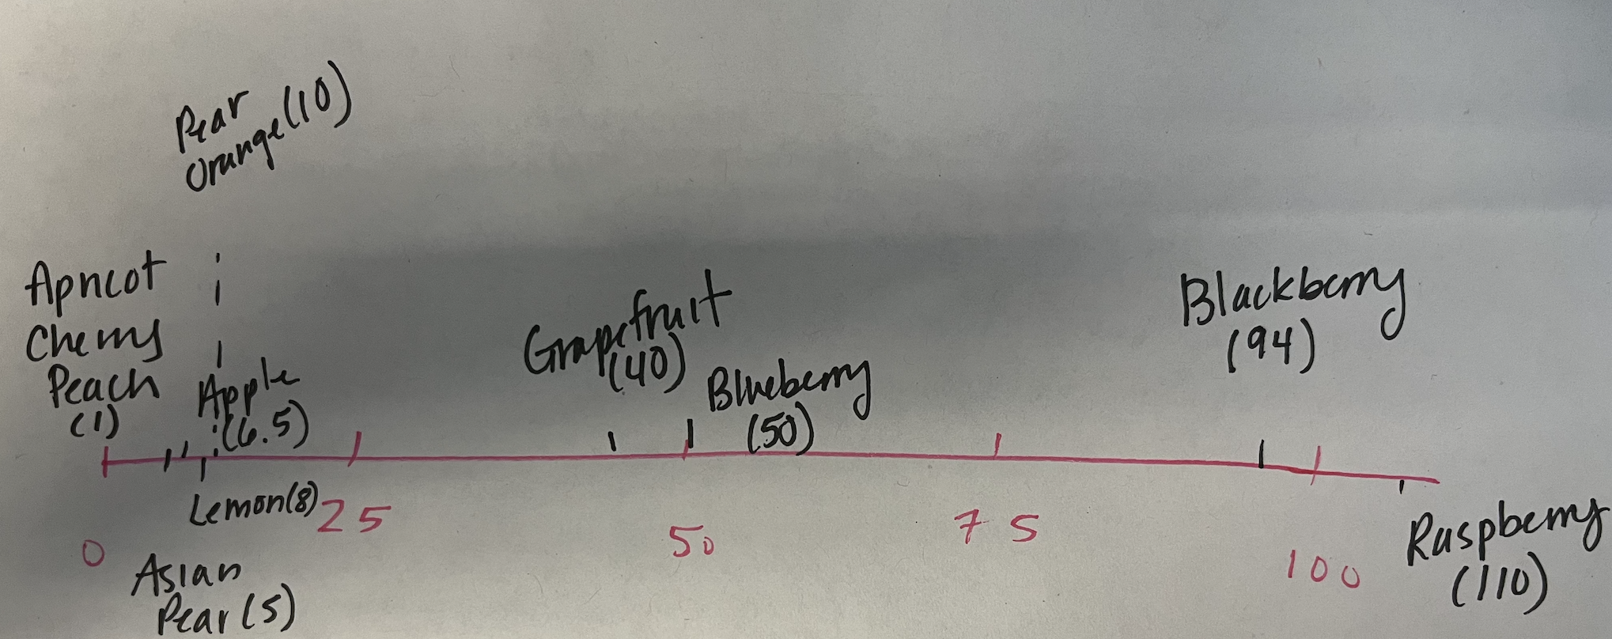

- The Goldy Fruit has 10 seeds. Include the Goldy Fruit in your previous plot.
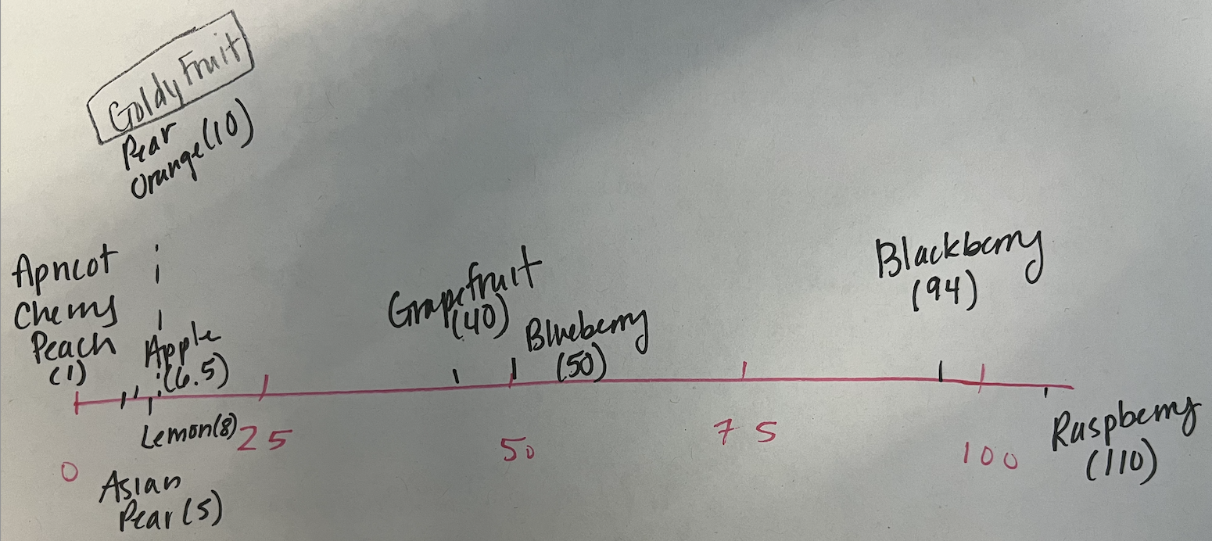

- Which fruits are the Goldy Fruit most similar to?

Pear and orange

- Based on your response to the previous question, do you have a guess for what type of fruit the Goldy Fruit may be? Explain.

Based on the plot I would guess it could be a citrus or a pome.

Part II: Quantifying Similarity
- Come up with and describe a way to quantify how similar two fruits are based on their number of seeds. Use your method to compute how similar the Goldy Fruit is to a grapefruit. Also compute how similar the Goldy Fruit is to an Asian pear.

Method: Subtraction
Grapefruit: 40 - 10 = 30
Asian Pear: 5 - 10 = -5

- Use your method to compute how similar each fruit is to the Goldy Fruit. Add a column to the table of fruits to record your similarity values.

Name | Type | Number of Seeds | Similarity
Blackberry | Berry | 94 | 84
Blueberry | Berry | 50 | 40
Raspberry | Berry | 110 | 100
Grapefruit | Citrus | 40 | 30
Lemon | Citrus | 8 | -2
Orange | Citrus | 10 | 0
Apricot | Drupe | 1 | -9
Cherry | Drupe | 1 | -9
Peach | Drupe | 1 | -9
Apple | Pome | 6.5 | -3.5
Asian pear | Pome | 5 | -5
Pear | Pome | 10 | 0

- Explain how you might use the similarity measures you computed to determine what type of fruit the Goldy Fruit may be.

We would expect a small similarity measure will indicate that the fruits are more similar. A fruit with a lower similarity measure might be the same type as the Goldy Fruit.

