“Unpeeling” k-Nearest Neighbors
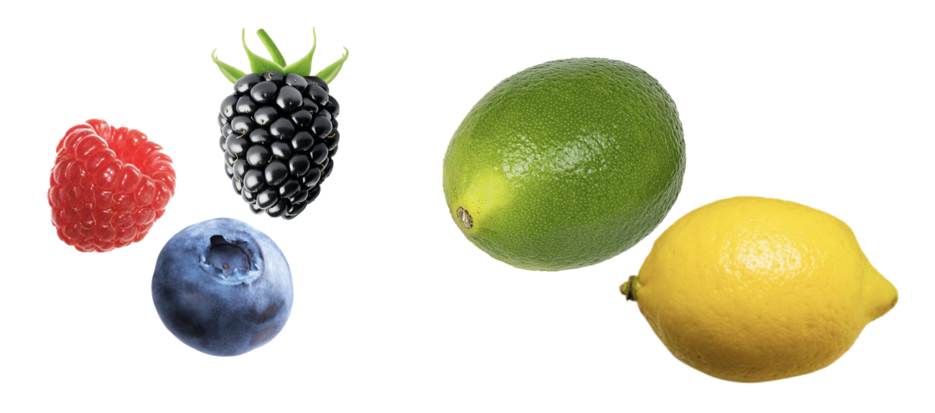

The k-Nearest Neighbors Algorithm
One method of classifying the Goldy Fruit is to use an algorithm called K-Nearest Neighbors (kNN). The main idea is that an unclassified case is classified based on the k cases that are most similar to it using majority "vote". The algorithm for this is:

Step-1: Select the number k of the neighbors
Step-2: Calculate a similarity measure between the unclassified case and all the classified cases
Step-3: Identify the k nearest neighbors as per the calculated similarity measure.
Step-4: Among these k neighbors, count the number of cases in each class (i.e., category).
Step-5: Assign the unclassified case to the majority class within the k nearest neighbors (the one with the most cases)

- Use the kNN algorithm and k = 3, to determine what type of fruit the Goldy Fruit may be. Also report the “vote” tally for each of the four classes (i.e., fruit types).

Name | Type | Number of Seeds | Similarity
Blackberry | Berry | 94 | 84
Blueberry | Berry | 50 | 40
Raspberry | Berry | 110 | 100
Grapefruit | Citrus | 40 | 30
Lemon | Citrus | 8 | -2
Orange | Citrus | 10 | 0
Apricot | Drupe | 1 | -9
Cherry | Drupe | 1 | -9
Peach | Drupe | 1 | -9
Apple | Pome | 6.5 | -3.5
Asian pear | Pome | 5 | -5
Pear | Pome | 10 | 0

Pear = 0
Orange = 0
Lemon = -2
Vote Tally:
Citrus = 2
Pome = 1
Based on this k value we would classify it as a citrus.

STOP: Raise your hand to check in with us.
- Use the kNN algorithm and k = 5, to determine what type of fruit the Goldy Fruit may be. Also report the “vote” tally for each of the four classes (i.e., fruit types).

Pear = 0
Orange = 0
Lemon = -2
Apple = -3.5
Asian Pear = -5

Vote Tally:
Citrus = 2
Pome = 3

Based on this k value we would classify it as a pome.

- Use the kNN algorithm and k = 7, to determine what type of fruit the Goldy Fruit may be. Also report the “vote” tally for each of the four classes (i.e., fruit types).

Pear = 0
Orange = 0
Lemon = -2
Apple = -3.5
Asian Pear = -5
Apricot = 9
Cherry = 9

Vote Tally:
Citrus = 2
Pome = 3
Drupe = 2

This k value will have us classify it as a pome.

Part IV: Choosing the Value of k
In the previous section, you saw that different values of k can result in different classifications for the Goldy Fruit. In practice we would have to evaluate which k value is optimal by testing some cases for which we know the correct classification. We would then choose the k value that seemed to consistently classify these cases correctly. Rather than have you do that, we are going to determine the k value via the following formula, which works well in most situations.

where n is the number of cases for which we know the classification, and is the ceiling function (round up to the nearest integer).

- Compute the value for k for our fruit classification using the formula. Show your work.

sqrt(12) = 3.46 = 4
Optimal k = 4

- Use the optimal number of nearest neighbors (that you reported in the previous question) to determine what type of fruit the Goldy Fruit may be. Also report the “vote” tally for each of the four classes (i.e., fruit types).

Pear = 0
Orange = 0
Lemon = -2
Apple = -3.5
Vote Tally:
Citrus = 2
Pome = 2
It may be a citrus or a pome based on this classification.

