Bottom-Up Parsing

In contrast with Top-down parsing algorithms and grammars, the family of Bottom-up parsing algorithms and grammars can be characterized by those algorithms that attempt to produce the reverse of a rightmost derivation with respect to some underlying context-free grammar, G. A rightmost derivation in a context-free grammar tends to expand the final terminal string in a right-to-left fashion. Whereas a Top-down parsing algorithms apply grammar rules in the natural way – by expanding the leftside (nonterminal) of the rule with the rightside (handle) – a Bottom-up parser reverses this process by pushing input symbols into the stack (shift action) until the rightside of some rule can be recognized in the stack. The Bottom-up parser then “reduces the stack” by replacing the rightside of some rule (in the stack) with the corresponding leftside (nonterminal) of the rule. This process continues until one of two conditions occur: (1) an erroneous symbol or token is recognized as not being consistent with the grammar (in some way), or (2) the entire input has been successfully reduced to just the start symbol of the grammar (S). Figure 1 illustrates the conceptual model of a Bottom-up parse.

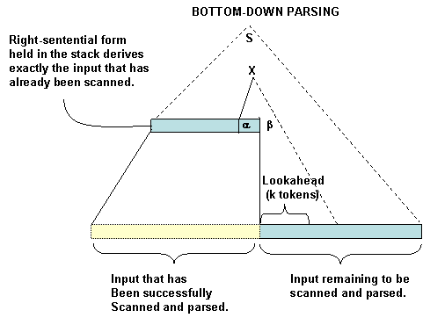
Figure 1. Conceptual Model of a Bottom-up Parser.

The family of deterministic Bottom-up parsers and grammars is larger and more powerful than the family of deterministic Top-down parsers. The most commonly used family of grammars for defining programming languages and building Bottom-up parsers is the family of LR(k) grammars. UNIX tools such as YACC produce a parser as output when presented with an LR(1) grammar as input. In general, LR(k) parsers are very complicated and their parsers are quite complex. However, there is a sub-family of LR(1) grammars, the Weak Precedence Grammars, that are easier to understand and much less difficult to parse. We therefore continue with a discussion of these grammars and their parsing algorithms.

Weak Precedence Grammars
DEFINITION (LEFT and RIGHT sets)
Let G = (N, Σ, P, S) be a reduce context-free grammar. We define the LEFT and RIGHT sets for each nonterminal, X ∈ N, as follows.

LEFT(X) = { Y ∈V_{G} | X ⇒+ Yα, for some α ∈V_{G}* }
RIGHT(X) = { Y ∈V_{G} | X ⇒+ αY, for some α ∈V_{G}* }

Example G = (N, Σ, P, S), where N = {S, X, Y, B}, Σ = {a, b, c}
P = {
1: S → XY
2: X → a X B
3: X → a b
4: B → b
5: Y → Y c
6: Y → c }

Symbol | LEFT | RIGHT
B | { b } | { b }
Y | { Y, c } | { c }
X | { a } | { b, B }
S | { X, a } | { Y, c }

DEFINITION (Wirth-Weber Precedence Relations)
Let G = (N, Σ, P, S) be a reduce context-free grammar. For X,Y ∈ V_{G}, the relations are defined on the vocabulary V_{G} as follows:
(a) X Y if and only if ∃ (A → uXYv ∈ P), where u,v are any strings.
- X Y if and only if ∃ (Z ∈N) such that X Z and Y ∈ LEFT(Z).
- X a, a ∈ Σ, if and only if
∃ (Z ∈N) such that Z a and X ∈ RIGHT(Z), OR
∃ (Z₁, Z₂ ∈N) such that Z₁ Z₂ and X ∈ RIGHT(Z₁) and a ∈ LEFT(Z₂).
- For technical reasons (ease of proofs and developing parsing algorithms), we also define
$ Y, for all Y ∈ LEFT(S), AND
Y $, for all Y ∈ RIGHT(S).
Where $ is a special symbol used as an end marker for sentential forms derived in G.

The WWP relations encode the structure of the syntax tree corresponding to rightmost derivation of a sentential form of G in the following way. The relation marks the left edge of a subtree rooted at the nonterminal Z described in (b), while the marks the right edge of a subtree. The relation holds between pairs of symbols that occur adjacent in the same right part. The figure below illustrates graphically the meaning associated with these three relations.
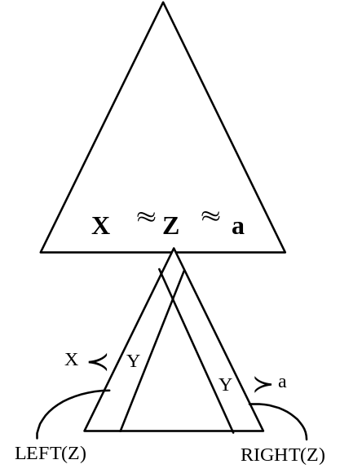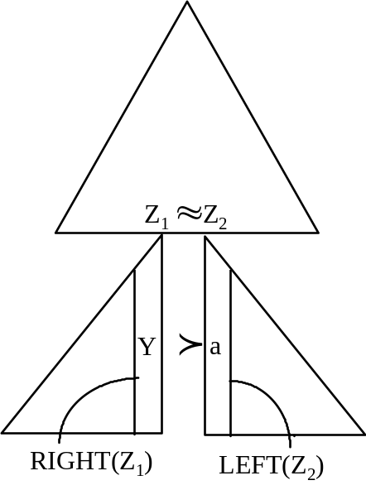

In reference to the grammar in the previous example, we construct the precedence matrix shown below. The rows of the matrix correspond to symbols X, and columns correspond to symbols Y that potentially define a related pair (X,Y) belonging to one (or more) of the WWP relations indicated in the table entry at the intersection of a given row and column.

 | S | X | Y | B | a | b | c | $
S
X
Y
B
a
b
c
$

The table entries are defined by the following equations:
- $ LEFT(S)
- RIGHT(S) $
- 1: X Y, X LEFT(Y), and RIGHT(X) LEFT(Y) ∩ Σ
- 2: a X B, a LEFT(X), X LEFT(B), and RIGHT(X) LEFT(B) ∩ Σ
- 3: a b
- 5: Y c, RIGHT(Y) c

As you observe from the table, there is only one pair (X,Y) are related by more than one of the three WWP relations. A grammar for which the three relations are pair-wise disjoint is called a Wirth-Weber precedence(WWP) grammar. The class of WWP grammars is an important class of context-free grammars for two reasons: (1) every Context-free language without λ can be defined by some WWP grammar, and (2) WWP grammars provide the basis for deterministic parsing algorithms for a subfamily of grammars that can be used to describe the syntax of programming languages. The Weak-precedence (WP) grammars, introduce by the next definition, are just such a family of grammars.

DEFINITION (Weak-Precedence Grammars)
Let G = (N, Σ, P, S) be a reduced context-free grammar. G is said to be a Weak-Precedence grammar if and only if G satisfies each of the following properties:
- G is λ-free (contains no erasing rules)
- G is cycle-free (for all A ∈ N, no derivation of the form A ⇒+ A is possible in G)
- G is uniquely invertible (no two rules of G have the same rightpart)
- The WWP relations ( ∪ ) ∩ = Φ
- For any pair of rules of the form: A → uXβ, and B → β, where u and β are any strings over V_{G} and X ∈V_{G}, then (X,B) are not related by any WWP relation.

Example G = (N, Σ, P, S), where N = {S, X, Y, B}, Σ = {a, b, c}
P = {
1: S → XY
2: X → a X B
3: X → a b
4: B → b
5: Y → Y c
6: Y → c }
This is the grammar we examined in the previous example. It is obvious that G satisfies (a)-(c) by inspection. Condition (d) is also met as demonstrated by the precedence matrix constructed above. To verify condition (e) we must consider rules 3 and 4, and 5 and 6. In Rule 4, β is taken to be "b." In rule 3, X is taken to be "a." Observe that no WWP relation is defined in the matrix for the pair (a, B). Considering rule 6, β is taken to be "c" and in rule 5, X is taken to be "Y." Again we note that (Y, Y) is not related by any WWP relation. Thus G is an example of a Weak Precedence grammar.

Although we will not prove it here, every WP grammar is unambiguous. This fact, and an important property of right-sentential forms defined by a WP grammar, lead to a very efficient parsing algorithm. This property of right-sentential forms is illustrated with the following rightmost derivation.

$S$ ¹⇒ $XY$ ⁵⇒ $XYc$ ⁵⇒ $XYcc$ ⁶⇒ $Xccc$ ²⇒ $aXBccc$ ⁴⇒ $aXbccc$ ³⇒ $aabbccc$

Observe that, except for the initial sentential form, every pair of adjacent symbols in each sentential form is related by one of the WWP relations. And, except for the pair XY, exactly one relation holds between each pair of adjacent symbols. Now, the most important property to note is that, the string of symbols appearing between the righmost occurrence of and the leftmost occurrence of is always the rightpart of the last rule applied in the derivation. This property together with the unique invertibility property of WP grammars make it possible to reverse the steps of the derivation beginning with the last sentential form (which is a string in Σ⁺). This is the property that makes G unambiguous and is also the property that enables a compiler to parse the language L(G).

$S$ ¹⇒
$XY$ ⁵⇒
$XYc$ ⁵⇒
$XYcc$ ⁶⇒
$Xccc$ ²⇒
$aXBccc$ ⁴⇒
$aXbccc$ ³⇒

$aabbccc$

This property of right-sentential forms of a WP grammar is formalized by our next Lemma.

LEMMA. Let G = (N, Σ, P, S) be a Weak Precedence grammar with special end marker $. Then for π ≠ λ, a rightmost derivation in G, $S$ ^{π} ⇒ $α$, where α ∈ V_{G}⁺, implies the following:
(1) α = β w x, where β∈V_{G}*, A → w ∈ P, for some A, x ∈Σ*, and
(2) Suff₁($β) Pref₁(w)
(3) Suff₁(w) Pref₁(x$)
(4) |$β| > 1 implies $β = Y₁Y₂…Y_{m}, m ≥ 2, and (Y_{i},Y_{i+1}) ∈(∪), for 1≤ i < m.

Proof. This can be shown by induction on |π|.

THEOREM. Let G = (N, Σ, P, S) be a Weak Precedence grammar with special end marker $. Then G is unambiguous.

Proof. Using the previous lemma, it can be shown that assuming the existence of two distinct right-most derivations of some string x ∈L(G) leads to a logical contradiction.

Now that we have informally established that WP grammars are unambiguous, we can present a deterministic parsing algorithm for them. This will be done in the next section.
Parsing WP Grammars

ALGORITHM (Bottom-up Parsing for WP Grammars)
Input:
G = (N, S, P, S) a Weak-precedence grammar. Let T be the table of precdence relations for [V_{G} ∪{$}] × [Σ ∪{$}], where T[X,Y] ⊆ 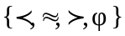 ; T[X,Y] = φ if and only if the symbols X,Y are not related by any WW relation. Let P be the table of productions ordered in descending order by length of rightpart; P[i].rightpart will denote the rightpart of production #(i), while P[i].leftpart wll denote the leftpart. Let Stk denote the parse stack initialized to the special marker ($); Stk[Top] will denote the top symbol of Stk; Stk should be thought of as a string with the rightmost symbol corresponding to Stk[Top]. Finally, let Action be a table of function pointers. The function identified by Action[k] is designed to perform some sematic processing action associated with rule k of the grammar, G; e.g., generate object code or enter a declaration in a Symbol table, etc.
Procedure:
(1) Set C = Next_Source_Token. // C will be set to "$" on an end-of-file.
(2) If C = $ and Stk = "$S" Then { Accept and Halt }.
(3) Set X = Stk[Top].
(4) Case T[X,C] {
When φ ⇒ Report Syntax Error and Halt.
When 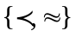 ⇒ Push(C, Stk); Goto (1). //Shift input
When ⇒ for k in 1..#P {
if (for some θ) Stk = θP[k].rightpart then // Reduce Stack
{ Set Stk = θP[k].leftpart ; Action[k]; Goto (3)}
}
Report Syntax Error and Halt.
// Note: this is the mathematical specification for finding the
// the first rule in the Production table (P) such that the rightpart
// matches the top of the stack (remember how P is organized).
// When such a rule is found, pop the rightpart from the stack and
// push the leftpart on the stack. If no rule in P matches the stack,
// halt and report a “Syntax Error”.
}//end case

Example (Expression Grammar).

G’ = (N, Σ, P, S), where N = {S, T, F, X}, Σ = {n,v} ∪ {+, -, , /, ~}∪ {(,)}
Note: “~” denotes negation, the other operators denote the obvious arithmetic operations.
P = {
1: S → S+T
2: S → S-T
3: S → T
4: T → T* F
5: T → T / F
6: T → F
7: F → ~X
8: F → X
9: X → n
10: X → v
11: X → ( S )
}

The LEFT and RIGHT sets for this grammar are given below.
Symbol | LEFT | RIGHT
S | { S, T, F, X, ~, n, v, ( } | { T, F, X, n, v, ) }
T | { T, F, X, ~, n, v, ( } | { F, X, n, v, ) }
F | { X, ~, n, v, ( } | { X, n, v, ) }
X | { n,v,( } | { n, v, ) }

From this table we can construct the table of WW Precedence Relations.

 | S | T | F | X | n,v | ~ | */ | +- | ( | ) | $
S
T
F
X
n,v
~
*/
+-
(
)
$

To apply the parsing algorithm, you will need the tables T and P. These are shown below for the grammar G’.

Parse table T
T[] | n,v | ~ | */ | +- | ( | ) | $
S
T
F
X
n,v
~
*/
+-
(
)
$

The Stack[Top] is used to index the rows of T while the lookahead is used to index the columns of T. In the stack, “$” denotes the bottom stack symbol. As a lookahead symbol, “$” denotes the end-of-file. The empty entries in T denote error entries.

Production Table, P.
Rule# | Rightpart | Leftpart | Action
1 | S+T | S | gencode
2 | S-T | S | gencode
4 | T*F | T | gencode
5 | T/F | T | gencode
11 | (S) | X
7 | ~X | F | gencode
3 | T | S
6 | F | T
8 | X | F
9 | n | X | gencode
10 | v | X | gencode

Use the above tables to parse the expression: ~n*(v-n)/~v

Example.

[$ | ~n*(v-n)/~v $] ($, ~) ∈ (shift)
[$~ | n*(v-n)/~v $] (~, n) ∈ (shift)
[$~n | *(v-n)/~v $] (n, *) ∈ (reduce by 9)
[$~X | *(v-n)/~v $] (X, *) ∈ (reduce by 7)
[$F | *(v-n)/~v $] (F, *) ∈ (reduce by 6)
[$T | *(v-n)/~v $] (T, *) ∈ (shift)
[$T* | (v-n)/~v $] (*, ( ) ∈ (shift)
[$T*( | v-n)/~v $] ( (, v ) ∈ (shift)
[$T*( v | -n)/~v $] ( v, - ) ∈ (reduce by 10)
[$T*( X | -n)/~v $] ( X, - ) ∈ (reduce by 8)
[$T*( F | -n)/~v $] ( F, - ) ∈ (reduce by 6)
[$T*( T | -n)/~v $] ( T, - ) ∈ (reduce by 3)
[$T*( S | -n)/~v $] ( S , - ) ∈ (shift)
[$T*( S- | n)/~v $] ( - , n ) ∈ (shift)
[$T*( S-n | )/~v $] ( n , ) ) ∈ (reduce by 9)
[$T*( S-X | )/~v $] (X , ) ) ∈ (reduce by 8)
[$T*( S-F | )/~v $] (F , ) ) ∈ (reduce by 6)
[$T*( S-T | )/~v $] (T , ) ) ∈ (reduce by 2)
[$T*( S | )/~v $] (S , ) ) ∈ (shift)
[$T*( S ) | /~v $] ( ), / ) ∈ (reduce by 11)
[$T* X | /~v $] ( X, / ) ∈ (reduce by 8)
[$T* F | /~v $] ( F, / ) ∈ (reduce by 4)
[$T | /~v $] ( T , / ) ∈ (shift)
[$T/ | ~v $] ( / , ~ ) ∈ (shift)
[$T/~ | v $] ( ~ , v ) ∈ (shift)
[$T/~v | $] ( v, $ ) ∈ (reduce by 10)
[$T/~X | $] ( X, $ ) ∈ (reduce by 7)
[$T/F | $] ( F, $ ) ∈ (reduce by 5)
[$T | $] ( T, $ ) ∈ (reduce by 3)
[$S | $] Halt and Accept!

