**Approach 1: Start with Zero or Start with One**

**Intuition**

Once we make s alternating, there are two possibilities:

1. s starts with 0.
2. s starts with 1.

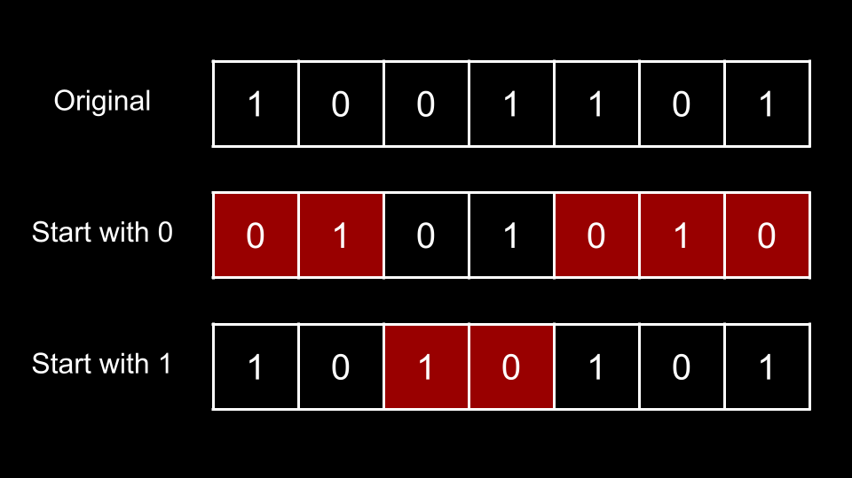

In the above image, we have the original s, then two alternating strings: one that starts with 0 and one that starts with 1. We must convert s to either of these alternating strings, and the squares in red indicate mismatched positions with the original s.

To fix any mismatched position, we require 1 operation. Thus, if we were to convert s to an alternating string starting with 0, we would require 5 operations. If we were to convert s to an alternative string starting with 1, we would require 2 operations. Since we want the minimum, we would have an answer of 2.

This brings us to our solution. We initialize two integers:

1. start0 which represents the number of operations we require if we convert s to an alternating string starting with 0.
2. start1 which represents the number of operations we require if we convert s to an alternating string starting with 1.

We then iterate i over the indices of s. At each index, we check if i is an even index or an odd index. To determine if i is an even or odd index, we check the value if i % 2. Here, % is the modulus operator. If i % 2 = 0, then i is even. Otherwise, i is odd.

**If i is even**

When considering an alternating string that starts with 0, all even indices should have 0, as indices 0, 2, 4, ... will be 0.

When considering an alternating string that starts with 1, all even indices should have 1, as indices 0, 2, 4, ... will be 1.

Thus, if s[i] = '0', we will increment start1 since s[i] is mismatched and we would need an operation to fix it. Otherwise, s[i] = '1' and we increment start0.

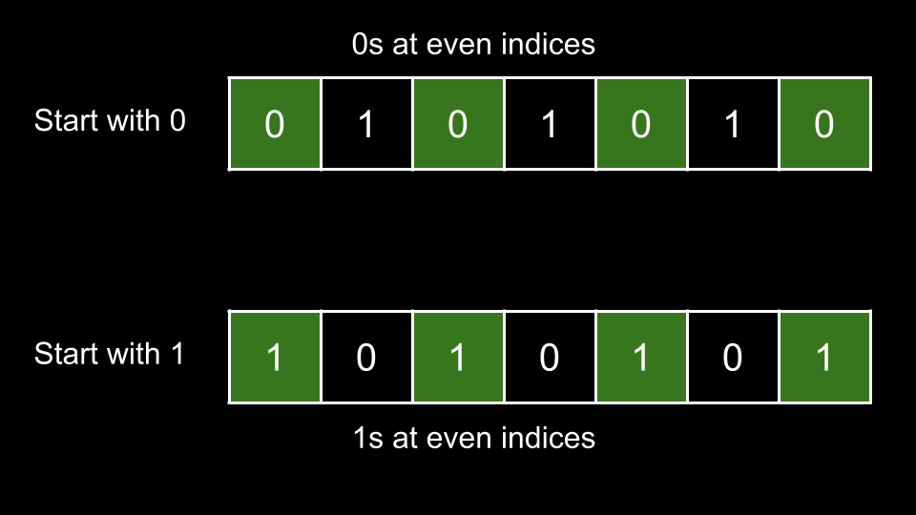

**If i is odd**

When considering an alternating string that starts with 0, all odd indices should have 1, as indices 1, 3, 5, ... will be 0.

When considering an alternating string that starts with 1, all odd indices should have 0, as indices 1, 3, 5, ... will be 1.

Thus, if s[i] = '1', we will increment start1 since s[i] is mismatched and we would need an operation to fix it. Otherwise, s[i] = '0' and we increment start0.

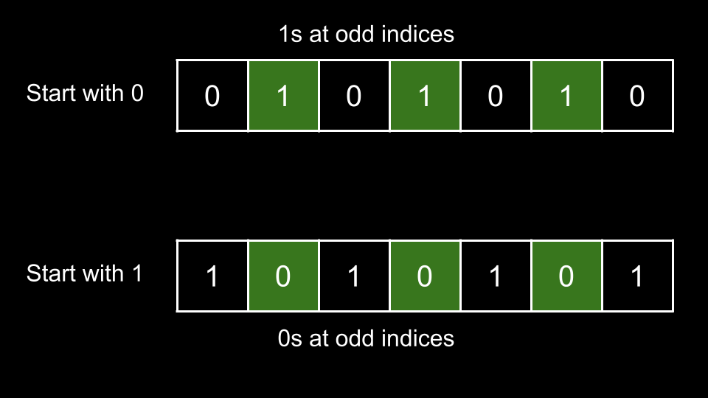

Once we have finished iterating over all characters of s, we return the minimum between start0 and start1.

**Algorithm**

1. Initialize start0 = 0 and start1 = 0.
2. Iterate i over the indices of s:
   * If i % 2 = 0:
     + If s[i] = '0', increment start1.
     + Otherwise, increment start0.
   * Else:
     + If s[i] = '0', increment start1.
     + Otherwise, increment start0.
3. Return the minimum between start0, start1.

**Implementation**

**Complexity Analysis**

Given nn*n* as the length of s,

* Time complexity: O(n)O(n)*O*(*n*)

We iterate over each character of s once, performing O(1)O(1)*O*(1) work at each iteration.

* Space complexity: O(1)O(1)*O*(1)

We aren't using any extra space other than a few integers.

**Approach 2: Only Check One**

**Intuition**

Take a look at the first image again:



Let n be the length of s. There are n indices. Notice that an index i only needs to be fixed for **either** start0 or start1, but never both. In the above image, if we create an alternating string that starts with 0, we need to perform operations at indices 0, 1, 4, 5, 6. This means that indices 0, 1, 4, 5, 6 are already correct for the alternating string that starts with 1.

If we create an alternating string that starts with 0, indices 2, 3 are already correct. Thus, when considering the alternating string that starts with 1, we would need to fix indices 2, 3.

What does this mean? For a given s, if we need start0 operations to create the alternating string that starts with 0, we will need exactly n - start0 operations to create the alternating string that starts with 1.

Thus, we only need to calculate either start0 or start1 (it doesn't matter which one, we'll calculate start0 in this article). We can then obtain the other value by subtracting from n.

**Algorithm**

1. Initialize start0 = 0.
2. Iterate i over the indices of s:
   * If i % 2 = 0:
     + If s[i] = '1', increment start0
   * Else:
     + If s[i] = '0', increment start0.
3. Return the minimum between start0 and s.length - start0.

**Implementation**

**Complexity Analysis**

Given *n* as the length of s,

* Time complexity: *O*(*n*)

We iterate over each character of s once, performing O(1)O(1)*O*(1) work at each iteration.

* Space complexity: *O*(1)

We aren't using any extra space other than a few integers.