PHOENIX PARSE SCORING
Paul C. Constantinides
School of Computer Science
Carnegie Mellon University
Pittsburgh, PA. 15213
pcc@cs.cmu.edu

ABSTRACT
This document presents a metric for characterizing semantic frame parses generated from the Phoenix parser. This scoring technique produces measurements indicating coverage, fragmentation and relevance of the parse. These measurements describe the relative structure of the parse, particularly with respect to expectation, allowing comparable measurements between parses. The scoring process is intended as an extension to the implicit scoring method used for parse disambiguation within Phoenix.

1. INTRODUCTION
The Phoenix parser segments and labels strings using a context-free semantic grammar. The tokenized parse consists of a sequence of semantic parse trees, where each tree is rooted by a slot and populated by nets, and each slot belongs to a particular frame. The parser uses a context free grammar, containing slot and net rewrite rule information, to perform this process. The parser searches the space of parses by maximizing the coverage while minimizing the number of slots, and frames. With complicated grammars, though, it is often possible that a single input string can have several valid, equally scoring top parses.
In the travel-planning domain, we found that spoken phrases often had several parse interpretations. We recognized the need for descriptive metrics for evaluating parses, for use at various stages in dialog control. The descriptions would reflect the overall parse quality, and the relevance of the parse and its slots with respect to expectation.
We present a scoring technique as an add-on to the Phoenix parse disambiguation process. This process does not modify the internal Phoenix process for eliminating parses, but rather annotates the top parses with quality and relevance information, allowing the parse consumer to define their own criteria for selecting which (if any) is the most germane parse.
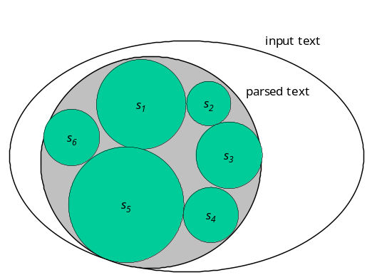2. PARSE SCORING
Coverage, fragmentation, min. slots, min frames, bias
Table 1 enumerates some useful symbols for describing the parse:
Description | Symbol
Total number of words in the input string | t
Number of words accounted for in the parse | p
Number of frames | f
Number of slots | s
Number of nets for slot s | n_{s}

(where 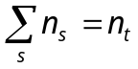)

3.1 Quality Metrics
We provide two measurements that characterize the overall structure of the parse. These measurements indicate the coverage of the parse over the input string, and the fragmentation of the parse. The coverage measurement is calculated as the ratio of the number words in the parse to the number of words from the input string. A parse with low coverage is characterized as only accounting for a small number of words in the input string. This can be seen graphically in Figure 1 as the size of the set of the parsed text, over the size of the input text, or calculated as:
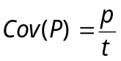
Another measurement quantifies the fragmentation of the parse with respect to the slots of the parse. A highly fragmented parse will have many slots that each cover small portions of the parse. This is calculated as the average number of parsed words per slot, or:
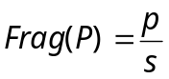

3.2 Relevance Metrics
We’ve found that different top scoring parses often contain contradictory information with respect to the segmented phrase annotations. We also noticed that knowledge of the topical context, expectation, narrows the selection of top parses, reducing or eliminating ambiguity or inconsistency. The metrics below account for semantic expectation, to score the parses accordingly.
The parse score consumer can bring into focus sets of frames, slots, and nets, to indicate that these tokens match the consumer’s expectation for the semantic interpretation of the parse. Generally, these scores present the proportion of the tokens that match the expectation.
On the entire parse, we check the proportion of slots that match expectation. This is calculated simply as:
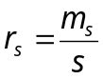
Also, we calculate the proportion of focus nets under focus slots, compared with all of the nets. We limit our net count to those occurring under focus slots, because a net’s meaning is modified by its slot parent value. Alternately stated, the same nets may have different meaning when they are children of different slots. This is ratio is calculated as:
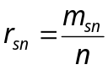
The last ratio that we calculate for the parse is the number of perfectly matching nets. These are nets that match net focus, slot focus and frame focus.
For particular slots within a parse we check the proportion of the nets matching the expectation under each of the slots.
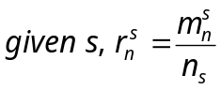

6. REFERENCES
- Ward, W. and Issar. S. Recent improvements in the CMU spoken language understanding system. In Proceedings of the ARPA Human Language Technology Workshop, March 1994, 213-216.

