*Abstract – write as last thing.
*Introduction
AI and game-playing
The goal of this exercise (and how it fits into that framework)
*Twixt: the game
At each move, player claims a nodeTwo nodes owned by one player may be connected if they are a knight’s move apart
Goal: connect your reserved rows of the board with a path of connected nodes
TwixT was invented by Alex Randolph. (xxx date?) and is a two-player board game of the connection family. The goal of these games is to build a path that connects something to something else. The board is a 24 by 24 grid of nodes, in which the four corner nodes have been removed (See figure 1). In the original game board, nodes are holes in which a player can place pegs, but the pencil and paper variant of TwixT is very popular too. The 44 nodes on two opposite sides of the board are reserved for one player, and the nodes on the other two sides are reserved for their opponent. (We will call the players Red and Blue from now on, to simplify the exposition.)

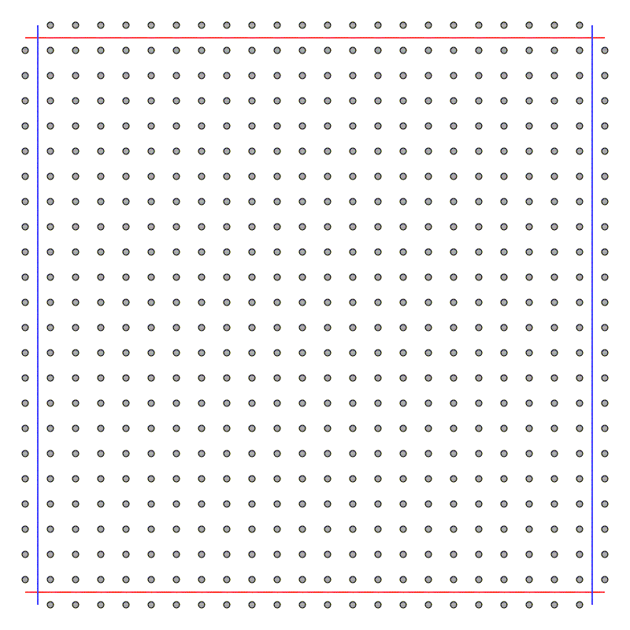
Figure 1. The 24 by 24 grid of nodes. The topmost and bottommost rows are reserved for Red, whereas the leftmost and rightmost rows are reserved for Blue.
*Rules
The board is empty at the start of the game and players take turns claiming one node per move.
A player may not claim a node already claimed by the opponent, nor can they claim nodes in the opponent’s reserved rows.
A player may place a link between two owned nodes only if they are a knight’s move away from each other (i.e., the nodes are at opposite corners of a 2 by 3 rectangle in the grid). Links cannot cross other links, and a player may remove any number of their own links at any move, if deemed necessary.
The first player to connect their two sides with an uninterrupted path of links wins. If the links are arranged in such a way that neither player can reach the goal, the game is a draw.
To help the reader familiarize with the rules, figure 6 shows a sample game on a 6 by 6 board.

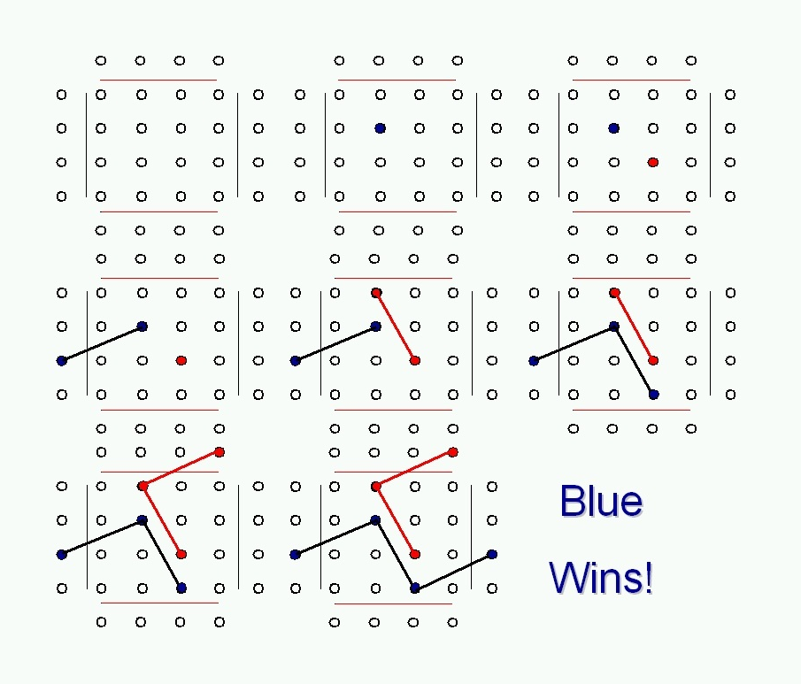
Figure 2. A complete game on a 6 by 6 board (top to bottom, left to right).
*Our variants
Although we have not introduced our computerized TwixT player yet, we think it is appropriate to explain here some variants we introduced in order to make the game more tractable.
A first important variant is that we made the board smaller. Our computerized players have played only on 6 by 6 and 8 by 8 boards so far. This is necessary to reduce the time required by the program to decide which move to make. The playing strategy of our players is based on lookahead and minimax. (We describe lookahead and minimax, as well as alfa-beta pruning, in other sections of this paper.) Adopting a minimum lookahead of four moves (two by the player and two by the opponent), this means that before deciding what move to make, the player needs to evaluate all possible configurations of the board (also referred to as states, from now on) for four levels in the tree representing its search space. On a 24 by 24 board, Red has 24*24-92 = 484 possible choices for its first move; Blue has 483 possible choices for its first move; Red has 482 choices for its second move and Blue has 481. This is just a rough estimate which does not take into account the fact that some moves may be blocked by existing bridges (and the number of available moves decreases when there are fewer available nodes later in the game), but the figure of 484! – 480! = 54,198,168,024 board configurations to examine for the first move makes it clear that reducing drastically the number of nodes was unavoidable, in order to keep the running time within reasonable limits. Since the nature of this exercise requires to run a high number of games, a board size larger than 8 by 8 proved to be unfeasible even for the latest versions of our players, which employ alfa-beta pruning to avoid building the entire lookahead tree.
We also decided to have our players always place a link whenever they own two linkable nodes, and to forbid link removal. Both choices were made to afford an easier implementation and also have the desirable feature of reducing the number of states to consider in the lookahead.
*Learning a playing strategy: a high-level description of the approach.
We saw in the previous section that the space a player has to explore when deciding the next move is extremely large. In this situation, defining a strategy by compiling a table of all possible (state, action) pairs is obviously unfeasible. We therefore decided to use the approach proposed by Samuel [Samuel, 1959] and described also more recently by Holland [Holland, 1998]. The basic idea of this approach is to try to group states into clusters, and have the player learn by playing a criterion to decide how “desirable” it is to find itself in a state belonging to a given cluster.
The clusters are created by defining a set of quantitative features, that is, variables whose value can be computed on the basis of the known state of the board. For instance, a feature can be the difference between the length of the longest connected path built by the player and the same parameter computed for the opponent. This quantity can be computed for any state of the game, and there are may states for which it will evaluate to the same number: these states form a cluster. The player should then learn whether states in this cluster are desirable (i.e., can lead to a win) by observing the consequences of making moves that lead states belonging the cluster.
Once we define a set of n features F = {f_{i} | f_{i} is a feature and I∈{1, 2, …, n}}, we can compute a value associated with each state as a function of the values of the features for that particular state. We defined our value function as:
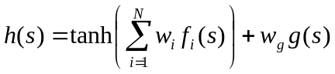
(1)

Where
s = state of the board;
f_{i}(s) = value of feature f_{i} in state s;
w_{i} = weight of feature f_{i};
w_{g} = weight of feature g;
g(s) = value of feature g in state s.
We will define the features f_{i} and g shortly, and explain why the latter is treated differently from the others. But first we complete the high-level description of our strategy-definition mechanism by detailing how learning fits into the framework.
Once F has been defined, the main problem of implementing equation 1 is to find the right values for the weights. The main goal of this project is to define and implement a mechanism through which a computerized TwixT player can learn how to weigh the features in order to yield a value h(s) that is a good predictor of the final outcome of the game. In other words, we want h(s) to evaluate to higher values when s is indicative of a situation in which a win is more likely, and to lower values when a win from s is less likely. To achieve this, we had our player start its learning with a set W of randomly assigned weights w_{i}. Before it makes a move, the player uses equation 1 to evaluate all the states (or part of them when alfa-beta pruning is used) required by the lookahead depth d, and uses these values to define the value of the current state s by employing the minimax algorithm. d moves later, the program evaluates the state s’ of the board using equation 1 again, and if it finds out that the estimate made d moves ahead was too optimistic (i.e., h(s) > h(s’)), it tries to adjust the weights in W to bring h(s) closer to h(s’). By iterating this scheme, it is hoped that with time the player will make increasingly better predictions as to what the outcome of a game will be when a given state is encountered, and will show a tendency to avoid “bad” states (i.e., it will have acquired a strategy). Sections xxx provide details on how the player is implemented and trained to achieve this goal.
*Our features
(see my notes on features and learning)
Design criteria: advantageous and unclear features
Two special features
*References
[Holland, 1998] Holland, J. H. (1998). Emergence – From chaos to order. Cambridge, MA (USA): Perseus Books.
[Samuel, 1959] Samuel, A. L. (1959). Some studies in machine learning using the game of checkers. IBM Journal of Research and Development 3 (3), 210-229.
URL http://www.research.ibm.com/journal/rd/033/ibmrd0303B.pdf

