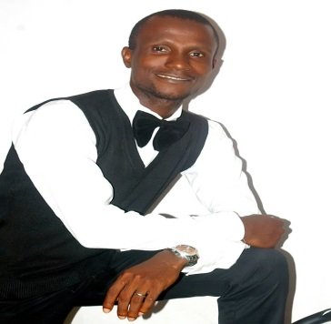Basit Olatunji is a professional tutor, gifted writer and talented speaker whose passion-driven engagements leave his audience readily motivated and inspired. He has vast experience in training, teaching and mentoring young people. He is a freelance copy editor, a writing coach and a speaker-mentor. He believes in the power of words and that is why he has chosen to engage the world in the business of motivation and inspiration. He lets his words throw his audience into actions. Basit is a budding scholar and a poet. He lives in Ipaja, Lagos

B.A (ED), English (Ife)

M.A, English Literature (Ibadan)

Gbemiga Afolabi Bankole (Mrs) teaches Biology in the Lagos State Teaching Service. Over the years, she has dedicated herself to providing help for students and youths. She is a pastor’s wife with passion for mentoring young girls and boys because of her belief in the power of words to induce change personally and globally. The power of words to make someone happy or sad has impressed her so much. To her, words are like math wherein one has to know a workable formula to deliver the right message. G.A. Bankole is married with children and lives in Alimosho, Lagos.

B Sc, Microbiology (LASU)

PGDE, Cohort Biology (Unilag)

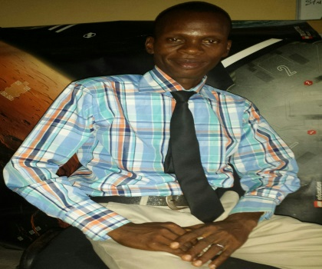Olatubosun Oluwadare is a chatered accountant, a professional instructor and a human development coach for the young class of scholars aspiring to have a future in the accounting world. He has over five years of field experience handling several trainings and seminars ranging from youth empowerment programmes. He has mentored personels leading to successive achievements in their endeavours. He is an award winner, a great thinker and a problem solver who has worked with great professional trainers and icons in capacity building. He is also a partner in Facilitation and Training Services Limited.  
BSc, Accounting (Unilag)

ACA (ICAN)

Oyebola Olutayo is by profession a change agent and a pastor-teacher with almost twenty years experience impacting knowledge. He is a farmer and agric scholar with passion for promoting young people’s interests in entrepreneural activities toward eradicating poverty and unemployment. He is a trainer-mentor, a critical analyst and researcher in agric business, rural extension and food security. He is currently on his PhD at University of Ibadan.

BSc, Agric Extension (UNAAB)

MSc, Agric Extension (Ibadan)