Introduction: The aim of this assignment was to use R package DESeq2 to identify differential patterns of gene expression among healthy and wasting *Pisaster ochraceus* individuals. DESeq2 uses the number of reads that mapped to each contig, in each sample, as a measure of gene expression. Genes with higher read counts are considered to be upregulated, while genes with lower read counts are downregulated. This analysis allows for the comparison of gene expression patterns in healthy versus wasting individuals. Through this analysis, it is also possible to identify specific genes that are highly differentially expressed. This information can be used to search databases for associated functions of orthologous genes, providing insight into the potential molecular mechanisms of host response to sea star wasting disease.

Methods:

* Clean reads (adapters, nucleotide quality, length)
* Evaluate quality
* Assemble de novo transcriptome
* Evaluate assembly
* Annotate reference (idk if we actually did this step)
* Map clean reads to de novo transcriptome
* Extracted read count info (# reads that map to each contig)
* Differential expression analysis (DESEQ2)

Results:

Discussion:

Intertidal PCA

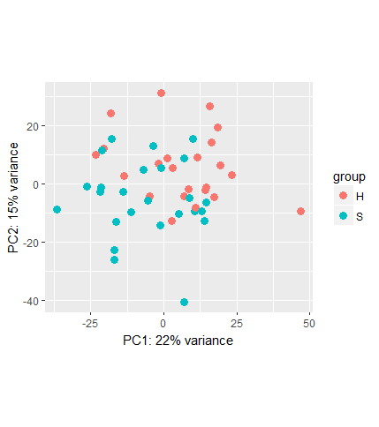

Subtidal PCA

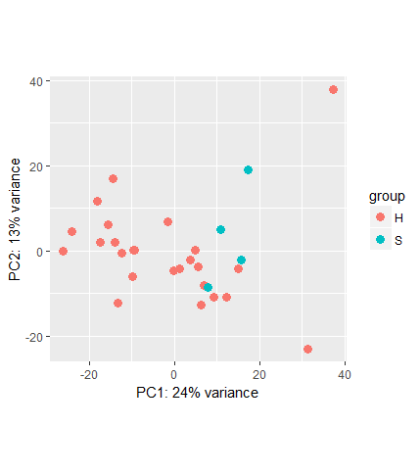

Full model PCA

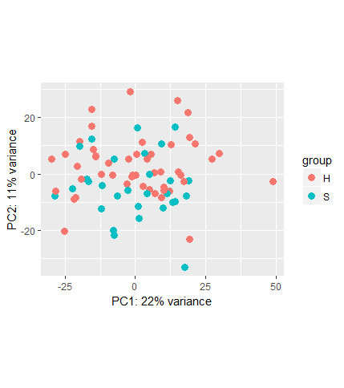

Intertidal Differential Expression of TRINITY_DN43080_c1

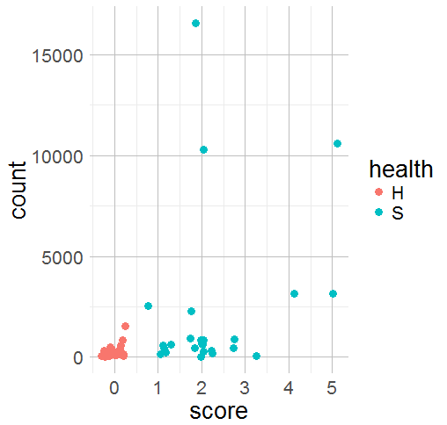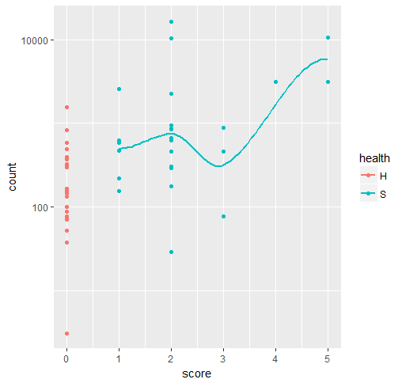

Subtidal Differential Expression of TRINITY_DN42073_c0

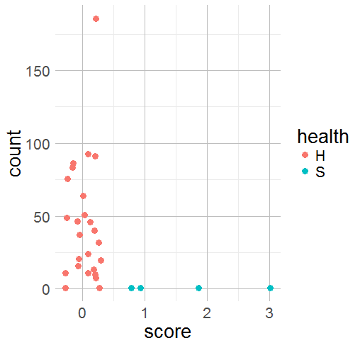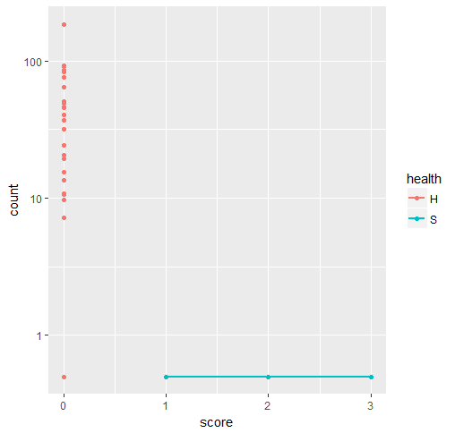

Full model Differential Expression of TRINITY_DN43080_c1

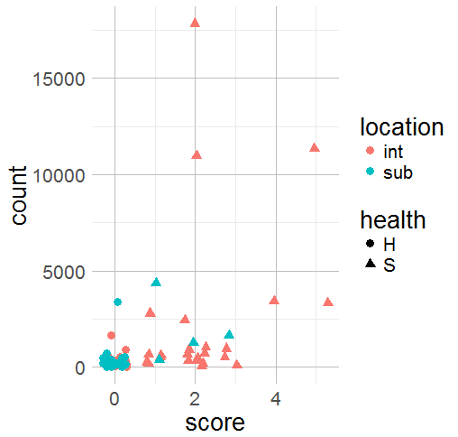 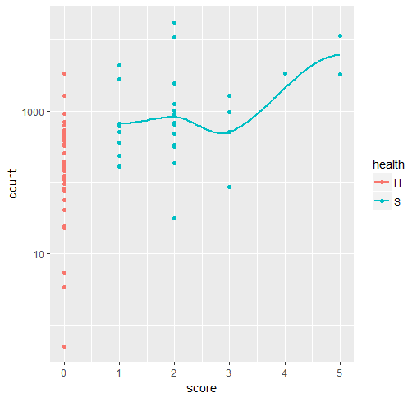

Extraneous info:

All specimens used for RNA sequencing were collected from Monterey Bay, California. However, they were collected from two divergent habitat types (intertidal and subtidal). Comparisons of healthy and wasting individuals were conducted keeping this information in mind.