|  |  |
| --- | --- |
| **Data Set** | **SNPs with PC1 Loading in 99.9th Percentile** |
| 1.0 | DN46269_c0_g1 |
| 1.0 | DN45155_c27_g1 |
| 1.0 | DN39079_c3_g1 |
| 1.0 | DN39696_c4_g1 |
| 1.0 | DN42225_c1_g1 |
| 2.0 | DN46193_c5_g2 |
| 2.0 | DN44693_c5_g1 |

**Table 1**. List of SNPs from dataset 1.0 and 2.0 that load strongly on PC1.

PCA by Health Status 1.0

A. 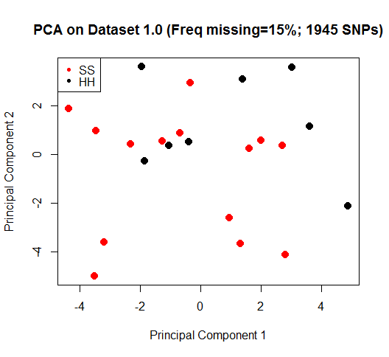B. 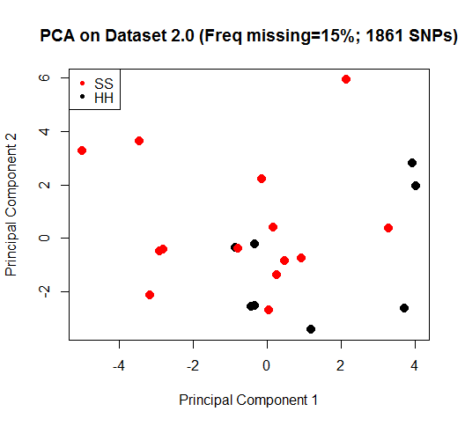

**Figure 1**. PCA plots depicting the variation in SNP genotypes for each individual sea star. Individuals are labeled by health status. A) Depicts results from the PCA performed on dataset 1.0. B) Depicts results from the PCA performed on dataset 2.0.

Loading Plot 1.0

A. 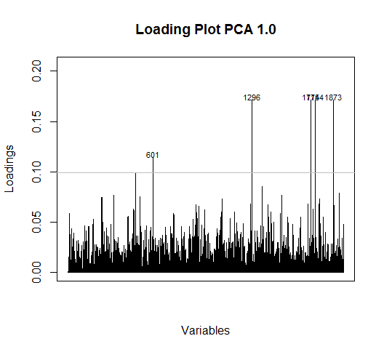B. 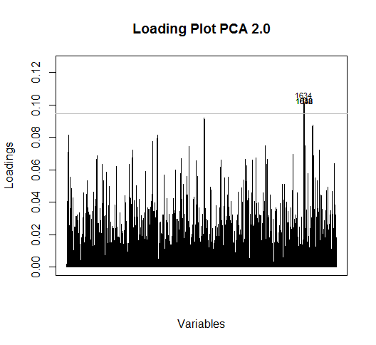

**Figure 2**. Plots depicting Loading for each SNP on PC1. The horizontal line depicts the 99.9th percentile. A) Depicts results from the PCA performed on dataset 1.0. B) Depicts results from the PCA performed on dataset 2.0.