- Download www.installshieldguru.com\source.zip
- Create a speed folder to install all the sample files.
- Create a magic folder and give it a value of two under the user install folder
- install the Blue Lace 16 and Coffee Bean bitmaps to the magic folder
- Place the test.exe and the readme.txt under the user install folder
- Create the following Pre-Install panels Introduction, Choose Install Set, Choose Install Folder and Pre-Install Summary.
- Create advanced – get user input called Get environment variables as follows
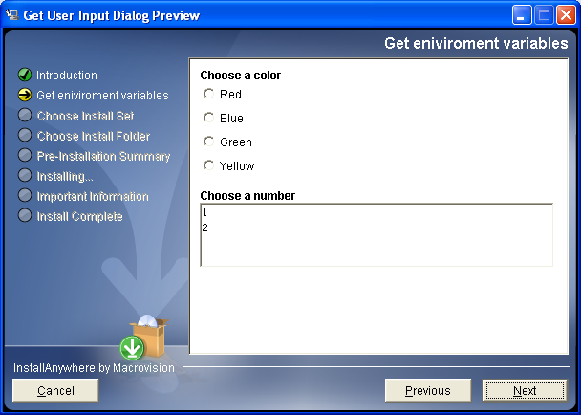
Do not let the user continue if color is blank.
- Set the System environment variable Color to the choice picked for color.
- Set the components so that the samples folder only get installed on a typical and not a minimal
- Create a shortcut for test.exe on the desktop
- Build an install for this for windows only with no java VM

