[draft 16 january 2008 robertd]

Display HTML Panel
In addition to displaying a simple message using the Display Message panel, you can display HTML content using the Display HTML Panel action. Using this panel, you can display HTML pages and images from a local archive or from an external URL.

You add the panel to (for example) the Pre-Install task the same way you add other panels, using the Add Action button, if necessary using the up-arrow and down-arrow buttons to schedule the action relative to other actions.

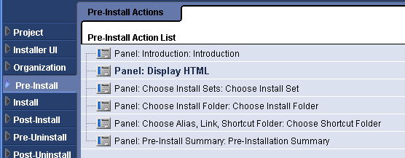

The customizer for the Display HTML panel enables you to specify the settings common to all panel actions, such as the panel title and the label settings.

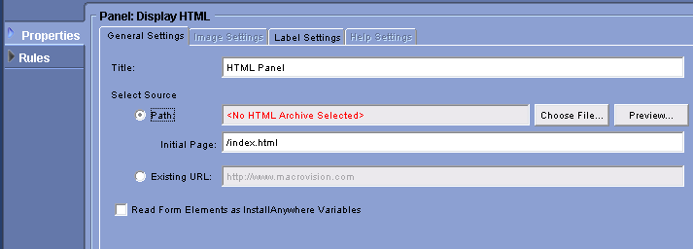

In addition, you specify the source of the HTML pages for the Display HTML panel. If you select Path, you will be prompted to browse for a .zip file or .jar file containing the HTML pages, images, and style sheets you want to display. After selecting the archive file, enter the name of the file within the archive to display in the Initial Page setting. The HTML content you display can include hyperlinks, either within the archive you selected or existing externally.

For an example archive containing HTML content, see the CustomCode/Samples/HTMLPanelSample subdirectory of your InstallAnywhere installation directory.

If you select Existing URL, simply enter the external URL of the HTML page to display.

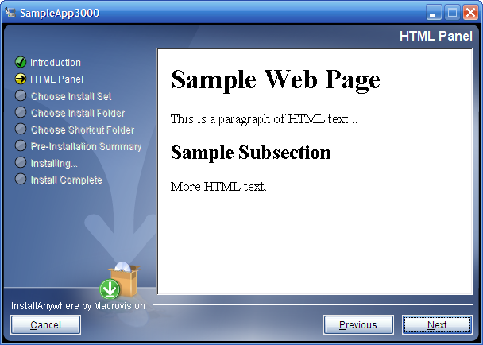

Your HTML content can also include forms, and the user’s input into the form can be passed to InstallAnywhere variables. To use this functionality, select the Read Form Elements as InstallAnywhere Variables check box in the Display HTML customizer.

In the HTML content, include a <form> element with <input> fields, and at run time the user input will be included in InstallAnywhere variables. For example, the following HTML excerpt includes an input field called username.

<form name="register">
<p>Please enter your user name:<br>
<input type="text" size="50" name="username"
value="(your name here)" class="textField">
</p>
</form>

At run time, the Display HTML panel appears similar to the following:

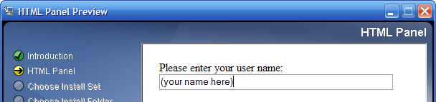

To reference the data entered by the user, you can use the expression $fieldname$, where fieldname is the value of the name attribute in the HTML input field. In the previous example, the data would be stored is accessible using the expression $username$.

