[draft 16 january 2008 robertd]

InstallAnywhere Collaboration and DIMs
InstallAnywhere Collaboration is a tool that enables developers to create Developer Installation Manifests, or DIMs. A DIM is an XML-format manifest (with the .dim file name extension) that contains information about files and other data to be installed by an installation program. Using InstallAnywhere, you—as an installation developer—can consume DIMs created by developers in your organization, and the InstallAnywhere build process converts the data in the DIM to the appropriate information in your build output.

When you install InstallAnywhere on a system that has Eclipse installed, you can optionally install a copy of InstallAnywhere Collaboration. For information about obtaining additional copies of InstallAnywhere Collaboration, visit the Macrovision web site at www.macrovision.com.

Creating a DIM
To create a DIM, a developer opens Eclipse and creates a new InstallAnywhere Collaboration project.

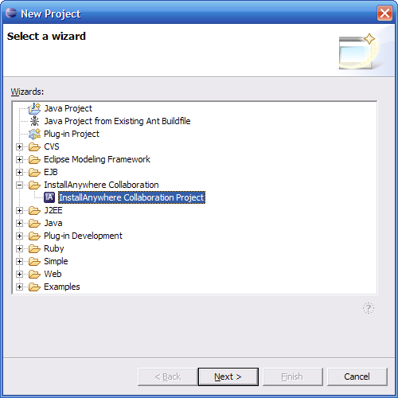

If appropriate, an InstallAnywhere Collaboration project can contain more than one DIM. By default, creating a new project creates a single DIM.

In Eclipse, the DIM settings are exposed in the following four views, which can be accessed at the bottom of the environment:

- General
- Contents
- Variables
- Dependencies

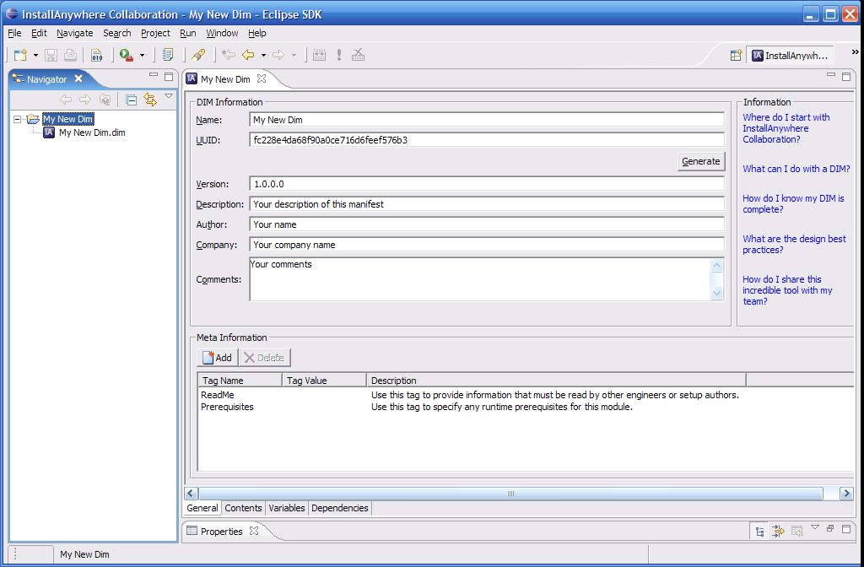

The Eclipse figures displayed here use the InstallAnywhere Collaboration perspective. To specify this perspective, click the Open Perspective toolbar button, select Other, and select InstallAnywhere Collaboration.

In the General view, the developer specifies global information regarding the DIM. Each DIM has a required name, UUID, and version. There are also optional Description, Author, Company, and Comments settings that are stored in the .dim file but that do not affect the target system.

In this view the developer can specify meta tags, which are arbitrary named strings that are displayed in the InstallAnywhere environment. Meta tags are made up of a name, value, and description. The values of meta tags are displayed in the InstallAnywhere environment when you consume the DIM, but the values are not used as installation data. (For run-time data, the developer can create run-time variables, as described later in this section.) Meta tags are useful for the developer to convey instructions concerning the DIM to the installation developer.

The Contents view is where the developer adds installation data such as files (files to install or changes to ASCII-file or XML-file contents), registry information, and environment-variable strings.

To specify files to install, for example, the developer right-clicks the File System icon and selects New File Set.

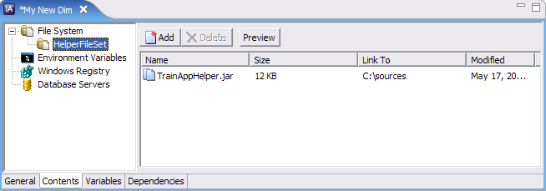

To add files or directories to the file set, the developer clicks the Add button and selects Add File, Add Dynamic File Source, or Add Empty Directory, followed by browsing for the desired item.

To specify properties of the file set as a whole, the developer selects the file set and modifies the Properties list that appears beneath the Contents view.

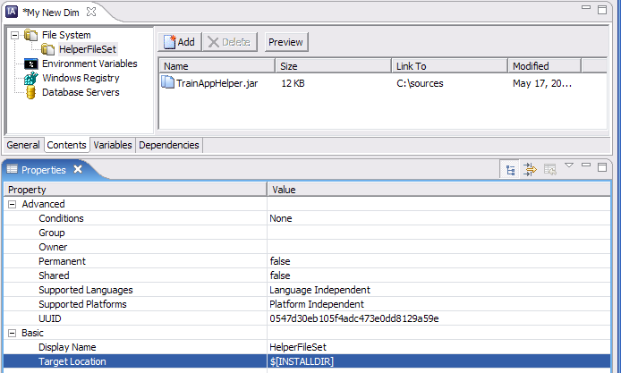

Because of the installer-independent nature of DIMs—they can also be used by InstallShield Windows—the system variables that represent destinations on the target system use a different syntax from the one used by InstallAnywhere. For example, the overall destination of the project that consumes the DIM is represented as $[INSTALLDIR]. The Target Location property of a file set provides a drop-down list of special system variables, such as $[ProgramFilesFolder], $[OSSystemFolder], $[TempFolder], and so forth.

In addition, the developer can specify conditions and supported languages and platforms for a file set, as well as properties such as file attributes and COM-registration information. Another consequence of the installer-independent nature of DIMs is that there are some properties that can be specified in a DIM that have no effect when you consume the DIM in an InstallAnywhere project. The following figure shows the Properties list for an individual file.

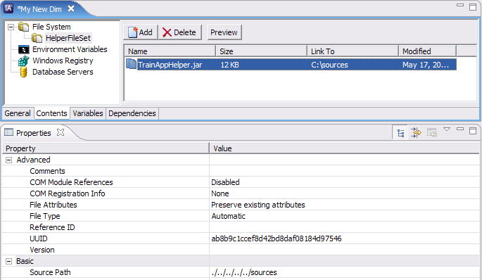

Other types of data that can be used by a DIM include registry data from .reg files and environment variables. For information regarding the creation of these types of data, see the InstallAnywhere Collaboration help library.

There are two kinds of variables used in DIMs, run-time variables and build variables. A run-time variable is available at run time, using the syntax $[VARNAME] (similar to an InstallAnywhere variable). For example, a run-time variable called MYVAR can be expressed as $[MYVAR] in a file set’s Target Location value, or the expression $[MYVAR] can be used in an environment variable value.

A DIM build variable is similar to an InstallAnywhere source path, representing the source path of a file at build time. Like InstallAnywhere source paths, DIM build variables are not available at run time.

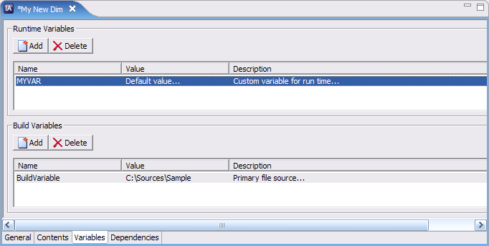

InstallAnywhere Collaboration uses either relative or absolute paths to source files. A recommended procedure is to treat DIMs as source code, meaning that they should be included in your version control system.

(Data in the Dependencies view of a DIM project is currently unused by InstallAnywhere.)

Unit Tests
Unlike working with an InstallAnywhere merge module, there is no build process for a DIM: the developer simply clicks Save, and the DIM maintains references to the data that will be consumed by the installation. To rename the DIM, use the Save As command.

To test the DIM, the developer can build a unit test of the DIM. With Eclipse, the unit test is a simple InstallAnywhere installation that installs the DIM data. To build the unit test, the developer clicks the Build Unit Test toolbar button. To run the unit test, the developer clicks Run Unit Test.

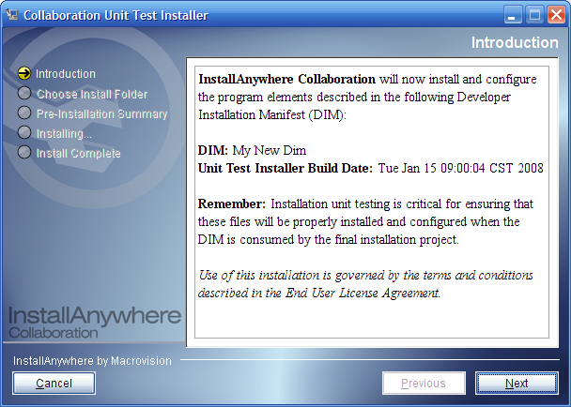

To uninstall the data installed by the unit test, use the uninstaller JAR file in the installation directory.

Consuming a DIM in an InstallAnywhere Project
You can use the Organization > DIM References task in the Advanced Designer to consume DIMs created by your developers. To add a DIM reference, click the Add DIM Reference button and browse for the desired .dim file. The new DIM Reference icon appears in the DIM References task.

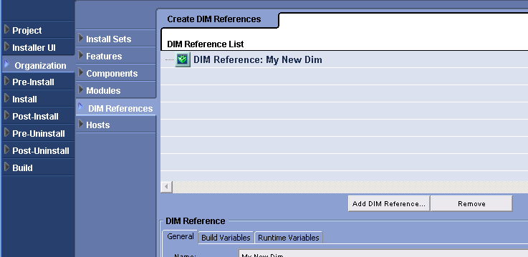

The DIM’s customizer organizes the settings into General, Build Variables, and Runtime Variables tabs. In the General tab, you see the global DIM information set by the developer, such as the DIM name, version, UUID, and destination path.

Apart from the destination path, the DIM settings in the General category are read-only. The value you specify in the DIM’s Destination Path setting is used as the DIM’s $[INSTALLDIR] value.

In the Meta Information section of the customizer, you can also view the meta tags defined by the developer. These tags can contain special instructions for using the DIM, and therefore it is recommended that you read the meta tags before building the project.

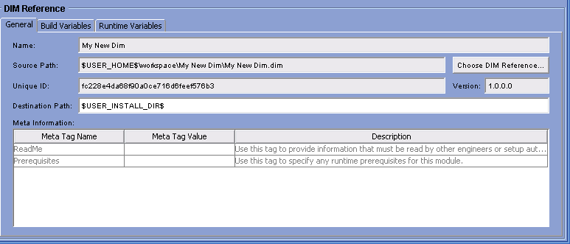

In the Build Variables and Runtime Variables tabs, you see the build variables and run-time variables that the developer defined in the DIM.

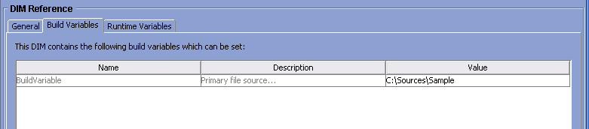

DIMs are also exposed in the Install task of your project. As with other actions in the Install task, you can assign the DIM reference to one or more product features or components.

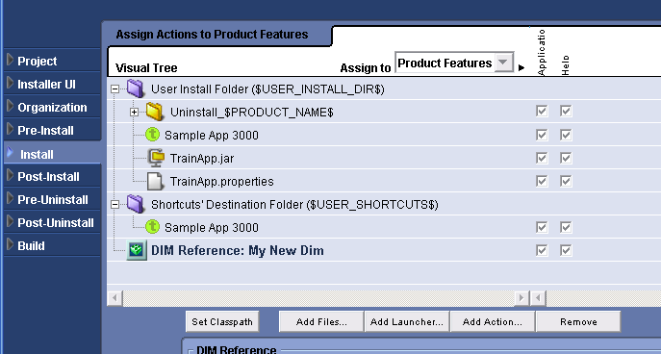

DIMs do not contain shortcuts, as it is typically the responsibility of the installation developer to specify where shortcuts should be placed on a target system. This helps to ensure that all the product shortcuts are created in the same directory of the Programs menu, for example. To create a shortcut to a file inside a DIM, you can use the Create Alias, Link, Shortcut to DIM File action.

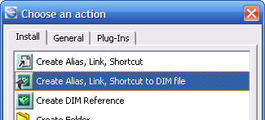

In the customizer for the Create Alias, Link, Shortcut to DIM File action, you browse for the target file inside the DIM.

Once the DIMs are in place, you can build your installation project, and the DIM data will be included in your InstallAnywhere installation program.

