Chapter 19: Custom Code
  - Writing Custom Code
  - ### draft 17-jan-2008 robertd ###
The majority of tasks needed to deploy an application can be handled using InstallAnywhere’s built-in actions and panels. If there is functionality not covered by InstallAnywhere’s built-in actions and panels, you can develop your own custom components using the Custom Code API.
InstallAnywhere offers an open Application Programming Interface (API) that enables you to develop Java code that can run within InstallAnywhere’s architecture. Using the API also gives you access to additional functionality in InstallAnywhere, such as its unique Variables and resource-loading features. You can use the API to create custom actions and GUI elements that seamlessly interact with and extend the InstallAnywhere framework.
All custom code that is going to run within the InstallAnywhere framework must be written in Java. The major forms of custom code are actions, panels, consoles, and rules:
Custom Code Actions | These actions run within InstallAnywhere’s action framework, alongside the default InstallAnywhere actions.
Custom Code Panels | These panels run within InstallAnywhere’s graphical interface during the installation process. The developer can use this mechanism to add panels to the Installer not provided in InstallAnywhere's default panels.
Custom Code Consoles | These actions run within InstallAnywhere’s console interface during the installation process. Developers can use this mechanism to add custom console elements to the Installer.
Custom Code Rules | These rules are evaluated when the action they are associated with is about to be executed. Custom Code rules need to return a Boolean value defining whether the action is to be run.
Macrovision provides sample custom code actions, panels, console actions, and rules. These can be found in the CustomCode subdirectory of the root InstallAnywhere installation directory. These samples can be used as examples of implementing InstallAnywhere custom code using the API. Additionally, there is a wide variety of custom code actions and panels located in the Downloads > Add-Ons > Custom Code area of the Macrovision web site.

Writing Custom Code
The steps you perform when creating custom code are the following:
    - Write and compile your custom Java code.
    - Package your custom class (and any resources it needs) into a JAR file.
    - Execute the class in your InstallAnywhere project.
Details about performing these steps are described in the following sections.

Custom Code Actions
Custom Code Actions enable you to create non-graphical actions which can manipulate data on your target system, affect InstallAnywhere Variables, pre-populate various install options, or even execute native code (using JNI). In fact, Custom Code Actions enable you to perform nearly any action possible with Java.

A Custom Code Action Example
Suppose you want your installation program to display an arbitrary message to the user in a simple dialog box, as shown in the following figure. The message box uses the showMessageDialog method of the Java Swing JOptionPane class.
NOTE: This example is designed to illustrate the technique of creating a custom code action. The implementation does not yet handle console mode or silent mode correctly.
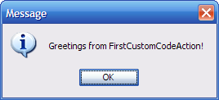

Writing the Action Code
First, you must write the source for the custom code action class. For this example, you will write a class called FirstCustomCodeAction, with its source in a file called FirstCustomCodeAction.java. Custom code actions must extend the class com.zerog.ia.api.pub.CustomCodeAction, so the general outline of the FirstCustomCodeAction class is as follows:
import com.zerog.ia.api.pub.*;

public class FirstCustomCodeAction extends CustomCodeAction
{
// ...
}
To integrate the custom code with the running installation, you must override the install method of the CustomCodeAction class. The install method has the following signature:
public void install(InstallerProxy ip) { ... }
Furthermore, to display a status message on the installer’s progress bar while your action is taking place, you must implement the getInstallStatusMessage method, which returns the string message to display.
public String getInstallStatusMessage( )
{
return "Installing FirstCustomCodeAction...";
}
There are similar methods for specifying the behavior and status message of the action during uninstallation. The signatures of the uninstall and getUninstallStatusMessage methods appear as follows:
public void uninstall(UninstallProxy up) { ... }

public String getUninstallStatusMessage( )
{
return "Uninstalling FirstCustomCodeAction...";
}
At installation time, the InstallAnywhere framework checks each custom code action for an install method with that specific signature, and executes the code in it.
The completed source file FirstCustomCodeAction.java appears as follows.
import com.zerog.ia.api.pub.*;
import javax.swing.*;

public class FirstCustomCodeAction extends CustomCodeAction
{
public void install(InstallerProxy ip)
{
JOptionPane.showMessageDialog(null,
"Greetings from FirstCustomCodeAction!");
}

public void uninstall(UninstallerProxy up)
{
// do nothing during uninstallation
}

public String getInstallStatusMessage( )
{
return "Installing FirstCustomCodeAction...";
}

public String getUninstallStatusMessage( )
{
return "Uninstalling FirstCustomCodeAction...";
}
}

Compiling and Packaging the Action Code
To compile the custom code action, the InstallAnywhere archive IAClasses.zip must be on the compiler class path. A command to compile the class appears similar to the following:
javac -classpath "...IA\IAClasses.zip" FirstCustomCodeAction.java
You must then package the resulting .class file into a .jar or .zip archive. Using the jar command from the Java SDK, for example, you would run a command similar to the following:
jar cvf FirstCustomCodeAction.jar FirstCustomCodeAction.class
Once you have the code packaged into a .jar or .zip file, you can execute it using an Execute Custom Code action.
If your custom class is inside a package, you must place the class file in a subdirectory that matches the package name. For a custom class whose full name is com.macrovision.training.AnotherCustomAction, you would copy the class file into the subdirectory structure com/macrovision/training.

Adding the Custom Action to Your Project
Next, you can specify to execute your custom code by adding an Execute Custom Code action to one of your project’s tasks. For example, the following figure shows a new Execute Custom Code action in the Install task.
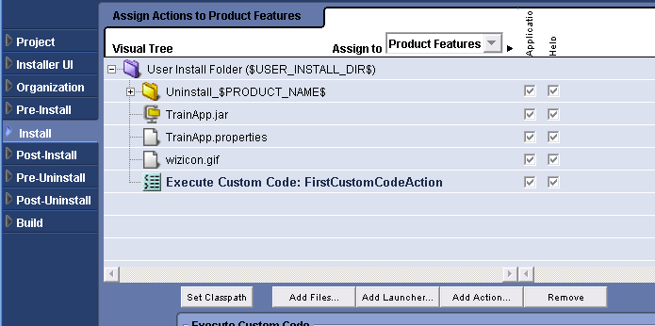
In the customizer for the Execute Custom Code action, you browse for the .jar or .zip file you created earlier (which populates the Path setting), and then enter the full class name in the Class field. (If the custom class is part of a package, enter the fully qualified class name, such as com.macrovision.training.ActionName.)
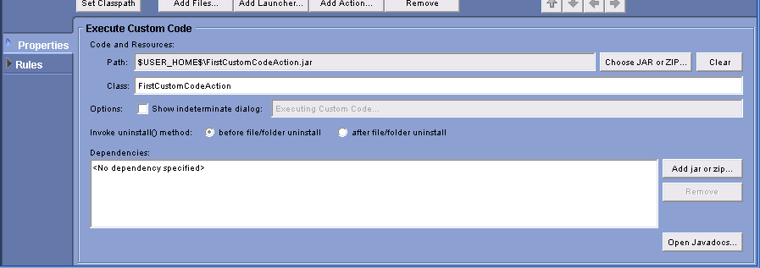
You can optionally specify whether to show the “indeterminate” progress dialog, which shows a constantly moving progress bar; and specify whether to call the uninstall method of your action before or after files and folders are removed. Moreover, if the action contains any dependencies, you can browse for the .jar or .zip files containing the dependent classes. (Do not specify IAClasses.zip as a dependency.)
Finally, when you build and run your project, the message box from the custom class is displayed while the Install task is taking place.
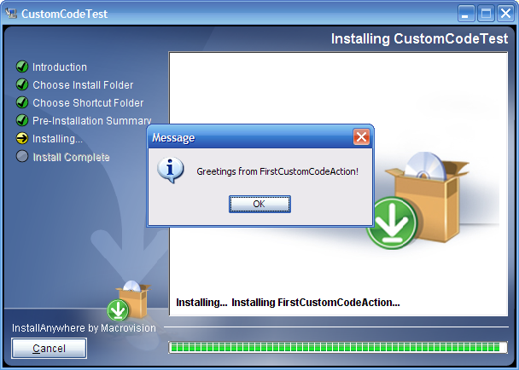

Packaging Custom Code as a Plug-in
In addition to executing custom code with the Execute Custom Code action, you can package frequently used custom classes as plug-ins, which enable you and other developers to insert your code into a project without needing to specify the class name or archive.
To package a custom class as a plug-in, you must create a properties file that describes the plug-in, and then copy it into the root level of your .jar file. The properties file should be named customCode.properties, and must contain the following entries:
- plugin.main.class=classname: The classname value should be the full name of your action class, such as FirstCustomCodeAction or com.macrovision.training.MyAction.
- plugin.name=DisplayName: The DisplayName value should be the human-readable display name for your action, to be displayed in the Insert Action panel.
- plugin.type=action or panel or console: This value should be set to the code’s type.
Additional optional entries include:
- plugin.icon.path=icon-path: This value should be set to the relative path within the .jar file to a 32-by-32-pixel .png or .jpg file to be displayed as the icon for the plug-in.
- property.propertyname=propertydefault: This value specifies a property the developer user can set in the customizer used by the plug-in.
- plugin.available=preinstall | install | postinstall | preuninstall | postuninstall: This value should be a comma-separated list of tasks in which the plug-in can be placed.
For this example, a sample customCode.properties file you would place in FirstCustomCodeAction.jar would appear similar to the following:
plugin.main.class=FirstCustomCodeAction
plugin.name=First Custom Code Action
plugin.type=action
Finally, you should place the .jar file in the plugins subdirectory of the InstallAnywhere installation.
After placing the .jar file in the plugins directory and restarting InstallAnywhere, you can insert the custom code action using the same Add Action functionality you use for built-in actions; the Plug-Ins tab of the Choose an action panel lists First Custom Code Action (along with other sample actions that ship with InstallAnywhere):
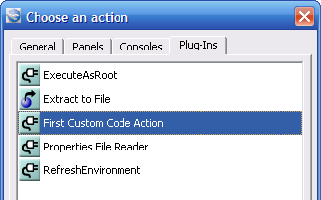
The action then appears in the selected task, and the customizer for the action exposes options for editing variable values and displaying status information.
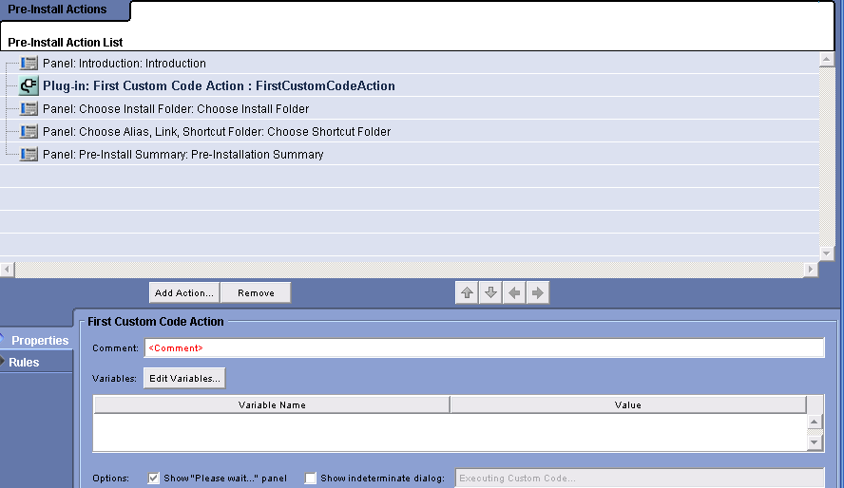

Adding Action Help
To provide development-time help for your action, you can add a file called help.html to the root of your .jar file. If a file with that name is present, a button labeled Help With Plug-in is displayed at the bottom of the action’s customizer; and if a developer user clicks that button, your help text from help.html is displayed.
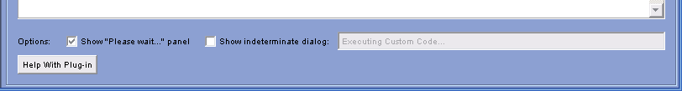

Accessing Properties and Variables
Instead of hard-coding data used by your custom code actions, it is useful to have action parameters that can be specified at design time. For example, in the previous FirstCustomCodeAction example, it may be desirable to have the message displayed be settable using a parameter in the action’s customizer.
To enable a property called message to contain the message displayed to the user at run time, you can add the following line to the customCode.properties file inside the custom .jar file.
property.message=Your message here...
Inside the code, you can use the substitute method of the InstallerProxy object passed to the install method:
public void install(InstallerProxy ip)
{
JOptionPane.showMessageDialog(null, ip.substitute("$smessage$"));
}
The argument to the substitute method is a string containing embedded expressions of the form $property$, and the return value is a string with the embedded expressions expanded to the values of the specified InstallAnywhere properties.
At design time, the presence of the property.message entry in your customCode.properties file causes the message variable and its default value to appear in the Variables list.
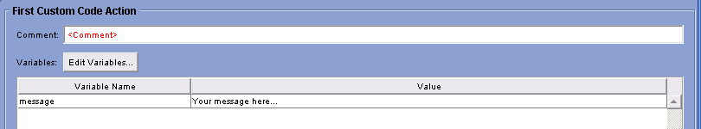
The developer user of your action can double-click the variable’s value to change it.
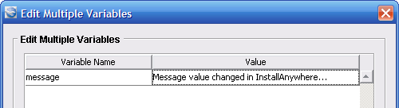
After changing the value and clicking OK, you can build the project and execute the installer. At run time, the message is the changed value:
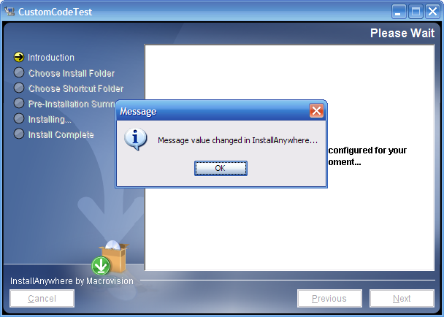

Example: Setting a Java System Property
Suppose you want to create a custom code action that creates and sets a Java system property, which can then be used

...other InstallerProxy usage: exiting (abortInstallation); getting localized resource bundle data; ...

...adding build method (...Builder class)

...logging

Custom Code Rules
The process of creating a custom rule is similar to creating a custom action. To create a rule, you create a custom class that extends com.zerog.ia.api.pub.CustomCodeRule, and this class must implement an evaluateRule method that returns true if the rule succeeds and false if the rule fails.
For example, the implementation of a rule that always succeeds would appear similar to the following:
import com.zerog.ia.api.pub.*;

public class AlwaysSucceedsRule extends CustomCodeRule
{
public boolean evaluateRule( )
{
return true; // always succeed
}
}
You compile the rule class the same way you compile other custom code (by including IAClasses.zip in the compiler class path), and package the .class file in a .jar file or .zip file as before.
To use the rule, you select the Rules tab in the customizer for the action to which you want to attach the rule, click the Add Rule button, and then select Evaluate Custom Rule.
In the customizer for the custom rule, you select the .jar or .zip file containing the custom class, and then specify the name of the Java class that implements the rule.
At run time, if the rule succeeds, the action associated with it will be installed or performed, and if the rule fails the action will be skipped.

...custom code rule proxy for properties...

Using Installer Services

...getService method

Custom Code Panels

Custom Console Panels

