Notes
Cover letter
This is draft version 0.5 (methods + results + outline of other sections). I expect to send you draft version 1 (complete) as soon as possible, but it would be great to get revisions for what I am sending you now as soon as possible, as these are the sections that will shape everything else.

I plan to one day submit this manuscript to the social science and medicine journal, so I am keeping the length and formatting expectations of that journal in mind (see below) while also adding additional details for my dissertation in the supplementary materials. There you will find descriptions of the fieldsite that will probably be moved somewhere else in the dissertation (introduction? appendix?).

I have organized what I have around two goals (included in my NSF grant) to keep things simple:
(a) Identify if objective water insecurity is associated with perceived stress among women in Iztapalapa
(b) identify the components of water insecurity that may be a source of distress for these women.

Expected feedback:
- Does what I have make sense so far?
- Am I responding to my two goals with the methods and results I show here?
- Identify mistakes/weaknesses of the analytical approach
- What suggestions do you have, and how crucial are they? (i.e. is this something I should include/modify in my dissertation, or are these modifications I will work on for a potential publication?)

Thank you!

Social science & medicine: original research articles (...) in any area of social science research relevant to health and healthcare. These papers may be up to 9000 words including abstract, tables, figures, references and (printed) appendices.
Other options are:
- Journal of public health (Oxford)
- International journal of environmental research and public health
- Plos One / Plos One water
- International journal of hygiene and environmental health
- American Journal of Human Biology

Intro

OUTLINE
Abstract (300)
1. Introduction
- Water insecurity as a global and urban problem; Mexico City/Iztapalapa context
- Definition of household water insecurity? In urban settings: From jepson 2021, torreon, mexico: Household water insecurity.
- Cases such as mexico city that have infrastructure for water delivery (percentage coverage is about 95%), and yet, an important portion of the population has an intermittent water supply (%).
- Importance - local biologies (wutich 2020), multiplicity of the water insecurity experience. Urban environment comes with a set of specific challenges. So measuring it using one universal tool has limitations. Need to study water insecurity in relation to specific health outcomes of interest and the social relationships and expectations in which water management and use is inmersed.Reecent studies have found that gender is an important factor, experience of children, relationship with food insecurity and multiplicative effect of having both (Mexico).
- Many studies in a national or state level in mexico. Now we know more about how different metrics behave due to the incorporation of hwise in ensanut.There is tremendous value in those studies, they are representative at the national level and have revealed important connections to mental health and food insecurity and socioeconomic status. Have traced changes over time, the most commonly reported experiences in urban vs rural environments, and the lack of relationship between frequency and intensity of droughts and household water insecurity. This studies allow us to have a very extensive understanding of the problematic at the national level. At the same time, the data has only been presented in aggregated forms, do not allow to understand the local experience of places with particular infrastructures and histories of the settlement and expectations and reference points.
- This is the first study of this kind (biocultural, responding to the water insecurity call made by wutich 2020) to focus on iztapalapa. Iztapalapa ranks last among Mexico City's 16 alcaldías in perceived water quality (González-Villarreal). This evaluation assessed three dimensions: perceived water quality, whether the supply is sufficient to meet household needs, and perceived scarcity. Scores increase when residents perceive their water positively, consider it adequate for all their needs, and do not experience scarcity. By these criteria, approximately 70% of Iztapalapa's population rates their water as poor or very poor.
My goals are: (a) Identify if objective water insecurity is associated with perceived stress among women in Iztapalapa (b) identify the components of water insecurity that may be a source of distress for these women.

- Biocultural framing: why perception and lived experience matter for health
- emotional and subjective dimensions of water insecurity (water affect)
- Study aims: examine links between water insecurity and psychological stress, and identify the main components of water insecurity driving perceived stress in Iztapalapa.

2. Background
- Water insecurity in Mexico City: infrastructure, intermittency, inequality between neighborhoods
ENSANUT included assessments of water insecurity starting in 2021, revealing:

- Water insecurity and psychological stress: what is known
- Water worry as distinct from objective water access (Jepson et al. 2021)
- Urban contexts as extreme environments
- Water infrastructure in Iztapalapa: intermittency, storage dependence, hours of supply

- Water insecurity and psychological/emotional stress: existing evidence
- Water worry and water affect literature (Wutich, Jepson et al.)
- Perception of injustice and relative deprivation

Migeot et al. (2024) — "Allostasis, health, and development in Latin America," Neuroscience & Biobehavioral Reviews. It's recent, Latin America–specific, and explicitly frames chronic psychosocial stressors (including resource insecurity) as accumulating into allostatic load in this region. The focus is developmental but the theoretical framework applies to your adult sample.
For the dignity/hygiene-norms side, Rosinger et al. (2021) — "The embodiment of water insecurity: Injuries and chronic stress in lowland Bolivia," Social Science & Medicine — is your strongest option. It's recent, Latin American, biocultural, and directly links water insecurity to chronic stress embodiment (using hair cortisol). It also uses the exact conceptual move you're making: water insecurity → repeated bodily/functional consequences → chronic stress. Rural Bolivia ≠ urban Mexico City, but the mechanism is the same and it's the closest available.

Methods (condensed)
3. Methods (1570 words)
3.1 Study design and participants
We conducted a cross-sectional study among adult women in Iztapalapa, Mexico City, a borough characterized by intermittent water supply and substantial intra-urban inequalities in water access. Data were collected in two geographically and infrastructurally distinct zones: (1) San Lorenzo Tezonco (western Iztapalapa), with mixed formal/informal housing and some centrally managed water systems, and (2) Santiago Acahualtepec/San Miguel Teotongo (eastern Iztapalapa), where informal hillside settlements experience more limited and irregular water supply. Data collection took place in community settings, including public recreation centers, outside of schools, and commercial areas, to facilitate access to a diverse sample of local residents.
Data were collected in two rounds: October–December 2022 (rainy season; n = 202) and April–June 2023 (dry season; n = 197). Trained research staff administered all surveys in Spanish in face-to-face sessions lasting approximately one hour. The survey included: (1) a screening questionnaire, (2) the Household Water Insecurity Experiences (HWISE) scale [REF], (3) the Perceived Stress Scale (PSS-14) [REF], and (4) the QUAIL-Mex instrument. The screening questionnaire assessed eligibility and collected information on some sociodemographic variables such as age, household size, parity, employment status, education, and socioeconomic status (NSE-AMAI index) [REF]. HWISE and PSS are previously validated tools that measure water insecurity and perceived stress, respectively. QUAIL-Mex was designed for this study using the questions listed in Wutich 2009 and Hadley & Wutich, 2009 as reference. It includes open-ended questions that explore perceptions and experiences regarding water supply.
Items were read aloud by interviewers. Participants were women aged 18–45 years who had resided in their neighborhood for ≥3 years. Women who were pregnant or lactating were excluded. Open-ended responses were coded by multiple researchers; discrepancies were resolved by consensus. Participants received compensation upon completion. Biological samples (saliva and hair) were also collected as part of a broader study. Participants were recruited through in-person outreach in public spaces, flyers, and word-of-mouth. Recruitment was balanced across study sites and seasons. All participants provided written informed consent. The study was approved by the University of Michigan Institutional Review Board (HUM00192307).

3.2 Measures
3.2.1 Outcome variables
Perceived stress (PSS): General perceived psychological stress was assessed using the 14-item Perceived Stress Scale, in its Spanish-language version (González-Ramírez et al., 2013). Participants rated how often they experienced specific stress-related feelings over the past month on a five-point scale (0 = never to 4 = very often). Total scores range from 0–56, with higher scores indicating greater stress.

Water-related emotions: Participants’ predominant emotional response to their water situation was assessed using an open-ended question from the QUAIL-Mex: "What would you say is the most predominant emotion or feeling you have about your water situation at home?". Example response options included worry, anger, fear, frustration, satisfaction, gratitude, relief, and sadness though participants were free to respond with any emotion they felt was most representative of their experience. Answers were coded as positive, negative, or mixed.
3.2.2 Predictor variables: aim 1 (measures of global water insecurity)
HWISE reduced: Each item asks about the frequency of a specific water-related experience in the last four weeks on a four-point scale (0 = never to 3 = often/always). Items cover domains including water interruption, inability to wash clothes or body, and changes to food preparation (Supplementary Material). The complete scale ranges 0–36 points. In this study, items about feeling shame or anger were excluded to avoid redundancy with our emotion outcomes; scores therefore range 0–30 points.
Water secure/insecure neighborhood: Neighborhood classification was based on a 2022 resolution from the government of Mexico City granting water fee condonations to households receiving inadequate public water supply [REF]. Water-insecure neighborhoods were selected from the resolution’s list of eligible colonias. Water secure neighborhoods were selected among those not included in the condonation program based on similarity in sociodemographic characteristics, specifically classification as “medium risk” on the vulnerability index, to minimize confounding by socioeconomic differences.
3.2.3 Predictor variables: aim 2 (components of water insecurity)
HWISE individual items: Each of the 12 HWISE items was tested as an independent predictor in separate models (see Sup.Material).
Hours of water supply per week: Participants were asked about the frequency and duration of their water supply during a normal week. When in doubt, participants were told to think about the water supply over the last four weeks. A composite variable reflecting the perceived number of hours of piped water received per week was constructed, combining information about the number of days per week and hours per day that water was available. This variable is continuous, with higher values indicating greater perceived water availability. We treat this measure as capturing perceived, rather than objectively measured, water availability.
Intermittency: Participants indicated whether they received water continuously or intermittently from the public network (binary variable).
Perceived neighborhood water disadvantage: A single item asked whether water conditions in the participant’s neighborhood were better, worse, or about the same as in other parts of Mexico City (three-category variable; “better” as reference).
Time burden of water management: Two sequential QUAIL-Mex items assessed perceived time burden. The first prompted participants to estimate how much time they or anyone in their household dedicate to managing water on a typical day or week, including obtaining water, distributing it within the household, and performing any water treatment. This open-ended question was included deliberately as a cognitive primer, designed to help participants think of an estimate of their water management time before being asked to evaluate it. The second item asked whether the household spent more time than desired managing water. Responses were coded as a binary variable (yes/no), with ambiguous responses coded as “other” and excluded from primary analyses.
Perceived water sufficiency: Subjective water sufficiency was assessed using vignettes in which participants first rated the water sufficiency of three hypothetical households receiving piped water one, three, and five days per week. This calibration sequence situated participants within a broader comparative context before they rated their own situation, making the final self-assessment a relative rather than absolute measure of perceived sufficiency. Responses were on a four-point scale (1 = not sufficient to 4 = completely sufficient).
3.3 Statistical analyses
Polychoric PCAs were used to explore the distribution of the HWISE data grouping by water security neighborhood type and season. Univariable associations between all candidate predictors and each outcome were examined independently. Two aims were addressed using adjusted regressions. All adjusted models were adjusted for age, SES, chronic disease and household size, as informed by unadjusted results. Models predicting water-related emotions additionally included PSS as a covariate to isolate water-specific emotional responses from general perceived stress. All analyses were performed in R (version).
3.3.1 Aim (1) Identify if water insecurity is associated with perceived stress among women in Mexico City
We tested two predictors in separate models: the reduced HWISE score and living in a water secure versus water insecure neighborhood (Table 3.1). Linear regressions were used for PSS models and logistic regressions for emotion type (positive vs. negative). To evaluate whether associations differed by season, each model was re-estimated with a predictor × season (rainy/dry) interaction term; significant interactions were followed up with season-stratified estimates.
Table 3.1: Models tested for aim 1
Outcome variables | Model name | Predictor variables | Covariates
- Perceived stress score (PSS)  (score 0-56) | Linear regression models |  | - Age  - SES score  - Household size
 | a1 | HWISE reduced (without items “angry”, “shame”)
 | a2 | HWISE reduced + interaction with Season (rainy/dry)
 | a3 | Water insecure neighborhood (yes/no)
 | a4 | Water insecure neighborhood + interaction with Season
b) Water-related emotions  (positive / negative) | Adjusted logistic regression models
 | b1 | HWISE reduced (without items “angry”, “shame”) | - PSS  - Age  - SES score  - Household size
 | b2 | HWISE reduced + interaction with Season (rainy/dry)
 | b3 | Water insecure neighborhood (yes/no)
 | b4 | Water insecure neighborhood + interaction with Season

3.3.2. Aim 2) Identify what components of water insecurity are most closely associated with distress among women from Mexico City
For Aim 2, multiple dimensions of water insecurity were tested in separate models: individual HWISE items, hours of piped water supply, intermittency, season, perceived water situation relative to other Mexico City neighborhoods, excessive time investment in water management, and water sufficiency rating (Table 3.2). Given the number of models estimated within each outcome, all resulting p-values were adjusted for the false discovery rate using the Benjamini-Hochberg procedure, applied separately within each outcome.
Table 3.2: Models tested for aim 2
Outcome variables | Model name | Predictor variables | Covariates
a) Perceived stress score (PSS)  (score 0-56) | Linear regression models |  | - Age  - SES score  - Household size
 | a5 | HWISE individual items
 | a6 | Hours of water supply per week (0-168)
 | a7 | Intermittent water supply (yes/no)
 | a8 | Season (dry/rainy)
 | a9 | Neighborhood comparison (better, same or worse)
 | a10 | Excessive time handling water (yes/no)
 | a11 | Sufficiency rating (0-3)
b) Water-related emotions  (positive / negative) | Adjusted logistic regression models
 | m_b5 | HWISE individual items | - PSS  - Age  - SES score  - Household size
 | m_b6 | Hours of water supply per week (0-168)
 | m_b7 | Intermittent water supply (yes/no)
 | m_b8 | Season (dry/rainy)
 | m_b9 | Neighborhood comparison (better, same or worse)
 | m_b10 | Excessive time handling water (yes/no)
 | m_b11 | Sufficiency rating (0-3)

Finally, to examine whether water-related emotional response mediates the association between water insecurity and perceived stress, a causal mediation analysis was conducted using the mediation package in R. The reduced HWISE score served as the exposure, water-related emotion as the mediator, and PSS as the outcome. Average causal mediation effects (ACME), direct effects, and the proportion mediated were estimated with bias-corrected 95% confidence intervals derived from 1,000 bootstrap iterations.

Results
4. Results (3120)
4.1. Sample characteristics
Of 400 recruited participants, three were excluded (outside age range, insufficient residential duration, or excessive missing data). A total of 397 remained in our dataset, with approximately equal representation across the rainy (n = 201) and dry (n = 196) seasons. On average, participants were 32.2 years old (SD = 7.4) and had lived in their neighborhoods for a mean of 22.4 years (SD = 11.4). Households had an average of 5.6 members (SD = 3.6) and participants reported an average parity of 1.9 (SD = 1.3). Missingness was generally low (<9%) (detailed report in (See Table S1).
Socioeconomic status (SES) was distributed across categories, with the largest proportions in the middle strata (C− and C), suggesting a predominantly lower- to middle-income population. Most participants were currently employed (70%), and most of them worked in the informal sector (72%). Most participants completed secondary school (35%) or high school (23%), had one bathroom (49%), 2 bedrooms (38%), no car (70%), internet access (78%), and two adults performing economic activities (40%) in their household. 27% reported suffering from chronic pain, and 16% have a chronic disease. Overall, the sample reflects a relatively young, long-term resident population living in large households with moderate socioeconomic resources and substantial reliance on informal employment (SM. Tables. Descriptive stats)).
**Table 1. Sample characteristics by season**
 |  | Season of data collection
Variable | Overall  N = 397¹ | Rainy  N = 201¹ | Dry  N = 196¹ | p-value² | Missing (%)
Age | 32.3 (7.4) | 33.2 (7.1) | 31.3 (7.6) | 0.011 | 0.50%
Household size | 5.6 (3.6) | 6.8 (4.3) | 4.4 (1.7) | <0.001 | 5.29%
Parity | 1.9 (1.3) | 1.9 (1.2) | 1.8 (1.3) | 0.309 | 4.53%
SES (NSE-AMAI) |  |  |  | 0.003 | 1.51%
E | 14 (3.58%) | 5 (2.54%) | 9 (4.64%)
D- | 54 (13.8%) | 23 (11.7%) | 31 (16.0%)
D+ | 60 (15.3%) | 25 (12.7%) | 35 (18.0%)
C- | 90 (23.0%) | 47 (23.9%) | 43 (22.2%)
C | 92 (23.5%) | 44 (22.3%) | 48 (24.7%)
C+ | 53 (13.6%) | 34 (17.3%) | 19 (9.79%)
AB | 28 (7.16%) | 19 (9.64%) | 9 (4.64%)
Employed | 268 (70.3%) | 138 (69.7%) | 130 (71.0%) | 0.823 | 4.03%
Chronic pain | 108 (27.2%) | 55 (27.4%) | 53 (27.0%) | >0.999 | 0%
Chronic disease | 65 (16.4%) | 24 (11.9%) | 41 (20.9%) | 0.021 | 0%
¹Mean (SD) for continuous variables; n (%) for categorical variables.
²Wilcoxon rank sum test; Kruskal-Wallis rank sum test; Fisher's exact test
Both primary scales showed acceptable to good internal consistency (PSS-14 Cronbach’s α = 0.81, 95% CI [0.79, 0.84]; HWISE α = 0.85, 95% CI [0.82, 0.87]). The weakest item-total correlations were for sleep (r = 0.36) and drinking water (r = 0.47). The mean PSS-14 score was 27.2 (SD = 7.2) and did not differ significantly by season (p > 0.9). Most participants (81%) fell in the moderate stress range (19–37).
Seasonal cohort comparisons were different in household size (rainy: 6.8 vs. dry: 4.4 members, p < 0.001), age (33.2 vs. 31.3 years, p = 0.012), and chronic disease prevalence (12% vs. 21%, p = 0.021). All these variables were included in our models. No significant seasonal differences were observed for years in the neighborhood, parity, SES, education, employment status, or chronic pain.
4.2. Water insecurity and stress characteristics
Water insecurity was highly prevalent in this sample, with 81% of participants experiencing some degree of water insecurity according to Frongillo 2024 HWISE categories (Table 4.2). Most participants receive water 6 to 7 days a week (72%) but only 28% of the participants have continuous water supply. According to the 5-item subscale proposed for Mexico using data from the National Health Survey (ENSANUT, 2022), 52% of our sample presents high water insecurity levels. The mean HWISE total score across the full sample was 8.4 (SD = 6.1), placing the average participant within the low insecurity range (scores 3–11). Approximately two-thirds (66%) reported a predominantly negative water-related emotion (Table 4.2).

Table 4.2. Perceived stress and water-related variables by season

 |  | Season
Characteristic | Overall  N = 397¹ | Rainy  N = 201¹ | Dry  N = 196¹ | p-value²
PSS-14 total score (0–56) | 27.2 (7.2) | 27.3 (6.9) | 27.2 (7.6) | 0.967
Perceived stress level |  |  |  | 0.342
Low stress (0–18) | 44 (11.1%) | 19 (9.50%) | 25 (12.8%)
Moderate stress (19–37) | 319 (80.6%) | 167 (83.5%) | 152 (77.6%)
High stress (38–56) | 33 (8.33%) | 14 (7.00%) | 19 (9.69%)
HWISE total score (0–36) | 8.4 (6.1) | 7.1 (5.7) | 9.8 (6.2) | <0.001
HWISE — Frongillo et al. 2024 |  |  |  | 0.003
No to marginal (0–2) | 77 (19.4%) | 52 (25.9%) | 25 (12.8%)
Low (3–11) | 209 (52.6%) | 104 (51.7%) | 105 (53.6%)
Moderate (12–23) | 105 (26.4%) | 43 (21.4%) | 62 (31.6%)
High (24–36) | 6 (1.51%) | 2 (1.00%) | 4 (2.04%)
Supply continuity |  |  |  | 0.017
Continuous | 108 (28.3%) | 61 (32.6%) | 47 (24.2%)
Intermittent | 268 (70.3%) | 126 (67.4%) | 142 (73.2%)
Other | 5 (1.31%) | 0 (0%) | 5 (2.58%)
Supply frequency |  |  |  | <0.001
Daily | 273 (70.5%) | 160 (82.1%) | 113 (58.9%)
4–6 days/week | 40 (10.3%) | 14 (7.18%) | 26 (13.5%)
1–3 days/week | 74 (19.1%) | 21 (10.8%) | 53 (27.6%)
Adequate water pressure |  |  |  | 0.014
Yes | 296 (76.3%) | 161 (81.7%) | 135 (70.7%)
No/Low | 85 (21.9%) | 35 (17.8%) | 50 (26.2%)
Variable | 7 (1.80%) | 1 (0.51%) | 6 (3.14%)
¹Mean (SD); n (%)
²Wilcoxon rank sum test; Fisher's exact test

Interestingly, a PCA of HWISE items showed that participants clustered more clearly by season than by neighborhood water security classification (Figure 4.2). All water-related variables were higher during the dry season, except hours of water supply per week and sufficiency of water pressure. Dry-season HWISE scores were significantly higher (9.8 ± 6.2) than rainy-season scores (7.1 ± 5.7; p < 0.001). Using the Young et al. (2019) binary cutoff (≥12), the proportion of water insecure households went up by 12% in the dry season (p = 0.014) (SM). Both the water worry subscale (dry: 2.8 ± 1.9 vs. rainy: 2.1 ± 1.8; p < 0.001) and the 5-item subscale (dry: 3.9 ± 3.2 vs. rainy: 2.5 ± 2.7; p < 0.001) were significantly elevated in the dry season.
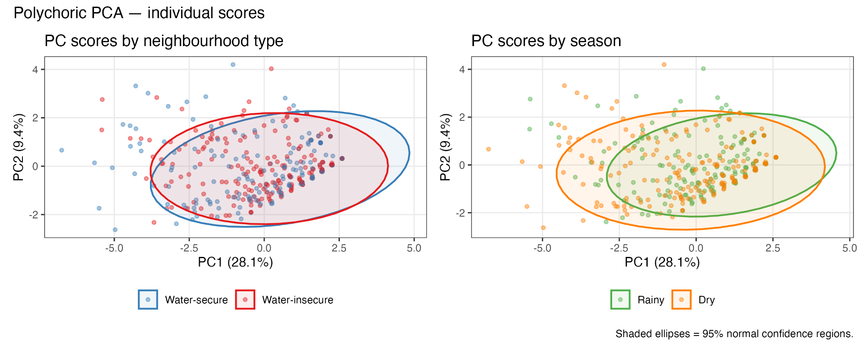
Figure 4.2. Polychoric PCA of HWISE items. Left: PC scores by neighborhood type (water-secure vs. water-insecure). Right: PC scores by season (rainy vs. dry). Shaded ellipses = 95% normal confidence regions. Scores separate more clearly by season than by neighbourhood type.

HWISE item response distributions are shown in Figure 4.2. The most commonly reported experiences were water supply interruptions (76%) and being worried or angry about their water supply (both 68%) over the last month. Least common experiences are feeling shame, not being able to wash hands after unhygienic activities, and going to sleep feeling thirsty.
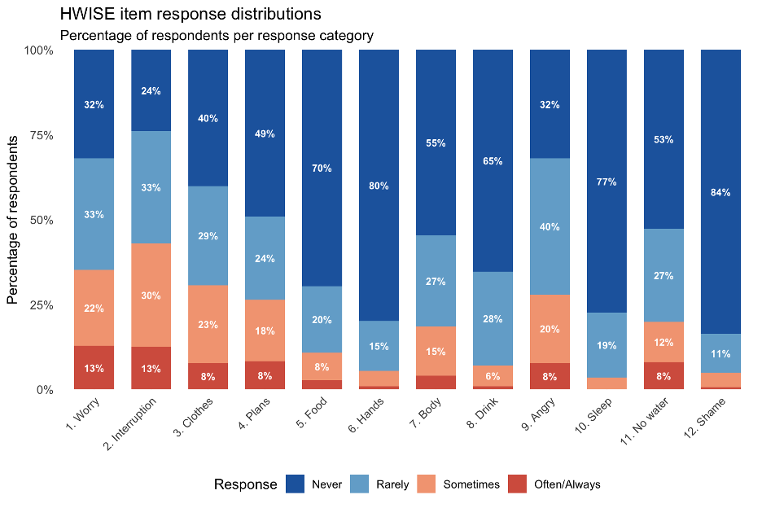
Figure 4.2. HWISE item response distributions. Stacked bars show percentage of respondents per response category (Never, Rarely, Sometimes, Often/Always) for each of the 12 HWISE items.

When answering the question: "What would you say is the most predominant emotion or feeling you have about your water situation at home?" most participants would say that thinking about their water service makes them worried, mad, or frustrated. Others mentioned feeling gratitude and feeling peaceful, with many clarifying that they understand the privilege of having enough and good quality water and indicating that they cannot complain.
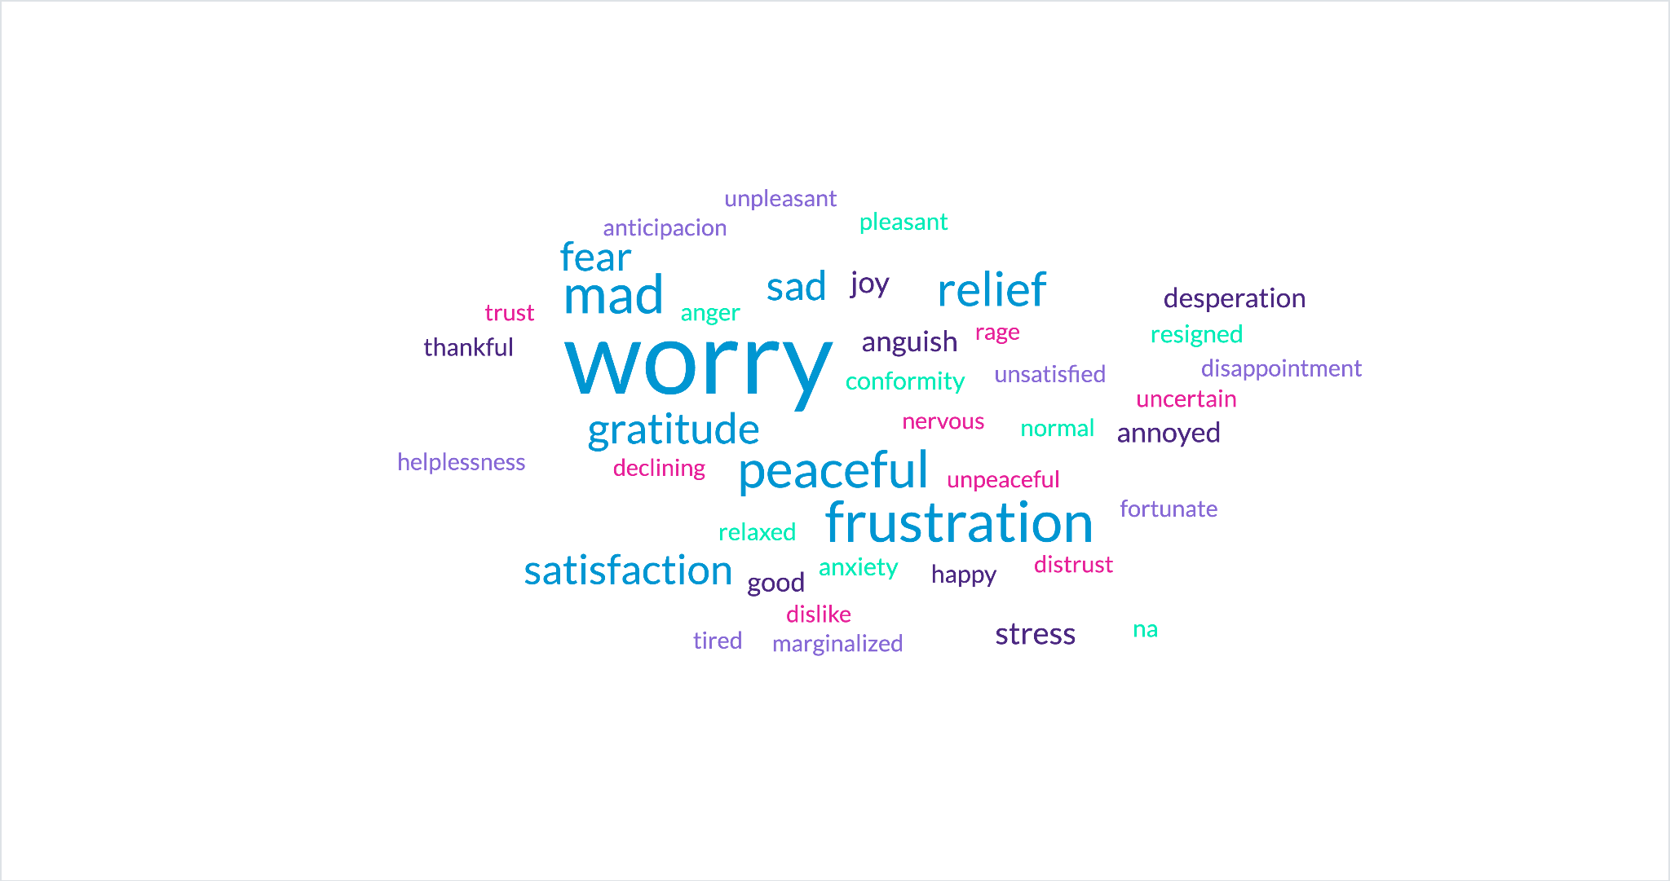
Figure 4.3. Word cloud of responses to a question on emotional responses to water service. Larger font size represents higher frequency for that word.
4.3 Aim 1: Association Between Water Insecurity and Perceived Stress and Water-Related
Emotions
Unadjusted models
Full results for unadjusted associations between all candidate predictors and PSS and emotions are shown in Supplementary Tables X and X.
For PSS, the strongest and most consistent associations involved chronic disease (β = 2.88, q = 0.016) and multiple water insecurity measures: HWISE total score (β = 0.22, 95% CI [0.10, 0.33], q < 0.01), HWISE moderate/severe category (β = 3.46, 95% CI [1.50, 5.42], q < 0.01), water worry subscale (β = 0.61, 95% CI [0.23, 1.00], q = 0.012), and the 5-item HWISE subscale (β = 0.38, 95% CI [0.15, 0.62], q = 0.012). Education and years in the neighborhood showed modest inverse associations (β = −0.49, q = 0.076). Intermittent water supply was associated with higher PSS (β = 1.77, p = 0.033), but not significantly after FDR correction (q = 0.107). Neighborhood type and season were not associated with PSS in unadjusted models (Fig. 4.3.1).
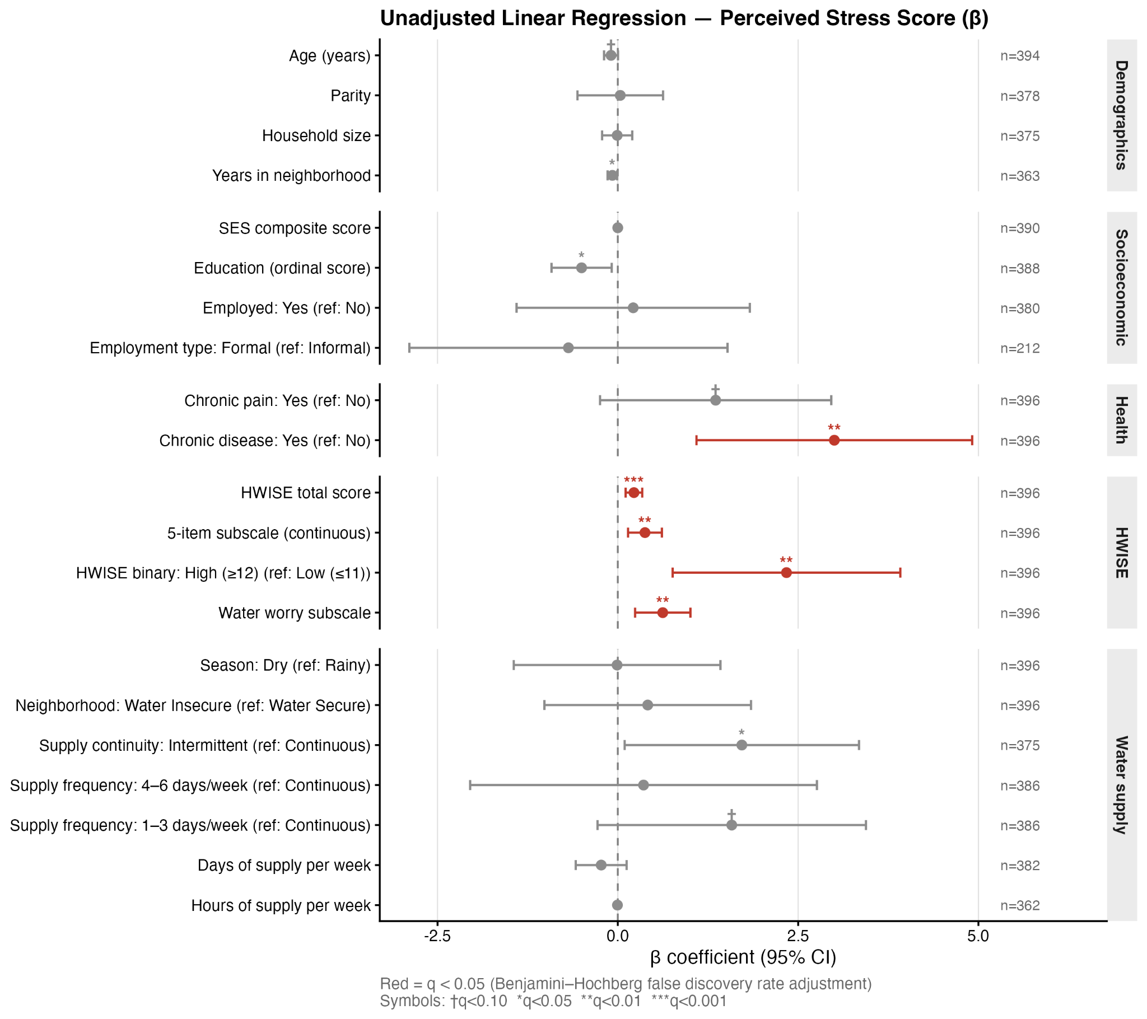
Figure 4.3.1. Unadjusted linear regression: predictors of Perceived Stress Score (β, 95% CI).

Water-related negative emotion was significantly associated with a broader set of water supply characteristics: HWISE total score (OR = 1.25, 95% CI [1.19, 1.33], q < 0.001), water worry subscale (OR = 2.00, 95% CI [1.69, 2.40], q < 0.001), HWISE moderate/severe category (OR = 20.22, 95% CI [9.39, 48.06], q < 0.001), intermittent supply (OR = 3.04, 95% CI [1.87, 4.99], q < 0.001), low water pressure (OR = 4.75, 95% CI [2.44, 10.17], q < 0.001), fewer days of supply per week (OR = 0.76, 95% CI [0.66, 0.86], q < 0.001), and PSS score (OR = 1.08, 95% CI [1.05, 1.12], q < 0.001). Neighborhood type showed only a marginal association (OR = 1.48, p = 0.076; q = 0.146); season was not significant (OR = 1.16, p = 0.510).(Fig. 4.3.2).

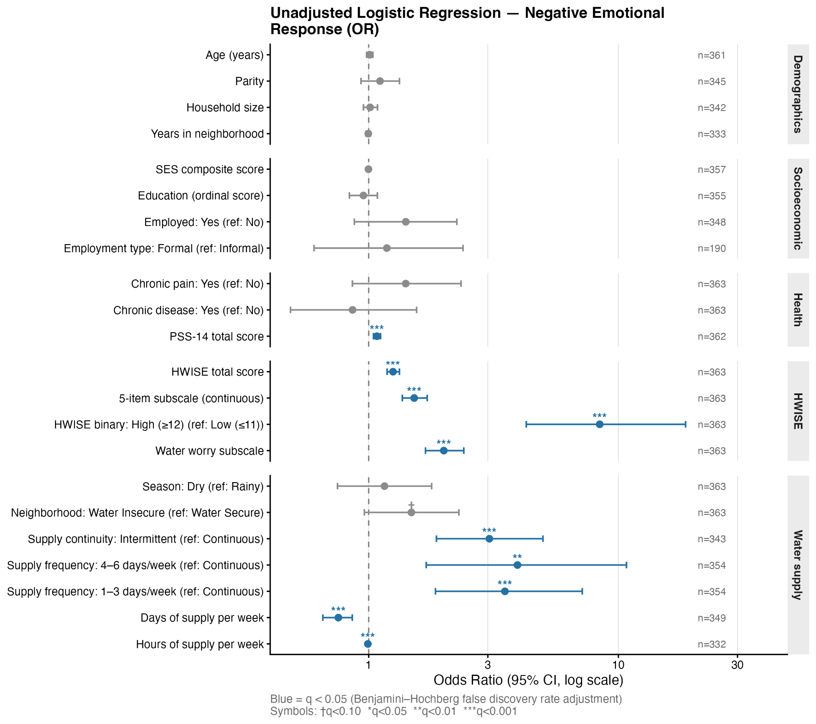

Figure 4.3.2 Unadjusted logistic regression: predictors of negative water-related emotion

Adjusted models
Perceived stress
In the adjusted model, higher HWISE scores were significantly associated with greater perceived stress (a1: β = 0.24, 95% CI [0.09, 0.38], p < 0.001). When a HWISE × season interaction was added (a2), the HWISE main effect was attenuated and non-significant (β = 0.12, 95% CI [−0.1, 0.33], p = 0.288), while the interaction approached significance (β = 0.27, 95% CI [−0.03, 0.56], p = 0.076), suggesting a trend toward stronger HWISE–stress association in the dry season. The dry season main effect in this model was associated with lower PSS (β = −2.91, p = 0.030). Adding season alongside HWISE (a5, SM) did not meaningfully alter the HWISE coefficient (β = 0.26, p < 0.001), and season remained non-significant.

Living in a water-insecure neighborhood was not significantly associated with PSS in any specification. When both HWISE and neighborhood type were included simultaneously (a9, SM), HWISE remained significant (β = 0.24, p < 0.001). Results were robust to use of the full total 12-item HWISE score (a10: β = 0.21, 95% CI [0.08, 0.33], p < 0.001) and to log-transformation of HWISE (ΔAIC < 2).

Table 4.3.1. Linear regression — Perceived Stress Score (β). Adjusted for age, household size, chronic disease and SES
Model | Variable | Beta | 95% CI | p-value
a1: HWISE reduced | HWISE reduced score | 0.27 | [0.12, 0.41] | 0.000 ***
a2: HWISE × Season | HWISE reduced score | 0.16 | [-0.05, 0.38] | 0.143
 | Season (Dry) | -2.69 | [-5.34, -0.05] | 0.046 *
 | HWISE × Season (Dry) | 0.24 | [-0.06, 0.54] | 0.115
a3: WI neighbourhood | Water-insecure neighbourhood | 0.29 | [-1.23, 1.81] | 0.708
a4: WI neighbourhood × Season | Water-insecure neighbourhood | 0.17 | [-1.93, 2.28] | 0.872
 | Season (Dry) | -0.53 | [-2.88, 1.82] | 0.656
 | WI neighbourhood × Season (Dry) | 0.25 | [-2.83, 3.33] | 0.872

Water-related emotions
Each unit increase in reduced HWISE score was associated with 26% higher odds of a negative water-related emotion after adjustment for PSS, chronic disease, age, SES, and household size (b1: OR = 1.26, 95% CI [1.18, 1.35], p < 0.001). Unlike for PSS, living in a water-insecure neighborhood was also significantly associated with greater odds of negative emotion in the adjusted model (b3: OR = 1.73, 95% CI [1.08, 2.8], p = 0.023). This association emerged only after adjustment — it was non-significant in the unadjusted model — suggesting that controlling for general stress and sociodemographic factors reveals an independent effect of neighborhood water exposure on how women emotionally relate to their water situation. Season and the neighborhood × season interaction were not significantly associated with emotions in any model (all p > 0.115), providing no evidence for seasonal moderation. Full model tables including covariate estimates are in Supplementary Material (X).
Table 4.3.2. Logistic regression — Water-related emotion (OR). Adjusted for age, household size, chronic disease and SES
Model | Variable | OR | 95% CI | p-value
b1: HWISE reduced | HWISE reduced score | 1.26 | [1.18, 1.35] | 0.000 ***
b2: HWISE × Season | HWISE reduced score | 1.35 | [1.22, 1.52] | 0.000 ***
 | Season (Dry) | 1.66 | [0.63, 4.35] | 0.304
 | HWISE × Season (Dry) | 0.89 | [0.77, 1.03] | 0.115
b3: WI neighbourhood | Water-insecure neighbourhood | 1.73 | [1.08, 2.80] | 0.023 *
b4: WI neighbourhood × Season | Water-insecure neighbourhood | 1.85 | [0.97, 3.59] | 0.064 †
 | Season (Dry) | 1.58 | [0.77, 3.28] | 0.213
 | WI neighbourhood × Season (Dry) | 0.85 | [0.32, 2.21] | 0.734
4.4 Aim 2: Components of water insecurity
To identify which specific dimensions of water insecurity were most strongly associated with stress and emotional outcomes, each component predictor was tested in a separate adjusted model with BH correction for multiple comparisons. Forest plots summarizing the full set of associations are shown in Figures 4.4.1 (PSS) and 4.4.3 (negative emotion). The top-ranked models by AIC for each outcome are presented in Tables 3 and 4. Individual HWISE items as predictors of PSS and of negative emotion are shown in Figures 4.4.2 and 4.4.4, respectively.
Perceived stress
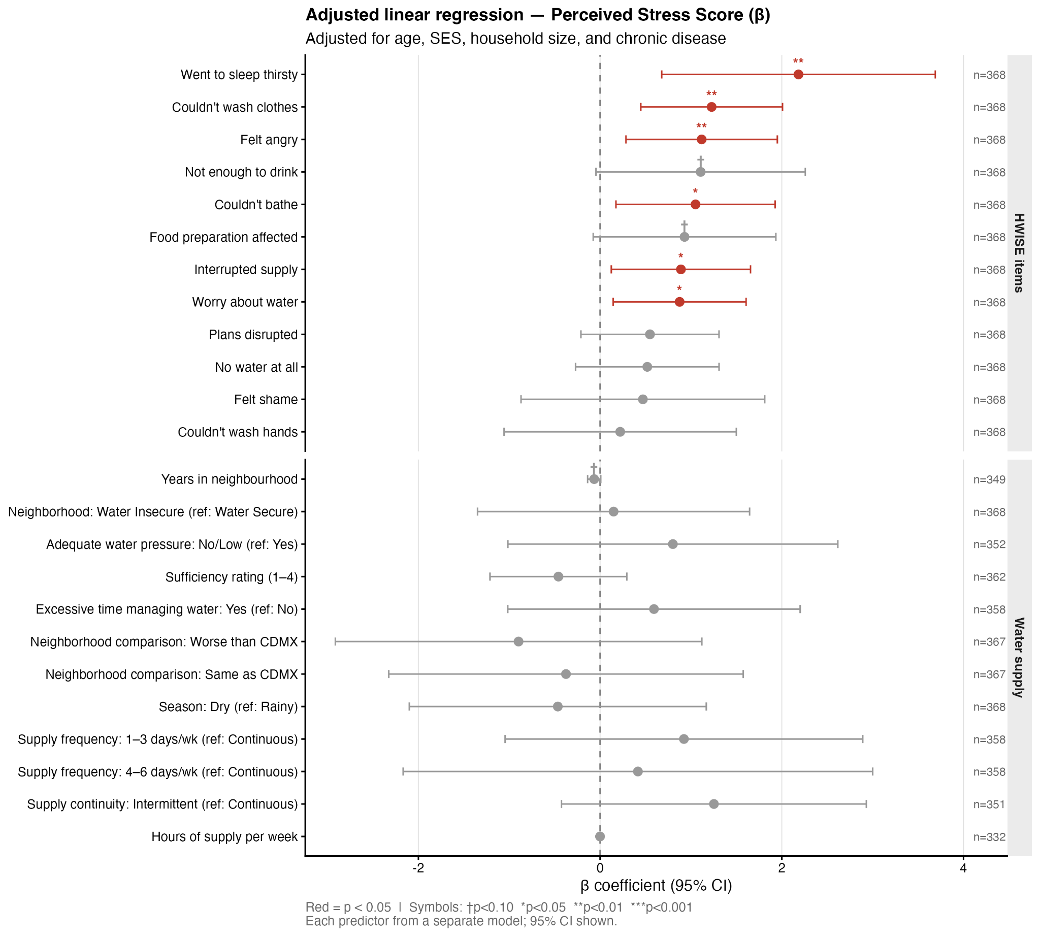
Figure 4.4.1. Water insecurity components as predictors of PSS (β, 95% CI). Each predictor is from a separate adjusted model. Red = p < 0.05.

Figure 4.4.1 shows that significant associations with PSS were confined to HWISE measures. HWISE moderate/severe category (≥12) was the strongest predictor (β ≈ 3.26, p < 0.035), followed by HWISE low (4–11; β ≈ 1.99, p = 0.035), the water worry subscale (β ≈ 0.58, p < 0.035), and the 5-item subscale continuous (β ≈ 0.36, p < 0.035). In contrast, all non-HWISE water supply characteristics — including hours of supply, intermittency, water pressure, supply frequency, season, and sufficiency rating — were non-significant after adjustment (all BH-adjusted p > 0.275). These patterns are confirmed in the top-5 AIC-ranked model table (Table 3): none of the top 5 models achieved BH-adjusted significance, while the HWISE composite models remained the only significant predictors of PSS.
Among individual HWISE items, went to sleep feeling thirsty was the strongest predictor of PSS (β ≈ 2.19, p < 0.009), followed by inability to wash clothes (β ≈ 1.23, p < 0.002), felt angry about water (β ≈ 1.3, p < 0.009), inability to bathe (β ≈ 1.05, p < 0.019), interrupted supply (β ≈ 0.89, p < 0.023) and worry about water (β ≈ 0.87, p < 0.02). Items reflecting insufficient drinking water and disrupted food preparation showed marginal associations (both p ≈ 0.059–0.07). Items with no significant associations included plans disrupted, no water at all, felt shame, and inability to wash hands. This pattern highlights that the emotional and hygiene-related dimensions of HWISE — rather than the most severe access failures — drive the association between HWISE and perceived stress.

Water-related emotions
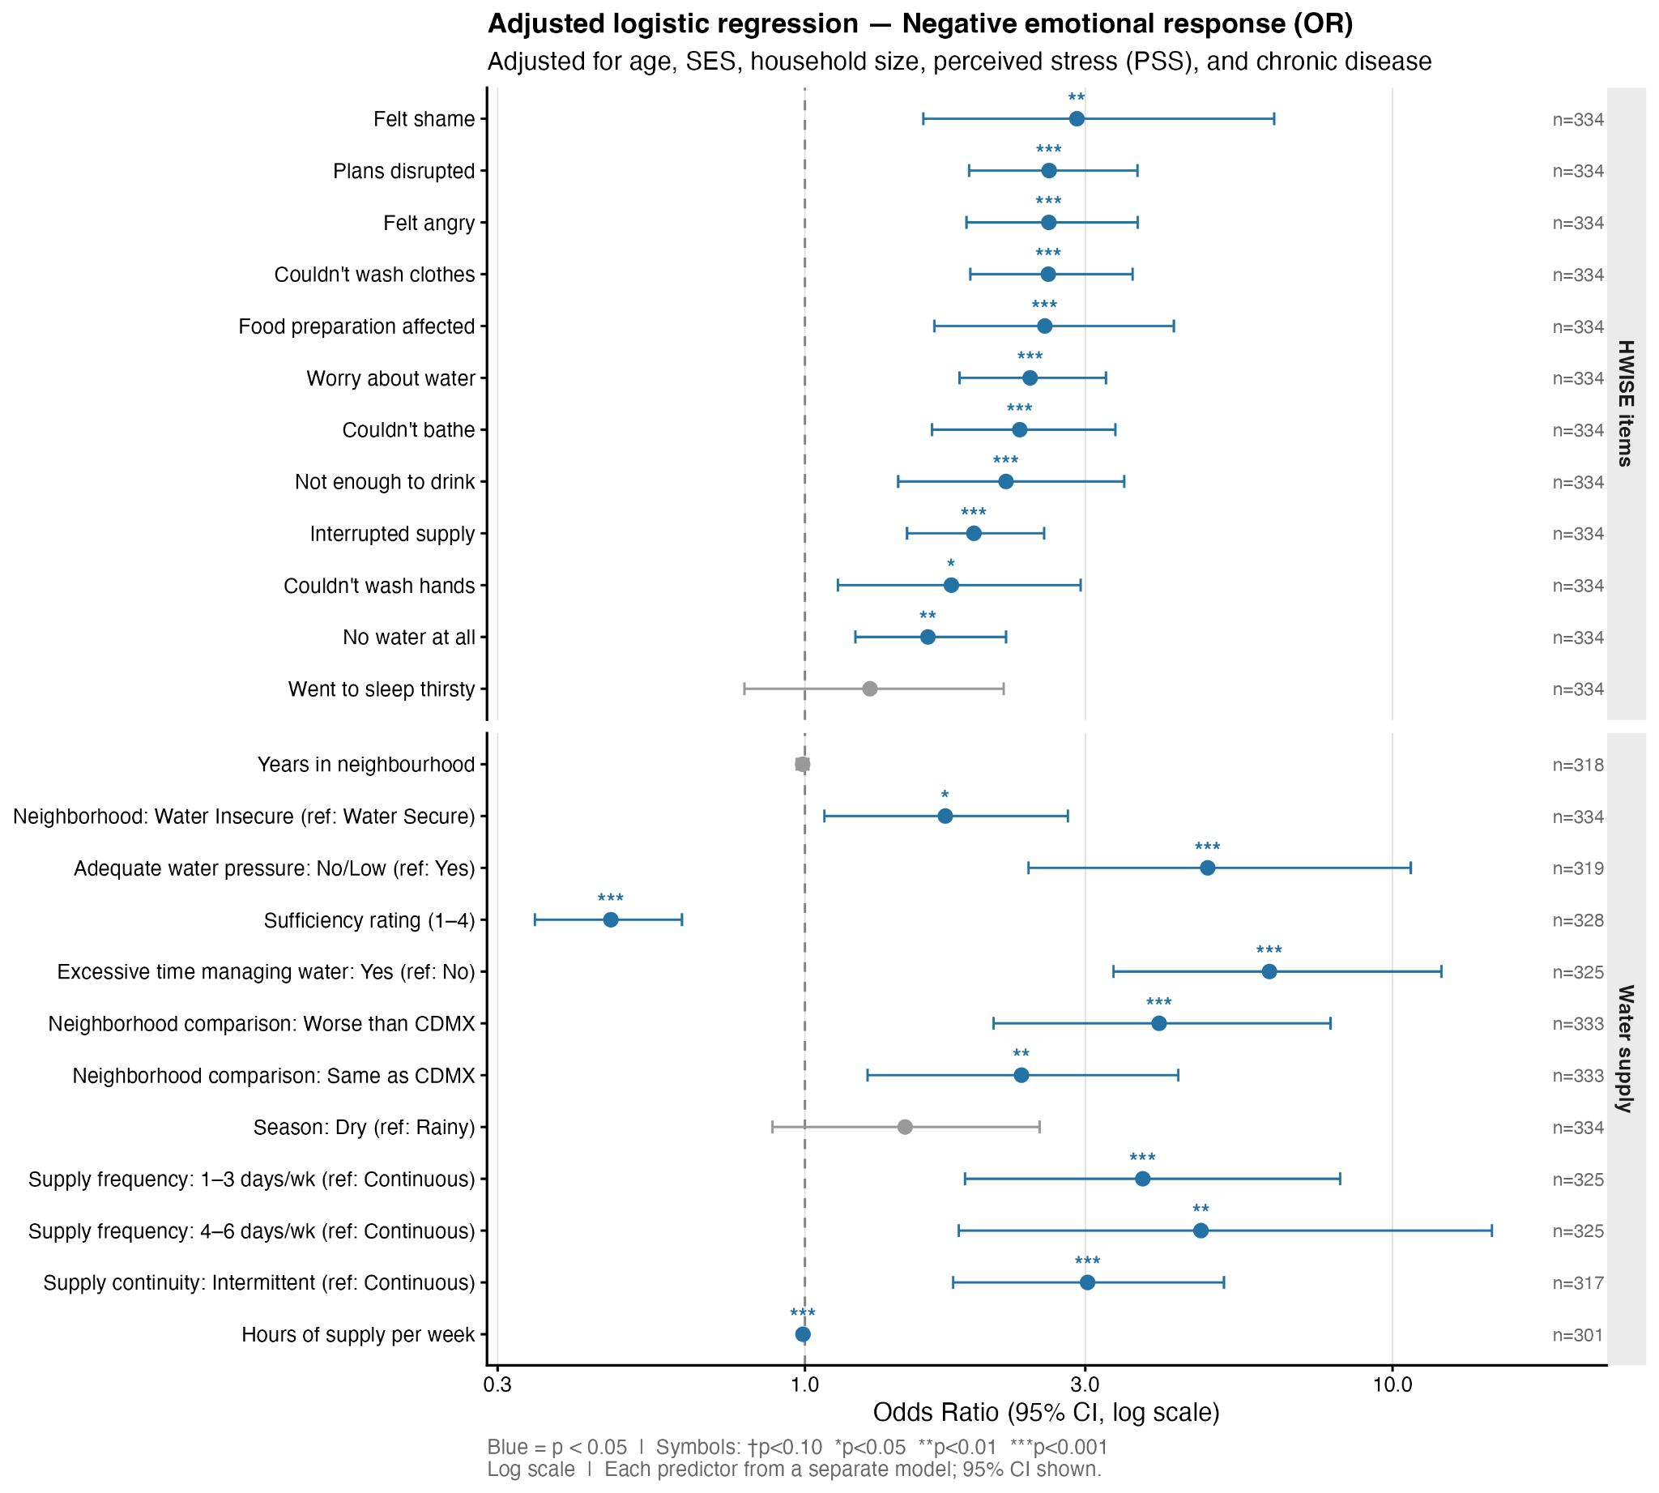
Figure 4.4.3. Water insecurity components as predictors of negative emotional responses to water service (OR, 95% CI). Each predictor is from a separate adjusted model. Blue = p < 0.05.

Water insecurity components showed far more associations with water-related emotions than with PSS (Figure 4.4.3). Multiple predictors were significantly associated with higher odds of a negative emotional response after adjustment.

Among HWISE scores, HWISE moderate/severe (≥12) showed the largest effect (OR ≈ 17, p < 0.001), followed by the 5-item subscale high category (OR ≈ 4.75, p < 0.001), HWISE low 4–11 (OR ≈ 3.48, p < 0.001), water worry subscale (OR ≈ 1.92, p < 0.001), and 5-item subscale continuous (OR ≈ 1.53, p < 0.001). Among water supply characteristics, excessive time managing water (OR ≈ 6.18, p < 0.001), low water pressure (OR ≈ 4.84, p < 0.001), supply frequency 1–3 days/week (OR ≈ 3.77, p < 0.001), supply frequency 4–6 days/week (OR ≈ 4.72, p < 0.01), and intermittent supply (OR ≈ 3.03, p < 0.001) were all significantly associated with negative emotion. More hours of supply per week was associated with lower odds (OR ≈ 0.99 per hour, p < 0.001), and lower perceived sufficiency rating was strongly associated with negative emotion (OR ≈ 0.47 per unit increase, p < 0.001). Among neighbourhood predictors, perceiving one’s neighbourhood as worse (OR ≈ 4.01, p < 0.001) or the same (OR ≈ 2.34, p < 0.006) as CDMX was associated with negative emotion, as was living in a water-insecure neighbourhood (OR ≈ 1.73, p < 0.023). Only season was non-significant (OR ≈ 1.48, p > 0.14).

In contrast to PSS, virtually all HWISE items were significant predictors of negative water-related emotion (Figure 8). Felt shame showed the largest effect (OR ≈ 3.5, p < 0.01), followed by felt angry (OR ≈ 2.8, p < 0.001), inability to wash clothes (OR ≈ 2.6, p < 0.001), plans disrupted (OR ≈ 2.6, p < 0.001), worry about water (OR ≈ 2.5, p < 0.001), food preparation affected (OR ≈ 2.5, p < 0.001), inability to bathe (OR ≈ 2.4, p < 0.001), not enough to drink (OR ≈ 2.2, p < 0.001), interrupted supply (OR ≈ 2.0, p < 0.001), inability to wash hands (OR ≈ 1.9, p < 0.05), and no water at all (OR ≈ 1.8, p < 0.001). Only going to sleep feeling thirsty was non-significant (OR ≈ 0.8, p > 0.4). This broad pattern suggests that water-related emotional distress is responsive to virtually every domain of water insecurity captured by HWISE, whereas PSS is more selectively associated with hygiene and going to sleep thirsty items.

The top-5 AIC-ranked models for negative emotion are shown in Table X. All five top models achieved BH-adjusted significance (all p < 0.001). The best-fitting model was the water worry subscale (b13: OR = 1.98, 95% CI [1.64, 2.43], McFadden R² = 0.217, ΔR² = 0.159 over covariates alone), followed by the 5-item subscale continuous (m_b15: OR = 1.53, 95% CI [1.36, 1.75]), hours of supply per week (m_b6: OR = 0.99, 95% CI [0.99, 1.00]), HWISE categorical (m_b12: low OR = 3.84, moderate/severe OR = 17.54), and the HWISE worry item (m_b5: OR = 2.48, 95% CI [1.87, 3.36]).

In summary: HWISE measures were the only significant predictors of Perceived Stress, whereas negative water-related emotions were associated with a wide range of objective and subjective water insecurity dimensions, including supply quantity, intermittency, pressure, time burden, perceived sufficiency, and neighborhood comparison. Perceived relative inequality — specifically reporting that one’s neighborhood is worse off for water than the rest of Mexico City — was uniquely associated with negative emotions but not with PSS, pointing to the role of injustice perception as a driver of water affect independent of multidimensional experiences of water insecurity.

Discussion
Discussion
- Compare values to those reported for other countries, and for Mexico in other studies
- This population has a lot more water insecure households than the average in the country
- Limitations (cross-sectional, two neighborhoods, self-report, no information on unpredictable supply). More rich information on wate-coping behaviors that cause stress: drinking water perceived to be unsafe, spending more on water treatment, borrowing water from others, subsequently feeling indebted to them, or withdrawing from social engagements, said in Thomson 2024, citing (23) Wenkataramanan et al. 2020. “Coping strategies for individual and household-level water insecurity a syustematic review. .

Conclusion
6. Conclusion (~300 words)

Sup. Material

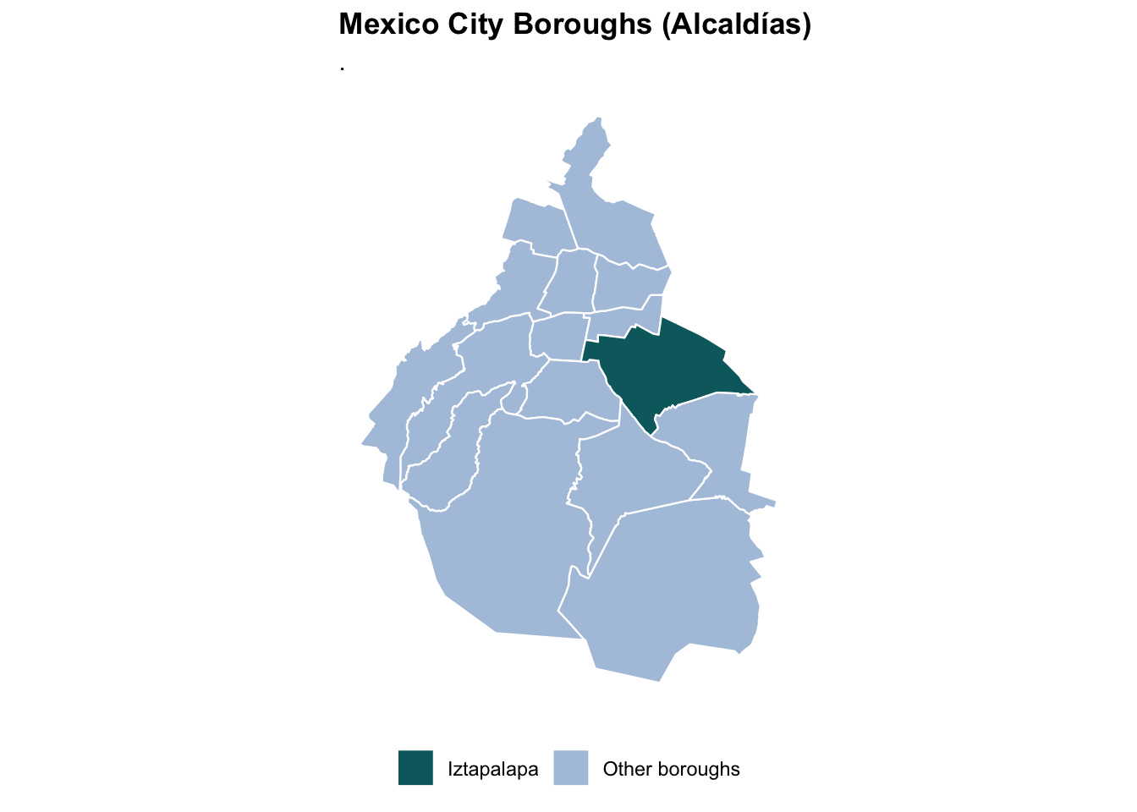
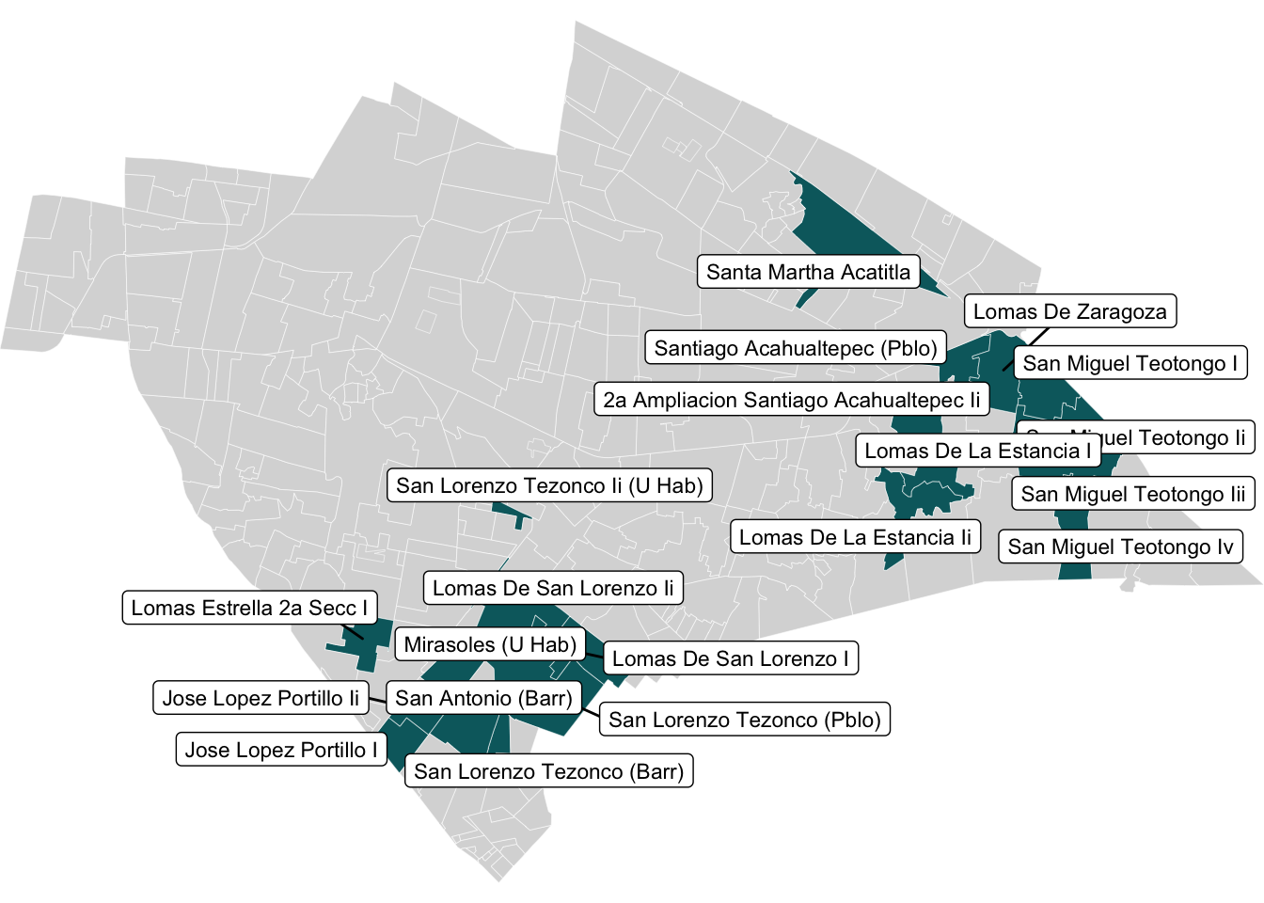

Surveys English/Spanish

Screening survey
HWISE scale
QUAIL-Mex questionnaire
Perceived stress scale PSS-14
Cuestionario inicial
Escala HWISE
QUAIL-Mex, Season 2
Escala de percepción de estrés PSS-14

Screening survey

- Year of birth
- Are you pregnant or lactating?
- Zip code
- What neighborhood do you live in?
- For how long have you lived in this neighborhood?
- Do you smoke?
- Are you under any hormonal treatment? Which one?
- Are you taking any medication, including birth control? What, or why?
- Do you suffer chronic pain? Where/what type?
- Do you have any chronic disease, such as diabetes, hypertension, high cholesterol, arthritis, coronary heart disease, depression, chronic obstructive pulmonary disease, or others?
- Number of individuals in your nuclear family (live together, share food and share salary)
- Does your family use water that goes through a water tank, cistern, or other form of water storage? Which ones and how many?
- Number of individuals in your household that share this water source or water storage):
- Have you had biological children? How many?
- Do you have a formal or informal job? (Any activities that give you an income)
- How many days per week do you work?

AMAI – INEGI questionnaire socioeconomic status

Answer the following questions thinking about your NUCLEAR FAMILY (live together, share food and salary)

- Of all the individuals living in your household that are older than 14 years old, how many worked over the last month?
Answer Points
0 individuals 0
1 individual 15
2 individuals 31
3 individuals 46
- or more individuals 61

- Consider the person that brings more income to your nuclear family, which one was the highest degree that person obtained?
Answer Points
No instruction 0
Preschool 0
Elementary incomplete 10
Elementary complete 22
Middle school incomplete 23
Middle school complete 31
Commercial degree 35
Technical degree 35
High school incomplete 35
High school complete 43
Undergraduate incomplete 59
Undergraduate complete 73
Certificate or master’s degree 101
Doctorate 101

- ¿How many full bathrooms, with a shower and W.C., are there in your home?
Answer Points
0 bathrooms 0
1 bathroom 24
2 or more bathrooms 47

- ¿How many cars or trucks are there in your household?
Answer Points
0 cars or trucks 0
1 car or truck 18
2 or more car or trucks 37

- Without considering internet access through phones, do you have internet in your household?
Answer Points
No 0
Yes 31

- In your house, how many rooms are used to sleep, without counting hallways or bathrooms?
Answer Points
0 rooms 0
1 room 6
2 rooms 12
3 rooms 17
4 rooms or more 23

HWISE scale
(Young et al. 2019)

Each item is phrased to capture experiences that members of your household have had in the last four weeks.
0 = never (0 times)
1 = rarely (1-2 times)
2 = sometimes (3-10 times)
3 = often/always (11 times or more)

1 | Worry* | In the last 4 weeks, how frequently did you or anyone in your household worry you would not have enough water for all of your household needs?
2 | Interruption | In the last 4 weeks, how frequently has your main water source been interrupted or limited (e.g. water pressure, less water than expected, river dried up)?
3 | Clothes | In the last 4 weeks, how frequently have problems with water meant that clothes could not be washed?
4 | Plans | In the last 4 weeks, how frequently have you or anyone in your household had to change schedules or plans due to problems with your water situation? (Activities that may have been interrupted include caring for others, doing household chores, agricultural work, income-generating activities, sleeping, etc.)
5 | Food | In the last 4 weeks, how frequently have you or anyone in your household had to change what was being eaten because there were problems with water (e.g., for washing foods, cooking, etc.)?
6 | Hands | In the last 4 weeks, how frequently have you or anyone in your household had to go without washing hands after dirty activities (e.g., defecating or changing diapers, cleaning animal dung) because of problems with water?
7 | Body | In the last 4 weeks, how frequently have you or anyone in your household had to go without washing their body because of problems with water (e.g., not enough water, dirty, unsafe)?
8 | Drink | In the last 4 weeks, how frequently has there not been as much water to drink as you would like for you or anyone in your household?
9 | Angry* | In the last 4 weeks, how frequently did you or anyone in your household feel angry  about your water situation?
10 | Sleep | In the last 4 weeks, how frequently have you or anyone in your household gone to sleep thirsty because there wasn’t any water to drink?
11 | None | In the last 4 weeks, how frequently has there been no useable or drinkable water whatsoever in your household?
12 | Shame* | In the last 4 weeks, how frequently have problems with water caused you or anyone in your household to feel ashamed, excluded, or stigmatized?

QUAIL-Mex questionnaire

In your household, is water stored? Where?
____It is not stored ____Water tanks _____Cistern
____Large Buckets ____ Buckets with a lid _____Buckets without a lid
____Other:

Water in your household comes from:
____public water company?
______ somewhere else? (well, another household, N/A)
Have you ever requested water from a water truck? Yes_____ No ____
How frequently? (times/year)____ When was the last time? ____ How do you request a water truck?

Over the last four weeks, how frequently did you receive water in your household?
____Daily ____4 - 6 days per week _____ 1 - 3 days per week
____1 - 3 times per month ____ We have not received water in the last 4 weeks
_____does not know
Is it possible that your water service was cut-off, but you did not realize due to your water tanks? Explain

Over the last four weeks, what days and times of the week did you receive piped water?

What time of year (month) is water most scarce in your household?

Think about the place in your house from where piped water arrives, before getting into a cistern, or another type of storage, do you receive water from the public water supply continuously or intermittently?
____Continuously (24 hours and 7 days a week)
____ Intermittent (when and for how long do you receive water?)

I will present you some scenarios and for each one, I would like you to tell me how sufficient you think is the water each person receives.
(1 = not sufficient for daily activities, 2 = slightly sufficient, 3 = almost sufficient, 4 = completely sufficient)
A) Maria gets water from the public supply one day per week, from 6am to 12pm. How sufficient is the water Maria receives for her daily tasks?
B) Paola receives water from the public supply three days per week. On those days, she gets water all day. How sufficient is the water Paola receives for her daily tasks?
C) Luisa receives water from the public supply five days per week. On those days, she gets water all day. How sufficient is the water Luisa receives for her daily tasks?
D) Now I would like you to think in your own water situation, and in how much water you receive during a normal week. How sufficient is the water you get over a week for your daily tasks?
Comments:

Do you and your family trust the water that comes from the public supply?
_______yes _______ no
Why?

Do you process water (boiling, filtering, etc) before drinking it? What method do you use?
_____Yes (which one?) ____No, explain:
Why?

¿What water sources do you and other household members use for drinking?
____Tap water ______Spring _____ Well
____Bottled water from known company _____Bottled water from local purifier
____Rainwater ______Individual water bottles
____Water truck ______Other (¿which one?)

Do you usually have enough water pressure to accomplish your daily tasks? (washing clothes, taking showers, cooking and washing dishes, cleaning the house, etc.).
_____Yes ____No, explain:

Do you pay for your water bill? How much? How does paying for water affect your household finances?

Has the price of the water that you purchase outside your home changed over the last year? (Either from the local purifier, convenience store, or delivered pipa water).
a. How much? (price before and after)
b. Do you think this impacts the way water is allocated in your household?

 | Manual (who is in charge of doing this?) | Automatic |  | Manual (who is in charge of doing this?) | Automatic
a.opening valves |  |  | f.turning pump on
b.waiting for water to arrive |  |  | g.buying bottled water
c.waiting for water truck |  |  | h.paying water bills
d.filling up water tanks |  |  | i.preparing buckets and filling them up
e. request water truck |  |  | j.others

How much time do you or anyone in your household have to dedicate to manage water, including getting, distributing water within the household, or performing any water treatment? (explain)

Do you think your household spends too much time, or more time that you would like, managing water? or, do you Think this is an appropriate time to dedicate to water management? (explain)

Do you save water? How and why?

If you had better water supply (predictable, high water pressure, 24 hours per day, every day), what impact would it have in your life? What would you be able to do that you cannot do now? How would you feel?

In the last month, how often have you had to plan very carefully to save water when bathing / cleaning the house / doing the laundry / cooking, or any other activities)? (1 to 4, 1 = never and 4 = always)

Have you assisted other people in the past, who have had difficulties accessing the water they needed? (explain)

Have other people [neighbors, family, local politicians, etc.] helped you? (explain)

In the past month, did you have disagreements with anyone in your family about water? (explain)

Have there been conflicts within your neighborhood or community over water? Examples could be conflicts with SACMEX, with vendors, with neighbors, or local governmental officials (explain)

In the last month, have you felt frustrated or angry about the water situation in your house? (explain)

In the last month, have you been afraid that water would run out in your house? (explain)

What would you say is the most predominant emotion or feeling you have about your water situation? (Worry, Anger, Fear, Frustration, Satisfaction, Gratitude, Relief, Sadness, etc.). (explain)

Do you think the water quality in your neighborhood is better, worse, or about the same as other parts of Mexico City?
_____same _____better ____ worse

Why do you think this difference exists?

What would you say is the most predominant emotion or feeling you have about the situation in Mexico City? (Worry, Anger, Fear, Frustration, Satisfaction, Gratitude, Relief, Sadness, etc.). (explain)

What would be the ideal water situation in your household? If you could change something, what would it be? (E.g.: would you prefer to have water for more time, higher water pressure, better quality, etc).

Do you think this is going to happen?
Why?

Comments

Perceived stress scale PSS-14
(Gonzalez-Ramirez et al. 2013)
The questions in this scale ask you about your feelings and thoughts during the last month. For each question choose from the following alternatives:
0 = never; 1 = almost never; 2 = sometimes; 3 = fairly often; 4 = very often

1. In the last month, how often have you been upset because of something that happened unexpectedly?
2. In the last month, how often have you felt that you were unable to control important things in your life?
3. In the last month, how often have you felt nervous and “stressed”?
4. In the last month, how often have you dealt successfully with irritating life hassles?
5. In the last month, how often have you felt that you were effectively coping with important changes that were occurring in your life?
6. In the last month, how often have you felt confident about your ability to handle your personal problems?
7. In the last month, how often have you felt that things were going your way?
8. In the last month, how often have you found that you could not cope with all the things that you had to do?
9. In the last month, how often have you been able to control irritations in your life?
10. In the last month, how often have you felt that you were on top of things?
11. In the last month, how often have you been angered because of things that happened that were outside of your control?
12. In the last month, how often have you found yourself thinking about things that you have to accomplish?
13. In the last month, how often have you been able to control the way you spend your time?
14. In the last month, how often have you felt difficulties were piling up so high that you could not overcome them?

Cuestionario inicial
¿Usted fuma?
Año de nacimiento
¿Está actualmente embarazada o lactando?
¿Ha tenido hijos o hijas biológicas? ¿Cuántos?
Código postal
¿En qué colonia vive?
¿Por cuánto tiempo ha vivido aquí?
¿Se encuentra bajo algún tratamiento hormonal? ¿Cuál?
¿Toma algún medicamento, incluyendo anticonceptivos? ¿Cuál o para qué?
¿Usted sufre de dolor crónico? ¿Cuál/de qué tipo?
¿Tiene alguna enfermedad crónica, como diabetes, hipertensión, colesterol alto, artritis, enfermedad coronaria, depresión, u otras?
Número de personas en su familia nuclear (viven juntos, comparten alimento y viven del mismo salario/s)
¿Su familia nuclear usa tinacos, cisternas, o alguna otra forma de almacenamiento de agua? ¿Cuáles, y cuántos de cada uno?
Número de personas en su terreno que comparten esa misma fuente de agua o almacenamiento
¿Tiene usted un empleo? (cualquier actividad que le de ingresos económicos) ¿formal o informal?
¿Cuántos días a la semana trabaja usted?

Cuestionario AMAI - INEGI estatus socioeconómico

Responda las siguientes preguntas pensando en su FAMILIA NUCLEAR (viven juntos, comparten alimento y viven del mismo salario/o)

1. En su familia nuclear ¿cuántas personas trabajaron en el último mes?
Respuesta Puntos
0 personas 0
1 persona 15
2 personas 31
3 personas 46
4 o más personas 61

2. Piense en la persona que genera mayores ingresos en su familia nuclear. ¿Cuál fue el último año de estudios que aprobó en la escuela esa persona?

Respuesta |  | Respuesta
No estudió/preescolar | 0 | Carrera técnica | 35
Primaria Incompleta | 10 | Preparatoria Incompleta | 35
Primaria Completa | 22 | Preparatoria Completa | 43
Secundaria Incompleta | 23 | Licenciatura Incompleta | 59
Secundaria Completa | 31 | Licenciatura Completa | 73
Carrera comercial | 35 | Postgrado | 101

3. ¿Cuántos baños completos con regadera y W.C. (excusado) hay en esta vivienda?

Respuesta Puntos
0 baños 0
1 baño 24
2 o más baños 47

4. ¿Cuántos automóviles o camionetas tienen en su hogar?
Respuesta Puntos
0 carros o camionetas 0
1 carro o camioneta 18
2 o más carros o camionetas 37

5. Sin tomar en cuenta la conexión móvil desde algún celular ¿su hogar cuenta con internet?
Respuesta Puntos
NO TIENE 0
SÍ TIENE 31

6. En su vivienda, ¿cuántos cuartos se usan para dormir, sin contar pasillos ni baños?
Respuesta Puntos
0 cuartos 0
1 cuarto 6
2 cuartos 12
3 cuartos 17
4 cuartos o más 23

Escala HWISE
(Young et al. 2019)
Cada pregunta intenta capturar las experiencias que los miembros del hogar han tenido en las últimas cuatro semanas.
0 = Nunca (0 veces)
1 = A veces (1-2 veces)
2 = De vez en cuando (3-10 veces)
3 = A menudo/siempre (11 veces o más)
1) Preocupación* | En las últimas 4 semanas, ¿con qué frecuencia usted o alguien en su hogar se preocupó de no tener suficiente agua para todas las necesidades de su hogar?
2) Interrupción | En las últimas 4 semanas, ¿con qué frecuencia se ha interrumpido o disminuido el suministro de las fuentes principales de agua en su hogar (por ejemplo, menor presión o interrupción del agua entubada, menos agua de la esperada, menos lluvia, etc.)?
3) Ropa | En las últimas 4 semanas, ¿con qué frecuencia no ha habido suficiente agua en el hogar para lavar la ropa?
4) Planes | En las últimas 4 semanas, ¿con qué frecuencia usted o alguien en su hogar tuvo que cambiar sus horarios o planes debido a problemas con el agua, tales como problemas para obtener o distribuir agua dentro del hogar? (Las actividades que pueden haber sido interrumpidas incluyen cuidar a otros, dormir, hacer tareas domésticas, llegar tarde al trabajo o a la escuela, etc.)
5) Alimentos | En las últimas 4 semanas, ¿con qué frecuencia alguien en su hogar tuvo que cambiar lo que iba a comer porque había problemas con el agua (por ejemplo, para lavar los alimentos, cocinar, etc.)?
6) Manos | En las últimas 4 semanas, ¿con qué frecuencia alguien en su hogar no pudo lavarse las manos después de actividades poco higiénicas (por ejemplo, después de ir al baño, cambiar pañales, etc.) porque no tenía suficiente agua?
7) Cuerpo | En las últimas 4 semanas, ¿con qué frecuencia usted o alguien en su hogar no pudo bañarse debido a problemas con el agua (por ejemplo, no había suficiente agua, estaba sucia, o era de difícil acceso)?
8) Bebida | En las últimas 4 semanas, ¿con qué frecuencia no hubo suficiente agua para beber para alguien en su hogar?
9) Enojo* | En las últimas 4 semanas, ¿con qué frecuencia usted o alguien en su hogar se sintió molesto/a por alguna situación referente al agua?
10) Sueño | En las últimas 4 semanas, ¿con qué frecuencia alguien en su hogar se durmió con sed porque no había agua para beber?
11) Ninguno | En las últimas 4 semanas, ¿con qué frecuencia no hubo en su hogar agua apta o recomendable para uso en el hogar (ni siquiera de garrafón)?
12) Vergüenza* | En las últimas 4 semanas, ¿con qué frecuencia alguien en su hogar sintió vergüenza o rechazo de otros a causa de los problemas con el agua? (mal, excluido)?

QUAIL-Mex, Season 2

10) En su casa ¿qué tipo de almacenamiento de agua tienen y usan? ¿Cuántos de cada uno?
a.____No se almacena agua b.____Tinaco c._____Cisterna h. ____Pileta
d.____Tambo e.____Cubeta con tapa f._____Cubeta sin tapa g. ____Otro:

11) ¿Usted paga el servicio del agua de la llave? ¿Cuánto paga/cómo impacta esto a sus finanzas?
1) ¿El agua que llega a su vivienda viene…
a.____ del servicio público? e. ____ de otro lugar? ¿Cual? (pozo, otra vivienda, no sabe)

1.g) En su hogar ¿han recibido agua de pipa? a. ____Si b. ____No
¿Con qué frecuencia? (veces por año)
¿Cuándo fue la última vez? ¿Cómo piden la pipa?
4) En las últimas 4 semanas, ¿con qué frecuencia llegó agua entubada a su vivienda?
a.____Diario b.____4 a 6 días a la semana
c.____1 a 3 días a la semana d.____en todo el mes, 1 a 3 veces
e.____no ha llegado en las últimas 4 semanas f. ____no sabe

4.g. ¿Sabe si el agua deja de llegar en algún momento, pero gracias al tinaco/cisterna no se dan cuenta? Explique

5) En las últimas 4 semanas, ¿Qué días, y a qué horas cada día llegó el agua entubada a su casa? (ej. Lun a vie, 6am a 2pm)

2) ¿En qué época del año (mes) escasea más el agua en su vivienda? ¿Por qué cree usted que pasa eso?

3) Piense en la parte de su casa o terreno por donde el agua entra desde la calle, antes de pasar por el tinaco o la cisterna. En épocas de mayor escasez durante un año normal, ¿usted recibe agua del suministro público de forma continua o intermitente?
a._____Continua (24 horas los 7 días de la semana)
b._____Intermitente ¿Cuándo y por cuánto tiempo recibe agua?

16) Le voy a presentar algunos escenarios y para cada uno, me gustaría que me dijera, qué tan suficiente considera que es el agua que la persona recibe: (1) no es suficiente para actividades diarias (2) moderadamente suficiente (3) casi suficiente (4) completamente suficiente.
16. A) María recibe agua del suministro público un día a la semana, de 6 am a 12 pm. ¿Qué tan suficiente es el agua que María recibe para sus necesidades cotidianas? (1) (2) (3) (4)
16. B) Paola recibe agua del suministro público tres días a la semana. Durante esos días tiene agua todo el día. ¿Qué tan suficiente es el agua que Paola recibe para sus necesidades cotidianas? (1) (2) (3) (4)
16. C) Luisa recibe agua del suministro público cinco días a la semana. Durante esos días tiene agua todo el día. ¿Qué tan suficiente es el agua que Luisa recibe para sus necesidades cotidianas? (1) (2) (3) (4)
16. D) Ahora me gustaría que piense en la situación del agua en su casa, en cuánta agua recibe durante la semana. ¿Qué tan suficiente es el agua que usted recibe durante la semana para sus necesidades cotidianas? (1) (2) (3) (4)
8) ¿Usted y su familia confían en el agua que viene del suministro público?
a._____Si b.____No

8.c) ¿Por qué? (preguntar por qué si, o por qué no)
Olor:______________ Color: _____________ Sabor____________

7) ¿Le da algún tratamiento al agua antes de usarla?
b. _____No a.____hervirla c.____gotas desinfectantes d._____ filtrarla con telita/calcetin (donde?)

7.c.) ¿Por qué? (preguntar por qué si, o por qué no)

9) ¿Qué fuentes de agua usan los miembros de su hogar para beber?
a._____Agua del suministro publico b._____Manantial c._____ Pozo
f._____ Captación de lluvia g._____Botellas de agua h._____Pipa
d._____Garrafón de marca, # por semana:_______ e._____Garrafón de purificadora, # por semana:_______
i._____ Otra (¿cuál?)

6) Usualmente, ¿cuenta con la presión de agua necesaria para llevar a cabo sus necesidades cotidianas? (lavar ropa, los trastes, bañarse, etc.).
a._____Si b.____No, explique:
31) ¿Ha cambiado el precio del agua que usted compra fuera de su hogar en el último año? (Ya sea de purificadora, tienda o entregada en pipa).
31.a) ¿Cuánto? (precio antes y después)
31.b) ¿Cree que esto afectó la forma en que se usa el agua en su casa?

12) ¿Cuáles de las siguientes actividades se realizan en su casa respecto al agua?
 | Manual (quién las hace?) | Automático |  | Manual (quién las hace?) | Automático
a.Abrir llaves |  |  | f.prender la bomba
b.estar pendiente a la llegada del agua |  |  | g.comprar garrafón
c.esperar la pipa |  |  | h.Pagar recibo de agua
d.llenar el tinaco |  |  | i.preparar cubetas
e.pedir la pipa |  |  | j.otros

19) ¿Qué le parece el tiempo que se usa en esas tareas?
______Poco, le parece bien ______Es más tiempo del le gustaría

14) ¿Usted ahorra, recicla o reutiliza el agua? ¿Cómo y por qué lo hace? (ej. Usar agua de la lavadora para regar plantas, para el baño, etc).

15) Si tuviera un mejor suministro de agua (de buena calidad, 24 horas al día todos los días), ¿Qué impacto tendría en su vida? ¿Qué haría que no puede hacer ahora? ¿Cómo se sentiría?

20) ¿Ha ayudado a otras personas a obtener agua? (o por ej. Permitir que alguien se bañe en su casa porque no tiene agua). Explique

21) ¿Le han ayudado a usted otras personas [vecinos, familia, políticos locales, etc.] a conseguir agua? (explique)

22) Durante el último mes, ¿ha tenido desacuerdos con alguien de su familia sobre el agua? (explique)

23) ¿Ha tenido conflictos dentro de su colonia sobre el agua? Ejemplos: conflictos con SACMEX, vendedores, vecinos o personas en puestos públicos locales (explique)

24) Durante el último mes, ¿se ha sentido frustrada o enojada sobre la situación del agua en su hogar?
Explique:

25) Durante el último mes, ¿Ha tenido miedo de que se le termine el agua en su casa?
Explique:

26) ¿Qué emoción o sentimiento diría que es el predominante en relación a su situación de agua [en su casa]? (Preocupación, Enojo, Miedo, Frustración, Satisfacción, Gratitud, Alivio, Tristeza, etc.). (explique)

28) ¿Usted considera que la calidad del agua en su colonia es mejor, peor o igual que en otras partes de la Ciudad de México?
a.____igual b.____ mejor c._____ peor
b y c: ¿por qué cree que existe esa diferencia?

27) Respecto a la situación del agua en la Ciudad de México, ¿Qué emoción o sentimiento diría que es el predominante? (Preocupación, Enojo, Miedo, Frustración, Satisfacción, Gratitud, Alivio, Tristeza, etc.). (explique)
¿por qué?

29) ¿Cuál sería la situación ideal del agua para su hogar? Si pudiese cambiar algo, ¿qué sería? (ej. que llegue más tiempo, con mayor presión, que llegue limpia, etc).
¿Cree que va a ocurrir/es posible?
¿Por qué?

Comentarios:

Escala de percepción de estrés PSS-14
(Gonzalez-Ramirez et al. 2013)
Marca la opción que mejor se adecúe a tu situación actual, teniendo en cuenta el último mes.
(0) nunca (1) casi nunca (2) de vez en cuando (3) a menudo (4) muy a menudo
1. En el último mes, ¿Con qué frecuencia has estado afectada por algo que ha ocurrido inesperadamente?
2. En el último mes, ¿Con qué frecuencia te has sentido incapaz de controlar las cosas importantes de tu vida?
3. En el último mes, ¿Con qué frecuencia te has sentido nerviosa o estresada (llena de tensión)?
4. En el último mes, ¿Con qué frecuencia has manejado con éxito los pequeños problemas irritantes de la vida? | *
5. En el último mes, ¿Con qué frecuencia has sentido que has afrontado efectivamente los cambios importantes que han estado ocurriendo en tu vida? | *
6. En el último mes, ¿Con qué frecuencia has estado segura sobre tu capacidad de manejar tus problemas personales? | *
7. En el último mes, ¿Con qué frecuencia has sentido que las cosas te van bien? | *
8. En el último mes, ¿Con qué frecuencia has sentido que NO podías afrontar todas las cosas que tenías que hacer?
9. En el último mes, ¿Con qué frecuencia has podido controlar las dificultades de tu vida? | *
10. En el último mes, ¿Con qué frecuencia has sentido que tienes el control de todo? | *
11. En el último mes, ¿Con qué frecuencia has estado enfadada porque las cosas que te han ocurrido estaban fuera de tu control?
12. En el último mes, ¿Con qué frecuencia has pensado sobre las cosas que no has terminado (pendientes de hacer)?
13. En el último mes, ¿Con qué frecuencia has podido controlar la forma de pasar el tiempo (organizar)? | *
14. En el último mes, ¿Con qué frecuencia has sentido que las dificultades se acumulan tanto que no puedes superarlas?

Site and recruitment (detail)

3.1 Study design and setting
3.2 Data collection
3.3 Participant recruitment and eligibility

3.1 Study design and setting
This study uses a cross-sectional, quantitative design, informed by prior ethnographic fieldwork conducted in working-class neighborhoods of Mexico City in 2019 as a team member of the NESTSMX project (Huberts et al., 2023). It examines the relationship between water insecurity and emotional outcomes among adult women in Iztapalapa, one of the 16 boroughs (alcaldías) of Mexico City.
Iztapalapa was selected because it is one of the most water-insecure boroughs in the city, characterized by intermittent water supply, high dependence on water storage infrastructure, and a historically underserved population with limited access to basic urban services/and significant variation in water access across neighborhoods (CITE). These conditions make Iztapalapa a suitable setting for studying the lived dimensions of water insecurity, as water scarcity and unpredictability are not exceptional events but rather structural features of everyday life for many residents.
Data were collected in two geographically distinct areas of the borough. The first area, San Lorenzo Tezonco and surrounding colonias, is located in the western part of Iztapalapa and is characterized by relatively flat terrain, a mix of formal and informal settlements, and some residential apartment complexes (condominios) where water is centrally managed and distributed. The second area, Santiago Acahualtepec and San Miguel Teotongo, is located in the eastern part of the borough, bordering the State of Mexico. This area is predominantly composed of informal settlements built on hilly terrain, which presents additional infrastructural challenges for water distribution. According to data published by SACMEX (Sistema de Aguas de la Ciudad de México), the public water utility, these two areas differ in their water supply conditions, with Santiago Acahualtepec/San Miguel Teotongo receiving fewer hours of piped water per week (CITE SACMEX data).
All data were collected in person, in outdoor settings near community centers and surrounding public spaces in the two study areas. In Iztapalapa, community centers are locally known as "Utopías" — large, publicly funded recreational and cultural facilities that were established as part of a social infrastructure program by the local government. Utopías offer a wide range of free services and activities to residents, including sports facilities, swimming pools, cultural workshops, music and dance classes, and medical services. As such, they are important gathering spaces for the local community, and are particularly frequented by women, who use them for exercise and classes, and who often drop off their children there for recreational activities and enrichment programs. The Utopías program has been recognized as an innovative urban social policy intervention in one of Mexico City's most densely populated and historically underserved boroughs (CITE ), and their presence made them ideal anchors for community-based data collection.
In addition to the Utopías, data collection sites were strategically located near schools and busy commercial areas, which ensured a steady and diverse flow of potential participants moving through the area throughout the day. This was particularly important for capturing women who may not regularly visit the Utopías but who pass through these public spaces as part of their daily routines — for example, while dropping children off at school, running errands, or commuting. Together, these settings allowed us to reach a broad cross-section of women in each study area while maintaining a comfortable and familiar environment for participants.
This community-embedded approach to data collection reflects our intention to facilitate participant recruitment by meeting them in their own spaces, rather than requiring them to travel to a formal research or clinical setting. We believe this approach contributed to participants' willingness to engage openly with questions about their household water situation, emotions, and perceptions of injustice. It also reflects the realities of conducting fieldwork in dense urban neighborhoods where access to private or institutional spaces is limited, and where public life unfolds largely in streets, markets, schools, and community facilities.

3.2 Data collection
Data collection was conducted in two rounds. The first round took place between October and December 2022 (rainy season), during which 204 participants were recruited. The second round took place between April and June 2023 (dry season), during which 197 participants were recruited. All data were collected in person, in outdoor settings near community centers and surrounding public spaces. In Iztapalapa, community centers are locally known as "Utopías"; large public recreational facilities where residents gather for exercise, classes, and other community activities, and where many women drop off their children. Data collection sites were also located near schools and commercial areas, which ensured a steady flow of potential participants moving through the area throughout the day. This setting was chosen to facilitate access to women in their local community context while maintaining a comfortable, familiar environment for participants.
Data collection was carried out by the primary investigator alongside a team of four trained research assistants with backgrounds in anthropology and biology, recruited locally in Mexico City. Research assistants were trained in survey administration, informed consent procedures, and participant interaction protocols prior to data collection. All surveys were administered in Spanish in a single session per participant. The session included informed consent (approximately 10 minutes), the screening survey (approximately 5 minutes), and the three study questionnaires: the HWISE scale, the PSS-14, and the QUAIL-Mex survey (approximately 30 minutes total). Unless otherwise noted, all survey items were read aloud to participants by the primary investigator or a trained research assistant, with responses recorded by the interviewer. An exception was made for the PSS-14, for which participants were given the option to read items themselves if they preferred. Finally, saliva and hair samples were collected from participants as part of the project examining biological markers of stress. The inclusion of biological sample collection extended the total session duration to approximately one hour per participant. All participants received economic compensation upon completion of the session.

3.3 Participant recruitment and eligibility
Recruitment was conducted through a combination of active outreach and passive recruitment strategies. Research assistants and the primary investigator actively approached women in outdoor public spaces near the Utopías, schools, and commercial areas in both study sites, briefly explaining the study and inviting interested individuals to participate. Simultaneously, posters and flyers with study information and a WhatsApp contact number were distributed throughout the study areas, allowing interested women to schedule a meeting with the research team at a convenient time or to contact us to confirm availability before coming to the data collection site. Additionally, word-of-mouth proved to be an important recruitment channel, as many women contacted us after learning about the study from a friend or neighbor who had already participated or been approached by the research team. This combination of strategies was designed to maximize reach across women with different schedules and levels of mobility, though we acknowledge that women with full-time formal employment outside the neighborhood were likely underrepresented, given that data collection took place during daytime hours on weekdays (see limitations). This potential selection bias is discussed further in the limitations section.
When a woman expressed interest in participating, a member of the research team provided a detailed explanation of the study, including its purpose, procedures, time commitment, compensation, and voluntary nature. Eligibility was assessed immediately through a brief screening conversation covering the primary inclusion and exclusion criteria before proceeding to the formal screening survey. This approach ensured that women who did not meet the basic eligibility criteria were not asked to provide detailed personal information unnecessarily. Women who passed the initial screening conversation then completed the full screening survey, after which data collection proceeded immediately in the same session.
Eligible participants were women aged 18–45 years who had lived in their current neighborhood for at least three years. Exclusion criteria included current pregnancy or lactation. Although lactation was among the most common reasons for exclusion encountered during fieldwork, systematic data on the number of women screened, excluded, or who declined to participate were not collected, and we are therefore unable to report a formal participation rate or assess potential selection bias introduced at the recruitment stage. Presence of a chronic disease (including diabetes, hypertension, high cholesterol, arthritis, coronary heart disease, or chronic obstructive pulmonary disease), current hormonal treatment, smoking status and medication use were recorded but were not exclusion criteria. Parity was recorded and limited to a maximum of four biological children. All interactions and surveys were conducted in Spanish.
Recruitment was balanced across the two study areas and across the two data collection seasons. The research team made a deliberate effort to maintain approximately equal numbers of participants from San Lorenzo Tezonco and Santiago Acahualtepec/San Miguel Teotongo at any given point during fieldwork, and data collection was roughly evenly split between the dry season (October–December 2022, n=202) and the rainy season (April–June 2023, n=197). This balanced design was essential for the planned analyses examining seasonal variation in water management time burden, as it ensures that season is not confounded with study area.
Season was coded as a binary variable based on the date of each participant's interview: rainy season (October–December 2022) or dry season (April–June 2023). In Mexico City, the dry season is characterized by reduced precipitation and lower water availability, while the rainy season brings increased precipitation that can supplement household water supply through rainwater harvesting and other practices. We hypothesized that participants interviewed during the dry season will report greater time burden associated with water management, as reduced water availability is expected to require greater effort and time dedicated to obtaining, storing, and distributing water within the household. Season was not randomly assigned — it is an inherent feature of the data collection timeline — and therefore any observed associations between season and time burden should be interpreted with caution, as other factors that co-vary with season (e.g. school calendars, employment patterns, household routines) could confound this relationship. These potential confounders will be accounted for in regression models by including relevant sociodemographic covariates.
All participants provided written informed consent prior to enrollment. Consent forms were reviewed verbally with each participant by the administering researcher to ensure comprehension; participants were also given the opportunity to read the form themselves if they preferred, and were encouraged to ask any questions before proceeding. Participants were informed that their responses would be anonymized and that they could withdraw from the study at any time without consequence. Upon completion of the data collection session, all participants received economic compensation. This study was approved by the Institutional Review Board of the University of Michigan (HUM00192307, approved April 11, 2023).

Measures (detailed)

3.4.1 QUAIL-Mex
a) Water-related emotions
b) Perceived neighborhood water disadvantage
c) Perceived hours of water supply
d) Time burden of water management
e) Perceived water sufficiency
3.4.2 Perceived psychological stress: PSS-14
3.4.3 Household water insecurity: HWISE scale
Water worry
3.4.4 Screening
Education level
Neighborhood: WI and WS

Measures

3.4.1 QUAIL-Mex
Water access, management practices, and emotional responses to water insecurity were assessed using the QUAIL-Mex (QUantitative And qualItative perceptions of water Insecurity Levels in Mexico City), a survey instrument developed specifically for this study. The QUAIL-Mex was designed to capture the particularities of water insecurity as experienced in working-class urban households in Mexico City, drawing on questions modified from existing water insecurity research (Wutich, 2006) and adapted using my own ethnographic knowledge of the local context as part of the NESTSMX project team (Hubberts et al., 2023). It includes both closed-ended items producing quantitative variables and open-ended items capturing qualitative responses. The specific QUAIL-Mex items used in the present study are described below.

Water-related emotions
Participants' predominant emotional response to their water situation was assessed using two open-ended questions from the QUAIL-Mex survey. The first question asked about the predominant emotion or feeling participants associated with their household water situation: "What would you say is the most predominant emotion or feeling you have about your water situation at home?" The second question asked about the predominant emotion or feeling associated with the Mexico City water situation more broadly: "What would you say is the most predominant emotion or feeling you have about the water situation in Mexico City?" Response options provided as examples in both questions included worry, anger, fear, frustration, satisfaction, gratitude, relief, and sadness, though participants were free to respond with any emotion they felt was most representative of their experience. Responses were recorded verbatim in Spanish by the interviewer during the session and subsequently coded by the research team.
Coding was conducted by multiple coders following a structured coding scheme. Responses were classified into three categories: positive (e.g., satisfaction, gratitude, relief), negative (e.g., worry, anger, fear, frustration, sadness), and mixed, for cases where participants reported more than one predominant emotion that spanned both valence categories [REV]. Cases where responses could not be clearly classified into any of these categories were labeled as "other" [REV]. Inter-rater reliability was assessed using Cohen's kappa [PENDING], and discrepancies between coders were resolved through discussion and consensus.
The two emotion variables — household water emotion and Mexico City water emotion — will be treated as separate binary outcome variables (negative vs. positive/mixed/other) in our analyses. Separate logistic regression models will be estimated for each outcome, allowing us to examine whether the predictors of negative emotion differ depending on whether participants are evaluating their immediate household water situation or the broader urban water context. We expect that perception of injustice may be a stronger predictor of negative emotion about the Mexico City situation, as this question more directly invites a comparative and structural evaluation of water access, while household-level water insecurity measures may be more strongly associated with negative emotion about the household situation. These hypotheses will be tested empirically [PENDING].

b) Perceived neighborhood water disadvantage
Participants' perception of their neighborhood water situation relative to other parts of Mexico City was assessed using a single item from the QUAIL-Mex survey: "Do you think the water quality in your neighborhood is better, worse, or about the same as other parts of Mexico City?" This item was read aloud to participants by the interviewer. Responses were recorded as one of three categories: worse, same, or better. In our sample, 138 participants ([CONFIRM %]) reported their neighborhood water quality as worse than other parts of Mexico City, 154 ([CONFIRM %]) reported it as about the same, and 91 ([CONFIRM %]) reported it as better, with the remaining participants not providing a response ([CONFIRM n missing]).
We use this item as a measure of perceived neighborhood water disadvantage — the degree to which participants perceive their water situation as inequitable relative to other urban residents. While this is a single-item measure and therefore has inherent limitations in terms of construct validity, it captures a comparative and relational dimension of water insecurity that is distinct from absolute measures of water access such as hours of supply or HWISE scores. Participants who perceive their neighborhood as worse off than others are not only recognizing a material deficit, but are also making a social comparison that situates their water situation within a broader urban landscape of unequal resource distribution. This comparative perception has been theorized as an important but understudied dimension of water insecurity experiences in urban contexts (CITE).
For the primary analyses, perceived neighborhood water disadvantage will be treated as a three-category variable (worse, same, better), with "same" serving as the reference category in logistic regression models. This approach allows us to examine whether perceiving one's neighborhood as worse than others is associated with negative water-related emotion independently of perceiving it as better, and avoids the loss of information that would result from collapsing the "same" and "better" categories into a single reference group. Sensitivity analyses collapsing "same" and "better" into a single reference category will also be conducted to assess the robustness of findings to this analytical decision [PENDING: confirm sensitivity analysis plan].

c) Perceived hours of water supply
Two variables from the QUAIL-Mex were used to characterize participants' perceived water supply from the public network. First, participants were asked about the frequency and duration of their water supply during a normal week. When in doubt, participants were told to think about the water supply over the last four weeks. From their responses, a composite variable reflecting the perceived number of hours of piped water received per week was constructed (MX5_WFREQ_HRS/WEEK), combining information about the number of days per week and hours per day that water was available. This variable is continuous, with higher values indicating greater perceived water availability. As noted in Image 2, reported hours ranged widely across participants, with some reporting near-continuous supply (up to ~150 hours per week), consistent with the presence of condominio residents in San Lorenzo Tezonco where water is centrally managed and distributed. We treat participant-reported hours as an intentional measure of perceived rather than objectively measured supply: consistent with our theoretical framework, the subjective experience of water availability is as analytically relevant as infrastructural reality in shaping water insecurity experiences and emotional responses (CITE).
Second, participants were asked whether they received water from the public supply continuously or intermittently (MX3_CONT_INT): "Do you receive water from the public water supply continuously or intermittently? If intermittently, please describe when and for how long you receive water." Responses were coded as binary: continuous (24 hours, 7 days a week) or intermittent. This variable captures a qualitatively distinct dimension of water supply beyond quantity alone — the predictability and reliability of supply — which has been identified as a particularly important driver of water-related stress in urban contexts (CITE). Participants with missing data on either variable were excluded from analyses in which these variables were used as predictors.

d) Time burden of water management
The perceived time burden of household water management was assessed using two sequential items from the QUAIL-Mex. The first item asked participants to estimate how much time they or anyone in their household dedicate to managing water on a typical day or week, including obtaining water, distributing it within the household, and performing any water treatment. This open-ended question was included deliberately as a cognitive primer, designed to help participants arrive at a concrete estimate of their water management time before being asked to evaluate it. Once participants had reflected on this estimate, they were asked the primary time burden question (MX19_WTIME_INV): "Do you think your household spends too much time, or more time than you would like, managing water?"
Responses to MX19_WTIME_INV were recorded verbatim and subsequently coded into a categorical variable (MX19_WTIME_INV_CAT). The primary coding categories were: yes (the household spends too much time managing water) and no (the time dedicated is considered acceptable). Cases where responses could not be clearly classified as yes or no — for example, responses that were conditional, ambiguous, or that described a mixed situation — were coded as "other" [PENDING: examples and frequency of "other" responses]. Given the binary nature of the primary outcome categories, time burden will be modeled using logistic regression, with "yes" coded as 1 and "no" coded as 0. "Other" responses will be excluded from the primary analysis [CONFIRM], and a sensitivity analysis including them as a separate category will be conducted if their frequency warrants it [Confirm].
The inclusion of this sequential question design — first eliciting a time estimate and then asking for an evaluation — reflects a broader methodological commitment in this study to grounding participants' responses in their concrete lived experience before asking for abstract assessments. This approach was informed by the primary investigator's prior ethnographic experience in Mexico City, which suggested that direct questions about time burden can be difficult to answer without first prompting participants to reflect on their actual water management practices.

e) Perceived water sufficiency
Subjective water sufficiency was measured using a single item drawn from a vignette-based question used in Huberts et al. 2023. This question was designed to anchor participants' perceptions of water adequacy to concrete supply scenarios. Participants were first asked to rate the sufficiency of water received by three hypothetical households receiving piped water one, three, and five days per week, respectively, providing a calibration frame before the self-referential item. They were then asked: "Now I would like you to think about your own household water situation — how much water you receive during a week. How sufficient is the water you receive over a week for your daily needs?" Responses were recorded on a four-point ordinal scale: 1 = not sufficient for daily activities, 2 = moderately sufficient, 3 = almost sufficient, 4 = completely sufficient. The vignette structure preceding this item was intended to reduce anchoring bias by giving participants an explicit reference frame before evaluating their own situation, making this measure a more calibrated index of subjective water adequacy than a standalone sufficiency question.

3.4.2 Perceived psychological stress: PSS-14
General perceived psychological stress was assessed using the 14-item Perceived Stress Scale (PSS-14; Cohen, Kamarck, and Mermelstein, 1983), in its Spanish-language version validated for Mexican populations (González-Ramírez et al., 2013). [Sup. Mat]. The PSS-14 is the most widely used instrument for assessing perceived psychological stress and has been extensively validated across cultural contexts. It asks participants to rate how often they have experienced specific stress-related feelings and thoughts over the past month on a five-point scale (0 = never, 1 = almost never, 2 = sometimes, 3 = fairly often, 4 = very often). Seven items are reverse-scored (items 4, 5, 6, 7, 9, 10, and 13), since higher scores on these items reflect lower perceived stress before reversal. Total scores range from 0 to 56, with higher scores indicating greater perceived stress.
Participants were given the option to read the PSS-14 items themselves or to have them read aloud by the interviewer, depending on their preference. This flexible administration approach was consistent across the full study session and was designed to accommodate variability in participants' literacy levels and personal comfort. Research assistants noted that some participants found the language used in certain PSS items somewhat unusual or unfamiliar, which is consistent with observations in other studies using translated psychological scales in non-academic populations (CITE). However, this did not result in systematic item nonresponse or notable data quality issues.
The PSS-14 was administered at the end of the interview (after the screening survey, the HWISE scale and the QUAIL-Mex survey). This ordering was deliberate: given that the PSS asks about general life stress and can elicit personal and emotionally sensitive responses, placing it towards the end of the session allowed the research team to first establish rapport with participants through the water-related questions, which were more directly grounded in participants' everyday experiences. We acknowledge, however, that completing water insecurity questions prior to the PSS may have primed participants' stress responses, potentially inflating PSS scores by making water-related stressors more cognitively salient at the time of completion. This potential order effect is discussed further in the limitations section.

3.4.3 Household water insecurity: HWISE scale
Household water insecurity was assessed using the Household Water Insecurity Experiences (HWISE) scale (Young et al., 2019), a validated 12-item instrument designed to capture a range of water insecurity experiences across diverse cultural and geographic contexts. The HWISE was developed through a cross-cultural validation process involving sites in Africa, Asia, and Latin America, and has since been applied and validated in multiple settings including urban Mexico (Jepson et al., 2021). Each item asks about the frequency of a specific water-related experience in the last four weeks, rated on a four-point scale (0 = never [0 times], 1 = rarely [1–2 times], 2 = sometimes [3–10 times], 3 = often/always [11 or more times]). Items cover a broad range of water insecurity domains including water interruption, inability to wash clothes or body, changes to food preparation, inability to wash hands after dirty activities, going to sleep thirsty, and the complete absence of usable water in the household [Sup. Mat]. All items were read aloud to participants by the primary investigator or a trained research assistant, and responses were recorded by the interviewer. This approach was chosen to ensure comprehension across participants to minimize item nonresponse. Missing data on HWISE items were minimal.
Total HWISE scores range from 0 to 36, with higher scores indicating greater household water insecurity. For the purposes of grouping participants by level of water insecurity, we will apply two classification approaches and compare their results. First, we will use the validated HWISE cutoff scores established in the literature (Young et al., 2019): 0 = water secure, 1–11 = marginally water insecure, 12–23 = moderately water insecure, and 24–36 = severely water insecure. Second, we will use a sample-based quantile approach [median split or quartiles — to confirm] to classify participants relative to the distribution of HWISE scores within our own sample. Comparing these two approaches serves an important methodological purpose: the validated cutoffs were developed across diverse global settings and may not optimally capture variation within a single urban context where the full range of water insecurity severity may not be represented. A sample-based quantile approach, by contrast, captures relative water insecurity within our specific population. Examining whether our key findings are sensitive to the classification method used will allow us to assess the robustness of our results and contribute to ongoing discussions about how best to operationalize water insecurity categories in urban Latin American contexts.

Water worry
In addition to the total HWISE score, we will calculate a Water Worry subscale score following the approach developed by Jepson et al. (2021) in their study of water insecurity in Torreón, Mexico. The Water Worry subscale consists of three items from the HWISE scale that capture the emotional and affective dimensions of water insecurity: worry about not having enough water, anger about the household water situation, and shame or stigma resulting from water problems. Subscale scores range from 0 to 9, with higher scores indicating greater water-related emotional distress. Jepson et al. (2021) demonstrated that water worry scores had a stronger association with perceived stress than total HWISE scores in an urban Mexican sample, suggesting that the emotional dimensions of water insecurity may be particularly salient drivers of psychological stress. Including the Water Worry subscale in our analyses will allow us to examine whether this finding replicates in our Iztapalapa sample, and to disentangle the contributions of the material and emotional dimensions of water insecurity to our primary outcomes. water-related worry subscale derived from the HWISE scale (worry, anger, and shame)

3.4.4 Screening
Age (D_AGE) was recorded as a continuous variable in years, ranging from 18 to 45 in this sample.
Household size (D_HH_SIZE) was recorded as the number of individuals living in the household who share food and income, recorded as a continuous variable.
Parity (D_CHLD) was recorded as the number of biological children, ranging from 0 to 8 in this sample.
Employment status (D_EMP_TYPE) was recorded as a binary variable indicating whether the participant had a formal or informal job providing income (yes/no).
Socioeconomic status (SES) was assessed using the NSE-AMAI scale (Niveles Socioeconómicos — Asociación Mexicana de Agencias de Inteligencia de Mercado y Opinión), a six-item instrument developed specifically for the Mexican context. The scale produces a composite score based on the number of household members who worked in the last month, the educational level of the head of household, the number of full bathrooms in the home, the number of cars or trucks in the household, internet access, and the number of rooms used for sleeping. Total scores are interpreted according to the following classification: A/B (205 or more), C+ (166–204), C (135–165), C- (112–134), D+ (90–111), D- (48–89), and E (less than 47), with higher scores indicating higher socioeconomic status. For the purposes of regression analyses, SES will be included as a continuous score [CONFIRM: or as categorical — to decide based on distribution].

Education level
Education level was initially recorded as a free-text or partially open-ended categorical variable. Prior to analysis, responses were harmonized to match the NSE-AMAI standard education categories. Responses indicating bachillerato completo, carrera técnica bachillerato, or a combined technical-bachillerato credential were mapped to Preparatoria Completa (12 years). Responses indicating carrera técnica or carrera técnica completa without an accompanying bachillerato credential were mapped to Preparatoria Incompleta, reflecting the typical 2–3 year post-secundaria duration of these programs. Carrera comercial was mapped to Secundaria Completa, as these short vocational programs are generally entered after secundaria and do not confer a bachillerato. Bachillerato trunco was mapped to Preparatoria Incompleta. One response indicating completed schooling prior to or at the preschool level (no estudio/preescolar) was mapped to Sin Instrucción. Three responses were flagged as ambiguous (code 444) and excluded from the education score pending manual review. One response carried a missing data sentinel code (999) and was treated accordingly. Following harmonization, NSE-AMAI education scores were assigned to each category per the standard scoring rubric.
Education level was initially recorded as a free-text or partially open-ended categorical variable. Prior to analysis, responses were harmonized into English-language education categories aligned with the NSE-AMAI standard scoring rubric. Responses indicating bachillerato completo, carrera técnica bachillerato, or a combined technical-bachillerato credential were mapped to Complete high school (12 years). Responses indicating carrera técnica or carrera técnica completa without an accompanying bachillerato credential were mapped to Incomplete high school (10–11 years), reflecting the typical 2–3 year post-secundaria duration of these programs. Carrera comercial was mapped to Complete secondary, as these short vocational programs are generally entered after secundaria and do not confer a bachillerato. Bachillerato trunco was mapped to Incomplete high school (10–11 years). One response indicating completed schooling prior to or at the preschool level (no estudio/preescolar) was mapped to No formal education. Three responses were flagged as ambiguous (code 444) and excluded from the education score pending manual review. One response carried a missing data sentinel code (999) and was treated accordingly. Following harmonization, NSE-AMAI education scores were assigned to each category per the standard scoring rubric. For display purposes, incomplete education categories are labeled with the corresponding range of possible completed years of schooling (e.g., Incomplete primary: 1–5 years; Incomplete secondary: 7–8 years; Incomplete high school: 10–11 years; Incomplete university: 13–15 years).

Responses | Years of education
Sin Instrucción, preescolar | 0
Primaria incompleta | 1–5
Primaria completa | 6
Secundaria incompleta | 7–8
Secundaria completa, carrera comercial | 9-10
Preparatoria Incompleta, carrera técnica completa, bachillerato trunco | 10-11
Preparatoria Completa, bachillerato completo | 12

Neighborhood: WI and WS
Neighborhood classification was informed by administrative criteria established by the Government of Mexico City. Specifically, we relied on information published in the official gazette (Gaceta Oficial de la Ciudad de México) in a general resolution granting partial or full condonations on water service charges. This fiscal benefit is directed toward households that have received public water service that is insufficient to meet basic needs, as determined by the city’s water authority, Sistema de Aguas de la Ciudad de México. The resolution includes an official list of colonias eligible for this benefit, which served as a key reference for identifying areas characterized by chronic water insufficiency.
The policy framework underlying this classification explicitly targets populations considered socioeconomically vulnerable, including older adults, pensioners, and households with limited or unstable income. As stated in the resolution, the measure aims to support residents facing structural economic disadvantage in contexts where essential services such as water are unreliable. In this study, colonias included in the condonation program were interpreted as administratively recognized sites of inadequate water provision.
To enable meaningful comparison, neighborhoods classified as relatively water secure were selected by identifying colonias that were not included in the condonation program but that closely matched the water-insecure areas in key sociodemographic characteristics (e.g., socioeconomic status, housing conditions, and population composition). This matching approach was used to reduce confounding by structural socioeconomic differences and to isolate variation in water access conditions across study sites.

Tables

Descriptive statistics
Descriptive statistics: PSS and Water related variables (by season)
Descriptive statistics: PSS and Water related variables (by neighborhood type)
Missing data summary table
Unadjusted models for Water-related emotion type
Adjusted models - PSS
Adjusted models (emotions)
Model coefficients (PSS)
Model coefficients (Emotions)

Descriptive statistics

Table S1. Descriptive statistics
 |  | Season of data collection
Variable | Overall  N = 397¹ | Rainy  N = 201¹ | Dry  N = 196¹ | p-value² | Missing (%)
Age | 32.3 (7.4) | 33.2 (7.1) | 31.3 (7.6) | 0.011 | 0.50%
Years in neighborhood | 22.4 (11.4) | 22.7 (11.3) | 22.1 (11.5) | 0.601 | 8.31%
Household size | 5.6 (3.6) | 6.8 (4.3) | 4.4 (1.7) | <0.001 | 5.29%
Parity | 1.9 (1.3) | 1.9 (1.2) | 1.8 (1.3) | 0.309 | 4.53%
SES (NSE-AMAI) |  |  |  | 0.003 | 1.51%
E | 14 (3.58%) | 5 (2.54%) | 9 (4.64%)
D- | 54 (13.8%) | 23 (11.7%) | 31 (16.0%)
D+ | 60 (15.3%) | 25 (12.7%) | 35 (18.0%)
C- | 90 (23.0%) | 47 (23.9%) | 43 (22.2%)
C | 92 (23.5%) | 44 (22.3%) | 48 (24.7%)
C+ | 53 (13.6%) | 34 (17.3%) | 19 (9.79%)
AB | 28 (7.16%) | 19 (9.64%) | 9 (4.64%)
Bathrooms |  |  |  | 0.023 | 1.01%
0 bathrooms | 119 (30.3%) | 51 (25.9%) | 68 (34.7%)
1 bathroom | 191 (48.6%) | 97 (49.2%) | 94 (48.0%)
2+ bathrooms | 83 (21.1%) | 49 (24.9%) | 34 (17.3%)
Car ownership |  |  |  | 0.068 | 1.01%
0 cars | 277 (70.5%) | 133 (66.8%) | 144 (74.2%)
1 car | 103 (26.2%) | 55 (27.6%) | 48 (24.7%)
2+ cars | 13 (3.31%) | 11 (5.53%) | 2 (1.03%)
Internet access | 305 (77.2%) | 157 (78.9%) | 148 (75.5%) | 0.472 | 0.50%
Workers in household |  |  |  | 0.003 | 0.50%
0 workers | 2 (0.51%) | 1 (0.50%) | 1 (0.51%)
1 worker | 132 (33.4%) | 56 (28.1%) | 76 (38.8%)
2 workers | 160 (40.5%) | 80 (40.2%) | 80 (40.8%)
3 workers | 51 (12.9%) | 28 (14.1%) | 23 (11.7%)
4+ workers | 50 (12.7%) | 34 (17.1%) | 16 (8.16%)
Bedrooms |  |  |  | 0.002 | 0.50%
0 bedrooms | 1 (0.25%) | 0 (0%) | 1 (0.51%)
1 bedroom | 96 (24.3%) | 43 (21.6%) | 53 (27.0%)
2 bedrooms | 153 (38.7%) | 67 (33.7%) | 86 (43.9%)
3 bedrooms | 87 (22.0%) | 50 (25.1%) | 37 (18.9%)
4+ bedrooms | 58 (14.7%) | 39 (19.6%) | 19 (9.69%)
Education |  |  |  | 0.237 | 2.02%
No formal / incomplete primary | 16 (4.11%) | 10 (5.05%) | 6 (3.14%)
Complete primary | 36 (9.25%) | 16 (8.08%) | 20 (10.5%)
Incomplete secondary | 24 (6.17%) | 15 (7.58%) | 9 (4.71%)
Complete secondary | 136 (35.0%) | 57 (28.8%) | 79 (41.4%)
Incomplete high school | 48 (12.3%) | 27 (13.6%) | 21 (11.0%)
Complete high school | 90 (23.1%) | 52 (26.3%) | 38 (19.9%)
University or higher | 39 (10.0%) | 21 (10.6%) | 18 (9.42%)
Employed | 268 (70.3%) | 138 (69.7%) | 130 (71.0%) | 0.823 | 4.03%
Employment type |  |  |  | 0.448 | 46.3%
Informal | 153 (71.8%) | 81 (74.3%) | 72 (69.2%)
Formal | 60 (28.2%) | 28 (25.7%) | 32 (30.8%)
Smoking | 114 (29.8%) | 57 (28.5%) | 57 (31.3%) | 0.577 | 3.78%
Chronic pain | 108 (27.2%) | 55 (27.4%) | 53 (27.0%) | >0.999 | 0%
Chronic disease | 65 (16.4%) | 24 (11.9%) | 41 (20.9%) | 0.021 | 0%
¹Mean (SD) for continuous variables; n (%) for categorical variables.
²Wilcoxon rank sum test; Kruskal-Wallis rank sum test; Fisher's exact test

Descriptive statistics: PSS and Water related variables (by season)

**Table S2. Water-related variables and PSS by season)**
 |  | Season
Characteristic | Overall  N = 397¹ | Rainy  N = 201¹ | Dry  N = 196¹ | p-value²
PSS-14 total score (0–56) | 27.2 (7.2) | 27.3 (6.9) | 27.2 (7.6) | 0.967
Perceived stress level |  |  |  | 0.342
Low stress (0–18) | 44 (11.1%) | 19 (9.50%) | 25 (12.8%)
Moderate stress (19–37) | 319 (80.6%) | 167 (83.5%) | 152 (77.6%)
High stress (38–56) | 33 (8.33%) | 14 (7.00%) | 19 (9.69%)
HWISE total score (0–36) | 8.4 (6.1) | 7.1 (5.7) | 9.8 (6.2) | <0.001
HWISE binary — Young 2019 (≥12 = insecure) |  |  |  | 0.014
Water secure (0–11) | 286 (72.0%) | 156 (77.6%) | 130 (66.3%)
Water insecure (≥12) | 111 (28.0%) | 45 (22.4%) | 66 (33.7%)
HWISE — Frongillo et al. 2024 (4 cat.) |  |  |  | 0.003
No to marginal (0–2) | 77 (19.4%) | 52 (25.9%) | 25 (12.8%)
Low (3–11) | 209 (52.6%) | 104 (51.7%) | 105 (53.6%)
Moderate (12–23) | 105 (26.4%) | 43 (21.4%) | 62 (31.6%)
High (24–36) | 6 (1.51%) | 2 (1.00%) | 4 (2.04%)
HWISE — Jepson et al. 2021 (5 cat.) |  |  |  | 0.010
Marginal (0–3) | 101 (25.4%) | 64 (31.8%) | 37 (18.9%)
Low (4–11) | 185 (46.6%) | 92 (45.8%) | 93 (47.4%)
Moderate (12–20) | 97 (24.4%) | 40 (19.9%) | 57 (29.1%)
High (21–29) | 14 (3.53%) | 5 (2.49%) | 9 (4.59%)
Severe (30–36) | 0 (0%) | 0 (0%) | 0 (0%)
Water 5-item subscale (0–15) | 3.2 (3.0) | 2.5 (2.7) | 3.9 (3.2) | <0.001
Water 5-item subscale — binary (high ≥3) |  |  |  | <0.001
Low (0–2) | 192 (48.4%) | 116 (57.7%) | 76 (38.8%)
High (≥3) | 205 (51.6%) | 85 (42.3%) | 120 (61.2%)
Water worry subscale (0–9) | 2.4 (1.8) | 2.1 (1.8) | 2.8 (1.9) | <0.001
**HWISE individual items**
1. Worried about water | 1.2 (1.0) | 0.9 (1.0) | 1.4 (1.0) | <0.001
2. Water interrupted | 1.3 (1.0) | 1.1 (1.0) | 1.5 (0.9) | <0.001
3. Unable to wash clothes | 1.0 (1.0) | 0.7 (0.9) | 1.2 (1.0) | <0.001
4. Changed plans due to water | 0.9 (1.0) | 0.7 (0.9) | 1.0 (1.0) | 0.010
5. Unable to prepare food | 0.4 (0.8) | 0.4 (0.7) | 0.5 (0.8) | 0.107
6. Unable to wash hands | 0.3 (0.6) | 0.2 (0.5) | 0.4 (0.7) | <0.001
7. Unable to wash body | 0.7 (0.9) | 0.5 (0.8) | 0.9 (0.9) | <0.001
8. No drinking water | 0.4 (0.7) | 0.4 (0.6) | 0.5 (0.7) | 0.095
9. Felt angry about water | 1.0 (0.9) | 1.0 (0.9) | 1.1 (0.9) | 0.044
10. Went to sleep thirsty | 0.3 (0.5) | 0.2 (0.5) | 0.3 (0.5) | 0.024
11. Had no water at all | 0.8 (1.0) | 0.7 (1.0) | 0.8 (0.9) | 0.358
12. Felt shame about water | 0.2 (0.6) | 0.2 (0.6) | 0.2 (0.5) | 0.997
Supply continuity |  |  |  | 0.017
Continuous | 108 (28.3%) | 61 (32.6%) | 47 (24.2%)
Intermittent | 268 (70.3%) | 126 (67.4%) | 142 (73.2%)
Other | 5 (1.31%) | 0 (0%) | 5 (2.58%)
Supply frequency |  |  |  | <0.001
Daily | 273 (70.5%) | 160 (82.1%) | 113 (58.9%)
4–6 days/week | 40 (10.3%) | 14 (7.18%) | 26 (13.5%)
1–3 days/week | 74 (19.1%) | 21 (10.8%) | 53 (27.6%)
Hours of supply per week | 85.6 (69.7) | 92.1 (70.0) | 78.5 (69.0) | 0.051
Days of supply per week |  |  |  | <0.001
1–2 days/week | 50 (13.1%) | 16 (8.25%) | 34 (18.0%)
3–5 days/week | 57 (14.9%) | 22 (11.3%) | 35 (18.5%)
6–7 days/week | 276 (72.1%) | 156 (80.4%) | 120 (63.5%)
Adequate water pressure |  |  |  | 0.014
Yes | 296 (76.3%) | 161 (81.7%) | 135 (70.7%)
No/Low | 85 (21.9%) | 35 (17.8%) | 50 (26.2%)
Variable | 7 (1.80%) | 1 (0.51%) | 6 (3.14%)
¹Mean (SD); n (%)
²Wilcoxon rank sum test; Fisher's exact test

Descriptive statistics: PSS and Water related variables (by neighborhood type)

**Table S3. Water-related variables and PSS by neighborhood (n = 397)**
 |  | Neighborhood
Characteristic | Overall  N = 397¹ | Water Secure  N = 196¹ | Water Insecure  N = 201¹ | p-value²
PSS-14 total score (0–56) | 27.2 (7.2) | 27.0 (7.7) | 27.5 (6.8) | 0.538
Perceived stress level |  |  |  | 0.470
Low stress (0–18) | 44 (11.1%) | 25 (12.8%) | 19 (9.50%)
Moderate stress (19–37) | 319 (80.6%) | 153 (78.1%) | 166 (83.0%)
High stress (38–56) | 33 (8.33%) | 18 (9.18%) | 15 (7.50%)
HWISE total score (0–36) | 8.4 (6.1) | 8.0 (6.5) | 8.8 (5.7) | 0.072
HWISE binary — Young 2019 (≥12 = insecure) |  |  |  | 0.577
Water secure (0–11) | 286 (72.0%) | 144 (73.5%) | 142 (70.6%)
Water insecure (≥12) | 111 (28.0%) | 52 (26.5%) | 59 (29.4%)
HWISE — Frongillo et al. 2024 (4 cat.) |  |  |  | 0.240
No to marginal (0–2) | 77 (19.4%) | 45 (23.0%) | 32 (15.9%)
Low (3–11) | 209 (52.6%) | 99 (50.5%) | 110 (54.7%)
Moderate (12–23) | 105 (26.4%) | 48 (24.5%) | 57 (28.4%)
High (24–36) | 6 (1.51%) | 4 (2.04%) | 2 (1.00%)
HWISE — Jepson et al. 2021 (5 cat.) |  |  |  | 0.241
Marginal (0–3) | 101 (25.4%) | 58 (29.6%) | 43 (21.4%)
Low (4–11) | 185 (46.6%) | 86 (43.9%) | 99 (49.3%)
Moderate (12–20) | 97 (24.4%) | 44 (22.4%) | 53 (26.4%)
High (21–29) | 14 (3.53%) | 8 (4.08%) | 6 (2.99%)
Severe (30–36) | 0 (0%) | 0 (0%) | 0 (0%)
Water 5-item subscale (0–15) | 3.2 (3.0) | 3.1 (3.3) | 3.3 (2.7) | 0.107
Water 5-item subscale — binary (high ≥3) |  |  |  | 0.109
Low (0–2) | 192 (48.4%) | 103 (52.6%) | 89 (44.3%)
High (≥3) | 205 (51.6%) | 93 (47.4%) | 112 (55.7%)
Water worry subscale (0–9) | 2.4 (1.8) | 2.3 (1.9) | 2.6 (1.8) | 0.067
**HWISE individual items**
1. Worried about water | 1.2 (1.0) | 1.2 (1.1) | 1.1 (0.9) | 0.837
2. Water interrupted | 1.3 (1.0) | 1.3 (1.0) | 1.4 (1.0) | 0.436
3. Unable to wash clothes | 1.0 (1.0) | 0.9 (1.0) | 1.0 (0.9) | 0.285
4. Changed plans due to water | 0.9 (1.0) | 0.8 (1.0) | 0.9 (1.0) | 0.225
5. Unable to prepare food | 0.4 (0.8) | 0.5 (0.8) | 0.4 (0.7) | 0.811
6. Unable to wash hands | 0.3 (0.6) | 0.3 (0.6) | 0.2 (0.5) | 0.699
7. Unable to wash body | 0.7 (0.9) | 0.7 (0.9) | 0.7 (0.8) | 0.394
8. No drinking water | 0.4 (0.7) | 0.4 (0.7) | 0.4 (0.6) | 0.808
9. Felt angry about water | 1.0 (0.9) | 1.0 (0.9) | 1.1 (0.9) | 0.055
10. Went to sleep thirsty | 0.3 (0.5) | 0.2 (0.5) | 0.3 (0.5) | 0.099
11. Had no water at all | 0.8 (1.0) | 0.7 (0.9) | 0.8 (1.0) | 0.185
12. Felt shame about water | 0.2 (0.6) | 0.1 (0.4) | 0.3 (0.6) | 0.012
Supply continuity |  |  |  | <0.001
Continuous | 108 (28.3%) | 97 (51.1%) | 11 (5.76%)
Intermittent | 268 (70.3%) | 91 (47.9%) | 177 (92.7%)
Other | 5 (1.31%) | 2 (1.05%) | 3 (1.57%)
Supply frequency |  |  |  | <0.001
Daily | 273 (70.5%) | 155 (81.6%) | 118 (59.9%)
4–6 days/week | 40 (10.3%) | 16 (8.42%) | 24 (12.2%)
1–3 days/week | 74 (19.1%) | 19 (10.0%) | 55 (27.9%)
Hours of supply per week | 85.6 (69.7) | 136.3 (56.9) | 38.4 (41.9) | <0.001
Days of supply per week |  |  |  | <0.001
1–2 days/week | 50 (13.1%) | 13 (6.84%) | 37 (19.2%)
3–5 days/week | 57 (14.9%) | 22 (11.6%) | 35 (18.1%)
6–7 days/week | 276 (72.1%) | 155 (81.6%) | 121 (62.7%)
Adequate water pressure |  |  |  | 0.064
Yes | 296 (76.3%) | 140 (72.5%) | 156 (80.0%)
No/Low | 85 (21.9%) | 47 (24.4%) | 38 (19.5%)
Variable | 7 (1.80%) | 6 (3.11%) | 1 (0.51%)
¹Mean (SD); n (%)
²Wilcoxon rank sum test; Fisher's exact test

Missing data summary table

Table S1.2. Missing data summary
 | Complete |  | Overall NA |  | By season (% NA)
Variable | n | % | n | % | Rainy  (n=201) | Dry  (n=196) | p-value
Employment type | 213 | 53.7 | 184 | 46.3 | 45.8 | 46.9 | 0.816
Medication use | 334 | 84.1 | 63 | 15.9 | 11.9 | 19.9 | 0.030
Hormonal treatment | 349 | 87.9 | 48 | 12.1 | 7.5 | 16.8 | 0.004
Hours of supply per week | 363 | 91.4 | 34 | 8.6 | 5.5 | 11.7 | 0.026
Years in neighborhood | 364 | 91.7 | 33 | 8.3 | 7.5 | 9.2 | 0.535
Household size | 376 | 94.7 | 21 | 5.3 | 2.5 | 8.2 | 0.012
Parity | 379 | 95.5 | 18 | 4.5 | 2.0 | 7.1 | 0.016
Employed | 381 | 96.0 | 16 | 4.0 | 1.5 | 6.6 | 0.010
Supply continuity | 381 | 96.0 | 16 | 4.0 | 7.0 | 1.0 | 0.004
Smoking | 382 | 96.2 | 15 | 3.8 | 0.5 | 7.1 | <0.001
Days of supply per week | 383 | 96.5 | 14 | 3.5 | 3.5 | 3.6 | 0.962
Supply frequency | 387 | 97.5 | 10 | 2.5 | 3.0 | 2.0 | 0.751
Water pressure | 388 | 97.7 | 9 | 2.3 | 2.0 | 2.6 | 0.748
Education | 389 | 98.0 | 8 | 2.0 | 1.5 | 2.6 | 0.499
SES (NSE-AMAI) | 391 | 98.5 | 6 | 1.5 | 2.0 | 1.0 | 0.685
Age | 395 | 99.5 | 2 | 0.5 | 0.5 | 0.5 | 1.000
PSS-14 total score | 396 | 99.7 | 1 | 0.3 | 0.5 | 0.0 | 1.000
Chronic pain | 397 | 100.0 | 0 | 0.0 | 0.0 | 0.0 | —
Chronic disease | 397 | 100.0 | 0 | 0.0 | 0.0 | 0.0 | —
HWISE total score | 397 | 100.0 | 0 | 0.0 | 0.0 | 0.0 | —
Water worry subscale | 397 | 100.0 | 0 | 0.0 | 0.0 | 0.0 | —
Rows sorted by number of true NAs (descending).
p-value from chi-square test (Fisher’s exact if any cell < 5) comparing proportion missing between seasons.

Unadjusted models for PSS

Table UV1. Unadjusted Linear Regression: Predictors of Perceived Stress Score
Predictor | n | β (95% CI) | Sig. | p-value | q-value (BH) | AIC
Employment type: Formal (ref: Informal) | 212 | -0.69 (-2.89, 1.52) |  | 0.541 | 0.823 | 1,450.8
Medication use: Yes (ref: No) | 333 | 0.74 (-3.07, 4.55) |  | 0.703 | 0.899 | 2,276.1
Hormonal treatment: Yes (ref: No) | 348 | -0.70 (-5.80, 4.40) |  | 0.788 | 0.899 | 2,370.9
Hours of supply per week | 362 | -0.01 (-0.02, 0.01) |  | 0.338 | 0.549 | 2,466.1
Years in neighborhood | 363 | -0.08 (-0.14, -0.01) | * | 0.025 | 0.080 | 2,474.3
SES composite score | 363 | -0.00 (-0.02, 0.01) |  | 0.751 | 0.899 | 2,479.2
Supply continuity: Intermittent (ref: Continuous) | 375 | 1.72 (0.09, 3.34) | * | 0.038 | 0.099 | 2,553.5
Household size | 375 | -0.01 (-0.22, 0.20) |  | 0.933 | 0.971 | 2,560.1
Parity | 378 | 0.03 (-0.56, 0.63) |  | 0.911 | 0.971 | 2,583.3
Adequate water pressure: No/Low (ref: Yes) | 380 | 1.02 (-0.73, 2.76) |  | 0.254 | 0.440 | 2,584.7
Employed: Yes (ref: No) | 380 | 0.21 (-1.40, 1.83) |  | 0.796 | 0.899 | 2,596.3
Days of supply per week | 382 | -0.23 (-0.58, 0.12) |  | 0.200 | 0.371 | 2,597.8
Supply frequency: 4–6 days/week (ref: Continuous) | 386 | 0.36 (-2.05, 2.76) |  | 0.771 | 0.899 | 2,626.5
Supply frequency: 1–3 days/week (ref: Continuous) | 386 | 1.58 (-0.28, 3.44) | † | 0.096 | 0.194 | 2,626.5
Education (ordinal score) | 388 | -0.50 (-0.92, -0.09) | * | 0.018 | 0.068 | 2,640.3
Age (years) | 394 | -0.09 (-0.19, 0.00) | † | 0.062 | 0.146 | 2,680.4
HWISE total score | 396 | 0.22 (0.11, 0.34) | *** | <0.001 | 0.004 | 2,682.5
HWISE: Low (4-11) (ref: Marginal (0-3)) | 396 | 1.92 (0.18, 3.67) | * | 0.030 | 0.088 | 2,685.7
HWISE: Moderate/Severe (≥12) (ref: Marginal (0-3)) | 396 | 3.59 (1.65, 5.52) | *** | <0.001 | 0.004 | 2,685.7
Water worry subscale | 396 | 0.62 (0.24, 1.01) | ** | 0.002 | 0.011 | 2,686.7
5-item subscale (continuous) | 396 | 0.38 (0.14, 0.61) | ** | 0.002 | 0.011 | 2,687.0
Chronic disease: Yes (ref: No) | 396 | 3.00 (1.09, 4.91) | ** | 0.002 | 0.011 | 2,687.4
5-item subscale (high ≥ 3): High (ref: Low/none) | 396 | 1.88 (0.46, 3.30) | ** | 0.010 | 0.042 | 2,690.1
Chronic pain: Yes (ref: No) | 396 | 1.36 (-0.25, 2.96) | † | 0.097 | 0.194 | 2,694.1
Neighborhood: Water Insecure (ref: Water Secure) | 396 | 0.41 (-1.02, 1.85) |  | 0.570 | 0.823 | 2,696.5
Season: Dry (ref: Rainy) | 396 | -0.01 (-1.44, 1.42) |  | 0.989 | 0.989 | 2,696.9
Highlighted rows: p < 0.05 (shown in amber). Sig.: † p<0.10, * p<0.05, ** p<0.01, *** p<0.001. p-value: unadjusted two-sided Wald test. q-value (BH): p-value corrected for multiple comparisons using the Benjamini-Hochberg false discovery rate (FDR) procedure across all predictors in this table. A q-value < 0.05 indicates the result is expected to remain significant while controlling the FDR at 5%. AIC: Akaike Information Criterion; lower = better fit.

Unadjusted models for Water-related emotion type

Table UV2. Unadjusted Logistic Regression: Predictors of Negative Emotional Response to Water
Predictor | n | OR (95% CI) | Sig. | p-value | q-value (BH) | AIC
Employment type: Formal (ref: Informal) | 190 | 1.18 (0.60, 2.39) |  | 0.631 | 0.719 | 237.6
HWISE total score | 363 | 1.25 (1.19, 1.33) | *** | <0.001 | <0.001 | 381.2
Water worry subscale | 363 | 2.00 (1.69, 2.40) | *** | <0.001 | <0.001 | 386.9
Medication use: Yes (ref: No) | 303 | 0.94 (0.32, 3.12) |  | 0.911 | 0.911 | 393.7
5-item subscale (continuous) | 363 | 1.52 (1.36, 1.72) | *** | <0.001 | <0.001 | 395.9
HWISE: Low (4-11) (ref: Marginal (0-3)) | 363 | 3.91 (2.30, 6.76) | *** | <0.001 | <0.001 | 398.5
HWISE: Moderate/Severe (≥12) (ref: Marginal (0-3)) | 363 | 20.22 (9.39, 48.06) | *** | <0.001 | <0.001 | 398.5
Hours of supply per week | 332 | 0.99 (0.99, 1.00) | *** | <0.001 | <0.001 | 410.4
5-item subscale (high ≥ 3): High (ref: Low/none) | 363 | 5.29 (3.31, 8.60) | *** | <0.001 | <0.001 | 419.7
Hormonal treatment: Yes (ref: No) | 319 | 0.74 (0.16, 3.79) |  | 0.692 | 0.719 | 419.8
Supply continuity: Intermittent (ref: Continuous) | 343 | 3.04 (1.87, 4.99) | *** | <0.001 | <0.001 | 421.6
Adequate water pressure: No/Low (ref: Yes) | 348 | 4.75 (2.44, 10.17) | *** | <0.001 | <0.001 | 429.5
Days of supply per week | 349 | 0.76 (0.66, 0.86) | *** | <0.001 | <0.001 | 433.0
Years in neighborhood | 333 | 1.00 (0.98, 1.02) |  | 0.684 | 0.719 | 433.1
SES composite score | 333 | 1.00 (0.99, 1.00) |  | 0.539 | 0.693 | 436.6
Supply frequency: 4–6 days/week (ref: Continuous) | 354 | 3.94 (1.70, 10.77) | ** | 0.003 | 0.006 | 439.8
Supply frequency: 1–3 days/week (ref: Continuous) | 354 | 3.51 (1.85, 7.17) | *** | <0.001 | <0.001 | 439.8
Household size | 342 | 1.01 (0.95, 1.08) |  | 0.687 | 0.719 | 445.8
PSS-14 total score | 362 | 1.08 (1.05, 1.12) | *** | <0.001 | <0.001 | 446.3
Parity | 345 | 1.11 (0.93, 1.33) |  | 0.247 | 0.393 | 450.9
Employed: Yes (ref: No) | 348 | 1.41 (0.88, 2.25) |  | 0.155 | 0.279 | 452.9
Education (ordinal score) | 355 | 0.95 (0.84, 1.08) |  | 0.461 | 0.692 | 461.6
Age (years) | 361 | 1.01 (0.98, 1.04) |  | 0.527 | 0.693 | 468.1
Neighborhood: Water Insecure (ref: Water Secure) | 363 | 1.48 (0.96, 2.30) | † | 0.076 | 0.146 | 468.3
Chronic pain: Yes (ref: No) | 363 | 1.41 (0.86, 2.34) |  | 0.180 | 0.304 | 469.6
Season: Dry (ref: Rainy) | 363 | 1.16 (0.75, 1.79) |  | 0.510 | 0.693 | 471.0
Chronic disease: Yes (ref: No) | 363 | 0.86 (0.49, 1.56) |  | 0.614 | 0.719 | 471.2
Highlighted rows: p < 0.05 (shown in blue). OR: odds ratio from binary logistic regression (outcome: negative emotion = 1 vs. positive = 0); OR > 1 indicates higher odds of negative emotional response. Sig.: † p<0.10, * p<0.05, ** p<0.01, *** p<0.001. p-value: unadjusted two-sided Wald test. q-value (BH): p-value corrected for multiple comparisons using the Benjamini-Hochberg false discovery rate (FDR) procedure across all predictors in this table. A q-value < 0.05 indicates the result is expected to remain significant while controlling the FDR at 5%. AIC: Akaike Information Criterion; lower = better fit.

Adjusted models - PSS

Panel A. Linear regression — Perceived Stress Score (β). Covariates excluded.
Model | Variable | Beta | 95% CI | p-value
a1: HWISE reduced | HWISE reduced score | 0.27 | [0.12, 0.41] | 0.000 ***
a2: HWISE × Season | HWISE reduced score | 0.16 | [-0.05, 0.38] | 0.143
 | Season (Dry) | -2.69 | [-5.34, -0.05] | 0.046 *
 | HWISE × Season (Dry) | 0.24 | [-0.06, 0.54] | 0.115
a3: WI neighbourhood | Water-insecure neighbourhood | 0.29 | [-1.23, 1.81] | 0.708
a4: WI neighbourhood × Season | Water-insecure neighbourhood | 0.17 | [-1.93, 2.28] | 0.872
 | Season (Dry) | -0.53 | [-2.88, 1.82] | 0.656
 | WI neighbourhood × Season (Dry) | 0.25 | [-2.83, 3.33] | 0.872
a5: HWISE + Season | HWISE reduced score | 0.29 | [0.14, 0.44] | 0.000 ***
 | Season (Dry) | -1.03 | [-2.67, 0.62] | 0.221
a6: WI neighbourhood + Season | Water-insecure neighbourhood | 0.29 | [-1.23, 1.82] | 0.707
 | Season (Dry) | -0.39 | [-2.04, 1.25] | 0.638
a7: Season only | Season (Dry) | -0.39 | [-2.04, 1.25] | 0.639
a8: HWISE × WI neighbourhood | HWISE reduced score | 0.35 | [0.15, 0.56] | 0.001 ***
 | Water-insecure neighbourhood | 1.36 | [-1.18, 3.90] | 0.293
 | HWISE × WI neighbourhood | -0.18 | [-0.48, 0.11] | 0.217
a9: HWISE + WI neighbourhood | HWISE reduced score | 0.27 | [0.12, 0.41] | 0.000 ***
 | Water-insecure neighbourhood | 0.07 | [-1.43, 1.58] | 0.924
a10: HWISE full score | HWISE full score (12 items) | 0.23 | [0.10, 0.36] | 0.000 ***
All adjusted for chronic disease, SES, age and household size.

Adjusted models (emotions)

Panel B. Logistic regression — Water-related emotion (OR). Covariates excluded.
Model | Variable | OR | 95% CI | p-value
b1: HWISE reduced | HWISE reduced score | 1.27 | [1.19, 1.36] | 0.000 ***
b2: HWISE × Season | HWISE reduced score | 1.37 | [1.23, 1.54] | 0.000 ***
 | Season (Dry) | 1.89 | [0.71, 5.06] | 0.199
 | HWISE × Season (Dry) | 0.88 | [0.76, 1.01] | 0.078 †
b3: WI neighbourhood | Water-insecure neighbourhood | 1.90 | [1.17, 3.11] | 0.010 **
b4: WI neighbourhood × Season | Water-insecure neighbourhood | 2.08 | [1.08, 4.08] | 0.030 *
 | Season (Dry) | 1.66 | [0.80, 3.49] | 0.174
 | WI neighbourhood × Season (Dry) | 0.80 | [0.30, 2.13] | 0.658
b5: HWISE + Season | HWISE reduced score | 1.27 | [1.19, 1.37] | 0.000 ***
 | Season (Dry) | 0.94 | [0.52, 1.70] | 0.834
b6: WI neighbourhood + Season | Water-insecure neighbourhood | 1.88 | [1.16, 3.08] | 0.011 *
 | Season (Dry) | 1.48 | [0.87, 2.54] | 0.146
b7: Season only | Season (Dry) | 1.51 | [0.89, 2.57] | 0.125
b8: HWISE × WI neighbourhood | HWISE reduced score | 1.21 | [1.12, 1.33] | 0.000 ***
 | Water-insecure neighbourhood | 1.03 | [0.41, 2.56] | 0.952
 | HWISE × WI neighbourhood | 1.09 | [0.95, 1.26] | 0.208
b9: HWISE + WI neighbourhood | HWISE reduced score | 1.26 | [1.18, 1.35] | 0.000 ***
 | Water-insecure neighbourhood | 1.66 | [0.97, 2.85] | 0.065 †
All adjusted for chronic disease, SES, age and household size.

Model coefficients (PSS)

Table 1. PSS Models — Water Predictors (m_a6–m_a18)
Predictor | N | β [95% CI] | Adj. R² | Δ Adj. R² | AIC | p (coef.) | pₐₑⱪ (BH)
HWISE Composite
5-item subscale (continuous) | 355 | 0.41 [0.15, 0.67] | 0.046 | 0.024 | 2,410.1 | 0.002 | 0.021
HWISE: Low (4–11) | 355 | 2.25 [0.43, 4.08] | 0.047 | 0.026 | 2,410.5 | 0.016 | 0.021
HWISE: Moderate/Severe (≥12) | 355 | 3.49 [1.42, 5.56] | 0.047 | 0.026 | 2,410.5 | <0.001 | 0.021
Water worry subscale | 355 | 0.63 [0.22, 1.04] | 0.044 | 0.022 | 2,410.9 | 0.003 | 0.021
5-item subscale: High (≥3) | 355 | 1.84 [0.33, 3.34] | 0.035 | 0.013 | 2,414.2 | 0.017 | 0.043
Water Supply
Hours of supply / week | 320 | -0.00 [-0.02, 0.01] | 0.021 | -0.002 | 2,181.6 | 0.532 | 0.632
CONT_INTIntermittent | 338 | 1.34 [-0.37, 3.05] | 0.019 | 0.004 | 2,304.9 | 0.124 | 0.199
Water pressure: No/Low | 339 | 0.88 [-0.99, 2.75] | 0.020 | 0.000 | 2,308.8 | 0.357 | 0.524
Supply frequency: 4–6 days/wk | 345 | 0.31 [-2.38, 2.99] | 0.021 | 0.000 | 2,350.6 | 0.823 | 0.528
Supply frequency: 1–3 days/wk | 345 | 1.41 [-0.58, 3.41] | 0.021 | 0.000 | 2,350.6 | 0.165 | 0.528
Excessive time managing water | 345 | 0.59 [-1.04, 2.23] | 0.025 | -0.001 | 2,351.8 | 0.478 | 0.629
Sufficiency rating (1–4) | 349 | -0.60 [-1.36, 0.16] | 0.024 | 0.004 | 2,368.2 | 0.122 | 0.199
Dry vs. rainy season | 355 | -0.39 [-2.04, 1.25] | 0.019 | -0.002 | 2,419.8 | 0.639 | 0.674
Neighborhood
Neighborhood: same as CDMX | 354 | -0.68 [-2.66, 1.31] | 0.018 | -0.003 | 2,414.7 | 0.505 | 0.674
Neighborhood: worse than CDMX | 354 | -0.96 [-2.99, 1.08] | 0.018 | -0.003 | 2,414.7 | 0.355 | 0.674
Neighborhood: Water Insecure | 355 | 0.29 [-1.23, 1.81] | 0.019 | -0.002 | 2,419.8 | 0.708 | 0.708
β = unstandardised regression coefficient; 95% CI = confidence interval. Adj. R² = adjusted R-squared; Δ Adj. R² = change over core-covariate-only model. pₐₑⱪ (BH) = F-test p-value adjusted by Benjamini-Hochberg across all Aim 2 PSS models. Green rows: BH-adjusted p < 0.05. Bold blue: unadjusted p < 0.05. Core covariates: age, SES composite, household size, chronic disease.
All adjusted for chronic disease, SES, age and household size.

Table 2. PSS Models — HWISE Individual Items (m_a5)
HWISE Item | N | β [95% CI] | Adj. R² | Δ Adj. R² | AIC | p (coef.) | pₐₑⱪ (BH)
Couldn't wash hands | 355 | 0.38 [-0.90, 1.67] | 0.020 | -0.002 | 2,419.6 | 0.556 | 0.632
Felt shame | 355 | 0.44 [-0.90, 1.79] | 0.020 | -0.002 | 2,419.6 | 0.517 | 0.632
No water at all | 355 | 0.62 [-0.18, 1.41] | 0.025 | 0.004 | 2,417.6 | 0.127 | 0.199
Plans disrupted | 355 | 0.65 [-0.11, 1.42] | 0.027 | 0.005 | 2,417.1 | 0.094 | 0.181
Worry about water | 355 | 0.98 [0.24, 1.73] | 0.037 | 0.016 | 2,413.2 | 0.010 | 0.029
Food preparation affected | 355 | 0.99 [-0.03, 2.00] | 0.029 | 0.007 | 2,416.3 | 0.056 | 0.120
Interrupted supply | 355 | 1.02 [0.24, 1.80] | 0.037 | 0.015 | 2,413.3 | 0.011 | 0.029
Not enough to drink | 355 | 1.13 [-0.04, 2.31] | 0.029 | 0.007 | 2,416.3 | 0.058 | 0.120
Felt angry | 355 | 1.19 [0.35, 2.03] | 0.040 | 0.019 | 2,412.1 | 0.005 | 0.022
Couldn't bathe | 355 | 1.29 [0.41, 2.16] | 0.041 | 0.020 | 2,411.7 | 0.004 | 0.021
Couldn't wash clothes | 355 | 1.35 [0.57, 2.14] | 0.050 | 0.028 | 2,408.5 | <0.001 | 0.020
Went to sleep thirsty | 355 | 2.07 [0.52, 3.61] | 0.038 | 0.016 | 2,413.0 | 0.009 | 0.029
Each HWISE item tested in a separate model. β = unstandardised regression coefficient; 95% CI = confidence interval. Rows sorted by ascending β estimate. pₐₑⱪ (BH) = F-test p-value adjusted by Benjamini-Hochberg across all Aim 2 PSS models. Green rows: BH-adjusted p < 0.05. Bold blue: unadjusted p < 0.05. All adjusted for chronic disease, SES, age and household size.

Model coefficients (Emotions)

Table 3. Emotion Models — Water Predictors (m_b6–m_b18)
Predictor | N | OR [95% CI] | McFadden R² | Δ McFadden R² | AIC | p (coef.) | pₐₑⱪ (BH)
HWISE Composite
Water worry subscale | 324 | 1.98 [1.64, 2.43] | 0.217 | 0.159 | 342.0 | <0.001 | <0.001
5-item subscale (continuous) | 324 | 1.53 [1.36, 1.75] | 0.202 | 0.144 | 348.4 | <0.001 | <0.001
HWISE: Low (4–11) | 324 | 3.84 [2.15, 6.97] | 0.190 | 0.132 | 355.5 | <0.001 | <0.001
HWISE: Moderate/Severe (≥12) | 324 | 17.54 [7.59, 45.11] | 0.190 | 0.132 | 355.5 | <0.001 | <0.001
5-item subscale: High (≥3) | 324 | 4.67 [2.80, 7.93] | 0.146 | 0.088 | 371.9 | <0.001 | <0.001
Water Supply
Hours of supply / week | 292 | 0.99 [0.99, 1.00] | 0.105 | 0.051 | 351.1 | <0.001 | <0.001
Excessive time managing water | 315 | 5.95 [3.22, 11.71] | 0.142 | 0.090 | 364.7 | <0.001 | <0.001
CONT_INTIntermittent | 307 | 3.19 [1.86, 5.50] | 0.105 | 0.045 | 365.7 | <0.001 | <0.001
Water pressure: No/Low | 309 | 5.68 [2.67, 13.67] | 0.117 | 0.058 | 368.2 | <0.001 | <0.001
Sufficiency rating (1–4) | 318 | 0.44 [0.32, 0.58] | 0.138 | 0.086 | 368.8 | <0.001 | <0.001
Supply frequency: 4–6 days/wk | 315 | 4.38 [1.67, 13.84] | 0.118 | 0.058 | 376.7 | 0.005 | <0.001
Supply frequency: 1–3 days/wk | 315 | 4.44 [2.12, 10.28] | 0.118 | 0.058 | 376.7 | <0.001 | <0.001
Dry vs. rainy season | 324 | 1.51 [0.89, 2.57] | 0.064 | 0.006 | 406.3 | 0.125 | 0.128
Neighborhood
Neighborhood: same as CDMX | 323 | 2.41 [1.30, 4.53] | 0.102 | 0.043 | 391.5 | 0.005 | <0.001
Neighborhood: worse than CDMX | 323 | 4.09 [2.12, 8.07] | 0.102 | 0.043 | 391.5 | <0.001 | <0.001
Neighborhood: Water Insecure | 324 | 1.90 [1.17, 3.11] | 0.075 | 0.017 | 401.8 | 0.010 | 0.010
OR = odds ratio; 95% CI = confidence interval (logistic regression). McFadden R² = pseudo-R²; Δ McFadden R² = change over core-covariate-only model. pₐₑⱪ (BH) = LRT p-value adjusted by Benjamini-Hochberg across all Aim 2 emotion models. Green rows: BH-adjusted p < 0.05. Bold blue: unadjusted p < 0.05. Core covariates: age, SES composite, household size, PSS total, chronic disease.

Table 4. Emotion Models — HWISE Individual Items (m_b5)
HWISE Item | N | OR [95% CI] | McFadden R² | Δ McFadden R² | AIC | p (coef.) | pₐₑⱪ (BH)
Went to sleep thirsty | 324 | 1.31 [0.79, 2.23] | 0.061 | 0.003 | 407.6 | 0.309 | 0.302
No water at all | 324 | 1.66 [1.24, 2.27] | 0.088 | 0.030 | 396.2 | <0.001 | <0.001
Couldn't wash hands | 324 | 1.76 [1.13, 2.91] | 0.073 | 0.015 | 402.3 | 0.019 | 0.013
Interrupted supply | 324 | 1.97 [1.50, 2.61] | 0.120 | 0.062 | 382.8 | <0.001 | <0.001
Not enough to drink | 324 | 2.19 [1.43, 3.52] | 0.091 | 0.033 | 394.9 | <0.001 | <0.001
Couldn't bathe | 324 | 2.36 [1.67, 3.45] | 0.120 | 0.062 | 382.6 | <0.001 | <0.001
Food preparation affected | 324 | 2.47 [1.61, 4.10] | 0.105 | 0.047 | 388.9 | <0.001 | <0.001
Worry about water | 324 | 2.48 [1.87, 3.36] | 0.165 | 0.107 | 363.9 | <0.001 | <0.001
Plans disrupted | 324 | 2.54 [1.85, 3.59] | 0.153 | 0.095 | 368.8 | <0.001 | <0.001
Couldn't wash clothes | 324 | 2.62 [1.92, 3.67] | 0.159 | 0.101 | 366.4 | <0.001 | <0.001
Felt angry | 324 | 2.65 [1.91, 3.79] | 0.150 | 0.092 | 370.1 | <0.001 | <0.001
Felt shame | 324 | 3.26 [1.72, 7.52] | 0.097 | 0.039 | 392.4 | 0.001 | <0.001
Each HWISE item tested in a separate model. OR = odds ratio; 95% CI = confidence interval (logistic regression). Rows sorted by ascending OR estimate. pₐₑⱪ (BH) = LRT p-value adjusted by Benjamini-Hochberg across all Aim 2 emotion models. Green rows: BH-adjusted p < 0.05. Bold blue: unadjusted p < 0.05. All models adjusted for chronic disease, SES, age and household size.

Figures

