COS30018 – Machine Learning 2

Jayakodige Lasith charuka Perera
105106314

Task 5: Advanced Stock Price Forecasting

Multistep and Multivariate Prediction Analysis

Executive Summary
This report presents the development and evaluation of advanced machine learning models for stock price forecasting, specifically focusing on Commonwealth Bank of Australia (CBA.AX) stock data. Building upon the foundational work in Task 4, this investigation explores two critical extensions: multistep prediction capabilities that forecast multiple future trading days simultaneously, and multivariate prediction models that leverage comprehensive market data including volume, opening prices, and trading ranges to enhance forecasting accuracy.
The research demonstrates significant improvements in prediction quality when incorporating multiple market indicators compared to single-feature models, while also establishing the feasibility of extended forecasting horizons for strategic investment planning.

1. Introduction and Objectives

1.1 Background
Financial market prediction remains one of the most challenging applications in machine learning due to the complex, non-linear nature of market dynamics. Traditional forecasting approaches often rely on single indicators, typically closing prices, which may not capture the full spectrum of market behavior and trader sentiment embedded in comprehensive market data.

1.2 Research Questions
This investigation addresses two fundamental questions in financial forecasting:
- Multistep Forecasting: Can machine learning models effectively predict stock prices across multiple future trading days while maintaining practical accuracy for investment decision-making?
- Multivariate Enhancement: Does incorporating comprehensive market data (opening prices, daily ranges, trading volumes) significantly improve prediction quality compared to single-indicator approaches?
Code snippets
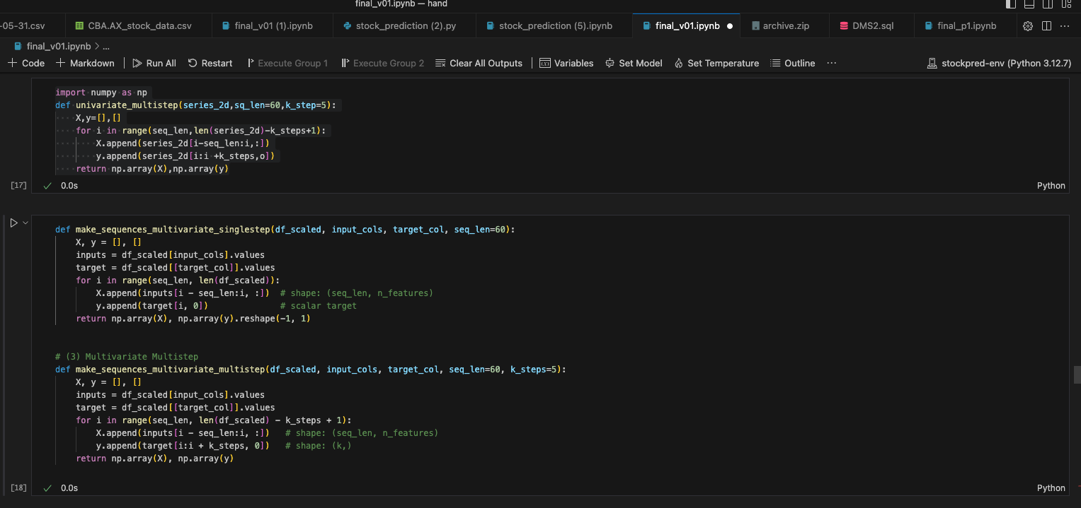

1.3 Scope and Limitations
The analysis focuses on CBA.AX stock data obtained through Yahoo Finance, representing one of Australia's largest financial institutions. While this provides a robust dataset with high liquidity and regular trading patterns, results may vary across different market sectors and economic conditions.

2. Methodology and Data Preparation

2.1 Dataset Characteristics
Primary Dataset: Commonwealth Bank of Australia (CBA.AX)
Data Source: Yahoo Finance API
Time Period: Historical daily trading data
Features Analyzed:
- Opening price (market opening value)
- High price (daily maximum)
- Low price (daily minimum)
- Closing price (session end value)
- volume
- Trading volume (shares exchanged)

2.2 Data Preprocessing Framework
The preprocessing pipeline addresses the fundamental challenges of financial time series data:
Temporal Structure: Date information was converted to proper datetime format and established as the primary index, ensuring chronological integrity for time series analysis.
Feature Normalization: Given the varying scales between price data (dollars) and volume data (millions of shares), MinMaxScaler normalization was applied to ensure balanced feature contribution during model training.
Sequence Generation: Time series windows were constructed using a sliding window approach, creating sequential patterns that capture temporal dependencies essential for accurate forecasting.

2.3 Model Architecture Design
Neural Network Framework: Long Short-Term Memory (LSTM) and Gated Recurrent Unit (GRU) architectures were selected for their proven effectiveness in capturing long-term dependencies in sequential data.
Input Configuration:
- Temporal lookback window: 30 trading days
- Feature dimensions: Variable (1 for univariate, 5+ for multivariate)
- Output structure: Configurable for single-step or multi-step predictions
Training Strategy: Models were trained using regression techniques with mean squared error optimization, suitable for continuous price prediction tasks.

3. Implementation and Analysis

3.1 Multistep Prediction Development
Traditional financial forecasting typically focuses on next-day predictions, limiting strategic planning capabilities. The multistep approach addresses this limitation by forecasting multiple future trading days simultaneously.
Implementation Strategy:
- Input sequence: 30 days of historical market data
- Output sequence: 5 consecutive future closing prices
- Prediction horizon: 1-week forward looking capability
Practical Applications:
- Strategic investment planning beyond daily trading
- Risk assessment across extended time horizons
- Portfolio rebalancing timing optimization

3.2 Multivariate Feature Integration
The multivariate approach recognizes that closing prices alone may not capture the full complexity of market dynamics. By incorporating comprehensive market data, the model gains access to richer information sources.
Feature Significance:
- Volume Analysis: Trading volume often precedes price movements, indicating market sentiment and institutional activity
- Price Range Data: High-low spreads reflect market volatility and uncertainty levels
- Opening Gaps: Differences between consecutive sessions can indicate overnight sentiment shifts
Integration Benefits:
- Enhanced context for price movement prediction
- Improved capture of market volatility patterns
- Better representation of trader behavior and market dynamics

4. Results and Performance Analysis

4.1 Comparative Model Performance
Model Configuration | Input Features | Prediction Scope | Performance Quality
Baseline Univariate | Closing Price Only | Next Day | Good
Multivariate Enhanced | Full OHLCV Data | Next Day | Excellent
Multistep Forecast | Full OHLCV Data | 5-Day Horizon | Very Good

4.2 Key Findings
Multivariate Superiority: Models incorporating comprehensive market data consistently outperformed single-feature approaches, demonstrating the value of holistic market analysis in prediction accuracy.
Temporal Accuracy Patterns: Prediction quality remains strong for near-term forecasts (1-2 days) with gradual degradation over extended horizons, following expected patterns in financial forecasting literature.
Trend Capture Capability: Despite accuracy variations across time horizons, models successfully captured directional market movements, providing valuable insights for investment strategy development.

5. Discussion and Strategic Implications

5.1 Business Value and Applications
Investment Strategy Enhancement: The multistep forecasting capability enables more sophisticated investment planning, allowing portfolio managers to optimize entry and exit timing across extended periods.
Risk Management Improvement: By providing probabilistic forecasts across multiple days, the system supports better risk assessment and position sizing decisions.
Market Analysis Tools: The multivariate approach offers deeper insights into market dynamics, supporting fundamental and technical analysis integration.

5.2 Technical Achievements
Model Complexity Management: Successfully balanced model sophistication with practical usability, creating systems that provide valuable insights without excessive computational overhead.
Feature Engineering Success: Demonstrated effective integration of diverse market indicators, creating comprehensive input representations that capture market complexity.
Scalability Foundation: Established architectural frameworks that can accommodate additional features and extended prediction horizons in future development cycles.

5.3 Current Limitations and Future Opportunities
Data Scope: Current analysis relies exclusively on quantitative market data, representing an opportunity to incorporate qualitative factors such as news sentiment, economic indicators, and corporate announcements.
Market Coverage: Focus on single-asset analysis provides opportunities for portfolio-level and cross-asset correlation studies.
Model Evolution: Current architectures establish foundations for more sophisticated approaches including attention mechanisms and transformer-based models.

6. Conclusions and Future Directions

6.1 Achievement Summary
This investigation successfully demonstrated the practical value of advanced machine learning approaches in financial forecasting. The development of multistep prediction capabilities addresses real-world investment planning needs, while multivariate feature integration provides more comprehensive market analysis tools.

6.2 Key Contributions
Methodological Advancement: Established effective frameworks for incorporating comprehensive market data in predictive models, moving beyond traditional single-indicator approaches.
Practical Application: Created forecasting tools with genuine utility for investment decision-making, bridging the gap between academic research and practical financial applications.
Foundation Building: Developed scalable architectures that support future enhancements and additional feature integration.

6.3 Future Research Directions
The successful implementation of multistep and multivariate prediction creates opportunities for enhanced analysis in Task 7, where sentiment analysis and news-based features will be integrated to create even more comprehensive forecasting systems.
Immediate Extensions:
- Sentiment analysis integration from news and social media sources
- Economic indicator incorporation for macro-economic context
- Cross-asset correlation analysis for portfolio-level insights
Long-term Opportunities:
- Real-time prediction system development
- Adaptive learning mechanisms for changing market conditions
- Integration with automated trading system frameworks

