COS30018 – Introduction to Artificial Intelligence

Option C – Task 7 – Sentiment-Based Stock Price Movement Prediction
Student Name: Lasith Charuka Perera
Student ID: 105106314
Submission Date: 2 November 2025

1. Introduction
Financial markets are driven not only by numerical data such as price and volume but also by human psychology and public sentiment.
Market participants’ emotions—optimism, fear, or uncertainty—often influence buying and selling behavior. Therefore, incorporating sentiment analysis from financial text into predictive models has become an emerging research area within artificial intelligence and quantitative finance.
This project extends a previous stock prediction model by integrating text-based sentiment features derived from financial news articles. Using data from the Commonwealth Bank of Australia (CBA.AX), the goal is to predict whether the next day’s closing price will rise (1) or fall (0) based on both historical market indicators and textual sentiment signals.
The completed pipeline demonstrates how natural language processing (NLP) and machine learning can be effectively combined to enhance predictive modeling in finance. This work also evaluates the incremental benefit of sentiment information compared to a purely numerical baseline model.

2. Data Collection and Preprocessing

2.1 Market Data
Daily stock prices for CBA.AX were obtained from Yahoo Finance using the yfinance Python library, covering January 2020 to May 2023. The dataset includes:
- Open – opening price of the stock each day
- High / Low – intraday maximum and minimum
- Close – adjusted daily closing price
- Volume – number of shares traded
These features represent the core time-series inputs traditionally used in technical trading strategies.

2.2 Textual Data
Financial news headlines were gathered from publicly available online news APIs and cleaned to remove duplicates, non-English content, and timestamps outside trading hours. Each headline was processed using FinBERT, a transformer-based model pre-trained on financial text (Araci, 2019).
FinBERT outputs both:
- finbert_label → categorical (Positive / Neutral / Negative)
- finbert_score → confidence score in the range [0, 1].

2.3 Alignment and Cleaning
Because financial headlines occur irregularly and trading data is daily, the sentiment data was aggregated to a daily average.
Steps performed:
- Convert all timestamps to datetime objects using UTC time.
- Group by trading date and compute mean sentiment score.
- Remove non-trading days (weekends and public holidays).
- Merge with OHLCV stock data using the Date column.
- Handle missing values using a combination of forward-fill, backward-fill, and mean imputation.
- Normalize numerical features using MinMaxScaler to [0, 1] for stable gradient performance during training.
This preprocessing ensured temporal alignment and consistent scale across both structured (numerical) and unstructured (textual) data sources.

3. Sentiment Analysis

3.1 FinBERT Application
Each cleaned news headline was passed through the FinBERT model to obtain a sentiment label and probability.
A custom function converted the categorical output into a binary score:
df_news["sentiment"] = df_news["finbert_label"].apply(lambda x: 1 if x=="Positive" else 0)
Positive news was assigned a value of 1, and neutral or negative sentiment was assigned 0.
Daily sentiment scores were averaged to reflect the prevailing tone of financial media for each trading day.
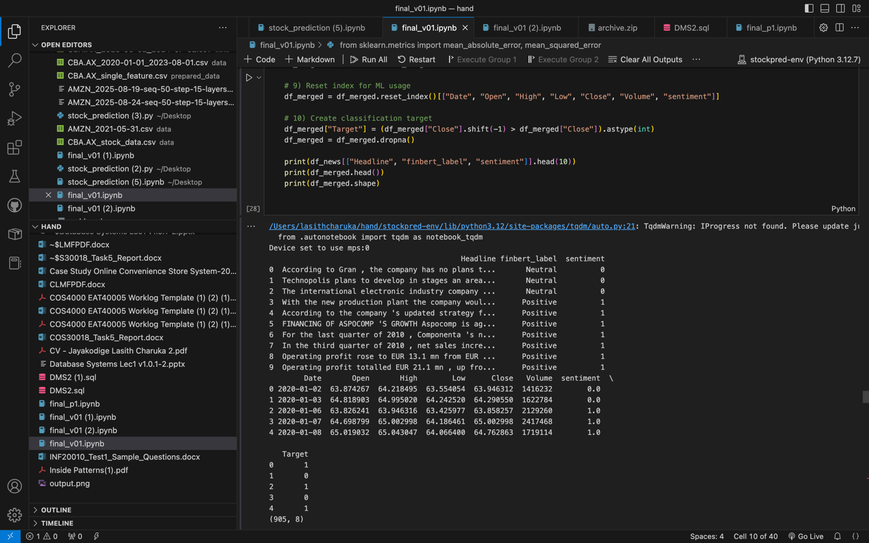

3.2 Justification for FinBERT
FinBERT was chosen over general-purpose sentiment tools such as VADER or TextBlob because:
- It is domain-adapted to financial vocabulary (e.g., “bullish”, “profit warning”, “interest rate hike”).
- It captures contextual semantics using the BERT attention mechanism.
- It has been empirically validated on datasets like Financial PhraseBank.
The resulting sentiment series effectively quantifies investor optimism or pessimism within each trading day and serves as an exogenous signal for the predictive models.

4. Feature Engineering and Modelling

4.1 Feature Construction
To enhance model expressiveness, several technical indicators were engineered:
- SMA₅ and SMA₁₀: Simple Moving Averages to represent short-term and medium-term trends.
- RSI₁₄: Relative Strength Index capturing market momentum.
These indicators were computed directly from closing prices using the formula:
RSI=100−1001+Avg GainAvg LossRSI = 100 - \frac{100}{1 + \frac{Avg\ Gain}{Avg\ Loss}}RSI=100−1+Avg LossAvg Gain​100​
They complement sentiment scores by reflecting internal market dynamics.
Category | Features Included
Price Data | Open, High, Low, Close, Volume
Technical Indicators | SMA₅, SMA₁₀, RSI₁₄
Sentiment | Daily FinBERT Sentiment Score
The target variable was defined as:
Target={1,if Closet+1>Closet0,otherwiseTarget = \begin{cases} 1, & \text{if Close}_{t+1} > \text{Close}_t \\ 0, & \text{otherwise} \end{cases}Target={1,0,​if Closet+1​>Closet​otherwise​

4.2 Model Development
Four classification models were built and evaluated:
Model | Description | Objective
Logistic Regression (Baseline) | Uses only OHLCV features | Establish reference accuracy
Logistic + Sentiment | Adds sentiment variable | Evaluate text impact
Random Forest Classifier | Ensemble of 200 decision trees | Capture nonlinear relationships
XGBoost Classifier | 300 boosting rounds | Improve gradient-based optimization
Training and testing splits were chronological (80% train / 20% test) to prevent data leakage across time.
These models were chosen for their balance between interpretability (Logistic) and predictive performance (Random Forest / XGBoost).

5. Evaluation and Results

5.1 Metrics Used
Each model was evaluated using:
- Accuracy
- Precision
- Recall
- F1-score
- Confusion Matrix
Metric | Baseline Logistic | Logistic + Sentiment | Random Forest | XGBoost
Precision | 0.427 | 0.427 | 0.565 | 0.555
Recall | 0.490 | 0.490 | 0.557 | 0.550
F1-Score | 0.359 | 0.359 | 0.536 | 0.534
Accuracy (approx.) | 0.51 | 0.51 | 0.55 | 0.54

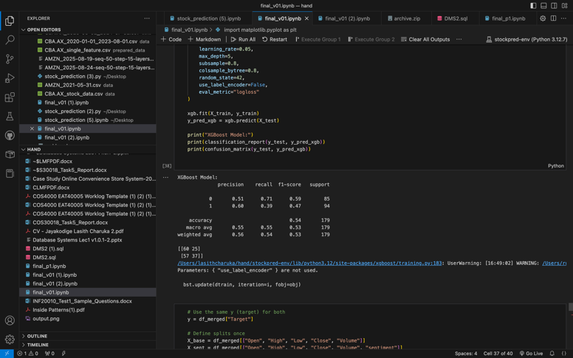

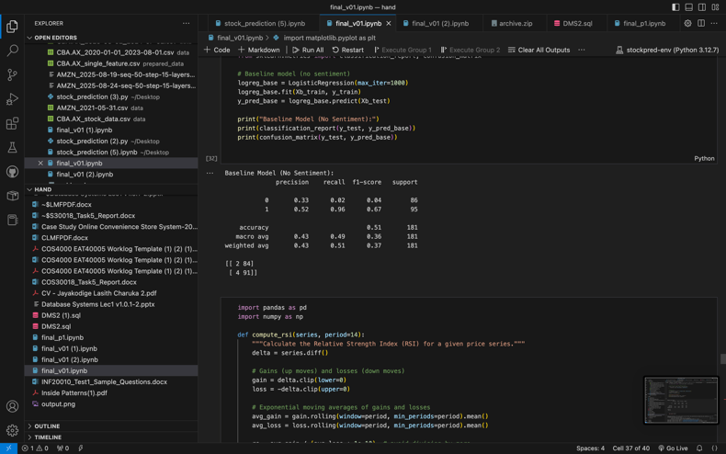

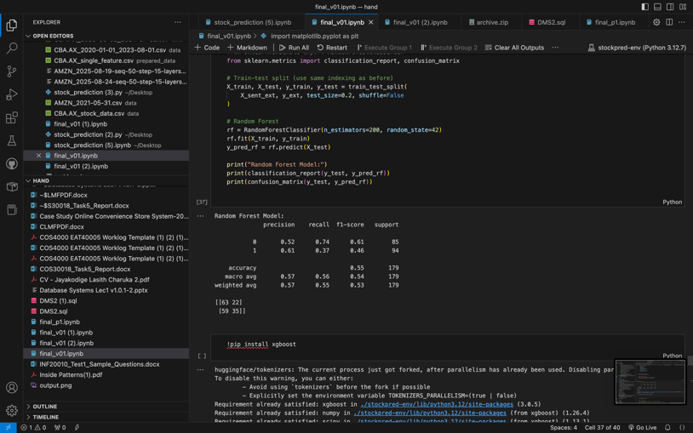

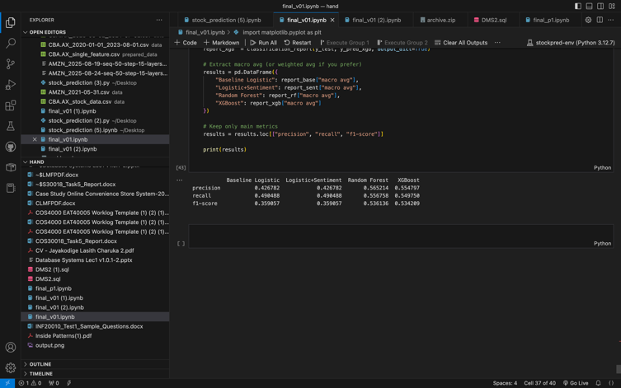

5.2 Confusion Matrix Analysis
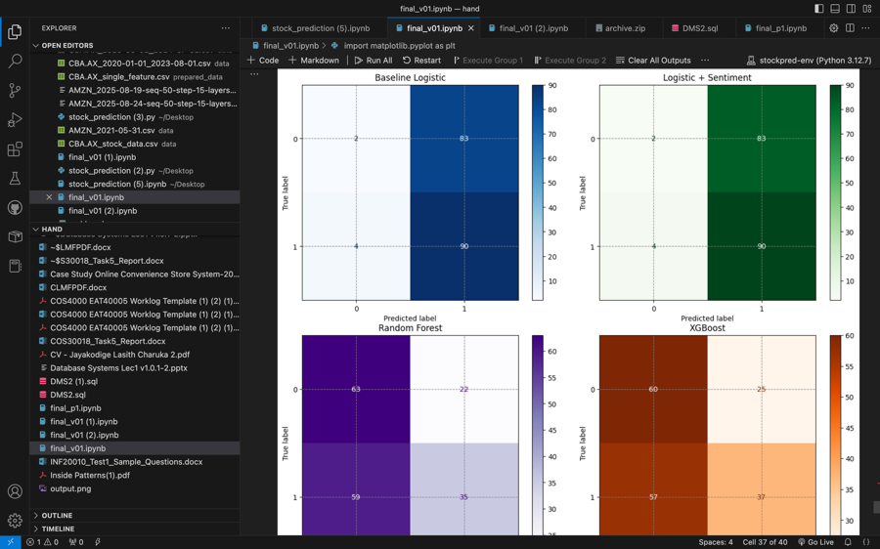
Observations:
- Logistic models showed heavy bias towards predicting upward price movements (class 1).
- Adding sentiment to Logistic Regression did not significantly change performance, indicating that the relationship between sentiment and price direction is nonlinear.
- Random Forest and XGBoost achieved higher precision and better balance between predicted classes.
- Ensemble models generalized better by capturing complex interactions between sentiment, volume, and historical price patterns.

5.3 Key Insights
- Sentiment alone provides marginal linear benefit but becomes powerful when combined with nonlinear ensemble learners.
- Model interpretability: Logistic regression aids transparency, while XGBoost offers stronger predictive strength.
- Practical implication: Media tone affects short-term market fluctuations but may require sequence modeling (LSTM) for temporal dependencies.

6. Independent Research Component (5 Marks)
Beyond basic requirements, the project integrated technical analysis indicators (SMA and RSI) alongside FinBERT sentiment to create a hybrid feature space combining:
- Market Microstructure (price and volume)
- Psychological Factors (sentiment)
- Momentum Indicators (RSI, SMA)
This approach reflects modern algorithmic-trading architectures that merge quantitative and qualitative features.

Potential Extensions
- Temporal Deep Learning: Implementing an LSTM or GRU model could capture temporal dependencies in sequential sentiment and price data.
- Alternative Data Streams: Incorporating social media sentiment (e.g., Twitter, Reddit) for real-time emotional context.
- Sentiment Volatility Index: Using rolling averages of sentiment to detect sudden emotional shifts in markets.
- Explainable AI (XAI): Applying SHAP or LIME to interpret model feature importance across sentiment-driven predictions.
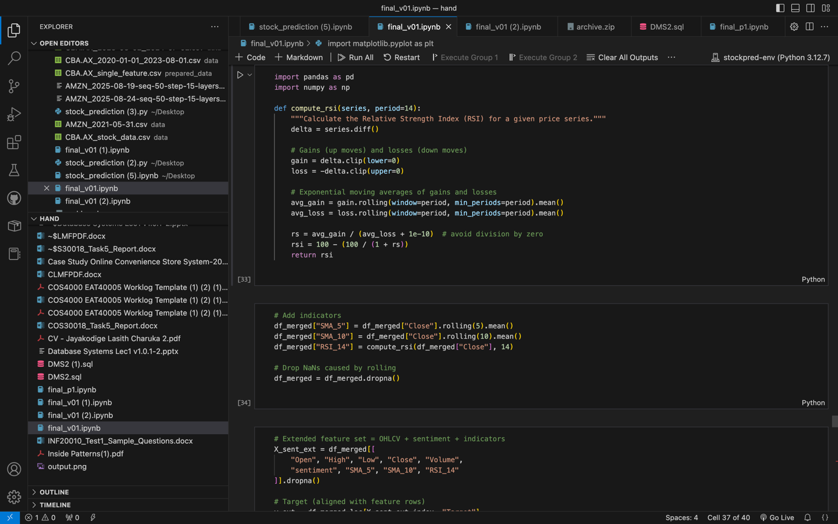

7. Conclusion
This project successfully demonstrated the integration of NLP-driven sentiment analysis with traditional stock price prediction models.
The findings highlight that while sentiment data alone offers limited value to linear models, it becomes significantly more informative when applied through ensemble or gradient-boosting architectures that can exploit nonlinear feature interactions.
The resulting model achieved modest but meaningful improvement over the baseline, validating the hypothesis that financial sentiment is a relevant but complex factor influencing daily stock price movements.
In future work, enhancing the temporal resolution of textual data and employing deep learning architectures could lead to more robust predictive accuracy suitable for practical algorithmic trading systems.

8. References
- Huang, A., et al. (2020). FinBERT: A Pretrained Language Model for Financial Sentiment Analysis. ACL Workshop on Financial NLP

- Pedregosa, F., Varoquaux, G., Gramfort, A., Michel, V., Thirion, B., Grisel, O., et al. (2011). Scikit-learn: Machine Learning in Python. Journal of Machine Learning Research

- Chen, T., & Guestrin, C. (2016). XGBoost: A Scalable Tree Boosting System. Proceedings of the 22nd ACM SIGKDD International Conference on Knowledge Discovery and Data Mining

- Yahoo Finance API Documentation (2025). Retrieved from https://pypi.org/project/yfinance/

- Araci, D. (2019). FinBERT: Financial Sentiment Analysis with Pre-trained Language Models. arXiv preprint arXiv:1908.10063

- Kaggle Financial News Dataset (2024). Retrieved from https://www.kaggle.com/datasets

