Efficient bitmap operations on high cardinality attributes for OLTP systems
Lasitha Weerasinghe, Kelum Deshapriya, Anushka Mahesh, Shemil Hashan and Dr. Amal Shehan Perera
Department of Computer Science and Engineering
University of Moratuwa
Katubedda, Sri Lanka
{lasitha.10, kelum.10, anushka.10, shemil.10 and shehan}@cse.mrt.ac.lk

Abstract – This research is done on the area of bitmap indexing on online transaction processing (OLTP) applications for high cardinality attributes. Generally bitmap indexing is not used in the case of high cardinality attributes because of the high space complexity. So our focus is to come up with a solution to reduce the space complexity while having the advantage of efficient access of data in OLTP applications.

Index Terms – Bitmap indexing, high cardinality, OLTP systems

I. Introduction
Bitmap index is a string of bits to indicate whether an attribute in a tuple is equal to a specific value or not for a one particular attribute [1]. For an example if we have an attribute to keep the gender of a particular set of people then we can keep two bitmaps to keeps the males and females and in the male bitmap only the records that are male will contain the value and similar thing applies to the female bitmap.
Bitmap indexing is not used very often in the area of online transaction processing due to the high overhead of maintaining the bitmap index. Also when the cardinality increases the normal bitmap index becomes inefficient because it needs more and more bitmaps to accommodate all the possible values.
There are three different approaches we can find in the literature named as binning, encoding and the compression for the case of handling high cardinality attributes. In this paper we are discuss the binning and encoding approach and evaluate the performance of them on top of the a model system.
The following sections of the paper discuss about the related work in the area, our implementation, complexity analysis and finally the results evaluation.
II. Related Work
Canahuate et.al.[2] have worked on the area of the bitmap indices for the OLTP systems and they have developed a solution which tries to give faster response time for the queries. They do that by padding the bitmaps early and increase the bitmap when the padded size is also full. They also pad the existence bitmaps which is used to keep track of deleted records from the database. A similar work has done by Philips et.al.[3] and we have used their system as the base system for our implementation work. Both of those solutions were able to perform insert, update and delete operations in O(1) time according to their amortized cost analysis.
When it comes to the high cardinality attributes there are three basic solutions in the literature named as binning, encoding and compression.
Maneewongvatana et.al.[4] have tried the binning solution and they suggest candidate test to filter out the irrelevant records from the results set because with binning there can be collisions in the record values and because of that several attribute values can be mapped on to the same bitmap index. Kung lu et.al.[5] discuss about a dynamically adjusting bin boundaries so that if the attribute values are skewed no particular bin will be highly collided while other bins remain vacant.
Ming Chuan et.al.[1] discuss about an interesting approach of encoding the different attribute values so that we can encode n different attribute values to just ceil(log2(n)) bitmaps. Kesheng et.al[6] discuss about compressing the bitmaps using two approaches named as Byte aligned bitmap code (BBC) and Word aligned hybrid (WAH).

III. Implementation
Our project is based on the previous work done by Philips et.al. [3]. But their work is thoroughly focused on the insert and update operations of the bitmaps but not on the read operations using that bitmap. Therefore as the initial work we have implemented the read operation on top of their model.
A. Read Operation
If we consider a execute query specific query which gives an output of several rows, this will have consume of time in disk reading to find those particular rows. So this an inefficient task to perform in an OLTP because if the result set is too long, it will show a significant delay for users. In order to reduce that for significant level, we have implement a simple machines to gain those result set quickly.
So our approach is to get data according indices in bitmap for that particular table which contain the row with needed details. This approach can be easily implement. First search through the bitmaps get the required bitmap according to the query. Then get the index of bit where it contain value one. After getting those it is able to get fast access to the data in database because those index provides the id values of the particular table. If the table is indexed then row access process will be much faster than a typical searching in database table. It already gather the id which is needed to query search. By having ids for particular rows, it is easy to access those particular row at an instance. Also, if table is indexed with ids then this process will gain a very effective access of data with great speed.
So to access those rows, a specific query need to be written. Consider a table contains details of workers. From the bitmap, it has taken the index of particular ids needed for search. It is needed all the details of worker for that query, so then query can run as below,
After executing this intermediate query to get the particular data sets, it is able to gain the result much faster than it has been. Because this mechanism directly uses the id which has been indexed or not. By giving direct access data, this provide a better speed in searching multiple rows rather than typical search.

B. Bitmap operations on high cardinality attributes
After implementing the read operation next we moved on to develop a solution for high cardinality attributes. We have implemented two basic solutions for that and evaluated the performances for both of the solutions.

- Binning
In the case of using bitmap indexes, we face the problem of curse of high cardinality. So for high-cardinality columns we can use bins to store the values. Each bin keeps multiple values and build the bitmaps to represent the values in the bins. In our case we initially create 100 bins. Record values are hashed before we put into a bin. So there might be few or more values which maps to the same bin. If we select a bin depending on the query, it might contain the unnecessary data which were matched to the bin after hashing. SO we have to do a checking on the base data, candidate checking, to get the correct results. But candidate checking cost is high. So the binned indexes exhibit irregular performance.

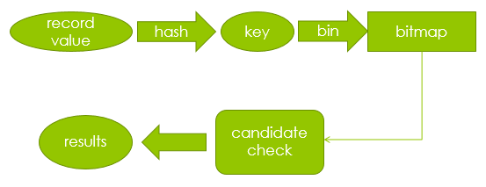
Fig. 1 Binning solution

- Encoding solution
The second approach we have tried is the encoding solution which tries to reduce the number of bitmaps required in a minimum level by encoding the key value and storing the attribute values in several bitmaps. For an example say we have a table T with a particular attribute ‘A’ which contains p, q and r as the attribute values. So in the general bitmap indexing implementation we have to keep 3 bitmaps to store them. But in this encoding solution we can store them in just two bitmaps by encoding the different key values. So p will be encoded as 00, q will be encoded as 01 and r will be encoded as 10. If we want to add q to the bitmaps index then we will add 0 to the bitmap 1 and a 0 to the bitmap 1. Then in order to map key values to the encoded values we have to keep a mapping table. The figure xx shows this concept in details.

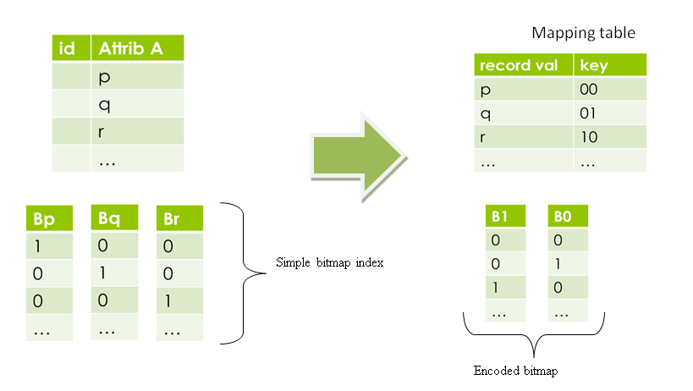
Fig. 2 Encoded bitmap index

So for an attribute which has a cardinality of ‘c’ it will only require bitmaps to represent all the possible attribute values.
When retrieving the results from this model we have to get the encoded value from the mapping table and according to that value we have to do AND operation on all the bitmaps to get the final bitmap for the actual bitmap for the table.

B. Complexity Analysis
- Space complexity
According to the model in both solutions the space requirement for storing a single bitmap is equal to number of entries plus a constant value to store additional metadata. Therefore for a single bitmap the space complexity would be . Then depending on the solution implemented (i.e. binning solution or the encoding solution) the total space complexity may vary. But when compared to the actual attribute values it is very small value. For an example for a varchar of 20 characters it takes approximately 8 * 20 bits per record max. But for the bitmaps its only one bit.

Binning solution
When it comes to the binning solution the total space complexity would be , where bin_count stands for the number of bins allocated in the memory to keep the bins. According to our implementation the bin_count would be a constant value (even though the cardinality may increase) and therefore the space complexity will be a function of n.
Encoding solution
In the encoding model when the cardinality increases the number of bitmaps required increases. Therefore the total space complexity would be where cardinality stands for the number of different attribute values in that bitmapped attribute. So ceiling value of that log value will give the number of bitmaps needed to encode all the different attribute values.

TABLE I
cardinality vs. the number of bitmaps required
Cardinality | Number of bitmaps required
1 | 1
2 | 1
3 | 2
4 | 2
5 | 3
10 | 4
20 | 5
50 | 6
100 | 7
500 | 9

The table xx shows how the number of bitmaps needed and as you can see it grows as a logarithmic function and it reduces the number of bitmaps needed drastically when the cardinality increases.
Apart from this main bitmap we need to keep a mapping table to map the key values to the actual bitmaps in this solution. That table has a space complexity of because for each different attribute we need to keep an entry in that table and for each entry there can be maximum of items.

- Time complexity
Similar to the space complexity when accessing data items it takes time to iterate through a simple bitmap. But depending on the solution it has to access different number of bitmaps to access a particular attribute value.

Binning solution
It only takes time to access a particular bitmap for attribute value but it returns non related results also in the binning solution due to the hash collisions. Therefore after retrieving the bitmap we have to do a candidate test on the results which is quite computationally expensive because rather than doing bit operations now it has to perform operations on actual attribute values.

Encoding solution
To retrieve a single attribute value we have to access all the bitmaps in this encoding solution. Therefore the time complexity would be. But since the number of bitmaps is a logarithmic function it would be a considerably small value when the cardinality increases.
But when accessing we have to get the mapping from the mapping table which also takes time. In our implementation we have used a hash table to store mapping values so the access time would be approximately constant, but if we have used a normal table the access time would be in the worst case. But we can speed up that by using a binary tree data structure.

IV. RESULTS
We tested our approaches with database which has several thousand data entries. We take average time in milliseconds (each average time bellow is taken using 10 samples). Read times of our approaches has been compared with normal read time of database. Y axis is represent time in millisecond and X axis represent number of reads performed.

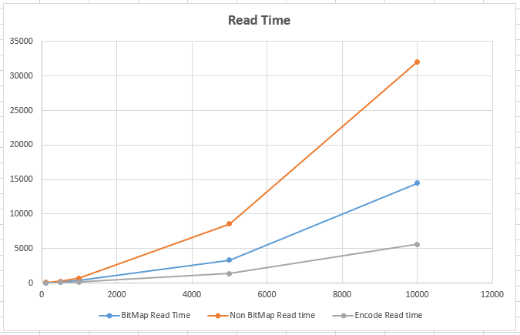
Fig. 3 Read Time Graph

According to the graph we can see that our both approach give better results than default reading of MySQL database. We also test our approach changing cardinality. Following graph show the result we get.

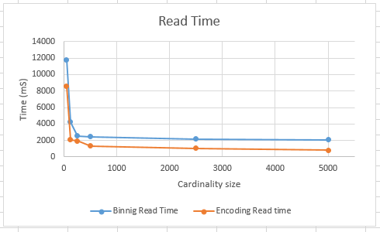
Fig. 4 Read Time Graph when cardinality change

According the result our both approaches behave almost same way when cardinality size increase and read time reduce as cardinality increase. We get these result for 1000 reads from table where more than 10000 entries has. But big problem with this is that the insert time growth when cardinality size increase. Following graph shows insertion time behavior when cardinality size increase.

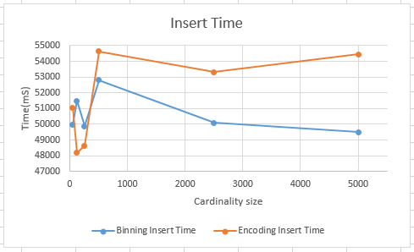
Fig. 5 Insertion Time Graph when cardinality change

This results show that using encoding method it take much time when cardinality increase than binning method. But binning method have higher reading time and space consumption than encoding method. So when consider all aspect encoding give better results than binning and default approach of MySQL database although it takes more time to insert than binning approach.

V. Conclusion
With the results we got we can conclude that bitmap indexing can be used successfully for the high cardinality attributes in the online transaction processing databases. But when the cardinality reduces or the data is skewed the binning solution will no longer suit because there will be higher number of collisions and we have to filter out so many unrelated entries from the results. The encoding solution will reduce its performance when the queries become complex because in order to do union, intersection or complement operations on attributes the same set of bitmaps will have to be accessed so many times.
Acknowledgment
We would like to thank Dr. Amal Shehan Perera, Senior Lecturer of the department of Computer Science and Engineering for the guidance and constant support throughout this project. Our sincere thank goes to the Department of Computer Science and Engineering, faculty of Engineering, University of Moratuwa for giving us the opportunity to carry out this project successfully.
References
- Wu, Ming-Chuan, and Alejandro P. Buchmann. "Encoded bitmap indexing for data warehouses." Data Engineering, 1998. Proceedings., 14th International Conference on. IEEE, 1998.
- Canahuate, Guadalupe, Michael Gibas, and Hakan Ferhatosmanoglu. "Update conscious bitmap indices." Scientific and Statistical Database Management, 2007. SSBDM'07. 19th International Conference on. IEEE, 2007.
- Philips, Rukshan, Dhananjaya and Balachandran. “Definitive customizable bitmap designing scheme”, Department of Computer Science and Engineering, University of Moratuwa. 2014.
- Maneewongvatana, Songrit. "Bitmap Index Partition Techniques for Continuous and High Cardinality Discrete Attributes." Department of Computer Engineering, King's Mongkut's University of Technology, Thailand (2003): 1-9.
- Wu, Kun-Lung, and Philip S. Yu. "Range-based bitmap indexing for high cardinality attributes with skew." Computer Software and Applications Conference, 1998. COMPSAC'98. Proceedings. The Twenty-Second Annual International. IEEE, 1998.
- Wu, Kesheng, Ekow Otoo, and Arie Shoshani. "On the performance of bitmap indices for high cardinality attributes." Proceedings of the Thirtieth international conference on Very large data bases-Volume 30. VLDB Endowment, 2004.

Because for a one attribute we need one bitmap

