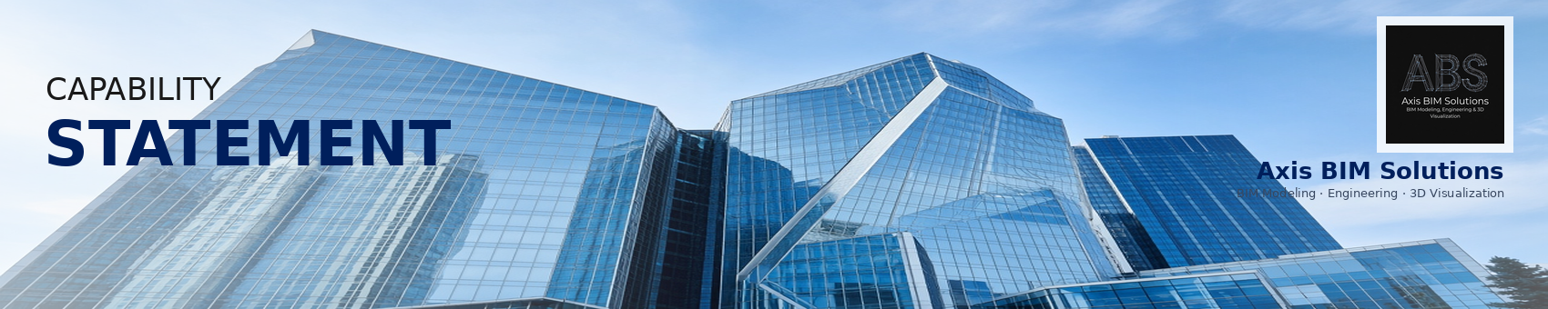

Axis BIM Solutions is a Warsaw-based BIM practice supporting owners, A/E firms and contractors when geometry, data and documents must stay consistent. We deliver engineering-grade model coordination, construction documents from the model, Scan to BIM for existing assets and BIM process implementation—on-site or remote across the EU.  Model coordination: Federate disciplines, run clash detection and keep the shared model under version control through design and construction.  Drawing production: Extract plans, sections, details and schedules from the model so permit and construction sets stay aligned with the geometry.  Scan to BIM: Capture existing conditions with point clouds and convert them into accurate as-built models for renovation, fit-out and verification.  BIM implementation: Define BEP, detail matrices, naming and responsibilities—then coach project teams until the workflow holds without constant oversight.  Commercial office: Multidisciplinary federation and weekly clash packages for a dense MEP office fit-out; reduced late design conflicts before CD freeze.  Multifamily housing: Corridor MEP coordination and repetitive-unit drawing extraction; aligned sheet sets with the live model through CD.  Industrial facility: Equipment clearance modelling and phased coordination reviews; IFC packages handed to the contractor CDE.  Institutional campus: Scan to BIM of existing wings plus deviation checks vs design; as-built model used for renovation packages. | WHY CHOOSE US?  Engineering focus  We treat BIM as delivery infrastructure—not visualisation theatre. Models, drawings and CDE rules stay aligned under project pressure.  Federated coordination  Discipline overlays, clash detection and issue tracking run as a weekly rhythm so conflicts are closed before documents freeze.  Scan to BIM expertise  Point cloud registration and as-built authoring for renovation and verification, with measurable deviation checks vs design.  Process that sticks  BEP, naming, RACI and pilot coaching so teams keep the workflow after handoff—not only during our engagement.  EU delivery  Warsaw-based, available on-site or remote across the EU for owners, A/E firms and contractors.  OUR DIFFERENTIATORS  • Model-first drawing production (plans, sections, schedules from the federated model)  • Clash detection tied to clear tolerances and coordination packages  • Scan to BIM for existing assets and renovation verification  • Authoring in Revit · AutoCAD · Tekla; coordination in Navisworks · Solibri  • CDE setup on Autodesk Construction Cloud / BIM 360  • Detail-level alignment, IFC exchange and as-built updates  CERTIFICATIONS & PLATFORM  • Authoring: Revit · AutoCAD · Tekla  • Coordination: Navisworks · Solibri  • CDE: Autodesk Construction Cloud / BIM 360  • Exchange: IFC and project-specific deliverable packages  • Sectors: Commercial · Multifamily · Industrial · Institutional
  WHO WE ARE
  CORE CAPABILITIES
  PAST PERFORMANCE

Phone: +48 22 555 01 48  Email: hello@axisbim.com  Website: axisbim.com  Address: Warsaw, Poland · EU remote |   Scan for the website  axisbimsolutions.com

