--Використато PostgreSQL

--DB creation  
create database airbusiness;  
  
create table if not exists clients (  
 id serial primary key,  
 firstname varchar(50) not null,  
 lastname varchar(50) not null,  
 gender varchar(50) not null,  
 phoneNumber varchar(50) not null,  
 email varchar(50) not null  
);  
  
create table if not exists cities (  
 id serial primary key,  
 cityName varchar(100) not null,  
 location varchar(100) not null  
);  
  
create table if not exists planes (  
 id serial primary key,  
 planeName varchar(100) not null,  
 passengersCapacity int not null  
);  
  
create table if not exists flights (  
 id serial primary key,  
 dispatch int not null,  
 destination int not null,  
 plane_id int not null,  
 departure_time timestamptz not null,  
 arrival_time timestamptz not null,  
 status int not null,  
 foreign key (dispatch) references cities(id),  
 foreign key (destination) references cities(id),  
 foreign key (plane_id) references planes(id)  
);  
  
create table if not exists classes (  
 id serial primary key,  
 className varchar(50) not null  
);  
  
create table if not exists tickets (  
 id serial primary key,  
 flight_id int not null,  
 place int not null,  
 class_id int not null,  
 price float4 not null,  
 foreign key (flight_id) references flights(id),  
 foreign key (class_id) references classes(id)  
);  
  
create table if not exists client_tickets (  
 client_id int not null,  
 ticket_id int not null,  
 selled_at timestamptz not null,  
 foreign key (client_id) references clients(id),  
 foreign key (ticket_id) references tickets(id)  
);

Список квитків з даними клієнта.

select ct.client_id, ct.ticket_id,c.firstname, c.lastname, c.gender,  
 c.email, c.phoneNumber, t.place, t.price, t.flight_id, f.departure_time,  
 f.arrival_time, c1.cityName as departure, c2.cityName as destination  
 from client_tickets ct  
 join clients c on c.id = ct.client_id  
 join tickets t on t.id = ct.ticket_id  
 join flights f on f.id = t.flight_id  
 join cities c1 on c1.id = f.dispatch  
 join cities c2 on c2.id = f.destination;

Останні 5 проданих квитків

select ct.ticket_id, ct.selled_at, t.price, t.place, t.class_id from client_tickets ct  
 join tickets t on t.id = ct.ticket_id  
 order by selled_at desc limit 5;

Топ 3 клієнтів за частотою польотів

select *count*(f.id), ct.client_id from flights f  
 join tickets t on f.id = t.flight_id  
 join client_tickets ct on t.id = ct.ticket_id  
 where f.status = 3  
group by client_id order by *count*(f.id) desc limit 3;

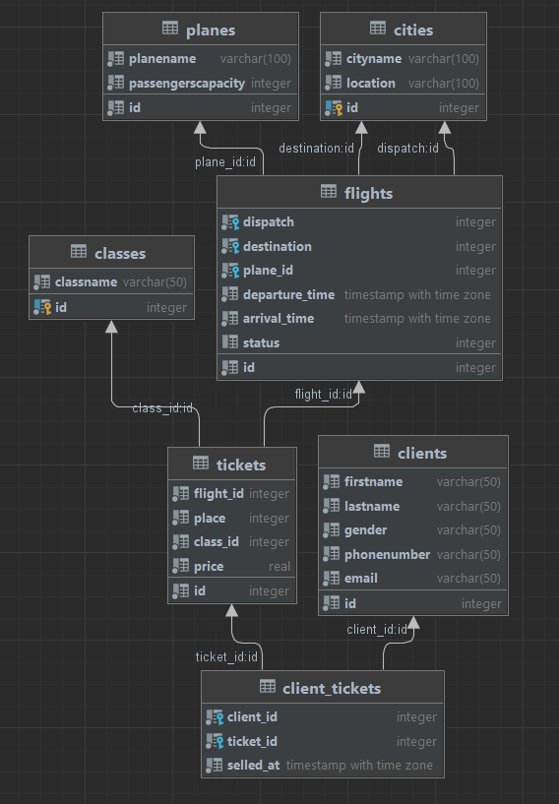

Схема бази даних