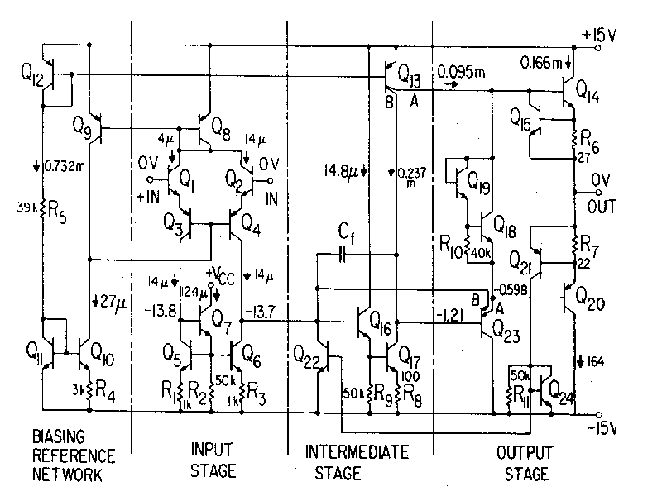

n-p-n device (1)

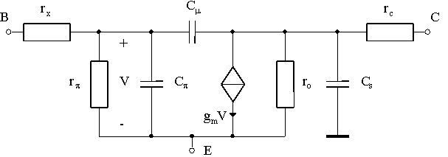

n-p-n device (1)



Substrate p-n-p device (3)

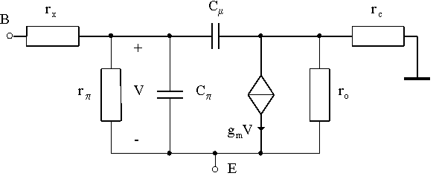

1. n-p-n device
2. lateral p-n-p device
3. substrate p-n-p device

|  |  |  |  |  |  |  |  |  |
| --- | --- | --- | --- | --- | --- | --- | --- | --- |
| **BJT** | **gm** | **r** | **rx** | **ro** | **C** | **Cµ** | **Cs** | **rc** |
| Q1 (1) | 0.489 | 455 | 0.670 | 15100 | 1.65 | 0.112 | 1.42 | 0.300 |
| Q2 (1) | 0.488 | 456 | 0.670 | 15200 | 1.65 | 0.112 | 1.42 | 0.300 |
| Q3 (2) | 0.514 | 165 | 0.500 | 4890 | 14.3 | 0.342 | 2.26 | 0.150 |
| Q4 (2) | 0.470 | 181 | 0.500 | 5340 | 13.1 | 0.345 | 2.26 | 0.150 |
| Q5 (1) | 0.484 | 427 | 0.670 | 14200 | 1.64 | 0.273 | 1.42 | 0.300 |
| Q6 (1) | 0.484 | 427 | 0.670 | 14200 | 1.64 | 0.247 | 1.42 | 0.300 |
| Q7 (1) | 0.470 | 510 | 0.670 | 16900 | 1.62 | 0.09 | 1.42 | 0.300 |
| Q8 (2) | 0.882 | 71.9 | 0.500 | 2230 | 24.4 | 1.05 | 2.26 | 0.150 |
| Q9 (2) | 1.13 | 71.9 | 0.500 | 2230 | 31.2 | 0.32 | 2.26 | 0.150 |
| Q10 (1) | 1.2 | 181 | 0.670 | 6090 | 2.49 | 0.112 | 1.42 | 0.300 |
| Q11 (1) | 21.5 | 5.11 | 0.670 | 245 | 25.9 | 0.447 | 1.42 | 0.300 |
| Q12 (2) | 15.3 | 0.813 | 0.500 | 81.2 | 419 | 1.13 | 2.26 | 0.150 |
| Q13A (1) | 3.65 | 3.78 | 0.100 | 879.5 | 100 | 0.3 | 2.26 | 0.080 |
| Q13B (1) | 9.11 | 1.62 | 0.160 | 352.5 | 250 | 1.0 | 2.26 | 0.120 |
| Q14 (1) | 6.07 | 67.4 | 0.185 | 1770 | 9.67 | 0.485 | 3.46 | 0.015 |
| Q15 (1) | 5E-11 | 2E+11 | 0.670 | 3E+10 | 0.65 | 0.36 | 1.42 | 0.300 |
| Q16 (1) | 0.571 | 418 | 0.670 | 13900 | 1.74 | 0.09 | 1.42 | 0.300 |
| Q17 (1) | 8.04 | 24.2 | 0.670 | 760 | 10.4 | 0.09 | 1.42 | 0.300 |
| Q18 (1) | 2.89 | 66 | 0.670 | 2290 | 4.46 | 0.273 | 1.42 | 0.300 |
| Q19 (1) | 0.628 | 326 | 0.670 | 1090 | 1.4 | 0.36 | 1.42 | 0.300 |
| Q20 (3) | 5.2 | 19.6 | 0.080 | 457 | 144 | 1.25 | N/A | 0.156 |
| Q21 (2) | 8E-11 | 6.6E+10 | 0.500 | 6.7E+8 | 1.05 | 0.1 | 2.26 | 0.150 |
| Q22 (1) | 2E-15 | 2E+11 | 0.670 | 9.5E+8 | 0.65 | 0.3 | 1.42 | 0.300 |
| Q23A (3) | 2.41 | 131 | 1.100 | 998 | 65.7 | 1.09 | N/A | 0.170 |
| Q23B (3) | 2E-15 | 2E+11 | 0.650 | 9.5E+8 | 1.9 | 2.4 | N/A | 0.100 |
| Q24 (1) | 2E-15 | 2E+11 | 0.670 | 9.5E+8 | 0.65 | 0.36 | 1.42 | 0.300 |