Boilerplate – Webpack

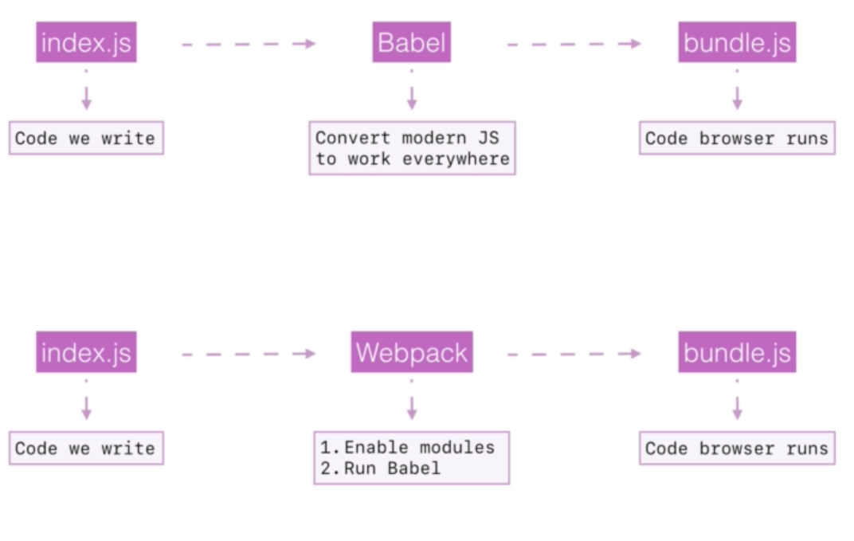

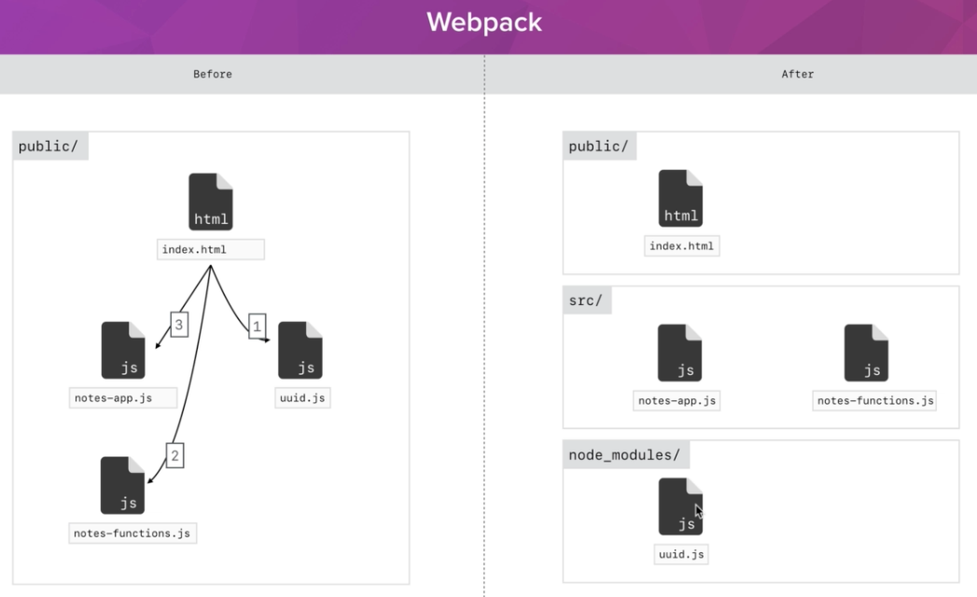

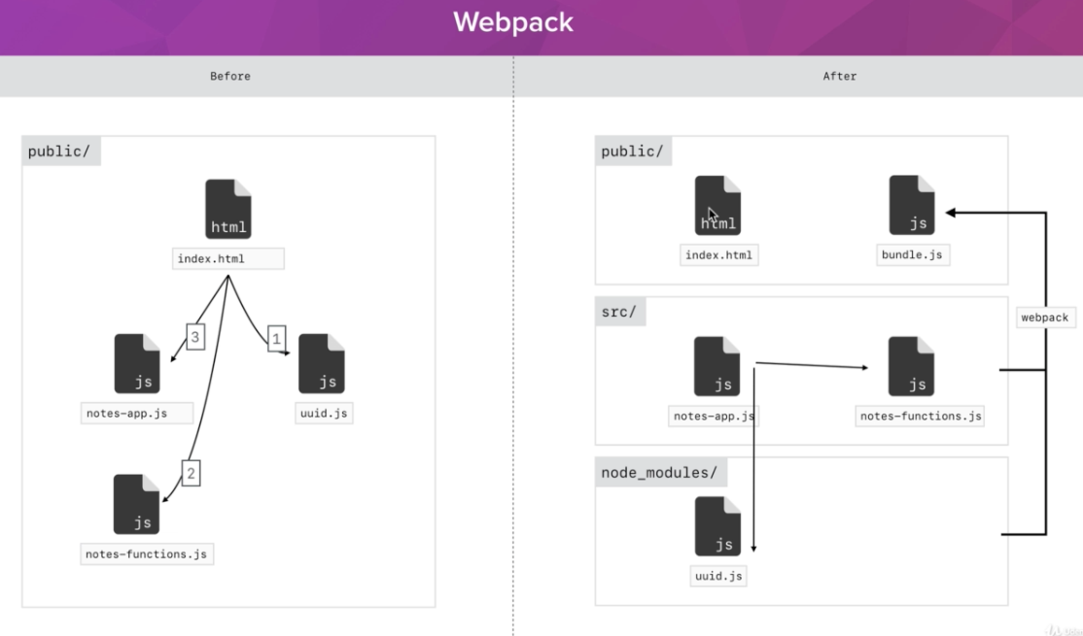

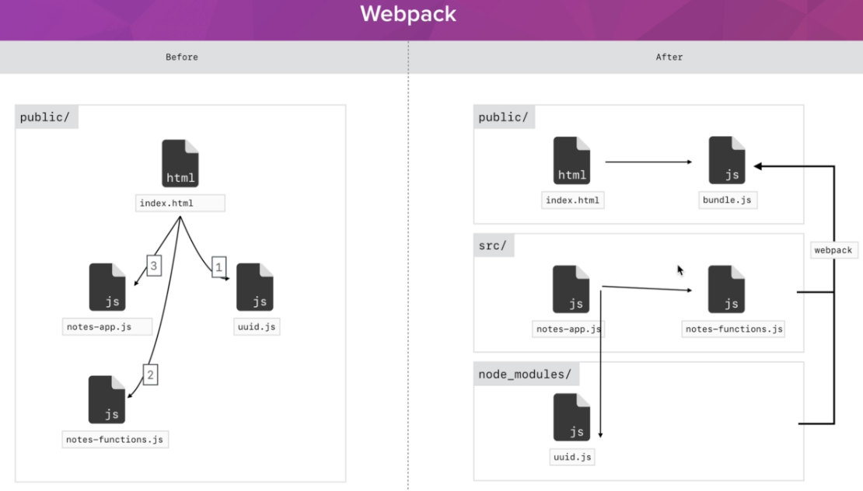

webpack.config.js

const path = require('path')

module.exports = {
entry: './src/index.js',
output: {
path: path.resolve(__dirname, 'public/scripts'),
filename: 'bundle.js'
},
module: {
rules: [{
test: /\.js$/,
exclude: /node_modules/,
use: {
loader: 'babel-loader',
options: {
presets: ['env']
}
}
}]
},
devServer: {
contentBase: path.resolve(__dirname, 'public'),
publicPath: '/scripts/'
}
}

package.json

{
"name": "boilerplate",
"version": "1.0.0",
"description": "",
"main": "input.js",
"scripts": {
"dev-server": "webpack-dev-server --mode development",
"build": "webpack --mode production"
},
"author": "",
"license": "ISC",
"dependencies": {
"babel-cli": "^6.26.0",
"babel-loader": "^7.1.4",
"babel-preset-env": "^1.6.1",
"live-server": "^1.2.0",
"webpack": "^4.5.0",
"webpack-cli": "^2.0.14",
"webpack-dev-server": "^3.1.3"
}
}

If you want to run new build: run build – makes the bundle (not virtual)

About boilerplate

- without node modules, use npm install

- ReferenceError: regeneratorRuntime is not defined
- /hangman$ npm install babel-polyfill$6.26.0

3th party libraries e.g. npm validator

- npm install uuid, import uuidv4 from 'uuid/v4'
- npm install validator, import validator from 'validator';

- npm uninstall uuid validator (if not used)

- npm install moment

Websites to deploy:

- Netlify
- Surge

Hangman to webpack:

- copy boilerplate to new name and source to *.old
- copy: images and styles dir to 'boilerplate' public
- copy index.html into 'boilerplate' index.html
delete other script tag leave just: <script src="/scripts/bundle.js"></script>
- copy src/ app.js to index.html
- copy hangman.js and requests.js to src/
- add exports in source files and imports to src/index.js
- run npm install
- install: npm install babel-polyfill

Todo-app to webpack:

- copy boilerplate to new name and source to *.old
- copy: images and styles dir to 'boilerplate' public
- copy challenge setup dir to src/
- filters, todos, views and index.js in this order
- importint stuff from todo-app-old to new one
diffuculties were withi const filteredTodos in views.js

const filteredTodos = todos.filter((todo) => {
const searchTextMatch = todo.text.toLowerCase().includes(filters.searchText.toLowerCase())
const completedMatch = !filters.completed || !todo.completed

return searchTextMatch && completedMatch
})
const incompleteTodos = filteredTodos.filter((todo) => !todo.completed)

todoEl.innerHTML = ''
document.querySelector('#todos').appendChild(generateSummaryDOM(incompleteTodos))
- and with some functions without parameters after change

Notes-app to webpack

- copy boilerplate to new name and source to *.old
- copy images and styles to public-dir
- copy index.html and edit.html to public-dir
- create edit.js to src/
- edit webpack.config.js

entry: ['babel-polyfill', './src/index.js'],
output: {
path: path.resolve(__dirname, 'public/scripts'),
filename: 'bundle.js'
},

to ->

entry: {
index: ['babel-polyfill', './src/index.js'],
edit :['babel-polyfill', './src/edit.js']
},
output: {
path: path.resolve(__dirname, 'public/scripts'),
filename: '[name]-bundle.js'
},

- edit.html and index.html: <script src="/scripts/edit-bundle.js"></script>
- create new file notes.js to src/
- npm install moment uuid
- edit functions to notes.js file
- getNotes changed to loadNotes, new functions getNotes and copied createNotes,saveNotes, sortNotes, updateNote from notes-app and notes-functions
- new file to src/ filters.js (15 lines of code)
- new file to src/ views.js to which generateNoteDom, renderNotes and generateLastEdited
- copy everything from notes-app.js to index.js - do editing
- copy everything from notes-edit.js to edit.js - do editing

Some qustions concerning Recipe-app:

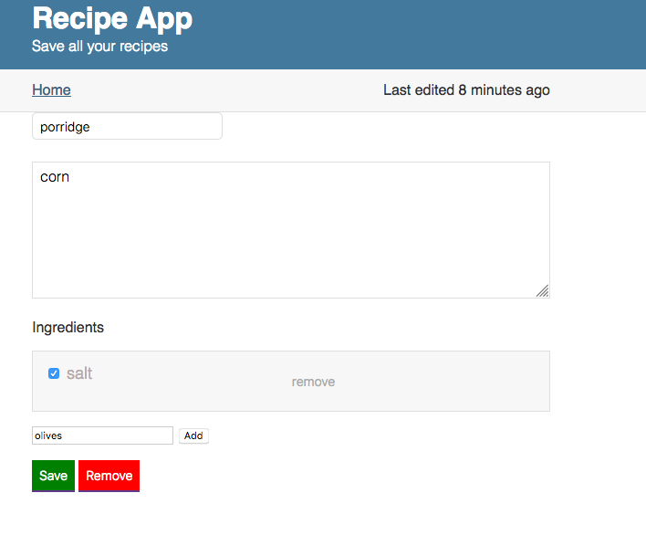
Running the app on Firefox, somehow the every-prototype doesn't work on chrome when testing locally on Mac.
On the other hand, on Netlify it works also with chrome – giving some errors (also with firefox) e.g
-adding ingredient:
ReferenceError: generatelastEdited is not defined edit.js:31:4
-deleting ingredient:
views.js:57 Uncaught TypeError: Cannot set property 'innerHTML' of null views.js:57

what might be the reason.

Trying to remove ingredient the window doesn't upgrade and the input area doesn't go
blank. And well the checkbox button works as a 'pointed handle' but remove is active in the
whole area.

There are also some mysterious reference errors while running the app.

