Table of Contents

[Project Wether App 2](#_Toc99912569)

[Testing Plan 2](#_Toc99912570)

[Project Background 2](#_Toc99912571)

[Project Illustration 2](#_Toc99912572)

[Application interface – mobile phone (Gayatri) 3](#_Toc99912573)

[Iot -interface (Suman) 3](#_Toc99912574)

[End-to-end testing (Nithya) 3](#_Toc99912575)

[Cloud interface (Lauri) 3](#_Toc99912576)

[The main diagram types in UML 4](#_Toc99912577)

[What about the followings would we need? 4](#_Toc99912578)

[UML-design 4](#_Toc99912579)

[Nithya´s notes 6](#_Toc99912580)

[What kind of document selection we have time to produce 8](#_Toc99912581)

[AccuWeather user Azure plus other MS services 8](#_Toc99912582)

[About the links 9](#_Toc99912583)

[Slack discussions 9](#_Toc99912584)

[RobotFramework 9](#_Toc99912585)

[CodeClinic 10](#_Toc99912586)

[List of Testing Tools 10](#_Toc99912587)

# Project Wether App

## Testing Plan

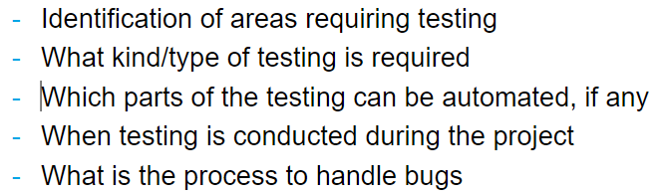

## Project Background

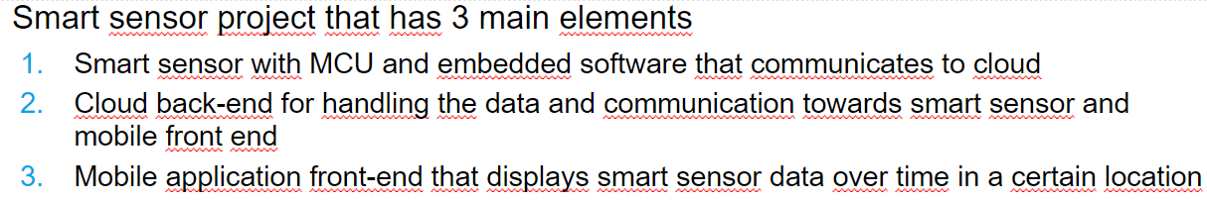

## Project Illustration

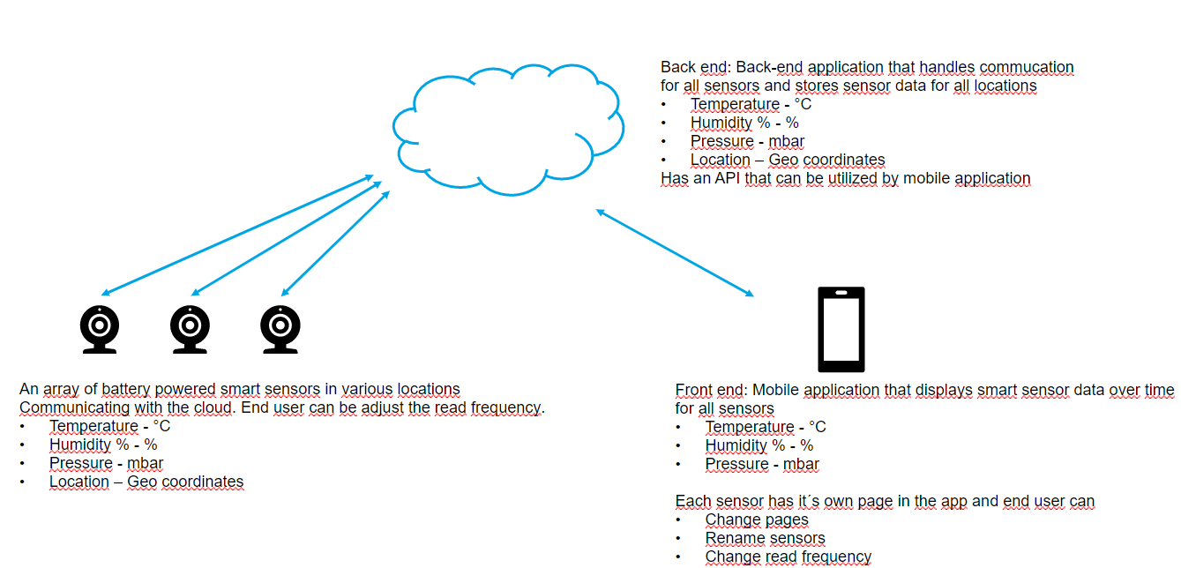

# Application interface – mobile phone (Gayatri)

Is the App a special kind of app like loading from Appstore or Google Store?

Or can it be used also on PCs and browsers within OAuth logins?

In latter case maybe more testing is needed?

Send test request to Iot-sensors to test they functionality?

# Iot -interface (Suman)

What kind of data sensors send, should be possible to send direct JSON-data?

What about GPS data?

# End-to-end testing (Nithya)

How it is done, with which testing tools, scripts?

# Cloud interface (Lauri)

How to test, with which test tools, input? Output is API interface?

API can be integrated to the cloud, so the other interface to test is API?

How to test that sample/raw input data gets correctly to out to API-interface?

IoT -------- gateway ---- Cloud---------------mobile app

* Functionality
* Reliability
* Usability
* Efficiency
* Maintainability
* Portability
* Security testing

Different mobiles & browser – Jenkins + Robot Framework + IntelliIJ

## The main diagram types in UML

structure diagrams and behavior diagrams

### What about the followings would we need?

* Structure Diagrams
  + [Class Diagram](https://creately.com/blog/diagrams/uml-diagram-types-examples/#ClassDiagram)
  + [Component Diagram](https://creately.com/blog/diagrams/uml-diagram-types-examples/#ComponentDiagram)
  + [Deployment Diagram](https://creately.com/blog/diagrams/uml-diagram-types-examples/#DeploymentDiagram)
  + [Object Diagram](https://creately.com/blog/diagrams/uml-diagram-types-examples/#ObjectDiagram)
  + [Package Diagram](https://creately.com/blog/diagrams/uml-diagram-types-examples/#PackageDiagram)
  + [Profile Diagram](https://creately.com/blog/diagrams/uml-diagram-types-examples/#ProfileDiagram)
  + [Composite Structure Diagram](https://creately.com/blog/diagrams/uml-diagram-types-examples/#CompStrDiagram)
* Behavioral Diagrams (could be devided into behavior and interaction)
  + [Use Case Diagram](https://creately.com/blog/diagrams/uml-diagram-types-examples/#UseCaseDiagram)
  + [Activity Diagram](https://creately.com/blog/diagrams/uml-diagram-types-examples/#ActivityDiagram)
  + [State Machine Diagram](https://creately.com/blog/diagrams/uml-diagram-types-examples/#StateMachDiagram)
  + [Sequence Diagram](https://creately.com/blog/diagrams/uml-diagram-types-examples/#SequenceDiagram)
  + [Communication Diagram](https://creately.com/blog/diagrams/uml-diagram-types-examples/#CommDiagram)
  + [Interaction Overview Diagram](https://creately.com/blog/diagrams/uml-diagram-types-examples/#IntOverDiagram)
  + [Timing Diagram](https://creately.com/blog/diagrams/uml-diagram-types-examples/#TimingDiagram)

## UML-design

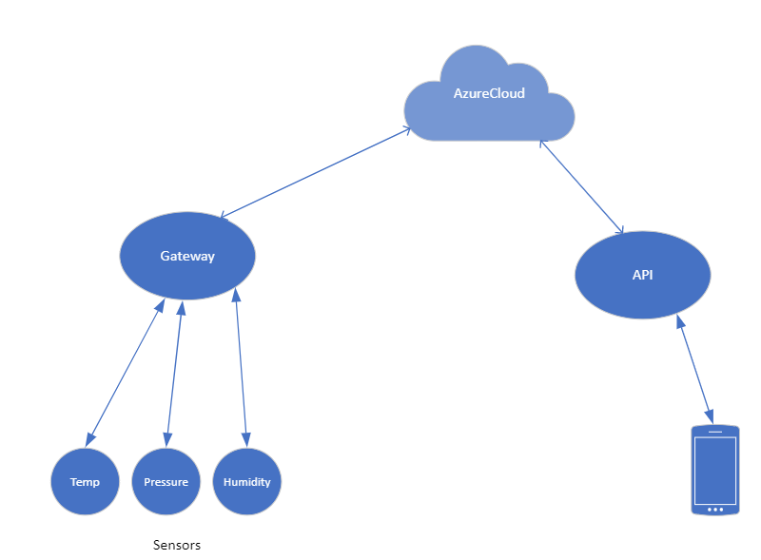

Picture\_1 Basic layout

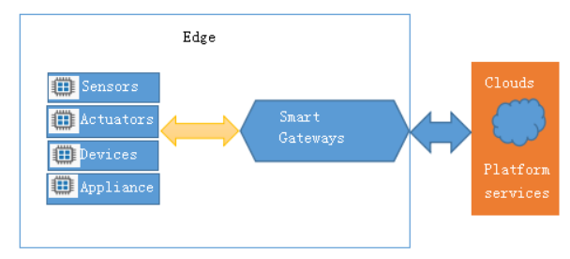

Picture 2 Iot Gateway

An IOT gateway is a hardware device with a script running on it or an individual software program that serves as a mediator between the cloud and physical sensors, computing devices and control systems.

The data flow is mainly towards the cloud but can also be to and fro in cases where actuation is required . Sensors may generate thousands of data points per second.

An edge connects an internal local area network (LAN) with the Internet.

A gateway facilitates to pre-process the data locally at the edge before sending it on to the cloud. When data is aggregated, summarized and analyzed at the edge, it minimizes the volume of data that needs to be forwarded on to the cloud, which can have a big impact on response time.

Gateways also provide security to the data flowing to the cloud through firewalls, tamper detection, encryption, PKI, etc.

Types:

IoT gateways can depend on Ethernet, WiFi or on GSM for their network connectivity.

IoT gateways use protocols such as MQTT, HTTP/S, REST, TCP, etc to send data to the cloud.

The gateways can be controller based or can even possess a processor which adds to modulation and modification of the functioning, speed and computing capability.

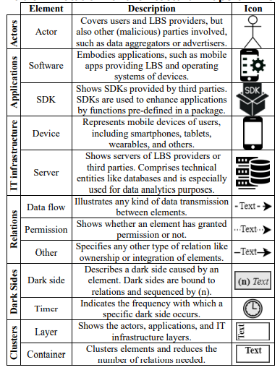

Picture 3 from conference paper 2021 <https://www.researchgate.net/publication/346317687>

## Nithya´s notes

Food Processing Industries :: cause food poisoning, check food quality and safety,freshness evaluation.

y its needed :: avoid food  borne  and  water  borne  pathogens,  toxins  and  pesticide  residues  with  high specificity.

IoT ------------ Cloud---------------mobile app

Testing to be done at each module.

IoT :: Gray box testing (limited knowledge on sensor) for functionality testing

       security testing :: (include device authentication, data collection, transmission,software)

       Sensor-protocol compatibility testing: wifi,bluetooth (efficient communication and interaction between devices and servers. )

       Device-to-Cloud connectivity testing: test data capture, data transfer and data storage between the device and the cloud.

       Network performance testing: scalability,stabilty,performance,

       AUTOMATION

cloud ::

Cloud services integration testing: IoT and cloud

Cloud security testing:

Cloud migration testing:migration between device or

Cloud connectivity testing:

AUTOMATION ??

application::

Web/mobile functional testing:the application is tested on both web and mobile consoles to check whether it is working properly

End-to-end system & integration testing : The entire application is tested in a real-world scenario to ensure smooth interaction between the front-end (UI) and the back-end (database).

API/SDK testing: integration with third-party IoT devices and the ecosystem

AUTOMATION

## What kind of document selection we have time to produce

* UserDocument
* ChangeManagement
* ConfigurationManagement
* ProjectDocument
* Requirements
* TestPlan
* TestReport

## AccuWeather user Azure plus other MS services

Next the company moved its big data storage and processing, using services such as [Azure Blob storage](https://azure.microsoft.com/en-us/services/storage/blobs/), [Azure Data Factory](https://azure.microsoft.com/en-us/services/data-factory/), and [Azure SQL Database](https://azure.microsoft.com/en-us/services/sql-database/).

# About the links

<https://www.accuweather.com/>

<https://www.researchgate.net/publication/346317687>

## Slack discussions

### RobotFramework

[**Robin**](https://app.slack.com/team/U8WMN4Q8M)**:flag-nl:**  [1 day ago](https://robotframework.slack.com/archives/C07PJM876/p1648897970773899?thread_ts=1648897577.733519&cid=C07PJM876)

That depends entirely on your interfaces. RF is an extendable framework, so it can integrate with anything that you can integrate with using Python. In your image, you could integrate with / plug into any of the components, given a Python-compatible interface.Now the Sensor is interesting: will it be a physical sensor? Will you simulate it (i.e. create a simulator that communicates with the Gateway, so you can in your scripts set the value reported to the Gateway)? Does the MPhone have an interface you can hook into?

white_check_markeyesraised_hands



[**Lauri Kyttälä**](https://app.slack.com/team/U031HJQ4BJ6)  [1 day ago](https://robotframework.slack.com/archives/C07PJM876/p1648904863115219?thread_ts=1648897577.733519&cid=C07PJM876)

Hi Robin, the sensor for humidity, temperature and pressure will be physical connected to Gateway. I was thinking in this scenario that mobile phone frontend-app reads the sensor data as JSON showing it on either browser or app's own window.  - So anyways in this scenario I think I would use also other tools than RF? Please I'm new with Iot, could you help me a bit with this.



[**Robin**](https://app.slack.com/team/U8WMN4Q8M)**:flag-nl:**  [1 day ago](https://robotframework.slack.com/archives/C07PJM876/p1648906824203329?thread_ts=1648897577.733519&cid=C07PJM876)

To read the value from the browser you can use the Browser library ([#browser](https://robotframework.slack.com/archives/C015KB1QSDN)) or SeleniumLibrary ([#seleniumlibrary](https://robotframework.slack.com/archives/C07PKKCTF)). For the JSON, there's RESTinstance or RequestLibrary ([#requests](https://robotframework.slack.com/archives/C3S6SGYTD)) and to interact with a mobile phone there's AppiumLibrary ([#appiumlibrary](https://robotframework.slack.com/archives/C15B82CLW))

### CodeClinic

[**Pawel**](https://app.slack.com/team/UPVBALVFG)****  [1 day ago](https://koodiklinikka.slack.com/archives/C03GN732H/p1648893706409669?thread_ts=1648890375.742259&cid=C03GN732H)

Ole hyvä:  
<https://koodiklinikka.slack.com/archives/C03GN732H/p1648715449897279>Eli Playwright web-testaukseen ja Robot Framework kaikkeen muuhun olisi sellainen erittäin hyvä valinta jo.

white_check_markeyesraised_hands



[**Pawel**](https://app.slack.com/team/UPVBALVFG)****  [1 day ago](https://koodiklinikka.slack.com/archives/C03GN732H/p1648893718052279?thread_ts=1648890375.742259&cid=C03GN732H)

Myös tällainen keskustelu:  
<https://koodiklinikka.slack.com/archives/C1BUPTTL0/p1648722240948789>

## List of Testing Tools

Etteplan\_testing\_tools  
  
<https://www.valagroup.com/wp-content/uploads/2021/12/software-qualit_53686470-compressed.pdf>  
  
<https://www.valagroup.com/wp-content/uploads/2021/12/software-qualit_53686470-compressed.pdf>  
  
<https://jmeter.apache.org/>  
  
<https://www.wireshark.org/>  
  
TestRail: <https://www.gurock.com/testrail/qa-tools/?utm_campaign=gg_dg_eu1_search_generic_medium_intent&utm_source=google&utm_medium=cpc&utm_content=qa_tools&utm_term=software%20qa%20testing%20tools&gclid=Cj0KCQjw6J-SBhCrARIsAH0yMZgs1IxYG58hXv5QHiTVyDqowc9P4nhDUiV3wOhsYFDZwOBQT-WaQ3MaAnuEEALw_wcB>  
  
List of testing tools google search:  
[https://www.google.com/search?q=list+of+software+testing+tools&oq=list+of+software+testing+&aqs=chrome.1.69i57j0i19l9.12396j0j7&sourceid=chrome&ie=UTF-8](https://www.google.com/search?q=list%20of%20software%20testing%20tools&oq=list%20of%20software%20testing%20&aqs=chrome.1.69i57j0i19l9.12396j0j7&sourceid=chrome&ie=UTF-8&authuser=0)  
  
testing tools for cloud api list:  
[https://www.google.com/search?q=testing+tools+for+cloud+api+list&sxsrf=APq-WBsdNxu4R8THRlXk7o3UPmxc4XYkzA%3A1648899873171&ei=ITdIYtL9CYi\_rgSB9q\_4BQ&ved=0ahUKEwiSktfZpvX2AhWIn4sKHQH7C18Q4dUDCA4&uact=5&oq=testing+tools+for+cloud+api+list&gs\_lcp=Cgdnd3Mtd2l6EAM6BwgAEEcQsAM6BwgjELACECc6BggAEAcQHjoICAAQCBAHEB46BQgAEMsBOgYIABAFEB46BggAEAgQHkoFCDwSATJKBAhBGABKBAhGGABQ8gZYg3tg5okBaAJwAXgAgAH-AYgBlBSSAQYxMC44LjOYAQCgAQHIAQjAAQE&sclient=gws-wiz](https://www.google.com/search?q=testing%20tools%20for%20cloud%20api%20list&sxsrf=APq-WBsdNxu4R8THRlXk7o3UPmxc4XYkzA%3A1648899873171&ei=ITdIYtL9CYi_rgSB9q_4BQ&ved=0ahUKEwiSktfZpvX2AhWIn4sKHQH7C18Q4dUDCA4&uact=5&oq=testing%20tools%20for%20cloud%20api%20list&gs_lcp=Cgdnd3Mtd2l6EAM6BwgAEEcQsAM6BwgjELACECc6BggAEAcQHjoICAAQCBAHEB46BQgAEMsBOgYIABAFEB46BggAEAgQHkoFCDwSATJKBAhBGABKBAhGGABQ8gZYg3tg5okBaAJwAXgAgAH-AYgBlBSSAQYxMC44LjOYAQCgAQHIAQjAAQE&sclient=gws-wiz&authuser=0)  
  
  
<https://www.testim.io/blog/the-9-api-testing-tools-you-cant-live-without-in-2019-2/>  
  
Iot sensor data format:  
<https://stackoverflow.com/questions/69708846/iot-sensor-data-format-unification>  
  
Katalon - API testing tests:  
<https://katalon.com/resources-cente>  
r/blog/api-testing-tips  
  
25 API-test tools:  
<https://nordicapis.com/top-25-api-testing-tools/>  
  
100 Best testing tools:  
<https://www.tricentis.com/blog/100-plus-best-software-testing-tools/>  
  
Iot sensor data formats:  
<https://www.quora.com/In-what-format-do-sensors-send-the-data-to-the-IoT-gateways>  
  
Iot gateways:  
<https://www.quora.com/What-is-an-iot-gateway-and-what-is-it-supposed-to-do>  
  
Zigbee format:  
<https://i.pinimg.com/originals/16/66/d9/1666d9cfc98b3d544d8a2256766e3730.png>  
  
In what format do sensors send the data to the IoT gateways?:  
<https://www.quora.com/What-is-an-iot-gateway-and-what-is-it-supposed-to-do>  
  
Quora Iot sensors  
<https://www.quora.com/In-what-format-do-sensors-send-the-data-to-the-IoT-gateways>