**INTEGRATED IOT BASED DESIGN AND ANDROID OPERATED MULTI-PURPOSE FIELD SURVEILLANCE ROBOT FOR MILITARY APPLICATIONS**

**A PROJECT REPORT**

***Submitted by***

**ARIVUDAI NAMBI A 830116106004 SURIYA M 830116106036**

**DHARANEESHWARAN B 830116106701**

**RAMPRAKASH J 830116106706**

**in partial fulfillment for the award of the degree**

***of***

**BACHELOR OF ENGINEERING**

**in**

**ELECTRONICS AND COMMUNICATION ENGINEERING**

**GOVERNMENT COLLEGE OF ENGINEERING - SRIRANGAM**

**TIRUCHIRAPALLI-620 012**



**ANNA UNIVERSITY: CHENNAI 600 025**

**SEPTEMBER 2020**

**ANNA UNIVERSITY: CHENNAI 620 025**

**BONAFIDE CERTIFICATE**

Certified that this project report entitled **“INTEGRATED IOT BASED DESIGN AND ANDROID OPERATED MULTI-PURPOSE FIELD SURVEILLANCE ROBOT FOR MILITARY APPLICATIONS”** is the bonafide work of **ARIVUDAI NAMBI A (830116106004), SURIYA M (830116106036), DHARANEESHWARAN B (830116106701), RAMPRAKASH J (830116106706)** who carried out the project work under my supervision.

**Dr. C. SANTHI, M.E., Ph.D. Dr.T.S.MURUGESH, M.E, Ph.D.,**

Professor and Head of the Department, Supervisor / Assistant Professor,

Electronics and Communication Engg. Electronics and Communication Engg.

Government College of Engineering, Government College of Engineering,

Srirangam, Tiruchirapalli-620012. Srirangam, Tiruchirapalli-620012.

Submitted for the Project Viva-Voce Examination held on…………………..

**INTERNAL EXAMINAR EXTERNAL EXAMINAR**

**ACKNOWLEDGEMENT**

We, first of all thank **GOD ALMIGHTY** for giving us a golden opportunity to express our individual and technical skills in the field of Electronics and Communication Engineering.

We express our gratitude to our beloved Principal **Prof. Dr.V.M. SHANTHI,** for giving us a chance to complete our higher education in one the reputed Government Institution running under her magnificent leadership.

We express our sincere thanks to **Prof. Dr. C. SANTHI,** Head of The Department for his invaluable guidance and encouragement.

We express our deep sense of gratitude to our project guide **Dr.T.S.MURUGESH,** Assistant Professor, Department of ECE for his continuous support, suggestion, encouragement and timely help in different stages of our project.

Foremost of all we thank **OUR PARENTS, OUR FRIENDS** and all **OUR WELL WISHERS** who have helped as directly and indirectly for the successful completion of our work.

**ABSTRACT**

This project deals about the design, construction and fabrication of multi-purpose field surveillance robot that can be used for land mine detection, toxic gas sensing and temperature and humidity sensor monitoring in war fields without putting serious manual risks. The land mine detector can detect covered metals, gas sensor can detect toxic gas attacks and the robot can be controlled wirelessly by Android phone. The robot uses Arduino Uno microcontroller to gather sensor information and NodeMCU WiFi to interface the controller and the robot. Based on the input information from Android application, the robot can move and climb on any terrains. The distinguishing feature of our project from traditional ones is that the integrated design of Android phone operation and multiple IoT cloud servers. All robotic sensor information are delivered to cloud servers and viewed through Webpage. In this way the robot can be used at Military war fields and simultaneously monitored at Military headquarters. This is a novel attempt to integrate field robots and IoT technologies at an expandable mode of design. Additional enhancement of the design made it an outstanding choice for deployment and use in dangerous zones infested with land mines and other hazardous metallic items.

**TABLE OF CONTENTS**

|  |  |  |  |
| --- | --- | --- | --- |
| **CHAPTER No.** | **TITLE** | | **PAGE No.** |
|  | **ACKNOWLEDGEMENT** | | **iv** |
|  | **ABSTRACT** | | **v** |
|  | **LIST OF CONTENTS** | | **vi** |
|  | **LIST OF FIGURES** | | **viii** |
|  | **LIST OF ABBREVIATIONS** | | **ix** |
| **1** | **INTRODUCTION** | | **1** |
| **2** | **LITERATURE SURVEY** | | **5** |
| **3** | **EXISTING SYSTEM** | | **10** |
|  | 3.1 | Existing Method | 10 |
| **4** | **PROPOSED SYSTEM** | | 12 |
|  | 4.1 | Project Discription | 12 |
|  | 4.2 | Block Diagram | 12 |
|  | 4.3 | Working Principle | 13 |
|  | 4.4 | System Architecture | 13 |
|  | 4.5 | Power Supply Design | 15 |
| **5** | **HARDWARE COMPONENTS** | | 21 |
|  | 5.1 | Microcontroller | 22 |
|  | 5.2 | Ardiuno Mega | 27 |
|  | 5.3 | Ultrasonic Sensor | 39 |
|  | 5.4 | Infrared | 41 |
|  | 5.5 | Passive Infrared Sensor | 43 |
|  | 5.6 | DC Motor | 45 |
| **6** | **SOFTWARE DESCRIPTION** | | 47 |
|  | 6.1 | Arduino | 47 |
|  | 6.2 | Arduino Bulid Process | 49 |
|  | 6.3 | Blynk IOT | 52 |
| **7** | **RESULTS AND DISCUSSION** | | 55 |
|  | 7.1 | App View | 55 |
|  | 7.2 | Program | 56 |
| **8** | **CONCLUSION** | | 58 |
|  | **REFERENCES** | | 61 |

**LIST OF FIGURES**

|  |  |  |
| --- | --- | --- |
| **FIGURE No.** | **TITLE** | **PAGE No.** |
| 3.1 | Existing Block Diagram | 10 |
| 4.1 | Proposed Block Diagram | 12 |
| 4.2 | Archiecture Diagram 1 | 13 |
| 4.3 | Archiecture Diagram 2 | 14 |
| 4.4 | LM7805 Diagram | 17 |
| 4.5 | LM7805 Physical View | 17 |
| 4.6 | Full Wave Rectifier | 18 |
| 4.7 | Wave Form | 19 |
| 4.8 | Circuit Analysis | 20 |
| 4.9 | Full Wave Rectifier | 21 |
| 4.10 | L293 Chip | 22 |
| 4.11 | L293d with DC Motor | 23 |
| 5.1 | Microcontroller | 25 |
| 5.2 | Arduino Mega2560 | 27 |
| 5.3 | Pins of Arduino Mega2560 | 28 |
| 5.4 | Arduino Mega2560 Pin Configuration | 38 |
| 5.5 | Ultrasonic sensor | 39 |
| 5.6 | Pins of Ultrasonic Sensor | 39 |
| 5.7 | IR Sensor | 41 |
| 5.8 | IR Sensor Working Function | 42 |
| 5.9 | PIR Sensor | 43 |
| 5.10 | Inner View of PIR Sensor | 44 |
| 5.11 | Pins of PIR Sensor | 44 |
| 5.12 | DC motor | 46 |
| 6.1 | BLYNK App Overview | 53 |
| 6.2 | BLYNK Cloud Architecture | 53 |
| 6.3 | Result in App | 55 |

**CHAPTER 1**

**INTRODUCTION**

India is a large country with rich coals. However, the current safe production level of coal mine is still low, especially in recent years, disasters in coal mine occur frequently, which lead to great loss of possession and life. The safety problems of coal mine has gradually become to the focus that the nation and society concern on. The disasters happening in coal mine are due to the complexity of mine environment and the variety of work condition of coal mine, so it is very necessary to monitor mine working environment. Traditional coal mine monitoring systems tend to be wired network systems, which play an important role in coal mine safe production. With continuous enlarging of exploiting areas and extension of depth in coal mine, many laneways become blind areas, where in there are lots of hidden dangers.

Moreover, it is inconvenient to lay cables which are expensive and consume time. In order to solve the problems, we will design a coal mine safety monitoring system based on wireless sensor network, which can improve the level of monitoring production safety and reduce accident in the coal mines Wireless sensor networks is composed of a large number of micro-sensor nodes which have small volume and low cost. It possesses self-organized capability by wireless Communication. In recent years, it is widely used in the fields of our lives, scientific research, military, intelligent traffic,

The **Internet of things** (stylized **Internet of Things** or **IoT**) is the [inter-networking](https://en.wikipedia.org/wiki/Internetworking) of physical devices, vehicles (also referred to as "connected devices" and "[smart devices](https://en.wikipedia.org/wiki/Smart_device)"), buildings, and­ other items [embedded](https://en.wikipedia.org/wiki/Embedded_system) with [electronics](https://en.wikipedia.org/wiki/Electronics), [software](https://en.wikipedia.org/wiki/Software), [sensors](https://en.wikipedia.org/wiki/Sensor), actuators, and [network connectivity](https://en.wikipedia.org/wiki/Internet_access) that enable these objects to collect and exchange data. In 2013 the Global Standards Initiative on Internet of Things (IoT-GSI) defined the IoT as "the infrastructure of the information society." The IoT allows objects to be sensed or controlled remotely across existing network infrastructure, creating opportunities for more direct integration of the physical world into computer-based systems, and resulting in improved efficiency, accuracy and economic benefit in addition to reduced human intervention. When IoT is augmented with sensors and actuators, the technology becomes an instance of the more general class of [cyber-physical systems](https://en.wikipedia.org/wiki/Cyber-physical_system), which also encompasses technologies such as [smart grids](https://en.wikipedia.org/wiki/Smart_grid), [smart homes](https://en.wikipedia.org/wiki/Smart_home), [intelligent transportation](https://en.wikipedia.org/wiki/Intelligent_transportation) and [smart cities](https://en.wikipedia.org/wiki/Smart_city). Each thing is uniquely identifiable through its embedded computing system but is able to interoperate within the existing [Internet](https://en.wikipedia.org/wiki/Internet) infrastructure. Experts estimate that the IoT will consist of almost 50 billion objects by 2020.

Typically, IoT is expected to offer advanced connectivity of devices, systems, and services that goes beyond [machine-to-machine](https://en.wikipedia.org/wiki/Machine_to_machine) (M2M) communications and covers a variety of protocols, domains, and applications. The interconnection of these embedded devices (including [smart objects](https://en.wikipedia.org/wiki/Smart_objects)), is expected to usher in automation in nearly all fields, while also enabling advanced applications like a smart grid, and expanding to areas such as smart cities.

"Things," in the IoT sense, can refer to a wide variety of devices such as heart monitoring implants, [biochip](https://en.wikipedia.org/wiki/Biochip) transponders on farm animals, electric clams in coastal waters, automobiles with built-in sensors, DNA analysis devices for environmental/food/pathogen monitoring or field operation devices that assist firefighters in [search and rescue](https://en.wikipedia.org/wiki/Search_and_rescue) operations. Legal scholars suggest to look at "Things" as an "inextricable mixture of hardware, software, data and service". These devices collect useful data with the help of various existing technologies and then autonomously flow the data between other devices. Current market examples include [home automation](https://en.wikipedia.org/wiki/Home_automation) (also known as smart home devices) such as the control and automation of lighting, heating (like [smart thermostat](https://en.wikipedia.org/wiki/Smart_thermostat)), ventilation, air conditioning (HVAC) systems, and appliances such as washer/dryers, robotic vacuums, air purifiers, ovens or refrigerators/freezers that use Wi-Fi for remote monitoring.

As well as the expansion of Internet-connected automation into a plethora of new application areas, IoT is also expected to generate large amounts of data from diverse locations, with the consequent necessity for quick aggregation of the data, and an increase in the need to index, store, and process such data more effectively. IoT is one of the platforms of today's Smart City, and Smart Energy Management Systems.

The concept of the Internet of Things was invented by and term coined by Peter T. Lewis in September 1985 in a speech he delivered at a [U.S. Federal Communications Commission](https://en.wikipedia.org/wiki/Federal_Communications_Commission) (FCC) supported session at the [Congressional Black Caucus](https://en.wikipedia.org/wiki/Congressional_Black_Caucus) 15th Legislative Weekend Conference.

According to [Gartner, Inc.](https://en.wikipedia.org/wiki/Gartner) (a technology research and advisory corporation), there will be nearly 20.8 billion devices on the Internet of things by 2020. [ABI Research](https://en.wikipedia.org/w/index.php?title=ABI_Research&action=edit&redlink=1) estimates that more than 30 billion devices will be wirelessly connected to the Internet of things by 2020. As per a 2014 survey and study done by [Pew Research](https://en.wikipedia.org/wiki/Pew_Research_Center) Internet Project, a large majority of the technology experts and engaged Internet users who responded—83 percent—agreed with the notion that the Internet/Cloud of Things, embedded and [wearable computing](https://en.wikipedia.org/wiki/Wearable_computing) (and the corresponding dynamic systems) will have widespread and beneficial effects by 2025. As such, it is clear that the IoT will consist of a very large number of devices being connected to the Internet. In an active move to accommodate new and emerging technological innovation, the UK Government, in their 2015 budget, allocated £40,000,000 towards research into the Internet of things. The former British [Chancellor of the Exchequer](https://en.wikipedia.org/wiki/Chancellor_of_the_Exchequer) [George Osborne](https://en.wikipedia.org/wiki/George_Osborne), posited that the Internet of things is the next stage of the [information revolution](https://en.wikipedia.org/wiki/Information_revolution) and referenced the inter-connectivity of everything from urban transport to medical devices to household appliances.

Integration with the Internet implies that devices will use an [IP address](https://en.wikipedia.org/wiki/IP_address) as a unique identifier. However, due to the [limited address space](https://en.wikipedia.org/wiki/IPv4_address_exhaustion) of [IPv4](https://en.wikipedia.org/wiki/IPv4) (which allows for 4.3 billion unique addresses), objects in the IoT will have to use [IPv6](https://en.wikipedia.org/wiki/IPv6) to accommodate the extremely large address space required. Objects in the IoT will not only be devices with sensory capabilities, but also provide actuation capabilities (e.g., bulbs or locks controlled over the Internet). To a large extent, the future of the Internet of things will not be possible without the support of IPv6; and consequently the global adoption of IPv6 in the coming years will be critical for the successful development of the IoT in the future.

The ability to network embedded devices with limited CPU, memory and power resources means that IoT finds applications in nearly every field. Such systems could be in charge of collecting information in settings ranging from natural ecosystems to buildings and factories, thereby finding applications in fields of [environmental sensing](https://en.wikipedia.org/wiki/Environmental_monitoring) and [urban planning](https://en.wikipedia.org/wiki/Urban_planning).

On the other hand, IoT systems could also be responsible for performing actions, not just sensing things. [Intelligent shopping systems](https://en.wikipedia.org/wiki/Retail_Intelligence), for example, could monitor specific users' purchasing habits in a store by tracking their specific mobile phones. These users could then be provided with special offers on their favorite products, or even location of items that they need, which their fridge has automatically conveyed to the phone. Additional examples of sensing and actuating are reflected in applications that deal with heat, water, electricity and [energy management](https://en.wikipedia.org/wiki/Energy_management), as well as cruise-assisting [transportation systems](https://en.wikipedia.org/wiki/Intelligent_transportation_system). Other applications that the Internet of things can provide is enabling extended home security features and home automation. The concept of an "Internet of living things" has been proposed to describe networks of [biological sensors](https://en.wikipedia.org/wiki/Biosensor) that could use [cloud](https://en.wikipedia.org/wiki/Cloud_computing)-based analyses to allow users to study DNA or other molecules.

However, the application of the IoT is not only restricted to these areas. Other specialized use cases of the IoT may also exist. An overview of some of the most prominent application areas is provided here. Based on the application domain, IoT products can be classified broadly into five different categories: [smart wearable](https://en.wikipedia.org/wiki/Wearable_technology), [smart home](https://en.wikipedia.org/wiki/Smart_home), smart city, smart environment, and smart enterprise. The IoT products and solutions in each of these markets have different characteristics.

**CHAPTER 2**

**LITERATURE SURVEY**

|  |  |  |
| --- | --- | --- |
| **S.NO.** | **TITLE** | **FINDINGS** |
| **1** | **Coal Mine Robot for Detection of Hazardous Gas -** S. D. Mitragotri, A. R. Karwankar - 2016. | Safety of human life is an important factor .So improve life safety, many system have been developed. While working environment such coal mine safety is an important factor because coal mine is an underground tunnel.  In previous work environment in coal mine different accident take place due to gas explosion, fire, and low percentage oxygen gas (O2) content layer, excess amount of carbon monoxide gas (CO), carbon dioxide gas (), methane gas (CH4) so that, in that accident many worker’s injured and died.  This system helps people who were working in coal mine by using coal mine robot. A control system uses microcontroller and a Zigbee communication system to transfer the coal mine environment data acquired through the MQ135 and temperature sensor.  Robot enters and move in coal mine and detect hazardous gas and provide safety against fire explosion, poisoned gases like CO,, CH4 and alert people in tunnel. So using coal mine robot probability of accident reduced. |

|  |  |  |
| --- | --- | --- |
| **2** | **Hazardous Gas & Mine Detecting Robot -** Sharath Sethu Raghavan, Jasim M, Aqib Saman K, Jisnu Thomas - 2015 | Robots are being used now-a-days for a variety of purposes, which replaces humans work. Wireless communicating robot is a new generation type in robotics field in which researches are being held in order to improvise in those areas where these robots can increase their maneuverability and feasibility.  The gas detecting robot is a new generation robots which provides an answer to the problems of coal mines and provide an ease to the militant operations in war fields. The gas detecting robot has many uses, such as, it can detect hazardous gas as well as mines in the war fields.  The wirelessly controlled robotic vehicle is attached with sensors and a camera which helps in capturing the detailed video of the surroundings to a system. The robot is implemented with the help of Bluetooth which helps in sending the details of system surroundings.  This kind of robot is controlled by a remote controller which helps in the movement of robot in terrains. |

|  |  |  |
| --- | --- | --- |
| **3** | **Hazardous gas detecting method applied in coal mine detection robot -** Niu Zhigang, Wang Lu - 2011. | As one of the largest coal production and consumption countries in the world, China is also one of the related accidents occurred frequently countries such as gas explosion, flood, breaking out of fire during the exploitation of coal mine.  Coal Mine Detection Robot can be substituted or partial substituted for emergency workers to enter the mine shaft disaster site and detect hazardous gas and do some environmental exploration and surveying task. Coal Mine Detection Robot uses infra-red spectrum absorption way to detect methane, carbon monoxide and such gas simultaneously.  The principle of gas survey meter of infra-red spectrum is according to the selectively absorption of infrared radiation by the mash gas, CO to achieve the detection of their concentration. The advantages of this kind of hazardous gas detecting are: simultaneously and rapidly detecting methane, CO and high sensitivity, good selectivity and fast response.  Otherwise, it is easy to be taken by robot due to its simple and light structure, have a lager detection range and probe is not easy failure to be poisoning and aging. |
| **4** | **Hazardous gas detecting rescue robot in coal mines -** T S Kumar Reddy, G Bala Siva Krishna - 2014 | Rescue operation in coal mine is extremely dangerous due to several factors. It is particularly very harmful for the rescuers to get into the coal mine tunnel in disaster without the prior knowledge of environment because the subsequent explosions may likely to occur at any time it is therefore essential to detect the explosive environment details such as toxic gases, high temperatures and also to perform a visual inspection of miners, trapped in collapsed tunnel through a wireless camera.  These details will help the rescuers to make a preparatory plan and to equip themselves for carrying the rescue operation defensively. This paper designs a rescue robot for coal mines. It is composed of a mechanism to bear the rest of the subsystems and also to assist the locomotion, a control system to control and a communication system to transfer the environment data acquired through the camera and other sensors.  Also it can carry some food and medicine to the miners trapped in the disaster. With the help of this mobile robot, we reduce the loss due to coal mine disaster and efficient rescue operation can be carried out.    . |
| **5** | **Embedded Control System Design for Coal Mine Detect and Rescue Robot -** Zhu Jianguo, Gao Junyao, Li Kejie, Lin Wei, Bi Shengjun - 2014 | The coal mine detect and rescue robot is used for detecting the explosion environment of coal mine and rescuing miners who are trapped in the underground coal mine after gas explosion. Coal mine is a dangerous place in which many fatal factors menace miners' life, especially when blasts occurred. Rescue crews usually don't know the actual situation of the mine tunnel under such circumstances.  Therefore it can be very dangerous for rescuers to go into mine tunnels to search survivors without detecting environmental information beforehand. To solve this problem, the coal mine detect and rescue robot has been developed for assisting people to do rescue work. In this paper, the implementation of embedded control system based on the ARM9 microprocessor S3C2410 for our coal mine detect and rescue robot is presented.  Based on the design of robot's hardware, Linux operating system is ported as the platform of the software development. The embedded control system can achieve many tasks of the robot, such as motion control, environmental information acquisition, communication with the remote control system and executing complex control algorithms.    . |

**CHAPTER 3**

**EXISTING SYSTEM**

**3.1 EXISTING METHOD**

In this project we are going to merge two applications viz. spying and bomb detection. The Mini Spy Robot is small robot with a camera attached to it. The motors will be run by the relays which will be then controlled through Remote via RF module. The work is designed to develop a War field robot which is capable of detecting bombs, land mines in its path and which is wirelessly controlled through RF module. It is used to monitor the Warfield. The robot can be moved in all the directions using the remote wirelessly. The robot system is also used for bomb detection .The controlling device of the whole system is a Arduino. Due to that circuit complexity is reduced and performance speed is increased. Whenever, land mines or bombs are detected, it alerts through blinking LED’s of system. The Arduino used in the project is programmed using Embedded C language. Just by using a RF module enabled, the user can control the ARDUINO MILITARY SPYING AND BOMB DETECTING ROBOT from any area**.**

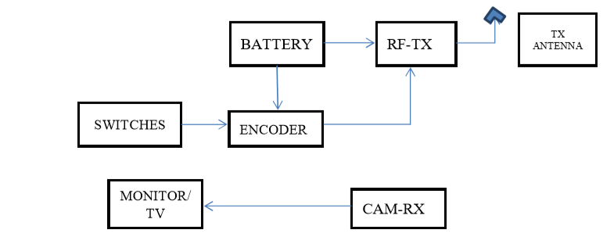

**Fig.3.1.1.Existing Block Diagram**

The technical improvement together with the need for high performance robots created faster, more accurate and more intelligent robots using new robots control devices, new drives and advanced control algorithms. The presented robot control system can be used for different sophisticated robot applications. This spy and bomb detecting robot is fully controlled by the remote and the commands from the remote via RF transmitter are received by the Arduino. So this spy and bomb detecting robot can be used in military applications. Most of the military organization now takes the help of robots to carry out many risky jobs that cannot be done by the soldier. These spy robots used in military are usually employed with the integrated system including gripper and cameras, video screens, sensors. The military robots also have different shapes according to the purposes of each robot. Thus the proposed system, an Intelligent Robot using RF module saves human lives and reduces manual error in defense side. This is specially designed spy and bomb detecting robot system to save human life and protect the country from enemies. One of the most important things about these robots is that they have the capability to perform missions remotely in the field, without any actual danger to human lives.

It detects the RF data sent by transmitter and according to that control robot in Forward, backward, left turn, right turn movements. Metal/Bomb detector can detect the metals and alert with LED to notify the Metal/Bomb .Because, we can’t detect the actual bomb we don’t have that much authority .The camera detects the exact location of the robot. In this manner our project plays a crucial role in Military as well as in our police department. In this project, we have introduced a new application using two techniques i.e. spying and bomb detection implemented by using Arduino kit. In future, we can also implement bomb diffusion technique in this project. It can be used in radar detection systems to detect objects by implementing other hardware.

**CHAPTER 4**

**PROPOSED SYSTEM**

**4.1 PROJECT DESCRIPTION**

Security basedindustrial monitoring system is proposed. The proposed system monitors the industrial workers conditions in every situation. The proposed system consisting of gas sensor, temperature sensor, Temperature level and gas level is always monitored in the industrial environment. Hazardous gases like carbon monoxide, carbon dioxide contents are present more in underground. If the gases are detected more than the threshold value, it will be monitored. In both condition, information will be send to the monitoring center through IoT. Along with these temperature level also monitored if it increases or decreases from the threshold value, in case of land slide situation. By this we can be able to know the critical situations of the coal mine workers immediately. Also in case of emergency we can give immediate treatment for them.

**4.2 BLOCK DIAGRAM**

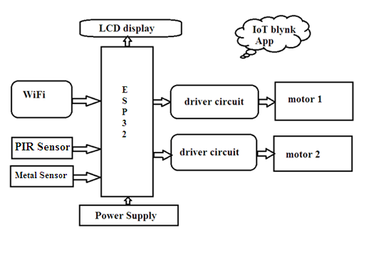

**Fig.4.2.1.Proposed Block Diagram**

**4.3 WORKING PRINCIPLE**

Robot successfully gathers the human detection and bomb detection information of the area under surveillance and sends the information back to the Android Phone. Thus the robot can able to detect the metals, toxic gases and monitor temperature humidity of the field using the sensors installed on the carrying vehicle. In order to achieve the accuracy in the detection and monitoring process, User conduct fine tune the sensor meters to increase accuracy and efficiency on the system. The voltage levels are regulated to desired operating range of the vehicle and micro controllers. Henceforth the robot is a novel design framework of modern IoT robots in the field.

**4.4 SYSTEM ARCHIECTURE**



**Fig.4.4.1.Archiecture Diagram 1**

Robot platform is selected to be perfect for making robotic vehicle, smart robots and robotic projects which can be used for various applications and IoT projects. This is an excellent rover robotics platform for development of any autonomous robotic projects without spending a lot of money. Robotic platform consists of high quality, multi- purpose, laser cut acrylic double layer robotic chassis fitted with 2 DC Geared motors, 2 dummy motor shafts and 4 wheels. Double sided foam pieces and Holes are provided on acrylic platform to mount the circuitry, board or sensors easily. It can be installed with different electronic components, sensors, microprocessors and IoT devices



**Fig.4.4.2.Archiecture Diagram 2**

An embedded system is a combination of computer hardware and software, either fixed in capability or programmable, that is designed for a specific function or for specific functions within a larger system.

Robots are an application of Embedded Systems. Robots are constructed using hardware components like microcontrollers, motors, sensors, relays and integrated with sensible software programs using Embedded C, which are designed to perform Industrial robotic machines, agricultural and process industry robotic devices, automobile robots, medical robots, and toy robots are robotic embedded systems. Nowadays, the Internet of Things (IoT) drives the robotic embedded systems base. This research study introduces the concept of the IoT where intelligent devices can monitor events, fuse sensor data from a variety of sources, use local and distributed **“**intelligence**”** to determine a best course of action and then act to control or manipulate objects the physical world and in some cases while physically moving through that world.

**4.5 POWER SUPPLY UNIT**

In most of our electronic products or projects we need a power supply for converting mains AC voltage to a regulated DC voltage. For making a power supply designing of each and every component is essential. Here I’m going to discuss the designing of  a regulated 5V Power Supply.

Let’s start with very basic things the choosing of components

**Component List :**

1. Step down transformer
2. Voltage regulator
3. Capacitors
4. Diodes

**4.5.1 Voltage regulator :**

As we require 5V we need LM7805 Voltage Regulator IC.

7805 IC Rating :

* Input voltage range 7V- 35V
* Current rating Ic =1A
* Output voltage range   VMax=5.2V ,VMin=4.8V

[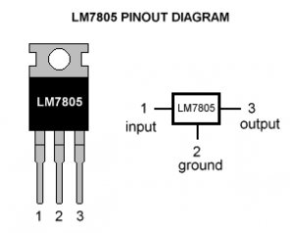](https://electrosome.com/wp-content/uploads/2013/05/Lm7805-pinout-diagram.gif)

**Fig.4.5.1.1** **LM7805 Diagram**

# 4.5.2 Understanding 7805 IC

A regulated power supply is very much essential for several electronic devices due to the semiconductor material employed in them have a fixed rate of current as well as voltage. The device may get damaged if there is any deviation from the fixed rate. The AC power supply gets converted into constant DC by this circuit. By the help of a voltage regulator DC, unregulated output will be fixed to a constant voltage. The circuit is made up of linear voltage regulator 7805 along with capacitors and resistors with bridge rectifier made up from diodes. From giving an unchanging voltage supply to building confident that output reaches uninterrupted to the appliance, the diodes along with capacitors handle elevated efficient signal conveniently.

As we have previously talked about that regulated power supply is a device that mechanized on DC voltages and also it can uphold its output accurately at a fixed voltage all the time  although if there is a significant alteration in the DC input voltage.

IC regulator is mainly used in the circuit to maintain the exact voltage which is followed by the power supply. A regulator is mainly employed with the capacitor connected in parallel to the input terminal and the output terminal of the IC regulator. For the checking of gigantic alterations in the input as well as in the output filter, capacitors are used. While the bypass capacitors are used to check the small period spikes on the input and output level. Bypass capacitors are mainly of small values that are used to bypass the small period pulses straightly into the Earth.

A circuit diagram having regulator IC and all the above discussed components arrangement revealed in the figure below.

IC 7805 is a DC regulated IC of 5V. This IC is very flexible and is widely employed in all types of circuit like a voltage regulator. It is a three terminal device and mainly called input , output and ground. Pin diagram of the IC 7805 is shown in the diagram belowThe output generated from the unregulated DC output is susceptible to the fluctuations of the input signal.IC voltage regulator  is connected with bridge rectifier in series in these project so to steady the DC output against the variations in the input DC voltage.To obtain a stable output of 5V

[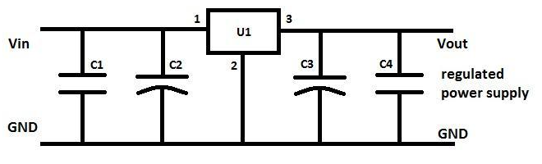](http://www.electronicshub.org/wp-content/uploads/2013/12/Regulated-Power-Supply-Circuit.png)

**Fig.4.5.2.1** **LM7805 Circuit Diagram**

As we have made the whole circuit till now to be operated on the 5V DC supply, so we have to use an IC regulator for 5V DC. And the most generally used IC regulators get into the market for 5V DC regulation use is 7805. So we are connecting the similar IC in the circuit as U1.

.[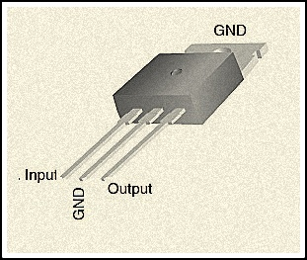](http://www.electronicshub.org/wp-content/uploads/2013/12/Pin-diagram-of-IC-7805.jpg)

**Fig.4.5.2.2** **LM7805 Physical View**

IC 7805 is attached with 6-0-6V along with 500mA step down transformer as well as with rectifier. To suppress the oscillation which might generate in the regulator IC, C2 capacitor of 0.1 μF value is used. When the power supply filter  is far away from the regulated IC capacitor C2 is used. Ripple rejection in the regulator is been improved by C4 capacitor (35μf) by avoiding the ripple voltage to be amplified at the regulator output. The output voltage is strengthen and deduction of the output voltage is done capacitor C3 (0.1μF). To avoid the chance of the input get shorted D5 diode is used to save the regulator. If D5 is not presented in the circuit, the output capacitor can leave its charge immediately during low impedance course inside  the regulators

### 4.5.3 Step Down Transformer

A step down transformer will step down the [voltage](http://www.electrical4u.com/voltage-or-electric-potential-difference/) from the ac mains to the required [voltage](http://www.electrical4u.com/voltage-or-electric-potential-difference/) level. The turn’s ratio of the transformer is so adjusted such as to obtain the required [voltage](http://www.electrical4u.com/voltage-or-electric-potential-difference/) value. The output of the transformer is given as an input to the rectifier circuit.

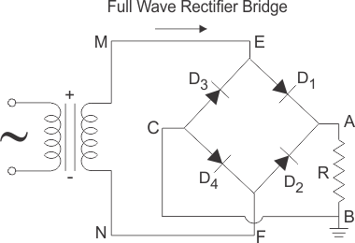Rectifier is an electronic circuit consisting of diodes which carries out the rectification process. Rectification is the process of converting an alternating [voltage](http://www.electrical4u.com/voltage-or-electric-potential-difference/) or [current](http://www.electrical4u.com/electric-current-and-theory-of-electricity/) into corresponding direct (dc) quantity. The input to a rectifier is ac whereas its output is unidirectional pulsating dc. Usually a full wave rectifier or a bridge rectifier is used to rectify both the half cycles of the ac supply (full wave rectification). Figure below shows a [full wave bridge rectifier](http://www.electrical4u.com/full-wave-diode-rectifier/).

**Fig.4.5.3.1** **Full Wave Rectifier**

A bridge rectifier consists of four p-n junction diodes connected in the above shown manner. In the positive half cycle of the supply the [voltage](http://www.electrical4u.com/voltage-or-electric-potential-difference/) induced across the secondary of the [electrical transformer](http://www.electrical4u.com/what-is-transformer-definition-working-principle-of-transformer/) i.e. VMN is positive. Therefore point E is positive with respect to F. Hence, diodes D3 and D2 are reversed biased and diodes D1 and D4 are forward biased. The [diode](http://www.electrical4u.com/diode-working-principle-and-types-of-diode/) D3 and D2 will act as open switches (practically there is some [voltage](http://www.electrical4u.com/voltage-or-electric-potential-difference/) drop) and diodes D1 andD4 will act as closed switches and will start conducting. Hence a rectified waveform appears at the output of the rectifier as shown in the first figure. When [voltage](http://www.electrical4u.com/voltage-or-electric-potential-difference/) induced in secondary i.e. VMN is negative than D3 and D2 are forward biased with the other two reversed biased and a positive [voltage](http://www.electrical4u.com/voltage-or-electric-potential-difference/) appears at the input of the filter.

The rectified [voltage](http://www.electrical4u.com/voltage-or-electric-potential-difference/) from the rectifier is a pulsating dc [voltage](http://www.electrical4u.com/voltage-or-electric-potential-difference/) having very high ripple content. But this is not we want, we want a pure ripple free dc waveform. Hence a filter is used. Different types of filters are used such as [capacitor](http://www.electrical4u.com/what-is-capacitor-and-what-is-dielectric/) filter, LC filter, Choke input filter, π type filter. Figure below shows a [capacitor](http://www.electrical4u.com/what-is-capacitor-and-what-is-dielectric/) filter connected along the output of the rectifier and the resultant output waveform.

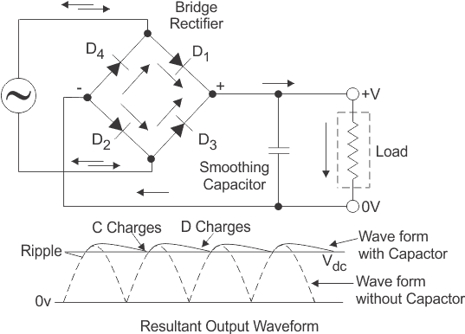

**Fig.4.5.3.2** **Wave form**

As the instantaneous [voltage](http://www.electrical4u.com/voltage-or-electric-potential-difference/) starts increasing the [capacitor](http://www.electrical4u.com/what-is-capacitor-and-what-is-dielectric/) charges, it charges till the waveform reaches its peak value. When the instantaneous value starts reducing the [capacitor](http://www.electrical4u.com/what-is-capacitor-and-what-is-dielectric/) starts discharging exponentially and slowly through the load (input of the regulator in this case). Hence, an almost constant dc value having very less ripple content is obtained.

This is the last block in a regulated DC power supply. The output [voltage](http://www.electrical4u.com/voltage-or-electric-potential-difference/) or [current](http://www.electrical4u.com/electric-current-and-theory-of-electricity/) will change or fluctuate when there is change in the input from ac mains or due to change in load current at the output of the regulated power supply or due to other factors like temperature changes. This problem can be eliminated by using a regulator. A regulator will maintain the output constant even when changes at the input or any other changes occur. Transistor series regulator, Fixed and variable IC regulators or a zener [diode](http://www.electrical4u.com/diode-working-principle-and-types-of-diode/) operated in the zener region can be used depending on their applications. IC’s like 78XX and 79XX are used to obtained fixed values of voltages at the output. With IC’s like LM 317 and 723 etc we can adjust the output [voltage](http://www.electrical4u.com/voltage-or-electric-potential-difference/) to a required constant value. Figure below shows the LM317 [voltage](http://www.electrical4u.com/voltage-or-electric-potential-difference/) regulator. The output [voltage](http://www.electrical4u.com/voltage-or-electric-potential-difference/) can be adjusted with adjusting the values of resistances R1 and R2. Usually coupling [capacitors](http://www.electrical4u.com/what-is-capacitor-and-what-is-dielectric/) of values about 0.01µF to 10µF needs to be connected at the output and input to address input noise and output transients. Ideally the output [voltage](http://www.electrical4u.com/voltage-or-electric-potential-difference/) is given by 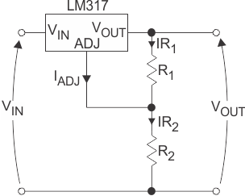

**Fig.4.5.3.3** **Circuit Anaylsis**

Figure below shows the complete circuit of a regulated +5V DC power supply using transformer, bridge rectifier, filter (smoothing) and a fixed +5 V [voltage](http://www.electrical4u.com/voltage-or-electric-potential-difference/) regulator. Here we can use IC 7803(for 3V),7809(for 9 V),7812(for 12V) etc.

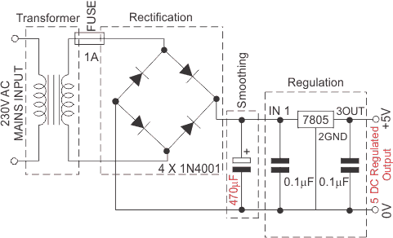

. **Fig.4.5.3.4** Full Wave Rectifier

**4.5.4 IC L293D**

L293D is a typical Motor driver or Motor Driver IC which allows DC motor to drive on either direction. L293D is a 16-pin IC which can control a set of two DC motors simultaneously in any direction. It means that you can control two DC motor with a single L293D IC. Dual H-bridge Motor Driver integrated circuit (IC).

The L293d can drive small and quiet big motors as well, check the Voltage Specification at the end of this page for more info.

You can Buy L293D IC in any electronic shop very easily and it costs around 70 Rupees (INR) or around 1 $ Dollar (approx Cost) or even lesser cost. You can find the necessary pin diagram, working, a circuit diagram, Logic description and Project as you read through.

It works on the concept of H-bridge. H-bridge is a circuit which allows the voltage to be flown in either direction. As you know voltage need to change its direction for being able to rotate the motor in clockwise or anticlockwise direction, Hence H-bridge IC are ideal for driving a DC motor.

In a single L293D chip there are two h-Bridge circuit inside the IC which can rotate two dc motor independently. Due its size it is very much used in robotic application for controlling DC motors. Given below is the pin diagram of a L293D motor controller.

There are two Enable pins on l293d. Pin 1 and pin 9, for being able to drive the motor, the pin 1 and 9 need to be high. For driving the motor with left H-bridge you need to enable pin 1 to high. And for right H-Bridge you need to make the pin 9 to high. If anyone of the either pin1 or pin9 goes low then the motor in the corresponding section will suspend working. It’s like a switch.

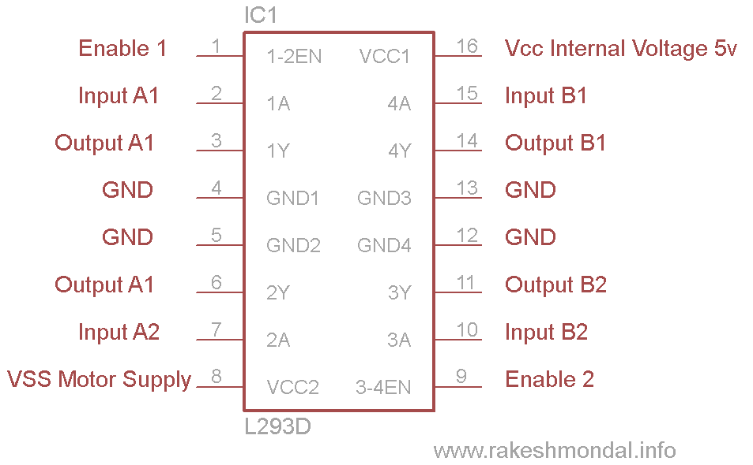

**Fig.4.5.4.1** **L293 Chip**

There are 4 input pins for l293d, pin 2,7 on the left and pin 15 ,10 on the right as shown on the pin diagram. Left input pins will regulate the rotation of motor connected across left side and right input for motor on the right hand side. The motors are rotated on the basis of the inputs provided across the input pins as LOGIC 0 or LOGIC 1.

In simple you need to provide Logic 0 or 1 across the input pins for rotating the motor.

Lets consider a Motor connected on left side output pins (pin 3,6). For rotating the motor in clockwise direction the input pins has to be provided with Logic 1 and Logic 0.

• **Pin 2** = **Logic 1** and **Pin 7**= **Logic 0** | Clockwise Direction  
• **Pin 2** = **Logic 0**and **Pin 7**= **Logic 1** | Anticlockwise Direction  
•**Pin 2**= **Logic 0** and **Pin 7** = **Logic 0** | Idle [No rotation] [Hi-Impedance state]  
• **Pin 2**= **Logic 1** and **Pin 7** = **Logic 1** | Idle [No rotation]

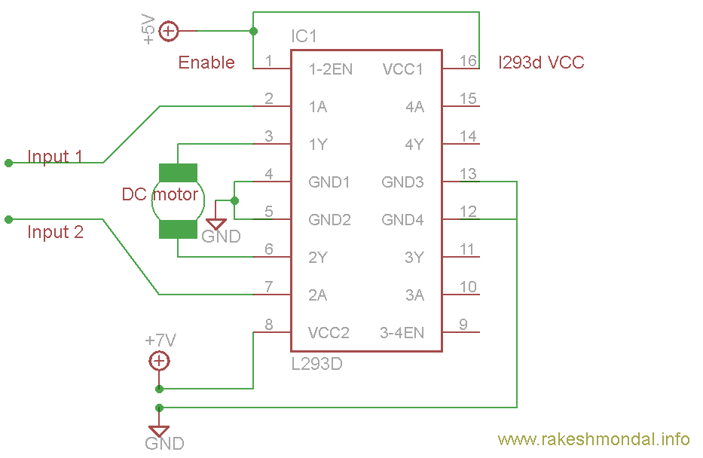

**Fig.4.5.4.2** **L293d with DC Motor**

The only difference between the sensor and module is that the module will have a filtering capacitor and pull-up resistor inbuilt, and for the sensor, you have to use them externally if required.

**4.5.5 CAPACITOR**

Capacitor is an electrical device used for storing electrical energy. The stored electrical energy is the form of a current in to the circuits which the capacitor form a part. Capacitor is one of the important components used in Radio, TV and other electronic circuits.

Filter circuits, which is usually a capacitor acting as a surge arrester always follow the rectifier unit. This capacitor is also called as a decoupling capacitor or a bypassing capacitor, is used not only to ‘short’ the ripple with frequency of 120Hz to ground but also to leave the frequency of the DC to appear at the output.

**TYPES OF CAPACITOR**:

1. Paper Capacitor
2. Mica Capacitor
3. Ceramic Capacitor
4. Electrolytic Capacitor
5. Variable Capacitor

**CHAPTER V**

**HARDWARE DESCRIPTION**

**5.1 MICROCONTROLLER**

A microcontroller is a compact integrated circuit designed to govern a specific operation in an embedded system. A typical microcontroller includes a processor, memory and input/output (I/O) [peripherals](https://searchmobilecomputing.techtarget.com/definition/peripheral) on a single chip. Sometimes referred to as an embedded controller or microcontroller unit (MCU), microcontrollers are found in vehicles, robots, office machines, medical devices, mobile radio transceivers, vending machines and home appliances, among other devices. They are essentially simple miniature personal computers (PCs) designed to control small features of a larger component, without a complex front-end operating system (OS).

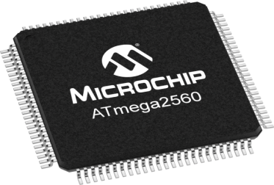

**Fig 5.1.1 Microcontroller**

**5.1.1 Microcontroller Working Function**

A microcontroller is embedded inside of a system to control a singular function in a device. It does this by interpreting data it receives from its I/O peripherals using its central processor. The temporary information that the microcontroller receives is stored in its data memory, where the processor accesses it and uses instructions stored in its program memory to decipher and apply the incoming data. It then uses its I/O peripherals to communicate and enact the appropriate action. Microcontrollers are used in a wide array of systems and devices. Devices often utilize multiple microcontrollers that work together within the device to handle their respective tasks.

For example, a car might have many microcontrollers that control various individual systems within, such as the anti-lock braking system, traction control, fuel injection or suspension control. All the microcontrollers communicate with each other to inform the correct actions.

**5.1.2 Elements of Microcontroller**

The core elements of a microcontroller are

* Processor ([CPU](https://whatis.techtarget.com/definition/processor))
* Memory

i). Program memory

ii). Data memory

* I/O peripherals

**5.1.3 Types of Microcontroller**

* Intel MCS-51, often referred to as an 8051 microcontroller,
* AVR microcontroller
* programmable interface controller (PIC)
* Various licensed Advanced RISC Machines (ARM) microcontrollers.

**5.1.4 Application**

Microcontrollers are used in multiple industries and applications, including in home and enterprise, building automation, manufacturing, robotics, automotive, lighting, smart energy, industrial automation, communications and internet of things ([IOT](https://internetofthingsagenda.techtarget.com/definition/Internet-of-Things-IoT)) deployments. A microcontroller can use its ADC and DAC to convert the incoming noisy analog signal into an even outgoing digital signal. The simplest microcontrollers facilitate the operation of electromechanical systems found in everyday convenience items, such as ovens, refrigerators, toasters, mobile devices, [key fobs](https://searchsecurity.techtarget.com/definition/key-fob), video game systems, televisions and lawn-watering systems. They are also common in office machines such as photocopiers, scanners, fax machines and printers, as well as [smart meters](https://internetofthingsagenda.techtarget.com/definition/smart-meter), ATMs and security systems. More sophisticated microcontrollers perform critical functions in aircraft, spacecraft, ocean-going vessels, vehicles, medical and life-support systems as well as in robots. In medical scenarios, microcontrollers can regulate the Operations of an artificial heart, kidney or other organs. They can also be instrumental in the functioning of prosthetic devices.

**5.2 ARDUINO MEGA**

The Arduino MEGA 2560 is designed for projects that require more I/O lines, more sketch memory and more RAM. With 54 digital I/O pins, 16 analog inputs and a larger space for your sketch it is the recommended board for 3D printers and robotics projects. This gives your projects plenty of room and opportunities maintaining the simplicity and effectiveness of the Arduino platform.

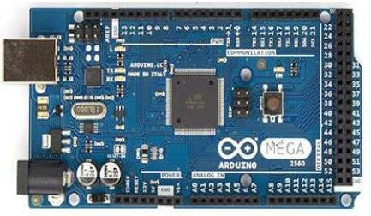

**Fig 5.2.1 Arduino Mega2560**

The Mega 2560 is a microcontroller board based on the [ATmega2560](http://www.atmel.com/Images/Atmel-2549-8-bit-AVR-Microcontroller-ATmega640-1280-1281-2560-2561_datasheet.pdf). It has 54 digital input/output pins (of which 15 can be used as PWM outputs), 16 analog inputs, 4 UARTs (hardware serial ports), a 16 MHz crystal oscillator, a USB connection, a power jack, an ICSP header, and a reset button. It contains everything needed to support the microcontroller; simply connect it to a computer with a USB cable or power it with an AC-to-DC adapter or battery to get started. The Mega 2560 board is compatible with most shields designed for the Uno and the former boards Arduino Duemilanove or Diecimila.

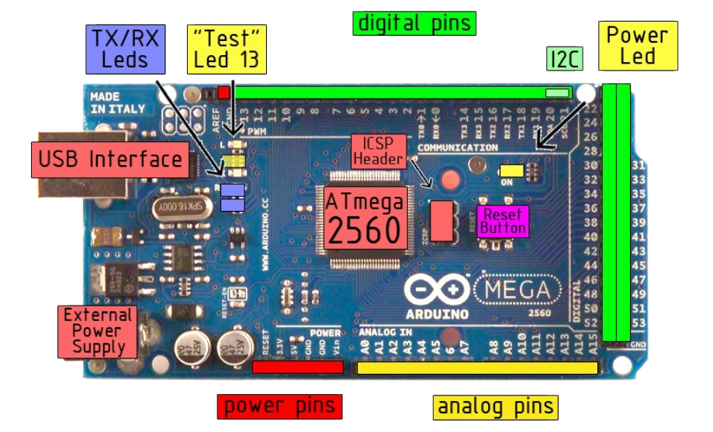

**Figure 5.2.2 Pins of Arduino Mega2560**

**Table 5.2.1 Technical Specification**

|  |  |  |
| --- | --- | --- |
| **S.NO** | **NAME** | **RANGE** |
| 1. | Microcontroller | [ATmega2560](http://www.atmel.com/Images/Atmel-2549-8-bit-AVR-Microcontroller-ATmega640-1280-1281-2560-2561_datasheet.pdf) |
| 2**.** | Operating Voltage | 5V |
| 3. | Input Voltage (recommended) | 7-12V |
| 4. | Input Voltage (limit) | 6-20V |
| 5. | Digital I/O Pins | 54 (of which 15 provide PWM output) |
| 6. | Analog Input Pins | 16 |
| 7. | DC Current per I/O Pin | 20 Ma |
| 8. | DC Current for 3.3V Pin | 50 mA |
| 9. | Flash Memory | 256 KB of which 8 KB used by bootloader |
| 10. | SRAM | 8 KB |
| 11. | EEPROM | 4 KB |
| 12. | Clock Speed | 16 MHz |
| 13. | LED_BUILTIN | 13 |
| 14. | Length | 101.52 mm |
| 15. | Width | 53.3 mm |
| 16. | Weight | 37 g |

**5.2.1 Pin Description**

The Mega 2560 can be powered via the USB connection or with an external power supply. The power source is selected automatically. External (non-USB) power can come either from an AC-to-DC adapter (wall-wart) or battery. The adapter can be connected by plugging a 2.1mm center-positive plug into the board's power jack. Leads from a battery can be inserted in the GND and Vin pin headers of the POWER connector. The board can operate on an external supply of 6 to 20 volts. If supplied with less than 7V, however, the 5V pin may supply less than five volts and the board may become unstable. If using more than 12V, the voltage regulator may overheat and damage the board. The recommended range is 7 to 12 volts.

The power pins are as follows:

Vin is the input voltage to the board when it's using an external power source (as opposed to 5 volts from the USB connection or other regulated power source). You can supply voltage through this pin, or, if supplying voltage via the power jack, access it through this pin.

The 5V pin outputs a regulated 5V from the regulator on the board. The board can be supplied with power either from the DC power jack (7 - 12V), the USB connector (5V), or the VIN pin of the board (7-12V). Supplying voltage via the 5V or 3.3V pins bypasses the regulator, and can damage your board. We don't advise it.

A 3.3 volt supply generated by the on-board regulator. Maximum current draw is 50 mA and GND are Ground pins. The IOREF pin on the board provides the voltage reference with which the microcontroller operates. A properly configured shield can read the IOREF pin voltage and select the appropriate power source or enable voltage translators on the outputs for working with the 5V or 3.3V.

The ATmega2560 has 256 KB of flash memory for storing code (of which 8 KB is used for the bootloader), 8 KB of SRAM and 4 KB of EEPROM (which can be read and written with the [EEPROM library](https://www.arduino.cc/en/Reference/EEPROM)).

**Table 5.2 Arduino Mega 2560 PIN mapping table**

|  |  |  |
| --- | --- | --- |
| **Pin Number** | **Pin Name** | **Mapped Pin Name** |
| 1 | PG5 ( OC0B ) | Digital pin 4 (PWM) |
| 2 | PE0 ( RXD0/PCINT8 ) | Digital pin 0 (RX0) |
| 3 | PE1 ( TXD0 ) | Digital pin 1 (TX0) |
| 4 | PE2 ( XCK0/AIN0 ) |  |
| 5 | PE3 ( OC3A/AIN1 ) | Digital pin 5 (PWM) |
| 6 | PE4 ( OC3B/INT4 ) | Digital pin 2 (PWM) |
| 7 | PE5 ( OC3C/INT5 ) | Digital pin 3 (PWM) |
| 8 | PE6 ( T3/INT6 ) |  |
| 9 | PE7 ( CLKO/ICP3/INT7 ) |  |
| 10 | VCC | VCC |
| 11 | GND | GND |
| 12 | PH0 ( RXD2 ) | Digital pin 17 (RX2) |
| 13 | PH1 ( TXD2 ) | Digital pin 16 (TX2) |
| 14 | PH2 ( XCK2 ) |  |
| 15 | PH3 ( OC4A ) | Digital pin 6 (PWM) |
| 16 | PH4 ( OC4B ) | Digital pin 7 (PWM) |
| 17 | PH5 ( OC4C ) | Digital pin 8 (PWM) |
| 18 | PH6 ( OC2B ) | Digital pin 9 (PWM) |
| 19 | PB0 ( SS/PCINT0 ) | Digital pin 53 (SS) |
| 20 | PB1 ( SCK/PCINT1 ) | Digital pin 52 (SCK) |
| 21 | PB2 ( MOSI/PCINT2 ) | Digital pin 51 (MOSI) |
| 22 | PB3 ( MISO/PCINT3 ) | Digital pin 50 (MISO) |
| 23 | PB4 ( OC2A/PCINT4 ) | Digital pin 10 (PWM) |
| 24 | PB5 ( OC1A/PCINT5 ) | Digital pin 11 (PWM) |
| 25 | PB6 ( OC1B/PCINT6 ) | Digital pin 12 (PWM) |
| 26 | PB7 ( OC0A/OC1C/PCINT7 ) | Digital pin 13 (PWM) |
| 27 | PH7 ( T4 ) |  |
| 28 | PG3 ( TOSC2 ) |  |
| 29 | PG4 ( TOSC1 ) |  |
| 30 | RESET | RESET |
| 31 | VCC | VCC |
| 32 | GND | GND |
| 33 | XTAL2 | XTAL2 |
| 34 | XTAL1 | XTAL1 |
| 35 | PL0 ( ICP4 ) | Digital pin 49 |
| 36 | PL1 ( ICP5 ) | Digital pin 48 |
| 37 | PL2 ( T5 ) | Digital pin 47 |
| 38 | PL3 ( OC5A ) | Digital pin 46 (PWM) |
| 39 | PL4 ( OC5B ) | Digital pin 45 (PWM) |
| 40 | PL5 ( OC5C ) | Digital pin 44 (PWM) |
| 41 | PL6 | Digital pin 43 |
| 42 | PL7 | Digital pin 42 |
| 43 | PD0 ( SCL/INT0 ) | Digital pin 21 (SCL) |
| 44 | PD1 ( SDA/INT1 ) | Digital pin 20 (SDA) |
| 45 | PD2 ( RXDI/INT2 ) | Digital pin 19 (RX1) |
| 46 | PD3 ( TXD1/INT3 ) | Digital pin 18 (TX1) |
| 47 | PD4 ( ICP1 ) |  |
| 48 | PD5 ( XCK1 ) |  |
| 49 | PD6 ( T1 ) |  |
| 50 | PD7 ( T0 ) | Digital pin 38 |
| 51 | PG0 ( WR ) | Digital pin 41 |
| 52 | PG1 ( RD ) | Digital pin 40 |
| 53 | PC0 ( A8 ) | Digital pin 37 |
| 54 | PC1 ( A9 ) | Digital pin 36 |
| 55 | PC2 ( A10 ) | Digital pin 35 |
| 56 | PC3 ( A11 ) | Digital pin 34 |
| 57 | PC4 ( A12 ) | Digital pin 33 |
| 58 | PC5 ( A13 ) | Digital pin 32 |
| 59 | PC6 ( A14 ) | Digital pin 31 |
| 60 | PC7 ( A15 ) | Digital pin 30 |
| 61 | VCC | VCC |
| 62 | GND | GND |
| 63 | PJ0 ( RXD3/PCINT9 ) | Digital pin 15 (RX3) |
| 64 | PJ1 ( TXD3/PCINT10 ) | Digital pin 14 (TX3) |
| 65 | PJ2 ( XCK3/PCINT11 ) |  |
| 66 | PJ3 ( PCINT12 ) |  |
| 67 | PJ4 ( PCINT13 ) |  |
| 68 | PJ5 ( PCINT14 ) |  |
| 69 | PJ6 ( PCINT 15 ) |  |
| 70 | PG2 ( ALE ) | Digital pin 39 |
| 71 | PA7 ( AD7 ) | Digital pin 29 |
| 72 | PA6 ( AD6 ) | Digital pin 28 |
| 73 | PA5 ( AD5 ) | Digital pin 27 |
| 74 | PA4 ( AD4 ) | Digital pin 26 |
| 75 | PA3 ( AD3 ) | Digital pin 25 |
| 76 | PA2 ( AD2 ) | Digital pin 24 |
| 77 | PA1 ( AD1 ) | Digital pin 23 |
| 78 | PA0 ( AD0 ) | Digital pin 22 |
| 79 | PJ7 |  |
| 80 | VCC | VCC |
| 81 | GND | GND |
| 82 | PK7 ( ADC15/PCINT23 ) | Analog pin 15 |
| 83 | PK6 ( ADC14/PCINT22 ) | Analog pin 14 |
| 84 | PK5 ( ADC13/PCINT21 ) | Analog pin 13 |
| 85 | PK4 ( ADC12/PCINT20 ) | Analog pin 12 |
| 86 | PK3 ( ADC11/PCINT19 ) | Analog pin 11 |
| 87 | PK2 ( ADC10/PCINT18 ) | Analog pin 10 |
| 88 | PK1 ( ADC9/PCINT17 ) | Analog pin 9 |
| 89 | PK0 ( ADC8/PCINT16 ) | Analog pin 8 |
| 90 | PF7 ( ADC7 ) | Analog pin 7 |
| 91 | PF6 ( ADC6 ) | Analog pin 6 |
| 92 | PF5 ( ADC5/TMS ) | Analog pin 5 |
| 93 | PF4 ( ADC4/TMK ) | Analog pin 4 |
| 94 | PF3 ( ADC3 ) | Analog pin 3 |
| 95 | PF2 ( ADC2 ) | Analog pin 2 |
| 96 | PF1 ( ADC1 ) | Analog pin 1 |
| 97 | PF0 ( ADC0 ) | Analog pin 0 |
| 98 | AREF | Analog Reference |
| 99 | GND | GND |
| 100 | AVCC | VCC |

Each of the 54 digital pins on the Mega can be used as an input or output, using [pinMode()](https://www.arduino.cc/en/Reference/PinMode), [digitalWrite()](https://www.arduino.cc/en/Reference/DigitalWrite), and [digitalRead()](https://www.arduino.cc/en/Reference/DigitalRead) functions. They operate at 5 volts. Each pin can provide or receive 20 mA as recommended operating condition and has an internal pull-up resistor (disconnected by default) of 20-50 k ohm. A maximum of 40mA is the value that must not be exceeded to avoid permanent damage to the microcontroller. In addition, some pins have specialized functions:

Serial: 0 (RX) and 1 (TX); Serial 1: 19 (RX) and 18 (TX); Serial 2: 17 (RX) and 16 (TX); Serial 3: 15 (RX) and 14 (TX). Used to receive (RX) and transmit (TX) TTL serial data. Pins 0 and 1 are also connected to the corresponding pins of the ATmega16U2 USB-to-TTL Serial chip.

External Interrupts: 2 (interrupt 0), 3 (interrupt 1), 18 (interrupt 5), 19 (interrupt4), 20 (interrupt 3), and 21 (interrupt 2). These pins can be configured to trigger an interrupt on a low level, a rising or falling edge, or a change in level. See the [attachInterrupt()](https://www.arduino.cc/en/Reference/AttachInterrupt) function for details.

PWM: 2 to 13 and 44 to 46. Provide 8-bit PWM output with the [analogWrite()](https://www.arduino.cc/en/Reference/AnalogWrite) function.

SPI: 50 (MISO), 51 (MOSI), 52 (SCK), 53 (SS). These pins support SPI communication using the [SPI library](https://www.arduino.cc/en/Reference/SPI). The SPI pins are also broken out on the ICSP header, which is physically compatible with the Arduino /Genuino Uno and the old Duemilanove and Diecimila Arduino boards.

LED: 13. There is a built-in LED connected to digital pin 13. When the pin is HIGH value, the LED is on, when the pin is LOW, it's off.

TWI: 20 (SDA) and 21 (SCL). Support TWI communication using the [Wire library](https://www.arduino.cc/en/Reference/Wire). Note that these pins are not in the same location as the TWI pins on the old Duemilanove or Diecimila Arduino boards.

The Mega 2560 has 16 analog inputs, each of which provide 10 bits of resolution (i.e. 1024 different values). By default they measure from ground to 5 volts, though is it possible to change the upper end of their range using the AREF pin and [analogReference()](https://www.arduino.cc/en/Reference/AnalogReference) function.

AREF is the Reference voltage for the analog inputs. Used with analogReference().

Reset is used to Bring this line LOW to reset the microcontroller. Typically used to add a reset button to shields which block the one on the board.

**5.2.2 Communication**

The Mega 2560 board has a number of facilities for communicating with a computer, another board, or other microcontrollers. The ATmega2560 provides four hardware UARTs for TTL (5V) serial communication. An ATmega16U2 (ATmega8U2 on the revision 1 and revision 2 boards) on the board channels one of these over USB and provides a virtual com port to software on the computer (Windows machines will need a .inf file, but OSX and Linux machines will recognize the board as a COM port automatically. The Arduino Software (IDE) includes a serial monitor which allows simple textual data to be sent to and from the board. The RX and TX LEDs on the board will flash when data is being transmitted via the ATmega8U2/ATmega16U2 chip and USB connection to the computer (but not for serial communication on pins 0 and 1).

A [Software Serial library](https://www.arduino.cc/en/Reference/SoftwareSerial) allows for serial communication on any of the Mega 2560's digital pins. The Mega 2560 also supports TWI and SPI communication. The Arduino Software (IDE) includes a Wire library to simplify use of the TWI bus; see the [documentation](https://www.arduino.cc/en/Reference/Wire) for details. For SPI communication, use the [SPI library](https://www.arduino.cc/en/Reference/SPI).

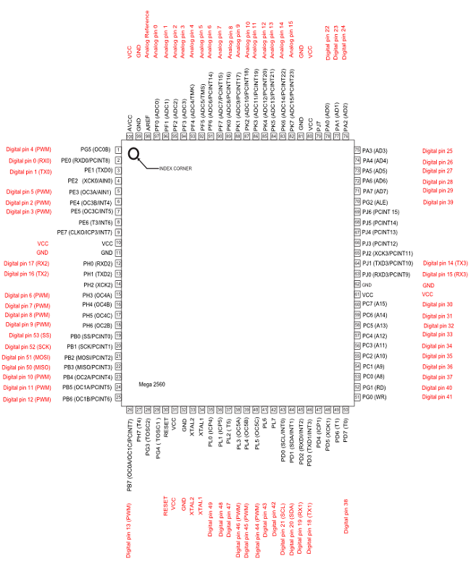

**Fig 5.2.1.1 Arduino Mega2560 Pin Configuration**

**5.3 ULTRASONIC SENSORS**

Ultrasonic sensors are devices that use electrical–mechanical energy transformation to measure distance from the sensor to the target object. Ultrasonic waves are longitudinal mechanical waves which travel as a sequence of compressions and rarefactions along the direction of wave propagation through the medium. Apart from distance measurement, they are also used in ultrasonic material testing (to detect cracks, air bubbles, and other flaws in the products), Object detection, position detection, ultrasonic mouse, etc.

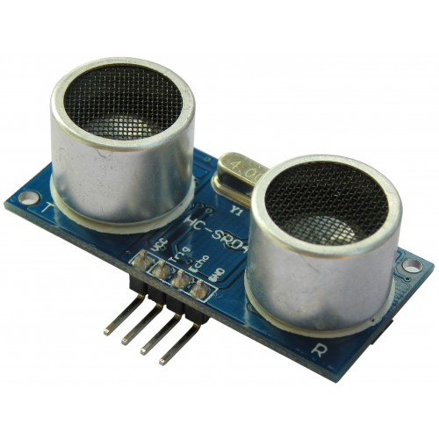

**Fig 5.3.1 Ultrasonic Sensor**

Ultrasonic sensors use sound waves rather than light, making them ideal for stable detection of uneven surfaces, liquids, clear objects, and objects in dirty environments. These sensors work well for applications that require precise measurements between stationary and moving objects.

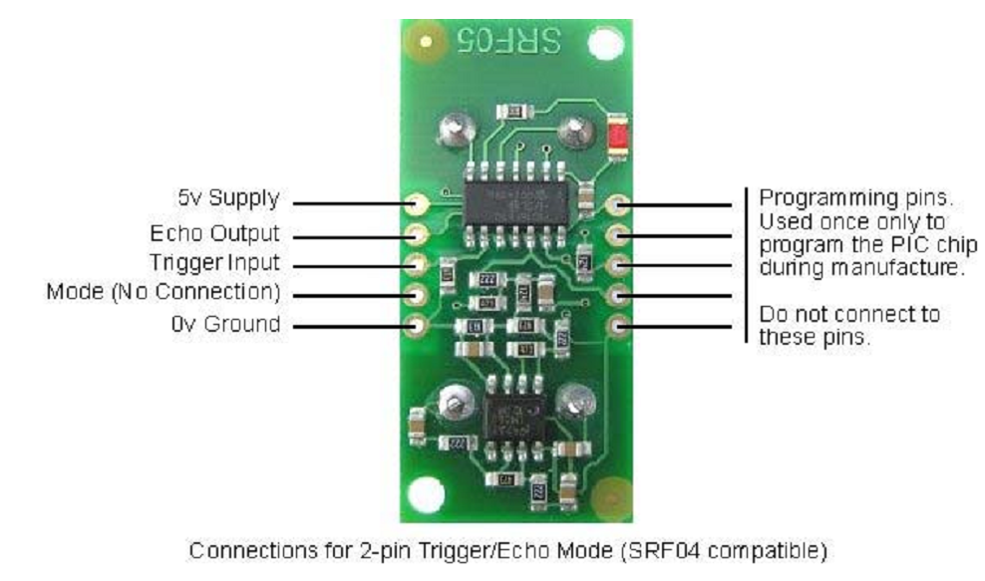

**Fig 5.3.2 Pins of Ultrasonic sensor**

These sensors are categorized in two types according to their working phenomenon – piezoelectric sensors and electrostatic sensors. Here discussing the ultrasonic sensor using the piezoelectric principle. Piezoelectric ultrasonic sensors use a piezoelectric material to generate the ultrasonic waves.

**An ultrasonic sensor** consists of a transmitter and receiver which are available as separate units or embedded together as single unit. The above image shows the ultrasonic transmitter and receiver. Ultrasonic sensors transmit ultrasonic waves from its sensor head and again receives the ultrasonic waves reflect from an object. By measuring the length of time from the transmission to reception of the sonic wave, it detects the position of the object.

Ultrasonic sensors can measure the following parameters without contacting the medium to be measured

* Distance
* Level
* Diameter
* Presence
* Position

Ultrasonic sensors make accurate measurements in many difficult environments and unusual materials. Measurements are unaffected by:

* Material
* Surface
* Light
* Dust
* Mist and Vapor

**5.4 IR SENSOR**

This device emits and/or detects infrared radiation to sense a particular phase in the environment. Generally, thermal radiation is emitted by all the objects in the infrared spectrum. The [infrared sensor](http://www.engineersgarage.com/electronic-circuit/infrared-ir-sensor) detects this type of radiation which is not visible to human eye.

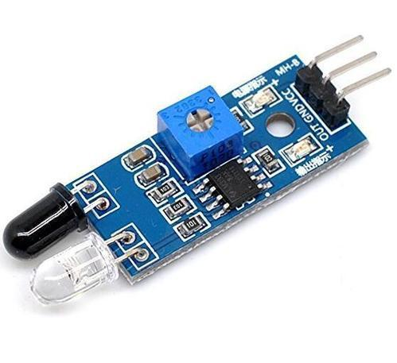

**Fig 5.4.1 IR Sensor**

**5.4.1 Working Function**

The basic idea is to make use of IR LEDs to send the infrared waves to the object. Another IR diode of the same type is to be used to detect the reflected wave from the object. The diagram is shown below.

When IR receiver is subjected to infrared light, a voltage difference is produced across the leads. Less voltage which is produced can be hardly detected and hence operational amplifiers ([Op-amps](http://www.engineersgarage.com/content/ic-lm324)) are used to detect the low voltages accurately.

Measuring the distance of the object from the receiver sensor: The electrical property of IR sensor components can be used to measure the distance of an object. The fact when IR receiver is subjected to light, a potential difference is produced across the leads.

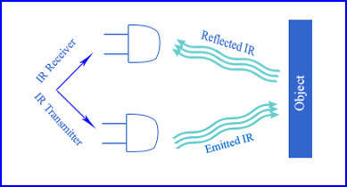

**Fig 5.4.1.1 IR Sensor Working Function**

.

**5.4.2** **Application**

* Thermography – According to the black body radiation law, it is possible to view the environment with or without visible illumination using thermography.
* Heating – Infrared can be used to cook and heat food items. They can take away ice from the wings of an aircraft.
* Photo bio-modulation – This is used for chemotherapy in cancer patients. This is used to treat anti-herpes virus.
* Communications – Infra red laser provide light for optical fibre communication.

**Specification**

* IR TX RX size: 5mm diameter package
* IR LED current rating: 30mA nominal, 600mA pulse loading at 1% duty cycle
* IR LED wavelength: 940nM
* Photodiode peak response wavelength: 940nM

**5.5 PASSIVE INFRARED SENSOR**

A Passive Infrared sensor (PIR sensor) is an electronic device that measures infrared (IR) light radiating from objects in its field of view. PIR sensors are often used in the construction of *PIR-*based motion detectors. A PIR-based motion detector is used to sense movement of people, animals, or other objects. They are commonly used in burglar alarms and automatically-activated lighting systems. Apparent motion is detected when an infrared source with one temperature, such as a human, passes in front of an infrared source with another temperature, such as a wall.

It is usually infrared radiation that is invisible to the human eye but can be detected by electronic devices designed for such a purpose. The term passive in this instance means that the PIR device does not emit an infrared beam but merely passively accepts incoming infrared radiation.

Every object that has a temperature above perfect zero emits thermal energy (heat) in form of radiation. The PIR sensors are tuned to detect this IR wavelength which only emanates when a human being arrives in their proximity. The term “pyroelectricity” means: heat that generates electricity (here, an electric signal of small amplitude).  Since these sensors do not have an infrared source of their own, they are also termed as passive.

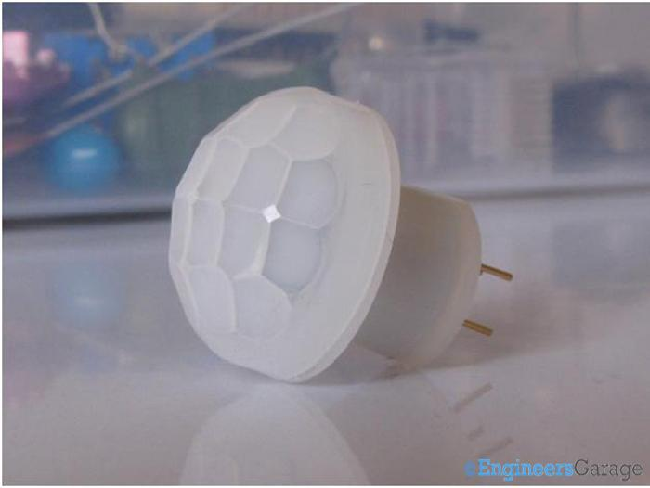

**Fig 5.5.1: PIR Sensor**

**5.6.1 Construction**

On closely observing the top region of the sensor, the beehive structure, curved segments are seen.  These curved segments are Fresnel lenses which constitute an array that increases the detection zone of the sensor. Fresnel lens array is known to capture more infrared radiation and focus it to a relatively smaller point. Detection is more stable and maximum distance for detection is also increased. Fresnel lens has been crafted to be translucent so that it can capture only infrared radiation without getting unwanted radiations from visible spectrum of light.

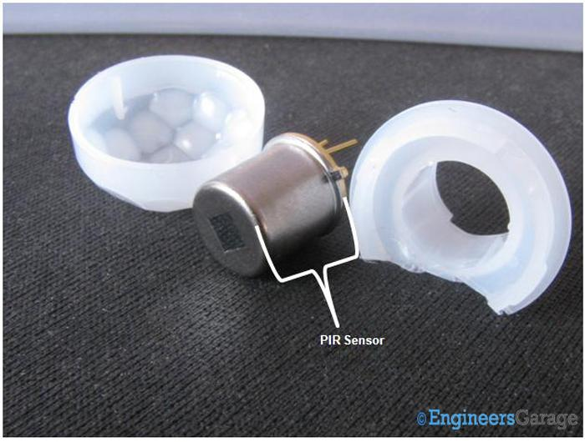

**Fig 5.6.1.1 Inner view of PIR Sensor**

At the top of the sensor is the infrared filter. Looking more like a square shaped glass, this filter selects the desired wavelength at which sensor is desired to respond. Since this sensor is designed to detect human presence, the wavelength chosen is 8micrometer to 14 micrometer which is the range within which human body radiates electromagnetic rays.

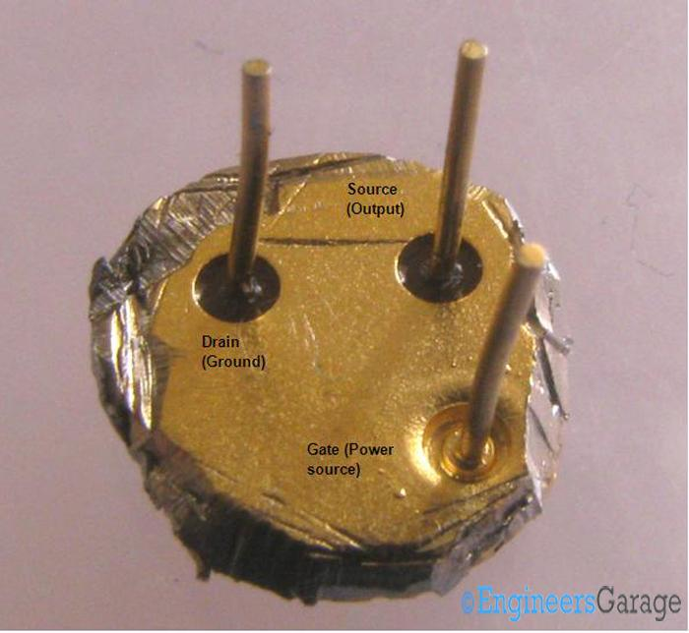

**Figure 5.6.1.2 Pins of PIR sensor**

The connecting lead placement are arranged in the same fashion as in a JFET. The specific function of each lead is shown in the image.

**5.6.2 OPERATION**

An individual PIR sensor detects changes in the amount of infrared radiation impinging upon it, which varies depending on the temperature and surface characteristics of the objects in front of the sensor. When an object, such as a human, passes in front of the background, such as a wall, the temperature at that point in the sensor's field of view will rise from room temperature to body temperature, and then back again. The sensor converts the resulting change in the incoming infrared radiation into a change in the output voltage, and this triggers the detection. Moving objects of similar temperature to the background but different surface characteristics may also have a different infrared emission pattern, and thus sometimes trigger the detector.

PIRs come in many configurations for a wide variety of applications. The most common models have numerous Fresnel lenses or mirror segments, an effective range of about ten meters (thirty feet), and a field of view less than 180 degrees. Models with wider fields of view, including 360 degrees, are available typically designed to mount on a ceiling. Some larger PIRs are made with single segment mirrors and can sense changes in infrared energy over one hundred feet away from PIR. There are also PIRs designed with reversible orientation mirrors which allow either broad coverage (110° wide) or very narrow "curtain" coverage or with individually selectable segments to "shape" the coverage.

**5.6.3 Specification**

* Can detect human and animals.
* Operating voltage 3.3V-5V.
* Comparators used in those sensor modules which give a digital output
* Output form: Digital switching output (0 and 1).

**CHAPTER VI**

**SOFTWARE DESCRIPTION**

**6.1 ARDUINO**

Arduino is a cross-platform IDE that works in conjunction with an Arduino controller in order to write, compile and upload code to the board.The software provides support for a wide array of Arduino boards, including Arduino Uno, Nano, Mega, Esplora, Ethernet, Fio, Pro or Pro Mini, as well as LilyPad Arduino.

The universal languages for Arduino are C and C++, thus the software is fit for professionals who are familiar with these two. Features such as syntax highlighting, automatic indentation and brace matching makes it a modern alternative to other IDEs.Wrapped inside a streamlined interface, the software features both the looks and the functionality that appeal to Arduino developers, paving the way to a successful output via the debugging modules.

All of its features are hosted inside a few buttons and menus that are easy to navigate and understand, especially for professional programmers. Also, the built-in collection of examples might be of great help for Arduino first timers provided that you’ve connected the Arduino board to the computer and installed all the necessary drivers, one of the first steps we see fit is to choose the model you’ll be working with using the Tools menu of the application.

Then, you can start writing the programs using the comfortable environment that Arduino offers. The program includes a rich array of built-in libraries such as EEPROM, Firmata, GSM, Servo, TFT, WiFI, etc, but adding your own is also possible. Designs can be verified and compiled, with an error log displayed in the lower part of the UI that allows you to review the code.

If the debugging process returns no errors, you can start the upload process and have your program delivered to the board so you can proceed with further testing.All in all, Arduino comes across as an extremely useful asset, providing the essentials that Arduino developers need in order to streamline the testing process.

**Arduino** is an [open-source](https://en.wikipedia.org/wiki/Open-source) computer hardware and software company, project and user community that designs and manufactures [microcontroller](https://en.wikipedia.org/wiki/Microcontroller)-based kits for building digital devices and interactive objects that can sense and control objects in the physical world. The project is based on microcontroller board designs, manufactured by several vendors, using various microcontrollers. These systems provide sets of digital and analog [I/O](https://en.wikipedia.org/wiki/I/O) pins that can be interfaced to various expansion boards ("shields") and other circuits.

The boards feature serial communications interfaces, including [USB](https://en.wikipedia.org/wiki/USB) on some models, for loading programs from personal computers. For programming the microcontrollers, the Arduino project provides an [integrated development environment](https://en.wikipedia.org/wiki/Integrated_development_environment) (IDE) based on the [Processing](https://en.wikipedia.org/wiki/Processing_(programming_language)) project, which includes support for the [C](https://en.wikipedia.org/wiki/C_programming_language) and [C++](https://en.wikipedia.org/wiki/C%2B%2B_programming_language) programming languages.

The first Arduino was introduced in 2005, aiming to provide an inexpensive and easy way for novices and professionals to create devices that interact with their environment using [sensors](https://en.wikipedia.org/wiki/Sensors) and [actuators](https://en.wikipedia.org/wiki/Actuators). Common examples of such devices intended for beginner hobbyists include simple [robots](https://en.wikipedia.org/wiki/Robots), [thermostats](https://en.wikipedia.org/wiki/Thermostats), and motion detectors. Arduino boards are available commercially in preassembled form, or as [do-it-yourself](https://en.wikipedia.org/wiki/Do-it-yourself) kits. The hardware design specifications are openly available, allowing the Arduino boards to be manufactured by anyone.

Arduino programs may be written in any [programming language](https://en.wikipedia.org/wiki/Programming_language) with a compiler that produces binary machine code. Atmel provides a development environment for their microcontrollers, AVR Studio and the newer Atmel Studio. The Arduino project provides the Arduino [integrated development environment](https://en.wikipedia.org/wiki/Integrated_development_environment) (IDE), which is a [cross-platform](https://en.wikipedia.org/wiki/Cross-platform) application written in[Java](https://en.wikipedia.org/wiki/Java_(programming_language)). It originated from the IDE for the [Processing programming language](https://en.wikipedia.org/wiki/Processing_(programming_language)) project and the [Wiring](https://en.wikipedia.org/wiki/Wiring_(development_platform)) project. It is designed to introduce programming to artists and other newcomers unfamiliar with software development. It includes a code editor with features such as [syntax highlighting](https://en.wikipedia.org/wiki/Syntax_highlighting), [brace matching](https://en.wikipedia.org/wiki/Brace_matching), and automatic indentation, and provides simple one-click mechanism for compiling and loading programs to an Arduino board. A program written with the IDE for Arduino is called a "sketch".

The Arduino IDE supports the [C](https://en.wikipedia.org/wiki/C_(programming_language)) and [C++](https://en.wikipedia.org/wiki/C%2B%2B) programming languages using special rules of code organization. The Arduino IDE supplies a [software library](https://en.wikipedia.org/wiki/Software_library) called "[Wiring](https://en.wikipedia.org/wiki/Wiring_(development_platform))" from the Wiring project, which provides many common input and output procedures. A typical Arduino C/C++ sketch consists of two functions that are compiled and linked with a program stub *main ()* into an executable cyclic program:

* *setup()*: a function that runs once at the start of a program and that can initialize settings.
* *loop()*: a function called repeatedly until the board powers off.

After compilation and linking with the [GNU tool chain](https://en.wikipedia.org/wiki/GNU_toolchain), also included with the IDE distribution, the Arduino IDE employs the program *avrdude* to convert the executable code into a text file in hexadecimal coding that is loaded into the Arduino board by a loader program in the board's firmware

## 6.2 ARDUINO BUILD PROCESS

### OVERVIEW

A number of things have to happen for your Arduino code to get onto the Arduino board. First, the Arduino environment performs some small transformations to make sure that the code is correct C or C++ (two common programming languages). It then gets passed to a compiler (avr-gcc), which turns the human readable code into machine readable instructions (or object files). Then, your code gets combined with (linked against), the standard Arduino libraries that provide basic functions like digitalWrite() or Serial.print().

The result is a single Intel hex file, which contains the specific bytes that need to be written to the program memory of the chip on the Arduino board. This file is then uploaded to the board: transmitted over the USB or serial connection via the bootloader already on the chip or with external programming hardware.

### Multi-file sketches

A sketch can contain multiple files (tabs). To manage them, click on the right-facing arrow just above the scroll bar near the top of the environment. Tabs have one of four extensions: no extension, .c, .cpp, or .h (if you provide any other extension, the period will be converted to an underscore). When your sketch is compiled, all tabs with no extension are concatenated together to form the "main sketch file". Tabs with .c or .cpp extensions are compiled separately. To use tabs with a .h extension, you need to #include it (using "double quotes" not <angle brackets.

### 

The Arduino environment performs a few transformations to your main sketch file (the concatenation of all the tabs in the sketch without extensions) before passing it to the avr-gcc compiler.First, #include "Arduino.h", or for versions less than 1.0, #include "WProgram.h" is added to the top of your sketch. This header file (found in <ARDUINO>/hardware/cores/<CORE>/) includes all the defintions needed for the standard Arduino core.

Next, the environment searches for function definitions within your main sketch file and creates declarations (prototypes) for them. These are inserted after any comments or pre-processor statements (#includes or #defines), but before any other statements (including type declarations). This means that if you want to use a custom type as a function argument, you should declare it within a separate header file. Also, this generation isn't perfect: it won't create prototypes for functions that have default argument values, or which are declared within a namespace or class.

### TARGETS

The Arduino environment supports multiple target boards with different chips (currently, only AVRs), CPU speeds, or bootloaders. These are defined in a board [preferences file](https://www.arduino.cc/en/Hacking/Preferences). Relevant variables include:

<BOARD>.name: the name to display in the Boards menu

<BOARD>.build.mcu: the microcontroller on the board (normally "atmega8" or "atmega168").

<BOARD>.f_cpu: the clock speed at which the microcontroller operates (normally "16000000L", or, for an ATmega168running on its internal clock, "8000000L").

<BOARD>.core: which sub-directory of the hardware/cores/ directory to link sketches against (normally "arduino").

Also useful is this setting in the main preferences.txt file:

build.verbose: whether or not to print debugging messages while building a sketch (e.g. "false"). If true, will print the complete command line of each external command executed as part of the build process.

Note: that in Arduino 0004 and later, build.extension is **unused** - the main sketch file is always treated as a .cpp file.

### Build process

Sketches are compiled by avr-gcc.

The include path includes the sketch's directory, the target directory (<ARDUINO>/hardware/core/<CORE>/) and the avr include directory (<ARDUINO>/hardware/tools/avr/avr/include/), as well as any library directories (in <ARDUINO>/hardware/libraries/) which contain a header file which is included by the main sketch file.

When you verify a sketch, it is built in a temporary directory in the system temp directory (e.g. /tmp on the Mac). When you upload it, it is built in the applet/ subdirectory of the sketch's directory (which you can access with the "Show Sketch Folder" item in the "Sketch" menu).

The .c and .cpp files of the target are compiled and output with .o extensions to this directory, as is the main sketch file and any other .c or .cpp files in the sketch and any .c or .cpp files in any libraries which are #included in the sketch. These .o files are then linked together into a static library and the main sketch file is linked against this library. Only the parts of the library needed for your sketch are included in the final .hex file, reducing the size of most sketches.

The .hex file is the final output of the compilation which is then uploaded to the board. During a "Verify" the .hex file is written to /tmp (on Mac and Linux) or \Documents and Settings\<USER>\Local Settings\Temp (on Windows). During upload, it's written to the applet sub-directory of the sketch directory (which you can open with the "Show Sketch Folder" item in the Sketch menu).

### Upload process

Sketches are uploaded by avrdude. The upload process is also controlled by variables in the boards and main preferences files. Those in the boards file include:

<BOARD>.upload. Protocol: the protocol that avrdude should use to talk to the board (typically "stk500").

<BOARD>.upload. Speed: the speed (baud rate) avrdude should use when uploading sketches (typically "19200").

<BOARD>.upload.maximum_size: the maximum size for a sketch on the board (dependent on the chip and the size of the boot loader).

**6.3 BLYNK IOT PLATFORM**

Blynk is a Platform with IOS and Android apps to control Arduino, Raspberry Pi and the likes over the Internet. It's a digital dashboard where you can build a graphic interface for our project by simply dragging and dropping widgets. It's really simple to set everything up and you'll start tinkering in less than 5 mins. Blynk is not tied to some specific board or shield. Instead, it's supporting hardware of your choice. Whether your Arduino or Raspberry Pi is linked to the Internet over Wi-Fi, Ethernet or this new ESP8266 chip, Blynk will get you online and ready for the Internet of Your Things. Blynk was designed for the Internet of Things. It can control hardware remotely, it can display sensor data, it can store data, visualize it and do many other cool things.

There are three major components in the platform:

* **Blynk App** - allows to you create amazing interfaces for your projects using various widgets we provide.
* **Blynk Server** - responsible for all the communications between the smartphone and hardware. You can use our Blynk Cloud or run your [private Blynk server](https://docs.blynk.cc/#blynk-server) locally. Its open

source, could easily handle thousands of devices and can even be launched on a Raspberry pi

. 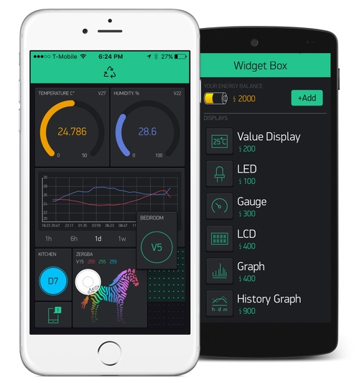

**Fig 6.3.1 BLYNK APP OVERVIEW**

* **Blynk Libraries** - for all the popular hardware platforms - enable communication with the server and process all the incoming and out coming commands.

Now imagine, every time you press a Button in the Blynk app, the message travels to the Blynk Cloud, where it magically finds its way to your hardware. It works the same in the opposite direction and everything happens in a blynk of an eye.

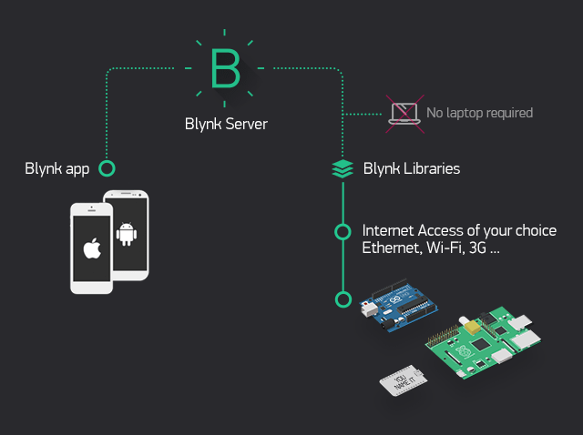

**Fig 6.3.2 BLYNK CLOUD ARCHITECTURE**

Characteristics of Blynk are: Similar API & UI for all supported hardware & devices Connection to the cloud can be done using Ethernet, Wi-Fi, Bluetooth, BLE and USB (Serial) Set of easy-to-use Widgets Direct pin manipulation with no code writing Easy to integrate and add new functionality using virtual pins History data monitoring via History Graph widget Device-to-Device communication using Bridge Widget Sending emails, tweets, push notifications, etc.

**CHAPTER VII**

**RESULT AND DISCUSSION**

**HARDWARE IMPLEMENTATION**

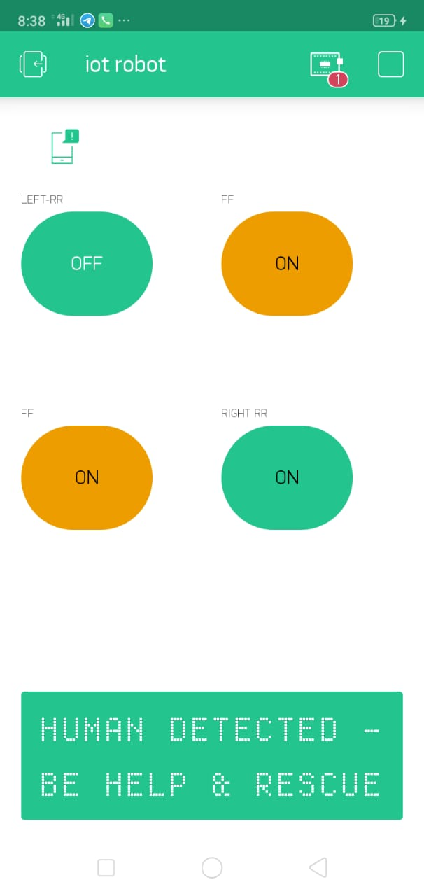 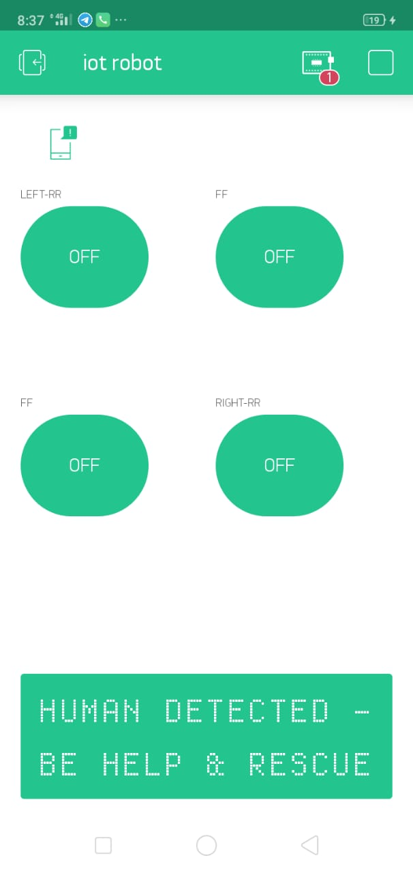

**7.1 Program**

#define BLYNK_PRINT Serial

#include <ESP8266WiFi.h>

#include <BlynkSimpleEsp8266.h>

#include <DHT.h>

char auth[] = "u1LirHeZK8ojrV6SvGGpFYoFzboNrZqa";

char ssid[] = "iotlab";

char pass[] = "password12345";

#define DHTPIN 10 // D0

const int leftForward = 5; //SD3

const int leftBackward =4;//SD2

const int rightForward = 0;//d3

const int rightBackward = 2;//d4

BlynkTimer timer;

int outputpin = A0;

WidgetLCD lcd(V1);

//int pirValue; // Place to store read PIR Value

//int motionDetected = 0;

void setup()

{

dht.begin();

// Debug console

Serial.begin(9600);

pinMode(D5, INPUT);

pinMode(D6, INPUT);

pinMode(D7, INPUT);

pinMode(D8, INPUT);

pinMode(A0, INPUT);

pinMode(D0, OUTPUT);

pinMode(D1, INPUT);

// pinMode(leftForward,OUTPUT);

pinMode(leftBackward,OUTPUT);

pinMode(rightForward,OUTPUT);

pinMode(rightBackward,OUTPUT);

Blynk.begin(auth, ssid, pass);

timer.setInterval(1000L, sendSensor);

}

void loop()

{

Blynk.run();

timer.run();

getPirValue();

metal();

delay(1000);

fire();

delay(1000);

}

void fire(void)

{

if(digitalRead(D1)==HIGH)

{

digitalWrite(D0,HIGH);

Blynk.notify("T==> HUMAN DETECTED-SAFE AND RESCUE");

lcd.clear();

lcd.print(0, 0, "HUMAN DETECTED -BE HELP & RESCUE");

}

else

{

digitalWrite(D0,LOW);

lcd.clear();

lcd.print(0, 0, " SEARCHING HUMAN.........");

}

}

void metal(void)

{

if(digitalRead(D2)==HIGH)

{

digitalWrite(D0,HIGH);

Blynk.notify("T==> METAL DETECTED-SAFE AND RESCUE");

lcd.clear();

lcd.print(0, 0, "METAL DETECTED -BE HELP & RESCUE");

}

else

{

digitalWrite(D0,LOW);

lcd.clear();

lcd.print(0, 0, " SEARCHING HUMAN.........");

}

}

void getPirValue(void)

{

if (digitalRead(D5)==HIGH)

{

digitalWrite(leftForward,HIGH);

digitalWrite(leftBackward,LOW);

digitalWrite(rightForward,HIGH);

digitalWrite(rightBackward,LOW);

lcd.clear();

lcd.print(0, 0, "forward");

}

else if (digitalRead(D6)==HIGH)

{

digitalWrite(leftForward,LOW);

digitalWrite(leftBackward,LOW);

digitalWrite(rightForward,HIGH);

digitalWrite(rightBackward,LOW);

lcd.clear();

lcd.print(0, 0, "left");

}

else if (digitalRead(D7)==HIGH)

{

digitalWrite(leftForward,HIGH);

digitalWrite(leftBackward,LOW);

digitalWrite(rightForward,LOW);

digitalWrite(rightBackward,LOW);

lcd.clear();

lcd.print(0, 0, "right");

}

else if (digitalRead(D8)==HIGH)

{

digitalWrite(leftForward,LOW);

digitalWrite(leftBackward,HIGH);

digitalWrite(rightForward,LOW);

digitalWrite(rightBackward,HIGH);

lcd.clear();

lcd.print(0, 0, "reverse");

}

else

{

digitalWrite(leftForward,LOW);

digitalWrite(leftBackward,LOW);

digitalWrite(rightForward,LOW);

digitalWrite(rightBackward,LOW);

lcd.clear();

lcd.print(0, 0, "MILITARY ROBOT - STOP");

}}

**7.2 CONCULSION**

The project is aimed at providing human safety for the rescue team in hazardous environments such as coal mines. This is a prototype which can be implemented in real time by using components with better range and efficiency. This robot enters into hazardous environments and provides data like the content of gases after the explosive has occurred and also the temperature based on which the rescue team will be sent with necessary precautionary measures in order to make sure that the rescue team does not come to any harm.

In future by the use of higher transmission range transceivers so that it can travel for a greater distance and can be used in different environments based on the transmission range. Development can also be made in the number of sensors incorporated in the robot. Various other sensors like O2 sensor, humidity sensor can be added and thus helping to get a much improved image of the environments inside. Implementation of an arm on the robot can help the robot pick up samples or removes small debris from path.

**CHAPTER VIII**

**8.1 REFERENCES**

1. Jayant Nivritti Patil “Advanced Rescue and Monitoring Robot For Coal Mine” in International Research Journal of Engineering and Technology (IRJET), vol: 04 issue 7 July 2017.
2. S. D. Mitragotri, Dr.A. R. Karwankar “Coal Mine Robot For Detection of Hazardous Gas” in International Journal of Advanced Research in Electrical, Electronics and Instrumentation Engineering Vol. 5, Issue 4, April 2016.
3. Sharath Sethu Raghavan, Jasim M, Aqib Saman K, Jisnu Thomas, Faheem E S, Lilly Raffy

Cheerotha “Hazardous Gas & Mine Detecting Robot“ in International Journal of Computer Trends and Technology (IJCTT) – volume 28 Number 1 – October

1. T S Kumar Reddy, G Bala Siva Krishna “Hazardous Gas Detecting Rescue Robot In Coal Mines “ in International Journal of Mechanical And Production Engineering, Volume- 2, Issue- 5, May-2014
2. Niu Zhigang, Wang Lu “Hazardous Gas Detecting Method Applied In Coal Mine Detection Robot” in 2011 Third International Conference on Measuring Technology and Mechatronics Automation.
3. Zhu Jianguo, Gao Junyao, Li Kejie, Lin Wei, Bi Shengjun “Embedded Control System Design For Coal Mine Detect And Rescue Robot” in International Journal of Advanced Research in 2010.