USER JOURNEY FLOWCHARTS
[BRAND]
Visual maps of the 5 primary customer journeys

Document | Value
Title | User Journey Flowcharts — [BRAND] v1.0
Version | 1.0 (Draft)
Date | April 2026
Owner | Philip Olaomo
Status | Draft
Companion to | Product Requirements Document v1.0
Audience | Engineering, Design, Product, Stakeholders

Introduction

This document maps the five primary customer journeys for [BRAND]. Each journey represents a distinct lifecycle moment for international residents in Germany, sourced from the April 2026 research report and validated against real pain points surfaced in expat forums, journalist reports, and government documentation.
The flowcharts use a shared visual language so that engineering and design teams can read across journeys without re-learning the notation.

Visual notation
- Blue rectangles — User steps (actions the immigrant must perform themselves).
- Orange diamonds — Decisions (branching points where the journey diverges).
- Green rectangles — [BRAND] actions (where the product intervenes to add value).
- Red rectangles — Common pain points (problems that justify [BRAND]'s existence).
- Dark green rounded rectangles — Outcomes (the successful end-state of the journey).
- Arrows — Sequence (default: left-to-right; curved arrows indicate journey transitions across lanes).

How to read each journey
Each journey is laid out in horizontal lanes, top to bottom. Lanes correspond to phases (e.g., pre-arrival, arrival, university, residence permit). At the bottom of each journey, a red panel summarises the most common pain points [BRAND] addresses. Below that, the green outcome box describes the successful end state. The italicised footer notes [BRAND]'s role and the monetisation hooks for that journey.
Together, the five journeys cover the full immigration lifecycle: arrival → settlement → renewal → family → permanence. They are not exhaustive — secondary journeys (Bürgergeld onboarding, asylum process, child birth registration, etc.) will be mapped in Phase 2 deliverables.

Journey 1 — First-time student arrival

Persona served
Primary: Persona 2 (Chiamaka, Nigerian master's student in Aschaffenburg). Secondary: any non-EU student arriving on a D-visa. This is [BRAND]'s MVP target persona — highest volume and most acute combination of bureaucratic friction, language barrier, and willingness to use a digital tool.

Trigger and horizon
Trigger: D-visa issued by a German consulate abroad. Horizon: 30 days pre-arrival to 90 days post-arrival. Critical deadlines fall inside this window — Anmeldung (within 14 days of moving in), Sperrkonto activation, switch to public health insurance, residence permit application before D-visa expires.

Critical moments where [BRAND] adds value
- Pre-arrival countdown: most students underestimate the sequencing of Sperrkonto, insurance, apostille, and translation. [BRAND] delivers a dated checklist starting 30 days before flight.
- Anmeldung slot finder: in Berlin, Munich, and Stuttgart, slot scarcity is a primary blocker. [BRAND] surfaces alternative offices and watches for newly-released slots.
- City-specific residence permit guidance: Munich's KVR, Berlin's LEA, and Stuttgart's Ausländerbehörde each operate different portals with different document lists. [BRAND] presents the right list for the user's exact city and visa type.
- GEZ/Rundfunkbeitrag warning: most students miss the Rundfunkbeitrag enrolment letter, which arrives 4–6 weeks after Anmeldung. [BRAND] flags it and explains the BAföG-based exemption pathway.
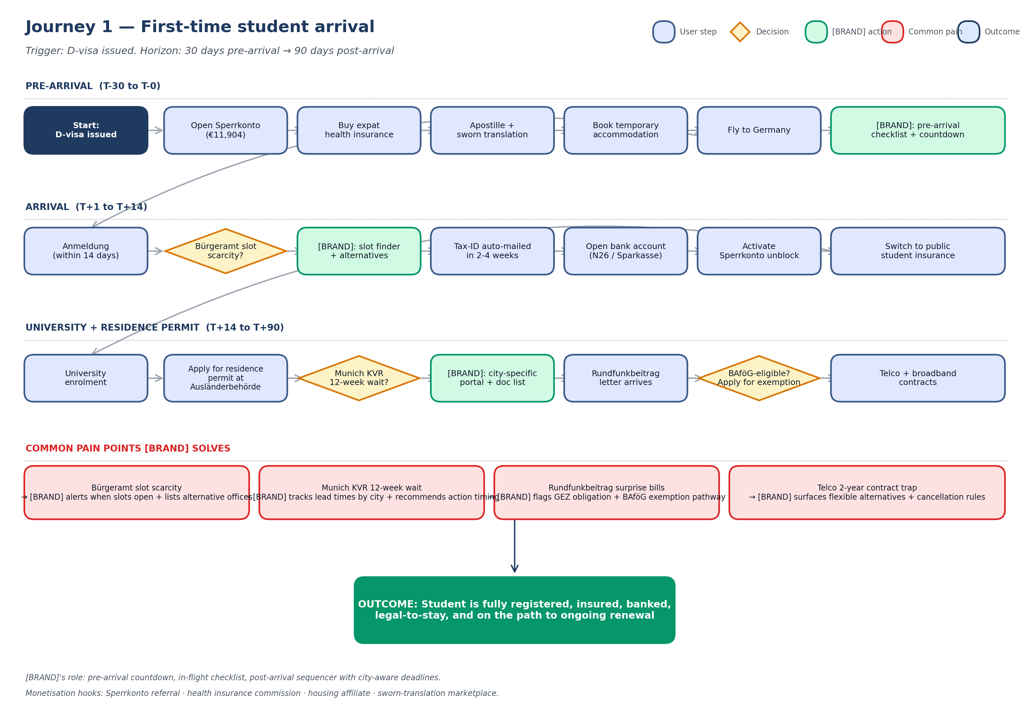

Journey 2 — Job seeker visa to work visa transition

Persona served
Primary: Persona 1 (Arjun, Indian software engineer with EU Blue Card). Secondary: any non-EU graduate transitioning from §20 graduate job-search permit to skilled-worker permit, or any Chancenkarte holder converting to a work permit. The 2024 Chancenkarte launch and the 2026 Blue Card thresholds make this journey rapidly evolving.

Trigger and horizon
Trigger: studies complete (graduate path) OR Chancenkarte issued. Horizon: 12–18 months from trigger to converted work permit. The journey forks into two parallel paths that converge at the residence permit application stage.

Critical moments where [BRAND] adds value
- Permit-expiry deadline tracking: §20 graduate permits last 18 months; Chancenkarte lasts 12 months. Missing the conversion window is catastrophic. [BRAND] tracks expiry and surfaces actions at 90, 60, 30 days.
- Salary threshold check: 2026 EU Blue Card requires €50,700 (standard) or €45,934.20 (shortage occupations). Many candidates are just below the line and don't realise. [BRAND] provides a calculator that catches this early.
- Employer letter validation: the most common application bounce reason is a non-conforming employer offer letter. [BRAND] gives users a checklist to hand to their employer's HR team.
- ZAB recognition workflow: degree recognition takes 6–12 weeks. If not started early, the application stalls. [BRAND] kicks this off in parallel with the job search, not at the residence permit stage.
- Untätigkeitsklage escalation: in Berlin, LEA silence beyond 3 months is grounds for a lawsuit. [BRAND] tracks the silence clock and routes users to lawyer partners.
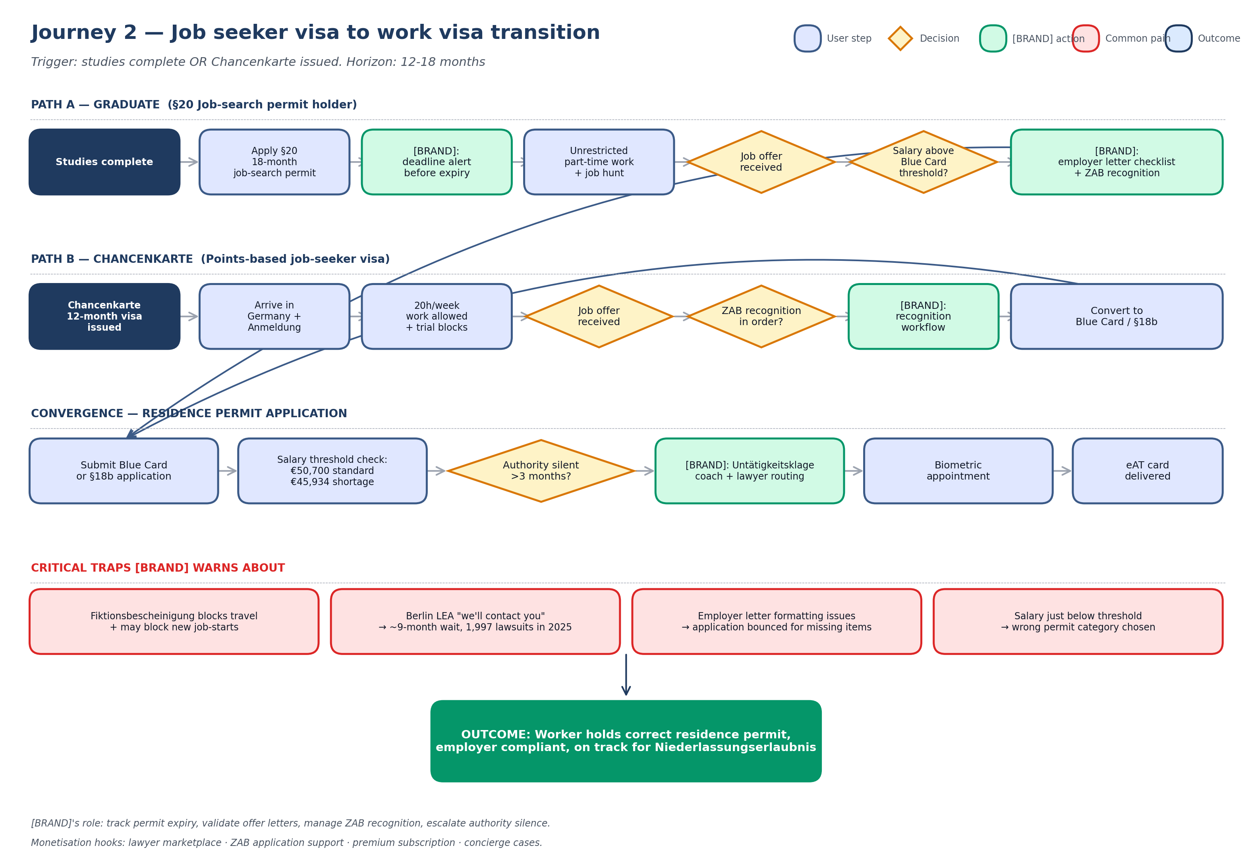

Journey 3 — Visa renewal

Persona served
All personas with a non-permanent residence permit. Renewal is the single most universal recurring pain in [BRAND]'s scope — every Aufenthaltstitel-holder hits it on a 1–4 year cycle.

Trigger and horizon
Trigger: residence permit expiry within 12 weeks. Horizon: 8–12 weeks if managed proactively, longer if delays occur. Frankfurt sends auto-renewal letters since 2018; most other cities do not.

Critical moments where [BRAND] adds value
- Countdown reminders: [BRAND] pushes notifications at 90, 60, 30, 14, 7, and 1 day intervals before expiry. Each reminder includes the exact next action.
- City portal routing: ten target cities operate ten different submission portals, with different document requirements and different communication patterns. [BRAND] routes users to the correct portal automatically.
- Document gap detection: the Document Vault flags missing or expired prerequisites (e.g., birth certificates older than 6 months, biometric photos in non-digital format) before submission.
- Fiktionsbescheinigung guidance: when permit expires before decision, the provisional Fiktionsbescheinigung blocks travel and may block new job-starts. [BRAND] explains the implications and routes users to legal help.
- Authority silence escalation: [BRAND] starts the 3-month silence clock automatically and prompts a Sachstandsanfrage, then an Untätigkeitsklage if needed.
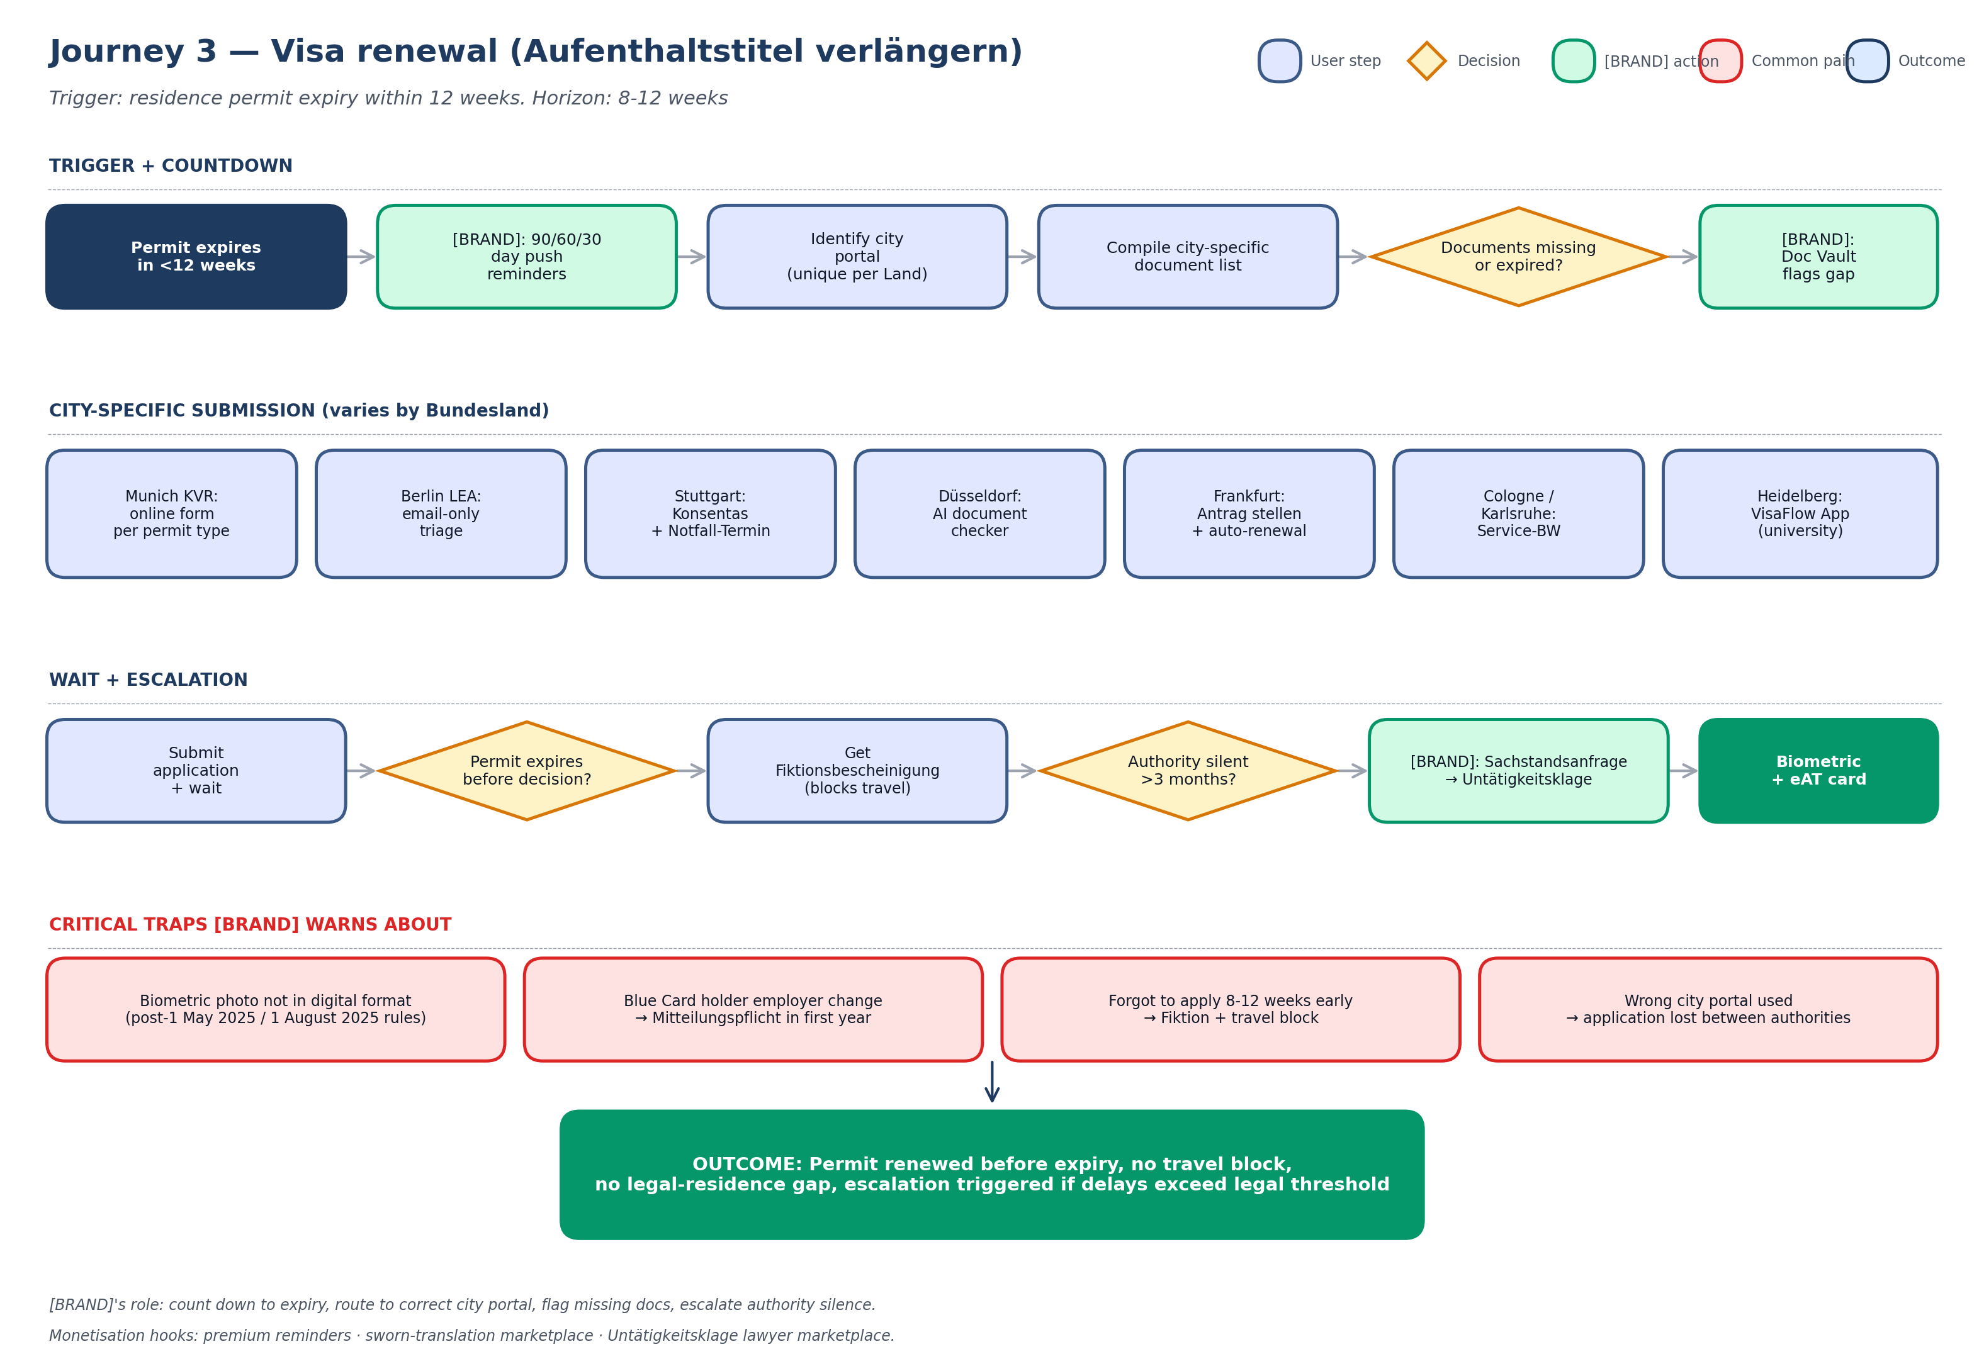

Journey 4 — Family reunification

Persona served
Primary: Personas 1 (Arjun bringing wife Priya), 3 (Marwan bringing wife from Beirut), 5 (Sahar bringing parents from Iran). Secondary: any sponsor wishing to bring spouse, children, or parents to Germany. The July 2025 suspension of subsidiary-protection family reunification (until July 2027) and the per-country embassy timelines create wildly different experiences depending on nationality and sponsor permit type.

Trigger and horizon
Trigger: sponsor decides to bring family. Horizon: 6 months (privileged passports) to 2 years (high-volume embassies + problem-country document chains). The longest pain is the embassy slot wait, which can exceed 18 months.

Critical moments where [BRAND] adds value
- Eligibility calculator: sponsor must show €1,200+/month income, adequate space (12m² per adult, 10m² per child under 6), and health insurance for joiners. [BRAND] catches eligibility gaps before the application is filed.
- A1 German exemption decision tree: spouses must show A1 unless privileged-country exempt or Blue-Card-spouse exempt. Many couples don't realise they qualify for an exemption.
- OLG-Befreiung detector: countries that don't issue Ehefähigkeitszeugnis (Pakistan, Nigeria, Iran, Syria, Vietnam, Thailand, USA, UK, Canada, Australia, Brazil) require an OLG-Befreiung — a 2–6 month, €15–305 process. [BRAND] flags this for couples whose origin countries are on the non-issuing list.
- Country-specific document timeline: India, Pakistan, Nigeria, Bangladesh, Sri Lanka, DR Congo, Iraq, Iran, Syria, Afghanistan require Vertrauensanwalt verification (€100–500, 2–6 months). [BRAND] generates a country-specific timeline so users don't underestimate.
- Embassy wait tracker: New Delhi, Lagos, Islamabad, and Tehran consulates have multi-month waits. [BRAND] surfaces current expected waits so users plan around them.
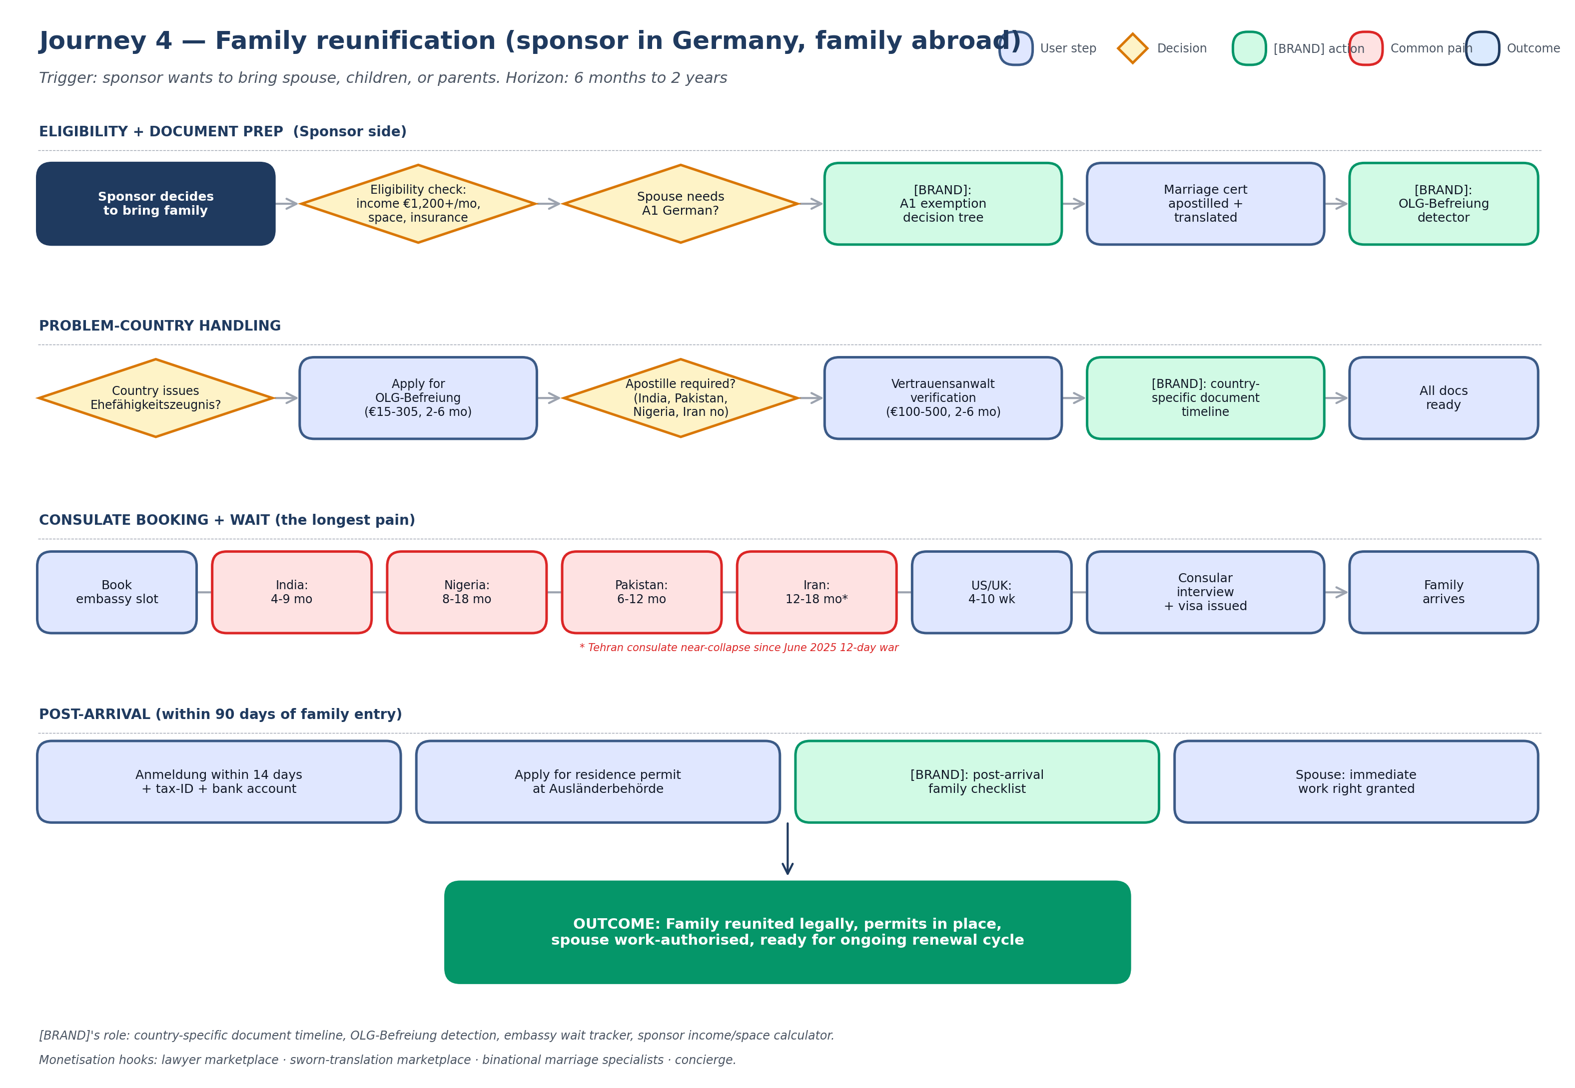

Journey 5 — Path to permanent residency and citizenship

Persona served
Long-term residents across all personas. Most acute for Personas 3 (Marwan, Syrian refugee eligible for citizenship under post-2024 5-year rule) and 1 (Arjun, EU Blue Card holder eligible for Niederlassungserlaubnis after 21–27 months). The June 2024 reform reduced the residence requirement from 8 to 5 years and allowed dual citizenship — but the October 2025 repeal of the 3-year fast-track means the journey is back to a single 5-year track.

Trigger and horizon
Trigger: 21 months (Blue Card with B1) for Niederlassungserlaubnis; 5 years for citizenship. Horizon: years. This is [BRAND]'s longest-tail journey and the one with the strongest retention argument — [BRAND] earns its place in the user's life by being there for 5+ years.

Critical moments where [BRAND] adds value
- Long-horizon eligibility tracker: [BRAND] tracks residence months, B1 certification, pension contribution months, financial self-sufficiency markers, and clean-record requirements. Users see a single counter to their next eligibility milestone.
- Pension month reminders: 60 months of pension contributions (or 36 for skilled workers) is a hard requirement. Self-employed users without statutory pension miss this. [BRAND] surfaces it early enough to fix.
- Test preparation: Leben-in-Deutschland test (33 questions, pass 17) for Niederlassungserlaubnis; Einbürgerungstest (33 questions, pass 17) for citizenship. [BRAND] offers practice and B1 booking integrations.
- Citizenship application bundler: required documents span Anmeldung history, marriage/birth certificates, employer letters, pension statement, criminal record, language certificate, fee proof. [BRAND] assembles the bundle from the user's existing Document Vault.
- Backlog escalation: Berlin LEA's 75,000-application citizenship backlog means 24+ month waits are common. [BRAND] tracks the silence clock and routes to Untätigkeitsklage when the legal threshold passes.
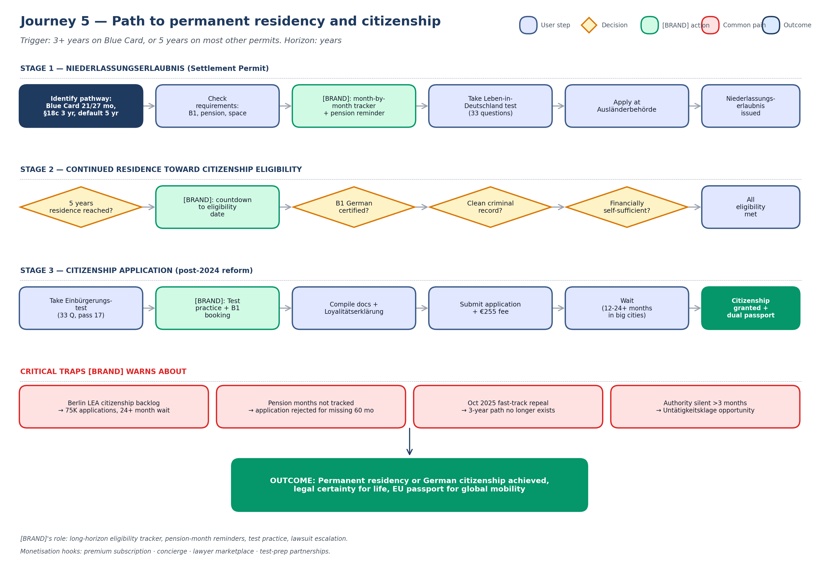

Cross-journey reference matrix

This matrix summarises every journey on a single page for product, design, and engineering reference. Use it as a quick map when evaluating new feature ideas — does the feature serve more than one journey, or only one?
Journey | Trigger | Horizon | Primary persona | Top monetisation hook
1 — First-time student arrival | D-visa issued | 30d pre → 90d post arrival | Chiamaka (non-EU master's student) | Sperrkonto referral + insurance brokerage + housing affiliate
2 — Job-seeker to work visa | Studies complete OR Chancenkarte issued | 12-18 months | Arjun (Indian Blue Card candidate) | Lawyer marketplace + ZAB application support + premium subscription
3 — Visa renewal | Permit expires within 12 weeks | 8-12 weeks | All permit holders | Premium reminders + sworn-translation marketplace + Untätigkeitsklage lawyers
4 — Family reunification | Sponsor decides to bring family | 6 months to 2 years | Arjun, Marwan, Sahar | Lawyer marketplace + sworn-translation marketplace + binational marriage specialists
5 — PR + citizenship | 21 months / 5 years residence | Years | Long-term residents (especially Marwan, Arjun) | Premium subscription + concierge + lawyer marketplace + test-prep partnerships

Document Control

Version history
Version | Date | Author | Summary of change
1.0 | April 2026 | Philip Olaomo | Initial release; 5 primary journeys; landscape PDF format

Companion documents
- Product Requirements Document v1.0
- Use Cases (UC-001 through UC-NN) — next deliverable
- Functional & Non-Functional Requirements — to follow
- Wireframes / Mockups — to follow
- Domain Model + API Specification — to follow
- Test Plan + Test Cases — to follow
- Migration Plan — to follow

