WIREFRAMES & MOCKUPS
[BRAND]
MVP screen designs with engineering and behaviour annotations

Document | Value
Title | Wireframes & Mockups — [BRAND] v1.0
Version | 1.0 (Draft)
Date | April 2026
Owner | Philip Olaomo
Status | Draft
Companion to | PRD v1.0; Use Cases v1.0; FRS/NFR v1.0
Audience | Design, Engineering, Product, QA
Wireframe count | 6 (MVP core flows)
Format | Mobile-first (375pt iPhone width); responsive web parity in Phase 2

Introduction

This document contains medium-fidelity wireframes for the 6 most important MVP screens, paired with annotations describing visible UI elements, interaction behaviours, engineering hooks, and edge-state handling.
These are not pixel-perfect mockups — they are deliberate wireframes. Visual design (colour palette, typography refinement, illustration style, motion) follows in a later design pass. The goal here is to lock down structure, hierarchy, and interaction model before pixel polish.

Conventions
- All screens are drawn at iPhone 13 width (375 pt × 812 pt) as the canonical mobile target.
- Tap targets are minimum 44×44 pt, per Apple HIG and WCAG 2.1.
- Numbered orange badges on each wireframe correspond to numbered annotations in the side panel.
- Each wireframe maps to one or more use cases (UC-NNN) and functional requirements (FR-NNN).
- Behaviour notes describe interaction. Engineering notes describe API and state. Edge states cover empty, loading, offline, and error.

Wireframe index
# | Screen | Maps to | Phase
1 | Onboarding wizard | UC-001 | MVP
2 | Dashboard (My Journey) | UC-002, UC-003, UC-005 | MVP
3 | Task detail | UC-002, UC-003, UC-004 | MVP
4 | Document Vault | UC-004 | MVP
5 | City office page | UC-006 | MVP
6 | Marketplace partner card (Sperrkonto) | UC-007, UC-008, UC-009 | MVP

What is NOT in this document
- Phase 2 screens (sworn translation marketplace, banking decision tree, family reunification module) — to be added in v2.
- Web responsive variants — Phase 2 deliverable.
- Visual design system (colours, type scale, components, spacing tokens) — separate Design Tokens document.
- Motion/animation specs — separate Motion document if required.

Wireframe 1 — Onboarding wizard

Maps to
UC-001 — User onboarding and personalisation

Description
The 6-step wizard that turns a new sign-up into a personalised user. Drop-off at any screen is a critical metric. Every wizard screen has 'Skip for now' to keep the funnel forgiving.

Visual
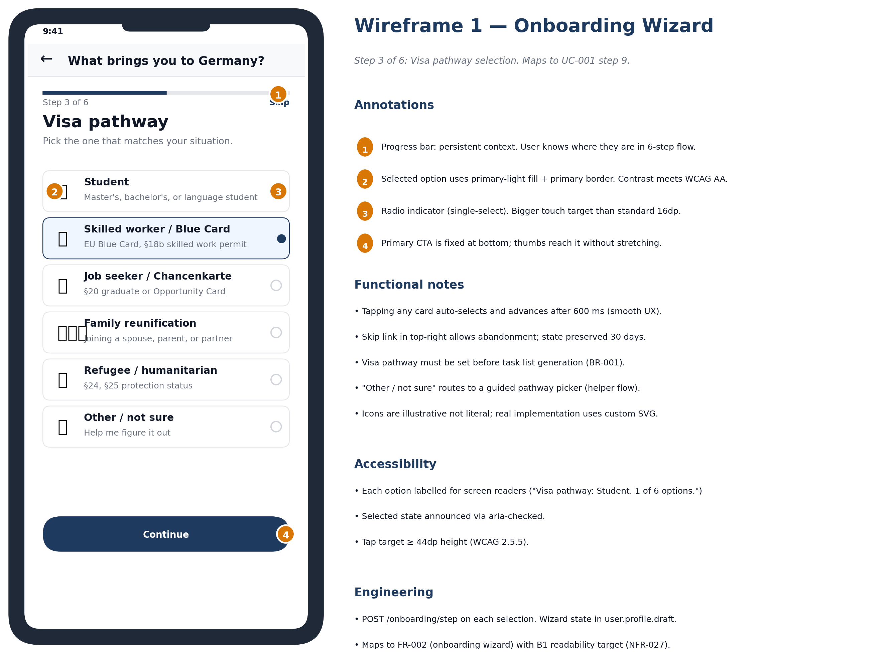

Core elements
- Step counter at top (1/6, 2/6 …) gives the user a clear sense of progress.
- Single primary action per screen: a large 'Continue' button at the bottom.
- 'Skip for now' tertiary action lets users escape without abandoning the account.
- Question copy uses plain language; no German bureaucracy jargon at this stage.

Behaviour
- Tapping Continue advances to the next screen with a subtle slide animation (no full page transition).
- Tapping Skip returns the user to the partial dashboard.
- Back button on screens 2-6 returns to the previous step without losing entered data.
- Auto-validate inputs on blur; surface inline errors in red below the field.

Engineering hooks
- Each screen submits to POST /onboarding/step/{n} with idempotency key.
- Final submission triggers personalisation engine via POST /onboarding/finalize.
- Local fallback: if API fails, save to IndexedDB; sync on next launch.

Edge states
- Loading: spinner replaces Continue button until the next screen loads.
- Offline: 'Looks like you're offline. Your answers are saved.' banner.
- API error: inline error 'We had trouble saving. Try again.' with retry.

Wireframe 2 — Dashboard (My Journey)

Maps to
UC-002 — View task list, UC-003 — Mark complete, UC-005 — Receive reminder

Description
The home screen and primary loop. Time-ordered task list with the persistent deadline banner at top. This is the first screen users see every time they open the app.

Visual
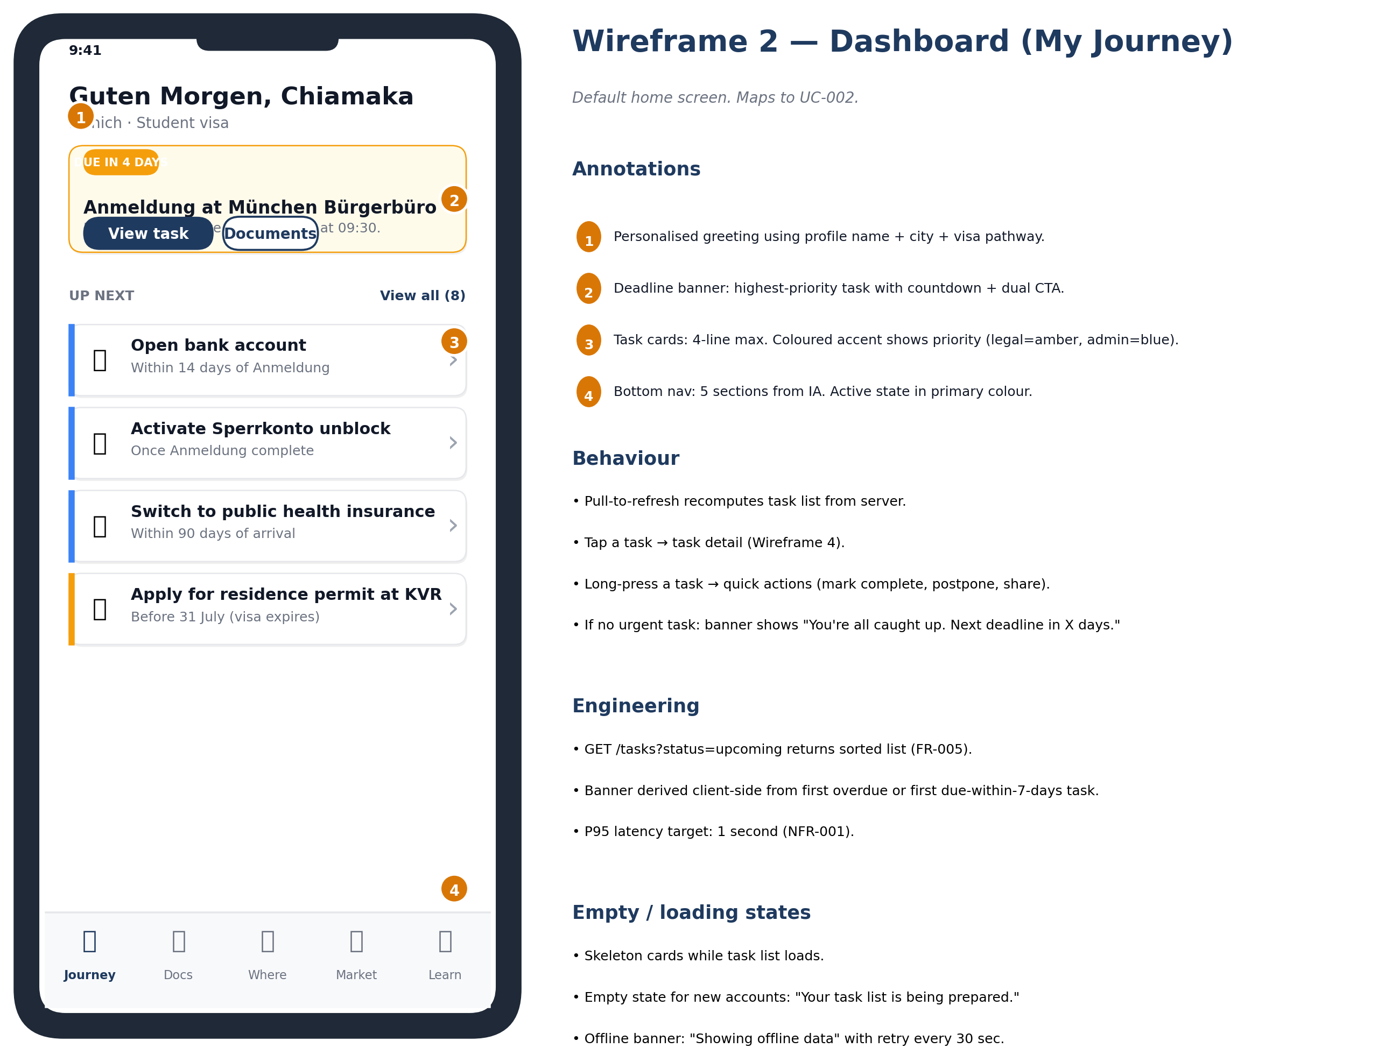

Core elements
- Personalised greeting with first name + city + visa pathway, gives context immediately.
- Persistent deadline banner: highest-priority upcoming or overdue task with countdown.
- Task list cards ordered by next-due-date ascending. 4-line max per card to keep scannable.
- Bottom nav: 5 sections (Journey, Docs, Where, Market, Learn) — never deeper than 1 tap to reach any section.

Behaviour
- Pull-to-refresh recomputes the task list from the server.
- Tap a task card → navigate to task detail (Wireframe 3).
- Long-press a task → quick actions menu (mark complete, postpone, share).
- If no urgent task: deadline banner shows 'You're all caught up. Next deadline in X days.'

Engineering hooks
- GET /tasks?status=upcoming returns the sorted list (FR-005).
- Deadline banner is computed client-side from the first overdue task, falling back to the first task due in <7 days.
- P95 latency target: 1 second on 4G (NFR-001).

Edge states
- Loading: skeleton cards animate while task list loads.
- Empty: 'Your task list is being prepared.' for new accounts.
- Offline: 'Showing offline data' banner with retry every 30 sec.

Wireframe 3 — Task detail

Maps to
UC-002, UC-003 — Mark task complete, UC-004 — Add document

Description
Single-task view containing instructions, what-to-bring checklist, related documents, related city office, and the primary 'Mark complete' action.

Visual
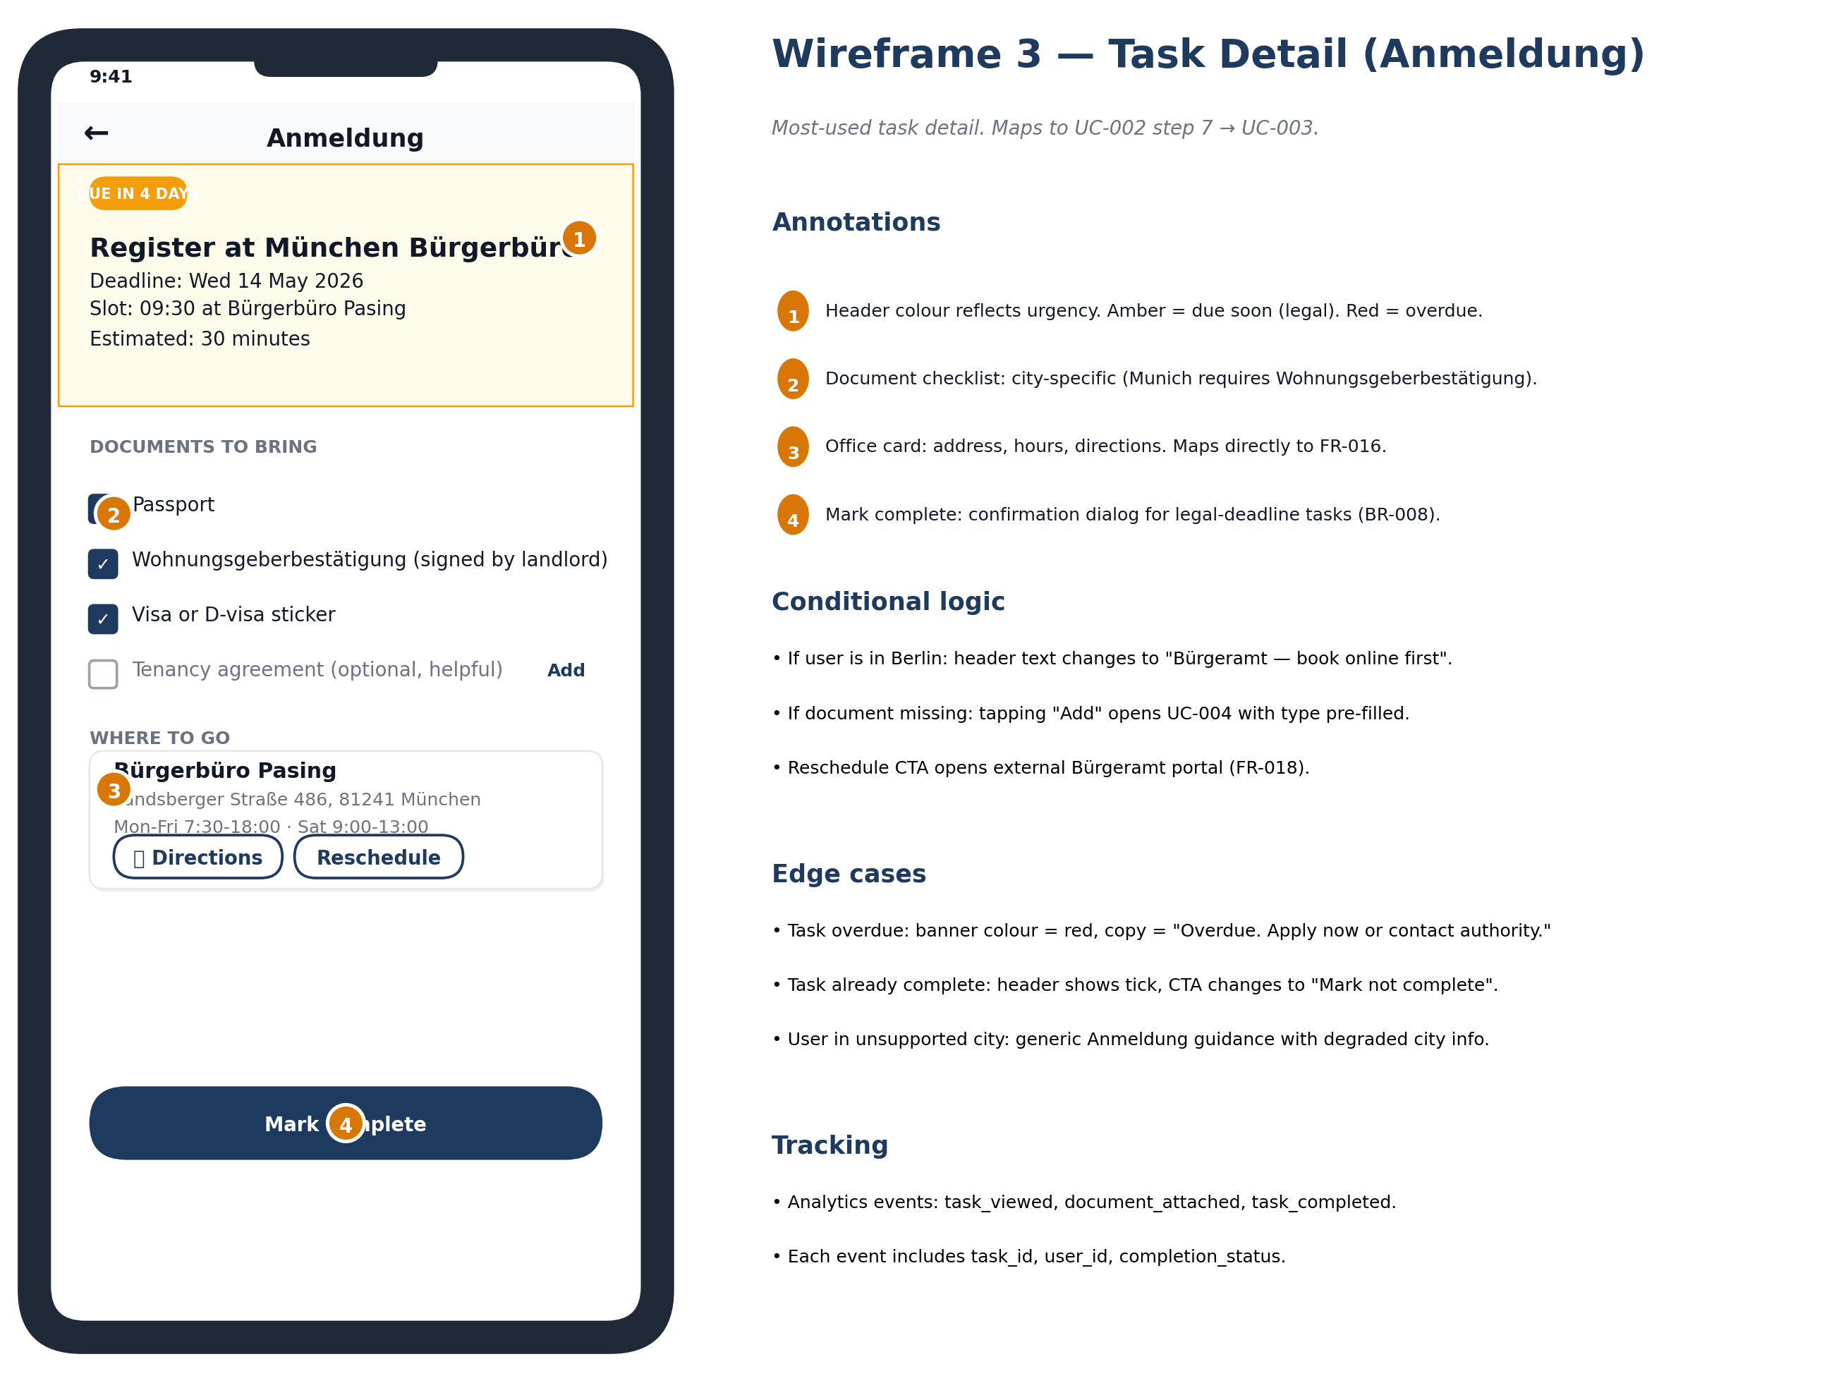

Core elements
- Task title at top with status pill (Upcoming / Due / Overdue).
- Time-to-deadline countdown beneath the title.
- Plain-language explanation: what to do, why it matters, what happens next.
- 'What to bring' checklist with checkboxes the user can tick as they prepare.
- Linked document slots: tap to attach from Vault or upload new.
- Linked city office card: tap to view office detail (Wireframe 5).
- Sticky bottom action bar: 'Mark complete' (primary) and 'Postpone' (secondary).

Behaviour
- Checkboxes on the 'What to bring' list persist locally; do not affect task status.
- Tapping Mark complete shows a confirmation sheet if dependencies exist.
- Tapping Postpone shows a date picker (max 30 days forward).
- Tapping a document slot opens the picker (camera, vault, upload).

Engineering hooks
- GET /tasks/{id} returns full task detail with linked entities.
- PATCH /tasks/{id} { status: 'complete' } triggers downstream task scheduling.
- Document attach is a POST /tasks/{id}/documents with multipart form data.

Edge states
- Loading: skeleton screen with task title placeholder.
- Task removed from plan: 'This task is no longer relevant. Return to dashboard.'
- Document upload fails: inline error with retry.

Wireframe 4 — Document Vault

Maps to
UC-004 — Add document

Description
User's encrypted document store. Folders by document type. Each document carries metadata and status flags (apostille, sworn translation, expiry). Designed for privacy: no preview is shown until the user explicitly opens.

Visual
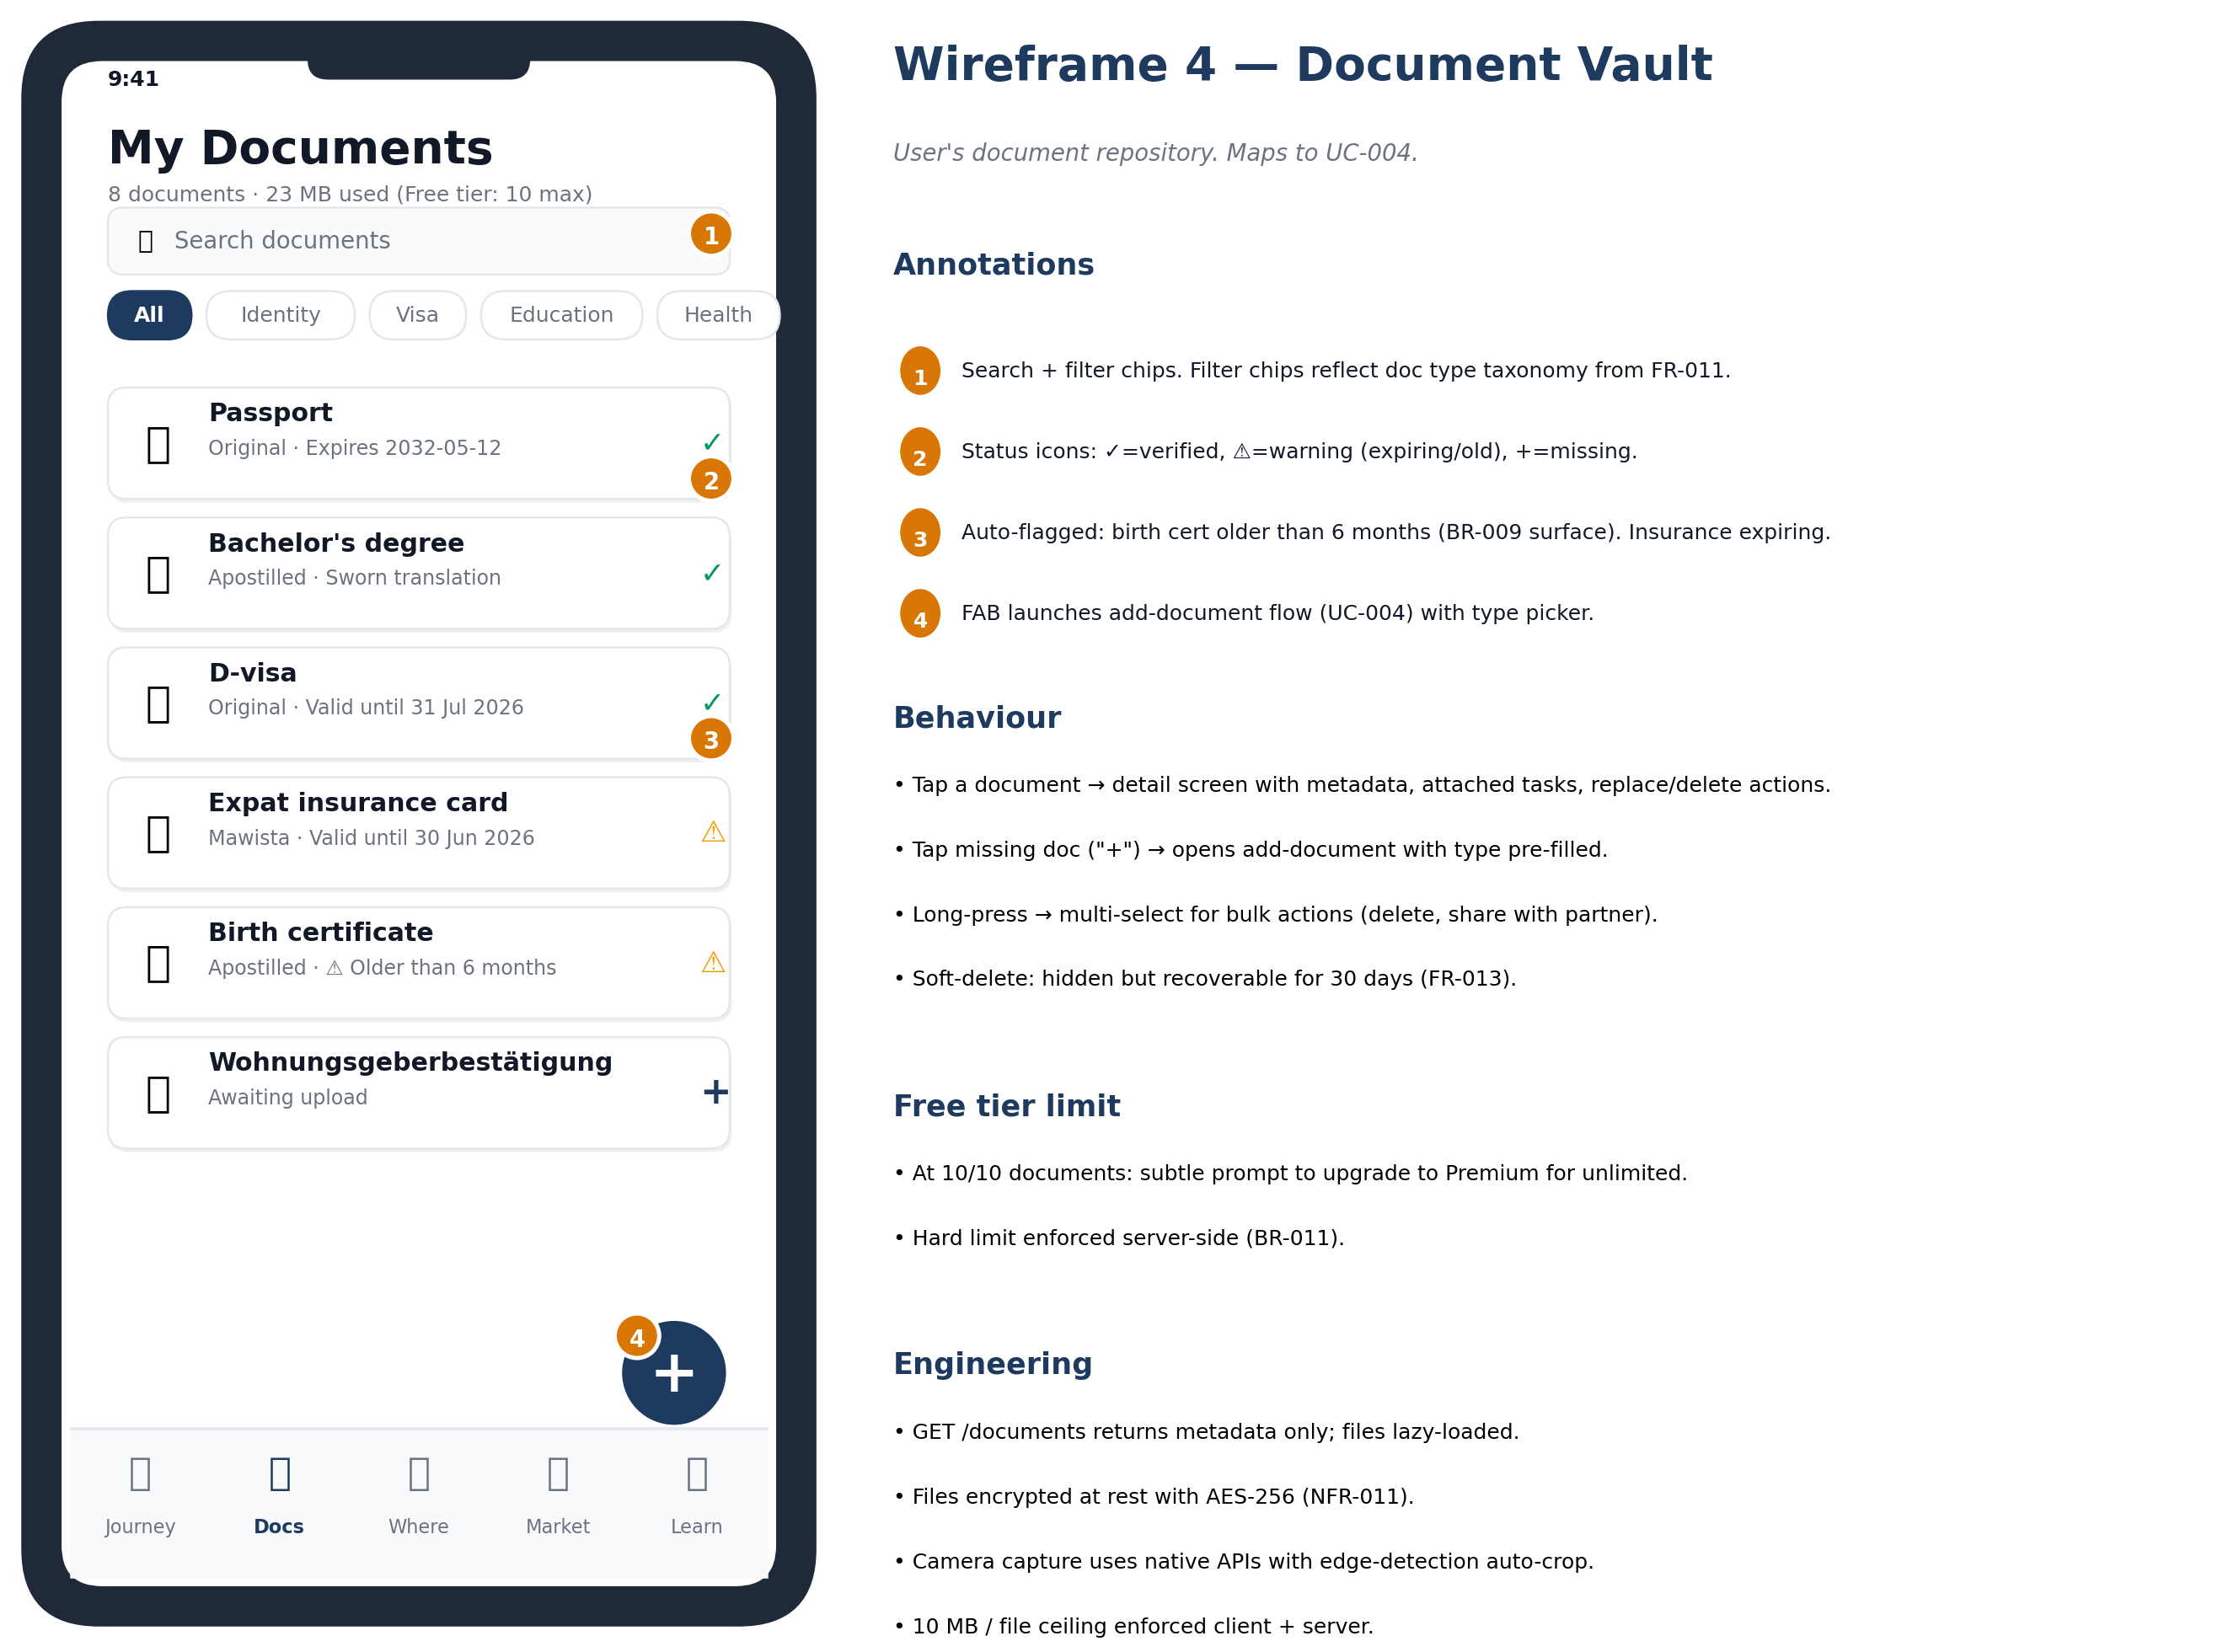

Core elements
- Search bar at top for fast retrieval.
- Filter chips by document type (passport, certificates, insurance, etc.).
- Document cards show: icon, title, document type, expiry status, and status flags.
- Floating Add button (FAB) with three-action sheet: Take photo, Choose file, Upload PDF.
- Storage usage bar at bottom: 'X MB of 10 MB used' (Free) or 'X MB of 1 GB' (Premium).

Behaviour
- Tap a document → preview screen (encrypted-on-the-fly decryption).
- Long-press → quick actions (rename, share, delete, mark expired).
- Pull-to-refresh syncs with server.
- If quota exceeded: Add button shows 'Upgrade for more storage' instead.

Engineering hooks
- GET /documents returns metadata only (no file content).
- GET /documents/{id}/content streams encrypted bytes for client-side decryption.
- POST /documents accepts multipart upload; server runs classifier + virus scan before returning success.
- All document content is AES-256 encrypted at rest in EU storage.

Edge states
- Empty: 'Your vault is empty. Add your first document.' with a prominent Add button.
- Quota full: red banner 'Vault full. Upgrade or remove documents.'
- Document failed virus scan: shown with red badge 'Failed security check'.

Wireframe 5 — City office page

Maps to
UC-006 — View city-specific office page

Description
Detail page for a specific authority office (e.g., Munich KVR, Berlin LEA). Shows address, hours, current booking portal, last-known wait times, and 'what to bring' organised by purpose.

Visual
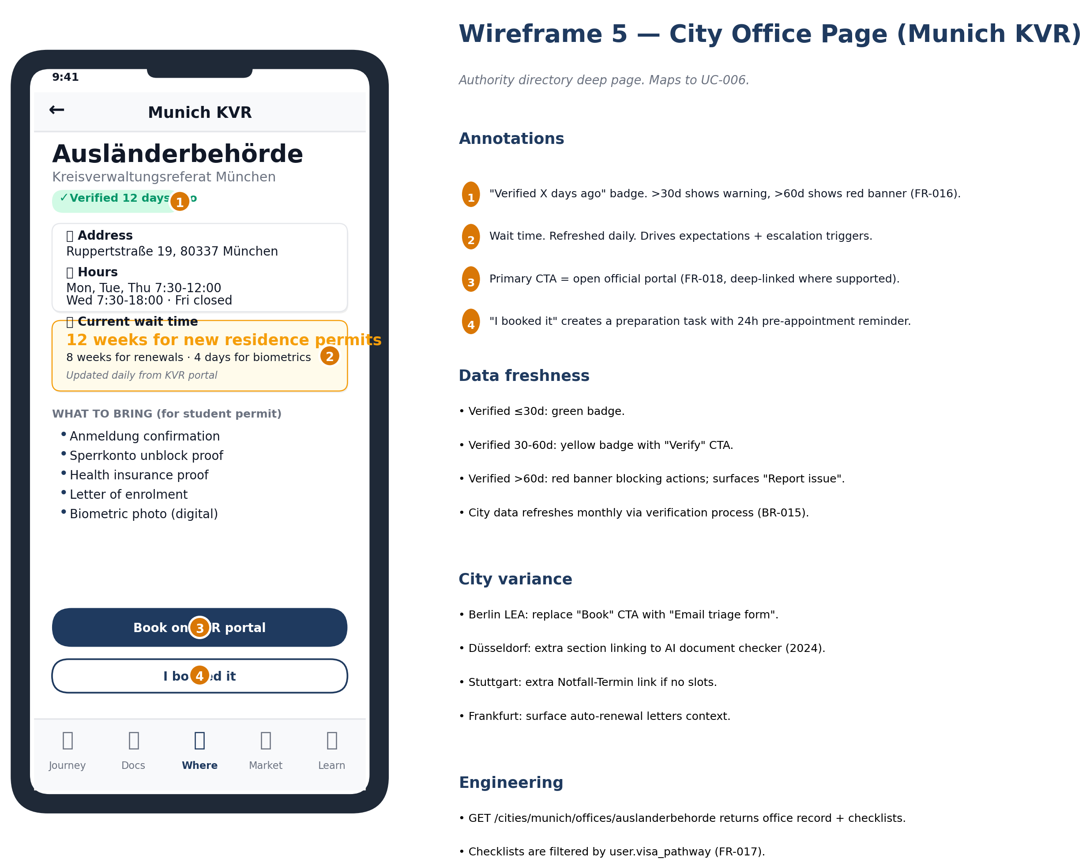

Core elements
- Office name + photo at top.
- Address card with map preview, tap to open in Apple Maps / Google Maps.
- Hours and language support badges.
- 'Last verified [date]' indicator, with yellow warning if older than 30 days.
- Big 'Book appointment' CTA that deep-links to the official booking portal.
- 'What to bring' accordion organised by purpose (Anmeldung, residence permit, etc.).
- 'Report broken link' / 'Suggest update' link at bottom.

Behaviour
- Tap the address card → opens map app.
- Tap Book appointment → opens the official booking portal in in-app browser.
- Tap a 'What to bring' purpose accordion → expands to show the full list.
- Tap Report broken link → opens a feedback form.

Engineering hooks
- GET /offices/{id} returns office data with last-verified timestamp.
- Booking URL is a database field, kept current via monthly verification.
- Office records are read-only for users; only [BRAND] admins can edit.

Edge states
- Loading: skeleton screen with office name placeholder.
- Office not found: 'Office not found. Tell us what we missed.'
- Booking URL invalid (404): inline alert 'The booking link looks broken.'

Wireframe 6 — Marketplace partner card (Sperrkonto comparator)

Maps to
UC-007 — Compare Sperrkonto, UC-008 — Insurance, UC-009 — Housing

Description
Marketplace screen for comparing partner offerings. The Sperrkonto comparator is the canonical example; other categories (insurance, housing, translation) follow the same pattern. Commission disclosure is mandatory and visible on every card.

Visual
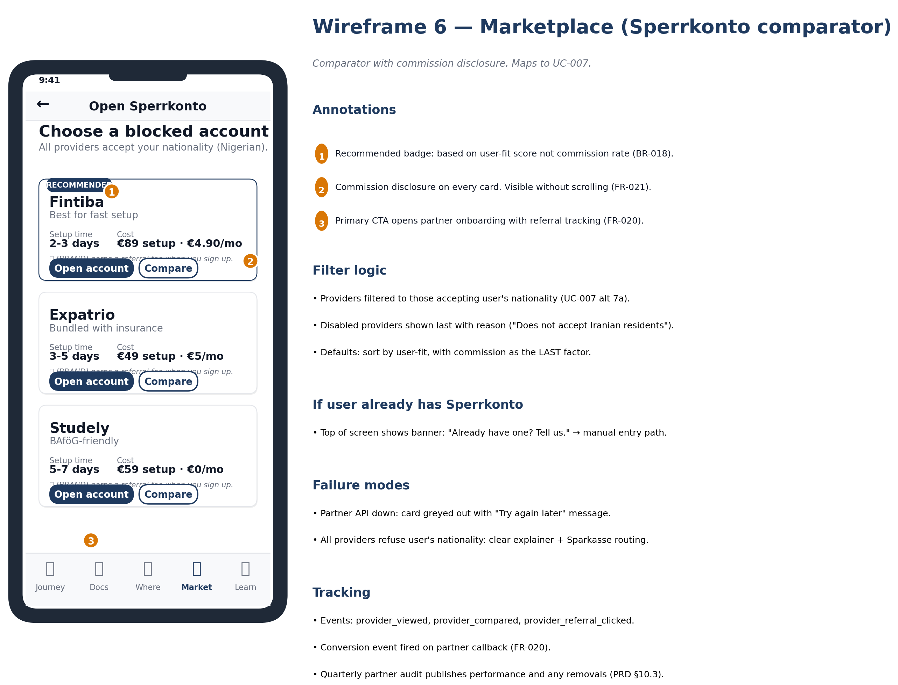

Core elements
- Category breadcrumb at top: Marketplace > Banking > Sperrkonto.
- Sort and filter chips (Recommended, Cheapest, Fastest setup).
- Provider cards: logo, headline (e.g., 'Setup in 24h'), monthly fee, total first-year cost, included extras.
- Commission disclosure: '[BRAND] earns a fee when you sign up here.' (or 'No commission relationship') on every card.
- Primary CTA: 'Open account' → opens partner's signup in in-app browser with affiliate token.
- Secondary action: 'Compare' to add up to 3 cards to a comparison sheet.

Behaviour
- Tap a card → expands to show full feature list and reviews.
- Tap Compare → adds to comparison sheet; sticky 'View comparison' button appears at bottom when 2+ items selected.
- Tap Open account → opens partner signup with [BRAND] affiliate token attached.
- Sort chips reorder cards immediately, no full reload.

Engineering hooks
- GET /marketplace/sperrkonto returns ranked provider list.
- Affiliate clicks tracked via click handler that hits POST /affiliate/click before opening partner URL.
- Conversion tracked via partner webhook to POST /affiliate/conversion.

Edge states
- No providers available for user's nationality: empty state with explanation and alternatives.
- Partner API down: card shows 'Currently unavailable' badge; CTA disabled.
- Affiliate click fails: open partner URL anyway (don't block user).

Working design tokens

These are working tokens used to generate the wireframes. They are not the final design system — that follows in a separate Design Tokens document. The values here are sufficient to maintain visual consistency across screens during the wireframe pass.

Colour
Token | Value | Usage
Primary navy | #1F3A5F | Headers, primary CTA fill, focus state
Primary navy light | #3B5A87 | Hover state, secondary headers
Accent orange | #D97706 | Deadline urgency, active filters, badges
Accent orange light | #FBBF24 | Decision diamonds in flowcharts
Success green | #059669 | Confirmation, [BRAND] action highlights
Warning red | #DC2626 | Pain points, errors, overdue
Neutral grey | #6B7280 | Body text, secondary copy
Background light | #F9FAFB | Card backgrounds, screen background

Typography
Token | Value | Usage
Display | 32pt Bold Inter | Splash, onboarding screen titles
H1 | 24pt Bold Inter | Section titles within screens
H2 | 20pt Bold Inter | Card titles
Body | 16pt Regular Inter | Default body text
Caption | 14pt Regular Inter | Metadata, timestamps
Mono small | 12pt Mono | Code, IDs, technical references

Spacing
Token | Value | Usage
xs | 4 pt | Inline icon padding
sm | 8 pt | Tight pairs, related elements
md | 16 pt | Default card and section padding
lg | 24 pt | Between major sections
xl | 32 pt | Top of screen, between groups
xxl | 48 pt | Hero spacing, end-of-screen

Component patterns
- Cards: white background, 12pt corner radius, 1px border #E5E7EB, soft shadow (y=2, blur=8, alpha=0.04).
- Buttons: primary = navy fill + white text + 8pt radius; secondary = white fill + navy border; tertiary = transparent + navy text.
- Inputs: 44pt min height, 8pt radius, 1px border that becomes 2px navy on focus.
- Lists: 56pt row height, divider 1px #E5E7EB.
- Bottom nav: 5 icons + labels, fixed 80pt height, active = navy with subtle scale animation.

Document Control

Version history
Version | Date | Author | Summary of change
1.0 | April 2026 | Philip Olaomo | Initial release; 6 MVP wireframes; mobile-first format

Companion documents
- Product Requirements Document v1.0
- User Journey Flowcharts v1.0
- Use Cases v1.0
- Functional & Non-Functional Requirements v1.0
- Domain Model + API Specification — to follow
- Test Plan + Test Cases — to follow
- Migration Plan — to follow

