Course One

Foundations of Data Science


Instructions
Use this PACE strategy document to record decisions and reflections as you work through this end-of-course project. You can use this document as a guide to consider your responses and reflections at different stages of the data analytical process. Additionally, the PACE strategy documents can be used as a resource when working on future projects.

Course Project Recap
Regardless of which track you have chosen to complete, your goals for this project are:
- Complete the PACE Strategy Document to plan your project while considering your audience members, teammates, key milestones, and overall project goal.
- Create a project proposal for the data team.

Relevant Interview Questions
Completing this end-of-course project will empower you to respond to the following interview topics:
- As a new member of a data analytics team, what steps could you take to get 'up to speed' with a current project? What steps would you take? Who would you like to meet with?
- How would you plan an analytics project?
- What steps would you take to translate a business question to an analytical solution?
- Why is actively managing data an important part of a data analytics team's responsibilities?
- What are some considerations you might need to be mindful of when reporting results?

Reference Guide
This project has three tasks; the following visual identifies how the stages of PACE are incorporated across those tasks.
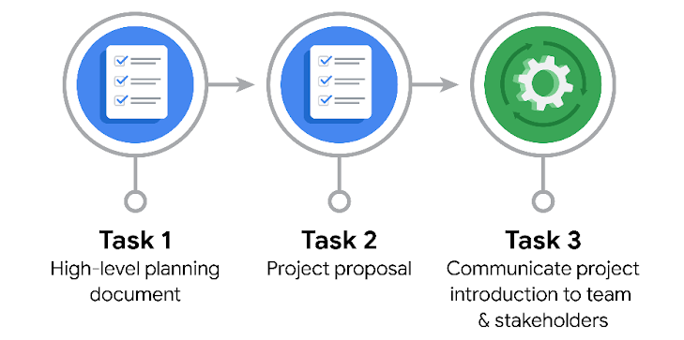

Data Project Questions & Considerations
PACE: Plan Stage

- Who is your audience for this project?
The target audience for this project is the New York City Taxi and Limousine Commission.

- What are you trying to solve or accomplish? And, what do you anticipate the impact of this work will be on the larger needs of the client?
The goal of this project is to estimate taxi fares by identifying and utilizing relevant variables. This analysis
aims to provide valuable insights that address broader client needs effectively.

- What questions need to be asked or answered?
Which variables have the strongest impact on fare estimation (e.g., trip distance, time of day, weather)?

- What resources are required to complete this project?
project dataset, Python notebook, and input from stakeholders.
- What are the deliverables that will need to be created over the course of this project?
A cleaned dataset ready for exploratory data analysis, Data visualizations, A statistical model, Regression
analysis and/or a machine learning model

THE PACE WORKFLOW
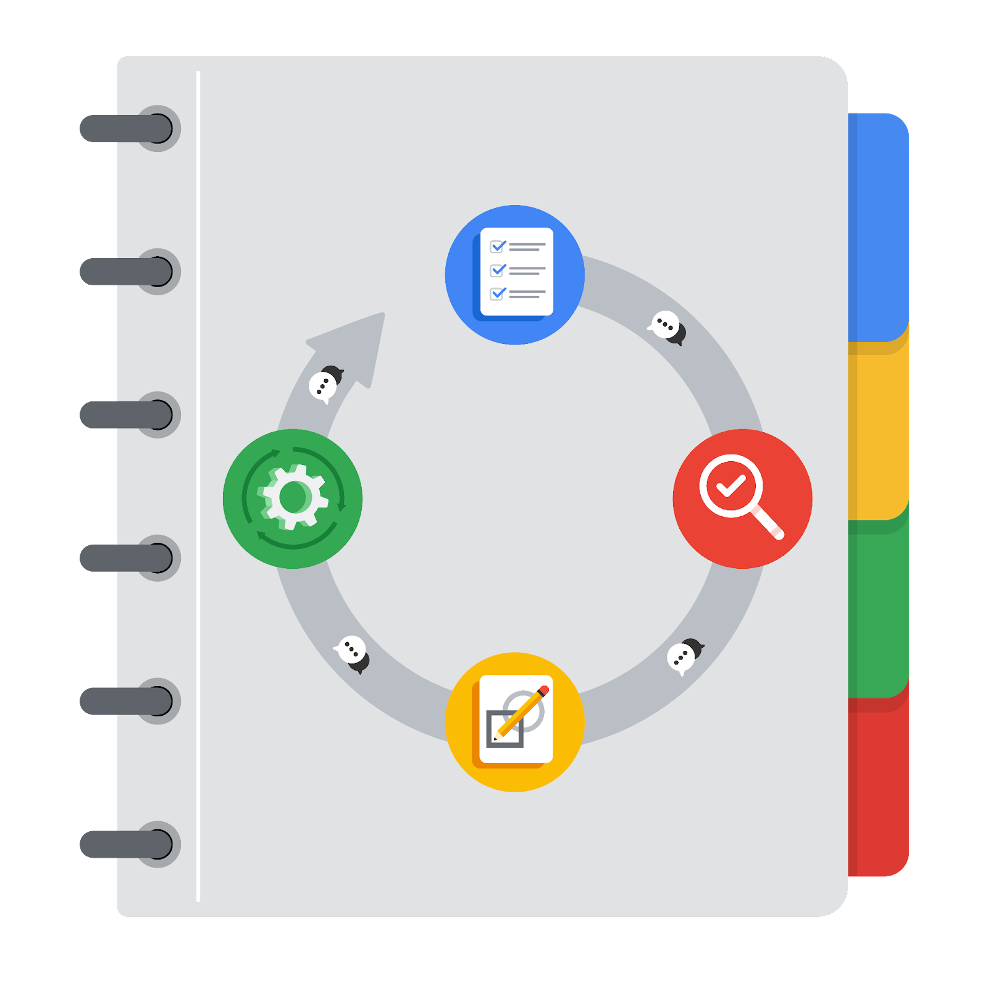
[Alt-text: The PACE Workflow with the four stages in a circle: plan, analyze, construct, and execute.]

You have been asked to demonstrate for the company's data team how you would use the PACE workflow to organize and classify tasks for the upcoming project. Select a PACE stage from the dropdown buttons. A few tasks involve more than one stage of the PACE workflow. Additionally, not every workplace scenario will require every task. Refer back to the Course 1 end-of-course portfolio project overview reading if you need more information about the tasks within the project.

Project tasks
Following are a group of tasks your company’s data team has determined need to be completed within this project. The data analysis manager has asked you to organize these tasks in preparation for the project proposal document. First, identify which stage of the PACE workflow each task would best fit under using the drop down menu. Next, give an explanation of why you selected the stage for each task. Review the following readings to help guide your selections and explanation: The PACE stages and Communicate objectives with a project proposal. You will later reorder these tasks within a project proposal.

- Evaluating the model: Execute
Why did you select this stage for this task?
This step involves testing the constructed model with data to determine if it meets the project's objectives and expectations.

- Conduct hypothesis testing: Analyze and Construct
Why did you select these stages for this task?
The statistical test is identified during the analysis phase and implemented during the construction phase.

- Begin exploring the data: Analyze
Why did you select this stage for this task?
The initial exploration occurs during the analysis stage to gain a thorough understanding of the dataset

- Data exploration and cleaning: Plan and Analyze
Why did you select these stages for this task?
The planning phase involves selecting methods, while the cleaning occurs as part of the analysis stage.

- Establish structure for project workflow (PACE): Plan
Why did you select this stage for this task?
The planning phase includes creating a PACE document to outline the workflow and structure for the project.

- Communicate final insights with stakeholders: Execute
Why did you select this stage for this task?
Stakeholder communication, particularly the presentation of final insights, is a key activity in the execution phase.

- Compute descriptive statistics: Analyze
Why did you select this stage for this task?
Calculating and interpreting statistical metrics are central to the analysis phase.

- Visualization building: Analyze and Construct
Why did you select these stages for this task?
Visualizations begin with data assessment in the analysis stage and are created during the construction phase.

- Write a project proposal: Plan
Why did you select this stage for this task?
Drafting a project proposal is a core planning activity that defines the project's objectives and approach.

- Build a regression model: Analyze and Construct
Why did you select this stage for this task?
The regression model is evaluated during the analysis stage and developed in the construction phase.

- Compile summary information about the data: Analyze
Why did you select this stage for this task?
Gathering and summarizing key details from the dataset takes place during the analysis phase.

- Build machine learning model: Construct
Why did you select this stage for this task?
Constructing the machine learning model is a specialized task in the construction phase.

