Course Three

Go Beyond the Numbers: Translate Data into Insights


Instructions
Use this PACE strategy document to record decisions and reflections as you work through this end-of-course project. You can use this document as a guide to consider your responses and reflections at different stages of the data analytical process. Additionally, the PACE strategy documents can be used as a resource when working on future projects.

Course Project Recap
Regardless of which track you have chosen to complete, your goals for this project are:
- Complete the questions in the Course 3 PACE strategy document
- Answer the questions in the Jupyter notebook project file
- Clean your data, perform exploratory data analysis (EDA)
- Create data visualizations
- Create an executive summary to share your results

Relevant Interview Questions
Completing the end-of-course project will help you respond these types of questions that are often asked during the interview process:
- How would you explain the difference between qualitative and quantitative data sources?
- Describe the difference between structured and unstructured data.
- Why is it important to do exploratory data analysis?
- How would you perform EDA on a given dataset?
- How do you create or alter a visualization based on different audiences?
- How do you avoid bias and ensure accessibility in a data visualization?
- How does data visualization inform your EDA?
Reference Guide
This project has six tasks; the visual below identifies how the stages of PACE are incorporated across those tasks.
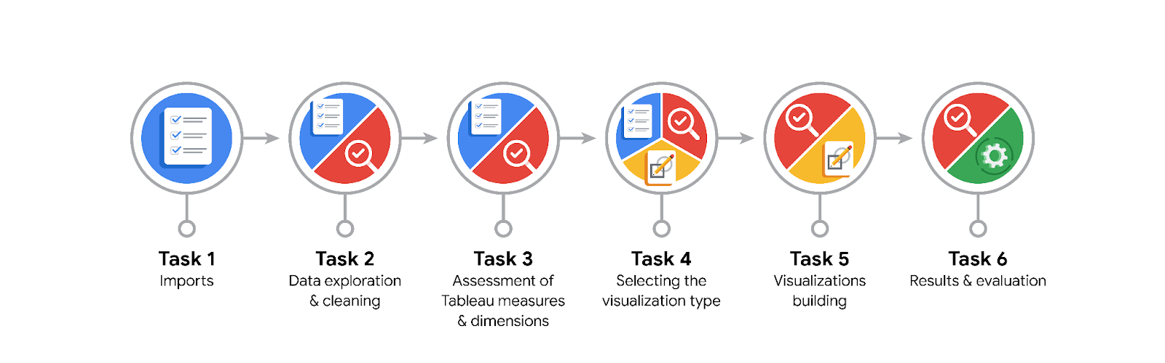
Data Project Questions & Considerations

PACE: Plan Stage
- What are the data columns and variables and which ones are most relevant to your deliverable?
The most relevant variables for predicting taxi fares are trip_distance, fare_amount, tpep_pickup_datetime, and PULocationID; these are most relevant for fare prediction.

- What units are your variables in?
The variables trip_distance are measured in miles, and total_amount (target) is measured in US dollars.

- What are your initial presumptions about the data that can inform your EDA, knowing you will need to confirm or deny with your future findings?
Longer trips increase fares, urban location density affects pricing, and outliers may exist due to data entry errors.

- Is there any missing or incomplete data?
No columns contain missing or incomplete data, as verified during initial analysis.

- Are all pieces of this dataset in the same format?
The dataset has consistent formats overall, but date-time columns need to be converted to a standard format for analysis.

- Which EDA practices will be required to begin this project?
Data type validation, feature exploration (e.g., fare and trip distance distributions), time-series analysis, and geographic trend visualization.

PACE: Analyze Stage
- What steps need to be taken to perform EDA in the most effective way to achieve the project goal?
Assess data quality, handle outliers, visualize distributions, identify correlations, and explore relationships between trip attributes and fare amount.

- Do you need to add more data using the EDA practice of joining? What type of structuring needs to be done to this dataset, such as filtering, sorting, etc.?
Yes, additional geographic or weather data could enhance analysis; filter invalid entries, handle date-time formats, and sort data for chronological consistency.

- What initial assumptions do you have about the types of visualizations that might best be suited for the intended audience?
Scatter plots for fare vs. distance, heatmaps for location-based trends, and bar charts for categorical insights like payment type distribution.

PACE: Construct Stage
- What data visualizations, machine learning algorithms, or other data outputs will need to be built in order to complete the project goals?
Scatter plots, heatmaps , time-series graphs, and a regression model using algorithms like Linear Regression or Random Forest.

- What processes need to be performed in order to build the necessary data visualizations?
Clean data, standardize formats, create derived variables, and group data by relevant categories.

- Which variables are most applicable for the visualizations in this data project?
Applicable Variables are fare_amount, trip_distance, PULocationID, DOLocationID, tpep_pickup_datetime, and passenger_count

- Going back to the Plan stage, how do you plan to deal with the missing data (if any)?
Missing data isn’t present, but if encountered, use imputation or removal depending on its relevance and volume.

PACE: Execute Stage
- What key insights emerged from your EDA and visualizations(s)?
Fare strongly correlates with trip distance, but outliers like negative fares need addressing.

- What business and/or organizational recommendations do you propose based on the visualization(s) built?
Optimize pricing by distance, address fare outliers, and encourage tipping through suggested amounts.

- Given what you know about the data and the visualizations you were using, what other questions could you research for the team?
Investigate peak hour fare trends, passenger count effects, and patterns in higher tips.

- How might you share these visualizations with different audiences?
Use interactive dashboards for stakeholders, summary reports for executives, and detailed graphs for analysts.

