Course Five

Regression Analysis: Simplifying Complex Data Relationships
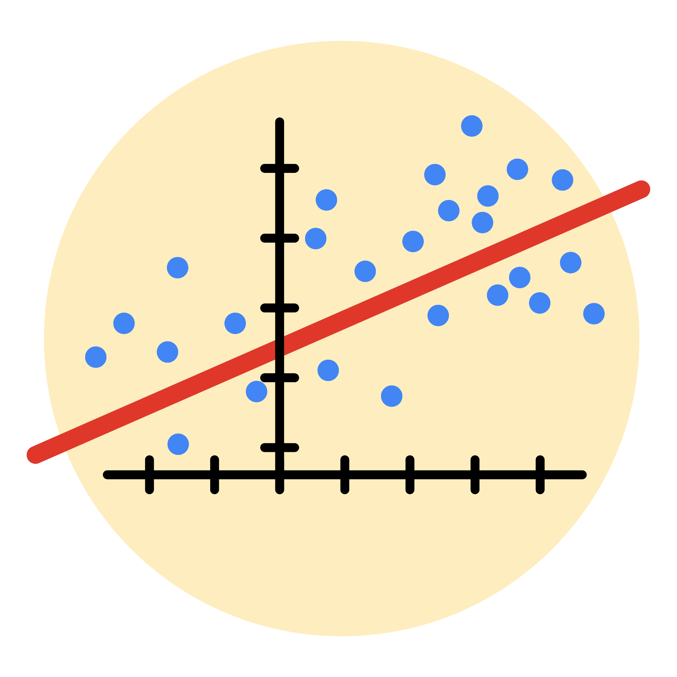

Instructions
Use this PACE strategy document to record decisions and reflections as you work through this end-of-course project. As a reminder, this document is a resource that you can reference in the future, and a guide to help you consider responses and reflections posed at various points throughout projects.

Course Project Recap
Regardless of which track you have chosen to complete, your goals for this project are:
- Complete the questions in the Course 5 PACE strategy document
- Answer the questions in the Jupyter notebook project file
- Build a multiple linear regression model
- Evaluate the model
- Create an executive summary for team members

Relevant Interview Questions
Completing the end-of-course project will empower you to respond to the following interview topics:
- Describe the steps you would take to run a regression-based analysis
- List and describe the critical assumptions of linear regression
- What is the primary difference between R² and adjusted R²?
- How do you interpret a Q-Q plot in a linear regression model?
- What is the bias-variance tradeoff? How does it relate to building a multiple linear regression model? Consider variable selection and adjusted R².

Reference Guide
This project has seven tasks; the visual below identifies how the stages of PACE are incorporated across those tasks.
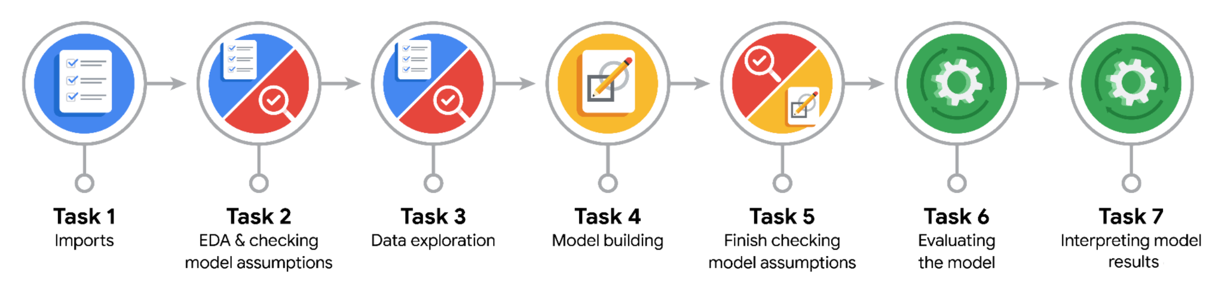

Data Project Questions & Considerations
PACE: Plan Stage
- Who are your external stakeholders for this project?
The external stakeholders are the New York City Taxi & Limousine Commission (NYC TLC).

- What are you trying to solve or accomplish?
the objective is to analyze and clean the raw NYC taxi data, identify key features, and ensure the dataset is well-structured for building a regression model.

- What are your initial observations when you explore the data?
The data contains key variables like fare_amount, payment_type, and trip_distance, along with some outliers and missing values that need cleaning.

- What resources do you find yourself using as you complete this stage?
Resources include the structured Jupyter Notebook, Python libraries like pandas and matplotlib for analysis, and statistical methods for hypothesis testing.

PACE: Analyze Stage
- What are some purposes of EDA before constructing a multiple linear regression model?
EDA helps identify key predictors, check data distributions, detect multicollinearity, handle outliers, and ensure data quality for reliable modeling.

- Do you have any ethical considerations in this stage?
Ensure unbiased feature selection, avoid misrepresenting relationships, and handle data privacy responsibly to maintain stakeholder trust and model fairness.

PACE: Construct Stage
- Do you notice anything odd?
The dataset may have anomalies, such as outliers in fare_amount, trip_distance, or unrealistic passenger_count, which could affect model training.

- Can you improve it? Is there anything you would change about the model?
Improvements can include outlier removal, encoding categorical features (e.g., RatecodeID), and incorporating feature scaling to standardize variables for better regression performance.

- What resources do you find yourself using as you complete this stage?
Common resources include the Pandas library for data manipulation, Seaborn/Matplotlib for visualization, and Scikit-learn for preprocessing and regression tools.

PACE: Execute Stage
- What key insights emerged from your model(s)?
The model indicates that for every +1 standard deviation increase in mean_distance, the fare increases by $7.13 on average, controlling for other variables, though multicollinearity broadens the confidence interval.

- What business recommendations do you propose based on the models built?
Consider adjusting fare structures based on trip distances while addressing multicollinearity by refining feature selection

- To interpret model results, why is it important to interpret the beta coefficients?
Beta coefficients quantify the relationship between each predictor and the target variable, allowing for meaningful interpretation of model dynamics.

- What potential recommendations would you make?
Focus on improving feature selection by removing highly correlated variables to enhance model accuracy and reliability.

- Do you think your model could be improved? Why or why not? How?
Yes, by addressing multicollinearity through better feature engineering and possibly applying regularization techniques like Ridge or Lasso regression.
- What business/organizational recommendations would you propose based on the models built?
Implement distance-based fare adjustments, ensure feature updates in the pricing algorithm, and invest in continuous model evaluation to adapt to evolving travel patterns.

- Given what you know about the data and the models you were using, what other questions could you address for the team?
Are there seasonal patterns in fare amounts that could reveal peak times and annual fluctuations, helping to optimize pricing and driver allocation?

- Do you have any ethical considerations at this stage?
Yes, ensure data privacy and fairness by avoiding bias in fare predictions, especially related to trip locations or passenger demographics. Transparent communication about fare calculation methods would also enhance public trust.

