**SPSS Practical 10:**

**Part A**:

In this experimental study, we are trying to assess the effects of teaching methods (Traditional, Traditional and Progressive, Progressive) on math achievement by comparing the average math achievement score in different teaching method groups after controlling the effects of student IQ. **Does teaching method impact mathmatics achievement controlling for IQ?**

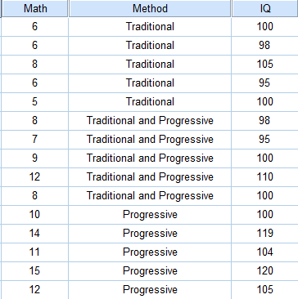

Perform the following tasks:

1. Testing the independence of the independent variable and covariate.

/analyze ->general linear model -> depent 에 iq, factor에 indep넣기

|  |  |  |  |  |  |
| --- | --- | --- | --- | --- | --- |
| **Tests of Between-Subjects Effects** | | | | | |
| Dependent Variable: IQ | | | | | |
| Source | Type III Sum of Squares | df | Mean Square | F | Sig. |
| Corrected Model | 303.333a | 2 | 151.667 | 3.489 | .064 |
| Intercept | 159960.067 | 1 | 159960.067 | 3680.063 | .000 |
| Method | 303.333 | 2 | 151.667 | 3.489 | .064 |
| Error | 521.600 | 12 | 43.467 |  |  |
| Total | 160785.000 | 15 |  |  |  |
| Corrected Total | 824.933 | 14 |  |  |  |
| a. R Squared = .368 (Adjusted R Squared = .262) | | | | | |

$H_{0}:$ The covariate was roughly equal across levels of the independent variable.

$H_{1}:$ The covariate was roughly not equal across levels of the independent variable.

F(2,12) = 3.489, sig=0.064(>0.05)

This test is non-significant.

Accept $H_{0}$

Conclusion: It is appropriate to use IQ as a covariate in the analysis.

Covariate 인거 확인 하고 나서

다시 돌리기

1. Assessment of the Assumption of Regression Homogeneity

|  |  |  |  |  |  |
| --- | --- | --- | --- | --- | --- |
| **Tests of Between-Subjects Effects** | | | | | |
| Dependent Variable: Math | | | | | |
| Source | Type III Sum of Squares | df | Mean Square | F | Sig. |
| Corrected Model | 129.632a | 5 | 25.926 | 56.886 | .000 |
| Intercept | 8.213 | 1 | 8.213 | 18.021 | .002 |
| Method | 1.556 | 2 | .778 | 1.707 | .235 |
| IQ | 18.991 | 1 | 18.991 | 41.669 | .000 |
| Method * IQ | 1.385 | 2 | .693 | 1.520 | .270 |
| Error | 4.102 | 9 | .456 |  |  |
| Total | 1385.000 | 15 |  |  |  |
| Corrected Total | 133.733 | 14 |  |  |  |
| a. R Squared = .969 (Adjusted R Squared = .952) | | | | | |

$H_{0}:$ Homogeneity of regression slopes can be assumed.

$H_{1}:$ Homogeneity of regression slopes can not be assumed.

F(2,9) = 1.520, sig=0.270(>0.05)

This test is non-significant.

Accept $H_{0}$

Conclusion: Homogeneity of regression slopes can be assumed.

Note: An interaction effect does not exist.

Analyze > GLM > UNI > model > custom > 각각 다 넣고, main effect는 그냥 넣고 interaction effect는 곱해서 넣기(그냥 2개 동시클릭해서 넣으면됨) 만약 더 많이 있다면 나올 수 있는 main effect 의 경우의수를 계산해서 넣을 것.

1. Assessment of the Main Effect of Teaching Method Controlling for IQ.

위와 같은 방법으로 진행하다가, interaction effect 제거 후 option에서 overall을 넣고 돌리면 ANCOVA, Method를 넣고 compare main effects 체크 후 아래 박스에 sidak을 선택 한 후 display에 1,2번을 넣고 돌리면 그게 post hoc 이다.

|  |  |  |  |  |  |
| --- | --- | --- | --- | --- | --- |
| **Tests of Between-Subjects Effects** | | | | | |
| Dependent Variable: Math | | | | | |
| Source | Type III Sum of Squares | df | Mean Square | F | Sig. |
| Corrected Model | 128.246a | 3 | 42.749 | 85.699 | .000 |
| Intercept | 12.745 | 1 | 12.745 | 25.551 | .000 |
| Method | 26.673 | 2 | 13.337 | 26.736 | .000 |
| IQ | 31.313 | 1 | 31.313 | 62.774 | .000 |
| Error | 5.487 | 11 | .499 |  |  |
| Total | 1385.000 | 15 |  |  |  |
| Corrected Total | 133.733 | 14 |  |  |  |
| a. R Squared = .959 (Adjusted R Squared = .948) | | | | | |

Main Effect of Teaching Method Controlling for IQ Test:

$H_{0}:$ All adjusted means are the same.

$H_{1}:$ At least two adjusted means are different

F(2,11)=26.736, sig = 0.000(<0.05)

This test is significant.

Reject $H_{0}$

Conclusion: At least two adjusted means are different.

같은게 아니므로 follow up test 필요

여기서 추가정보 없으니까Post hoc 돌려야함 사진 첨부할 것.

=================여기부터는 문제와 상관 x but 필요한 부분===========

반드시 outcome과 covariate 사이에 relation이 있음을 확인해야 됨.

없으면 ANCOVA해도 결과가 똑같음. 의미 x

IMPORTANT: The primary purpose of the test of the covariate(IQ) is that it evaluates the relationship between the covariate and the dependent variable, controlling for the factor(i.e., for any particular group).

$H_{0}:$ There is no relationship between the covariate and the dependent variable.

$H_{1}:$ There is a relationship between the covariate and the dependent variable

F(1,11) = 62.774, sig=0.000(<0.05)

This test is significant.

Reject $H_{0}$

Conclusion: There is a relationship between IQ and Math.

|  |  |  |  |  |  |  |
| --- | --- | --- | --- | --- | --- | --- |
| **Pairwise Comparisons** | | | | | | |
| Dependent Variable: Math | | | | | | |
| (I) Method | (J) Method | Mean Difference (I-J) | Std. Error | Sig.b | 95% Confidence Interval for Differenceb | |
| Lower Bound | Upper Bound |
| Traditional | Traditional and Progressive | -2.355* | .448 | .001 | -3.613 | -1.097 |
| Progressive | -3.750* | .543 | .000 | -5.277 | -2.223 |
| Traditional and Progressive | Traditional | 2.355* | .448 | .001 | 1.097 | 3.613 |
| Progressive | -1.395 | .526 | .066 | -2.874 | .084 |
| Progressive | Traditional | 3.750* | .543 | .000 | 2.223 | 5.277 |
| Traditional and Progressive | 1.395 | .526 | .066 | -.084 | 2.874 |
| Based on estimated marginal means | | | | | | |
| *. The mean difference is significant at the .05 level. | | | | | | |
| b. Adjustment for multiple comparisons: Sidak. | | | | | | |

Comparison 1:

$H_{0}:$ $μ_{t}'$ = $μ_{tp}'$

$H_{1}:$ $μ_{t}'≠$ $μ_{tp}'$

Since Sig = 0.001(<0.05)

This test is significant

Reject $H_{0}$

$μ_{t}'≠$ $μ_{tp}'$

Comparison 2:

$H_{0}:$ $μ_{t}'$ = $μ_{p}'$

$H_{1}:$ $μ_{t}'≠$ $μ_{p}'$

Since Sig =0.000(<0.05)

This test is significant

Reject $H_{0}$

$μ_{t}'≠$ $μ_{p}'$

Comparison 3:

$H_{0}:$ $μ_{tp}'$ = $μ_{p}'$

$H_{1}:$ $μ_{tp}'≠$ $μ_{p}'$

Since Sig =0.066(>0.05)

This test is non-significant

Accept $H_{0}$

$μ_{tp}'$ = $μ_{p}'$

$μ_{t}'≠$ $μ_{tp}'$ = $μ_{p}'$

Post Hoc Test revealed that Traditional and Progressive method (M=9.453,SE=0.326)produced significant better scores that Traditional method(M=7.098,SE=0.336)but produced non-significant better scores with Progressive method (M=10.848, SE=0.372), after controlling for the effect of IQ,

1. Computes all the means (before and after the test) for math achievement in each method.

This is original

|  |  |  |  |
| --- | --- | --- | --- |
| **Descriptive Statistics** | | | |
| Dependent Variable: Math | | | |
| Method | Mean | Std. Deviation | N |
| Traditional | 6.20 | 1.095 | 5 |
| Traditional and Progressive | 8.80 | 1.924 | 5 |
| Progressive | 12.40 | 2.074 | 5 |
| Total | 9.13 | 3.091 | 15 |

This is adjusted.

|  |  |  |  |  |
| --- | --- | --- | --- | --- |
| **Estimates** | | | | |
| Dependent Variable: Math | | | | |
| Method | Mean | Std. Error | 95% Confidence Interval | |
| Lower Bound | Upper Bound |
| Traditional | 7.098a | .336 | 6.360 | 7.837 |
| Traditional and Progressive | 9.453a | .326 | 8.735 | 10.172 |
| Progressive | 10.848a | .372 | 10.030 | 11.666 |
| a. Covariates appearing in the model are evaluated at the following values: IQ = 103.27. | | | | |

**Part B**:

**Does instruction method impact achievement controlling for motivation?**

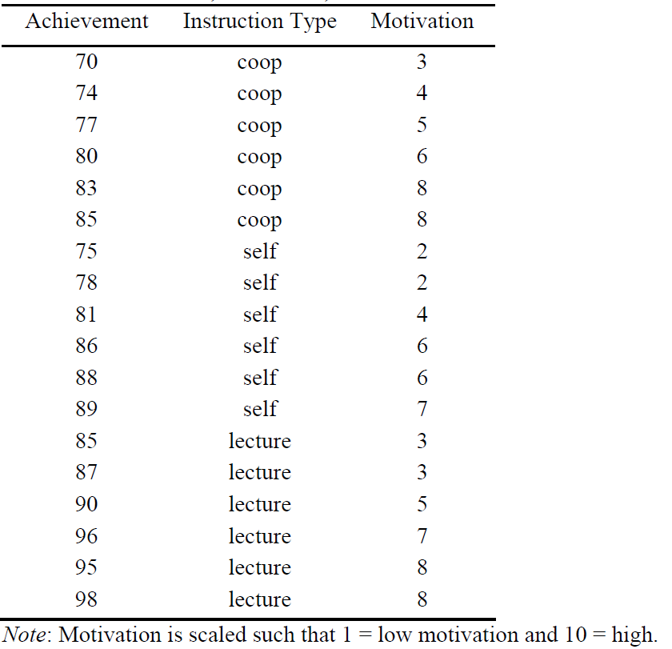

Perform the following tasks:

1. Testing the independence of the independent variable and covariate.

|  |  |  |  |  |  |
| --- | --- | --- | --- | --- | --- |
| **Tests of Between-Subjects Effects** | | | | | |
| Dependent Variable: Motivation | | | | | |
| Source | Type III Sum of Squares | df | Mean Square | F | Sig. |
| Corrected Model | 5.444a | 2 | 2.722 | .566 | .580 |
| Intercept | 501.389 | 1 | 501.389 | 104.215 | .000 |
| Instruction_Type | 5.444 | 2 | 2.722 | .566 | .580 |
| Error | 72.167 | 15 | 4.811 |  |  |
| Total | 579.000 | 18 |  |  |  |
| Corrected Total | 77.611 | 17 |  |  |  |
| a. R Squared = .070 (Adjusted R Squared = -.054) | | | | | |

$H_{0}:$ The covariate was roughly equal across levels of the independent variable.

$H_{1}:$ The covariate was roughly not equal across levels of the independent variable.

F(2,15) = 0.566, sig=0.580(>0.05)

This test is non-significant.

Accept $H_{0}$

Conclusion: It is appropriate to use IQ as a covariate in the analysis.

1. Assessment of the Assumption of Regression Homogeneity

|  |  |  |  |  |  |
| --- | --- | --- | --- | --- | --- |
| **Tests of Between-Subjects Effects** | | | | | |
| Dependent Variable: Achievement | | | | | |
| Source | Type III Sum of Squares | df | Mean Square | F | Sig. |
| Corrected Model | 1019.198a | 5 | 203.840 | 119.827 | .000 |
| Intercept | 11293.731 | 1 | 11293.731 | 6639.017 | .000 |
| Instruction_Type | 91.048 | 2 | 45.524 | 26.761 | .000 |
| Motivation | 439.845 | 1 | 439.845 | 258.563 | .000 |
| Instruction_Type * Motivation | 3.510 | 2 | 1.755 | 1.032 | .386 |
| Error | 20.413 | 12 | 1.701 |  |  |
| Total | 128889.000 | 18 |  |  |  |
| Corrected Total | 1039.611 | 17 |  |  |  |
| a. R Squared = .980 (Adjusted R Squared = .972) | | | | | |

$H_{0}:$ Homogeneity of regression slopes can be assumed.

$H_{1}:$ Homogeneity of regression slopes can not be assumed.

F(2,12) = 1.032, sig=0.386(>0.05)

This test is non-significant.

Accept $H_{0}$

Conclusion: Homogeneity of regression slopes can be assumed.

Note: An interaction effect does not exist.

1. Assessment of the Main Effect of Instruction Type Controlling for Motivation.

|  |  |  |  |  |  |
| --- | --- | --- | --- | --- | --- |
| **Tests of Between-Subjects Effects** | | | | | |
| Dependent Variable: Achievement | | | | | |
| Source | Type III Sum of Squares | df | Mean Square | F | Sig. |
| Corrected Model | 1015.687a | 3 | 338.562 | 198.124 | .000 |
| Intercept | 11512.556 | 1 | 11512.556 | 6737.051 | .000 |
| Instruction_Type | 562.171 | 2 | 281.085 | 164.489 | .000 |
| Motivation | 436.576 | 1 | 436.576 | 255.481 | .000 |
| Error | 23.924 | 14 | 1.709 |  |  |
| Total | 128889.000 | 18 |  |  |  |
| Corrected Total | 1039.611 | 17 |  |  |  |
| a. R Squared = .977 (Adjusted R Squared = .972) | | | | | |

Main Effect of Teaching Method Controlling for IQ Test:

$H_{0}:$ All adjusted means are the same.

$H_{1}:$ At least two adjusted means are different

F(2,14)=164.486, sig = 0.000(<0.05)

This test is significant.

Reject $H_{0}$

Conclusion: At least two adjusted means are different.

+알파로 똑같이 확인 해보자. Motivation과 Achievement 사이에 관계가 있는지?

>파란색 참고

$H_{0}:$ There is no relationship between the covariate and the dependent variable.

$H_{1}:$ There is a relationship between the covariate and the dependent variable

F(1,14) = 255.481, sig=0.000(<0.05)

This test is significant.

Reject $H_{0}$

Conclusion: There is a relationship between Motivation and Achievement

1. Computes all the means (before and after the test) for achievement in each instruction type.

This is original M and Sd.

|  |  |  |  |
| --- | --- | --- | --- |
| **Descriptive Statistics** | | | |
| Dependent Variable: Achievement | | | |
| Instruction_Type | Mean | Std. Deviation | N |
| coop | 78.17 | 5.636 | 6 |
| self | 82.83 | 5.707 | 6 |
| lecture | 91.83 | 5.269 | 6 |
| Total | 84.28 | 7.820 | 18 |

This is adjusted M and SE.

|  |  |  |  |  |
| --- | --- | --- | --- | --- |
| **Estimates** | | | | |
| Dependent Variable: Achievement | | | | |
| Instruction_Type | Mean | Std. Error | 95% Confidence Interval | |
| Lower Bound | Upper Bound |
| coop | 77.210a | .537 | 76.058 | 78.362 |
| self | 84.746a | .547 | 83.573 | 85.919 |
| lecture | 90.877a | .537 | 89.725 | 92.029 |
| a. Covariates appearing in the model are evaluated at the following values: Motivation = 5.28. | | | | |