**(SPSS Practical 11:**

**Objective**: We run two-way factorial ANOVA when we want to study the effect of two independent categorical variables on the dependent variable. In a two-way factorial ANOVA, we can test the main effect of each independent variable. We can also test if the effect of one independent variable on the dependent variable is the same across all level of the other independent variable, that is, if there is any interaction between the independent variables.

**Part A**

In the study, people were randomly assigned either to come to class all the time, or never come to class or to get the lecture notes from the World Wide Web. Those who came to class are in the Lecture condition, while those who did not come to class are in the Distance Learning condition. The students were also divided according to their GPA prior to the class. There were people with Higher GPAs and people with Lower GPAs. The dependent variable was the total number of points they received in the class (out of 400 possible points.) The following table summarizes the data:

|  |  |  |  |  |  |
| --- | --- | --- | --- | --- | --- |
| **Class** | **GPA** | **Points in Class** | **Class** | **GPA** | **Points in Class** |
| Lecture | High | 354.67 | Distance | High | 332.00 |
| Lecture | High | 353.50 | Distance | High | 380.00 |
| Lecture | High | 304.00 | Distance | High | 371.00 |
| Lecture | High | 365.00 | Distance | High | 366.00 |
| Lecture | High | 339.00 | Distance | High | 354.00 |
| Lecture | Low | 306.00 | Distance | Low | 259.50 |
| Lecture | Low | 339.00 | Distance | Low | 302.50 |
| Lecture | Low | 353.00 | Distance | Low | 296.00 |
| Lecture | Low | 351.00 | Distance | Low | 349.00 |
| Lecture | Low | 333.00 | Distance | Low | 309.00 |

Conduct a Two-way ANOVA for the following statistical tests:

|  |  |  |  |
| --- | --- | --- | --- |
| **Levene's Test of Equality of Error Variancesa** | | | |
| Dependent Variable: Point_in_Class | | | |
| F | df1 | df2 | Sig. |
| .240 | 3 | 16 | .867 |
| Tests the null hypothesis that the error variance of the dependent variable is equal across groups. | | | |
| a. Design: Intercept + Class + GPA + Class * GPA | | | |

$H_{0}:$ Homogeneity of variance can be assumed.

$H_{1}:$ Homogeneity of variance can not be assumed.

F(3,16) = 0.240, sig = 0.867(>0.05)

This test is Non-Significant

Accept $H_{0}$

Homogeneity of variance can be assumed.

1. Main Effect of Type of Class.

Class 에 대해서 main effect 보려고 하면 여기서는 2개이므로

>indep t test이다

|  |  |  |  |  |
| --- | --- | --- | --- | --- |
| **1. Class** | | | | |
| Dependent Variable: Point_in_Class | | | | |
| Class | Mean | Std. Error | 95% Confidence Interval | |
| Lower Bound | Upper Bound |
| Lecture | 339.817 | 7.569 | 323.771 | 355.863 |
| Distance | 331.900 | 7.569 | 315.854 | 347.946 |

$$H_{0}:μ_{lecture}=μ_{distance}$$

$$H_{1}:μ_{lecture}≠μ_{distance}$$

F(1,16)=0.547, sig = 0.47

This test is Non-significant

Accept $H_{0}$

The test failed to reveal a main effect of Class

1. Main Effect of GPA.

|  |  |  |  |  |
| --- | --- | --- | --- | --- |
| **2. GPA** | | | | |
| Dependent Variable: Point_in_Class | | | | |
| GPA | Mean | Std. Error | 95% Confidence Interval | |
| Lower Bound | Upper Bound |
| High | 351.917 | 7.569 | 335.871 | 367.963 |
| Low | 319.800 | 7.569 | 303.754 | 335.846 |

$$H_{0}:μ_{high}=μ_{low}$$

$$H_{1}:μ_{high}≠μ_{low}$$

F(1,16) = 9.002, sig = 0.008

This test is Significant

Reject ${ H}_{0}$

The test revealed a main effect of GPA

1. Interaction Effect of Type of Class and GPA.

순서가 중요하다 , 2x2에서 순서가 바뀌어도 결과값이 달라짐.So Gpa class 순으로 factor에 넣어야함

|  |  |  |  |  |  |
| --- | --- | --- | --- | --- | --- |
| **3. Class * GPA** | | | | | |
| Dependent Variable: Point_in_Class | | | | | |
| Class | GPA | Mean | Std. Error | 95% Confidence Interval | |
| Lower Bound | Upper Bound |
| Lecture | High | 343.234 | 10.704 | 320.542 | 365.926 |
| Low | 336.400 | 10.704 | 313.708 | 359.092 |
| Distance | High | 360.600 | 10.704 | 337.908 | 383.292 |
| Low | 303.200 | 10.704 | 280.508 | 325.892 |

$$H_{0}:μ_{lecuture,high}-μ_{lecture,low}=μ_{distance,high}-μ_{distance,low}$$

$$H_{1}:μ_{lecuture,high}-μ_{lecture,low}≠μ_{distance,high}-μ_{distance,low}$$

F(1,16)=5.579, sig = 0.031

This test is significant

Reject $H_{0}$

The test revealed an interaction effect of Class and GPA.

여기는 2개의 group 이므로

//class gpa 순서로 들어 가 있으므로 중요한 것은 class 이다.

//여기서 reject h0 이라면 ,결국 서로의 interaction mean이 다른 것이니 interaction이 존재 함을 알 수 있다.

Profile Plot

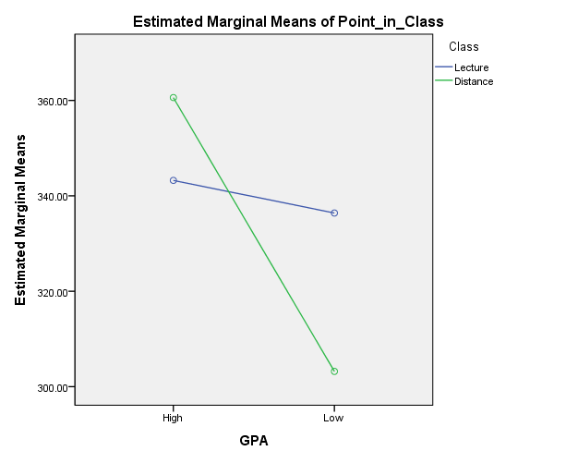

Cross interaction이 있으므로 interaction effect가 존재한다는 것을 알 수 있음.

There is interaction effect because There is cross interaction.

**Part B**

A professor of a statistics course was interested in the effect of teaching method (punishment, indifferent, reward) and the language used (English, Korean) in the exam paper.

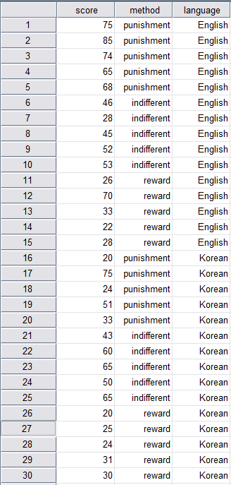

Conduct a Two-way ANOVA for the following statistical tests:

|  |  |  |  |
| --- | --- | --- | --- |
| Levene's Test of Equality of Error Variancesa | | | |
| Dependent Variable: score | | | |
| F | df1 | df2 | Sig. |
| 2.606 | 5 | 24 | .051 |
| Tests the null hypothesis that the error variance of the dependent variable is equal across groups. | | | |
| a. Design: Intercept + method + language + method * language | | | |

$H_{0}:$ Homogeneity of variance can be assumed.

$H_{1}:$ Homogeneity of variance can not be assumed.

F(5,24) = 2.606, sig = 0.051(>0.05)

This test is Non-Significant

Accept $H_{0}$

Homogeneity of variance can be assumed.

1. Main Effect of Teaching Method.

|  |  |  |  |  |
| --- | --- | --- | --- | --- |
| **1. method** | | | | |
| Dependent Variable: score | | | | |
| method | Mean | Std. Error | 95% Confidence Interval | |
| Lower Bound | Upper Bound |
| punishment | 57.000 | 4.415 | 47.889 | 66.111 |
| indifferent | 50.700 | 4.415 | 41.589 | 59.811 |
| reward | 30.900 | 4.415 | 21.789 | 40.011 |

$$H_{0}:All means are the same$$

$$H_{1}:At least two means are different$$

F(2,24)=9.518, sig = 0.001(<0.05)

This test is Significant

Reject ${ H}_{0}$

At least two means are different.

|  |  |  |  |  |  |  |
| --- | --- | --- | --- | --- | --- | --- |
| **Multiple Comparisons** | | | | | | |
| Dependent Variable: score | | | | | | |
| Tukey HSD | | | | | | |
| (I) method | (J) method | Mean Difference (I-J) | Std. Error | Sig. | 95% Confidence Interval | |
| Lower Bound | Upper Bound |
| punishment | indifferent | 6.30 | 7.676 | .694 | -12.73 | 25.33 |
| reward | 26.10* | 7.676 | .006 | 7.07 | 45.13 |
| indifferent | punishment | -6.30 | 7.676 | .694 | -25.33 | 12.73 |
| reward | 19.80* | 7.676 | .040 | .77 | 38.83 |
| reward | punishment | -26.10* | 7.676 | .006 | -45.13 | -7.07 |
| indifferent | -19.80* | 7.676 | .040 | -38.83 | -.77 |
| Based on observed means.  The error term is Mean Square(Error) = 294.630. | | | | | | |
| *. The mean difference is significant at the .05 level. | | | | | | |

Comparison1

$$H_{0}:μ_{punishment}=μ_{indifferent}$$

$$H_{1}:μ_{punishment}≠μ_{indifferent}$$

Since sig = 0.694(>0.05)

This test is Non-significant

Accept $H_{0}$

Conclusion: $μ_{punishment}=μ_{indifferent}$

Comparison2

$$H_{0}:μ_{punishment}=μ_{reward}$$

$$H_{1}:μ_{punishment}≠μ_{reward}$$

Since sig = 0.006(<0.05)

This test is Significant

Reject $H_{0}$

Conclusion: $μ_{punishment}≠μ_{reward}$

Conclusion $μ_{punishment}=μ_{indifferent}≠μ_{reward}$

1. Main Effect of Language Used.

|  |  |  |  |  |
| --- | --- | --- | --- | --- |
| **language** | | | | |
| Dependent Variable: score | | | | |
| language | Mean | Std. Error | 95% Confidence Interval | |
| Lower Bound | Upper Bound |
| English | 51.333 | 5.088 | 40.910 | 61.756 |
| Korean | 41.067 | 5.088 | 30.644 | 51.490 |

$$H_{0}:μ_{English}=μ_{Korean}$$

$$H_{1}:μ_{English}≠μ_{Korean}$$

F(1,24) = 4.056, sig = 0.055(>0.05)

This test is Non-significant

Accept $H_{0}$

The test failed to reveal a main effect of Language.

1. Interaction Effect of Teaching Method and Language Used.

|  |  |  |  |  |  |
| --- | --- | --- | --- | --- | --- |
| **3. method * language** | | | | | |
| Dependent Variable: score | | | | | |
| method | language | Mean | Std. Error | 95% Confidence Interval | |
| Lower Bound | Upper Bound |
| punishment | English | 73.400 | 6.243 | 60.515 | 86.285 |
| Korean | 40.600 | 6.243 | 27.715 | 53.485 |
| indifferent | English | 44.800 | 6.243 | 31.915 | 57.685 |
| Korean | 56.600 | 6.243 | 43.715 | 69.485 |
| reward | English | 35.800 | 6.243 | 22.915 | 48.685 |
| Korean | 26.000 | 6.243 | 13.115 | 38.885 |

$$H_{0}:all interaction means are the same.$$

$$H_{1}:at least two interaction means are different$$

**F(2,24)=6.3810, sig =0.006(<0.05)**

**This test is Significant**

**Reject $H_{0}$**

**The test revealed an interaction effect of Method and language.**

**Profile Plot**

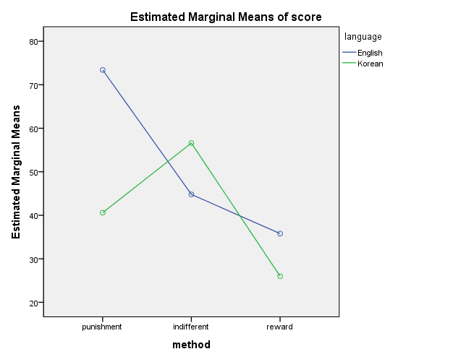

**There is an interaction effect of Method and Language.**

|  |  |  |  |
| --- | --- | --- | --- |
| **Between-Subjects Factors** | | | |
|  | | Value Label | N |
| method | 0 | punishment | 10 |
| 1 | indifferent | 10 |
| 2 | reward | 10 |
| language | 0 | English | 15 |
| 1 | Korean | 15 |

|  |  |
| --- | --- |
| **Group** | **Interaction** |
| **1** | **Method =0, language =0** |
| **2** | **Method =0, language =1** |
| **3** | **Method =1, language =0** |
| **4** | **Method =1, language =1** |
| **5** | **Method =2, language =0** |
| **6** | **Method =2, language =1** |

|  |  |  |  |  |  |  |
| --- | --- | --- | --- | --- | --- | --- |
| **Multiple Comparisons** | | | | | | |
| Dependent Variable: score | | | | | | |
| Tukey HSD | | | | | | |
| (I) Group | (J) Group | Mean Difference (I-J) | Std. Error | Sig. | 95% Confidence Interval | |
| Lower Bound | Upper Bound |
| 1 | 2 | 32.800* | 8.829 | .012 | 5.50 | 60.10 |
| 3 | 28.600* | 8.829 | .036 | 1.30 | 55.90 |
| 4 | 16.800 | 8.829 | .425 | -10.50 | 44.10 |
| 5 | 37.600* | 8.829 | .003 | 10.30 | 64.90 |
| 6 | 47.400* | 8.829 | .000 | 20.10 | 74.70 |
| 2 | 1 | -32.800* | 8.829 | .012 | -60.10 | -5.50 |
| 3 | -4.200 | 8.829 | .997 | -31.50 | 23.10 |
| 4 | -16.000 | 8.829 | .477 | -43.30 | 11.30 |
| 5 | 4.800 | 8.829 | .994 | -22.50 | 32.10 |
| 6 | 14.600 | 8.829 | .573 | -12.70 | 41.90 |
| 3 | 1 | -28.600* | 8.829 | .036 | -55.90 | -1.30 |
| 2 | 4.200 | 8.829 | .997 | -23.10 | 31.50 |
| 4 | -11.800 | 8.829 | .762 | -39.10 | 15.50 |
| 5 | 9.000 | 8.829 | .907 | -18.30 | 36.30 |
| 6 | 18.800 | 8.829 | .306 | -8.50 | 46.10 |
| 4 | 1 | -16.800 | 8.829 | .425 | -44.10 | 10.50 |
| 2 | 16.000 | 8.829 | .477 | -11.30 | 43.30 |
| 3 | 11.800 | 8.829 | .762 | -15.50 | 39.10 |
| 5 | 20.800 | 8.829 | .212 | -6.50 | 48.10 |
| 6 | 30.600* | 8.829 | .022 | 3.30 | 57.90 |
| 5 | 1 | -37.600* | 8.829 | .003 | -64.90 | -10.30 |
| 2 | -4.800 | 8.829 | .994 | -32.10 | 22.50 |
| 3 | -9.000 | 8.829 | .907 | -36.30 | 18.30 |
| 4 | -20.800 | 8.829 | .212 | -48.10 | 6.50 |
| 6 | 9.800 | 8.829 | .872 | -17.50 | 37.10 |
| 6 | 1 | -47.400* | 8.829 | .000 | -74.70 | -20.10 |
| 2 | -14.600 | 8.829 | .573 | -41.90 | 12.70 |
| 3 | -18.800 | 8.829 | .306 | -46.10 | 8.50 |
| 4 | -30.600* | 8.829 | .022 | -57.90 | -3.30 |
| 5 | -9.800 | 8.829 | .872 | -37.10 | 17.50 |
| *. The mean difference is significant at the 0.05 level. | | | | | | |

**Comparison 1(Group 1 &2)**

$$H_{0}:μ_{punishment,English}=μ_{punishment,Korean}$$

$$H_{1}:μ_{punishment,English}≠μ_{punishment,Korean}$$

**Since sig = 0.012(<0.05)**

**This test is Significant**

**Reject $H_{0}$**

**Conclusion $μ_{punishment,English}≠μ_{punishment,Korean}$**

**Comparison 2(Group 3& 4)**

$$H_{0}:μ_{indifferent,English}=μ_{indifferent,Korean}$$

$$H_{1}:μ_{indifferent,English}≠μ_{indifferent,Korean}$$

**Since sig =0.762 (>0.05)**

**This test is Non-significant**

**Accept $H_{0}$**

**Conclusion $μ_{indifferent,English}=μ_{indifferent,Korean}$**

**Comparison 3(Group 5 &6)**

$$H_{0}:μ_{reward,English}=μ_{reward,Korean}$$

$$H_{1}:μ_{reward,English}≠μ_{reward,Korean}$$

**Since sig =0.872 (>0.05)**

**This test is Non-significant**

**Accept $H_{0}$**

**Conclusion $μ_{reward,English}=μ_{reward,Korean}$**

**Conclusion:**

$${μ_{punishment,English}-μ_{punishment,Korean}≠μ}_{indifferent,English}-μ_{indifferent,Korean}=μ_{reward,English}-μ_{reward,Korean}$$

**//오늘 정리 2x2로 쓸 수 있으면 값을 쓰고 아닌 경우 문장으로 h0,h1표현**

**2x2인 경우, post hoc 돌릴 필요 없이 그냥 보면 서로 다르거나 같음을 알 수 있음.**

**그 이상인 경우 post hoc 을 돌려서 정확히 어느부분이 같고 다른지 알아야함.**