**SPSS Practical 8:**

**Part A: 1**

The following data were collected from a group of students who participates in a statistics test. Each student completes two sets of questions which are written in English and Korean. The full score for the test is 250 points. You are required to compare the means for the two scores.

|  |  |  |  |  |  |  |  |  |  |  |
| --- | --- | --- | --- | --- | --- | --- | --- | --- | --- | --- |
| English | 180 | 190 | 170 | 220 | 170 | 190 | 200 | 195 | 205 | 190 |
| Korean | 210 | 205 | 165 | 230 | 185 | 215 | 220 | 185 | 220 | 210 |

1. Run a t-test to compare the means between the two tests. Interpret your answers based on the SPSS outputs.

// 여기서 사용하는 diff의 경우 절대값이어도 되고 양,음 구분해도 상관 x

Diff의 normality 를 확인하기위해 k-s 테스트 사용, normal임이 증명됨.

|  |  |  |  |  |  |  |
| --- | --- | --- | --- | --- | --- | --- |
| **Tests of Normality** | | | | | | |
|  | Kolmogorov-Smirnova | | | Shapiro-Wilk | | |
| Statistic | df | Sig. | Statistic | df | Sig. |
| diff_English_Korean | .248 | 10 | .082 | .902 | 10 | .233 |
| a. Lilliefors Significance Correction | | | | | | |

// 두 sig가 같은 범위에 있으므로 ks 사용

$H_{0}$: normality can be assumed.

$H_{1}$: normality can not be assumed.

D(10) = 0.248 ,sig = 0.082 (>0.05)

This is nonsignificant.

Accept $H_{0}$

Diff English Korean is normal distribution.

Dependent T test 사용법

Analyze -> compute mean -> pair sample t test 에서 이용,

Pair 1에 var 2개 넣고 돌리면 됨.

이때 option에서 ci 조절가능.

//두 값의 correlation 값은 적어도 moderate 즉 , 0.3보다 커야함.

|  |  |  |  |  |  |
| --- | --- | --- | --- | --- | --- |
| **Paired Samples Statistics** | | | | | |
|  | | Mean | N | Std. Deviation | Std. Error Mean |
| Pair 1 | English_A | 191.00 | 10 | 15.420 | 4.876 |
| Korean_score | 204.50 | 10 | 20.062 | 6.344 |

|  |  |  |  |  |
| --- | --- | --- | --- | --- |
| **Paired Samples Correlations** | | | | |
|  | | N | Correlation | Sig. |
| Pair 1 | English_A & Korean_score | 10 | .783 | .007 |

|  |  |  |  |  |  |  |  |  |  |
| --- | --- | --- | --- | --- | --- | --- | --- | --- | --- |
| **Paired Samples Test** | | | | | | | | | |
|  | | Paired Differences | | | | | t | df | Sig. (2-tailed) |
| Mean | Std. Deviation | Std. Error Mean | 95% Confidence Interval of the Difference | |
| Lower | Upper |
| Pair 1 | English_A - Korean_score | -13.500 | 12.483 | 3.948 | -22.430 | -4.570 | -3.420 | 9 | .008 |

**Dependent T-Test:**

$H_{0}$**: $μ_{D}$ = 0**

$H_{1}$**: $μ_{D}≠$ 0**

**Since sig = 0.**008 ( <0.05)

This test is significant

Reject $H_{0}$

Conclusion: The difference between two means is significant.

1. Students perform better in which language?

On average, students performed better in test written in Korean(M=204.5, SE=6.344)

Than test written in English(M=191, SE=4.876), t(9) = -3.42, p<0.05

**Part B:**

Another group of students participate in the same test. The following data were collected for the test written in English:

|  |  |  |  |  |  |  |  |  |  |  |
| --- | --- | --- | --- | --- | --- | --- | --- | --- | --- | --- |
| English | 185 | 200 | 180 | 210 | 190 | 190 | 200 | 190 | 185 | 195 |

1. Run a t-test to compare the means between the two groups (test written in English). Interpret your answers based on the SPSS outputs.

|  |  |  |  |  |  |  |  |
| --- | --- | --- | --- | --- | --- | --- | --- |
| **Tests of Normality** | | | | | | | |
|  | Group_Type | Kolmogorov-Smirnova | | | Shapiro-Wilk | | |
|  | Statistic | df | Sig. | Statistic | df | Sig. |
| English | Group_A | .174 | 10 | .200* | .950 | 10 | .674 |
| Group_B | .211 | 10 | .200* | .947 | 10 | .633 |
| *. This is a lower bound of the true significance. | | | | | | | |
| a. Lilliefors Significance Correction | | | | | | | |

이건 independent t test 이므로 각 group에 따라 normality test 진행

Factor에 group 넣으면 해결됨.

Group A(K-S Test)

$H_{0}$: normality can be assumed.

$H_{1}$: normality can not be assumed.

Nonconflict 이므로 KS사용

D(10) = 0.174 ,sig = 0.200 (>0.05)

This is nonsignificant.

Accept $H_{0}$

Group A’s English score is normal distribution.

Group B(K-S Test)

$H_{0}$: normality can be assumed.

$H_{1}$: normality can not be assumed.

Nonconflict 이므로 KS사용

D(10) = 0.211 ,sig = 0.200 (>0.05)

This is nonsignificant.

Accept $H_{0}$

Group A’s English score is normal distribution.

// normal curve 를 그릴경우, 문제가 발생하므로 split data 사용, data에 있음

다 사용하고 난 후에는 split off를 할 것, reset하고 ok 하면 사라짐.

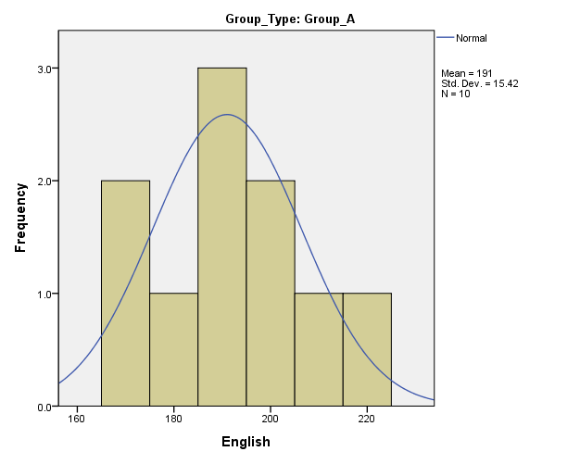

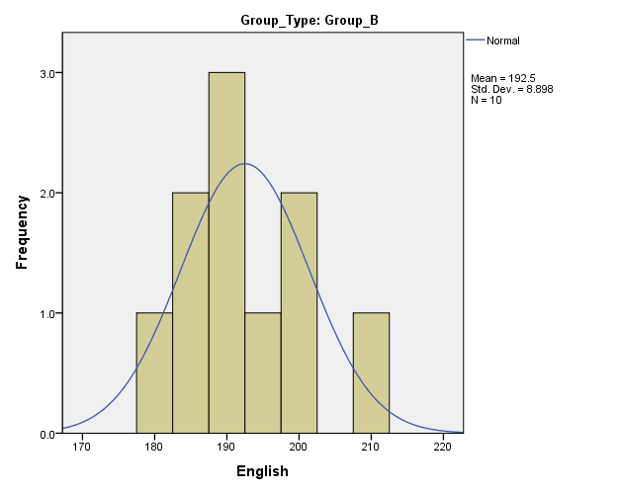

|  |  |  |  |  |  |  |  |  |  |  |
| --- | --- | --- | --- | --- | --- | --- | --- | --- | --- | --- |
| **Independent Samples Test** | | | | | | | | | | |
|  | | Levene's Test for Equality of Variances | | t-test for Equality of Means | | | | | | |
| F | Sig. | t | df | Sig. (2-tailed) | Mean Difference | Std. Error Difference | 95% Confidence Interval of the Difference | |
| Lower | Upper |
| English | Equal variances assumed | 1.433 | .247 | -.266 | 18 | .793 | -1.500 | 5.630 | -13.328 | 10.328 |
| Equal variances not assumed |  |  | -.266 | 14.395 | .794 | -1.500 | 5.630 | -13.544 | 10.544 |

Levene’s Test

$H_{0}$: Homogenity of variance can be assumed.

$H_{1}$: Homogenity of variance can not be assumed.

F(18) = 1.433

Since sig = 0.247 (>0.05)

This test is nonsignificant.

Accept $H_{0}$

Homogenity of variance can be assumed.

Independent T-Test

$H_{0}$**: $μ_{A}$- $μ_{B}$ = 0**

$H_{1}$**: $μ_{A}-μ_{B} ≠$ 0**

Since sig = 0.793 (>0.05)

This test is nonsignificant.

Accept $H_{0}$

Conclusion: The difference between two means is non-significant.

1. Which group of students performs better in the test written in English?

On average, students performed about the same in test written in English, Group A(M=191.00,SE=4.876), and Group B(M=192.50, SE=2.814) ,t(18)=-0.266, p>0.05

1. Find a linear regression between the group and the test result.

|  |  |  |  |  |  |  |
| --- | --- | --- | --- | --- | --- | --- |
| **Coefficientsa** | | | | | | |
| Model | | Unstandardized Coefficients | | Standardized Coefficients | t | Sig. |
| B | Std. Error | Beta |
| 1 | (Constant) | 191.000 | 3.981 |  | 47.980 | .000 |
| Group_Type | 1.500 | 5.630 | .063 | .266 | .793 |
| a. Dependent Variable: English | | | | | | |

**English = 191 + 1.5(Group_Type)**

**//여기서는 prediction을 위해 LR을 쓰는게 아님.**

Model 을 보기 위해, 즉 관계를 보기 위해서 사용하는 것.