**Practical 2:**

**Part A:**

Objective: Creating SPSS data.

Identify all the possible variables for the sample survey.

**Instructions:**

1. Create an SPSS file (“Smoking_Survey”) for the above survey result.
2. For each variable, you must create a variable name and label the variable.

|  |  |  |
| --- | --- | --- |
| Variable | Variable Name | Label |
| Subject# | Subject_Numb | The number of the subject |
| Sex | Gender | The gender of the subject |
| Weight | Weight | The weight of the subject |
| Cigarette per day | Ciga_day | The cigarettes per a day. |
| Year of smoked | Year_smoke | The cigarettes experience year |
| Breathing | Breathing | The case of Breathing |
| Exercise | Exercise | The case of Exercise |
| Health | Health | The case of Health |
| Age | Age | The age of the subject |

1. You must also create a coding scheme (e.g. 0 = male, 1 = female) by assigning values to the answer options in order to actually enter the data.  You must create labels for those values.

|  |  |
| --- | --- |
| Variable Name | Coding Scheme |
| Breathing | 0 = I have a great deal of trouble breathing  1 = I have a moderate amount of trouble breathing  2 = I have a small amount of trouble breathing  3 = I have no trouble breathing |
| Gender | 0 = Male  1 = Female |
| Exercise | 0 = I regularly exercise  1 = I sometimes exercise  2 = I rarely, if ever, exercise |
| Health | 0 = very healthy  1 = somewhat healthy  2 = Somewhat Unhealthy  3 = very Unhealthy |

**Part B:**

Objective: Generating uniform random numbers in SPSS.

**Instructions:**

1. Create a variable called Random.
2. In the Transform menu, click Compute Variable…
3. In the Target Variable box, type the name of the column where your random numbers go.
4. Go to the Function group box, and select Random Numbers.
5. Select Rv.Uniform and specify the bottom and top values.

**Question 1:**

1. Generate 25 uniform random numbers for each of the following dataset:
2. Between 0 to 1.
3. Between 1 to 100.
4. Between 1 to 1000.
5. Between 10 to 15.
6. Between -1 to 1.
7. Sample output:

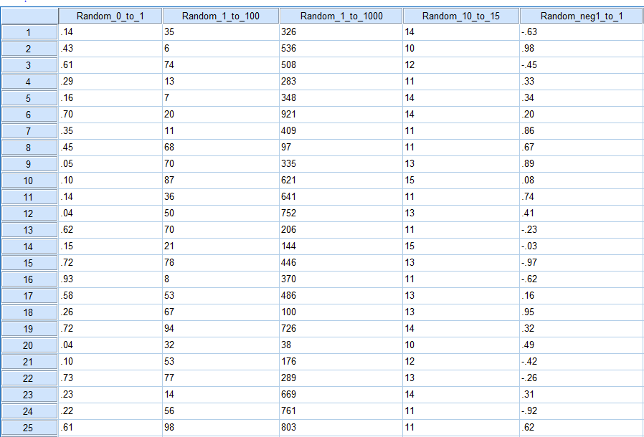

|  |  |  |  |  |  |  |  |
| --- | --- | --- | --- | --- | --- | --- | --- |
|  | Range | Minimum | Maximum | Sum | Mean | Std. Deviation | Variance |
| Random_0_to_1 | 0.8912088 | 0.03709 | 0.92830 | 9.37162 | 0.37486 | 0.270096 | 0.07295188 |
| Random_1_to_100 | 92.05067 | 6.228 | 98.279 | 1195.699 | 47.828 | 29.79085 | 887.4949 |
| Random_1_to_1000 | 882.9495 | 38.21 | 921.16 | 10991.43 | 439.66 | 248.4428 | 61723.83 |
| Random_10_to_15 | 4.384061 | 10.24 | 14.62 | 309.7718 | 12.39 | 1.457421 | 2.124077 |
| Random_neg1_to_1 | 1.953686 | -0.9707 | 0.9830 | 3.840356 | 0.1536 | 0.5846167 | 0.3417767 |

1. Export your data into “random.csv” file. Compute range, min, max, sum, mean, standard deviation and variance for each dataset by using R Program.
2. Compute range, min, max, sum, mean, standard deviation and variance for each dataset by using SPSS built-in functions.

|  |  |  |  |  |  |  |  |  |
| --- | --- | --- | --- | --- | --- | --- | --- | --- |
| **Descriptive Statistics** | | | | | | | | |
|  | N | Range | Minimum | Maximum | Sum | Mean | Std. Deviation | Variance |
| Random_0_to_1 | 25 | .89 | .04 | .93 | 9.37 | .3749 | .27010 | .073 |
| Random_1_to_100 | 25 | 92 | 6 | 98 | 1196 | 47.83 | 29.791 | 887.495 |
| Random_1_to_1000 | 25 | 883 | 38 | 921 | 10991 | 439.66 | 248.443 | 61723.827 |
| Random_10_to_15 | 25 | 4 | 10 | 15 | 310 | 12.39 | 1.457 | 2.124 |
| Random_neg1_to_1 | 25 | 1.95 | -.97 | .98 | 3.84 | .1536 | .58462 | .342 |
| Valid N (listwise) | 25 |  |  |  |  |  |  |  |

**Part C:**

Objective: Importing data into SPSS

**Instructions:**Preparing Data for Import into SPSS (Using Excel)

1. Row 1 of your Excel spreadsheet should contain variable names that are compatible with SPSS naming conventions. Variable names should only be on row 1. Do not extend names to row 2.
   1. Variable names must begin with a letter. Other characters allowed in the name include any letter, any digit, a period, or the symbols @, #, _, or $. Variable names cannot end with a period. Avoid names that end with an underscore since that might conflict with internal SPSS variables.
   2. Variable names cannot exceed 64 characters.
   3. Do not use blanks or special characters (for example, !, ?, ', and *)
   4. Variable names must be unique; duplication is not allowed.
   5. Do not use reserved SPSS keywords as names. Keywords include: ALL, AND, BY, EQ, GE, GT, LE, LT, NE, NOT, OR, TO, WITH.
   6. Case does not matter. Use any mixture of upper and lowercase characters when naming your variable.
2. Each row (line) in the Excel spreadsheet (other than the variable row) should represent a single subject or observed entity.
3. Avoid blank rows – it will complicate your import and analysis
4. If you have missing data, do not leave that cell in Excel blank. Define a missing value code and place that code in any cell that contains missing data.

**Question 2**: Importing data from “result.xlsx” file into SPSS. Compute range, min, max, sum, mean, standard deviation and variance for score variable [점수].

|  |  |  |  |  |  |  |  |  |
| --- | --- | --- | --- | --- | --- | --- | --- | --- |
| **Descriptive Statistics** | | | | | | | | |
|  | N | Range | Minimum | Maximum | Sum | Mean | Std. Deviation | Variance |
| 점수 | 112 | 97 | 0 | 97 | 9143 | 81.63 | 18.993 | 360.739 |
| Valid N (listwise) | 112 |  |  |  |  |  |  |  |

**Question 3**: Importing data from “demo.txt” file into SPSS. Compute range, min, max, sum, mean, standard deviation and variance for age, income and employ.

|  |  |  |  |  |  |  |  |  |
| --- | --- | --- | --- | --- | --- | --- | --- | --- |
| **Descriptive Statistics** | | | | | | | | |
|  | N | Range | Minimum | Maximum | Sum | Mean | Std. Deviation | Variance |
| age | 6400 | 61 | 18 | 79 | 268663 | 41.98 | 12.252 | 150.103 |
| income | 6400 | 1061 | 9 | 1070 | 447277 | 69.89 | 77.994 | 6083.053 |
| employ | 6400 | 56 | 0 | 56 | 68016 | 10.63 | 9.716 | 94.408 |
| Valid N (listwise) | 6400 |  |  |  |  |  |  |  |