**Practical 3:**

**Part A:** Exploring data using SPSS Chart Builder.

1. Based on the “Smoking_Survey.sav” file, generate the following graphs for Age:
   1. Simple Histogram

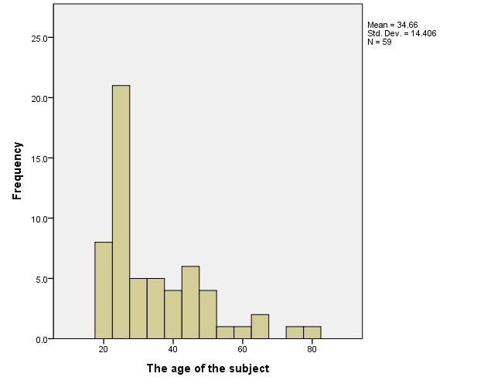

* 1. Stacked Histogram (based on the Gender)

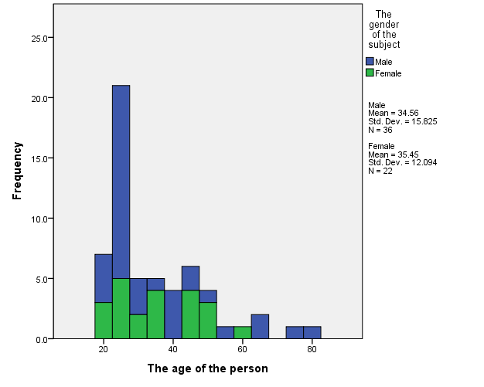

* 1. Boxplot

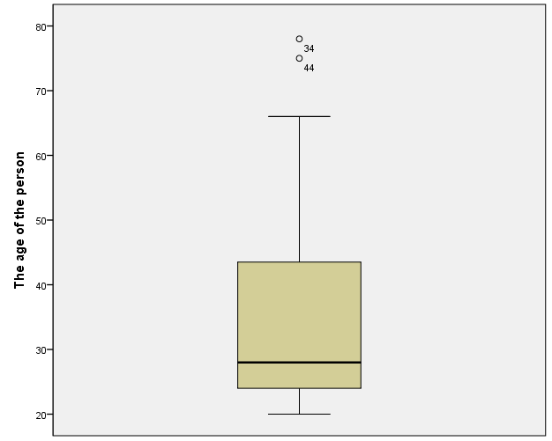

* 1. Boxplot (based on the Gender)

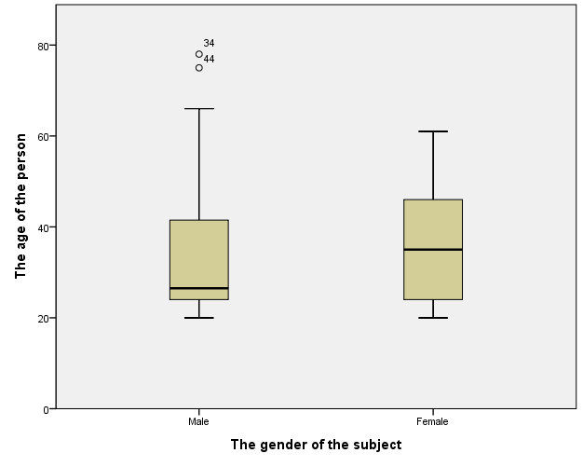

* 1. Normal Curve

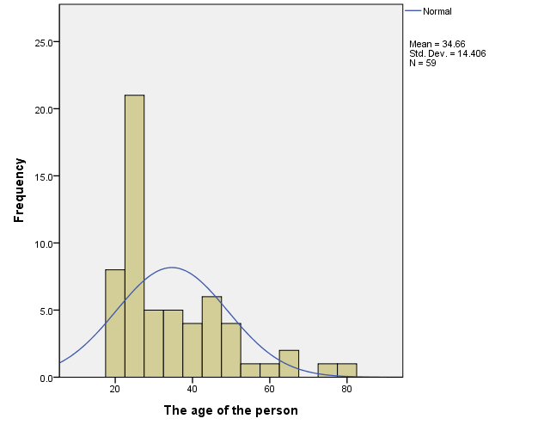

* 1. Scatterplot for age (axis-X) and the number of cigarettes smoked (axis-Y) with the regression line.

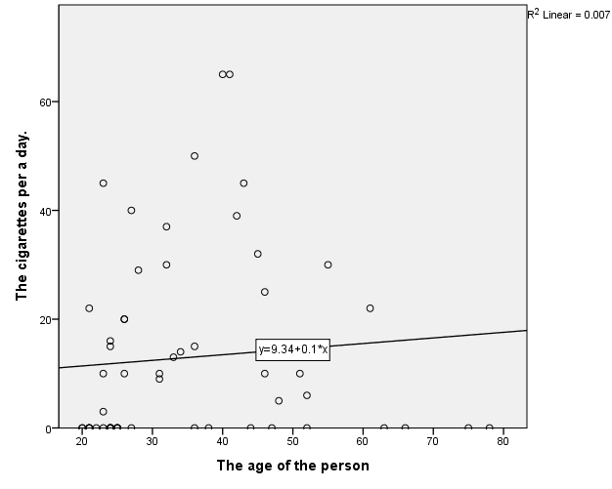

* 1. Grouped scatter for age (axis-X) and the number of cigarettes smoked (axis-Y) with the regression lines.

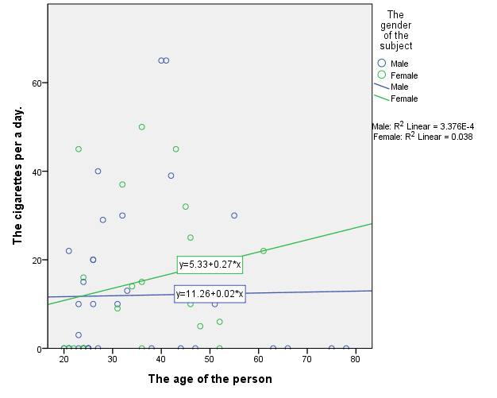

**Part B:** Explore data using R Program.

1. Based on the data from “Smoking_Survey.sav” file, plot the following graphs (by using R Program):
2. Histogram for Age

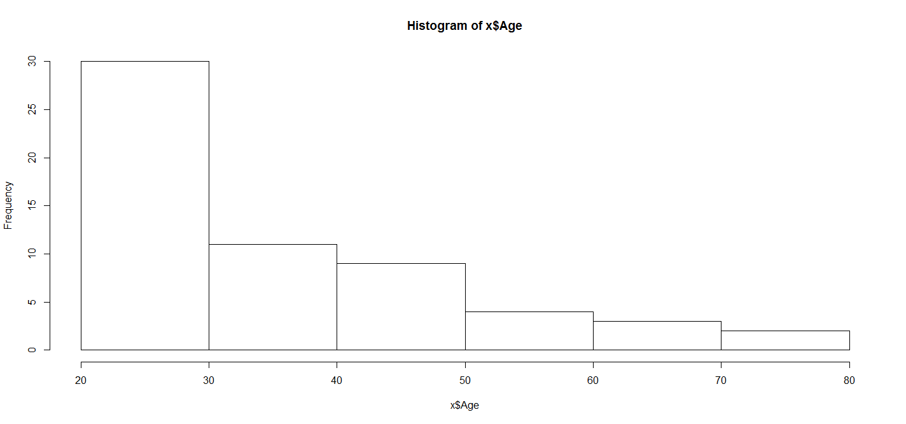

**> hist(x$Age)**

1. Boxplot for Age

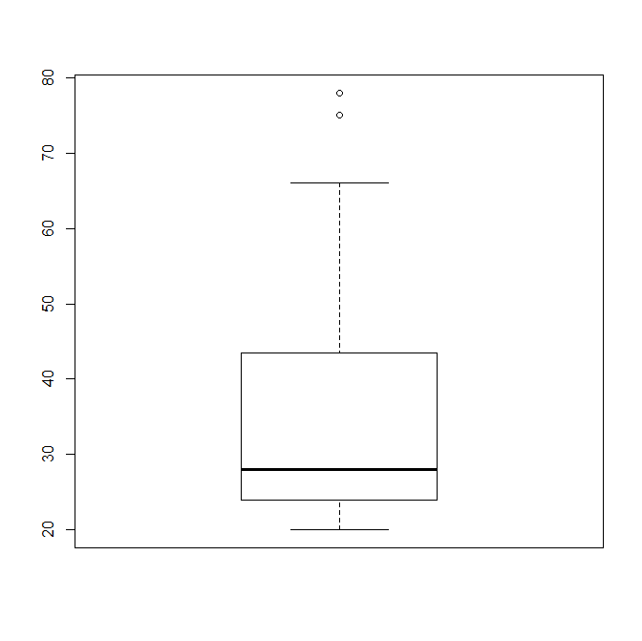

> boxplot(x$Age)

1. Scatterplot for Age and Number of years smoked.

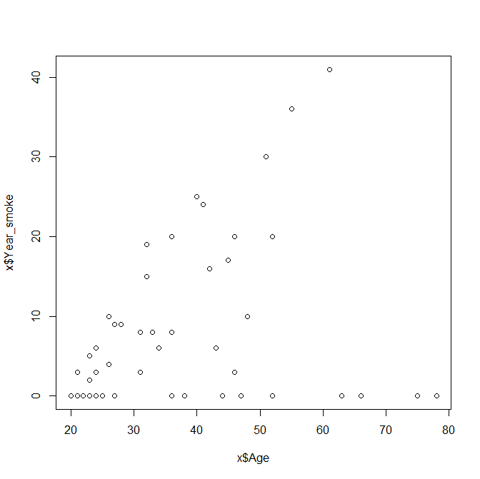

> plot(x$Age,x$Year_smoke)

1. Scatterplot for Age and Number of years smoked with a regression line.

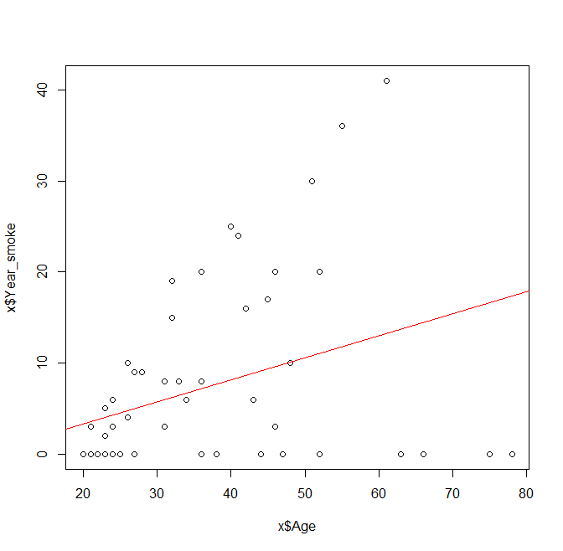

> abline(lm(x$Year_smoke~x$Age),col="red")

//abline을 사용하기 위해서는 반드시 먼저 plot을 사용해야한다.