**SPSS Practical 5:**

**Part A: Correlation Test**

A student was interested in whether there was a positive relationship between the time spent doing an essay and the mark received. He got 45 of his friends and timed how long they spent writing an essay (**hours**) and the percentage they got in the essay (**score**). He also translated these grades into their degree classifications (**grade**): first, upper second, lower second and third class.

1. Write the null and alternative hypothesis for this test?

$H_{0}$: r = 0

$H_{1}$: r > 0 //내가 positive relastionship 임을 알고있으므로. 문제에 나와있음

1. By using the data in the file **EssayMarks.sav**, find out what the relationship was between the time spent doing an essay (hours) and the eventual mark in terms of
2. score

이건 r 값이 0.26<0.3이므로 weak 한 positive이다.

1. 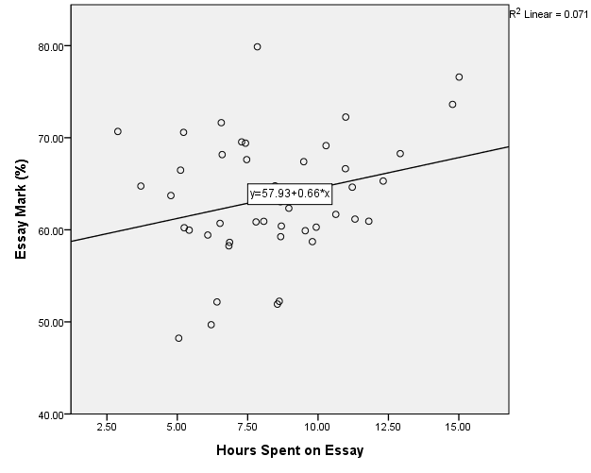

|  |  |  |  |  |  |  |
| --- | --- | --- | --- | --- | --- | --- |
| **Tests of Normality** | | | | | | |
|  | Kolmogorov-Smirnova | | | Shapiro-Wilk | | |
| Statistic | df | Sig. | Statistic | df | Sig. |
| Essay Mark (%) | .110 | 45 | .200* | .977 | 45 | .518 |
| Hours Spent on Essay | .091 | 45 | .200* | .981 | 45 | .662 |
| *. This is a lower bound of the true significance. | | | | | | |
| a. Lilliefors Significance Correction | | | | | | |

$H_{0}$: Nomality can be asumed

${ H}_{1}$: -----------------not-----------

K-S Test(Score)

D(45) = 0.110, sig = 0.200(>0.05)

This test is nonsignificant

Accept $H_{0}$

Conclustion : Nomality can be asummed.

K-S Test(Hours)

D(45) = 0.091, sig = 0.200( 0>0.5)\\\

This test is nonsignificant

Accept $H_{0}$

Conclustion : Nomality can be asummed.

Pearson’s Correlation Test:

|  |  |  |  |
| --- | --- | --- | --- |
| **Correlations** | | | |
|  | | Essay Mark (%) | Hours Spent on Essay |
| Essay Mark (%) | Pearson Correlation | 1 | .267* |
| Sig. (1-tailed) |  | .038 |
| Sum of Squares and Cross-products | 2009.060 | 216.101 |
| Covariance | 45.660 | 4.911 |
| N | 45 | 45 |
| Hours Spent on Essay | Pearson Correlation | .267* | 1 |
| Sig. (1-tailed) | .038 |  |
| Sum of Squares and Cross-products | 216.101 | 326.835 |
| Covariance | 4.911 | 7.428 |
| N | 45 | 45 |
| *. Correlation is significant at the 0.05 level (1-tailed). | | | |

$H_{0}$: r = 0

$H_{1}$: r > 0

The correlation is r(45) = 0.267, sig = 0.038(<0.05)

This test is significant

Reject $H_{0}$

Conclusion : There is a positive relationship.

// Analyze -> correlate -> 에서

1. Peaerson, separman, kendall 쓸거면

Bivariate 로 들어가서 씀

이때

// tip cross –product 찾는 법 option에서 체크하면 바로나옴.

1. Partial 쓸거면

Partial 들어가서 씀

3 변수 중 2변수의 관계만을 보고싶다면 controll에 할 것 을 넣어.

Significant 가 two , one 차이는 내가 양수,음수관계임을 알고있을 때 one

모르는 경우 two를 사용!

1. degree class.

|  |  |  |  |  |
| --- | --- | --- | --- | --- |
| **Correlations** | | | | |
|  | | | Hours Spent on Essay | Grade |
| Kendall's tau_b | Hours Spent on Essay | Correlation Coefficient | 1.000 | -.158 |
| Sig. (1-tailed) | . | .089 |
| N | 45 | 45 |
| Grade | Correlation Coefficient | -.158 | 1.000 |
| Sig. (1-tailed) | .089 | . |
| N | 45 | 45 |
| Spearman's rho | Hours Spent on Essay | Correlation Coefficient | 1.000 | -.193 |
| Sig. (1-tailed) | . | .102 |
| N | 45 | 45 |
| Grade | Correlation Coefficient | -.193 | 1.000 |
| Sig. (1-tailed) | .102 | . |
| N | 45 | 45 |

$H_{0}$: $τ$ = 0

${ H}_{1}$: $τ$ > 0

Kendall’s tau

The correlation is $τ\left(45\right)= -0.158, sig=0.089\left(>0.05\right)$

This test is non-significant

Accept $H_{0}$

Conclusion: There is no relationship.

//test 진행하는 방법과 결론 도출과정을 모두 외워야함. 단순히 답만 원하는 것이 아님.

**Important**: You may need to draw a scatterplot to support your answer.

**Part B: Partial Correlation Test**

* A partial correlation provides an index of whether two variables are linearly related (hours and score) if the effects of a third control variable (say IQ) are removed from their relationship.
* A partial correlation is a type of Pearson correlation coefficient that can range in value from -1 to +1.
* A significant positive partial correlation implies that as the values on one variable increase, the values on a second variable also tend to increase, while holding constant the values of the control variable(s).

A professor was interested in whether there was a positive relationship between the time spent doing an essay and the mark received when considering the IQ of each student.

1. Write the null and alternative hypothesis for this test?

$H_{0}$: $When controlling for IQ, there is no relationship between Hours and Score.$

$$H_{1}:When controlling for IQ, there is a positive relationship between Hours and Score.$$

//analyze – correlate -> partial -> 제어하는 것을밑에

1. Perform the partial correlation test and interpret the SPSS output.

|  |  |  |  |  |
| --- | --- | --- | --- | --- |
| **Correlations** | | | | |
| Control Variables | | | Essay Mark (%) | Hours Spent on Essay |
| IQ | Essay Mark (%) | Correlation | 1.000 | .247 |
| Significance (1-tailed) | . | .053 |
| df | 0 | 42 |
| Hours Spent on Essay | Correlation | .247 | 1.000 |
| Significance (1-tailed) | .053 | . |
| df | 42 | 0 |

The partial correlation is r(42) = 0.247, sig = 0.053(>0.05)

This is non-significant

Accept $H_{0}$

Conclusion: $When controlling for IQ, there is no relationship between Hours and Score.$

//scale data여야만 함.

**Part C:**

From the Smoking_Survey file, identify variables with the following relationships (use scatterplot and coefficient of determination value to support your answer):

(coefficient of determination = r제곱)

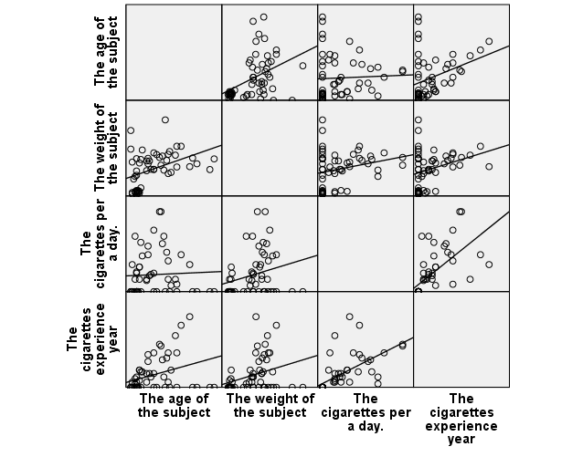

//이 matrix를 읽는 방법은 대각선으로 잘라서 위쪽삼각형을 보면됨

이때 기울기가 가장 큰 것이 strongest, 거의없는것이 no, 있는 것들중 가장 약한 것이 weakest.

분석시 r제곱값이 나오므로 반드시 r로 변환해서 범위를 확인할 것

1. Strongest positive relationship:

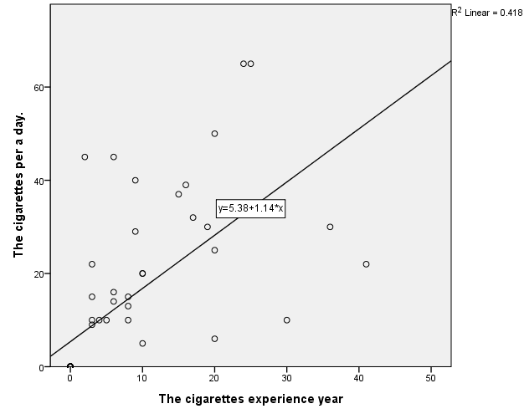

There is a moderate positive relationship, coefficient of determination = 0.418

(R 제곱이 0.418 이므로 r 은 0.646)

1. Weakest positive relationship:

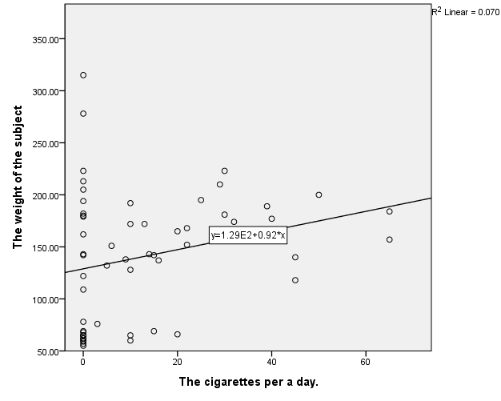

There is a weak positive relationship, coefficient of determination = 0.070

(r 제곱이 0.070 이므로 r = 0.26 < 0.3)

1. No relationship:

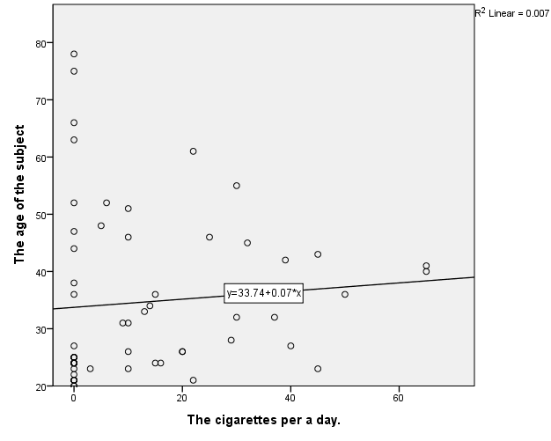

There is almost no relationship, coefficient of determination = 0.007

(r 제곱이 0.007이므로 r = 0.083 < 0.3)