4
Practical Assignment 04 Problem statement: Introduction to Android Studio:
- Create a simple Android app that displays "Hello World" on the screen using a TextView and modify the app to change the text when a button is clicked.
- Create an Android app that demonstrates text formatting features such as changing text color, background color, size, and alignment.

Code:
- Display and Change Text using Button Activity_main.xml:
<?xml version="1.0" encoding="utf-8"?>
<RelativeLayout xmlns:android="http://schemas.android.com/apk/res/android" android:layout_width="match_parent" android:layout_height="match_parent">
<TextView android:id="@+id/textView" android:layout_width="wrap_content" android:layout_height="wrap_content" android:text="Hello World"
android:layout_centerInParent="true"android:textSize="24sp" />
<Button android:id="@+id/button"
android:layout_width="wrap_content" android:layout_height="wrap_content" android:text="Change Text" android:layout_below="@id/textView" android:layout_centerHorizontal="true" android:layout_marginTop="20dp" />
</RelativeLayout>

MainActivity.Java:
package com.example.pa4; import android.os.Bundle; import android.view.View; import android.widget.Button;
import android.widget.TextView;
import androidx.appcompat.app.AppCompatActivity; public class MainActivity extends AppCompatActivity { private TextView textView;
private Button button; @Override
protected void onCreate(Bundle savedInstanceState) { super.onCreate(savedInstanceState); setContentView(R.layout.activity_main);
textView = findViewById(R.id.textView); button = findViewById(R.id.button);
button.setOnClickListener(new View.OnClickListener() { @Override
public void onClick(View v) { textView.setText("Text Changed!");
}
});
}
}

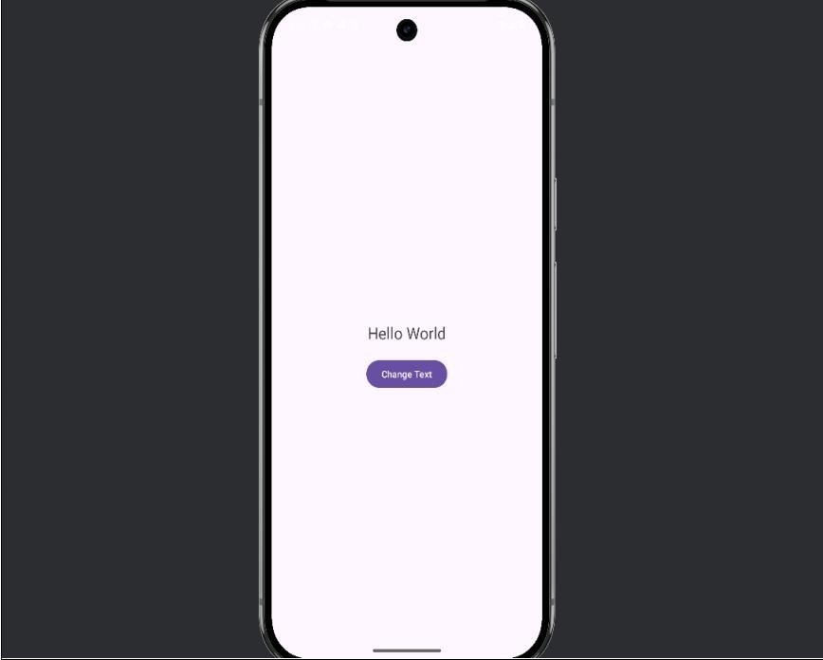
Output:

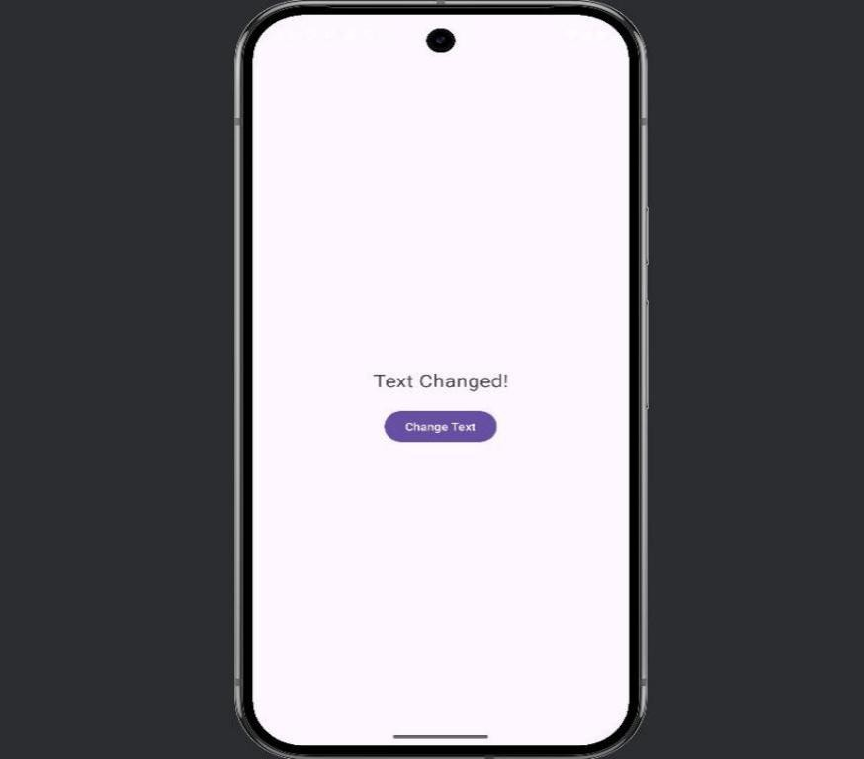

- Text Formatting Features Activity_main.xml:
<?xml version="1.0" encoding="utf-8"?>
<RelativeLayout xmlns:android="http://schemas.android.com/apk/res/android" android:layout_width="match_parent" android:layout_height="match_parent">
<TextView android:id="@+id/formattedTextView" android:layout_width="wrap_content" android:layout_height="wrap_content" android:text="This Is Formatted Text" android:textSize="30sp" android:textColor="#FF5722" android:background="#E0E0E0" android:layout_centerInParent="true" android:gravity="center" />
</RelativeLayout>

MainActivity.Java:
package com.example.pa4; import android.os.Bundle;
import androidx.appcompat.app.AppCompatActivity; public class MainActivity extends AppCompatActivity { @Override
protected void onCreate(Bundle savedInstanceState) { super.onCreate(savedInstanceState); setContentView(R.layout.activity_main);
}
}

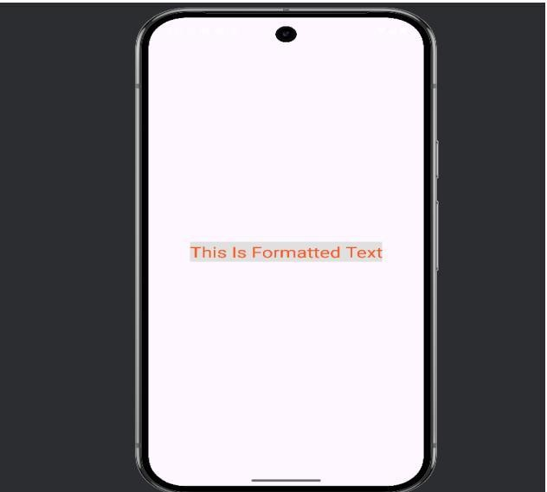

5
Increment
counter

Practical Assignment 05

Problem statement:
- Develop an Android app with buttons that increment a counter each time they are clicked, displaying the total count to the user.
- Create a simple form-based Android app that collects user details like Name, Email, Age, and Gender, and displays the information using a Toast on submission.

Aim:
To learn how to use TextView, Button, EditText, and RadioGroup in Android.
  - To implement event handling in Android using OnClickListener.
  - To use Toasts for displaying user-input information

Code:

- Counter App

Activity_main.xml:
<?xml version="1.0" encoding="utf-8"?>
<RelativeLayout xmlns:android="http://schemas.android.com/apk/res/android" android:layout_width="match_parent"
android:layout_height="match_parent" android:padding="16dp">
<TextView android:id="@+id/counterTextView" android:layout_width="wrap_content" android:layout_height="wrap_content" android:text="Count: 0" android:textSize="24sp" android:layout_centerHorizontal="true" android:layout_marginBottom="24dp"/>
<Button android:id="@+id/incrementButton" android:layout_width="wrap_content" android:layout_height="wrap_content" android:text="Increment" android:layout_centerHorizontal="true"
android:layout_below="@id/counterTextView"/>
android:id="@+id/resetButton" android:layout_width="wrap_content" android:layout_height="wrap_content" android:text="Reset" android:layout_centerHorizontal="true" android:layout_below="@id/incrementButton" android:layout_marginTop="16dp"/>
</RelativeLayout>

MainActivity.Java:
package com.example.myapplication; import android.os.Bundle;
import android.view.View; import android.widget.Button; import android.widget.TextView;
import androidx.appcompat.app.AppCompatActivity; public class MainActivity extends AppCompatActivity { private int count = 0;
private TextView counterTextView; @Override
protected void onCreate(Bundle savedInstanceState) { super.onCreate(savedInstanceState); setContentView(R.layout.activity_main); counterTextView = findViewById(R.id.counterTextView);
Button incrementButton = findViewById(R.id.incrementButton); Button resetButton = findViewById(R.id.resetButton); incrementButton.setOnClickListener(new View.OnClickListener() { @Override
public void onClick(View v) { count++; updateCounterText();
}
});
resetButton.setOnClickListener(new View.OnClickListener() { @Override
public void onClick(View v) { count = 0; updateCounterText();
}
});
}
private void updateCounterText() { counterTextView.setText("Count: " + count);
}
}

Output:

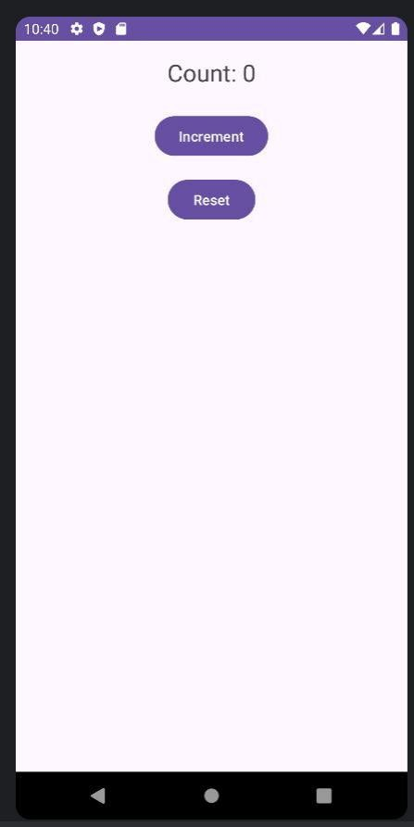

- Form App with Toast

Activity_main.xml:
<?xml version="1.0" encoding="utf-8"?>
<LinearLayout xmlns:android="http://schemas.android.com/apk/res/android" android:layout_width="match_parent" android:layout_height="match_parent"
android:orientation="vertical" android:padding="16dp">
<TextView android:layout_width="wrap_content" android:layout_height="wrap_content" android:text="Name:" />
<EditText android:id="@+id/nameEditText" android:layout_width="match_parent" android:layout_height="wrap_content" android:hint="Enter your name" />
<TextView android:layout_width="wrap_content" android:layout_height="wrap_content" android:text="Email:" />
<EditText android:id="@+id/emailEditText" android:layout_width="match_parent" android:layout_height="wrap_content" android:hint="Enter your email" android:inputType="textEmailAddress" />
<TextView android:layout_width="wrap_content" android:layout_height="wrap_content" android:text="Age:" />
<EditText android:id="@+id/ageEditText" android:layout_width="match_parent" android:layout_height="wrap_content" android:hint="Enter your age"
android:inputType="number" /><TextView android:layout_width="wrap_content" android:layout_height="wrap_content" android:text="Gender:" />
<RadioGroup android:id="@+id/genderRadioGroup" android:layout_width="match_parent" android:layout_height="wrap_content">
<RadioButton android:id="@+id/maleRadioButton" android:layout_width="wrap_content" android:layout_height="wrap_content" android:text="Male" />
<RadioButton
android:id="@+id/femaleRadioButton" android:layout_width="wrap_content" android:layout_height="wrap_content" android:text="Female" />
</RadioGroup>
<Button android:id="@+id/submitButton" android:layout_width="match_parent" android:layout_height="wrap_content" android:text="Submit" android:layout_marginTop="16dp"/>
</LinearLayout>

MainActivity.Java:
package com.example.assign5; import android.os.Bundle; import android.view.View; import android.widget.Button; import android.widget.EditText;
import android.widget.RadioButton; import android.widget.RadioGroup; import android.widget.Toast;
import androidx.appcompat.app.AppCompatActivity; public class MainActivity extends AppCompatActivity {
private EditText nameEditText;private EditText emailEditText; private EditText ageEditText;
private RadioGroup genderRadioGroup; @Override
protected void onCreate(Bundle savedInstanceState) { super.onCreate(savedInstanceState); setContentView(R.layout.activity_main); nameEditText = findViewById(R.id.nameEditText); emailEditText = findViewById(R.id.emailEditText); ageEditText = findViewById(R.id.ageEditText);
genderRadioGroup = findViewById(R.id.genderRadioGroup); Button submitButton = findViewById(R.id.submitButton); submitButton.setOnClickListener(new View.OnClickListener() { @Override
public void onClick(View v) {
String name = nameEditText.getText().toString(); String email = emailEditText.getText().toString(); String age = ageEditText.getText().toString();
int selectedGenderId = genderRadioGroup.getCheckedRadioButtonId(); String gender = "";
if (selectedGenderId != -1) { // Check if a gender is selected RadioButton selectedGenderButton = findViewById(selectedGenderId); gender = selectedGenderButton.getText().toString();
}
String message = "Name: " + name + "\nEmail: " + email + "\nAge: " + age
+ "\nGender: " + gender; Toast.makeText(MainActivity.this, message, Toast.LENGTH_LONG).show();
} });}}

6

Date picker

Practical Assignment 06

Problem statement:
- Create an Android application that includes a Date Picker. The app should display the current date, and upon clicking the "Change Date" button, allow the user to select a new date and update the displayed date accordingly.
- Create a simple Calculator app using EditText fields for inputs and buttons for addition, subtraction, multiplication, and division. The result should be displayed on the screen.

Code:
- Date Picker App activity_main.xml:
<?xml version="1.0" encoding="utf-8"?>
<RelativeLayout xmlns:android="http://schemas.android.com/apk/res/android" android:layout_width="match_parent" android:layout_height="match_parent" android:padding="16dp">
<TextView android:id="@+id/currentDateTextView" android:layout_width="wrap_content" android:layout_height="wrap_content" android:text="Current Date" android:textSize="24sp" />
<Button android:id="@+id/changeDateButton"android:layout_width="wrap_content" android:layout_height="wrap_content"
android:text="Change Date" android:layout_below="@id/currentDateTextView" android:layout_marginTop="20dp" />
</RelativeLayout>

MainActivity.java:
package com.example.date;
import android.app.DatePickerDialog;
import android.os.Bundle;
import android.widget.Button;
import android.widget.TextView;
import androidx.appcompat.app.AppCompatActivity;
import java.util.Calendar;
public class MainActivity extends AppCompatActivity {
TextView textView;
Button button;
@Override
protected void onCreate(Bundle savedInstanceState) {
super.onCreate(savedInstanceState);
setContentView(R.layout.activity_main);
textView = findViewById(R.id.TextView);
button = findViewById(R.id.Button);
button.setOnClickListener(v -> {
DatePickerDialog picker = new DatePickerDialog(this);
picker.setOnDateSetListener((view, year, month, day) -> {
textView.setText(day + "/" + (month + 1) + "/" + year);
});
picker.show();
});
}
}

Output:
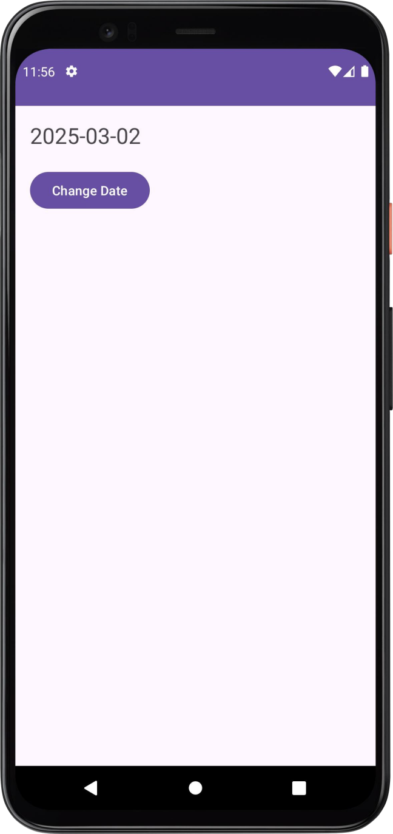
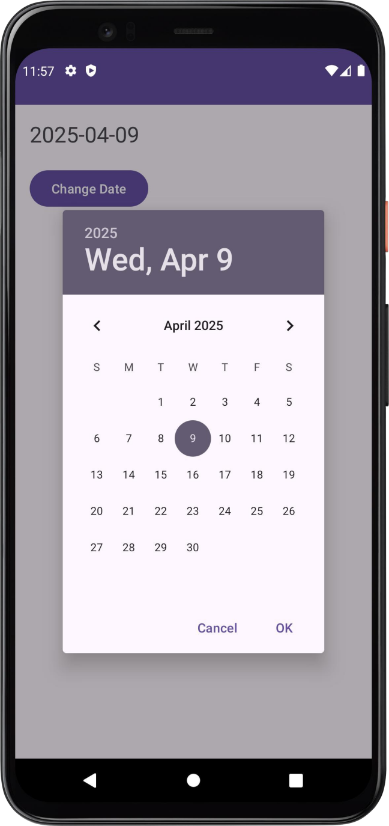

20

Calculator App activity_main.xml:
<?xml version="1.0" encoding="utf-8"?>
<LinearLayout xmlns:android="http://schemas.android.com/apk/res/android" android:layout_width="match_parent" android:layout_height="match_parent" android:orientation="vertical"
android:padding="16dp">
<!-- Heading -->
<TextView android:id="@+id/textViewHeading" android:layout_width="match_parent" android:layout_height="wrap_content" android:text="Calculator" android:textSize="24sp" android:textStyle="bold" android:gravity="center" android:layout_marginBottom="16dp" />
<!-- First Number Input -->
<EditText android:id="@+id/editTextNumber1" android:layout_width="match_parent" android:layout_height="wrap_content" android:hint="Enter first number" android:inputType="numberDecimal" android:layout_marginBottom="8dp" />
<!-- Second Number Input -->
<EditText android:id="@+id/editTextNumber2"
android:layout_width="match_parent"android:layout_height="wrap_content" android:hint="Enter second number"
android:inputType="numberDecimal" android:layout_marginBottom="16dp" />
<!-- Button Layout -->
<GridLayout android:layout_width="match_parent" android:layout_height="wrap_content" android:columnCount="2" android:rowCount="2" android:layout_marginBottom="16dp">
<Button android:id="@+id/buttonAdd" android:layout_width="0dp"
android:layout_height="wrap_content" 21

android:layout_columnWeight="1" android:text="Add" />
<Button android:id="@+id/buttonSubtract" android:layout_width="0dp" android:layout_height="wrap_content" android:layout_columnWeight="1" android:text="Subtract" />
<Button android:id="@+id/buttonMultiply" android:layout_width="0dp" android:layout_height="wrap_content" android:layout_columnWeight="1" android:text="Multiply" />
<Button android:id="@+id/buttonDivide" android:layout_width="0dp" android:layout_height="wrap_content" android:layout_columnWeight="1" android:text="Divide" /></GridLayout>
<!-- Result Display -->
<TextView android:id="@+id/textViewResult" android:layout_width="match_parent" android:layout_height="wrap_content" android:textSize="18sp" android:layout_marginTop="16dp" android:gravity="center" />
</LinearLayout>

MainActivity.java:
package com.example.calculator;

import android.os.Bundle;
import android.widget.Button;
import android.widget.EditText;
import android.widget.TextView;

import androidx.appcompat.app.AppCompatActivity;

public class MainActivity extends AppCompatActivity {
EditText firstnum,secondnum;
Button add,subtract,multiply,divide;
double num1,num2;
TextView result;

@Override
protected void onCreate(Bundle savedInstanceState) {
super.onCreate(savedInstanceState);
setContentView(R.layout.activity_main);
firstnum=findViewById(R.id.firstnum);
secondnum=findViewById(R.id.secondnum);
add = findViewById(R.id.add);
subtract = findViewById(R.id.subtract);
multiply = findViewById(R.id.multiply);
divide = findViewById(R.id.divide);
result = findViewById(R.id.result);
Clicklisteners();
}

private void Clicklisteners() {
add.setOnClickListener(v -> {
num1 = Double.parseDouble(firstnum.getText().toString());
num2 = Double.parseDouble(secondnum.getText().toString());
result.setText(String.valueOf(num1 + num2));
});
subtract.setOnClickListener(v -> {
num1 = Double.parseDouble(firstnum.getText().toString());
num2 = Double.parseDouble(secondnum.getText().toString());
result.setText(String.valueOf(num1 - num2));
});
multiply.setOnClickListener(v -> {
num1 = Double.parseDouble(firstnum.getText().toString());
num2 = Double.parseDouble(secondnum.getText().toString());
result.setText(String.valueOf(num1 * num2));
});
divide.setOnClickListener(v -> {
num1 = Double.parseDouble(firstnum.getText().toString());
num2 = Double.parseDouble(secondnum.getText().toString());
result.setText(String.valueOf(num1 / num2));
});
}
}}

8

Dialog and task box

Practical Assignment 08

Problem statement:
Develop an Android application featuring two buttons labeled "Demo Dialog" and

"Task Dialog".
- When the "Demo Dialog" button is clicked, a dialog box should appear with a demonstration message.
- When the "Task Dialog" button is clicked, another dialog box should appear with task-specific information and Yes/No options.
This functionality should be implemented using Java in Android Studio.

Aim:
To design and implement an Android application that demonstrates the use of dialog boxes using Java and Android Studio. The app provides user interaction through alert dialogs for demo and task-based prompts.

Code:
Activity_main.xml
<?xml version="1.0" encoding="utf-8"?>
<LinearLayout xmlns:android="http://schemas.android.com/apk/res/android"
android:layout_width="match_parent"
android:layout_height="match_parent"
android:gravity="center"
android:orientation="vertical">

<Button
android:id="@+id/dialogButton"
android:layout_width="wrap_content"
android:layout_height="wrap_content"
android:text="Show Dialog" />
</LinearLayout>

MainActivity.java
package com.example.dialogbox;

import android.os.Bundle;
import android.view.View;
import android.widget.Button;
import android.widget.Toast;
import androidx.appcompat.app.AlertDialog;
import androidx.appcompat.app.AppCompatActivity;

public class MainActivity extends AppCompatActivity {

@Override
protected void onCreate(Bundle savedInstanceState) {
super.onCreate(savedInstanceState);
setContentView(R.layout.activity_main);

Button btn = findViewById(R.id.dialogButton);

btn.setOnClickListener(new View.OnClickListener() {
@Override
public void onClick(View view) {
AlertDialog.Builder dialog = new AlertDialog.Builder(MainActivity.this);
dialog.setMessage("Click Yes or No");
dialog.setPositiveButton("Yes", (d, w) -> Toast.makeText(MainActivity.this, "Yes clicked", Toast.LENGTH_SHORT).show());
dialog.setNegativeButton("No", (d, w) -> Toast.makeText(MainActivity.this, "No clicked", Toast.LENGTH_SHORT).show());
dialog.show();
}
});
}
}

Output:

DIALOG BOX:

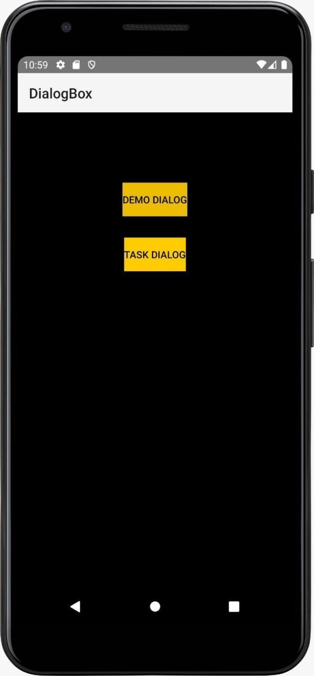
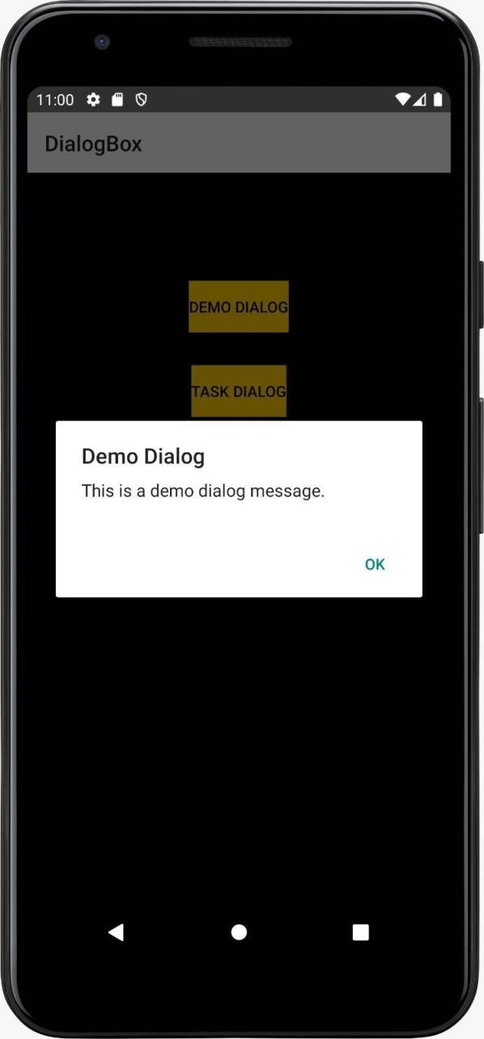

TASK BOX:

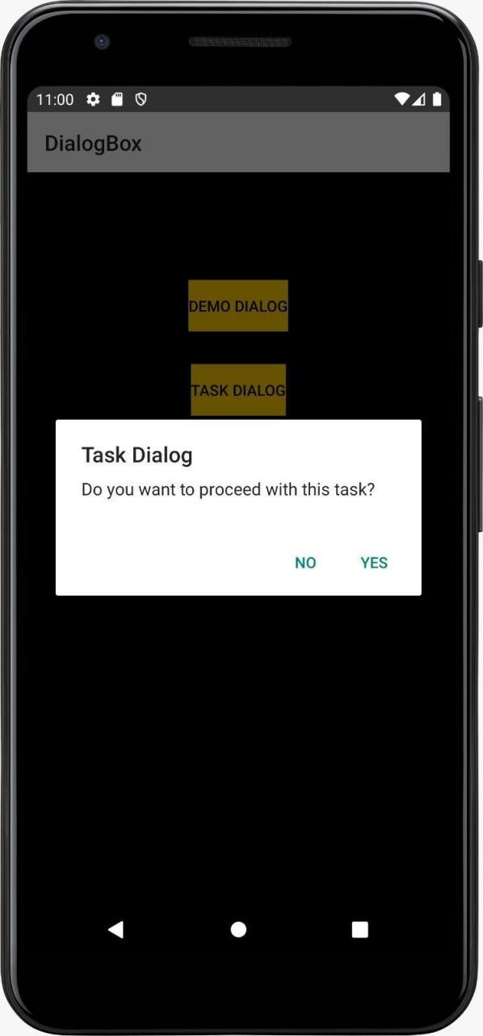
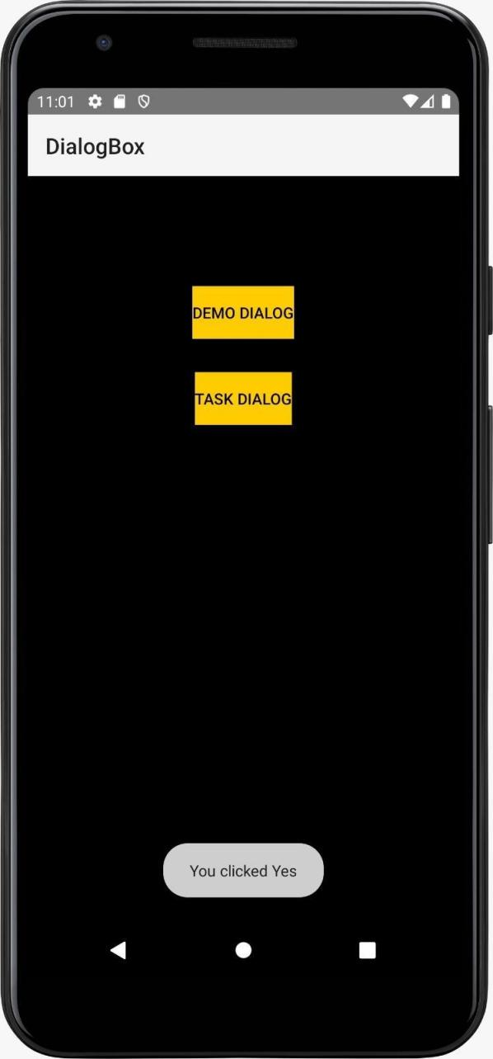

9
Traffic light

Practical Assignment 09

Problem statement:
Design and develop an Android application that simulates a Traffic Light System. The app should have three buttons labeled Red, Yellow, and Green. When any button is clicked, the corresponding color should be displayed in a traffic light-style layout, visually indicating the light is active.

Aim:
To implement a simple Android application using Java that demonstrates event handling and dynamic UI updates by simulating a traffic signal system with red, yellow, and green lights.

Code:

Activity_main.xml:
<LinearLayout xmlns:android="http://schemas.android.com/apk/res/android" android:layout_width="match_parent" android:layout_height="match_parent" android:orientation="vertical"
android:gravity="center" android:padding="16dp">
<!-- ImageView for Traffic Light -->
<ImageView android:id="@+id/trafficLightImage" android:layout_width="200dp" android:layout_height="400dp" android:src="@drawable/red" android:contentDescription="Traffic Light" />
<!-- Buttons -->
<LinearLayout android:layout_width="wrap_content" android:layout_height="wrap_content" android:orientation="horizontal" android:gravity="center" android:layout_marginTop="20dp">
<Button android:id="@+id/btnRed"
android:layout_width="wrap_content" android:layout_height="wrap_content"
android:text="Red" />
<Button android:id="@+id/btnYellow" android:layout_width="wrap_content" android:layout_height="wrap_content" android:text="Yellow" android:layout_marginStart="10dp" android:layout_marginEnd="10dp" />
<Button android:id="@+id/btnGreen"
android:layout_width="wrap_content" D.Y.P.I.U, Pune android:layout_height="wrap_content" android:text="Green" />
</LinearLayout>
</LinearLayout>

MainActivity.Java:
package com.example.pa9; import android.os.Bundle; import android.widget.Button;
import android.widget.ImageView;
import androidx.appcompat.app.AppCompatActivity; public class MainActivity extends AppCompatActivity { @Override
protected void onCreate(Bundle savedInstanceState) { super.onCreate(savedInstanceState); setContentView(R.layout.activity_main);
// Reference to ImageView
ImageView trafficLightImage = findViewById(R.id.trafficLightImage);
// References to Buttons
Button btnRed = findViewById(R.id.btnRed);] Button btnYellow = findViewById(R.id.btnYellow); Button btnGreen = findViewById(R.id.btnGreen);
// Button Click Listeners
btnRed.setOnClickListener(v -> trafficLightImage.setImageResource(R.drawable.red)); btnYellow.setOnClickListener(v -> trafficLightImage.setImageResource(R.drawable.yellow));
btnGreen.setOnClickListener(v -> trafficLightImage.setImageResource(R.drawable.green));
}
}

Images are added in drawable folder:
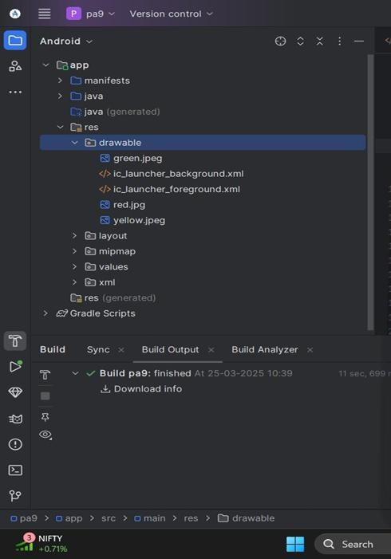

Output:

10
MCQ

Practical Assignment 10

Problem statement:
Create an Android application that displays a set of multiple-choice questions. The user should be able to select an answer for each question. After all questions have been answered, the app should display the user's total score.

Code:
Activity_main.xml:
<?xml version="1.0" encoding="utf-8"?>
<LinearLayout xmlns:android="http://schemas.android.com/apk/res/android" android:layout_width="match_parent" android:layout_height="match_parent"
android:orientation="vertical" android:padding="16dp">
<TextView android:id="@+id/questionText" android:layout_width="wrap_content" android:layout_height="wrap_content" android:text="Question appears here" android:textSize="20sp" android:textStyle="bold" android:paddingBottom="20dp"/>
<RadioGroup android:id="@+id/optionsGroup" android:layout_width="wrap_content" android:layout_height="wrap_content">
<RadioButton android:id="@+id/option1" android:layout_width="wrap_content" android:layout_height="wrap_content" android:text="Option 1"/>
<RadioButton android:id="@+id/option2" android:layout_width="wrap_content" android:layout_height="wrap_content" android:text="Option 2"/>
<RadioButton android:id="@+id/option3" android:layout_width="wrap_content" android:layout_height="wrap_content" android:text="Option 3"/>
<RadioButton
android:id="@+id/option4" android:layout_width="wrap_content" android:layout_height="wrap_content" android:text="Option 4"/>
</RadioGroup>
<Button android:id="@+id/nextButton" android:layout_width="wrap_content" android:layout_height="wrap_content" android:text="Next" android:layout_marginTop="20dp"/>
<TextView android:id="@+id/scoreText" android:layout_width="wrap_content" android:layout_height="wrap_content" android:text="Score: 0" android:visibility="gone" android:textSize="18sp" android:textStyle="bold” android:layout_marginTop="20dp"/>
</LinearLayout>

MainActivity.Java:
package com.example.pract_10; import android.os.Bundle; import android.view.View; import android.widget.Button;
import android.widget.RadioButton; import android.widget.RadioGroup; import android.widget.TextView; import android.widget.Toast;
import androidx.appcompat.app.AppCompatActivity; public class MainActivity extends AppCompatActivity { private TextView questionText, scoreText;
private RadioGroup optionsGroup;
private RadioButton option1, option2, option3, option4; private Button nextButton;
private String[] questions = { "What is the capital of France?",
"Which planet is known as the Red Planet?", "What is 5 + 3?",
"Who wrote 'Hamlet'?",
"Which is the largest ocean on Earth?"
};
private String[][] options = {
{"Paris", "London", "Berlin", "Rome"},
{"Earth", "Mars", "Jupiter", "Venus"},
{"5", "8", "10", "15"},
{"Shakespeare", "Hemingway", "Austen", "Dickens"},
{"Atlantic", "Indian", "Arctic", "Pacific"}
};
private int[] correctAnswers = {0, 1, 1, 0, 3}; // Indexes of correct answers private int currentQuestionIndex = 0;
private int score = 0; @Override
protected void onCreate(Bundle savedInstanceState) { super.onCreate(savedInstanceState);
setContentView(R.layout.activity_main); questionText = findViewById(R.id.questionText);
optionsGroup = findViewById(R.id.optionsGroup);
option1 = findViewById(R.id.option1); option2 = findViewById(R.id.option2); option3 = findViewById(R.id.option3); option4 = findViewById(R.id.option4); nextButton = findViewById(R.id.nextButton); scoreText = findViewById(R.id.scoreText); loadQuestion();
nextButton.setOnClickListener(new View.OnClickListener() { @Override
public void onClick(View v) { checkAnswer();
}
});
}
private void loadQuestion() {
if (currentQuestionIndex < questions.length) { questionText.setText(questions[currentQuestionIndex]); option1.setText(options[currentQuestionIndex][0]); option2.setText(options[currentQuestionIndex][1]); option3.setText(options[currentQuestionIndex][2]); option4.setText(options[currentQuestionIndex][3]); optionsGroup.clearCheck();
} else { displayScore();
}
}
private void checkAnswer() {
int selectedId = optionsGroup.getCheckedRadioButtonId(); if (selectedId == -1) {
Toast.makeText(this, "Please select an answer!", Toast.LENGTH_SHORT).show(); return;
}
int answerIndex = -1;
if (selectedId == option1.getId()) answerIndex = 0; else if (selectedId == option2.getId()) answerIndex = 1; else if (selectedId == option3.getId()) answerIndex = 2; else if (selectedId == option4.getId()) answerIndex = 3;
if (answerIndex == correctAnswers[currentQuestionIndex]) { score++;
}
currentQuestionIndex++; loadQuestion();
}
private void displayScore() { questionText.setVisibility(View.GONE); optionsGroup.setVisibility(View.GONE); nextButton.setVisibility(View.GONE); scoreText.setVisibility(View.VISIBLE);
scoreText.setText("Your Score: " + score + "/" + questions.length);
}
}

Form

Student form:

<?xml version="1.0" encoding="utf-8"?>
<LinearLayout xmlns:android="http://schemas.android.com/apk/res/android"
android:layout_width="match_parent"
android:layout_height="match_parent"
android:orientation="vertical"
android:padding="16dp"
android:paddingTop="40dp">

<!-- Name Question -->
<TextView
android:layout_width="wrap_content"
android:layout_height="wrap_content"
android:text="Enter your Name:"
android:textSize="18sp"
android:textStyle="bold" />

<EditText
android:id="@+id/Name"
android:layout_width="match_parent"
android:layout_height="wrap_content"
android:hint="Name"
android:inputType="textPersonName" />

<!-- Age Question -->
<TextView
android:layout_width="wrap_content"
android:layout_height="wrap_content"
android:text="Enter your Age:"
android:textSize="18sp"
android:textStyle="bold" />

<EditText
android:id="@+id/Age"
android:layout_width="match_parent"
android:layout_height="wrap_content"
android:hint="Age"
android:inputType="number" />

<!-- Year of Study Question -->
<TextView
android:layout_width="wrap_content"
android:layout_height="wrap_content"
android:text="Enter your Year of Study:"
android:textSize="18sp"
android:textStyle="bold" />

<EditText
android:id="@+id/YearOfStudy"
android:layout_width="match_parent"
android:layout_height="wrap_content"
android:hint="Year of Study"
android:inputType="text" />

<!-- Email Question -->
<TextView
android:layout_width="wrap_content"
android:layout_height="wrap_content"
android:text="Enter your Email:"
android:textSize="18sp"
android:textStyle="bold" />

<EditText
android:id="@+id/Email"
android:layout_width="match_parent"
android:layout_height="wrap_content"
android:hint="Email"
android:inputType="textEmailAddress" />

<!-- Contact Question -->
<TextView
android:layout_width="wrap_content"
android:layout_height="wrap_content"
android:text="Enter your Contact Number:"
android:textSize="18sp"
android:textStyle="bold" />

<EditText
android:id="@+id/Contact"
android:layout_width="match_parent"
android:layout_height="wrap_content"
android:hint="Contact Number"
android:inputType="phone" />

<!-- Marks Question -->
<TextView
android:layout_width="wrap_content"
android:layout_height="wrap_content"
android:text="Enter your Marks:"
android:textSize="18sp"
android:textStyle="bold" />

<EditText
android:id="@+id/Marks"
android:layout_width="match_parent"
android:layout_height="wrap_content"
android:hint="Marks"
android:inputType="number" />

<!-- Radio Group for Course Selection -->
<TextView
android:layout_width="wrap_content"
android:layout_height="wrap_content"
android:text="Select your Course:"
android:textSize="18sp"
android:textStyle="bold" />

<RadioGroup
android:id="@+id/RadioGroup"
android:layout_width="match_parent"
android:layout_height="wrap_content">

<RadioButton
android:id="@+id/Btech"
android:layout_width="wrap_content"
android:layout_height="wrap_content"
android:text="BTech" />

<RadioButton
android:id="@+id/BCA"
android:layout_width="wrap_content"
android:layout_height="wrap_content"
android:text="BCA" />

<RadioButton
android:id="@+id/MCA"
android:layout_width="wrap_content"
android:layout_height="wrap_content"
android:text="MCA" />
</RadioGroup>

<!-- Checkbox Group for Subjects -->
<TextView
android:layout_width="wrap_content"
android:layout_height="wrap_content"
android:text="Select Subjects:"
android:textSize="18sp"
android:textStyle="bold" />

<CheckBox
android:id="@+id/Physics"
android:layout_width="wrap_content"
android:layout_height="wrap_content"
android:text="Physics" />

<CheckBox
android:id="@+id/Chemistry"
android:layout_width="wrap_content"
android:layout_height="wrap_content"
android:text="Chemistry" />

<CheckBox
android:id="@+id/Maths"
android:layout_width="wrap_content"
android:layout_height="wrap_content"
android:text="Maths" />

<!-- Checkbox Group for Hobbies -->
<TextView
android:layout_width="wrap_content"
android:layout_height="wrap_content"
android:text="Select Hobbies:"
android:textSize="18sp"
android:textStyle="bold" />

<CheckBox
android:id="@+id/Sports"
android:layout_width="wrap_content"
android:layout_height="wrap_content"
android:text="Sports" />

<CheckBox
android:id="@+id/Sing"
android:layout_width="wrap_content"
android:layout_height="wrap_content"
android:text="Singing" />

<CheckBox
android:id="@+id/Dance"
android:layout_width="wrap_content"
android:layout_height="wrap_content"
android:text="Dancing" />

<!-- Submit Button -->
<Button
android:id="@+id/Submit"
android:layout_width="match_parent"
android:layout_height="wrap_content"
android:text="Submit" />

<!-- Calculate Button -->
<Button
android:id="@+id/Calculate"
android:layout_width="match_parent"
android:layout_height="wrap_content"
android:text="Calculate" />

<!-- TextView to display result or messages -->
<TextView
android:id="@+id/resultText"
android:layout_width="match_parent"
android:layout_height="wrap_content"
android:text="Result will appear here"
android:textSize="18sp"
android:textStyle="bold"
android:visibility="gone"
android:layout_marginTop="20dp" />

</LinearLayout>

Java

package com.example.studentinfo;

import android.os.Bundle;
import android.view.View;
import android.widget.Button;
import android.widget.CheckBox;
import android.widget.EditText;
import android.widget.RadioButton;
import android.widget.RadioGroup;
import android.widget.Toast;

import androidx.activity.EdgeToEdge;
import androidx.appcompat.app.AppCompatActivity;
import androidx.core.graphics.Insets;
import androidx.core.view.ViewCompat;
import androidx.core.view.WindowInsetsCompat;

public class MainActivity extends AppCompatActivity {

EditText name, age, year, email, number, marks;
RadioGroup radiogrp;
RadioButton btech, bca, mca;
CheckBox physics, chem, math, sport, sing, dance;
Button submit, calculate;
@Override
protected void onCreate(Bundle savedInstanceState) {
super.onCreate(savedInstanceState);
EdgeToEdge.enable(this);
setContentView(R.layout.activity_main);

name = findViewById(R.id.Name);
age = findViewById(R.id.Age);
year = findViewById(R.id.YearOfStudy);
email = findViewById(R.id.Email);
number = findViewById(R.id.Contact);
marks = findViewById(R.id.Marks);

radiogrp = findViewById(R.id.RadioGroup);
btech = findViewById(R.id.Btech);
bca = findViewById(R.id.BCA);
mca = findViewById(R.id.MCA);

physics = findViewById(R.id.Physics);
chem = findViewById(R.id.Chemistry);
math = findViewById(R.id.Maths);

sport = findViewById(R.id.Sports);
sing = findViewById(R.id.Sing);
dance = findViewById(R.id.Dance);

submit = findViewById(R.id.Submit);
calculate = findViewById(R.id.Calculate);

submit.setOnClickListener(new View.OnClickListener() {
@Override
public void onClick(View v) {

int selectedcourse = radiogrp.getCheckedRadioButtonId();
String course;

if (selectedcourse == R.id.Btech){
course = "Btech";
} else if (selectedcourse == R.id.BCA) {
course = "BCA";
} else if (selectedcourse == R.id.MCA) {
course = "MCA";
}

StringBuilder subjects = new StringBuilder();
if (physics.isChecked()){
subjects.append("Physics");
}
if (chem.isChecked()){
subjects.append("Chemistry");
}
if (math.isChecked()){
subjects.append("Maths");
}

StringBuilder hobbies = new StringBuilder();
if (sport.isChecked()){
subjects.append("Sports");
}
if (sing.isChecked()){
subjects.append("Singing");
}
if (dance.isChecked()){
subjects.append("Dancing");
}

Toast.makeText(MainActivity.this, "Submitted Succesfully", Toast.LENGTH_SHORT).show();
}
});

calculate.setOnClickListener(new View.OnClickListener() {
@Override
public void onClick(View v) {

String markscal = marks.getText().toString();
if (!markscal.isEmpty()){
int markst = Integer.parseInt(markscal);
int percentage = markst * 100 / 250;
String grade = "";

if (percentage >= 90){
grade = "A";
} else if (percentage >= 70) {
grade = "B";
} else if (percentage >= 40) {
grade = "C";
}
String tmarks = "%: " + percentage + " Grade: " + grade;
Toast.makeText(MainActivity.this, tmarks, Toast.LENGTH_SHORT).show();
}
}
});

}
}

employee

<?xml version="1.0" encoding="utf-8"?>
<LinearLayout xmlns:android="http://schemas.android.com/apk/res/android"
android:layout_width="match_parent"
android:layout_height="match_parent"
android:orientation="vertical"
android:padding="16dp"
android:paddingTop="40dp">

<!-- Name Question -->
<TextView
android:layout_width="wrap_content"
android:layout_height="wrap_content"
android:text="Enter your Full Name:"
android:textSize="18sp"
android:textStyle="bold" />

<EditText
android:id="@+id/Name"
android:layout_width="match_parent"
android:layout_height="wrap_content"
android:hint="Full Name"
android:inputType="textPersonName" />

<!-- Employee ID -->
<TextView
android:layout_width="wrap_content"
android:layout_height="wrap_content"
android:text="Enter your Employee ID:"
android:textSize="18sp"
android:textStyle="bold" />

<EditText
android:id="@+id/ID"
android:layout_width="match_parent"
android:layout_height="wrap_content"
android:hint="Employee ID"
android:inputType="text" />

<!-- Department -->
<TextView
android:layout_width="wrap_content"
android:layout_height="wrap_content"
android:text="Enter your Department:"
android:textSize="18sp"
android:textStyle="bold" />

<EditText
android:id="@+id/Department"
android:layout_width="match_parent"
android:layout_height="wrap_content"
android:hint="Department"
android:inputType="text" />

<!-- Position -->
<TextView
android:layout_width="wrap_content"
android:layout_height="wrap_content"
android:text="Enter your Position:"
android:textSize="18sp"
android:textStyle="bold" />

<EditText
android:id="@+id/Position"
android:layout_width="match_parent"
android:layout_height="wrap_content"
android:hint="Position"
android:inputType="text" />

<!-- Year of Experience -->
<TextView
android:layout_width="wrap_content"
android:layout_height="wrap_content"
android:text="Enter your Years of Experience:"
android:textSize="18sp"
android:textStyle="bold" />

<EditText
android:id="@+id/YearOfExperience"
android:layout_width="match_parent"
android:layout_height="wrap_content"
android:hint="Years of Experience"
android:inputType="number" />

<!-- Supervisor -->
<TextView
android:layout_width="wrap_content"
android:layout_height="wrap_content"
android:text="Enter your Supervisor's Name:"
android:textSize="18sp"
android:textStyle="bold" />

<EditText
android:id="@+id/Supevisor"
android:layout_width="match_parent"
android:layout_height="wrap_content"
android:hint="Supervisor Name"
android:inputType="text" />

<!-- Salary -->
<TextView
android:layout_width="wrap_content"
android:layout_height="wrap_content"
android:text="Enter your Salary:"
android:textSize="18sp"
android:textStyle="bold" />

<EditText
android:id="@+id/Salary"
android:layout_width="match_parent"
android:layout_height="wrap_content"
android:hint="Salary"
android:inputType="numberDecimal" />

<!-- Gender RadioGroup -->
<TextView
android:layout_width="wrap_content"
android:layout_height="wrap_content"
android:text="Select Gender:"
android:textSize="18sp"
android:textStyle="bold" />

<RadioGroup
android:id="@+id/RadioGrp"
android:layout_width="match_parent"
android:layout_height="wrap_content">

<RadioButton
android:id="@+id/Male"
android:layout_width="wrap_content"
android:layout_height="wrap_content"
android:text="Male" />

<RadioButton
android:id="@+id/Female"
android:layout_width="wrap_content"
android:layout_height="wrap_content"
android:text="Female" />
</RadioGroup>

<!-- Insurance CheckBoxes -->
<TextView
android:layout_width="wrap_content"
android:layout_height="wrap_content"
android:text="Select Insurance:"
android:textSize="18sp"
android:textStyle="bold" />

<CheckBox
android:id="@+id/LifeIns"
android:layout_width="wrap_content"
android:layout_height="wrap_content"
android:text="Life Insurance" />

<CheckBox
android:id="@+id/CarIns"
android:layout_width="wrap_content"
android:layout_height="wrap_content"
android:text="Car Insurance" />

<!-- Location CheckBoxes -->
<TextView
android:layout_width="wrap_content"
android:layout_height="wrap_content"
android:text="Preferred Locations:"
android:textSize="18sp"
android:textStyle="bold" />

<CheckBox
android:id="@+id/Pune"
android:layout_width="wrap_content"
android:layout_height="wrap_content"
android:text="Pune" />

<CheckBox
android:id="@+id/Banglore"
android:layout_width="wrap_content"
android:layout_height="wrap_content"
android:text="Bangalore" />

<CheckBox
android:id="@+id/Hydrabad"
android:layout_width="wrap_content"
android:layout_height="wrap_content"
android:text="Hyderabad" />

<!-- Buttons -->
<Button
android:id="@+id/Submit"
android:layout_width="match_parent"
android:layout_height="wrap_content"
android:text="Submit" />

<Button
android:id="@+id/Calculate"
android:layout_width="match_parent"
android:layout_height="wrap_content"
android:text="Calculate CTC" />

<Button
android:id="@+id/Exit"
android:layout_width="match_parent"
android:layout_height="wrap_content"
android:text="Exit" />

</LinearLayout>

Java

package com.example.employeeinformationform;

import android.os.Bundle;
import android.view.View;
import android.widget.Button;
import android.widget.CheckBox;
import android.widget.EditText;
import android.widget.RadioButton;
import android.widget.RadioGroup;
import android.widget.Toast;

import androidx.activity.EdgeToEdge;
import androidx.appcompat.app.AppCompatActivity;
import androidx.core.graphics.Insets;
import androidx.core.view.ViewCompat;
import androidx.core.view.WindowInsetsCompat;

public class MainActivity extends AppCompatActivity {

EditText name, id, department, position, year, supervisor, salary;
RadioGroup radiogrp;
RadioButton male, female;
CheckBox life, car, pune, banglore, hydrabad;
Button submit, calculate, exit;

@Override
protected void onCreate(Bundle savedInstanceState) {
super.onCreate(savedInstanceState);
EdgeToEdge.enable(this);
setContentView(R.layout.activity_main);

name = findViewById(R.id.Name);
id = findViewById(R.id.ID);
department = findViewById(R.id.Department);
position = findViewById(R.id.Position);
year = findViewById(R.id.YearOfExperience);
supervisor = findViewById(R.id.Supevisor);
salary = findViewById(R.id.Salary);

radiogrp = findViewById(R.id.RadioGrp);
male = findViewById(R.id.Male);
female = findViewById(R.id.Female);

life = findViewById(R.id.LifeIns);
car = findViewById(R.id.CarIns);

pune = findViewById(R.id.Pune);
banglore = findViewById(R.id.Banglore);
hydrabad = findViewById(R.id.Hydrabad);

submit = findViewById(R.id.Submit);
calculate = findViewById(R.id.Calculate);
exit = findViewById(R.id.Exit);

submit.setOnClickListener(new View.OnClickListener() {
@Override
public void onClick(View v) {
String fname = name.getText().toString();
String emp_id = id.getText().toString();
String dep = department.getText().toString();
String pos = position.getText().toString();
String year_of_exp = year.getText().toString();
String sal = salary.getText().toString();
String gen1 = male.getText().toString();
String gen2 = female.getText().toString();
String ins1 = life.getText().toString();
String ins2 = car.getText().toString();
String loc1 = pune.getText().toString();
String loc2 = banglore.getText().toString();
String loc3 = hydrabad.getText().toString();

if (fname.isEmpty() || emp_id.isEmpty() || dep.isEmpty() || pos.isEmpty() || year_of_exp.isEmpty() || sal.isEmpty() || gen1.isEmpty() || gen2.isEmpty() ||
ins2.isEmpty() || ins1.isEmpty() || loc1.isEmpty() || loc2.isEmpty() || loc3.isEmpty())
{
Toast.makeText(MainActivity.this, "Please fill Details", Toast.LENGTH_LONG).show();
} else {
int selectgender = radiogrp.getCheckedRadioButtonId();
String gender;

if (selectgender == R.id.Male){
gender = "Male";
} else if (selectgender == R.id.Female) {
gender = "Female";
}

StringBuilder Insurance = new StringBuilder();
if (life.isChecked()){
Insurance.append("Life Insurance");
}
if (car.isChecked()){
Insurance.append("Car Insurance");
}

StringBuilder Location = new StringBuilder();
if (pune.isChecked()){
Location.append("Pune");
}
if (banglore.isChecked()){
Location.append("Banglore");
}
if (hydrabad.isChecked()){
Location.append("Hydrabad");
}

Toast.makeText(MainActivity.this, "Submitted Sucessfully", Toast.LENGTH_SHORT).show();
}
}

});

calculate.setOnClickListener(new View.OnClickListener() {
@Override
public void onClick(View v) {
String sal = salary.getText().toString();
if (!sal.isEmpty()){

Double tsal = Double.parseDouble(sal);
Double ctc = tsal + (tsal * 0.12) + (tsal * 0.08); //adding 12%pf and 8% bonus

String display = "Salary: " + tsal + " CTC : " + ctc;
Toast.makeText(MainActivity.this, display, Toast.LENGTH_LONG).show();
}
}
});

exit.setOnClickListener(new View.OnClickListener() {
@Override
public void onClick(View v) {
finish();
System.exit(0);
}
});

}
}

Hotel

<?xml version="1.0" encoding="utf-8"?>
<LinearLayout xmlns:android="http://schemas.android.com/apk/res/android"
android:layout_width="match_parent"
android:layout_height="match_parent"
android:orientation="vertical"
android:padding="16dp"
android:paddingTop="40dp">

<!-- Name Question -->
<TextView
android:layout_width="wrap_content"
android:layout_height="wrap_content"
android:text="Enter your Full Name:"
android:textSize="18sp"
android:textStyle="bold" />

<EditText
android:id="@+id/Name"
android:layout_width="match_parent"
android:layout_height="wrap_content"
android:hint="Full Name"
android:inputType="textPersonName"
android:layout_marginBottom="16dp" />

<!-- Employee ID -->
<TextView
android:layout_width="wrap_content"
android:layout_height="wrap_content"
android:text="Enter your Employee ID:"
android:textSize="18sp"
android:textStyle="bold" />

<EditText
android:id="@+id/ID"
android:layout_width="match_parent"
android:layout_height="wrap_content"
android:hint="Employee ID"
android:inputType="text"
android:layout_marginBottom="16dp" />

<!-- Department -->
<TextView
android:layout_width="wrap_content"
android:layout_height="wrap_content"
android:text="Enter your Department:"
android:textSize="18sp"
android:textStyle="bold" />

<EditText
android:id="@+id/Department"
android:layout_width="match_parent"
android:layout_height="wrap_content"
android:hint="Department"
android:inputType="text"
android:layout_marginBottom="16dp" />

<!-- Position -->
<TextView
android:layout_width="wrap_content"
android:layout_height="wrap_content"
android:text="Enter your Position:"
android:textSize="18sp"
android:textStyle="bold" />

<EditText
android:id="@+id/Position"
android:layout_width="match_parent"
android:layout_height="wrap_content"
android:hint="Position"
android:inputType="text"
android:layout_marginBottom="16dp" />

<!-- Year of Experience -->
<TextView
android:layout_width="wrap_content"
android:layout_height="wrap_content"
android:text="Enter your Years of Experience:"
android:textSize="18sp"
android:textStyle="bold" />

<EditText
android:id="@+id/YearOfExperience"
android:layout_width="match_parent"
android:layout_height="wrap_content"
android:hint="Years of Experience"
android:inputType="number"
android:layout_marginBottom="16dp" />

<!-- Supervisor -->
<TextView
android:layout_width="wrap_content"
android:layout_height="wrap_content"
android:text="Enter your Supervisor's Name:"
android:textSize="18sp"
android:textStyle="bold" />

<EditText
android:id="@+id/Supervisor"
android:layout_width="match_parent"
android:layout_height="wrap_content"
android:hint="Supervisor Name"
android:inputType="text"
android:layout_marginBottom="16dp" />

<!-- Salary -->
<TextView
android:layout_width="wrap_content"
android:layout_height="wrap_content"
android:text="Enter your Salary:"
android:textSize="18sp"
android:textStyle="bold" />

<EditText
android:id="@+id/Salary"
android:layout_width="match_parent"
android:layout_height="wrap_content"
android:hint="Salary"
android:inputType="numberDecimal"
android:layout_marginBottom="16dp" />

<!-- Gender RadioGroup -->
<TextView
android:layout_width="wrap_content"
android:layout_height="wrap_content"
android:text="Select Gender:"
android:textSize="18sp"
android:textStyle="bold" />

<RadioGroup
android:id="@+id/RadioGrp"
android:layout_width="match_parent"
android:layout_height="wrap_content"
android:orientation="horizontal"
android:layout_marginBottom="16dp">

<RadioButton
android:id="@+id/Male"
android:layout_width="wrap_content"
android:layout_height="wrap_content"
android:text="Male" />

<RadioButton
android:id="@+id/Female"
android:layout_width="wrap_content"
android:layout_height="wrap_content"
android:text="Female" />
</RadioGroup>

<!-- Insurance CheckBoxes -->
<TextView
android:layout_width="wrap_content"
android:layout_height="wrap_content"
android:text="Select Insurance:"
android:textSize="18sp"
android:textStyle="bold" />

<CheckBox
android:id="@+id/LifeIns"
android:layout_width="wrap_content"
android:layout_height="wrap_content"
android:text="Life Insurance" />

<CheckBox
android:id="@+id/CarIns"
android:layout_width="wrap_content"
android:layout_height="wrap_content"
android:text="Car Insurance" />

<!-- Location CheckBoxes -->
<TextView
android:layout_width="wrap_content"
android:layout_height="wrap_content"
android:text="Preferred Locations:"
android:textSize="18sp"
android:textStyle="bold" />

<CheckBox
android:id="@+id/Pune"
android:layout_width="wrap_content"
android:layout_height="wrap_content"
android:text="Pune" />

<CheckBox
android:id="@+id/Bangalore"
android:layout_width="wrap_content"
android:layout_height="wrap_content"
android:text="Bangalore" />

<CheckBox
android:id="@+id/Hyderabad"
android:layout_width="wrap_content"
android:layout_height="wrap_content"
android:text="Hyderabad" />

<!-- Buttons -->
<Button
android:id="@+id/Submit"
android:layout_width="match_parent"
android:layout_height="wrap_content"
android:text="Submit"
android:layout_marginBottom="16dp" />

<Button
android:id="@+id/Calculate"
android:layout_width="match_parent"
android:layout_height="wrap_content"
android:text="Calculate CTC"
android:layout_marginBottom="16dp" />

<Button
android:id="@+id/Exit"
android:layout_width="match_parent"
android:layout_height="wrap_content"
android:text="Exit" />

</LinearLayout>

Java

package com.example.hotelform;

import android.app.DatePickerDialog;
import android.os.Bundle;
import android.view.View;
import android.widget.Button;
import android.widget.CheckBox;
import android.widget.DatePicker;
import android.widget.EditText;
import android.widget.RadioButton;
import android.widget.RadioGroup;
import android.widget.Toast;

import androidx.activity.EdgeToEdge;
import androidx.appcompat.app.AppCompatActivity;
import androidx.core.graphics.Insets;
import androidx.core.view.ViewCompat;
import androidx.core.view.WindowInsetsCompat;

import java.util.Calendar;

public class MainActivity extends AppCompatActivity {

EditText name, checkin, checkout, guest, specialreq;
RadioGroup radiogrp;
RadioButton single, doble, suite;
CheckBox breakfast, airport, spa, gym, roomclean, smoking, nonsmoking, ocean, city, poolside, pet;
Button submit, clear, exit;

@Override
protected void onCreate(Bundle savedInstanceState) {
super.onCreate(savedInstanceState);
EdgeToEdge.enable(this);
setContentView(R.layout.activity_main);

name = findViewById(R.id.Name);
checkin = findViewById(R.id.Checkin);
checkout = findViewById(R.id.Checkout);
guest = findViewById(R.id.Guest);
specialreq = findViewById(R.id.SpecialReq);

radiogrp = findViewById(R.id.Radiogroup);
single =findViewById(R.id.Single);
doble = findViewById(R.id.Double);
suite = findViewById(R.id.Suite);

breakfast =findViewById(R.id.Breakfast);
airport = findViewById(R.id.AirportTransfer);
spa =findViewById(R.id.Spa);
gym = findViewById(R.id.Gym);
roomclean =findViewById(R.id.RoomCleaning);

smoking = findViewById(R.id.SmokingRoom);
nonsmoking = findViewById(R.id.NonSmokingRoom);
ocean = findViewById(R.id.OceanView);
city = findViewById(R.id.CityView);
poolside =findViewById(R.id.PoolsideView);
pet = findViewById(R.id.PetRoom);

submit = findViewById(R.id.Submit);
clear = findViewById(R.id.Clear);
exit = findViewById(R.id.Exit);

checkin.setOnClickListener(new View.OnClickListener() {
@Override
public void onClick(View v) {
Calendar calendar = Calendar.getInstance();
int day = calendar.get(Calendar.DAY_OF_MONTH);
int month = calendar.get(Calendar.MONTH);
int year = calendar.get(Calendar.YEAR);

DatePickerDialog datePickerDialog = new DatePickerDialog(MainActivity.this, new DatePickerDialog.OnDateSetListener() {
@Override
public void onDateSet(DatePicker view, int year, int month, int day) {
month +=1;
String date = day + "/" + month + "/" + year;
checkin.setText(date);
}
}, year, month, day);
datePickerDialog.show();
}
});

checkout.setOnClickListener(new View.OnClickListener() {
@Override
public void onClick(View v) {
Calendar calendar = Calendar.getInstance();
int day = calendar.get(Calendar.DAY_OF_MONTH);
int month = calendar.get(Calendar.MONTH);
int year = calendar.get(Calendar.YEAR);

DatePickerDialog datePickerDialog = new DatePickerDialog(MainActivity.this, new DatePickerDialog.OnDateSetListener() {
@Override
public void onDateSet(DatePicker view, int year, int month, int day) {
month +=1;
String date = day + "/" + month + "/" + year;
checkout.setText(date);
}
}, year, month, day);
datePickerDialog.show();
}
});

submit.setOnClickListener(new View.OnClickListener() {
@Override
public void onClick(View v) {
calculateTotalBill();
}
});

clear.setOnClickListener(new View.OnClickListener() {
@Override
public void onClick(View v) {
name.setText("");
checkin.setText("");
checkout.setText("");
guest.setText("");
specialreq.setText("");

single.setChecked(false);
doble.setChecked(false);
suite.setChecked(false);

breakfast.setChecked(false);
airport.setChecked(false);
spa.setChecked(false);
gym.setChecked(false);
roomclean.setChecked(false);

smoking.setChecked(false);
nonsmoking.setChecked(false);
ocean.setChecked(false);
city.setChecked(false);
poolside.setChecked(false);
pet.setChecked(false);
}
});

exit.setOnClickListener(new View.OnClickListener() {
@Override
public void onClick(View v) {
finish();
System.exit(0);
}
});

}
private void calculateTotalBill(){
int roomcost = 0;
int selectedroom = radiogrp.getCheckedRadioButtonId();

if (selectedroom == R.id.Single){
roomcost = 1000;
} else if (selectedroom == R.id.Double) {
roomcost = 2000;
} else if (selectedroom == R.id.Suite) {
roomcost = 5000;
}

int additionalServiceCost = 0;
if (breakfast.isChecked()) additionalServiceCost+=200;
if (airport.isChecked()) additionalServiceCost += 500;
if (spa.isChecked()) additionalServiceCost += 300;
if (gym.isChecked()) additionalServiceCost += 600;

int RoomPeferenceCost = 0;
if (smoking.isChecked()) RoomPeferenceCost +=400;
if (nonsmoking.isChecked()) RoomPeferenceCost += 200;
if (ocean.isChecked()) RoomPeferenceCost += 700;
if (city.isChecked()) RoomPeferenceCost += 500;
if (poolside.isChecked()) RoomPeferenceCost += 300;
if (pet.isChecked()) RoomPeferenceCost += 200;

String noofguest = guest.getText().toString();
int totalGuest = Integer.parseInt(noofguest);

int total_bill = (roomcost + additionalServiceCost + RoomPeferenceCost) * totalGuest;

String billmsg = "Total Bill: " + total_bill;
Toast.makeText(this, billmsg, Toast.LENGTH_SHORT).show();
}
}

Billing

<?xml version="1.0" encoding="utf-8"?>
<ScrollView xmlns:android="http://schemas.android.com/apk/res/android"
android:layout_width="match_parent"
android:layout_height="match_parent">

<LinearLayout
android:layout_width="match_parent"
android:layout_height="wrap_content"
android:orientation="vertical"
android:padding="20dp">

<EditText
android:id="@+id/Name"
android:layout_width="match_parent"
android:layout_height="wrap_content"
android:hint="Full Name"
android:inputType="textPersonName"/>

<EditText
android:id="@+id/Address"
android:layout_width="match_parent"
android:layout_height="wrap_content"
android:hint="Address"
android:inputType="textPostalAddress" />

<EditText
android:id="@+id/CardNumber"
android:layout_width="match_parent"
android:layout_height="wrap_content"
android:hint="Card Number"
android:inputType="number" />

<EditText
android:id="@+id/ExpireDate"
android:layout_width="match_parent"
android:layout_height="wrap_content"
android:hint="Expiration Date"
android:focusable="false" />

<EditText
android:id="@+id/CVV"
android:layout_width="match_parent"
android:layout_height="wrap_content"
android:hint="CVV"
android:inputType="numberPassword" />

<TextView
android:layout_width="wrap_content"
android:layout_height="wrap_content"
android:text="Payment Method:"
android:textStyle="bold"
android:layout_marginTop="10dp" />

<RadioGroup
android:id="@+id/RadioGroup"
android:layout_width="match_parent"
android:layout_height="wrap_content"
android:orientation="horizontal">

<RadioButton
android:id="@+id/CreditCard"
android:layout_width="wrap_content"
android:layout_height="wrap_content"
android:text="Credit Card" />

<RadioButton
android:id="@+id/DebitCard"
android:layout_width="wrap_content"
android:layout_height="wrap_content"
android:text="Debit Card" />

<RadioButton
android:id="@+id/Paypal"
android:layout_width="wrap_content"
android:layout_height="wrap_content"
android:text="PayPal" />
</RadioGroup>

<TextView
android:layout_width="wrap_content"
android:layout_height="wrap_content"
android:text="Select Products:"
android:textStyle="bold"
android:layout_marginTop="10dp" />

<CheckBox android:id="@+id/Clothing" android:layout_width="wrap_content" android:layout_height="wrap_content" android:text="Clothing (₹1000)" />
<CheckBox android:id="@+id/Electronics" android:layout_width="wrap_content" android:layout_height="wrap_content" android:text="Electronics (₹1200)" />
<CheckBox android:id="@+id/Books" android:layout_width="wrap_content" android:layout_height="wrap_content" android:text="Books (₹500)" />
<CheckBox android:id="@+id/Accessories" android:layout_width="wrap_content" android:layout_height="wrap_content" android:text="Accessories (₹400)" />
<CheckBox android:id="@+id/HomeAppliance" android:layout_width="wrap_content" android:layout_height="wrap_content" android:text="Home Appliance (₹5000)" />

<TextView
android:layout_width="wrap_content"
android:layout_height="wrap_content"
android:text="Newsletter Subscriptions:"
android:textStyle="bold"
android:layout_marginTop="10dp" />

<CheckBox android:id="@+id/WeeklyNL" android:layout_width="wrap_content" android:layout_height="wrap_content" android:text="Weekly Newsletter (₹100)" />
<CheckBox android:id="@+id/PromotionOffers" android:layout_width="wrap_content" android:layout_height="wrap_content" android:text="Promotion Offers (₹100)" />
<CheckBox android:id="@+id/ExclusiveDiscount" android:layout_width="wrap_content" android:layout_height="wrap_content" android:text="Exclusive Discounts (₹100)" />
<CheckBox android:id="@+id/ProductUpdates" android:layout_width="wrap_content" android:layout_height="wrap_content" android:text="Product Updates (₹100)" />
<CheckBox android:id="@+id/EventInvite" android:layout_width="wrap_content" android:layout_height="wrap_content" android:text="Event Invites (₹100)" />

<LinearLayout
android:layout_width="match_parent"
android:layout_height="wrap_content"
android:orientation="horizontal"
android:gravity="center"
android:layout_marginTop="20dp"
android:weightSum="3">

<Button
android:id="@+id/Submit"
android:layout_width="0dp"
android:layout_weight="1"
android:layout_height="wrap_content"
android:text="Submit" />

<Button
android:id="@+id/Clear"
android:layout_width="0dp"
android:layout_weight="1"
android:layout_height="wrap_content"
android:text="Clear" />

<Button
android:id="@+id/Exit"
android:layout_width="0dp"
android:layout_weight="1"
android:layout_height="wrap_content"
android:text="Exit" />
</LinearLayout>

</LinearLayout>
</ScrollView>

Java

package com.example.billingform;

import android.app.AlertDialog;
import android.app.DatePickerDialog;
import android.os.Bundle;
import android.view.View;
import android.widget.*;

import androidx.appcompat.app.AppCompatActivity;

import java.util.Calendar;

public class MainActivity extends AppCompatActivity {

EditText name, address, card, expire, cvv;
RadioGroup radiogrp;
RadioButton credit, debit, paypal;
CheckBox cloth, electronic, book, accessories, homeapp;
CheckBox weeknl, promooffer, exclusiveDiscount, produp, eventinvit;
Button submit, clear, exit;

@Override
protected void onCreate(Bundle savedInstanceState) {
super.onCreate(savedInstanceState);
setContentView(R.layout.activity_main);

name = findViewById(R.id.Name);
address = findViewById(R.id.Address);
card = findViewById(R.id.CardNumber);
expire = findViewById(R.id.ExpireDate);
cvv = findViewById(R.id.CVV);

radiogrp = findViewById(R.id.RadioGroup);
credit = findViewById(R.id.CreditCard);
debit = findViewById(R.id.DebitCard);
paypal = findViewById(R.id.Paypal);

cloth = findViewById(R.id.Clothing);
electronic = findViewById(R.id.Electronics);
book = findViewById(R.id.Books);
accessories = findViewById(R.id.Accessories);
homeapp = findViewById(R.id.HomeAppliance);

weeknl = findViewById(R.id.WeeklyNL);
promooffer = findViewById(R.id.PromotionOffers);
exclusiveDiscount = findViewById(R.id.ExclusiveDiscount);
produp = findViewById(R.id.ProductUpdates);
eventinvit = findViewById(R.id.EventInvite);

submit = findViewById(R.id.Submit);
clear = findViewById(R.id.Clear);
exit = findViewById(R.id.Exit);

expire.setOnClickListener(v -> {
Calendar calendar = Calendar.getInstance();
int year = calendar.get(Calendar.YEAR);
int month = calendar.get(Calendar.MONTH);
int day = calendar.get(Calendar.DAY_OF_MONTH);

DatePickerDialog datePickerDialog = new DatePickerDialog(MainActivity.this,
(view, selectedYear, selectedMonth, selectedDay) -> {
selectedMonth += 1;
String date = selectedDay + "/" + selectedMonth + "/" + selectedYear;
expire.setText(date);
}, year, month, day);
datePickerDialog.show();
});

submit.setOnClickListener(v -> calculateBill());

clear.setOnClickListener(v -> {
name.setText("");
address.setText("");
card.setText("");
expire.setText("");
cvv.setText("");
radiogrp.clearCheck();

cloth.setChecked(false);
electronic.setChecked(false);
book.setChecked(false);
accessories.setChecked(false);
homeapp.setChecked(false);

weeknl.setChecked(false);
promooffer.setChecked(false);
exclusiveDiscount.setChecked(false);
produp.setChecked(false);
eventinvit.setChecked(false);
});

exit.setOnClickListener(v -> {
new AlertDialog.Builder(MainActivity.this)
.setTitle("Exit")
.setMessage("Are you sure you want to exit?")
.setPositiveButton("Yes", (dialog, which) -> {
finish();
System.exit(0);
})
.setNegativeButton("No", null)
.show();
});
}

private void calculateBill() {
if (name.getText().toString().isEmpty() || card.getText().toString().isEmpty()) {
Toast.makeText(this, "Please fill all required fields", Toast.LENGTH_SHORT).show();
return;
}

int selectedId = radiogrp.getCheckedRadioButtonId();
if (selectedId == -1) {
Toast.makeText(this, "Please select a payment method", Toast.LENGTH_SHORT).show();
return;
}

double total = 0;

if (cloth.isChecked()) total += 1000;
if (electronic.isChecked()) total += 1200;
if (book.isChecked()) total += 500;
if (accessories.isChecked()) total += 400;
if (homeapp.isChecked()) total += 5000;

if (weeknl.isChecked()) total += 100;
if (promooffer.isChecked()) total += 100;
if (exclusiveDiscount.isChecked()) total += 100;
if (produp.isChecked()) total += 100;
if (eventinvit.isChecked()) total += 100;

Toast.makeText(this, "Total Bill: ₹" + total, Toast.LENGTH_LONG).show();
}
}

