ASTANA IT UNIVERSITY
Software Engineering • SE-2417
DIPLOMA PROJECT

Development of an AI-Assisted Platform for Generating Playable Browser Games from User-Provided Storylines
Разработка платформы для генерации готовых к запуску браузерных игр на основе пользовательских сюжетов с использованием искусственного интеллекта
PROJECT PROPOSAL AND INITIAL ANALYSIS
Students: Almadi Madiuly; Zhaksylyk Aldiyar; Yessengeldi Nurgeldi
Supervisor: Shyngys Alshynov
Astana 2026

Introduction
The proposed diploma project investigates the generation of playable 2D browser games from user-provided storylines. Its intended users have game concepts but may lack the technical expertise required to implement them. The project combines narrative interpretation, game specification, browser delivery and evaluation of generated results. This proposal defines the intended outcome and the questions to be examined through user research and technical feasibility work.

1 Project proposal

1.1 Problem and intended users
Prospective game creators may possess an original concept or storyline without the programming and game-engine expertise needed to implement it as a playable digital game. The proposed platform would accept a user-authored narrative and selected game preferences, then generate a complete 2D game that can be launched and played in a web browser. The central technical problem is to convert an underspecified narrative into a consistent representation of game state, player actions, progression rules and a reachable ending while retaining the essential elements of the original concept. The intended primary users are people without game-development experience; writers, educators and small creative teams are candidate groups for investigation. Planned user research will examine these groups’ needs, preferred workflows and tolerance for simplifying requested mechanics.

1.2 Aim and preliminary objectives
The aim is to design and evaluate an AI-assisted platform that transforms a user-provided storyline and selected constraints into a playable 2D browser game without requiring the user to program or operate a game engine. The evaluation will distinguish successful generation and launch from the ability to perform meaningful actions, reach an ending and recognize the intended story in the result. The preliminary objectives are:
- Investigate the intended users and their authoring needs through direct input, a review of relevant research and a comparison of existing tools.
- Define a feasible initial set of game mechanics and a representation for narrative goals, scenes, player actions and endings.
- Design and implement the browser interface, supporting platform service and AI-assisted generation workflow once the initial scope has been agreed.
- Evaluate generated games for execution, player actions, attainable completion and correspondence to the source narrative; document failure cases and limitations.

1.3 Expected outcome and open scope
The intended outcome is a working prototype that accepts a narrative game concept and produces a browser-playable game with an identifiable objective, consequential player input and a reachable conclusion. The proposed system comprises an authoring and play interface, a service that manages projects and generation requests, and a component that interprets the narrative for game generation. Supported genres and mechanics, the AI method, system architecture and evaluation thresholds will be determined through research and feasibility assessment. This work will also establish how the platform handles requests outside its supported scope, including when to simplify a mechanic and when to explain that generation is infeasible.

1.4 Team contribution
Table 1 Preliminary team contributions
Student | Preliminary contribution
Almadi Madiuly | Frontend and UX/UI: study the authoring workflow; subsequently implement and evaluate the browser interface.
Zhaksylyk Aldiyar | Backend and platform: assess integration constraints; subsequently implement the service and generation workflow.
Yessengeldi Nurgeldi | AI and generation: assess generation and validation methods; subsequently implement and evaluate the generation component.

2 Project relevance

2.1 Rationale and related approaches
The project addresses the gap between formulating a game concept and producing an executable game for creators who do not have development expertise. Whether this group values automated generation, and which limitations it would accept, is an empirical question. Existing products illustrate several relevant workflows: Rosebud AI describes game creation and iterative playable previews from prompts; GDevelop’s AI Agent modifies objects and event logic within an existing project; AI Dungeon provides open-ended interactive storytelling [1–3]. These descriptions show that related capabilities exist, but they do not establish comparative quality or a unique market gap.
The proposed study will examine the feasibility and usability of generating a complete browser-playable game from a user-provided narrative, with explicit treatment of unsupported mechanics and separate assessment of playability, completion and narrative correspondence.
Research on generated text games distinguishes execution from fidelity and winnability [4]. Although that setting differs from 2D browser games generated from user stories, it motivates separate evaluation criteria. Human–AI interaction guidelines support making capabilities and failures understandable [5]. Neither source measures demand for this platform or predicts its technical success. The supplied questionnaire export provides preliminary descriptive input for the proposed scope.

2.2 Evidence status
The team supplied a Google Forms export with 142 response records dated 23 October 2026. Of these, 98 records (69.0%) indicate no or beginner programming/game-engine experience. An immediately playable browser game is the most selected single output, with 65 records (45.8%); this is a plurality, not a majority. Asked about trying a future prototype, 57 records (40.1%) select yes, 48 (33.8%) maybe and 37 (26.1%) no. The most frequently selected barriers are translating a story into gameplay rules (48; 33.8%) and programming (47; 33.1%). These are descriptions of the supplied export, not estimates of demand or evidence of adoption. The team describes the respondents as students in a convenience sample. Self-reported preferences from this sample cannot represent the wider population of prospective creators. The questionnaire concerns a proposed product rather than a product trial.

2.3 Research questions and planned validation
Table 2 Research questions and evidence plan
Question | Observed indication and next step
Intended users | The supplied 142-record export includes role, prior attempt, technical experience, obstacle and output responses. Examine the intended-user subset and recruitment context before drawing scope conclusions.
Narrative fidelity | In the export, main player action (49; 34.5%) and an achievable ending (45; 31.7%) are the two most selected quality options. Review individual stories and the feasibility of alternatives.
Acceptable output | The export most often selects lost central idea (46; 32.4%) and crashes (45; 31.7%) as unacceptable. Evaluate actual generated games separately once a prototype exists.
Feasible scope | Compare research and existing tools, test a bounded set of mechanics, and agree evaluation criteria and initial scope with the supervisor.

The response distributions inform questions for the next scope review. A student convenience sample cannot represent all intended creators. Stated interest is not observed adoption, and answers do not establish technical feasibility.

3 Preliminary literature review
The initial review concerns three linked questions: how a narrative can be expressed as game rules, how generated games can be validated, and how an inexperienced author can understand and correct an AI-assisted result. Table 3 summarizes twelve research publications. These studies examine different inputs and game formats; none establishes that the proposed platform can reliably generate a complete 2D browser game from an arbitrary story.
Table 3 Selected research and its relevance to the project
Source | Contribution and limitation for this project
Wang et al. [4] | Text-game generation separates execution, adherence and winnability; its corpus and runtime differ from browser games.
Amershi et al. [5] | Human–AI interaction guidance motivates visible limits and correction; it is not product-specific evidence.
Rogosch and Schrader [6] | Constrained interactive-fiction generation uses validation; its educational seed format is narrower than free stories.
Agarwal et al. [7] | Schema-based educational game generation supports bounded mechanics; template results do not transfer directly.
Cai et al. [8] | A preprint separates execution and realized game rules for specified desktop games; raw stories and browsers differ.
Martens et al. [9] | State-transition rules make actions and endings explicit; automatic interpretation remains unresolved.
Facey et al. [10] | Reusable tile rules support bounded game authoring; the game family and study are limited.
Villanueva Aylagas et al. [11] | Automated playthrough informs level validation; match-3 findings do not establish narrative fidelity.
Fernandez-de-Retana et al. [12] | Browser permission findings motivate an explicit execution boundary; no platform configuration follows directly.
Hilbig et al. [13] | WebAssembly security observations warn against assuming compiled output is isolated; other runtimes need review.
Zamfirescu-Pereira et al. [14] | Novice prompting difficulties motivate guided input; observations concern chatbot design.
Kim et al. [15] | Guided creative prompting is a candidate UX approach; image creation is a different task.

A provisional synthesis is to represent the story as validated goals, actions and state transitions, run the result through a controlled browser runtime, and assess playability separately from fidelity to the author’s intent. The reviewed work motivates this design, but the first technical experiment and user study must test it.

4 Comparison of existing systems
Official documentation for three related systems was compared on nine common criteria [1–3, 16]. “Not established” denotes a documentation gap rather than proof of absence. This documentation review informs the proposed system scope and evaluation criteria.
Table 4 Documented capabilities of related systems
Criterion | Rosebud AI | GDevelop AI  Agent | AI Dungeon
Natural-language input | Game idea and revisions | Feature requests in project | Scenario and free text
Genre control | Prompt-based | Editor and events | Narrative guidance
Browser play | Documented game preview | Published game preview | Text adventure
Game actions/rules | Prompted and revised | Visible events and actions | Narrative actions
Explicit ending | Promptable condition | Author-defined event | Formal win rule not established
Validation | Manual preview | Preview; experimental gameplay tests, which AI can write and run [16] | Manual testing
Simplification record | Not established | Not established | Not established
Recovery | Prompt revision/history | Iterative editing | Undo/retry/edit
Sharing/versions | Published link/history | Published link/versions | Adventure sharing

Rosebud demonstrates prompt-to-browser-game creation, while GDevelop documents experimental gameplay tests that simulate input and assert outcomes [16]. Automated testing alone does not distinguish this proposal. The proposed study will evaluate a combined publication gate using specification validation, a replayed winning path for supported finite rules and a record of mechanic simplifications. The inspected documentation does not establish this combined gate; this is a documentation gap, not proof of absent competitor checks or a verified advantage.

5 Preliminary technology comparison
The proposed technology choices will be assessed through a small integration experiment and a comparison of implementation effort, validation support and runtime behavior. Team review will use these results to select the implementation stack.
Table 5 Three proposed technical decisions
Decision | Alternatives and trade-off | Next step
Server and jobs | Spring Boot with RabbitMQ offers explicit durable job orchestration but more integration work; FastAPI with Celery eases a Python-centered prototype but requires the same reliability controls. | Select after a status/failure integration spike.
Generation format | Direct game code is flexible but increases validation and execution risk; structured game data interpreted by fixed rules is easier to bound but limits genres; templates are predictable but less expressive. | Investigate versioned structured data with explicit refusal or simplification.
Browser runtime | Phaser provides a 2D game framework; PixiJS needs more game logic; Godot web export offers an editor workflow but a different delivery/build model. | Prototype one action-and-ending slice before choosing.

6 Initial requirements
These initial requirements translate the project concept and research implications into proposed acceptance criteria. “Must” denotes a condition for the first integrated story-to-playable-game path. Scope review will define the supported mechanics and numeric bounds.
Table 6 Prioritized, observable initial requirements
ID | Level | Requirement and acceptance observation
FR-1 | Must | An author enters a story, goal and desired action; submitted values can be inspected and an invalid input receives a correction.
FR-2 | Must | A request has a visible generation state; failure cannot be presented as a ready game.
FR-3 | Must | A validated result opens in the browser, accepts its declared primary action and displays an attainable ending.
FR-4 | Must | Any replacement or omission of a requested mechanic is stated with a reason; a result that cannot preserve the central goal and indispensable player action fails visibly.
NFR-1 | Must | Untrusted generated content is checked before publication and is not executed with platform privileges; invalid references or operations are rejected.
NFR-2 | Should | Essential controls and errors remain understandable by keyboard and at proposed phone, tablet and desktop widths.

Further platform, generation and accessibility criteria, along with traceability to tests, are recorded in the repository requirements draft. User conversations and a working prototype may alter priority or acceptance conditions.

7 Proposed architecture and diagrams
The proposed flow is author input in the browser, project and job management by the platform service, candidate specification from the generation component, validation before publication, and play through a maintained 2D runtime. The specification carries starting state, allowed actions, effects and ending conditions. The external model, if used, is outside the trusted execution boundary; its output is treated as data. The diagrams are provisional and their editable sources accompany the repository.
Figure 1 System context (proposed)
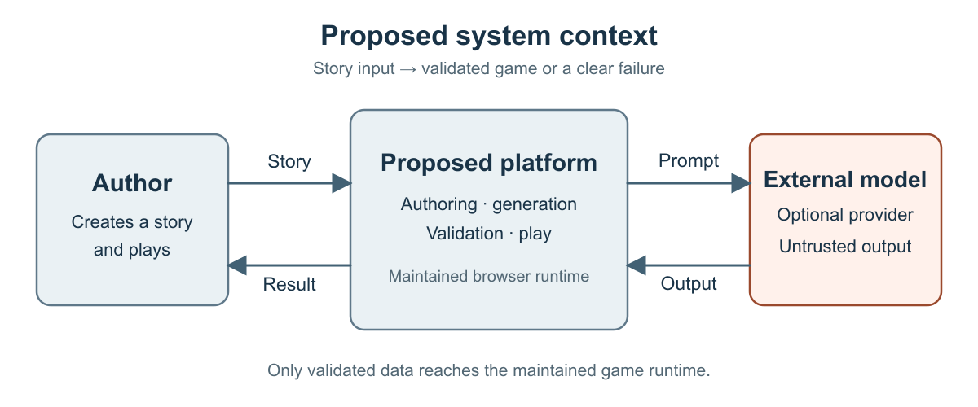
Figure 2 Author use cases (proposed)
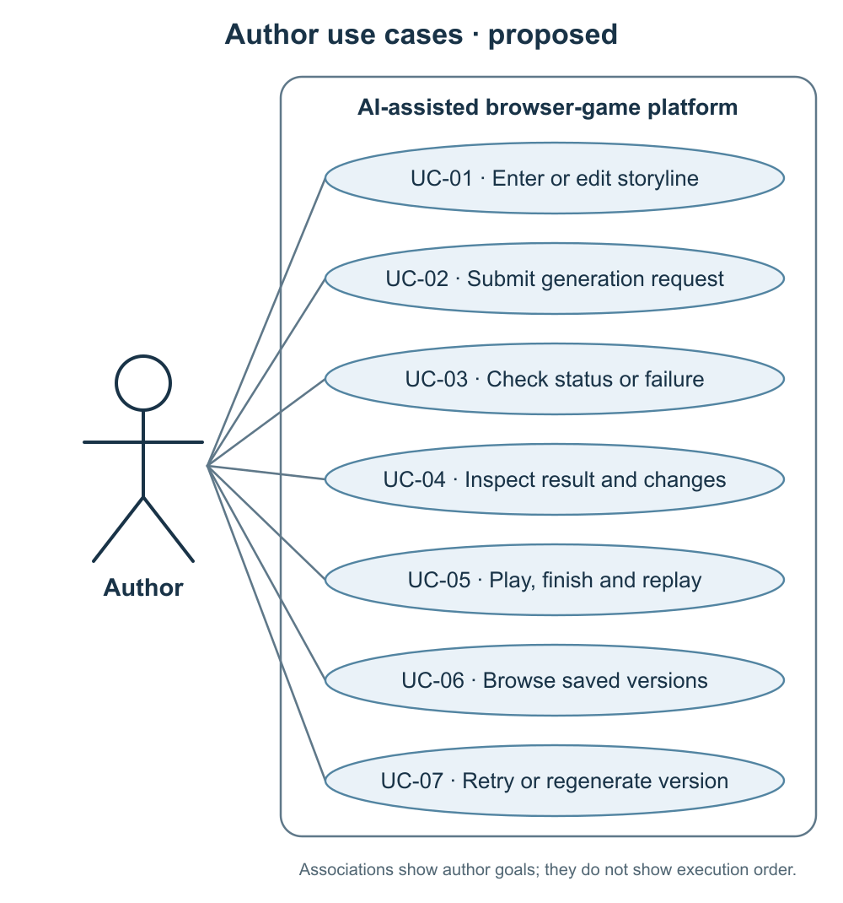
Figure 3 Component architecture (proposed)
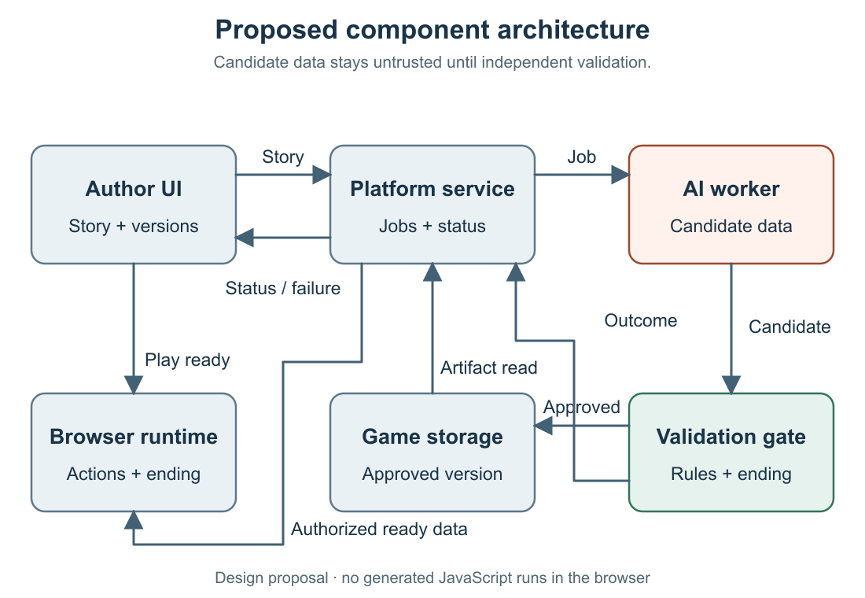
The component boundaries and status transitions require an integration check with a manually authored valid specification and an invalid candidate before any generated result is described as working.

8 Initial UX concept
The interface concept follows the author’s main path. The repository’s prototype/index.html presents linked static screen states for story entry, generation progress, result review, play and ending, saved versions and failure recovery. Request fields and game scenes are illustrative design examples.
Table 7 Key screens and feedback
Screen | Visible content and next action
Story and parameters | Editable story, goal, intended action and supported mechanic guidance; correct incomplete input before submission.
Progress and result | Actual job state, completed version, controls and any mechanic substitutions; show a useful failure and revision path.
Play and ending | Game canvas, control instructions, objective, restart and a visible completion state; preserve access to the submitted story.

A prototype walkthrough will examine whether prospective authors understand what the system can generate, how to reach play and what changed from the requested story. Observed confusion and resulting interface revisions will inform the design.

9 Verification and evaluation plan
A fixed corpus of short story prompts will be defined before evaluation, including cases beyond the supported mechanic set. A manually authored game in the same runtime will serve as a baseline for launch and controls; it is not a baseline for automated interpretation. Results will report all attempts and failures under recorded browser, model, configuration and prompt conditions.
Table 8 Planned checks, measures and conditions
Check | Evidence and measure
Specification and safety | Valid/invalid fixtures test schema, references, bounds and publication gating; count valid specifications out of all attempted prompts.
Playability | Browser smoke check observes launch, primary action changing state and a visible ending; report each proportion using all attempted prompts as denominator.
Story correspondence | Two reviewers compare goal, essential action and substitutions against a rubric; report disagreements and failed cases.
Operational failures | Inject worker/queue and invalid-result errors; inspect durable status, retry bounds and absence of false ready results.

Evaluation thresholds will be agreed before the first measured comparison.

10 Project organization, milestones and risks
The three students own frontend and UX, platform services, and AI generation respectively (Table 1); shared interfaces and research synthesis require cross-review. Draft artifacts are versioned in the GitHub repository lastnurik/diploma on branch pre-defense-draft. The team uses the YouTrack workspace at https://aitu-gamegen.youtrack.cloud/. The repository backlog specifies development deliverables, dependencies and acceptance conditions. The milestones provide the proposed sequence for implementation and evaluation.
Table 9 Proposed stages
Period | Reviewable output
Late October–mid December 2026 | Review exploratory questionnaire findings, agree the scope with the supervisor and propose a shared contract before implementation.
Late December 2026–January 2027 | A manually authored browser game with meaningful actions, an attainable ending and restart.
January–March 2027 | Bounded generation and validation, followed by integration of the request-to-play journey with visible failure and simplification.
March–May 2027 | Measured evaluation, supervisor review, revisions and final documentation.

Principal risks are unbounded genre expectations, invalid or unsafe generated output, divergence between component contracts, and a student sample that may not reflect intended users. The proposed responses are a limited first mechanic set, strict validation, a versioned shared specification with cross-review, and further user input where feasible. Ownership and acceptance conditions are recorded in the repository.

11 Supervisor review and subsequent revision
The recorded supervisor guidance prioritizes the project proposal and relevance and calls for concise treatment of the remaining required sections. This manuscript follows that emphasis through the detailed proposal and relevance analysis in Sections 1 and 2, supported by compact research, design and evaluation sections. Subsequent consultation will address the initial mechanic set, interpretation of questionnaire findings and evaluation criteria. Decisions and resulting revisions will be recorded with the consultation date, affected artifact and responsible author.

References
[1] Rosebud AI, tutorial, https://rosebud.ai/tutorial (accessed October 2026).
[2] GDevelop, “Make games with the AI Agent,” https://gdevelop.io/blog/make-games-with-ai-agent-gdevelop-automated-prompt (accessed October 2026).
[3] AI Dungeon, getting started guide, https://help.aidungeon.com/getting-started (accessed October 2026).
[4] Wang et al., “ByteSized32,” EMNLP 2023, https://aclanthology.org/2023.emnlp-main.830/.
[5] Amershi et al., “Guidelines for Human-AI Interaction,” CHI 2019, https://doi.org/10.1145/3290605.3300233.
[6] Rogosch and Schrader, “Automated Generation and Evaluation of Interactive-Fiction Serious Games with Open-Weight LLMs,” Applied Sciences 16(6), 2026, https://doi.org/10.3390/app16062932.
[7] Agarwal et al., “GAMED.AI,” ACL System Demonstrations 2026, https://doi.org/10.18653/v1/2026.acl-demo.84.
[8] Cai et al., “Spec2Game,” preprint, 2026, https://arxiv.org/abs/2610.04253.
[9] Martens et al., “Modeling Game Mechanics With Ceptre,” IEEE Transactions on Games 16(2), 2024, https://doi.org/10.1109/TG.2023.3292982.
[10] Facey et al., “Game Behaviour Trees Using Tile Rewrite Rules,” AIIDE 2025, https://doi.org/10.1609/aiide.v21i1.36825.
[11] Villanueva Aylagas et al., “Improving Conditional Level Generation using Automated Validation in Match-3 Games,” IEEE Transactions on Games, 2024, https://doi.org/10.1109/TG.2024.3440214.
[12] Fernandez-de-Retana et al., “A Permissions Odyssey,” ACM IMC 2025, https://doi.org/10.1145/3730567.3764489.
[13] Hilbig et al., “An Empirical Study of Real-World WebAssembly Binaries,” WWW 2021, https://doi.org/10.1145/3442381.3450138.
[14] Zamfirescu-Pereira et al., “Why Johnny Can’t Prompt,” CHI 2023, https://doi.org/10.1145/3544548.3581388.
[15] Kim et al., “A Guided Prompting Interface for Supporting Creative Intent in AI Image Generation,” Archives of Design Research 39(1), 2026, https://doi.org/10.15187/adr.2026.02.39.1.53.
[16] GDevelop, “Gameplay tests,” https://wiki.gdevelop.io/gdevelop5/interface/gameplay-tests/ (accessed 22 October 2026).

