Західноукраїнський національний університет

Лабораторна робота №5
“Робота з файлами, обробка текстової інформації”

Виконала:

Перевірив:

Тернопіль
2022

Варіант 1

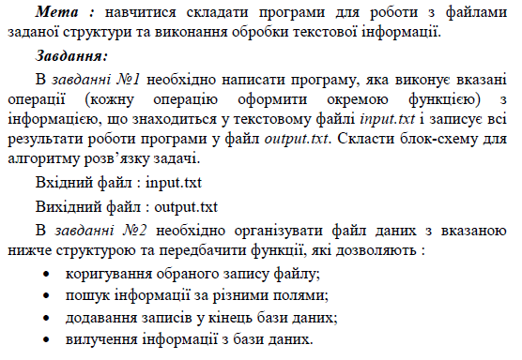
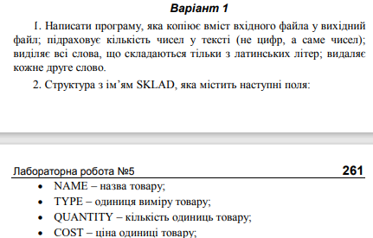

#include <fstream>
#include <sstream>
#include <iostream>
#include <vector>
using namespace std;

int NumberOfNumbers(string row) {
int numberOfNumbers = 0;
int result = 0;
for (int i = 0; i < row.length(); i++) {
if (isdigit(row[i])) {
numberOfNumbers += 1;
}
else {
if (numberOfNumbers >= 2) {
result++;
}
numberOfNumbers = 0;
}
}
return result;
}
bool IsLatinLetter(char letter) {
int charIndex = letter + 0;
if (charIndex <= 90 && charIndex >= 65 || charIndex <= 122 && charIndex >= 97) {
return true;
}
else {
return false;
}

}
string GetOnlyLatinWords(vector<string> rowSplit) {
bool isLatinWord = true;
string result = "";
for (int i = 0; i < rowSplit.size(); i++) {
for (int j = 0; j < rowSplit[i].length(); j++) {
if (!IsLatinLetter(rowSplit[i][j])) {
isLatinWord = false;
break;
}
}
if (isLatinWord) {
result += rowSplit[i] + " ";
}
isLatinWord = true;
}
return result;
}
string DeleteEvenWords(vector<string> rowSplit) {
string result = "";
for (int i = 0; i < rowSplit.size(); i++) {
if (i % 2 == 0) {
result += rowSplit[i] + " ";
}
}
return result;
}
void firstTask() {

stringstream buffer;
string row;
ifstream infile;
infile.open("input.txt");
buffer << infile.rdbuf();
row = buffer.str();
cout << "Data: " << row << endl;

vector<string> rowSplit;
int prevIndex = 0;
for (int i = 0; i < row.length(); i++) {
if (row[i] == ' ') {
rowSplit.push_back(row.substr(prevIndex, i - prevIndex));
prevIndex = i + 1;
}
}
rowSplit.push_back(row.substr(prevIndex, row.length() - prevIndex));
infile.close();

ofstream outfile;
outfile.open("output.txt");
outfile << row << endl;
outfile << "Number of numbers in text: " << NumberOfNumbers(row) << endl;
outfile << "Words with latin letters: " << GetOnlyLatinWords(rowSplit) << endl;
outfile << "Delete every second letter: " << DeleteEvenWords(rowSplit) << endl;

outfile.close();
}

// second task
struct SKLAD
{
string name;
string type;
int quantity;
double cost;
};
void WriteStructToFile(vector<SKLAD> sklads) {
ofstream outfile;
outfile.open("db.txt");
for (SKLAD sklad : sklads) {
outfile << sklad.name << ">" << sklad.type << ">" << sklad.quantity << ">"<< sklad.cost << ">";
}
outfile.close();
}
void writeSkladToConsole(SKLAD sklad, int index = -1) {
cout << "This sklad have these fields: " << endl;
if (index != -1)
cout << "0 - Index: " << index << endl;
cout << "1 - Name: " << sklad.name << endl;
cout << "2 - Type: " << sklad.type << endl;
cout << "3 - Quantity: " << sklad.quantity << endl;
cout << "4 - Cost: " << sklad.cost << endl;
}
void ChangeDataOfSklad(vector<SKLAD>& sklads) {
int index;
int rowNumber;
cout << "Enter index of abiturient to change: ";
cin >> index;
cout << "This abiturient have these fields: " << endl;
writeSkladToConsole(sklads.at(index));
cout << "Enter row number to change: ";
cin >> rowNumber;
switch (rowNumber)
{
case 1:
cout << "Set new name: ";
cin >> sklads[index].name;
break;
case 2:
cout << "Set new type: ";
cin >> sklads[index].type;
break;
case 3:
cout << "Set new quantity: ";
cin >> sklads[index].quantity;
break;
case 4:
cout << "Set new cost: ";
cin >> sklads[index].cost;
break;
default:
cout << "Wrong operation" << endl;
break;
}
cout << "Field was changed" << endl;

WriteStructToFile(sklads);
}
void FindSkladByField(vector<SKLAD>& sklads) {
int fieldType;
string searchWord;
cout << "1 - Name: " << endl;
cout << "2 - Type: " << endl;
cout << "3 - Quantity: " << endl;
cout << "4 - Cost: " << endl;
search:
cout << "Which field use to search: ";
cin >> fieldType;
cout << "Search word: ";
cin >> searchWord;
cout << "What have found: " << endl;
for (int i = 0; i < sklads.size(); i++) {
switch (fieldType)
{
case 1:
if (sklads[i].name == searchWord) {
writeSkladToConsole(sklads[i], i);
}
break;
case 2:
if (sklads[i].type == searchWord) {
writeSkladToConsole(sklads[i], i);
}
break;
case 3:
if (sklads[i].quantity == stoi(searchWord)) {
writeSkladToConsole(sklads[i], i);
}
break;
case 4:
if (sklads[i].cost == stod(searchWord)) {
writeSkladToConsole(sklads[i], i);
}
break;
default:
cout << "Wrong operation" << endl;
break;
}
}

}
void CreateNewSklad(vector<SKLAD>& sklads) {
string name;
string type;
int quantity;
double cost;
cout << "Enter name: ";
cin >> name;
cout << "Enter type: ";
cin >> type;
cout << "Enter quantity: ";
cin >> quantity;
cout << "Enter cost" << endl;
cin >> cost;
sklads.push_back({ name,type,quantity,cost });
cout << "Sklad was created" << endl;
WriteStructToFile(sklads);
}
void DeleteSklad(vector<SKLAD>& sklads) {
int index;
cout << "Enter index to delete: ";
cin >> index;
sklads.erase(sklads.begin() + index);
WriteStructToFile(sklads);
cout << "Sklad was deleted" << endl;
}
void secondTask() {
vector<SKLAD> sklads;
//read
stringstream buffer;
string row;
ifstream infile;
infile.open("db.txt");
buffer << infile.rdbuf();
row = buffer.str();
infile.close();
// split row
vector<string> rowSplit;
int prevIndex = 0;
for (int i = 0; i < row.length(); i++) {
if (row[i] == '>') {
rowSplit.push_back(row.substr(prevIndex, i - prevIndex));
prevIndex = i + 1;
}
}
rowSplit.push_back(row.substr(prevIndex, row.length() - prevIndex));

for (int i = 0; i < rowSplit.size() - 1; i += 6) {
sklads.push_back(SKLAD{ rowSplit.at(i),rowSplit.at(i + 1),stoi(rowSplit.at(i + 2)),{stod(rowSplit.at(i + 3))} });
}
int operation;
while (true) {
cout << "MENU" << endl;
cout << "1 - Change data of sklad" << endl;
cout << "2 - Find sklad by field" << endl;
cout << "3 - Create new sklad" << endl;
cout << "4 - Delete sklad" << endl;
cin >> operation;
switch (operation)
{
case 1:
ChangeDataOfSklad(sklads);
break;
case 2:
FindSkladByField(sklads);
break;
case 3:
CreateNewSklad(sklads);
break;
case 4:
DeleteSklad(sklads);
break;
default:
cout << "Wrong operation" << endl;;
}
}

}
int main()
{
firstTask();
secondTask();
}

Результат:
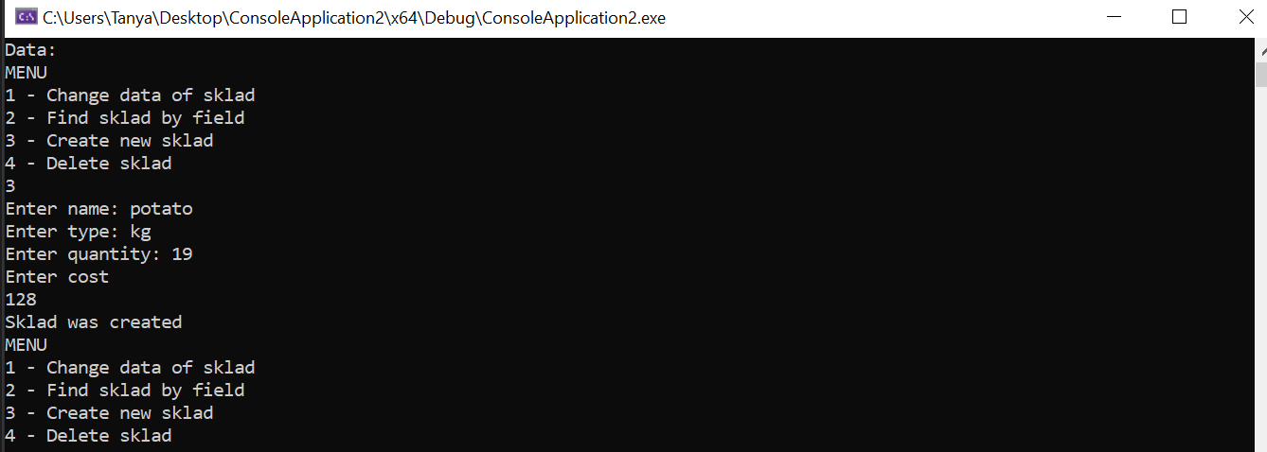
Висновок: під час виконання цієї лабораторної роботи я навчилась складати програми для роботи з файлами заданої структури та виконувати обробку текстової інформації.

