МІНІСТЕРСТВО ОСВІТИ І НАУКИ УКРАЇНИ
Західноукраїнський національний університет

Кафедра комп'ютерних наук

Комплексне практичне індивідуальне завдання
На тему: “ Робота з файлами. Обробка текстової інформації ”

Виконав:

Перевірив:

Тернопіль
2022 рік

Хід роботи:
Варіант 1

Написати програму, яка копіює вміст вхідного файлу у вихідний файл; підраховує кількість чисел у тексті; виділяє всі слова, що складаються тільки з латинських літер.

#define _CRT_SECURE_NO_WARNINGS
#include <iostream>
#include "ctime"
#include "cstring"
#include <fstream>
#include <string>
#include <cstdlib>
#include <cctype>
#include <iterator>
#include <algorithm>
#include <sstream>
#include <vector>
#include <stdio.h>
#include <stdlib.h>
using namespace std;
#define clean system("CLS")

/* GLOBAL VARIABLE */
const char* PATH = "data.txt";
/* PROTOTYPES */
struct Stock;
void Menu(Stock* a, int b);
void TaskStructure(Stock* a, int b);
void TaskFiles(Stock* a, int b);

/* TASK ONE - FILES */
void OutputFile(Stock* a, int b)
{
string line;
ifstream in("input.txt");
if (in.is_open())
{
while (getline(in, line))
cout << line << endl;
}
in.close();
ifstream out("output.txt");
if (out.is_open())
while (getline(out, line))
cout << line << endl;
out.close();
int ch = 0;
cout << "1 - Back to menu , 0 - Exit" << endl;
cout << "Input your choice: "; cin >> ch;
if (ch == 1)
TaskFiles(a, b);
else if (ch == 0)
exit(0);
}
void DeleteLatinWords(Stock* a, int b)
{
ifstream file("input.txt");
string str, s;
while (getline(file, str))
{
str += " ";
for (int i = 0; i < str.size(); i++)
if (!(isalpha(str[i])))
s += str[i];
}
str = s;
file.close();
ofstream infile("output.txt");
if (infile.is_open())
infile << "Sentence without latin symbols: " << str << endl;
infile.close();
cout << "Result sentence without latin symbols output.txt!" << endl;
int ch = 0;
cout << "1 - Back to menu , 0 - Exit" << endl;
cout << "Input your choice: "; cin >> ch;
if (ch == 1)
TaskFiles(a, b);
else if (ch == 0)
exit(0);
}
void DeleteSecondWords(Stock* a, int b)
{
ifstream file("input.txt");
vector <string> temp;
string str;
getline(file, str);
istringstream splitting(str);
while (splitting >> str)
{
temp.push_back(str);
splitting >> str;
}
file.close();
ofstream infile("output.txt");
if (infile.is_open())
copy(temp.begin(), temp.end(), ostream_iterator<string>(infile, " "));
infile.close();
int ch = 0;
cout << "Result of deleted second words in output.txt!" << endl;
cout << "1 - Back to menu , 0 - Exit" << endl;
cout << "Input your choice: "; cin >> ch;
if (ch == 1)
TaskFiles(a, b);
else if (ch == 0)
exit(0);
}
void CountOfNumbers(Stock* a, int b)
{
ifstream file("input.txt");
int count = 0;
string str, s;
while (getline(file, str))
{
str += ' ';
for (int i = 0; i < str.length(); i++)
{
if (isdigit(str[i]))
s += str[i];
if (!(isdigit(str[i])))
{
if (s != "")
count++;
s = "";
}
}
}
file.close();
ofstream infile("output.txt");
cout << "Results counts of numbers in output.txt!" << endl;
if (infile.is_open())
infile << count << endl;
infile.close();
int ch = 0;
cout << "Result of deleted second words in output.txt!" << endl;
cout << "1 - Back to menu , 0 - Exit" << endl;
cout << "Input your choice: "; cin >> ch;
if (ch == 1)
TaskFiles(a, b);
else if (ch == 0)
exit(0);
}

/* TASK TWO - STRUCTURE */
struct Stock
{
char name[100];
int type;
int quantity;
double cost;
};
void byName(Stock* a, int b);
void byType(Stock* a, int b);
void byQuantity(Stock* a, int b);
void byCost(Stock* a, int b);

/* FUNCTIONAL */
void Initiallization(Stock* a, int b)
{
for (int i = 0; i < b; i++)
{
cout << "\n";
cout << "Stock {" << i + 1 << "}" << endl;
cout << "Input name of stock: ";
cin >> a[i].name;
cout << "Input type of stock: ";
cin >> a[i].type;
cout << "Input quantity of stock: ";
cin >> a[i].quantity;
cout << "Input cost of stock: ";
cin >> a[i].cost;
}
}
void Show(Stock* a, int b)
{
for (int i = 0; i < b; i++)
{
cout << "\n";
cout << "Stock {" << i + 1 << "}" << endl;
cout << "Name: " << a[i].name << endl;
cout << "Type: " << a[i].type << endl;
cout << "Quantity: " << a[i].quantity << endl;
cout << "Cost: " << a[i].cost << endl;
}
}
void Find(Stock* a, int b)
{
clean;
int ch = 0;
cout << "1 - by Name , 2 - by Type , 3 - by Quantity , 4 - Cost, 5 - back to menu" << endl;
cout << "Choose by what field you wanna found: "; cin >> ch;
if (ch == 1)
byName(a, b);
else if (ch == 2)
byType(a, b);
else if (ch == 3)
byQuantity(a, b);
else if (ch == 4)
byCost(a, b);
else if (ch == 5)
TaskStructure(a, b);
else
{
clean;
Find(a, b);
}
}

/* SEARCH BY FIELD */
void byName(Stock* a, int b)
{
char buf[50];
cout << "\nEnter name of stock for search: ";
cin >> buf;
cout << " INFO BY NAME " << endl;
for (int i = 0; i < b; i++)
if (strcmp(a[i].name, buf) == 0)
cout << "\nName: " << a[i].name << "\nType: " << a[i].type << "\nQuantity: " << a[i].quantity << "\nCost:" << a[i].cost << endl;
int ch = 0;
cout << "Continue search by parameters or back to menu? " << endl;
cout << "1 - Search , 2 - Back to menu , 3 - Exit" << endl;
cout << "Input your choice: "; cin >> ch;
if (ch == 1)
Find(a, b);
else if (ch == 2)
TaskStructure(a, b);
else if (ch == 3)
exit(0);
}
void byType(Stock* a, int b)
{
int buf;
cout << "\nEnter name of stock for search: ";
cin >> buf;
cout << " INFO BY TYPE " << endl;
for (int i = 0; i < b; i++)
if (a[i].type == buf)
cout << "\nType: " << a[i].type << "\nName: " << a[i].name << "\nQuantity: " << a[i].quantity << "\nCost:" << a[i].cost << endl;
int ch = 0;
cout << "\nContinue search by parameters or back to menu? " << endl;
cout << "1 - Search , 2 - Back to menu , 3 - Exit" << endl;
cout << "Input your choice: "; cin >> ch;
if (ch == 1)
Find(a, b);
else if (ch == 2)
TaskStructure(a, b);
else if (ch == 3)
exit(0);
}
void byQuantity(Stock* a, int b)
{
int buf;
cout << "\nEnter name of stock for search: ";
cin >> buf;
cout << " INFO BY QUANTITY " << endl;
for (int i = 0; i < b; i++)
if (a[i].quantity == buf)
cout << "\nQuantity: " << a[i].quantity << "\nName: " << a[i].name << "\nType: " << a[i].type << "\nCost:" << a[i].cost << endl;
int ch = 0;
cout << "Continue search by parameters or back to menu? " << endl;
cout << "1 - Search , 2 - Back to menu , 3 - Exit" << endl;
cout << "Input your choice: "; cin >> ch;
if (ch == 1)
Find(a, b);
else if (ch == 2)
TaskStructure(a, b);
else if (ch == 3)
exit(0);
}
void byCost(Stock* a, int b)
{
double buf;
cout << "\nEnter name of stock for search: ";
cin >> buf;
cout << " INFO BY COST " << endl;
for (int i = 0; i < b; i++)
if (a[i].cost == buf)
cout << "\nCost:" << a[i].cost << "\nName: " << a[i].name << "\nType: " << a[i].type << "\nQuantity: " << a[i].quantity << endl;
int ch = 0;
cout << "Continue search by parameters or back to menu? " << endl;
cout << "1 - Search , 2 - Back to menu , 3 - Exit" << endl;
cout << "Input your choice: "; cin >> ch;
if (ch == 1)
Find(a, b);
else if (ch == 2)
TaskStructure(a, b);
else if (ch == 3)
exit(0);
}
void SaveToFile(Stock* a, int b)
{
ofstream fo(PATH, ios::binary);
for (unsigned i = 0; i < b; i++)
{
fo.write((char*)&a[i].name, sizeof(a[i].name));
fo.write((char*)&a[i].type, sizeof(a[i].type));
fo.write((char*)&a[i].quantity, sizeof(a[i].quantity));
fo.write((char*)&a[i].cost, sizeof(a[i].cost));
}
fo.close();
}
void LoadFromFile(Stock* a, int b)
{
Stock* ptrstock = new Stock[b];
ifstream fr(PATH, ios::binary);
for (unsigned i = 0; i < b; i++)
{
fr.read((char*)&ptrstock[i].name, sizeof(a[i].name));
fr.read((char*)&ptrstock[i].type, sizeof(a[i].type));
fr.read((char*)&ptrstock[i].quantity, sizeof(a[i].quantity));
fr.read((char*)&ptrstock[i].cost, sizeof(a[i].cost));
}
fr.close();
for (unsigned i = 0; i < b; i++)
cout << "Name: " << ptrstock[i].name << "\nType: " << ptrstock[i].type << "\nQuantity: " << ptrstock[i].quantity << "\nCost: " << ptrstock[i].cost << '\n';
delete[] ptrstock;
}

/* MENU */
void Menu(Stock* a, int b)
{
int ch = 0;
cout << "\tVARIANT 1" << endl;
cout << "1. Task One(Files)\n2. Task Two(Structure and Files)\n3. Exit" << endl;
cout << "Input number of task, what you wanna to do: ";
cin >> ch;
if (ch == 1)
{
clean;
TaskFiles(a, b);
}
else if (ch == 2)
{
clean;
TaskStructure(a, b);
}
else if (ch == 0)
exit(0);
else
{
clean;
Menu(a, b);
}
}
void TaskStructure(Stock* a, int b)
{
int ch = 0;
cout << "\n1. Init Stock/s\n2. Show Stock/s\n3. Search Stock by options\n4. Save Stocks to File\n5. Load Stocks from Filen\n0. Menu" << endl;
cout << "Input number of task, what you wanna to do: ";
cin >> ch;
if (ch == 1)
{
Initiallization(a, b);
clean;
TaskStructure(a, b);
}
else if (ch == 2)
{
clean;
Show(a, b);
TaskStructure(a, b);
}
else if (ch == 3)
{
clean;
Find(a, b);
TaskStructure(a, b);
}
else if (ch == 4)
{
SaveToFile(a, b);
TaskStructure(a, b);
}
else if (ch == 5)
{
LoadFromFile(a, b);
TaskStructure(a, b);
}
else if (ch == 0)
{
clean;
Menu(a, b);
}
}
void TaskFiles(Stock* a, int b)
{
clean;
int ch = 0;
cout << "\n1. Output File\n2. Delete Latin Words\n3. Delete Second Words\n4. Count of Numbers\n0. Menu" << endl;
cout << "Input number of task, what you wanna to do: ";
cin >> ch;
if (ch == 1)
OutputFile(a, b);
else if (ch == 2)
DeleteLatinWords(a, b);
else if (ch == 3)
DeleteSecondWords(a, b);
else if (ch == 4)
CountOfNumbers(a, b);
else if (ch == 0)
Menu(a, b);
else
{
clean;
TaskFiles(a, b);
}
}

int main()
{
int size = 0;
cout << "Input size of stocks: "; cin >> size;
Stock* stock = new Stock[size];
Menu(stock, size);
delete[]stock;
}

Контрольні приклади:
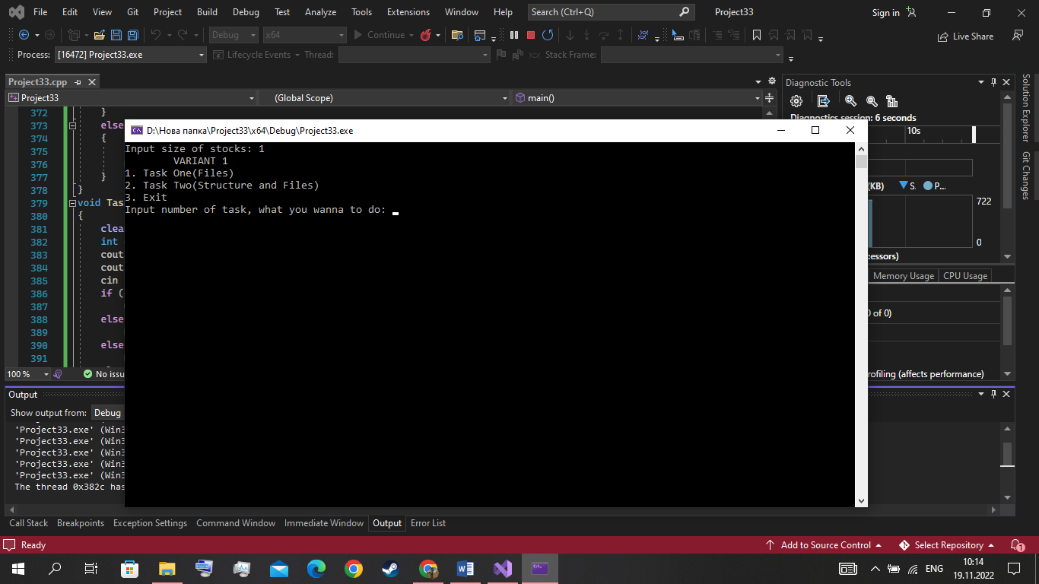

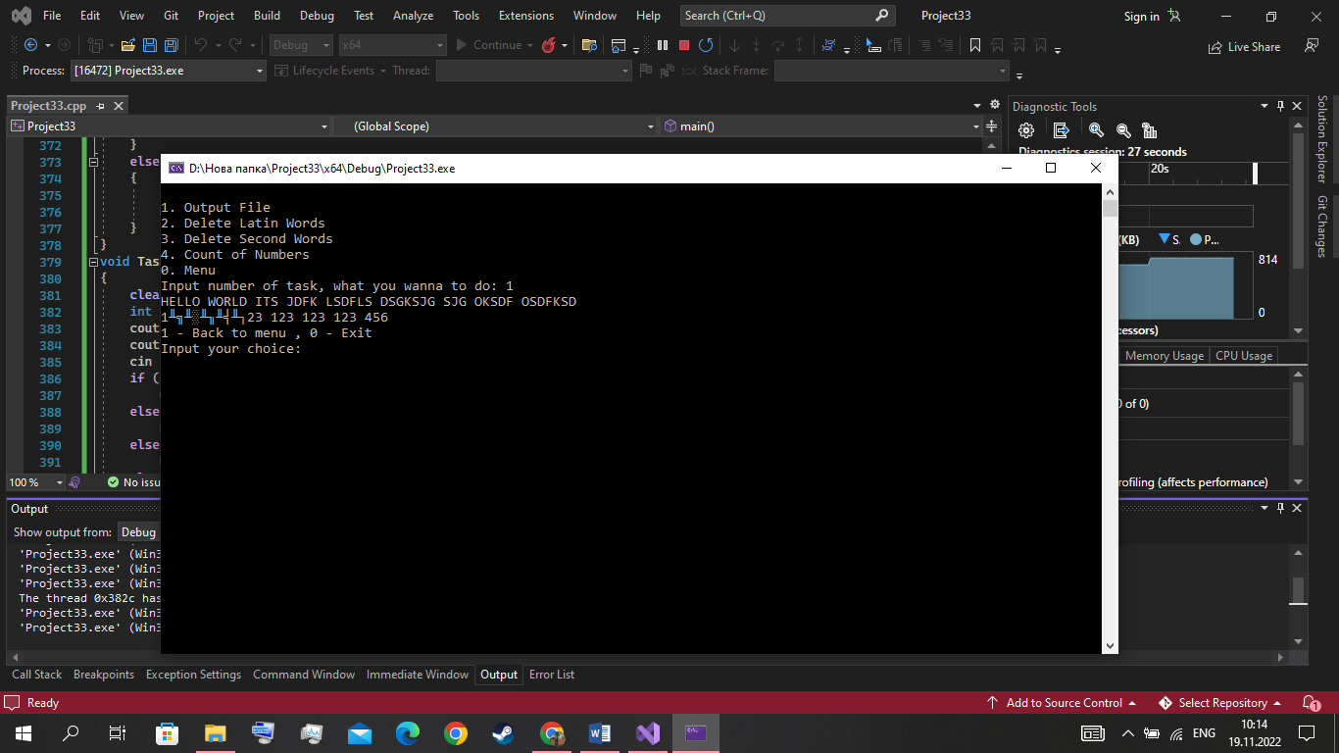

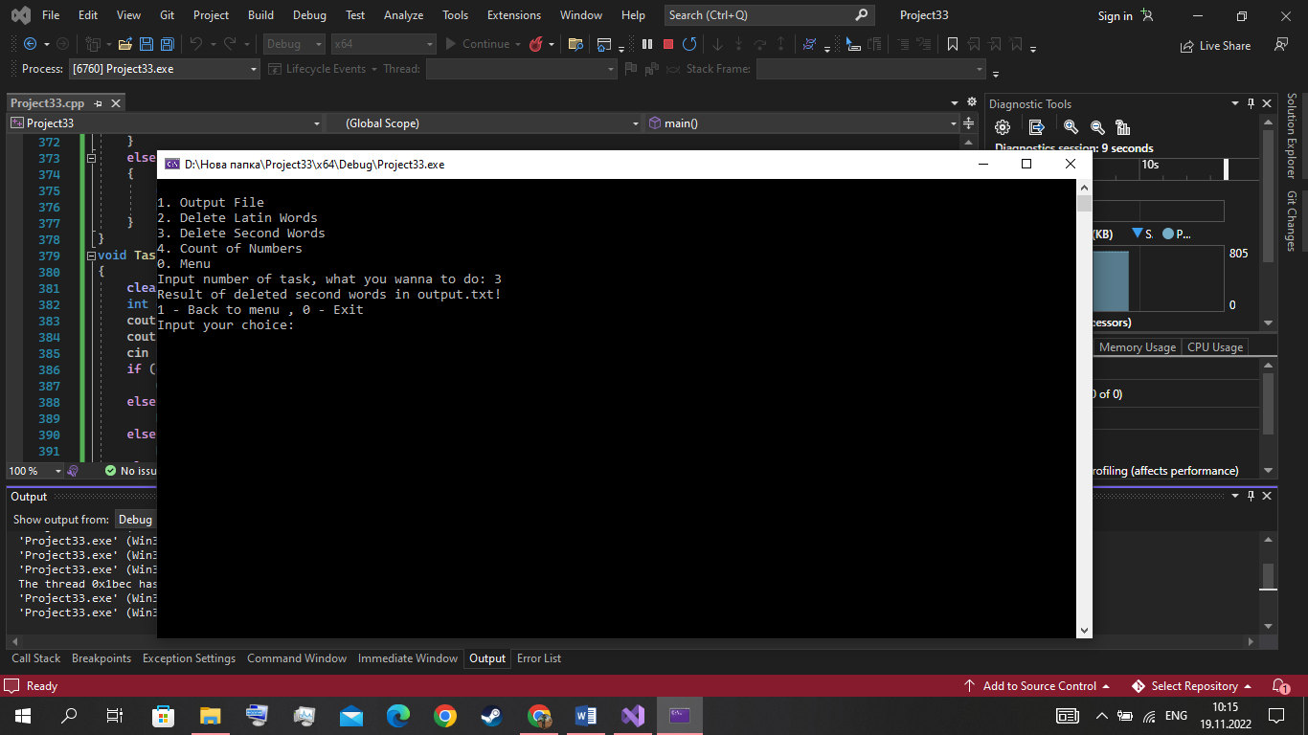

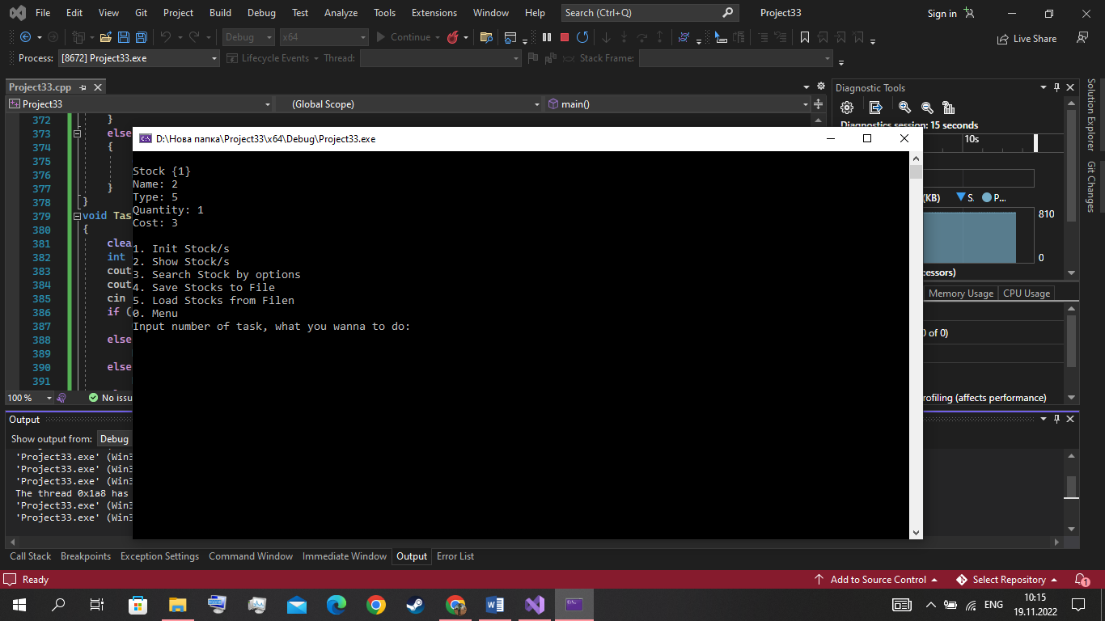

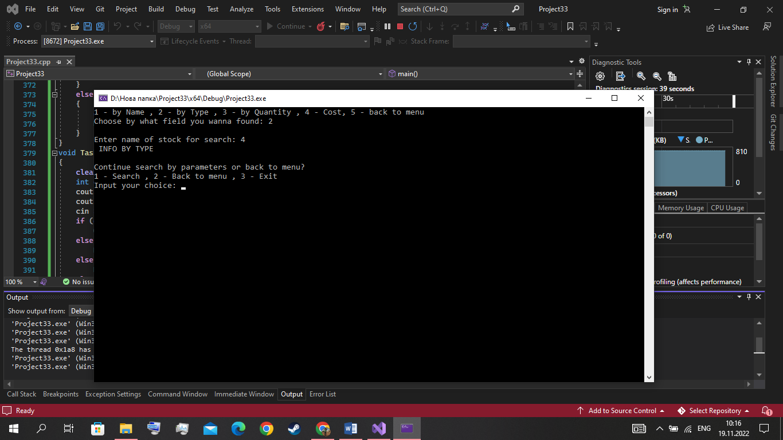

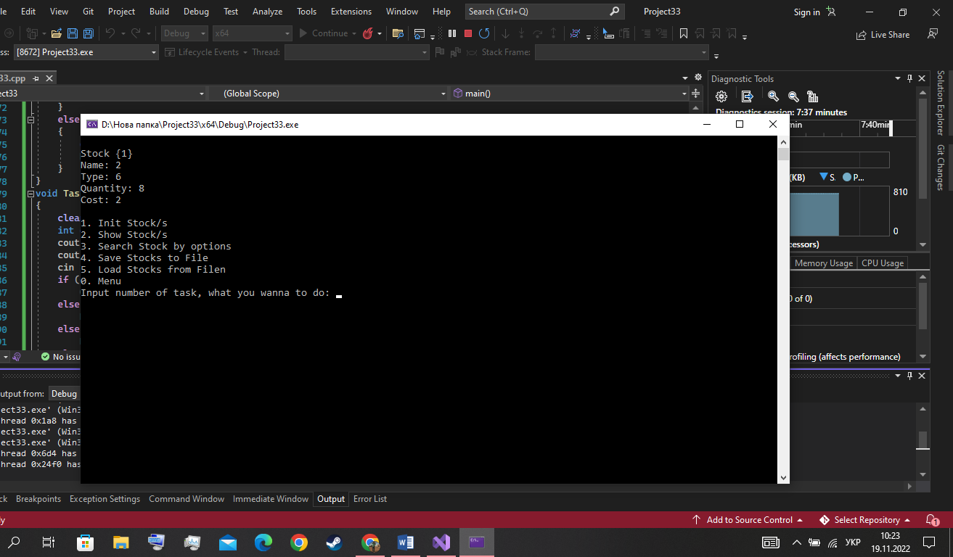
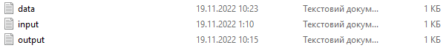
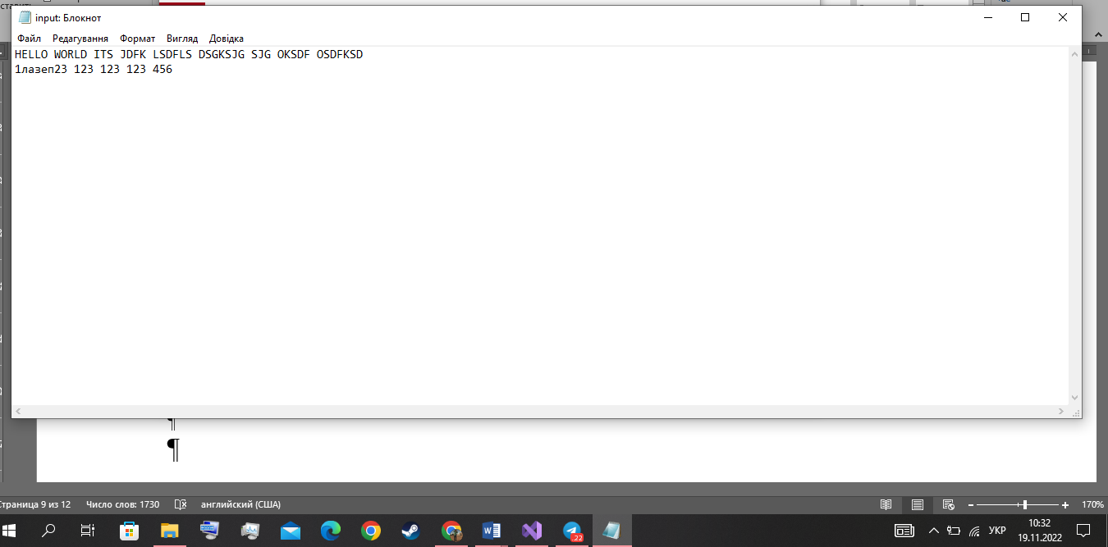
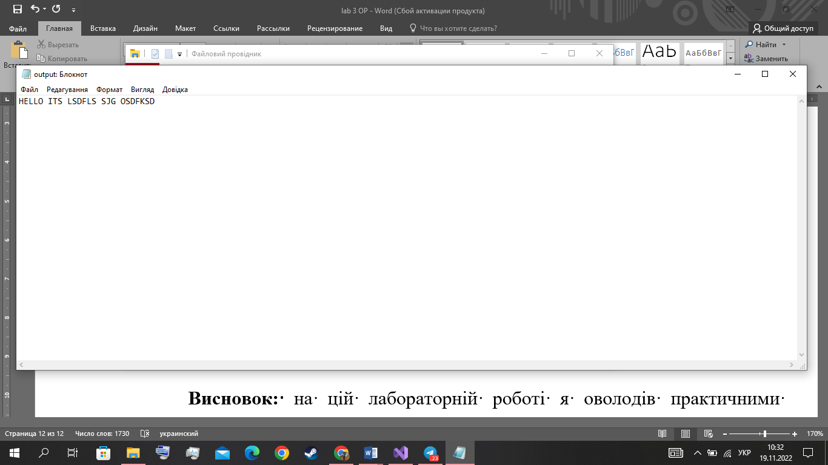
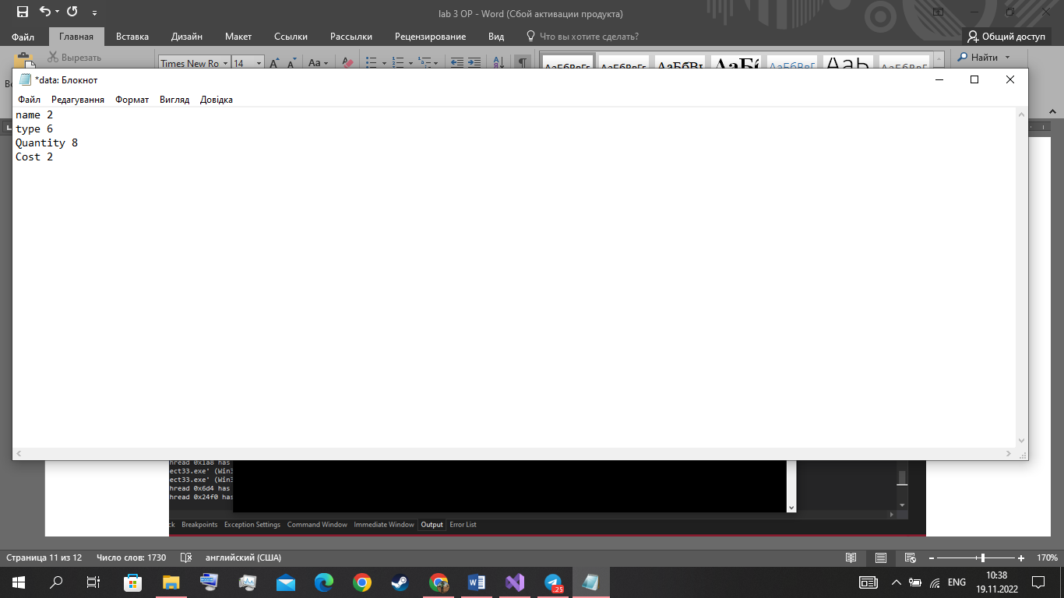

Висновок: в цій лабораторній роботі я оволодів практичними навичками використання структур та масивів структур, навчився складати програми для виконання операцій з полями структур, навчився використовувати динамічне виділення пам’яті.

