Home Watch

Overview
The purpose of the project is to create a surveillance system for home use that will be able to alert the owner by phone (SMS) when the door is opened or somebody is moving inside the house.

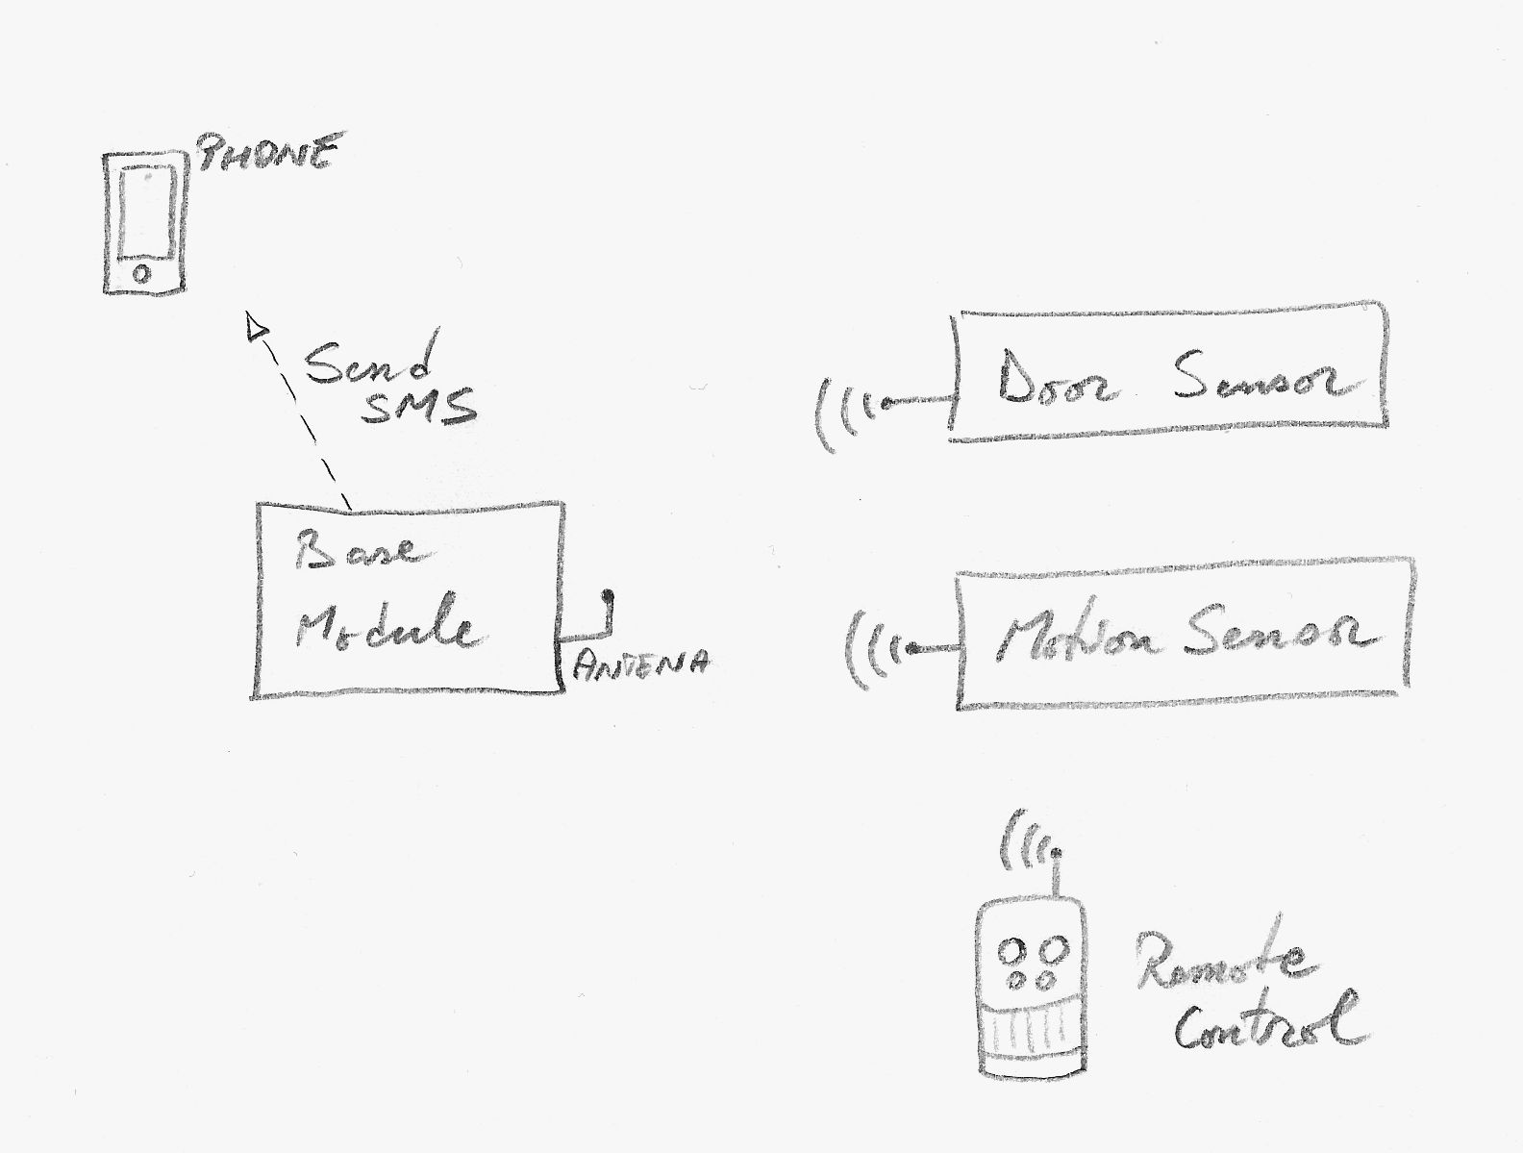

Used Hardware
The system is composed of one base module and a number of wireless sensors.

The Base Module
- Arduino Mega 2560 board
- Arduino GSM Shield 2
- One phone SIM that supports GSM.
- One radio receiver (433MHz)
- One piezoelectric speaker
- 5 LEDs
  - one red + one green => for GSM connection status
  - one red + one green => for arming status
  - one red => for signaling an alarm
- 5 x 220 Ohm resistors
- One breadboard
- Some wires of different lengths.

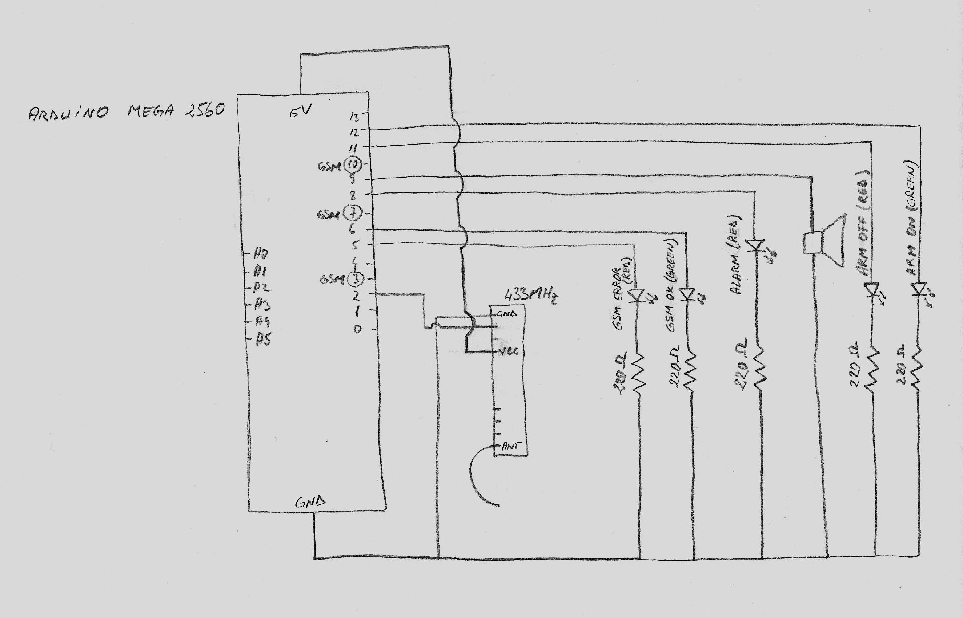

The Sensors
- Wireless door sensor (with magnet) (433MHz)
- Wireless motion sensor PIR (433MHz)
- Two remote controls with 2 buttons (433MHz)

Functionality

System Starting Time

GSM Shield Initialization
When the system starts, the GSM shield has to be initialized. The pin number is hard-coded. If the initialization succeeds and the GSM Shield is connected to the network, the GSM green LED is lighted. If the connection fails, the GSM red LED is lighted.

The Listener Status
When the system starts, it will be disarmed by default. It can be armed by using the remotes.

Remote Controls
Using the remote control the system can be armed or disarmed.

Arming
When arming the system by pressing the Arm button, it will make a specific sound for 60 seconds before it will be armed.
When the system is armed, the green System LED will be turned on and the red System LED will be turned off.
If the arming is performed when the system is already armed or in the process of arming (the 60 seconds), the arming process is started again from the beginning.

Disarming
When disarming the system, it will make a specific beep sound to announce it is disarmed.
When the system is disarmed, the red System LED will be turned on and the green System LED will be turned off.
If the disarming is performed when the system is already disarmed, the disarming process is executed again.

Door Sensor
When the door is opened, the door sensor will send a signal to the base module and the base module will:
- turn on the red Alarm LED;
- make a specific alert sound;
- send as alert SMS. (The phone number is hard-coded.);
- turn off the red Alarm LED.
Other signals from any other sensors will be ignored for the next 30 seconds.

Motion Sensor
When somebody moves inside the house, the motion sensor will send a signal to the base module and the base module will:
- turn on the red Alarm LED;
- make a specific alert sound;
- send as alert SMS. (The phone number is hard-coded.);
- turn off the red Alarm LED.
Other signals from any other sensors will be ignored for the next 30 seconds.

Others
After the system receives a signal through the 433MHz radio, the same signal will be ignored for the next 2 second.

