- KTSP_Train
- ForColon data
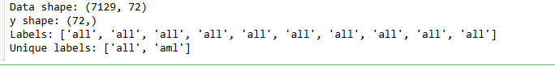
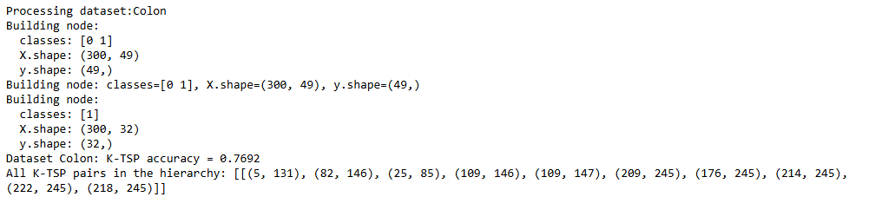
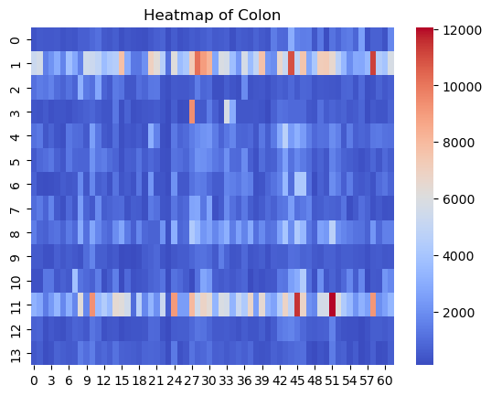

- For Leukemia data

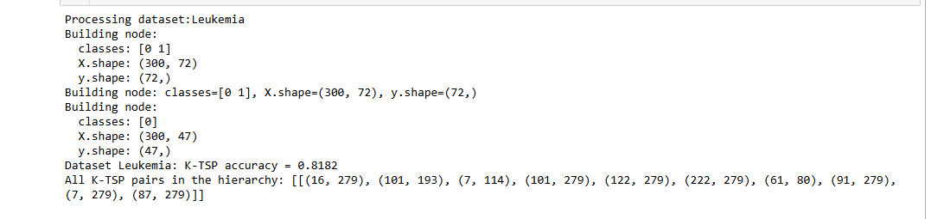
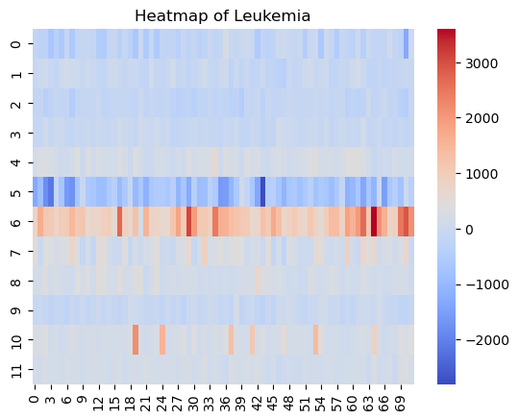

3.For DLBCL data
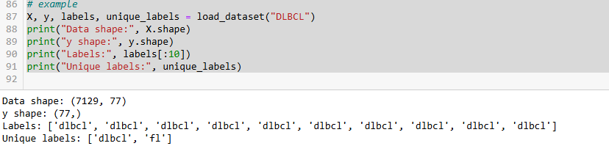
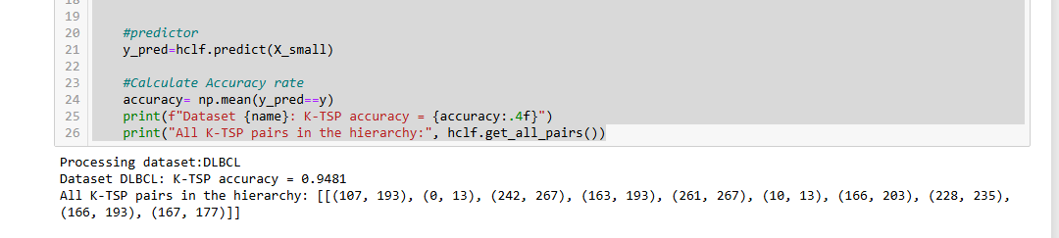
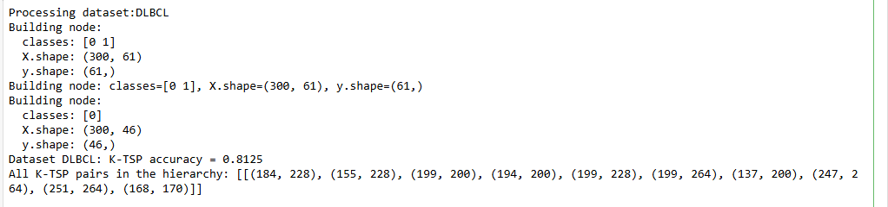
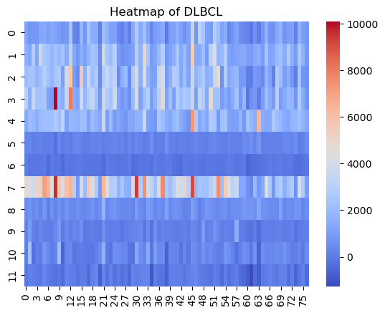

4.For Lung data
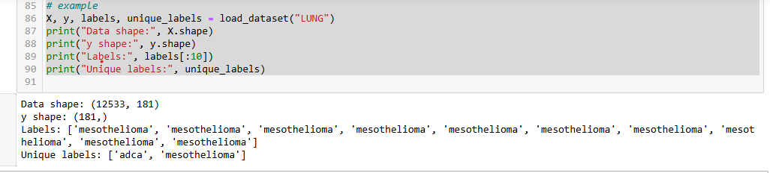

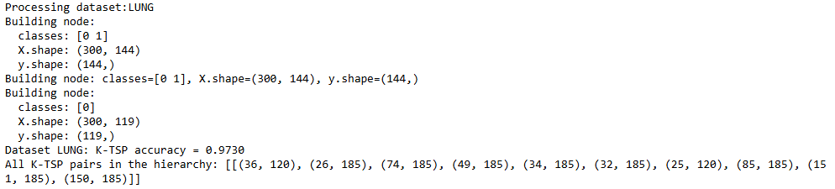
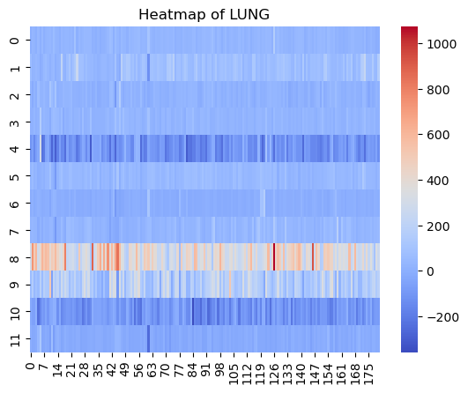
The data set is very easy to classify and samples are not lot while gene dimensions are much more and leads to overfit.Also it use for evalution for trainset while K-TSP is strong for fit for trainSet.Hierarchical K-TSP is easy for perfect for discrimination pair for every node.
5.For GCM data
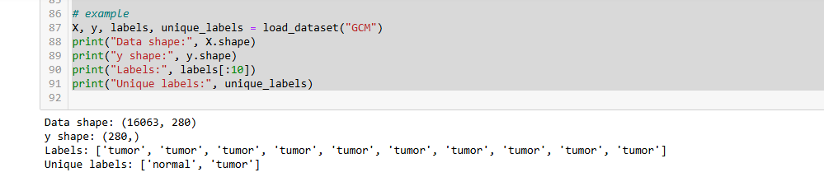
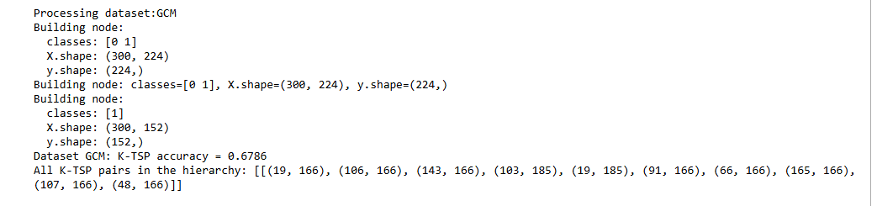
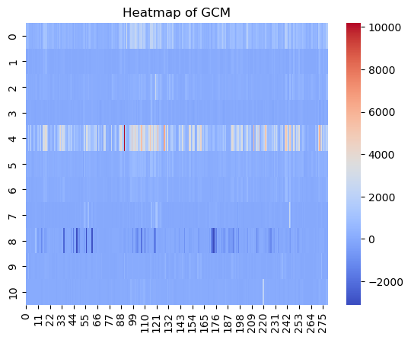

6.For prostate1 data (seperately process for 3 data)
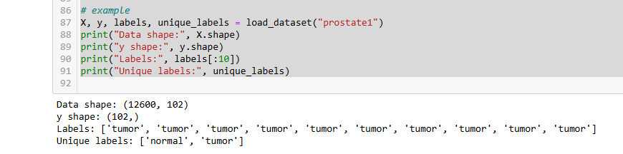

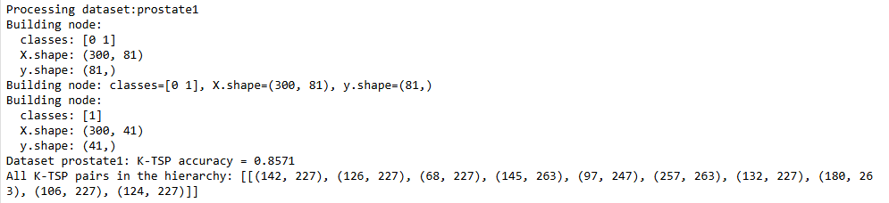
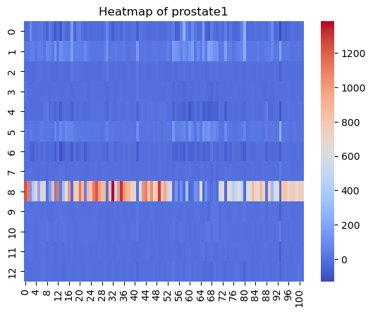

- For prostate2 data
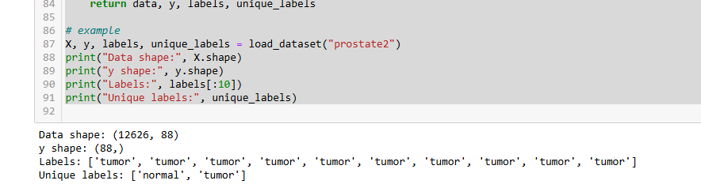

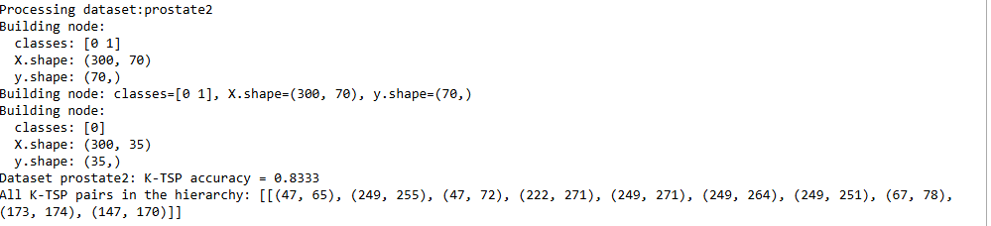
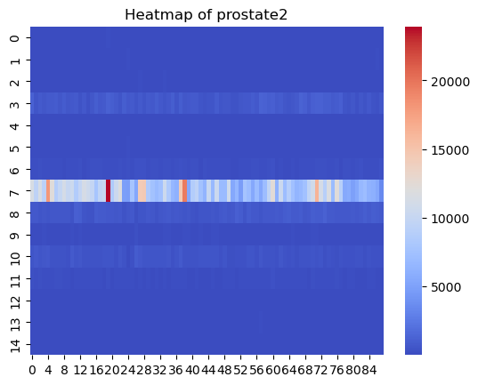

- For prostate3 data
