**Smart Lost & Found System — Phase 2: Org Setup & Configuration**

**1. Introduction**

This phase focuses on setting up a Salesforce Developer Org for the Smart Lost & Found System. The aim is to configure the organizational structure, user roles, profiles, sharing settings, and security policies to support core functionality such as reporting lost items, logging found items, and managing claim requests securely.

**2. Objectives**

* Configure a clean Salesforce Developer Org named **Smart Lost & Found**.
* Set up company profile, business hours, and holidays for the university environment.
* Create sample users representing Students, Staff, Security, and Admin.
* Define profiles and roles with appropriate permissions.
* Establish Org-Wide Defaults (OWD) and Sharing Rules for data security.
* Enable Login Access Policies and set up a Lightning App.
* Test role-based access and sharing logic.

**3. Configuration Steps**

**Step 0** - **Company Info**

* Signed up for Developer Edition and logged in.
* Setup → Company Information → updated:
  + **Organization Name:** Smart Lost & Found System
  + **Locale:** English (India)
  + **Timezone:** IST

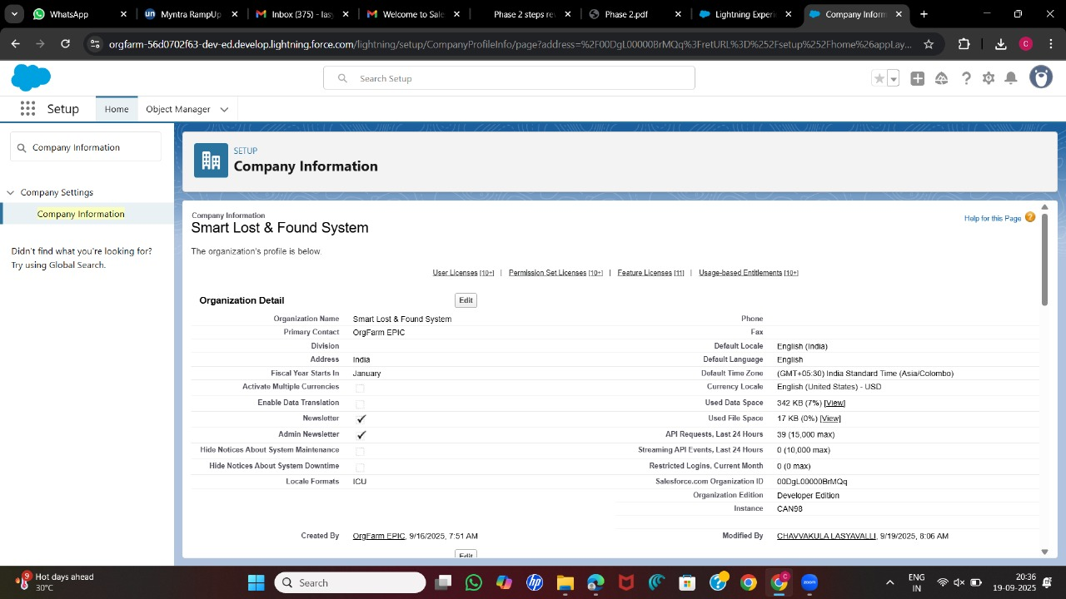

**Fig.0** - **Company Information Setup**

**Step 1** - **Business Hours & Holidays**

* Created **University Business Hours** (Mon–Sat, 9 AM–6 PM).
* Added key holidays (e.g., Independence Day, Diwali) and linked them to Business Hours.

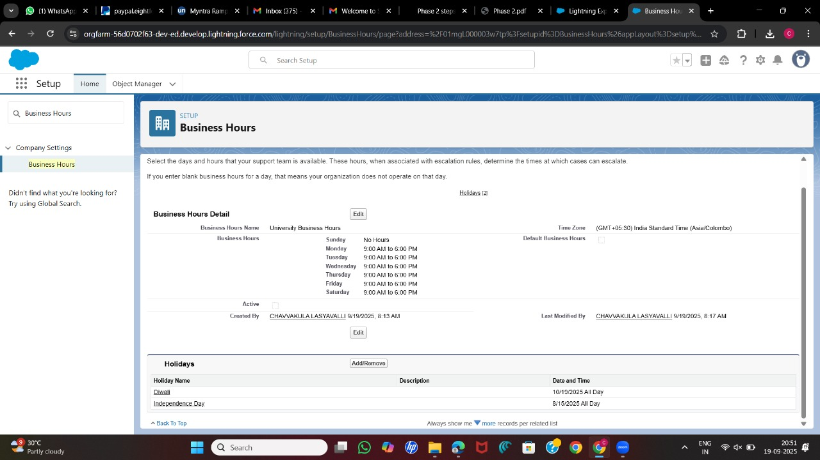

**Fig.1** - **University Business Hours & Holidays**

**Step 2** - **Users**

Created sample users:

|  |  |  |  |
| --- | --- | --- | --- |
| **Display Name** | **Username (example)** | **Profile** | **Role** |
| University Admin | admin@lostfound.com | System Administrator | Admin |
| Student Reporter | student1@lostfound.com | Student | Student |
| Staff Reporter | staff1@lostfound.com | Staff Reporter | Staff Reporter |
| Security Officer | security@lostfound.com | Security Staff | Security Officer |

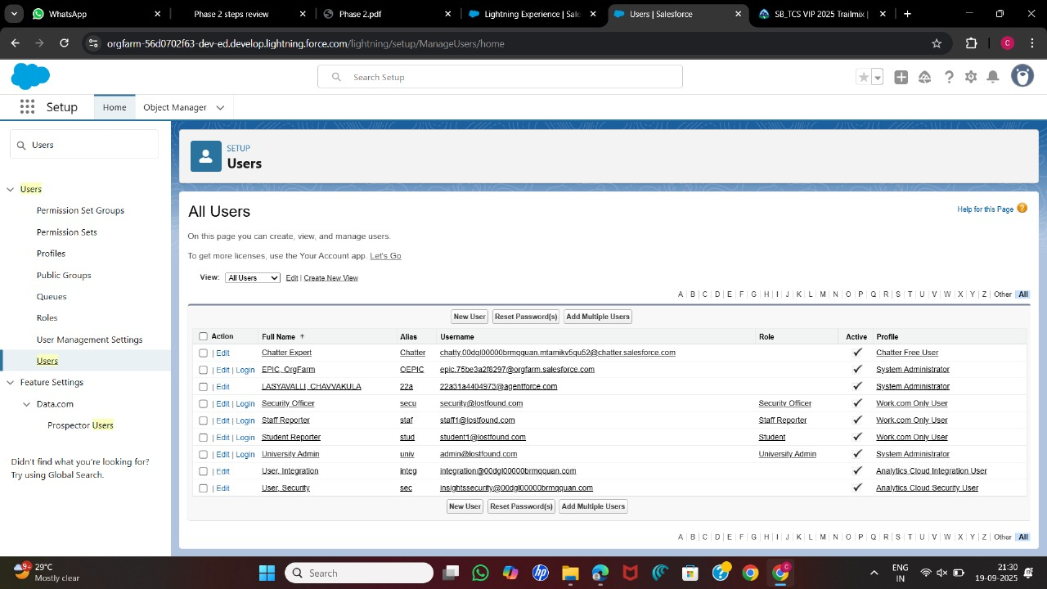

**Fig.2** - **Sample Users Creation**

**Step 3** - **Profiles**

* **Student Profile** (cloned from Standard User):
  + LostItem__c: Create/Read/Edit own records.
  + FoundItem__c: Read only.
  + ClaimRequest__c: Create/Read.
* **Staff Reporter Profile:**
  + LostItem__c: Read only.
  + FoundItem__c: Create/Read/Edit.
  + ClaimRequest__c: Read only.
* **Security Staff Profile:**
  + Full access to LostItem__c, FoundItem__c, ClaimRequest__c.

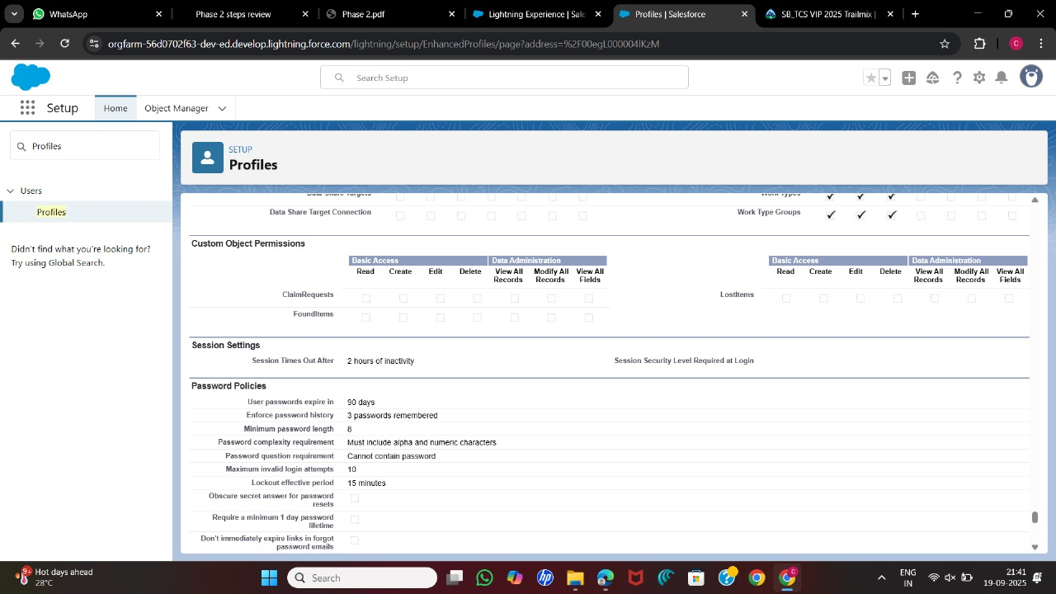

**Fig.3** - **Profiles Configuration**

**Step 4** - **Role Hierarchy**

* **University Admin** (Top)
  + **Security Officer**
* **Staff Reporter**
* **Students**

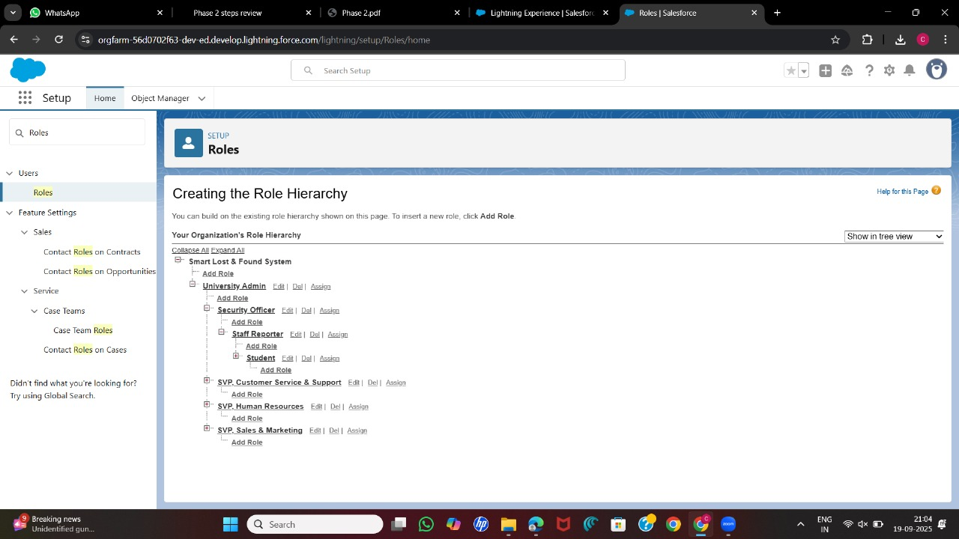

**Fig.4** - **Role Hierarchy Structure**

**Step 5** - **Org-Wide Defaults (OWD)**

* LostItem__c → Private
* FoundItem__c → Private
* ClaimRequest__c → Private

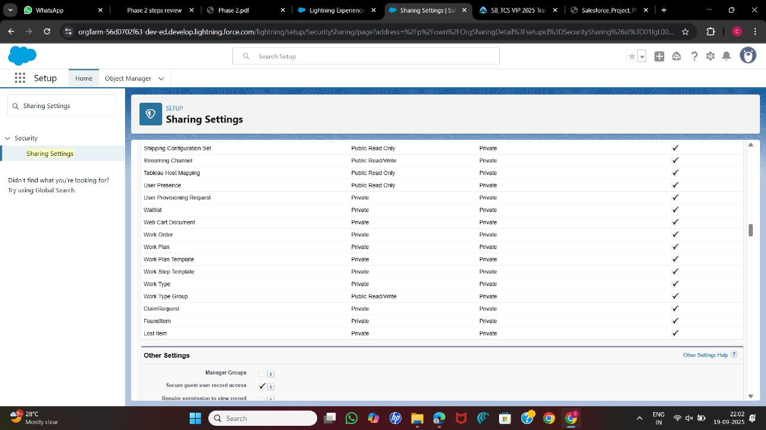

**Fig.5** - **Org-Wide Defaults (OWD) Settings**

**Step 6** - **Sharing Rules**

* Created Public Groups: **Students**, **Staff**, **Security**.
* Example Rules:
  + Share FoundItem__c created by Staff with **Security Staff** group → Read/Write.
  + 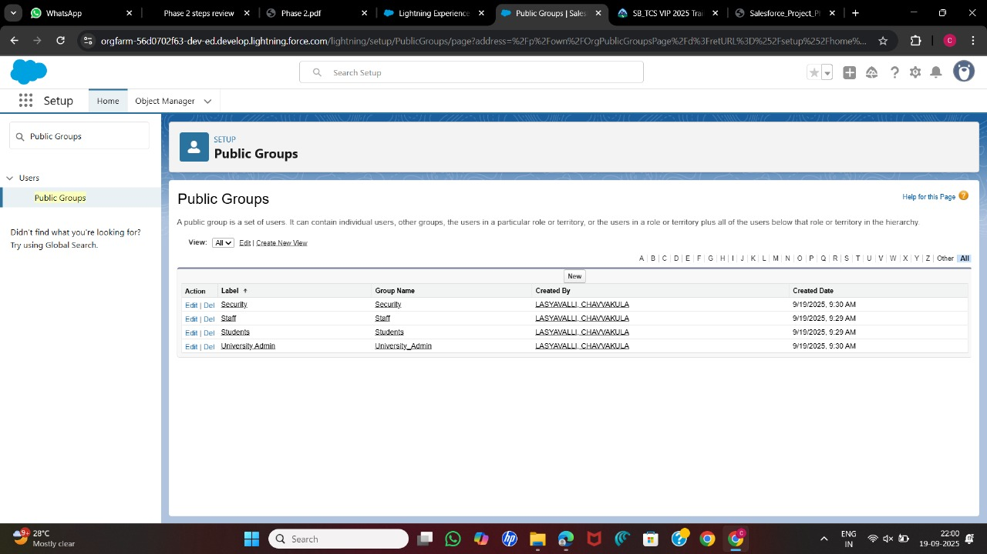Share ClaimRequest__c with **University Admin** group.

**Fig.6** - **Sharing Rules & Public Groups**

**Step 7 - Login Access Policies**

* Enabled “Administrators Can Log in as Any User.”

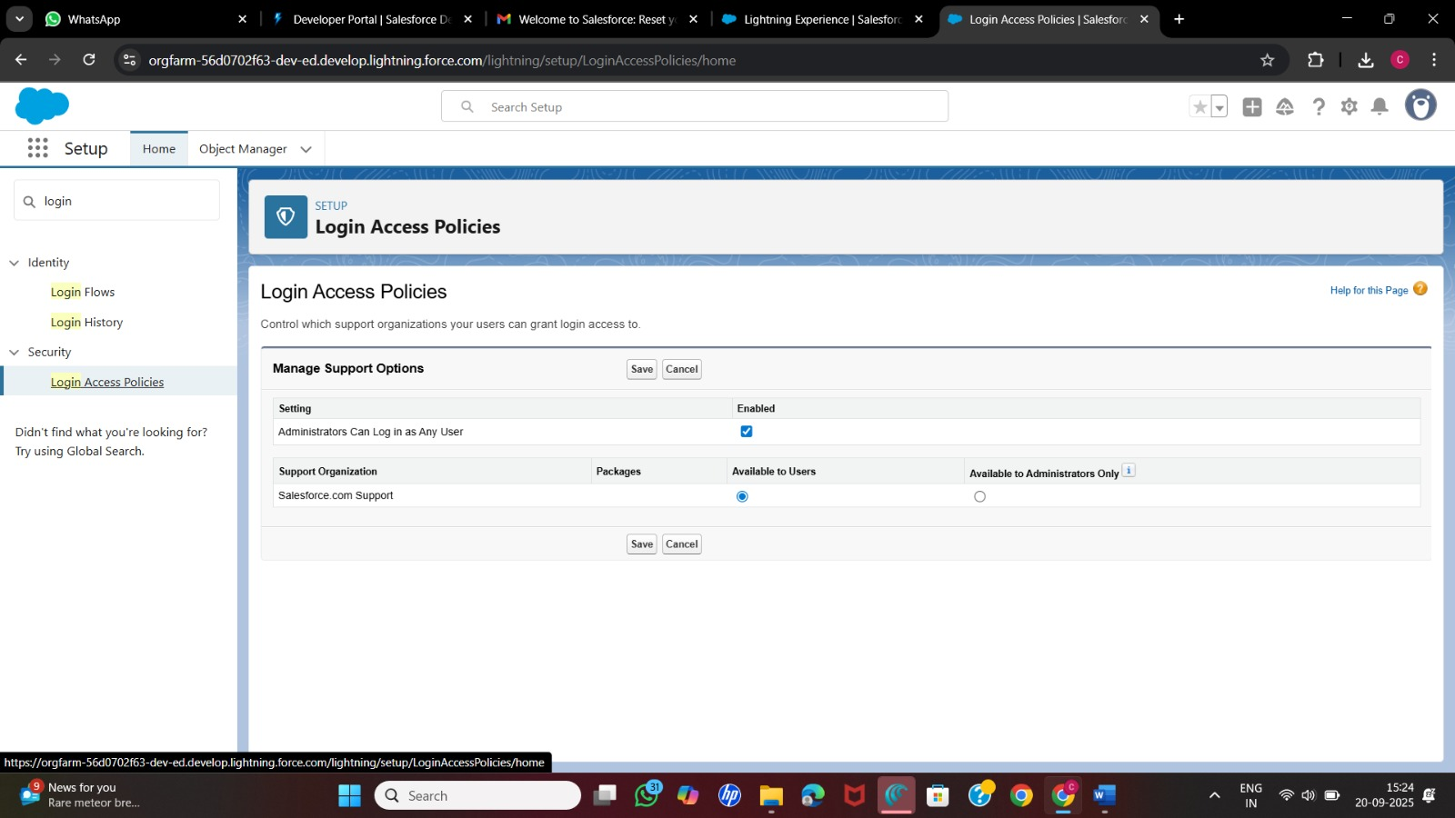

**Fig.7 - Login Access Policies Setup**

**Step 8 - Lightning App Setup**

* Created Lightning App: **Smart Lost & Found**
* Tabs added: Lost Items, Found Items, Claim Requests, Reports, Dashboards.

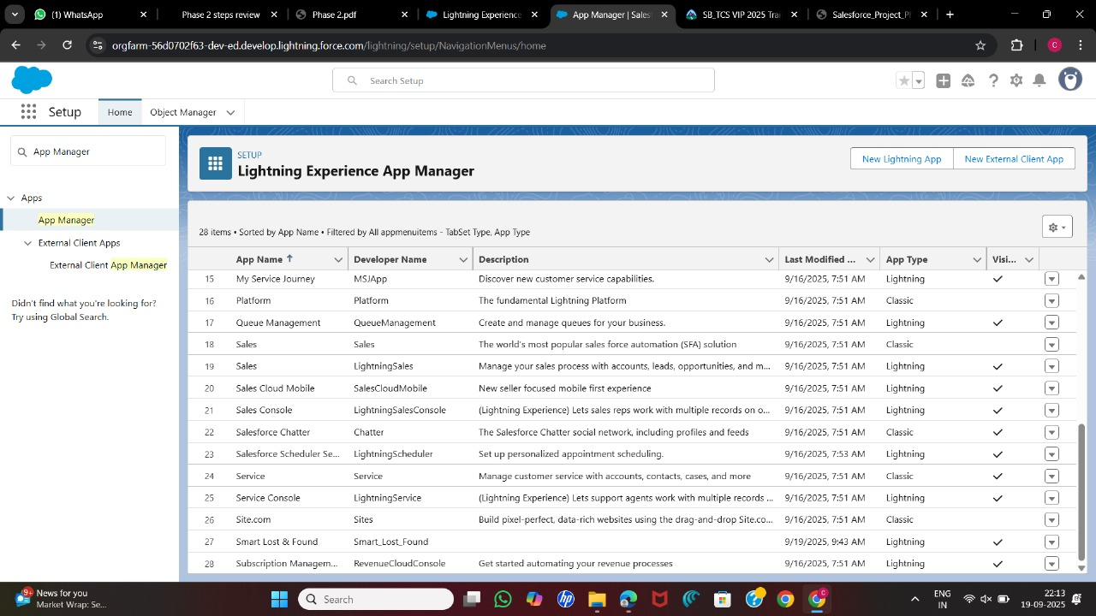

**Fig.8** - **Lightning App Setup (Smart Lost & Found App)**

**Step 9** -**Testing**

* Logged in as Student → created a Lost Item record.
* Logged in as Staff → created a Found Item record.
* Logged in as Security → viewed both Lost and Found items, approved ClaimRequest.
* Verified that Admin sees everything and OWD restrictions work correctly.

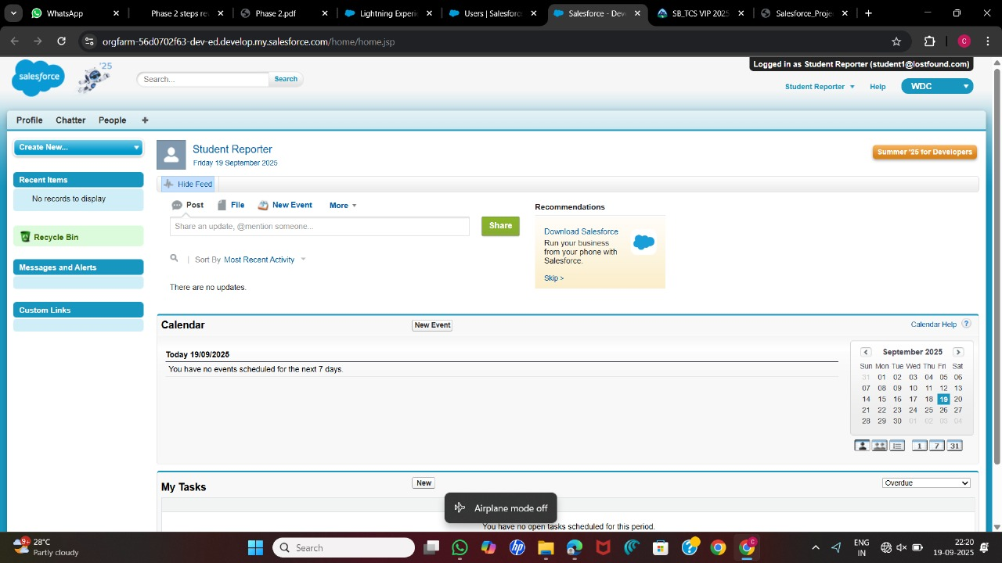

**Fig.9** - **Role-Based Access Testing Results**

**4. Results / Observations**

* Role hierarchy ensures proper data visibility.
* OWD set to **Private** secures all objects.
* Sharing Rules allow controlled collaboration between Students, Staff, and Security.
* Login Access policies simplify testing.
* Lightning App provides a user-friendly navigation for core objects.

**5. Next Steps**

* Introduce data modeling with custom objects (LostItem__c, FoundItem__c, ClaimRequest__c).
* Define relationships between objects (Student → LostItem, Staff → FoundItem, Security → ClaimRequest).
* Add automation flows for claim approvals and notification triggers.
* Build dashboards for recovery rates, lost item categories, and claim statistics.